# Test

## Image test

Image test

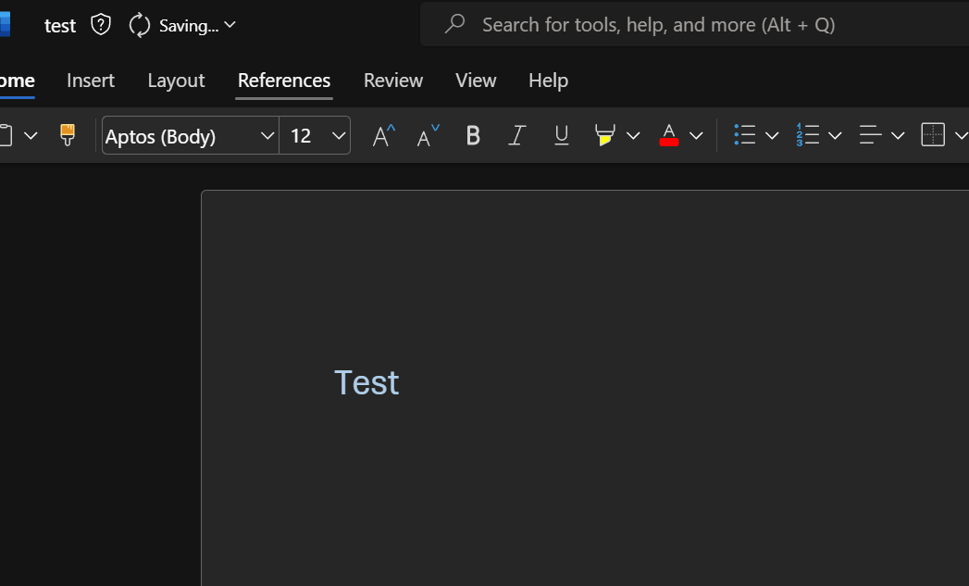

Try again