# Name: Section:

# Homework Assignment: submit via gradescope

1. Draw a detailed diagram of the oscilloscope grid required for Lab1 [Do not try to reuse and edit the picture below]. A detailed diagram must be drawn on green engineering paper (or draw using a computer program) and include

* (x,y) corners of the monitor.
* (x,y) each of the four major corners (already given).
* y-coordinates for all the major horizontal grid lines.
* (x,y) coordinates for one set of three horizontal of hatch marks. Indicate with an arrow which set of three.
* x-coordinates for all of the major vertical grid lines.
* (x,y) coordinates for one set of four vertical of hatch marks. Indicate with an arrow which set of four.

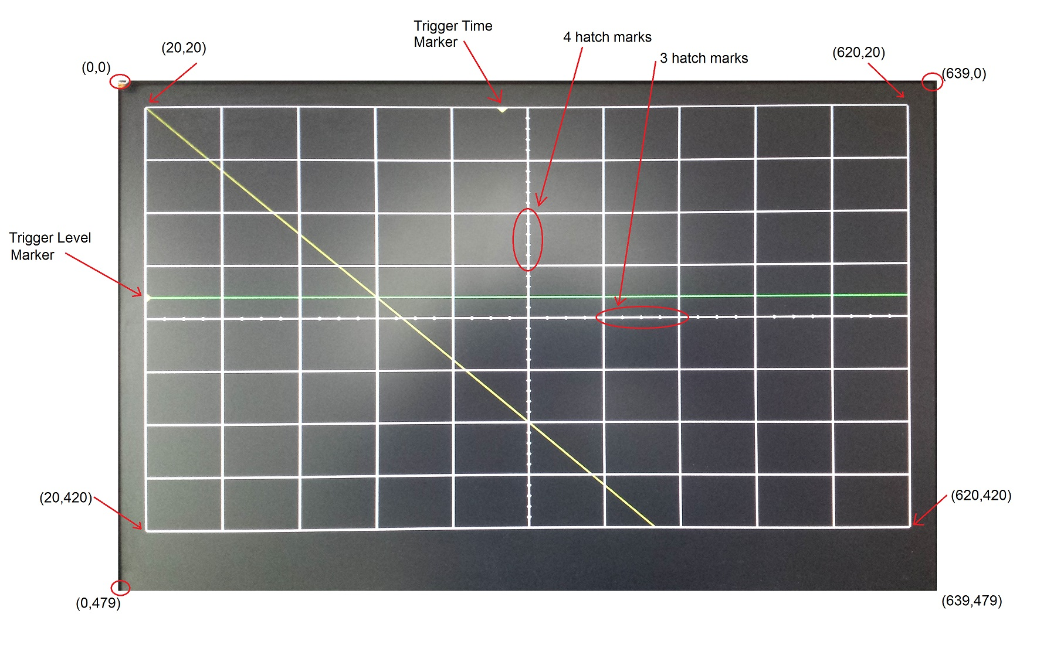

1. Given that the pixel clock is running at 25Mhz, add the **durations and counts** of the h_synch and v_synch signals show in Lab1. Set time=0 on the blue dashed line on the left side of the region labeled "Active Video". **You should add durations and counts for all blue lines.**   
   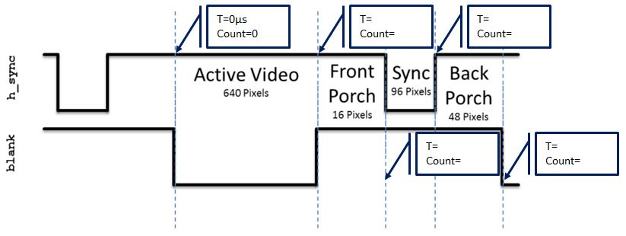  
   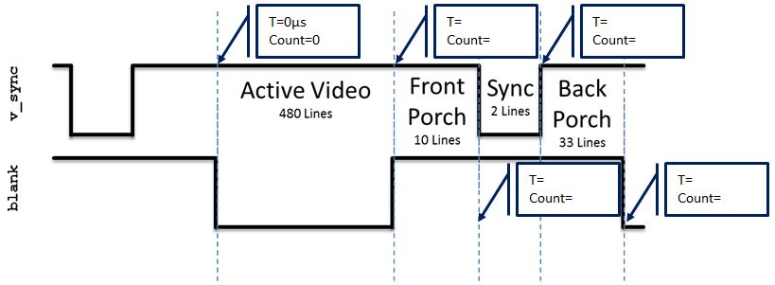

**Documentation Statement**: For all assignments in this course, you may work with any faculty members or students **currently** enrolled in ECE383 unless otherwise indicated. We expect all graded work, to include software programs, wired circuits, lab notebooks, and written reports, to be your own work. If they aren't, you've copied and will receive **no academic credit** even if the copying is documented. Further, copying without attribution is dishonorable and will be dealt with as a suspected honor code violation. As in all courses, cadets must document any assistance received in the execution of graded work. If you receive no assistance on an assignment, the use of the **Documentation: None** statement is mandatory. If no documentation statement exists, the assignment will be returned for correction and the work will be considered at least one day late.