Electrical Engineering 434 Names:_____________
DSP Hardware Lab ________________

This assignment is a team exercise, with two people per team. Follow this worksheet (one form submitted to gradescope per team), and turn in your answers by taps lesson M7. The files mentioned below can be found on the 434 Teams channel, under FilesDSP Hardware Lab.

Documentation and Collaboration: Your team must answer your questions alone but can ask other teams help for setting up the software or hardware. You are allowed to Generative AI like ChatGPT or search engines, like google at GenAI level 1: Organizational / Explanatory use of GenAI.

In these instructions, when is says “draw what you see” you can either try to hand draw what you see or take screenshots and cut-n-paste them into this worksheet.

1. Introduction
In this lab you will use the WinDSK8 application that runs real-time DSP applications on
the Texas Instruments OMAP LCDK L138 board. When you plug in the LCDK, you should see a green LED on. If not, it doesn’t have power. Make sure the power is connected to the port that says 5V, and the USB is plugged into the USB port. See picture below.

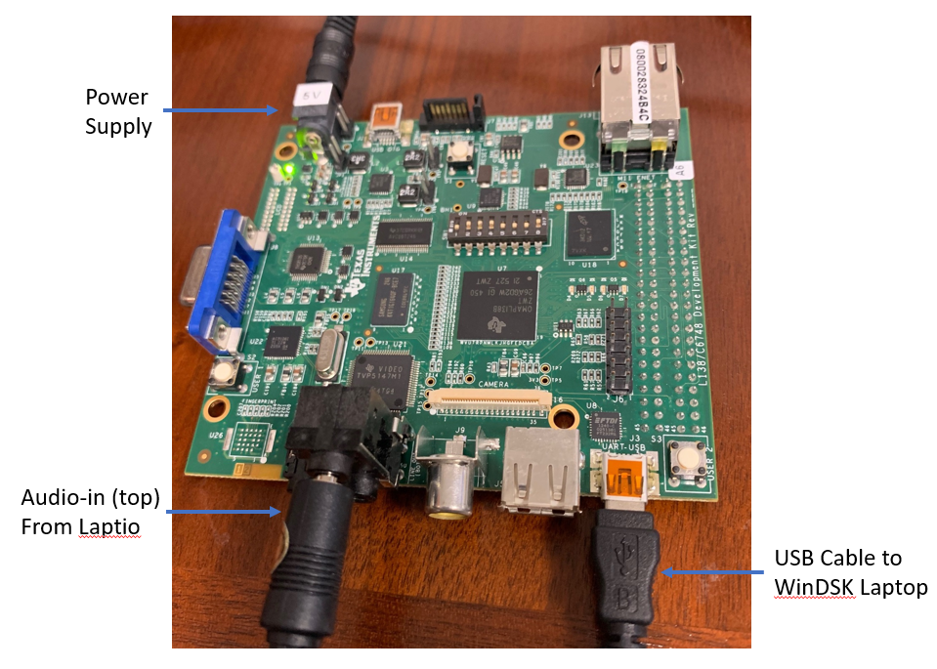

2. Reflash the LCDK [you probably can skip this step]
If the board has not been reflashed, follow the instructions in “Reflashing Correctly.pdf” or copy “Reflashing LCDK for winDSK8.zip” and follow “Reflashing the LCDK for winDSK8.pdf”

3. Install WinDSK8 on your Laptop
Install WinDSK8 using winDSK8_installer_2_0_2_0.exe on the K:drive
The original came from http://rt-dsp.com/2nd_ed/winDSK/winDSK8.html here

4. Configure WinDSK8 on your Laptop
- Open WinDSK8
- In the upper right dropdown, set
  - DSP: LCDK (OMAP)
  - Input Source: Line In
  - COM Port: COM4 (or whatever com port it is initialize to in devices)
    - Click “Rescan COM Ports”

5. Confidence Test
- Open WinDSK8
- Click Confidence Test and then “Run All Tests”

6. WinDSK8 HELP
- See the help button. This is your friend, especially when you want to know what an application is and how it works. Cadet Duffy says “they should basically have this help window open always”

7. TalkThru
• Plug a laptop, ipod, mp3 player, smart phone, or other sound generating device into the board using the supplied cable On the board, the two black jacks that are stacked are the audio ports (next to the yellow video port). The top port is “audio in” (plug in your laptop using an aux cable) and the bottom port is “audio out” (plug in your headphones). Also, you may have to crank the volume way up.
• On your laptop play an audio test tone, like 440 Hz, from a website like https://www.szynalski.com/tone-generator/ and/or play a song with horns like Louis Armstrong “La Vie En Rose”
• Set the Sample Rate to 8.0 KHz. Click on TalkThru. You should hear sound. If not, get your instructor.

• Effective Fs: Click Use Anti-Imaging Filter. Lower the Fs until you hear a change in the sound quality.
o Question 0: What is this value of Fs for Louis Armstrong versus the 440 Hz?

o Question 1: What caused this change in the quality of the sound?

• Anti-Imaging Filter: Reset Fs to 8.0 KHz, play 440Hz and compare what you hear by clicking and unclicking Use Anti-Imaging Filter. [if you do not hear any change lower Fs to 4.0 Hz]
Question 2: What caused this change in the quality of the sound?

• Quantization: Set Sample Rate up to 96000 Hz (close talk-thru, change Sample Rate on main window, re-enter talk-thru). Lower the number of bits until you hear a change in the sound quality.
o Question 3: What is the number of bits for Louis Armstrong versus the 440 Hz?

o Question 4: What caused this change in the quality of the sound?

• Invert Spectrum: Restore settings, click Use Anti-Imaging Filter, and set Effective Fs to 8 KHz. Click invert spectrum.
o Question 5: Hear any change? What has happened to your audio signal? [help will tell how this is implemented; however, you need to explain what it does to the signal]

8. O’Scope
- Σωιτχη τηε αυδιο χαβλε φρομ ψουρ Ιποδ αυδιο−ουτ το ψουρ λαπτοπ αυδιο−ουτ.
- To test the O’scope function, you will create a sound using MATLAB. Copy the “gen_tones_long.m” file to the MATLAB work directory. Run matlab:

>> x = gen_tones_long(N); % where N is the number of samples
% let N=10*48000 for 10 seconds of sound
% To play the sound to the DSK board (assuming the cable is hooked up)
>> soundsc(x, 48000);

o Click on Function-> Oscope/Analyzer. Play the sound.
􀂃Question 6: Explain and draw what you see. What does this display plot?

o Click on Codec Settings to change the Fs to 8 KHz.
Click on Function->Spectrum Analyzer and Display->Logarithmic and play the sound
􀂃Question 7: Explain and draw what you see. What does this display plot? How is it probably implemented?

􀂃Question 8: Change the windowing used. See any changes?

o Click on Display->Waterfall and play the gen_tones_long sound
􀂃Question 9: Explain and draw what you see. What does this display plot? How is it implemented? Is there a difference between the left and the right channel?

• Now you will test these displays with a “chirp” signal (often used in RADAR
applications). Download the “chirp2.m” file to the MATLAB work directory. Run matlab:
>> x = chirp2(N); % where N is the number of samples
% let N= 25*8000/5 for 25 seconds of sound
% To play the sound to the DSK board (assuming the cable is hooked up)
>> soundsc(x, 8000);
o Click on Function-> Oscilloscope; Display->Scope; Linear. Play the sound.
􀂃Question 10: Explain and draw what you see.

o Click on Function-> Spectrum Analyzer and Display->Scope; Logarithm and play the sound
􀂃Question 11: Explain and draw what you see.

o Click on Display->Waterfall and play the sound
􀂃Question 12: Explain and draw what you see.

• Now you will test the Waterfall display with the Louis Armstrong song

o Click on Display->Waterfall and play the sound
􀂃Question 13: Explain and draw what you see. What is the difference on the Waterfall display when a horn like the trumpet is played versus a percussive instrument like the piano?

9. Try out another function in WinDSK8
such as Audio Effects, Graphic Equalizer, Karplus-Strong String Algorithm, Guitar Synthesizer, DTMF Generator, Vocoder
• Σεε τηε Ηελπ υτιλιτψ, εσπεχιαλλψ τηε βλοχκ διαγραμσ, το σεε ηοω τηεψ ωορκ
- Φορ ονε οφ τηεσε φυνχτιονσ, τελλ με ωηατ ιτ δοεσ, ηοω ιτ ωορκσ, σομετηινγ ψου λεαρνεδ...

10. Documentation Statement. Your team must answer your questions alone, but can ask other teams help for setting up the software or hardware. You are allowed to Generative AI like ChatGPT or search engines, like google at GenAI level 1: Organizational / Explanatory use of GenAI. Provide your documentation statement below:

