PEX3 Analysis Report: LRU Page Replacement Simulation
CS 483 — Operating Systems — Spring 2026
Name: Aidan Blankenship Section: M4 Date: 4/23/2026

Documentation Statement
None.

1. Optimum Frame Size Recommendation (4 pts)
A frame size of 1kb is recommended because it only needs 7.76% of its maximum frames in order to have a fault rate below 10%. This is the lowest out of all of the frame sizes tested, making it the best in order to have a low fault rate while still keeping memory overhead low. The recommended number of frames is 318 because that is when the fault rate falls below 10%, and this also has the lowest memory overhead allowing better performance.

2. Frames Required to Achieve < 10% Page-Fault Rate (4 pts)
Frame Size | Min Frames for < 10% | Fault Rate at That Count
512 B | 689 | 0.09996
1 KB | 318 | 0.099937
2 KB | 179 | 0.099777
4 KB | 106 | 0.099938

3. Frames vs. Number of Page Faults — 4 charts (6 pts)

512 B Frames — Page Faults (1.5 pts)
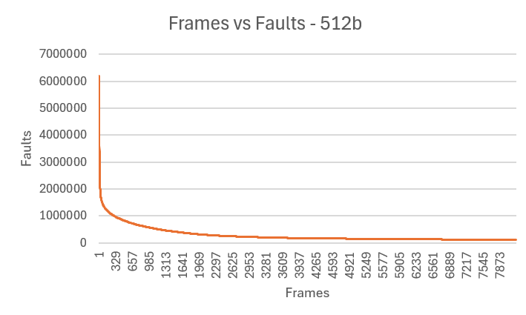

1 KB Frames — Page Faults (1.5 pts)
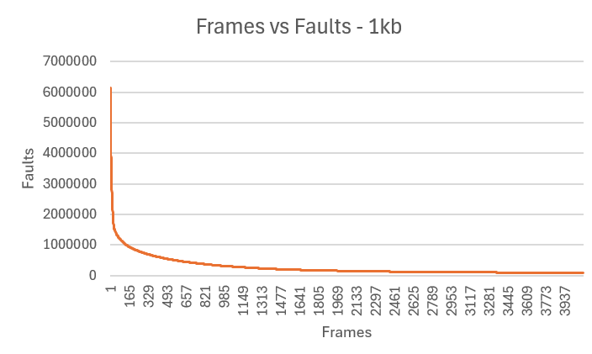

2 KB Frames — Page Faults (1.5 pts)
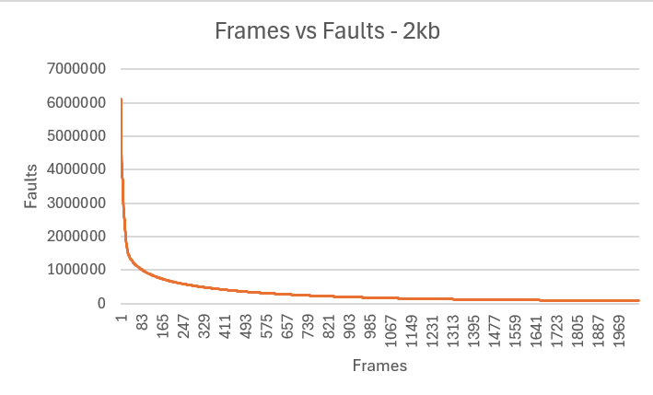

4 KB Frames — Page Faults (1.5 pts)
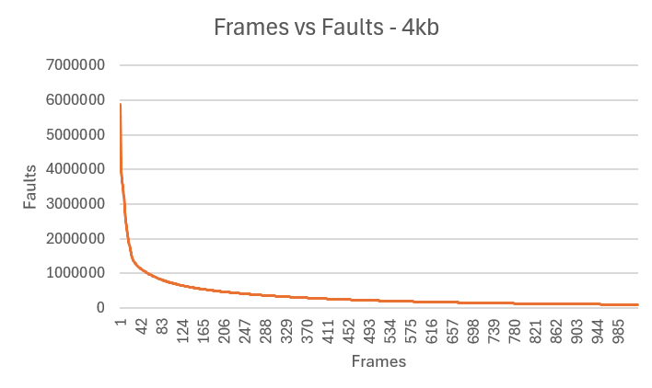

4. Frames vs. Page-Fault Rate — 4 charts (6 pts)

512 B Frames — Fault Rate (1.5 pts) 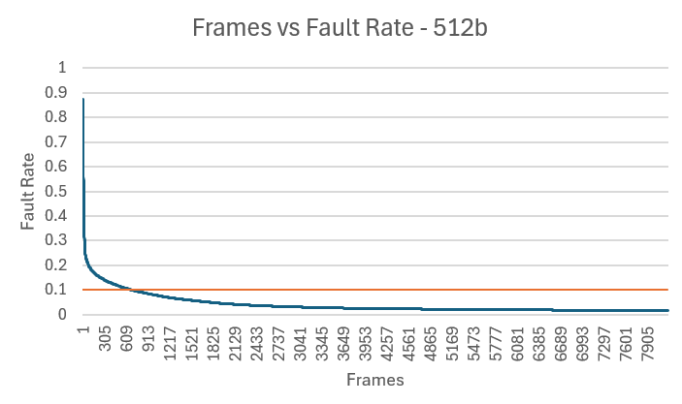

1 KB Frames — Fault Rate (1.5 pts)
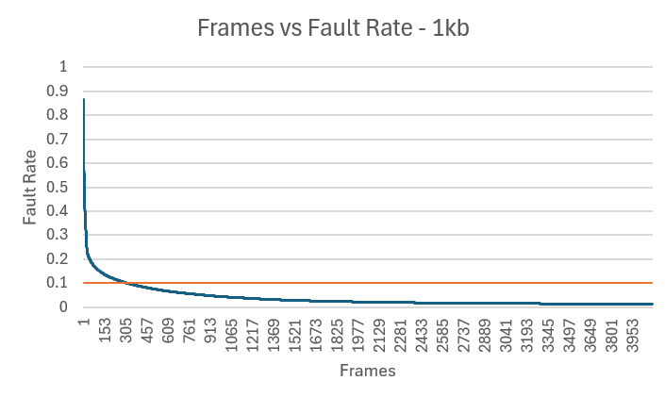

2 KB Frames — Fault Rate (1.5 pts)
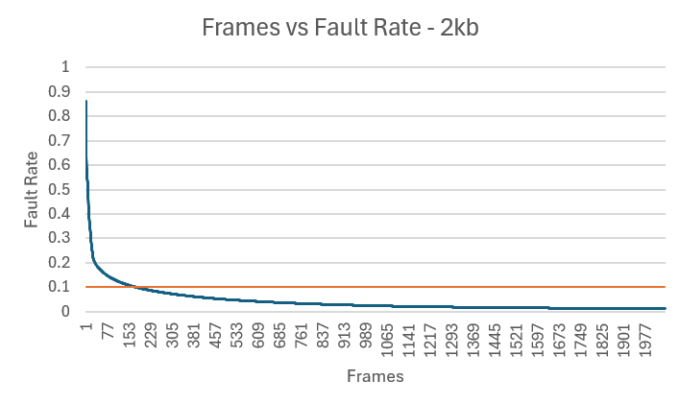

4 KB Frames — Fault Rate (1.5 pts)
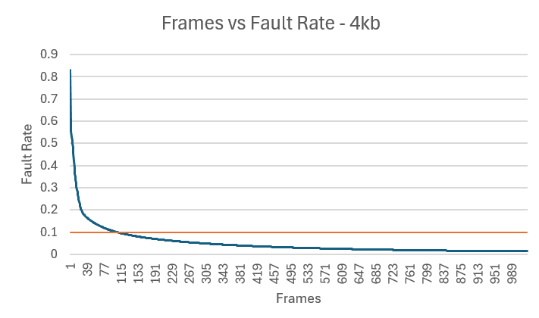

5. Curve Shape and Working Set Analysis (5 pts)
The curves all have a steep drop initially before quickly flattening out. The inflection point between a steep slope and the flattening out happens at around 15% fault rate for all curves, with them all crossing the 10% fault rate line at around 8-9% of the way to their max frames. The inflection point happens very early on, around 230 frames for 512b, 120 frames for 1kb, 70 frames for 2kb, and 50 frames for 4kb. These inflection points show where additional frames start to become inefficient for each frame size.

6. Frame Size and Fault Rate Tradeoffs (5 pts)
Larger frames have more memory, but if the page they have doesn’t take up the full memory, then they have empty space that leads to internal fragmentation. The data shows a preference for smaller page sizes as they were the most efficient with their frame use, getting their fault rates below 10% faster than 2kb and 4kb. Fewer faults leads to faster speeds on memory, but fragmentation leads to memory not being used efficiently meaning that it gets filled up faster.

Grading Rubric (delete this page before submitting)

Point Breakdown (30 pts total)
Component | Points
Optimum Frame Size Recommendation | 4
Frames for < 10% Target Table | 4
Page Fault Charts (4 charts x 1.5 pts) | 6
Fault Rate Charts (4 charts x 1.5 pts) | 6
Curve Shape / Working Set Analysis | 5
Frame Size Tradeoffs | 5
TOTAL | 30

General Deductions (applied at grader discretion)
The following may result in point deductions from any section where the issue appears:
Issue | Deduction | Description
Insufficient technical depth | up to -3 pts | Analysis should reflect understanding of virtual memory, page replacement, and working set concepts — not just restate numbers from the data.
Unprofessional presentation | up to -3 pts | The report should read as a polished technical document suitable for a professional audience. Sloppy formatting, missing chart labels, or inconsistent style will result in deductions.
Spelling and grammar errors | up to -2 pts | Proofread carefully. Use a spell checker. Technical writing demands precision in language as well as content.
Use of first person | up to -2 pts | Do not use "I," "we," "my," or "our." Write from an objective, third-person perspective throughout.
Passive voice | up to -1 pt | Use active voice. Write "LRU reduces the fault rate" rather than "The fault rate is reduced by LRU."
Verbose or unclear writing | up to -2 pts | Be direct and concise. Every sentence should contribute meaningful analysis. Avoid filler, redundancy, and vague statements such as "the results were interesting."

Submission Checklist
- All 8 charts embedded directly in the document (not linked)
- Each chart has a descriptive title (e.g., "Page-Fault Rate vs. Frames — 4KB")
- Axes labeled with units on every chart
- 10% reference line on all 4 fault-rate charts
- Minimum 250 words of written analysis
- No first person; active voice; concise language
- No spelling or grammar errors
- Report stands alone — readable without consulting CSV files
- Documentation statement completed in both main.c and this report
- File saved as .docx and committed to GitHub repo

