PEX3 Analysis Report: LRU Page Replacement Simulation
CS 483 — Operating Systems — Spring 2026
Name: ____Kenneth Wang_____ Section: __M4___ Date: _4/23/2026___

Documentation Statement
N/A

1. Optimum Frame Size Recommendation (4 pts)
[State which frame size and how many frames you recommend to keep the page-fault rate below 10%. Justify your recommendation using your simulation data. Consider both memory overhead and fault-rate performance.]
Recommend using a 1KB frame size since it requires the least total physical memory to get below 10% fault rate compared to the other three frame sizes. The 1KB simulation requires 1319KB to meet the 10% threshold, compared to the 512B setting which requires around 1487KB, 2KB setting which requires around 1370KB, and the 4KB which requires around 1520KB to achieve the same 10% fault-rate requirement. This is due to a balance between the tradeoffs of a larger and small page size, in which a large frame size can reduce fault counts with larger pages, the internal fragmentation is greater leading to greater memory consumption. The 1KB achieves a balance between the two extremes, which leads to a overall lower memory consumption.

2. Frames Required to Achieve < 10% Page-Fault Rate (4 pts)
For each frame size, identify the minimum number of frames where the page-fault rate first drops below 10%.
Frame Size | Min Frames for < 10% | Fault Rate at That Count
512 B | 2,974 | 0.09999
1 KB | 1,319 | 0.099995
2 KB | 685 | 0.099946
4 KB | 380 | 0.099904

3. Frames vs. Number of Page Faults — 4 charts (6 pts)
Insert one chart per frame size showing Frames (x-axis) vs. Number of Page Faults (y-axis). Each chart must have a descriptive title, labeled axes with units, and clean formatting. (1.5 pts per chart)

512 B Frames — Page Faults (1.5 pts)

1 KB Frames — Page Faults (1.5 pts)

2 KB Frames — Page Faults (1.5 pts)

4 KB Frames — Page Faults (1.5 pts)

4. Frames vs. Page-Fault Rate — 4 charts (6 pts)
Insert one chart per frame size showing Frames (x-axis) vs. Page-Fault Rate (y-axis). Each chart must include a horizontal reference line at 10% fault rate, descriptive title, and labeled axes. (1.5 pts per chart)

512 B Frames — Fault Rate (1.5 pts)
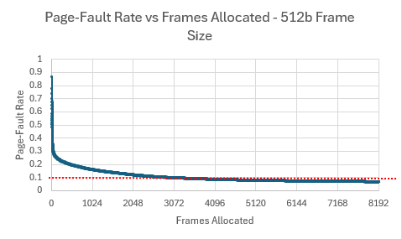

1 KB Frames — Fault Rate (1.5 pts)
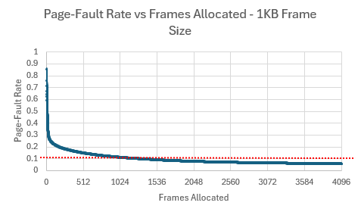

2 KB Frames — Fault Rate (1.5 pts)
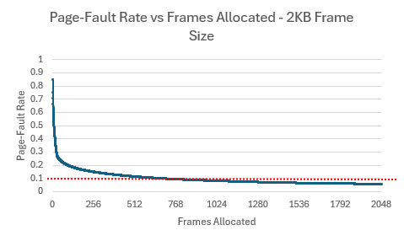

4 KB Frames — Fault Rate (1.5 pts)
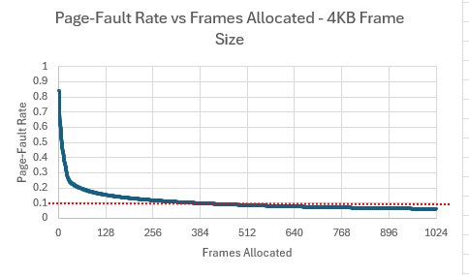

5. Curve Shape and Working Set Analysis (5 pts)
[Describe the shape of your fault-rate curves. Note the steep initial drop followed by flattening. Where does the inflection point occur for each frame size? What does the inflection point tell you about the process's working set size? Discuss any other interesting features you observe in the graphs.]
All curves follow the same general shape, a steep initial decline at the low frame allocation that eventually plateaus out into a gradual decrease. This inflection point always occurs around 1/16 of max frames allocated. This inflection point estimates the working set size for each process, which is the minimum number of frames needed to store the actively referenced pages in memory. Once the frame allocation exceeds this number, additional frames only produce diminishing results in terms of efficiency. Furthermore, since all the experiments working set/inflection point all occur around the same size, it supports the assumption that the working set is an aspect of the process rather than the page size.

6. Frame Size and Fault Rate Tradeoffs (5 pts)
[Discuss how larger frames reduce the number of distinct pages but increase internal fragmentation. Does your data support a preference for larger or smaller frames? What is the tradeoff between fewer faults (larger frames) and wasted memory (internal fragmentation)?]
Larger frames also result in a fewer number of distinct page numbers that can be referenced, which also lowers number of fault occurrences. However, larger frames also increase the internal fragmentation within a single frame, this causes a waste in memory when pages have wasted space. The data from the experiment shows that at the larger end of the experiment (4KB frames), which only needs 380 frames to reach the 10% threshold, consumes the most amount of data (1520KB), requires more physical memory than the smaller frame size test cases. However, with a frame size that is too small will run into the opposite issue in which smaller frames reduce internal fragmentation. However, the smaller frame size tests require many more frames to reach the 10% threshold, as in the case of 512B experiment. Therefore the data does not support a preference toward larger frames, as the reduction in fault count also results in a increase in internal fragmentation.

