PEX3 Analysis Report: LRU Page Replacement Simulation
CS 483 — Operating Systems — Spring 2026
Name: Bradley Richey Section: M3 Date: 30 April 2026

Documentation Statement
NONE other than CS220 DLL lab and PEX3 slides. Also teacher assistance (happened to be Claude but not my own prompt)

1. Optimum Frame Size Recommendation (4 pts)
The 1KB frame size is the optimum frame size. This is because, although its fault rate does not fall under ten percent at the lowest frame count, due to the different frame sizes it still gets under a ten percent fault rate with the lowest memory usage out of the four simulations. All of the simulations stay under ten percent consistently after they initially get to ten percent so that does not become a performance factor.

2. Frames Required to Achieve < 10% Page-Fault Rate (4 pts)
For each frame size, identify the minimum number of frames where the page-fault rate first drops below 10%.
Frame Size | Min Frames for < 10% | Fault Rate at That Count
512 B | 689 | 0.099996
1 KB | 318 | 0.099994
2 KB | 179 | 0.099777
4 KB | 106 | 0.099938

3. Frames vs. Number of Page Faults — 4 charts (6 pts)
Insert one chart per frame size showing Frames (x-axis) vs. Number of Page Faults (y-axis). Each chart must have a descriptive title, labeled axes with units, and clean formatting. (1.5 pts per chart)

512 B Frames — Page Faults (1.5 pts)

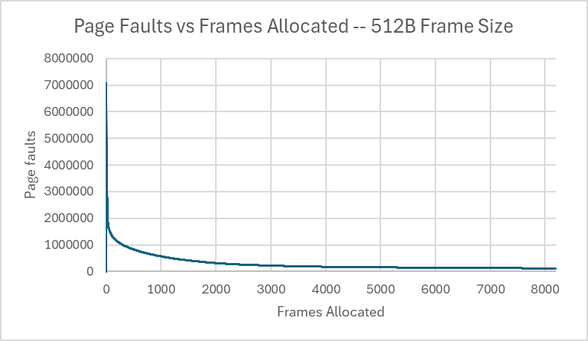

1 KB Frames — Page Faults (1.5 pts)

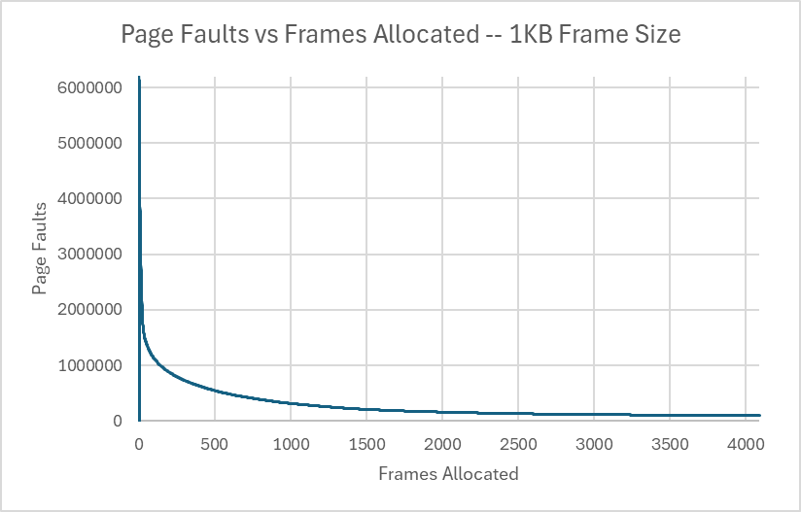

2 KB Frames — Page Faults (1.5 pts)

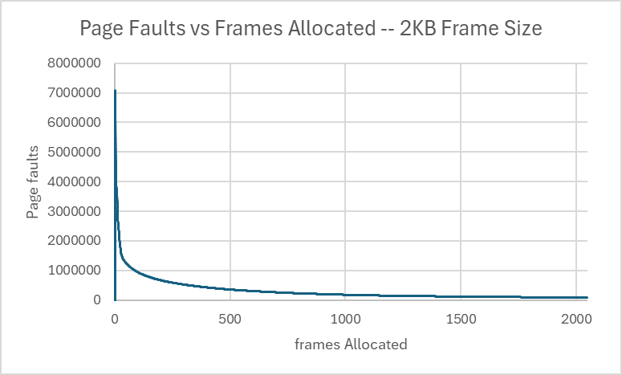

4 KB Frames — Page Faults (1.5 pts)

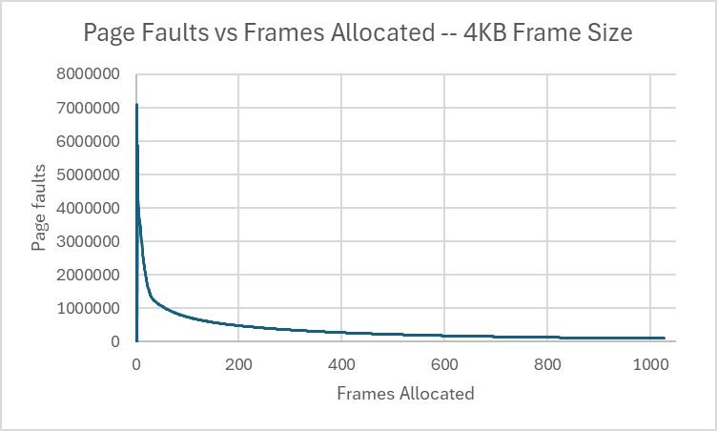

4. Frames vs. Page-Fault Rate — 4 charts (6 pts)
Insert one chart per frame size showing Frames (x-axis) vs. Page-Fault Rate (y-axis). Each chart must include a horizontal reference line at 10% fault rate, descriptive title, and labeled axes. (1.5 pts per chart)

512 B Frames — Fault Rate (1.5 pts)

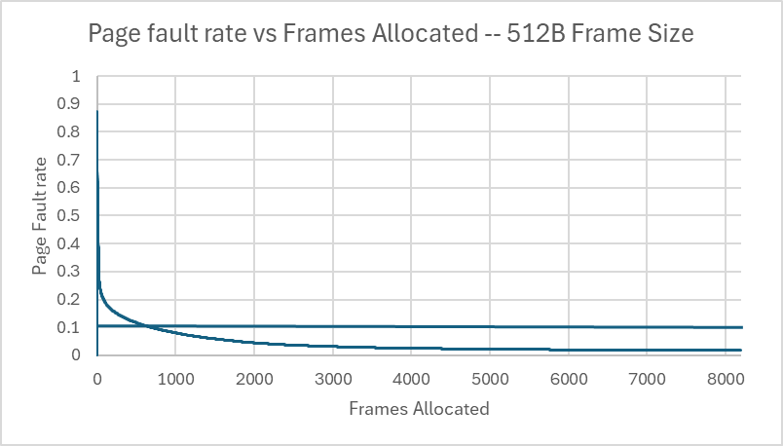

1 KB Frames — Fault Rate (1.5 pts)

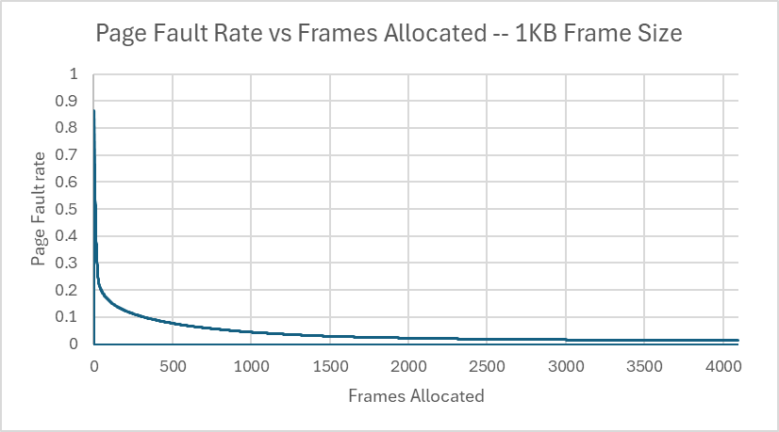

2 KB Frames — Fault Rate (1.5 pts)

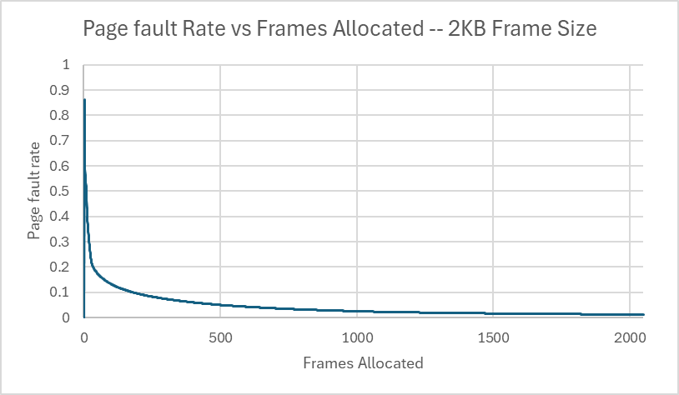

4 KB Frames — Fault Rate (1.5 pts)

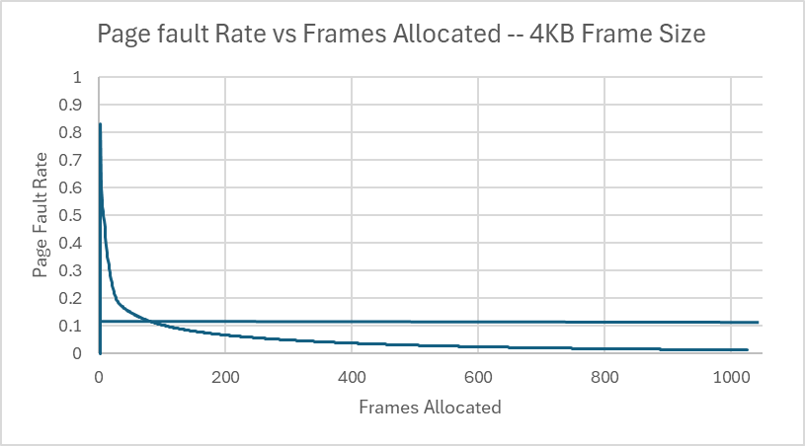

5. Curve Shape and Working Set Analysis (5 pts)
[Describe the shape of your fault-rate curves. Note the steep initial drop followed by flattening. Where does the inflection point occur for each frame size? What does the inflection point tell you about the process's working set size? Discuss any other interesting features you observe in the graphs.]

6. Frame Size and Fault Rate Tradeoffs (5 pts)
[Discuss how larger frames reduce the number of distinct pages but increase internal fragmentation. Does your data support a preference for larger or smaller frames? What is the tradeoff between fewer faults (larger frames) and wasted memory (internal fragmentation)?]

Grading Rubric (delete this page before submitting)

Point Breakdown (30 pts total)
Component | Points
Optimum Frame Size Recommendation | 4
Frames for < 10% Target Table | 4
Page Fault Charts (4 charts x 1.5 pts) | 6
Fault Rate Charts (4 charts x 1.5 pts) | 6
Curve Shape / Working Set Analysis | 5
Frame Size Tradeoffs | 5
TOTAL | 30

General Deductions (applied at grader discretion)
The following may result in point deductions from any section where the issue appears:
Issue | Deduction | Description
Insufficient technical depth | up to -3 pts | Analysis should reflect understanding of virtual memory, page replacement, and working set concepts — not just restate numbers from the data.
Unprofessional presentation | up to -3 pts | The report should read as a polished technical document suitable for a professional audience. Sloppy formatting, missing chart labels, or inconsistent style will result in deductions.
Spelling and grammar errors | up to -2 pts | Proofread carefully. Use a spell checker. Technical writing demands precision in language as well as content.
Use of first person | up to -2 pts | Do not use "I," "we," "my," or "our." Write from an objective, third-person perspective throughout.
Passive voice | up to -1 pt | Use active voice. Write "LRU reduces the fault rate" rather than "The fault rate is reduced by LRU."
Verbose or unclear writing | up to -2 pts | Be direct and concise. Every sentence should contribute meaningful analysis. Avoid filler, redundancy, and vague statements such as "the results were interesting."

Submission Checklist
- All 8 charts embedded directly in the document (not linked)
- Each chart has a descriptive title (e.g., "Page-Fault Rate vs. Frames — 4KB")
- Axes labeled with units on every chart
- 10% reference line on all 4 fault-rate charts
- Minimum 250 words of written analysis
- No first person; active voice; concise language
- No spelling or grammar errors
- Report stands alone — readable without consulting CSV files
- Documentation statement completed in both main.c and this report
- File saved as .docx and committed to GitHub repo

