PEX3 Analysis Report: LRU Page Replacement Simulation
CS 483 — Operating Systems — Spring 2026
Name: Jeff Kwon Section: M4 Date: April 23, 2026

Documentation Statement
None

1. Optimum Frame Size Recommendation (4 pts)
[State which frame size and how many frames you recommend to keep the page-fault rate below 10%. Justify your recommendation using your simulation data. Consider both memory overhead and fault-rate performance.]
1 KB frame size seems to be the most efficient to keep page fault rate below zero. Going from 512 B to 1KB more than halves the minimum number of frames required to keep fault rate below 10% but the same isn’t true of 1 KB to 2 KB and 2KB to 4KB. Looking at the graphs also shows the same distribution of number of page faults and fault rate for each graph. With the main difference being the number of frames allocated. 4KB has a much larger fault rate than the other frame sizes relative to the memory used while 512B has too many page faults for each frame allocated. As such, 1KB has the best middle ground between fault rate and page faults while also having the most efficient memory to reach 10% page fault rate.

2. Frames Required to Achieve < 10% Page-Fault Rate (4 pts)
For each frame size, identify the minimum number of frames where the page-fault rate first drops below 10%.
Frame Size | Min Frames for < 10% | Fault Rate at That Count
512 B | 689 | 0.09996
1 KB | 318 | 0.099937
2 KB | 179 | 0.099777
4 KB | 106 | 0.099938

3. Frames vs. Number of Page Faults — 4 charts (6 pts)
Insert one chart per frame size showing Frames (x-axis) vs. Number of Page Faults (y-axis). Each chart must have a descriptive title, labeled axes with units, and clean formatting. (1.5 pts per chart)

512 B Frames — Page Faults (1.5 pts)

1 KB Frames — Page Faults (1.5 pts)

2 KB Frames — Page Faults (1.5 pts)

4 KB Frames — Page Faults (1.5 pts)

4. Frames vs. Page-Fault Rate — 4 charts (6 pts)
Insert one chart per frame size showing Frames (x-axis) vs. Page-Fault Rate (y-axis). Each chart must include a horizontal reference line at 10% fault rate, descriptive title, and labeled axes. (1.5 pts per chart)

512 B Frames — Fault Rate (1.5 pts)
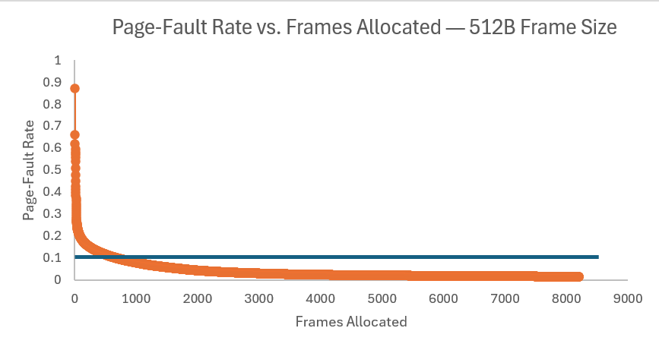

1 KB Frames — Fault Rate (1.5 pts)
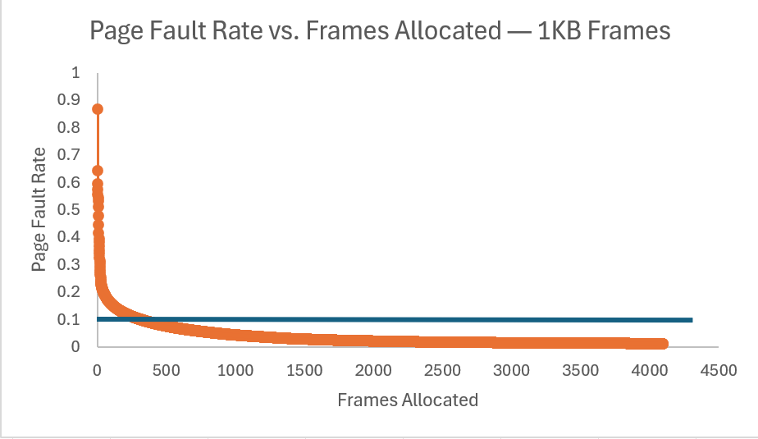

2 KB Frames — Fault Rate (1.5 pts)
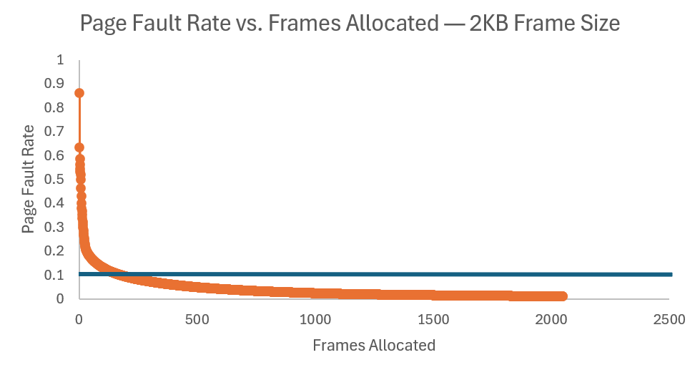

4 KB Frames — Fault Rate (1.5 pts)
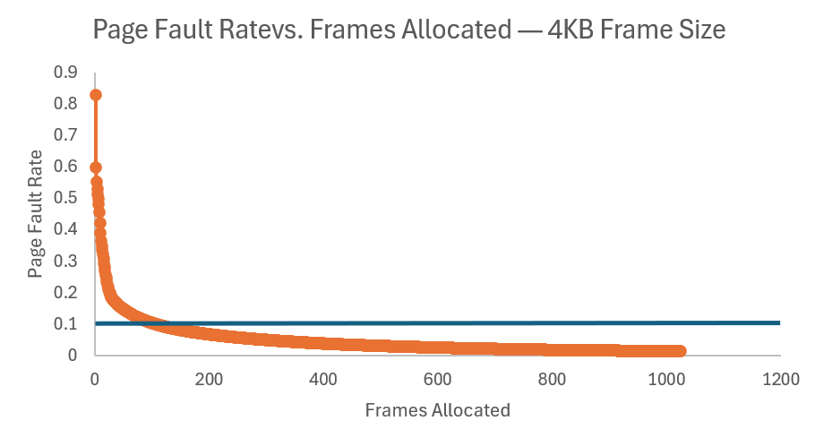

5. Curve Shape and Working Set Analysis (5 pts)
[Describe the shape of your fault-rate curves. Note the steep initial drop followed by flattening. Where does the inflection point occur for each frame size? What does the inflection point tell you about the process's working set size? Discuss any other interesting features you observe in the graphs.]
Most of the fault rate curves have a similar shape to that of 1/x graph where the closer to 0 the more exponentially higher the fault rate is. The inflection point for each frame size seems to occur roughly around the 10% fault rate line. This tells us that there is a certain number of frames for each process where progressing past that point is worth less as it decreases the fault rate less as we go past that minimum number of frames. Each graph also has the same distribution despite the number of frames cutting in half for each graph which suggests the minimum number of frames (where each frame past it exponentially lowers fault rate) could be at the same relative point for each graph.

6. Frame Size and Fault Rate Tradeoffs (5 pts)
[Discuss how larger frames reduce the number of distinct pages but increase internal fragmentation. Does your data support a preference for larger or smaller frames? What is the tradeoff between fewer faults (larger frames) and wasted memory (internal fragmentation)?]
Larger frames reduce the number of distinct pages because they take up more of the program’s memory with a single page and, as a result, leads to less need for distinct pages as necessary memory could be represented already without need for more pages. However, larger frames means that there is a lot of wasted space in those frames which means more internal fragmentation. The data supports a slight preference for larger frames as the graphs show the same relative distribution of page faults and fault rate but larger frames mean less frames need to be allocated and the minimum number of frames to be allocated for the smaller frames is relatively large. Fewer faults mean more of the program needs to be dedicated to dealing with faults which means significant overhead and increased average access time to memory. However, lowering the number of page faults usually means more wasted memory and much of the program’s available memory will also be wasted which may increase page fault rate as well.

Grading Rubric (delete this page before submitting)

Point Breakdown (30 pts total)
Component | Points
Optimum Frame Size Recommendation | 4
Frames for < 10% Target Table | 4
Page Fault Charts (4 charts x 1.5 pts) | 6
Fault Rate Charts (4 charts x 1.5 pts) | 6
Curve Shape / Working Set Analysis | 5
Frame Size Tradeoffs | 5
TOTAL | 30

General Deductions (applied at grader discretion)
The following may result in point deductions from any section where the issue appears:
Issue | Deduction | Description
Insufficient technical depth | up to -3 pts | Analysis should reflect understanding of virtual memory, page replacement, and working set concepts — not just restate numbers from the data.
Unprofessional presentation | up to -3 pts | The report should read as a polished technical document suitable for a professional audience. Sloppy formatting, missing chart labels, or inconsistent style will result in deductions.
Spelling and grammar errors | up to -2 pts | Proofread carefully. Use a spell checker. Technical writing demands precision in language as well as content.
Use of first person | up to -2 pts | Do not use "I," "we," "my," or "our." Write from an objective, third-person perspective throughout.
Passive voice | up to -1 pt | Use active voice. Write "LRU reduces the fault rate" rather than "The fault rate is reduced by LRU."
Verbose or unclear writing | up to -2 pts | Be direct and concise. Every sentence should contribute meaningful analysis. Avoid filler, redundancy, and vague statements such as "the results were interesting."

Submission Checklist
- All 8 charts embedded directly in the document (not linked)
- Each chart has a descriptive title (e.g., "Page-Fault Rate vs. Frames — 4KB")
- Axes labeled with units on every chart
- 10% reference line on all 4 fault-rate charts
- Minimum 250 words of written analysis
- No first person; active voice; concise language
- No spelling or grammar errors
- Report stands alone — readable without consulting CSV files
- Documentation statement completed in both main.c and this report
- File saved as .docx and committed to GitHub repo

