PEX3 Analysis Report: LRU Page Replacement Simulation
CS 483 — Operating Systems — Spring 2026
Name: Nathaniel Burleson Section: M3 Date: 4/23/2026

Documentation Statement

Asked C2C Aiden Blankenship questions about the final formatting of the output CSV. Otherwise, all work is my own.

1. Optimum Frame Size Recommendation (4 pts)
A 1KB frame size is recommended, along with 318 frames at a minimum to keep the fault-rate below 10%. When simulating the fault-rate, 318 frames at a size of 1KB kept the fault rate below 10% and reduced the overhead calculations by the largest amount. 2KB frame sizes are more efficient by themselves and require less total frames, it is not a proportional decrease in frames needed against the total memory used. The additional fault-rate performance gained by the 2KB frame size is not worth the much larger overhead of the 2KB size.

2. Frames Required to Achieve < 10% Page-Fault Rate (4 pts)
For each frame size, identify the minimum number of frames where the page-fault rate first drops below 10%.
Frame Size | Min Frames for < 10% | Fault Rate at That Count
512 B | 689 | 9.99%
1 KB | 318 | 9.99%
2 KB | 179 | 9.97%
4 KB | 106 | 9.99%

3. Frames vs. Number of Page Faults — 4 charts (6 pts)
Insert one chart per frame size showing Frames (x-axis) vs. Number of Page Faults (y-axis). Each chart must have a descriptive title, labeled axes with units, and clean formatting. (1.5 pts per chart)

512 B Frames — Page Faults (1.5 pts)
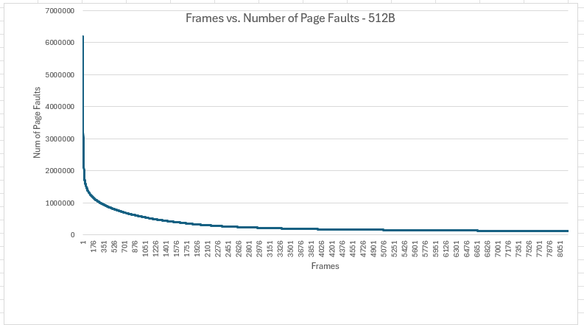

1 KB Frames — Page Faults (1.5 pts)
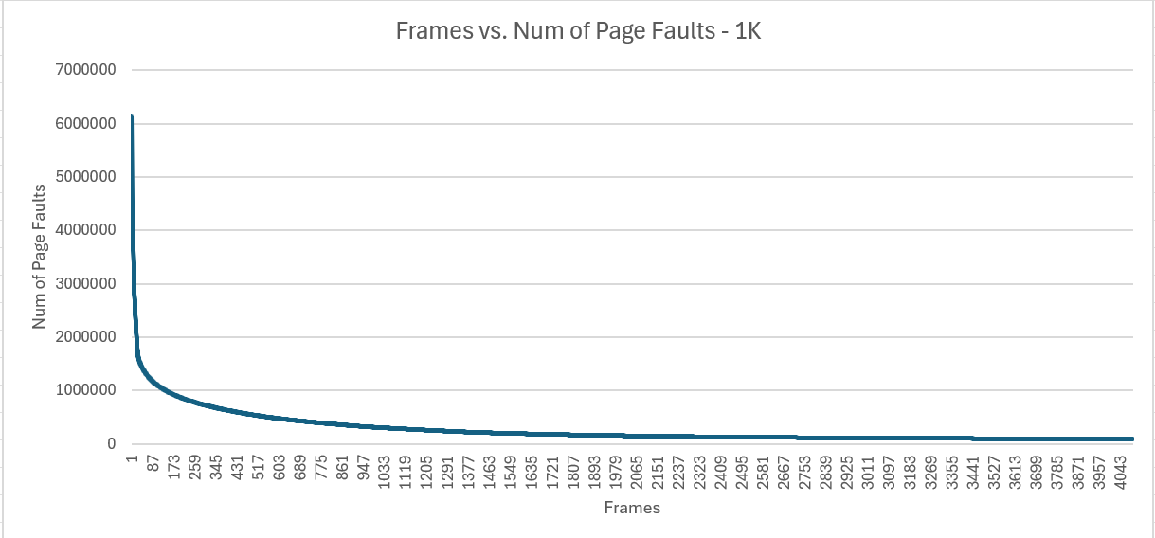

2 KB Frames — Page Faults (1.5 pts)
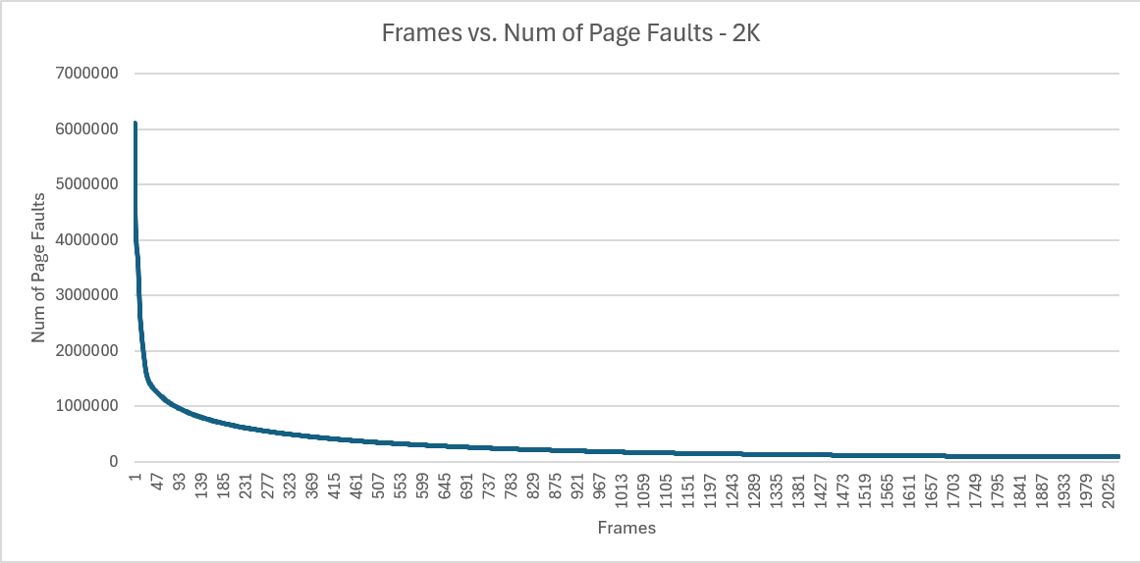

4 KB Frames — Page Faults (1.5 pts)
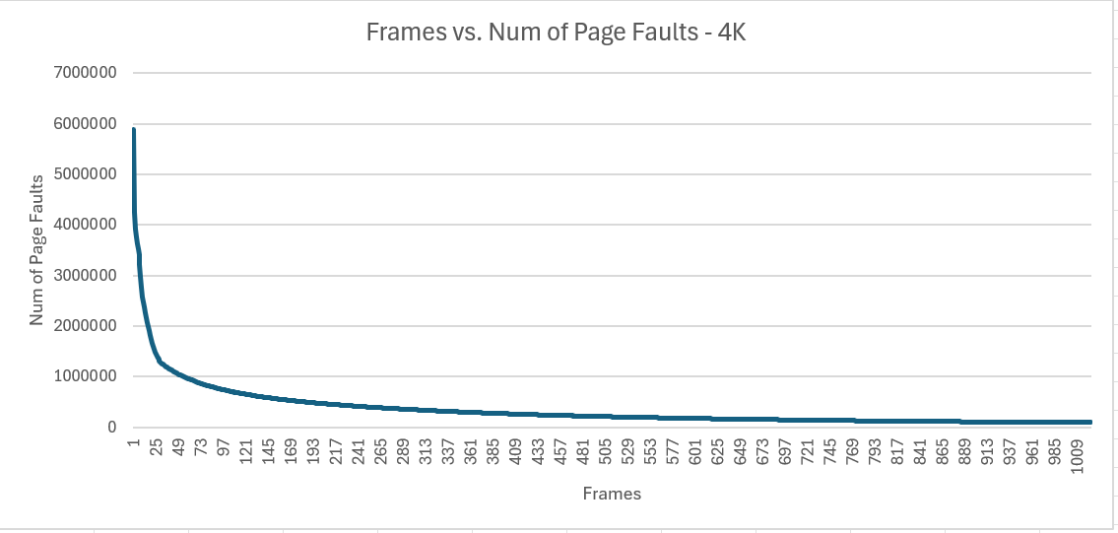

4. Frames vs. Page-Fault Rate — 4 charts (6 pts)
Insert one chart per frame size showing Frames (x-axis) vs. Page-Fault Rate (y-axis). Each chart must include a horizontal reference line at 10% fault rate, descriptive title, and labeled axes. (1.5 pts per chart)

512 B Frames — Fault Rate (1.5 pts)
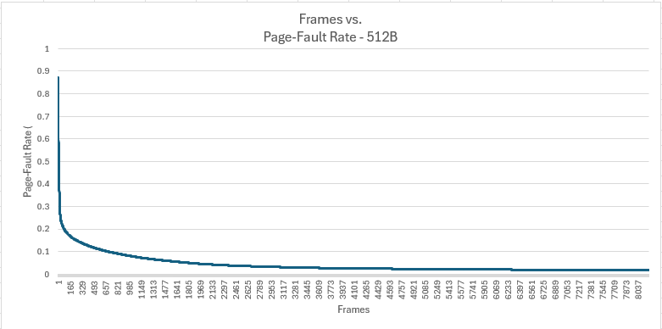

1 KB Frames — Fault Rate (1.5 pts)
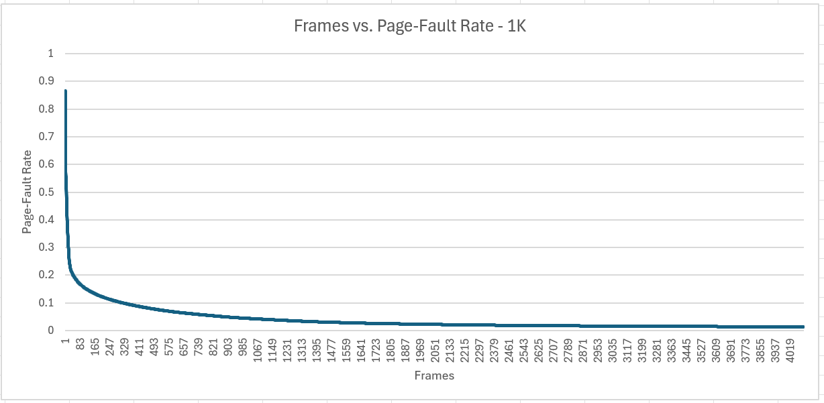

2 KB Frames — Fault Rate (1.5 pts)
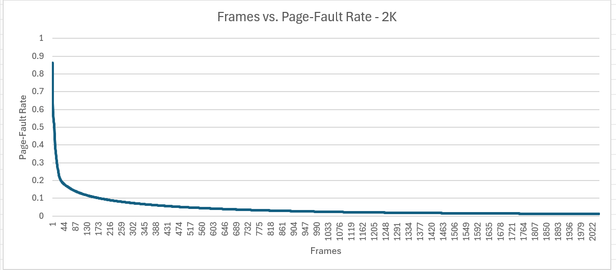

4 KB Frames — Fault Rate (1.5 pts)
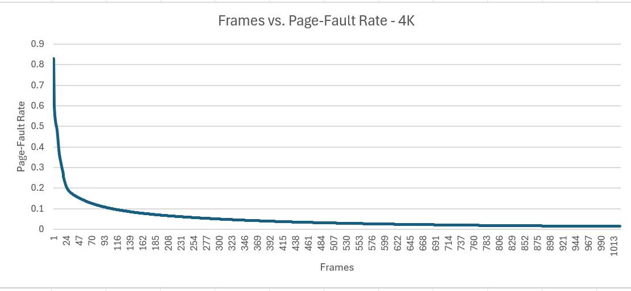

5. Curve Shape and Working Set Analysis (5 pts)
Each of the fault-rate curves are exponential decay graphs, that begin to level off their performance slope at the tail end while showing a significant spike at the beginning. This shows that the first frames added are worth the most performance gains while each subsequent frame improves performance by a smaller margin each time. The inflection point for each size occurs early, at 24 for 4KB, 44 for 2KB, 83 for 1KB, and 165 for 512B. The inflection point shows where the addition of more frames begins to significantly decrease in marginal value.

6. Frame Size and Fault Rate Tradeoffs (5 pts)
The larger frames reduce the number of pages because more data can be stored into each frame but means that the last frames will not be fully filled out. This means that a larger portion of the last frame will be empty and therefore not useful and thus means larger fragmentation. The data supports a preference for larger data frames but not the largest size. Having fewer faults with larger frame sizes is good but also results in more wasted memory as the last frame wont be completely filled.

Grading Rubric (delete this page before submitting)

Point Breakdown (30 pts total)
Component | Points
Optimum Frame Size Recommendation | 4
Frames for < 10% Target Table | 4
Page Fault Charts (4 charts x 1.5 pts) | 6
Fault Rate Charts (4 charts x 1.5 pts) | 6
Curve Shape / Working Set Analysis | 5
Frame Size Tradeoffs | 5
TOTAL | 30

General Deductions (applied at grader discretion)
The following may result in point deductions from any section where the issue appears:
Issue | Deduction | Description
Insufficient technical depth | up to -3 pts | Analysis should reflect understanding of virtual memory, page replacement, and working set concepts — not just restate numbers from the data.
Unprofessional presentation | up to -3 pts | The report should read as a polished technical document suitable for a professional audience. Sloppy formatting, missing chart labels, or inconsistent style will result in deductions.
Spelling and grammar errors | up to -2 pts | Proofread carefully. Use a spell checker. Technical writing demands precision in language as well as content.
Use of first person | up to -2 pts | Do not use "I," "we," "my," or "our." Write from an objective, third-person perspective throughout.
Passive voice | up to -1 pt | Use active voice. Write "LRU reduces the fault rate" rather than "The fault rate is reduced by LRU."
Verbose or unclear writing | up to -2 pts | Be direct and concise. Every sentence should contribute meaningful analysis. Avoid filler, redundancy, and vague statements such as "the results were interesting."

Submission Checklist
- All 8 charts embedded directly in the document (not linked)
- Each chart has a descriptive title (e.g., "Page-Fault Rate vs. Frames — 4KB")
- Axes labeled with units on every chart
- 10% reference line on all 4 fault-rate charts
- Minimum 250 words of written analysis
- No first person; active voice; concise language
- No spelling or grammar errors
- Report stands alone — readable without consulting CSV files
- Documentation statement completed in both main.c and this report
- File saved as .docx and committed to GitHub repo

