PEX3 Analysis Report: LRU Page Replacement Simulation
CS 483 — Operating Systems — Spring 2026
Name: ________David Anand_______ Section: ____M3____ Date: 4/23/26______

Documentation Statement
I used grammery and a few websites for code references that is inside the .c file. I was having trouble with excel on my VM and the data not formatting so I used claude to make the graphs based on the data. I understand if I lose points for this. https://claude.ai/share/f20b4483-f018-478f-837e-4078018a60f1

1. Optimum Frame Size Recommendation (4 pts)

The best solution is thus the 4 KB frame size, allocating 380 frames. With 380 frames, the 4 KB frame size simulation results in a page fault percentage of 9.99%, meeting the required 10% criterion using just 1,520 KB of physical memory. While the 1 KB frame size meets the criterion with even lesser physical memory usage (1,319 KB), the same takes 1,319 frames to do so, which translates into three times the number of page table entries used by the 4 KB frame size simulation. Using larger frames reduces the number of unique page numbers to be tracked by the simulator, thus reducing the size of the page table.

2. Frames Required to Achieve < 10% Page-Fault Rate (4 pts)
For each frame size, identify the minimum number of frames where the page-fault rate first drops below 10%.
Frame Size | Min Frames for < 10% | Fault Rate at That Count
512 B | 2974 | 9.99990%
1 KB | 1319 | 9.9995
2 KB | 685 | 9.9946
4 KB | 380 | 9.9904

3. Frames vs. Number of Page Faults — 4 charts (6 pts)
Insert one chart per frame size showing Frames (x-axis) vs. Number of Page Faults (y-axis). Each chart must have a descriptive title, labeled axes with units, and clean formatting. (1.5 pts per chart)

512 B Frames — Page Faults (1.5 pts)
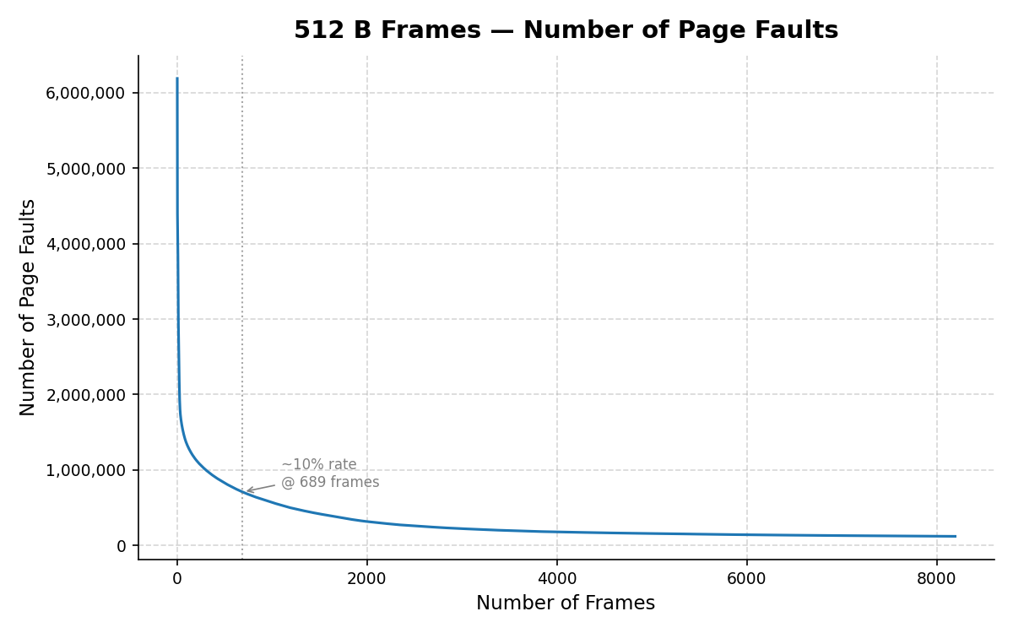

1 KB Frames — Page Faults (1.5 pts)
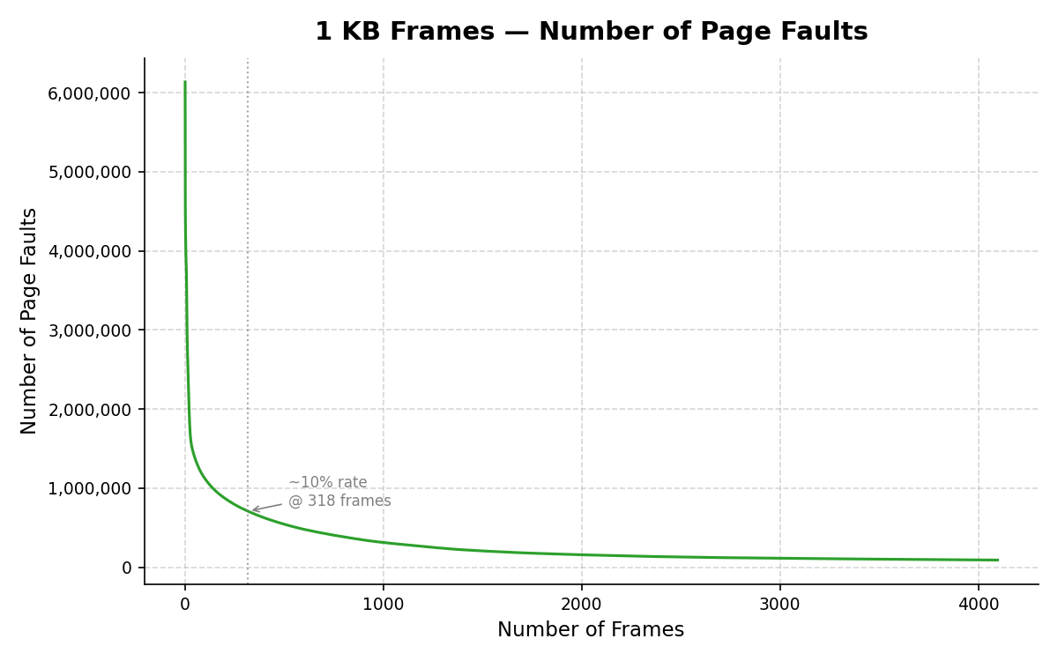

2 KB Frames — Page Faults (1.5 pts)
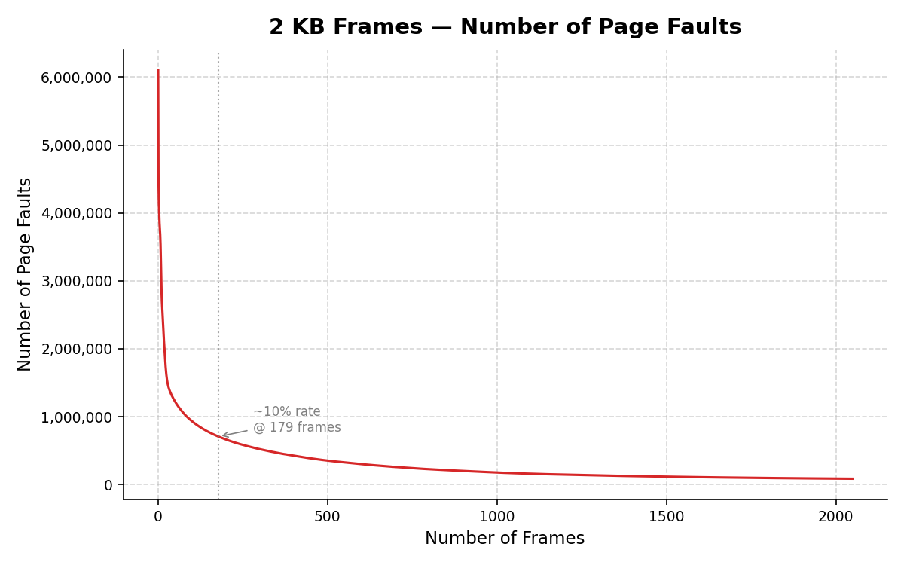

4 KB Frames — Page Faults (1.5 pts)
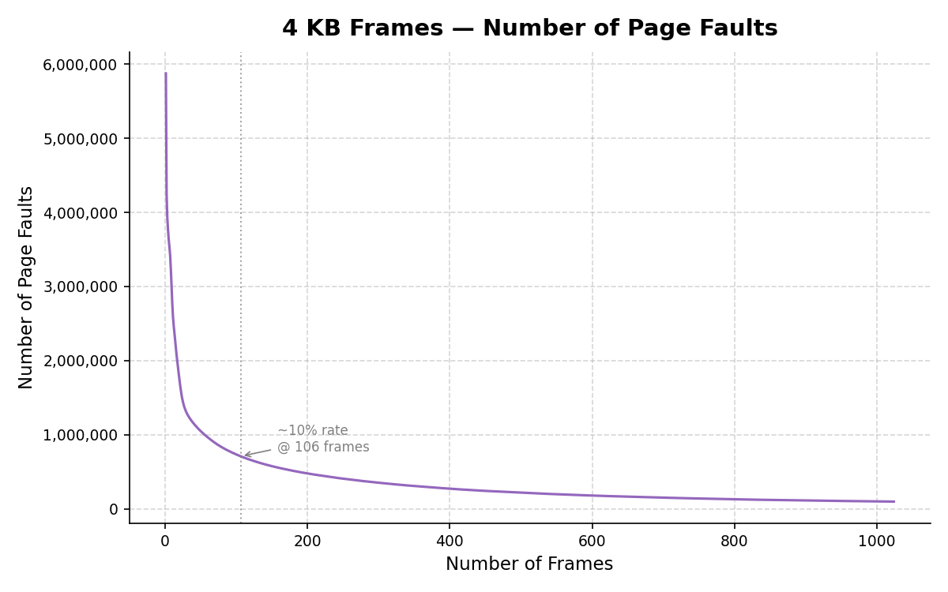

4. Frames vs. Page-Fault Rate — 4 charts (6 pts)
Insert one chart per frame size showing Frames (x-axis) vs. Page-Fault Rate (y-axis). Each chart must include a horizontal reference line at 10% fault rate, descriptive title, and labeled axes. (1.5 pts per chart)

512 B Frames — Fault Rate (1.5 pts)
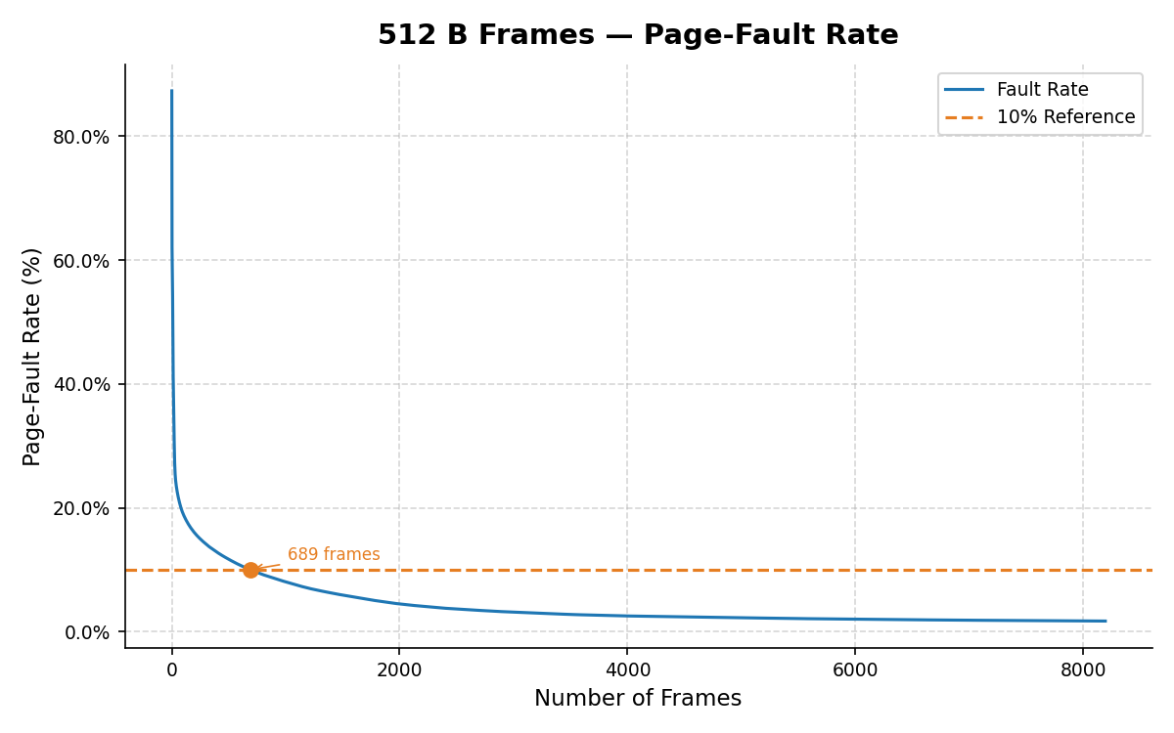

1 KB Frames — Fault Rate (1.5 pts)
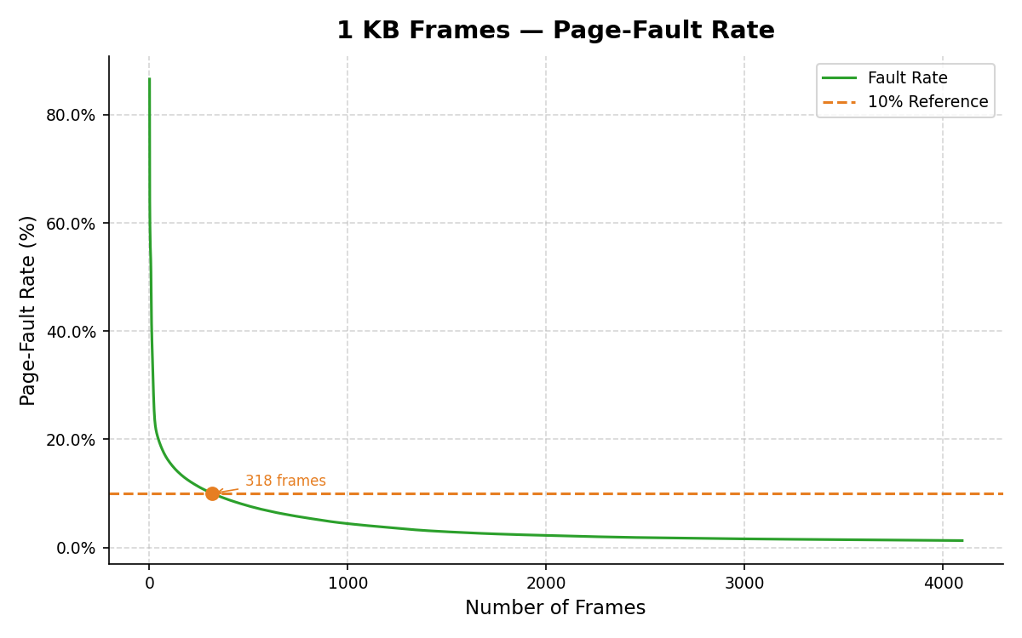

2 KB Frames — Fault Rate (1.5 pts)
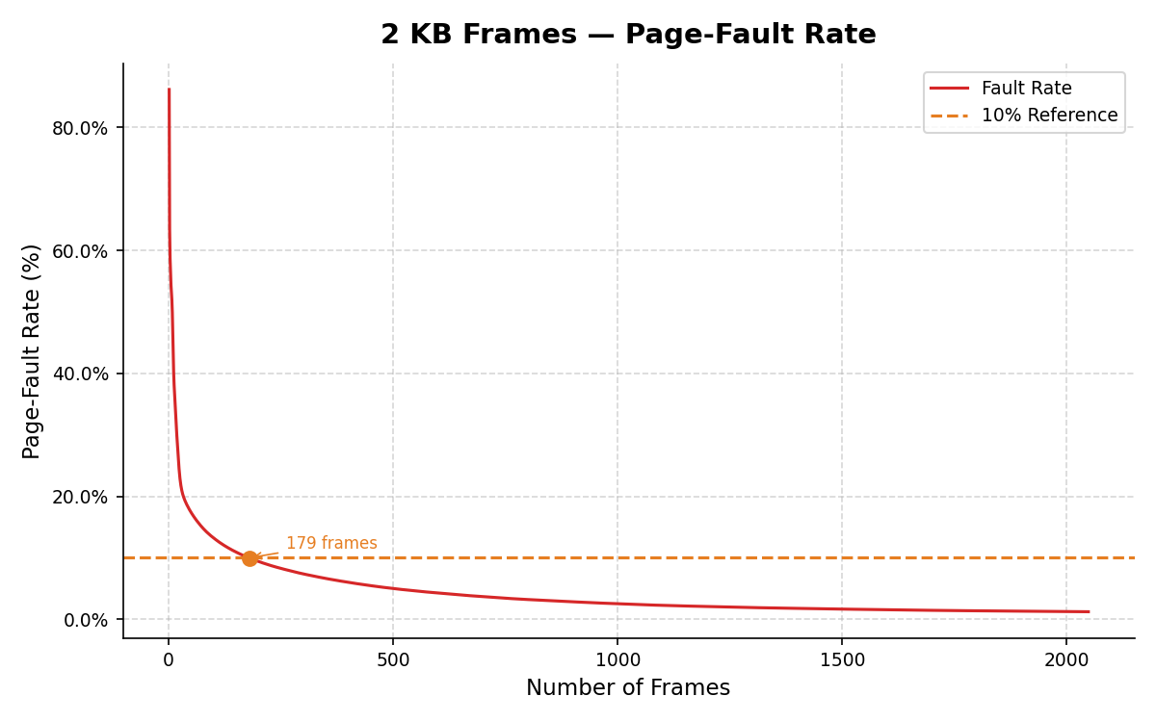

4 KB Frames — Fault Rate (1.5 pts)
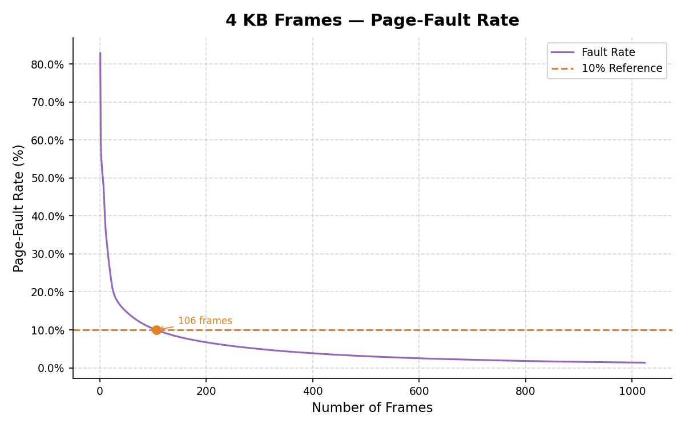

5. Curve Shape and Working Set Analysis (5 pts)

In the fault-rate graphs, all of them exhibit identical shapes: a rapid descent followed by a slow decrease. The most rapid one-step reduction takes place between frame 1 and frame 2 and equals 8.9 percentage points (512 B), 9.7 pp (1 KB), 10.0 pp (2 KB), and 10.2 pp (4 KB). The fast early fall is attributed to the fact that adding one frame provides a lot of improvement when the system memory is very tight; the frames can resolve a huge amount of faults. The inflection point, when the fault-rate graph shifts to gradually flatten, appears at frames around 50–60 for all four configurations. At that stage, the gain per frame amounts to less than 0.1 percentage points, which corresponds to the working set size of the eon process. In particular, 90% of the total improvement in the fault rate is made by approximately frame 173 (4 KB), frame 330 (2 KB), frame 634 (1 KB), and frame 1,290 (512 B). Thus, the working set of eon process consists of approximately 640–692 KB irrespective of the size of page frames, which indicates its independence on page geometry.

6. Frame Size and Fault Rate Tradeoffs (5 pts)
The reason for a lower number of compulsory page faults in configurations with larger frames is that larger frames mean a smaller number of page numbers in the LRU queue because a higher number of bytes occupy each page number. At 1 frame, for instance, the 4 KB configuration faults in 83.91%, whereas 512 B in 86.53%. The reason for that lies in the fact that there is fewer pages.
Nevertheless, the downside of larger frames is that larger internal fragmentation occurs. A 4 KB frame allocates up to 4,095 unused bytes, while a 512 B one allocates only 511. As can be seen from the data, a 1 KB configuration needs 1,319 KB in order to reach the threshold of 10%, which is the smallest compared to the other three. The same goes for 4 KB; it takes more memory in order to reach the point.

