PEX3 Analysis Report: LRU Page Replacement Simulation
CS 483 — Operating Systems — Spring 2026
Name: Dustin Mock Section: M4 Date: 23 April 2026

Documentation Statement
Used document writeup and PEX slides. Used my doubly linked list from CS220. Used Google to search minor uses of library functions. Used pyplot for generating the plots.

1. Optimum Frame Size Recommendation (4 pts)
The simulation supports allocating 1,319 frames of 1 KB pages (approximately 1319 KB total memory) to meet the 10% page-fault-rate target with the smallest physical-memory footprint of the four configurations evaluated. At this allocation the fault rate falls to 9.9995%, just below the threshold. This selection minimizes total RAM committed to the process while still satisfying the constraint.
If the operating system prioritizes smaller page tables and lower TLB pressure over raw memory consumption, the 4 KB page configuration with 380 frames (~1.49 MB) achieves the same fault-rate target while managing only 380 page-table entries, roughly one third the bookkeeping of the 1 KB recommendation. The choice depends on which resource (physical memory or page-table overhead) is more constrained on the target system. For the dataset measured here, the 1 KB / 1,319 frame configuration is the tightest fit; the 4 KB / 380 frame configuration is the operationally simplest fit.

2. Frames Required to Achieve < 10% Page-Fault Rate (4 pts)
For each frame size, identify the minimum number of frames where the page-fault rate first drops below 10%.
Frame Size | Min Frames for < 10% | Fault Rate at That Count
512 B | 2,974 | 9.9990%
1 KB | 1,319 | 9.9995%
2 KB | 685 | 9.9946%
4 KB | 380 | 9.9904%

3. Frames vs. Number of Page Faults — 4 charts (6 pts)
Insert one chart per frame size showing Frames (x-axis) vs. Number of Page Faults (y-axis). Each chart must have a descriptive title, labeled axes with units, and clean formatting. (1.5 pts per chart)

512 B Frames — Page Faults (1.5 pts)
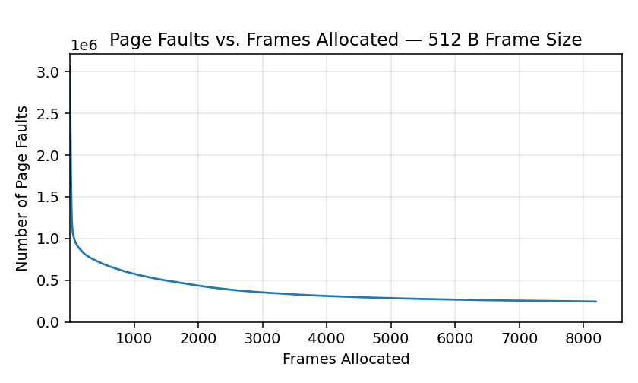

1 KB Frames — Page Faults (1.5 pts)
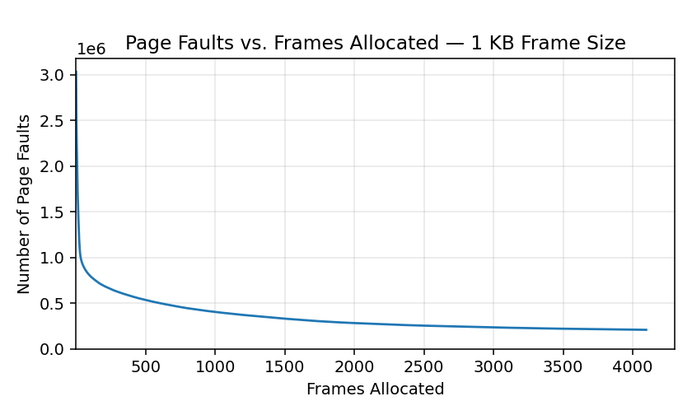

2 KB Frames — Page Faults (1.5 pts)
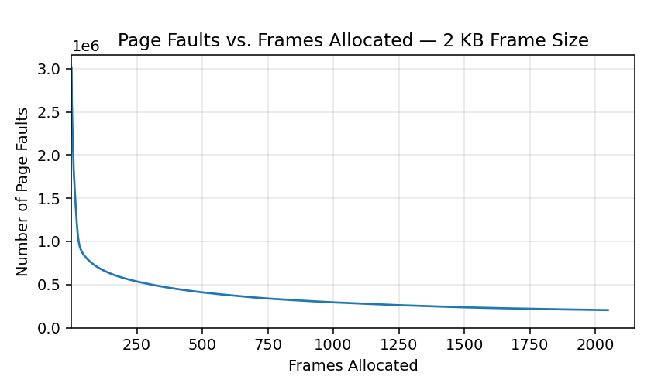

4 KB Frames — Page Faults (1.5 pts)
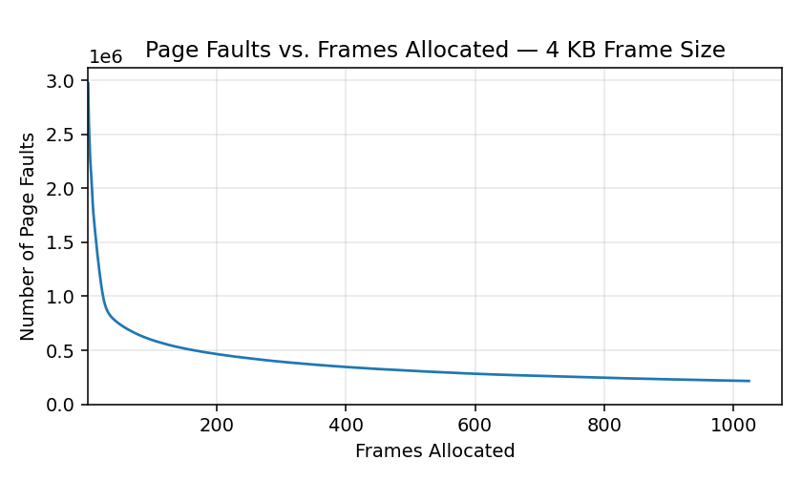

4. Frames vs. Page-Fault Rate — 4 charts (6 pts)
Insert one chart per frame size showing Frames (x-axis) vs. Page-Fault Rate (y-axis). Each chart must include a horizontal reference line at 10% fault rate, descriptive title, and labeled axes. (1.5 pts per chart)

512 B Frames — Fault Rate (1.5 pts)
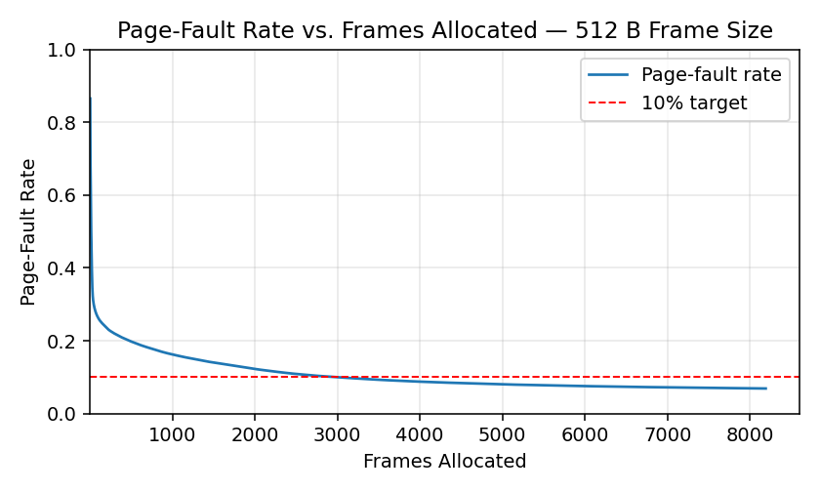

1 KB Frames — Fault Rate (1.5 pts)
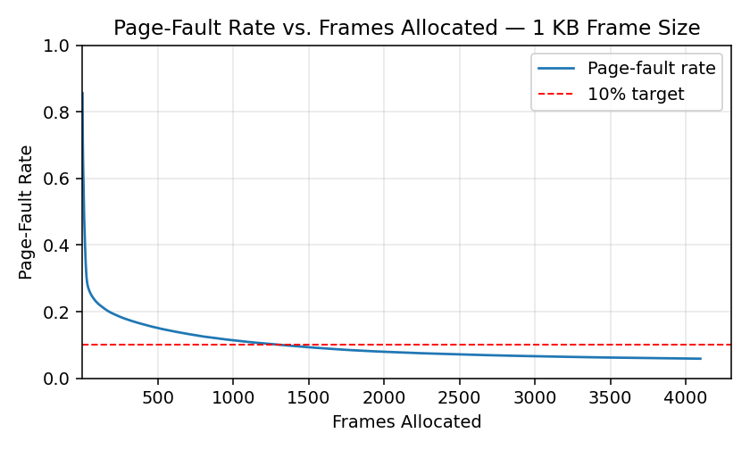

2 KB Frames — Fault Rate (1.5 pts)
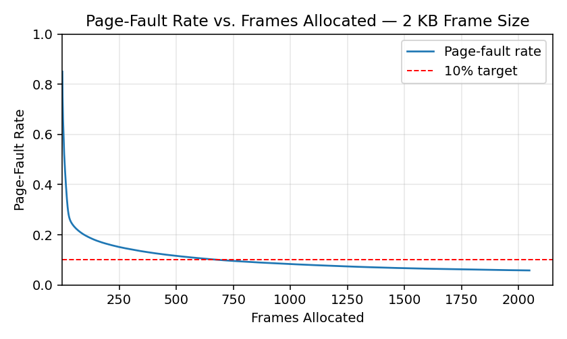

4 KB Frames — Fault Rate (1.5 pts)
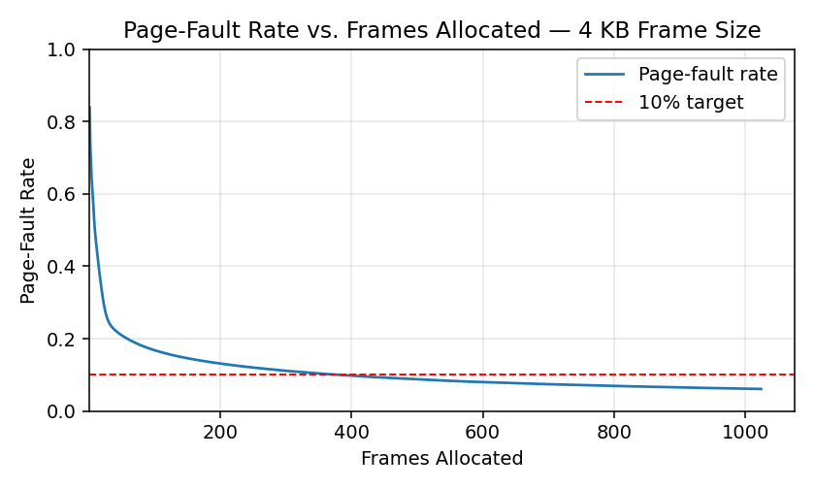

5. Curve Shape and Working Set Analysis (5 pts)
All four fault-rate curves exhibit the same three-phase shape. The first phase, from 1 to roughly 10 frames, drops sharply: each additional frame captures a high-traffic page that would otherwise have been evicted on every access. The second phase, from approximately 10 to 500 frames, decays much more slowly as frames begin to retain less frequently referenced pages. The third phase, beyond approximately 500–1,000 frames, approaches a horizontal asymptote near 6%; additional memory no longer reduces faults appreciably.
The inflection point coincides with the working-set size of the eon process at each page granularity. For 1 KB pages the inflection appears around 200–400 frames (~0.2–0.4 MB), corresponding to the dense reference set actively used during the captured execution window. The asymptote of approximately 6% represents the compulsory-miss rate: the fraction of accesses that reference pages for the first time and which no replacement policy can satisfy. The asymptote is essentially independent of frame size (5.79% – 6.88%), which is strong evidence that the trace exhibits a clean working-set structure rather than a streaming or random-access pattern.

6. Frame Size and Fault Rate Tradeoffs (5 pts)
Smaller frames track memory at finer granularity. A 512 B frame holds exactly the bytes a process touches in a small region; a 4 KB frame may hold the same useful bytes plus several kilobytes of unreferenced data brought in alongside them. The data shows that 512 B and 1 KB configurations sustain a slightly lower fault rate at intermediate frame counts when measured per byte of physical memory: the 1 KB configuration meets the 10% target with 1.29 MB of allocated memory, while the 4 KB configuration requires 1.49 MB (roughly 16% more).
However, the cost of fine granularity is page-table overhead. The 1 KB configuration manages 1,319 frame entries to meet the target; the 4 KB configuration manages 380. Each frame entry consumes page-table memory, TLB capacity, and dirty/access-bit bookkeeping in the OS. On hardware where the TLB is small or where page-walk latency dominates, the 4 KB configuration is the better trade despite its larger footprint.
The data therefore does not support a universal preference. Smaller frames win when physical memory is the binding constraint; larger frames win when page-table or TLB pressure is the binding constraint. The fact that all four curves converge to similar asymptotes (within roughly 1 percentage point) demonstrates that frame size primarily affects how memory is sliced, not how much information the process inherently demands.

