PEX3 Analysis Report: LRU Page Replacement Simulation
CS 483 — Operating Systems — Spring 2026
Name: Jonathon Watson Section: M4 Date: 4/15/2026

Documentation Statement
I consulted Claude AI while working in excel. Attached is the link: https://claude.ai/share/ddc46af7-302b-43e9-a45b-00594ede52d8

Optimum Frame Size Recommendation (4 pts)
The data supports a 2KB frame size with 179 frames to keep the page-fault rate below the 10% threshold. Using 179 2KB frames there are 707079 faults with a 9.9777% fault rate. Comparing this to the 318 1KB frames with 708216 faults at a 9.9937% fault rate and 106 4KB frames with 708224 faults at a 9.9938% fault rate, 2KB provides the best tradeoff between wasted memory and number of faults. Furthermore, using the number of frames directly below the 10% threshold takes advantage of the transition from a steep drop to a linear decrease as seen in the charts in section 4 below.

2. Frames Required to Achieve < 10% Page-Fault Rate (4 pts)

Frame Size | Min Frames for < 10% | Fault Rate at That Count
512 B | 689 | 9.996%
1 KB | 318 | 9.9937%
2 KB | 179 | 9.9777%
4 KB | 106 | 9.9938%

3. Frames vs. Number of Page Faults — 4 charts (6 pts)

512 B Frames — Page Faults (1.5 pts)
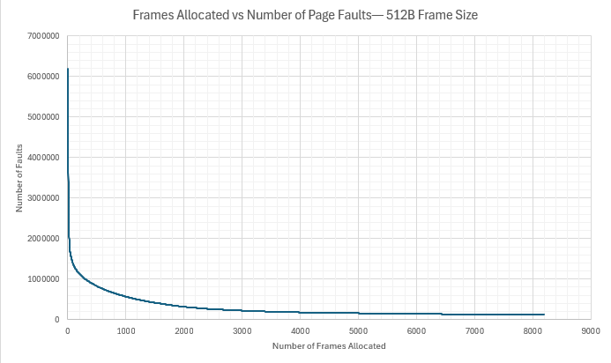

1 KB Frames — Page Faults (1.5 pts)
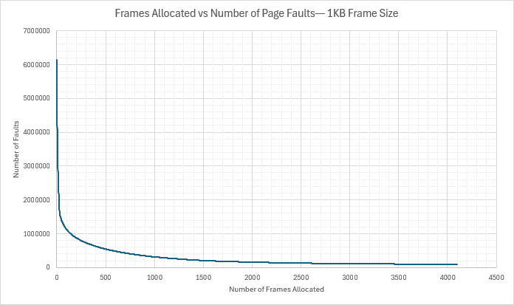

2 KB Frames — Page Faults (1.5 pts)
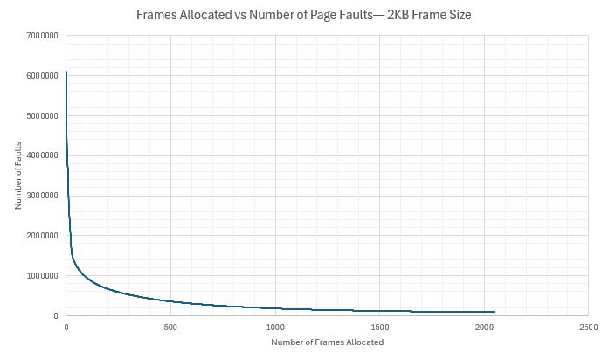

4 KB Frames — Page Faults (1.5 pts)
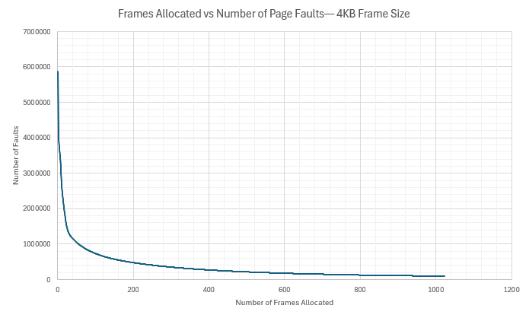

4. Frames vs. Page-Fault Rate — 4 charts (6 pts)

512 B Frames — Fault Rate (1.5 pts)
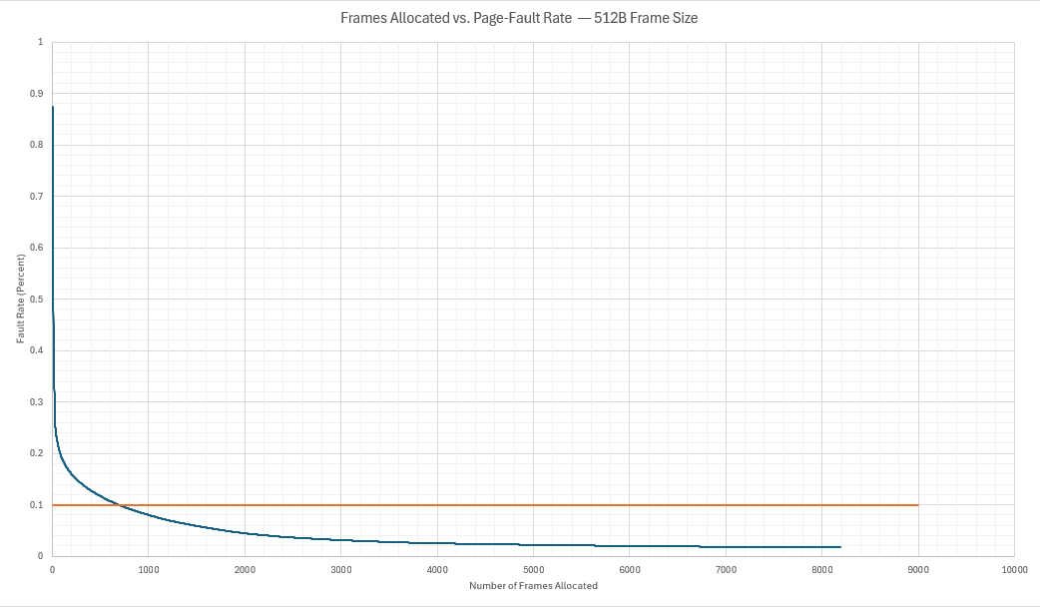

1 KB Frames — Fault Rate (1.5 pts)
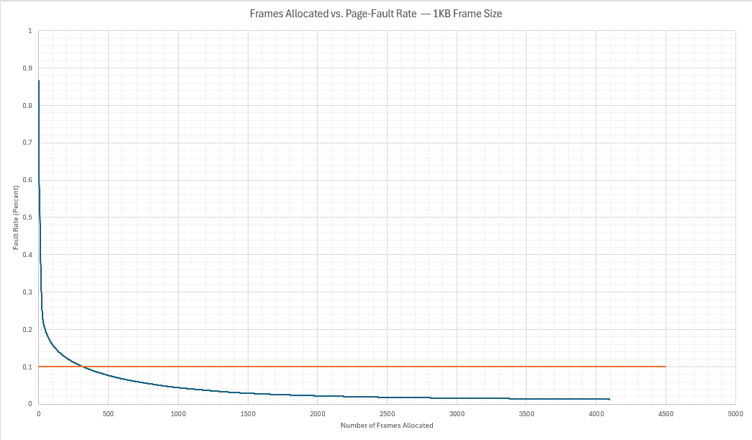

2 KB Frames — Fault Rate (1.5 pts)
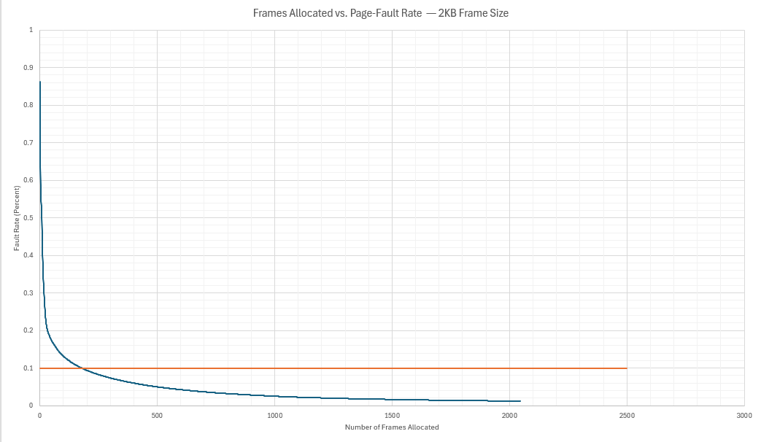

4 KB Frames — Fault Rate (1.5 pts)
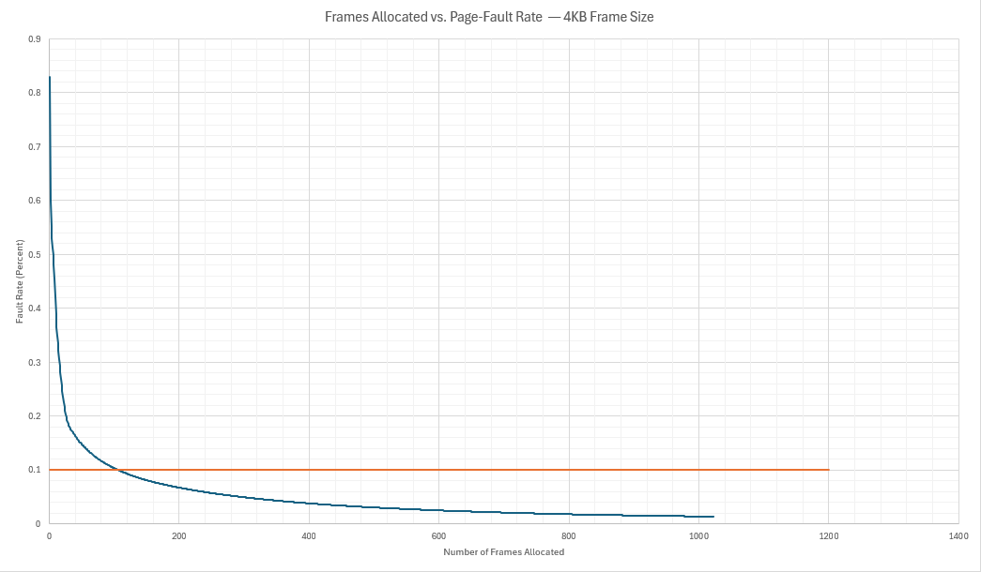

5. Curve Shape and Working Set Analysis (5 pts)
Initially, each curve has a steep drop demonstrating that faults dramatically decrease as the frames increase initially. At a certain point, Amdahl’s law applies, introducing diminishing returns that are reflected in the flattened portion of the graph. This inflection point occurs around the 10% fault rate for each graph regardless of the frame size. The inflection point provides a natural working set size which has the best tradeoff between the number of frames and the fault rate. It is interesting to see how low the number of frames is prior to the marked 10% fault rate.

6. Frame Size and Fault Rate Tradeoffs (5 pts)
Larger frame sizes reduce the number of pages needed to hold the same amount of data. This is seen in the progression of charts in sections 3 and 4. Larger frame size also reduces the number of frames needed to drop below the 10% fault rate threshold as seen in section 2. The downside is that larger frame size typically results in internal fragmentation. If the program size is smaller than the frame size, usable memory space is lost. For example, if a program only needs 1 KB of data from each 4KB frame, then the additional 3 KB in each frame is wasted. Weighing those features, the data supports a preference for a 2KB frame size, in between the minimum and maximum sizes. There is a large decrease in the number of frames needed to drop below the 10% fault rate threshold from 512B to 2KB. Following 2KB, there is only a 73 frame drop from 2KB to 4KB. Furthermore, there is an increase from 707079 faults to 708224 faults with a corresponding increase in fault rate. This increase suggests that 2KB provides the best tradeoff between the number of faults and wasted memory.

Grading Rubric (delete this page before submitting)

Point Breakdown (30 pts total)
Component | Points
Optimum Frame Size Recommendation | 4
Frames for < 10% Target Table | 4
Page Fault Charts (4 charts x 1.5 pts) | 6
Fault Rate Charts (4 charts x 1.5 pts) | 6
Curve Shape / Working Set Analysis | 5
Frame Size Tradeoffs | 5
TOTAL | 30

General Deductions (applied at grader discretion)
The following may result in point deductions from any section where the issue appears:
Issue | Deduction | Description
Insufficient technical depth | up to -3 pts | Analysis should reflect understanding of virtual memory, page replacement, and working set concepts — not just restate numbers from the data.
Unprofessional presentation | up to -3 pts | The report should read as a polished technical document suitable for a professional audience. Sloppy formatting, missing chart labels, or inconsistent style will result in deductions.
Spelling and grammar errors | up to -2 pts | Proofread carefully. Use a spell checker. Technical writing demands precision in language as well as content.
Use of first person | up to -2 pts | Do not use "I," "we," "my," or "our." Write from an objective, third-person perspective throughout.
Passive voice | up to -1 pt | Use active voice. Write "LRU reduces the fault rate" rather than "The fault rate is reduced by LRU."
Verbose or unclear writing | up to -2 pts | Be direct and concise. Every sentence should contribute meaningful analysis. Avoid filler, redundancy, and vague statements such as "the results were interesting."

Submission Checklist
- All 8 charts embedded directly in the document (not linked)
- Each chart has a descriptive title (e.g., "Page-Fault Rate vs. Frames — 4KB")
- Axes labeled with units on every chart
- 10% reference line on all 4 fault-rate charts
- Minimum 250 words of written analysis
- No first person; active voice; concise language
- No spelling or grammar errors
- Report stands alone — readable without consulting CSV files
- Documentation statement completed in both main.c and this report
- File saved as .docx and committed to GitHub repo

