PEX3 Analysis Report: LRU Page Replacement Simulation
CS 483 — Operating Systems — Spring 2026
Name: C1C Andrew J. Kim________ Section: __M3____ Date: 04/18/2026__

Documentation Statement
- https://stackoverflow.com/questions/4083916/two-arguments-to-calloc
  - Refreshed my memory on calloc arguments. Used to allocate faults array.
- https://stackoverflow.com/questions/3209909/how-to-printf-unsigned-long-in-c
  - Refreshed my memory on what to put after % for long ints for printing
- https://www.youtube.com/watch?v=JboBgHqld2U
  - Used video to figure out how to insert axis labels for Excel plots.

1. Optimum Frame Size Recommendation (4 pts)
The data supports a recommendation of using 318 1KB frames due to efficient memory usage and a compromise between performance and internal fragmentation. Of all the frame sizes (512b- 344.5KB, 1KB- 318KB, 2KB- 358KB, 4KB- 424KB), using a frame size of 1KB led to the lowest memory usage of 318KB. Although allocating more frames would decrease the page fault rate, the decrease in page fault rate for the addition of each singular frame gets lower and lower, especially after the 10% page fault threshold is crossed. The cause for this is because adding an infinite amount of frames ignores locality, where a process is more likely to reference a memory address it has recently interacted with over an address it has not interacted with in a long time. Adding more frames would only waste memory by having a page transferred to memory for it to not be used after the initial reference.
Compared to the 512b frame, a 1KB frame results in a smaller page table and less overhead, as fewer page faults occur for the same amount of KB needed by the programs. Although a 2KB and 4KB frame size would also result in less overhead, using larger frame sizes risks increasing the amount of physical memory lost due to internal fragmentation, where the unused address space within a frame is inaccessible to other processes, effectively wasting that space. A 1KB frame size minimizes memory usage while limiting the internal fragmentation compared to the 2KB and 4KB page frames.
Word Count: 250

2. Frames Required to Achieve < 10% Page-Fault Rate (4 pts)

Frame Size | Min Frames for < 10% | Fault Rate at That Count
512 B | 689 | 0.09996
1 KB | 318 | 0.099937
2 KB | 179 | 0.099777
4 KB | 106 | 0.099938

3. Frames vs. Number of Page Faults — 4 charts (6 pts)

512 B Frames — Page Faults (1.5 pts)
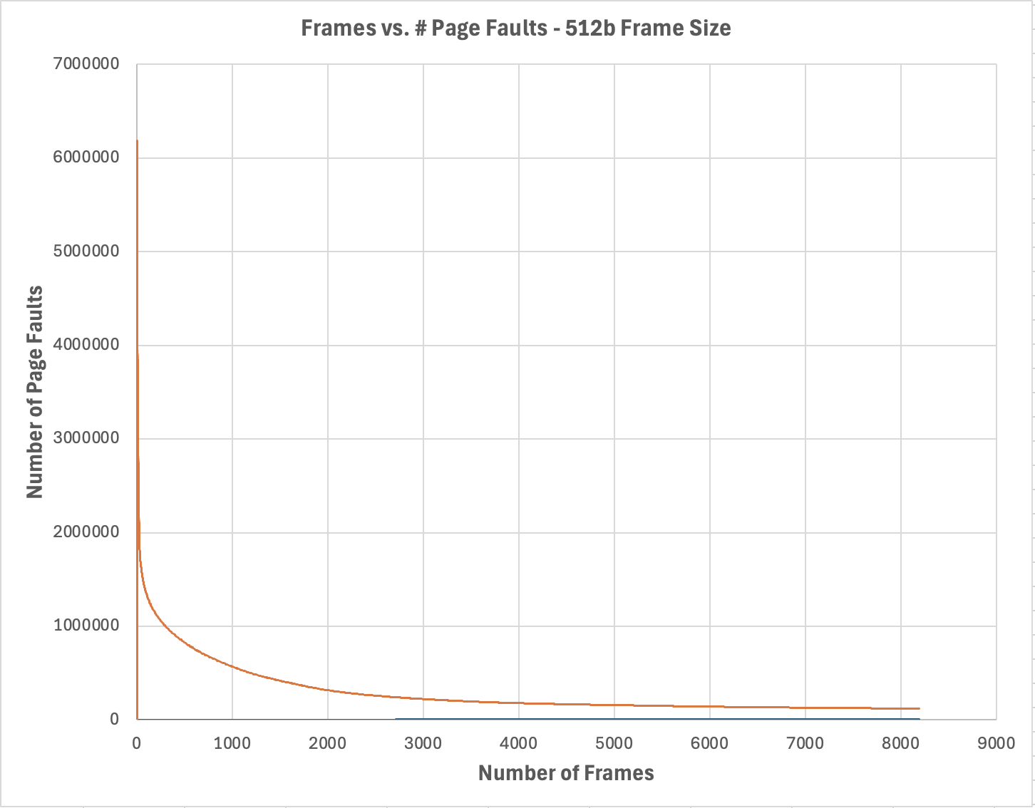

1 KB Frames — Page Faults (1.5 pts)
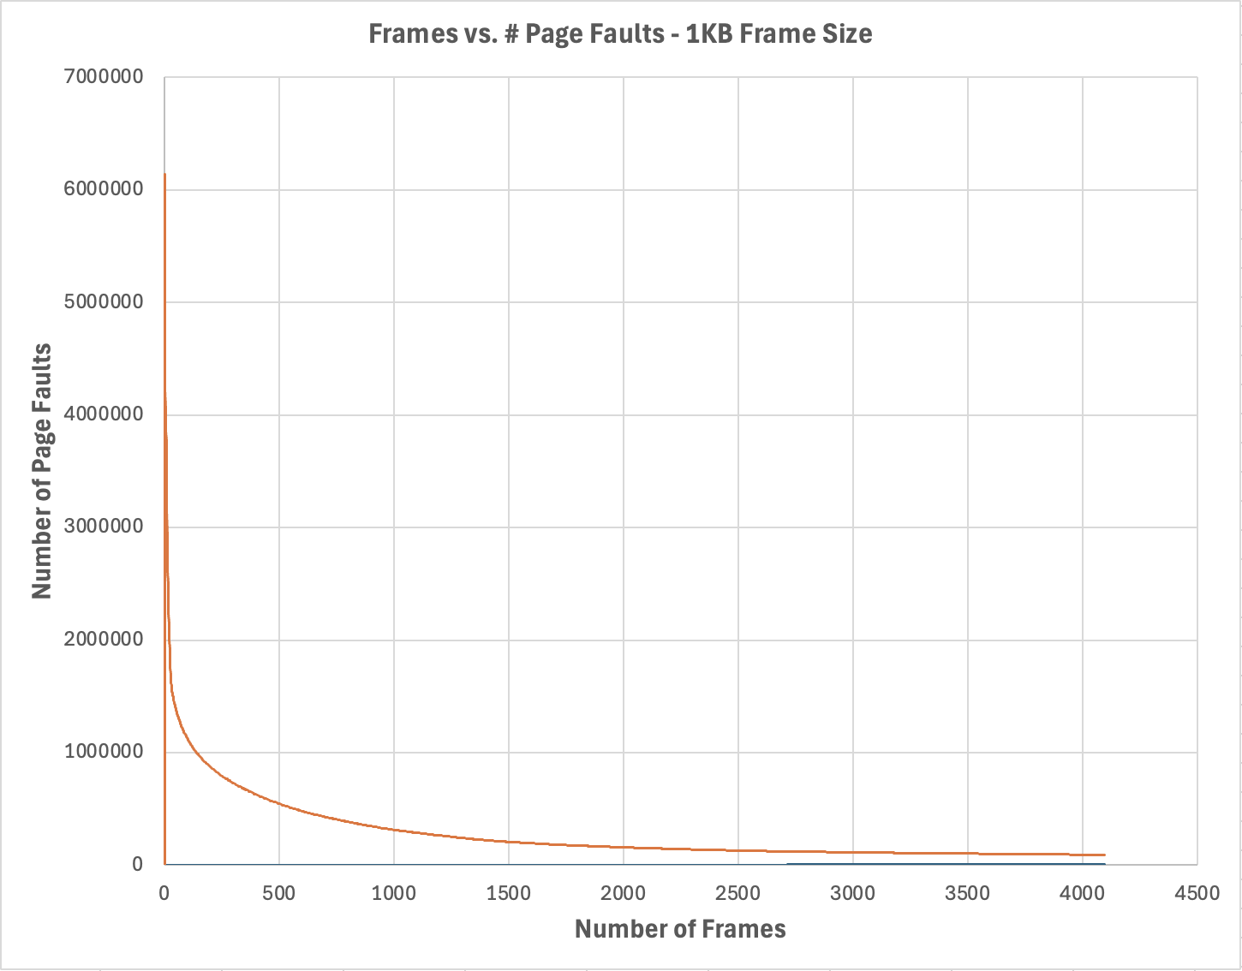

2 KB Frames — Page Faults (1.5 pts)
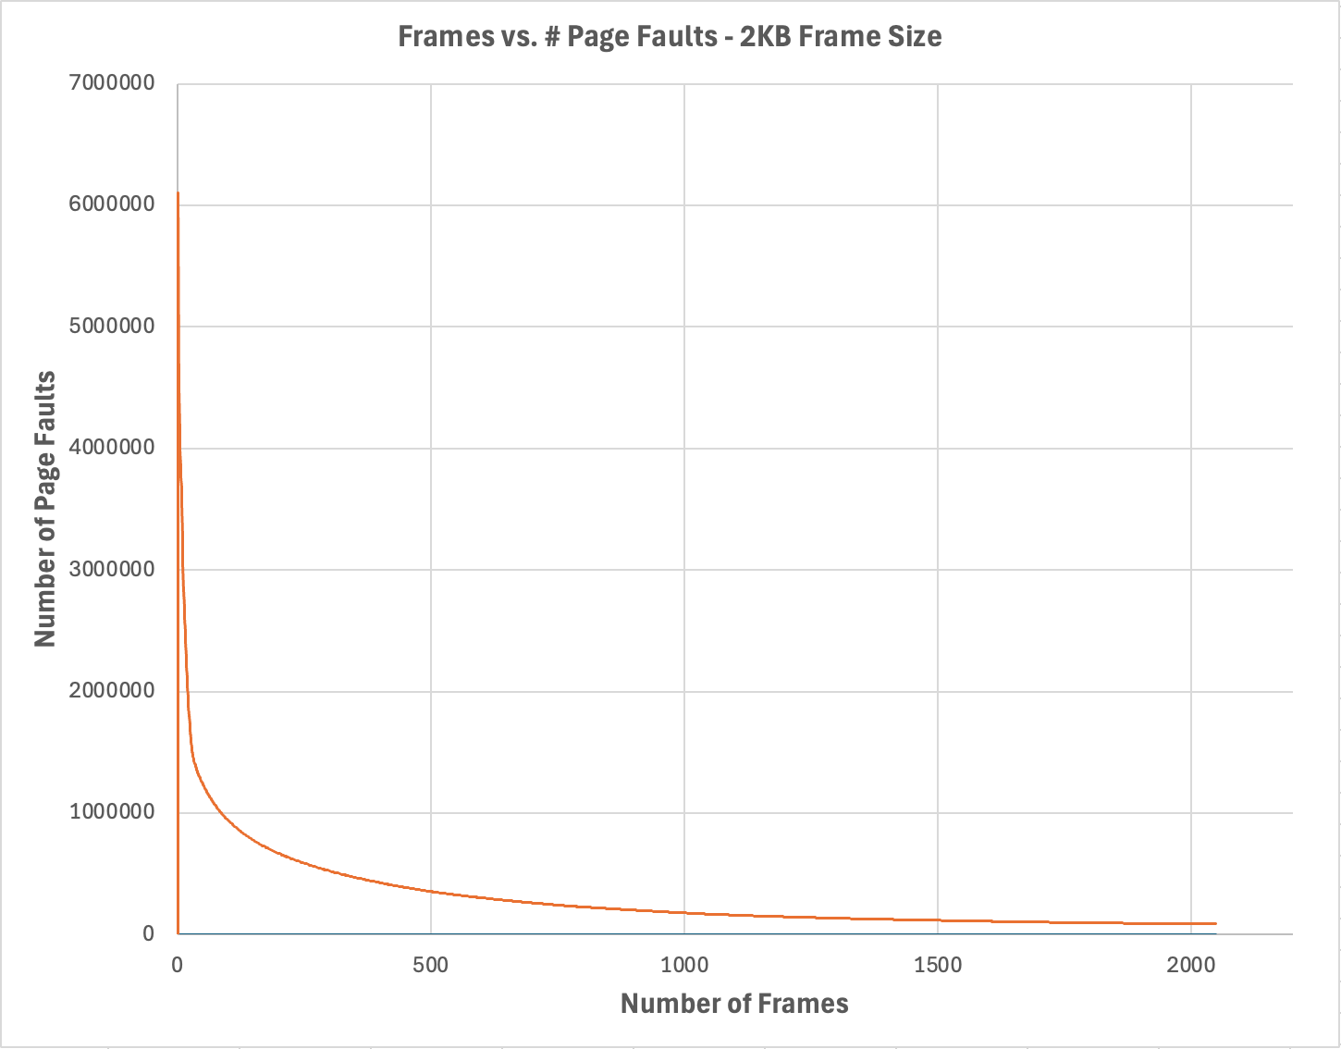

4 KB Frames — Page Faults (1.5 pts)
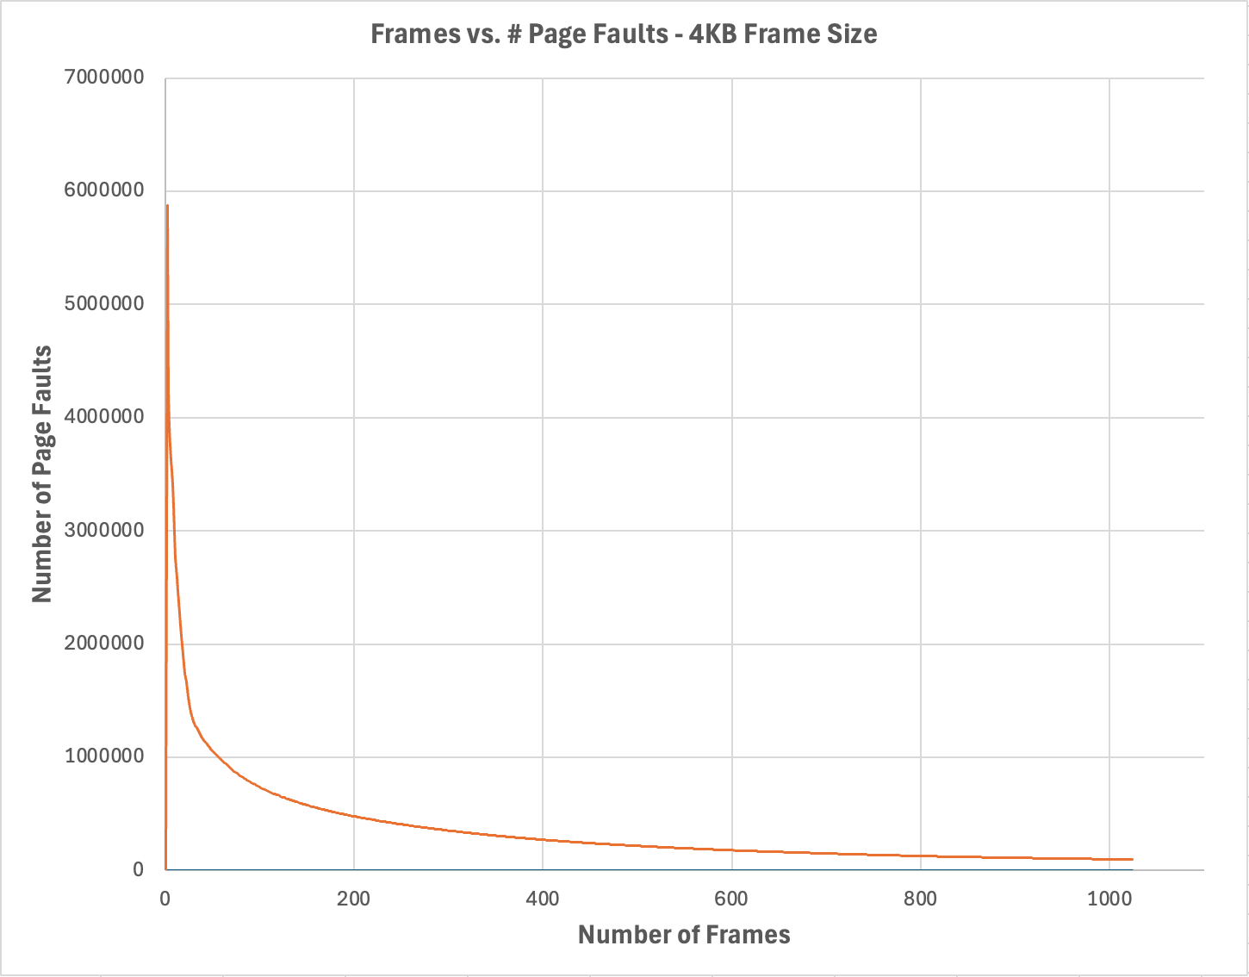

4. Frames vs. Page-Fault Rate — 4 charts (6 pts)

512 B Frames — Fault Rate (1.5 pts)
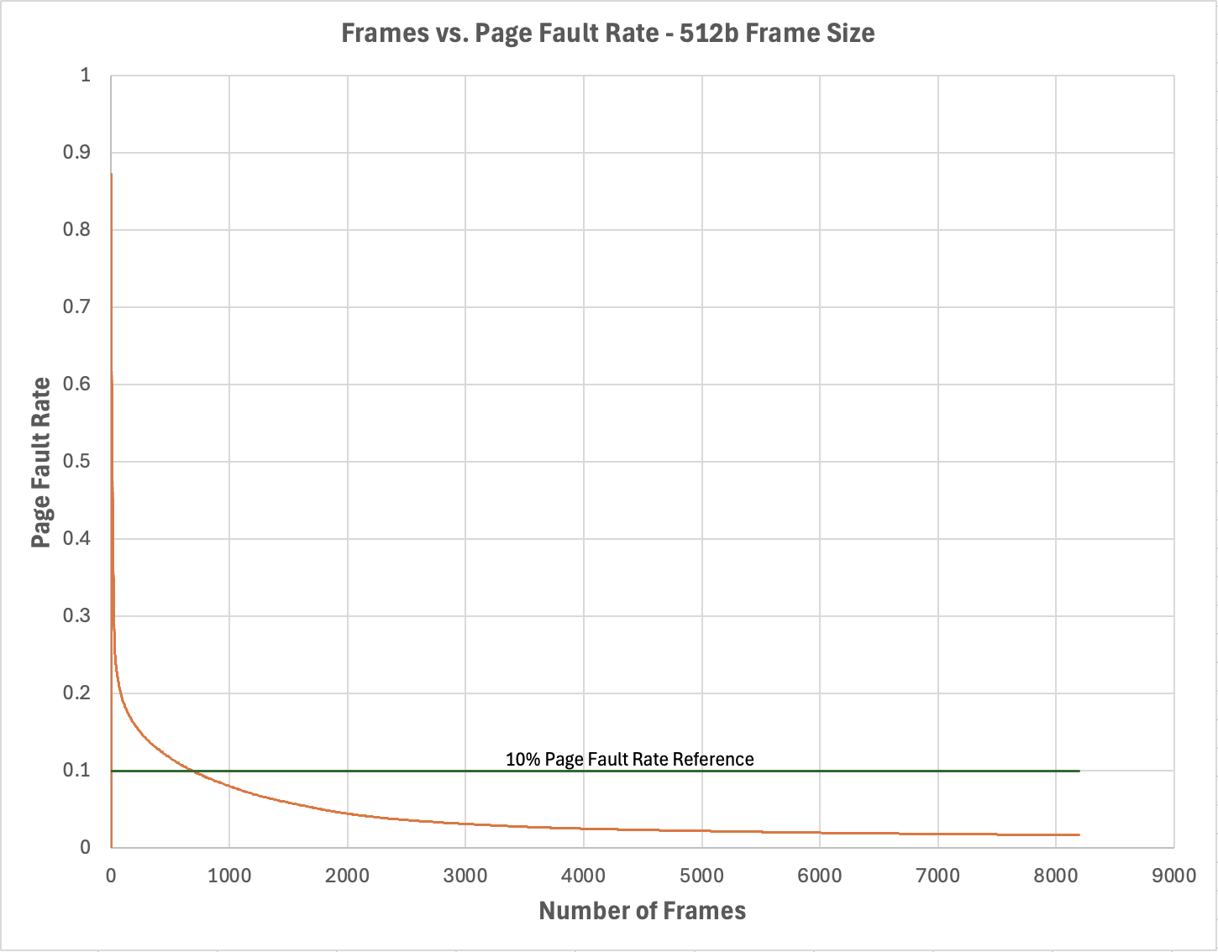

1 KB Frames — Fault Rate (1.5 pts)
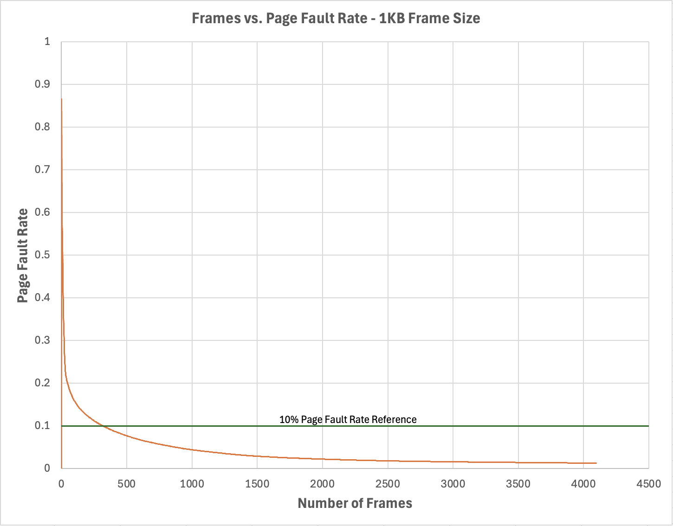

2 KB Frames — Fault Rate (1.5 pts)
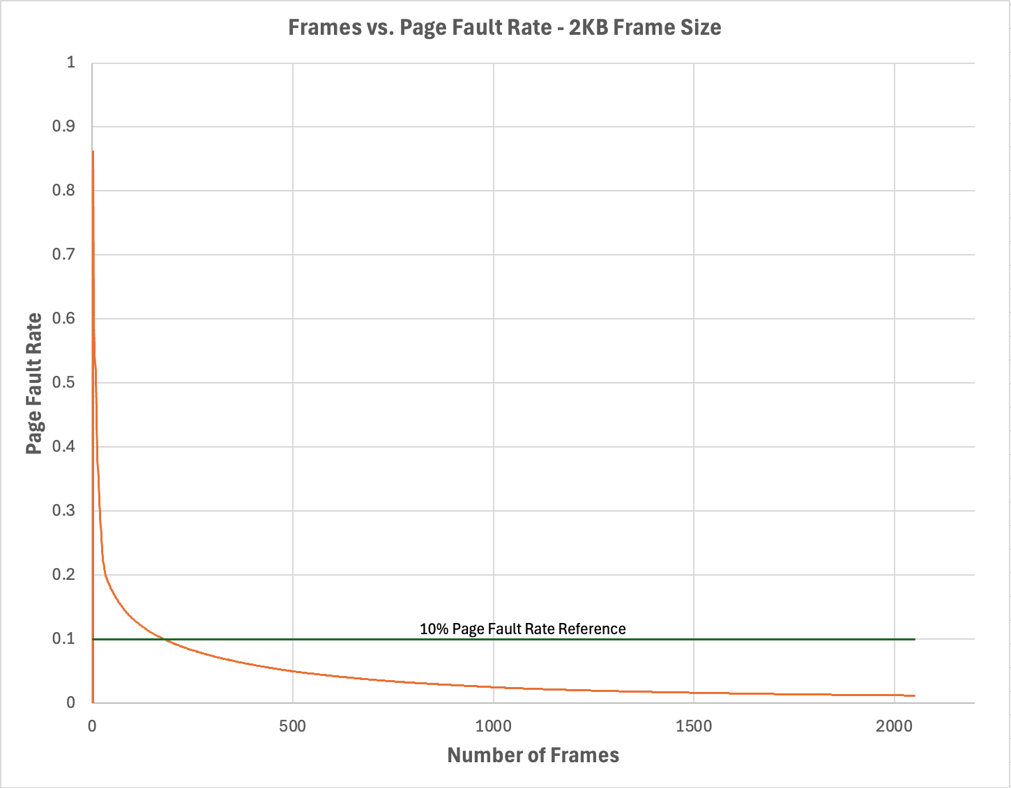

4 KB Frames — Fault Rate (1.5 pts)
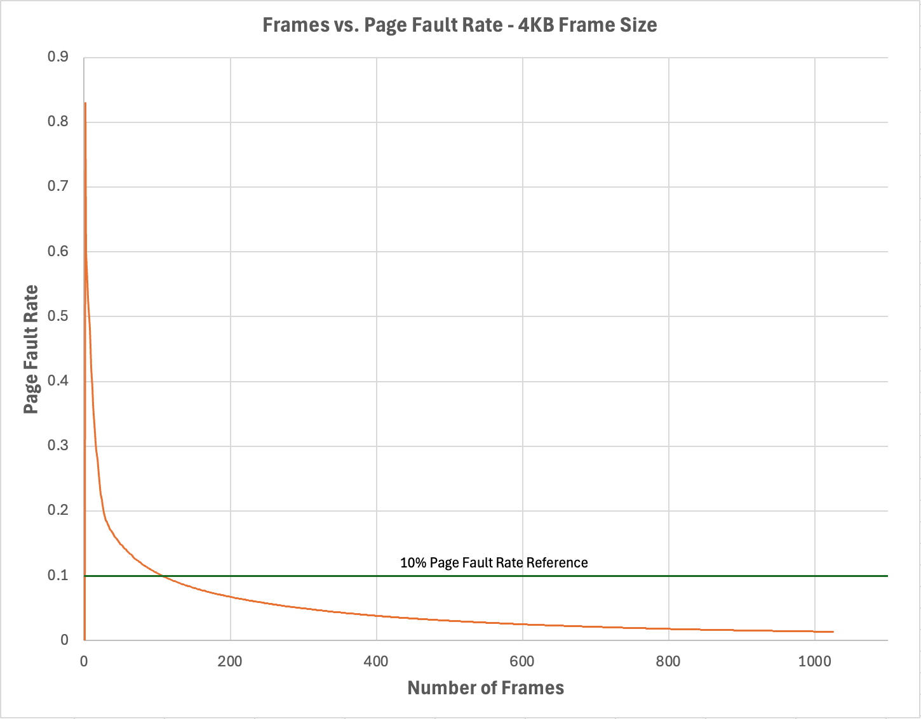

5. Curve Shape and Working Set Analysis (5 pts)
All of the four curves have an initial steep drop in fault rate from 1 to around 30-120 frames (depending on the frame size, with larger frames resulting in a greater drop in fault rate for each additional frame). The slope gradually flattens as the page fault rate tails off with the slope’s rate of change falling drastically. The inflection points for the four frame sizes occur around the number of frames where the page fault rate drops below 10%. The inflection point is likely the process’s average working set size when its contents in memory are split into the specified frame size. Since the 10% page fault threshold is crossed when 318KB of memory and 424KB of memory are used in the 1KB and 4KB frame sizes respectively, it is estimated that the running processes’ logical address size averages around 320-420KB in size before it gets transferred to memory from disk. With the very shallow slope near the end of the tails of the lines, it can be inferred that any frames added beyond the actively used working set are probably only referenced once or twice, as they are likely not used after the initial page fault when they are made resident to physical memory. This is a wasteful use of memory because it could be used more efficiently if given to another process, since adding frames results in large drops in page fault rate for each additional frame until the page fault rate gets lowered to 10 percent.
Word Count: 250

6. Frame Size and Fault Rate Tradeoffs (5 pts)
Using larger frames loads more contiguous blocks of memory for each page fault, so processes that require a large amount of contiguous memory in its logical address space will encounter fewer page faults, since each frame contains more memory. The data supports this assessment because 20 512b frames result in a miss rate of 32.67% while 20 4KB frames result in a 24.62% miss rate. An 8MB logical address space only results in 2 page faults when it is not resident in memory and is referenced by the processes while a 512b frame size would result in 16 faults, with the overhead associated with each fault wasting CPU time. Needing less frames due to a larger frame size also results in a lower number of entries in a page table, which can leave more bytes for words.
However, a large frame size wastes memory through internal fragmentation, which is when unused portions of a frame by one process cannot be used by other processes and is effectively wasted. This is shown by a comparison between the 4KB and 1KB frame sizes where in order to go below the 10% page fault rate threshold, the 1KB version uses 318KB of memory while the 4KB version uses 424KB.
The data supports a preference for frames that are not too large or too small. The 512b frame size version actually uses more memory to get below 10% compared to the 1KB version, so 1KB appears to be the best combination between memory efficiency and overhead costs.
Word Count: 253

