PEX3 Analysis Report: LRU Page Replacement Simulation
CS 483 — Operating Systems — Spring 2026
Name: Mason Casebeer Section: M4 Date: Apr 20 2026

Documentation Statement
Consulted Prof. Weingart for help with my code, he gave me the autograder summary which pointed out several edge case errors in my DLL implementation which I then fixed.

1. Optimum Frame Size Recommendation (4 pts)

A system with 1KB frame size and 318 frames is recommended in order to achieve the best ratio of memory overhead and performance. 1KB frame size is still much more storage efficient than the 2KB and 4KB, but sees a significant decrease in number of frames required to reach sub 10% fault rate compared to 512b. When multiplying frame size by minimum frames to measure data usage, 1KB also gives the smallest value out of all possible frame size minimum frames combo, suggesting it has the lowest memory overhead (this calculation has been added to the table below).

2. Frames Required to Achieve < 10% Page-Fault Rate (4 pts)
For each frame size, identify the minimum number of frames where the page-fault rate first drops below 10%.
Frame Size | Min Frames for < 10% | Fault Rate at That Count | Frame Size * Min Frames for 10% (KB)
512 B | 689 | 0.09996 | 344.5
1 KB | 318 | 0.099937 | 318
2 KB | 179 | 0.099777 | 358
4 KB | 106 | 0.099938 | 432

3. Frames vs. Number of Page Faults — 4 charts (6 pts)

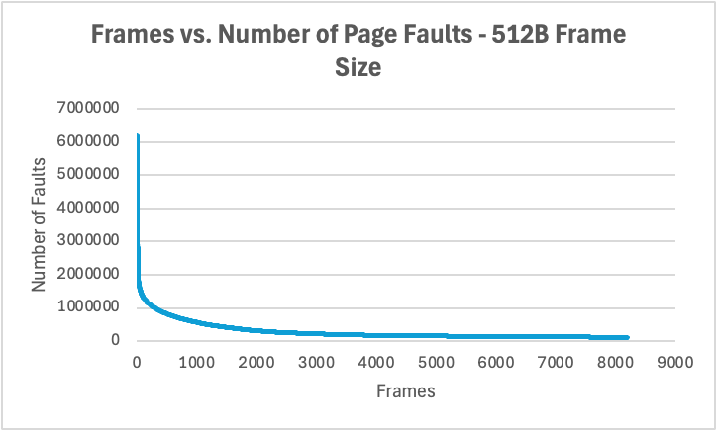
512 B Frames — Page Faults (1.5 pts)

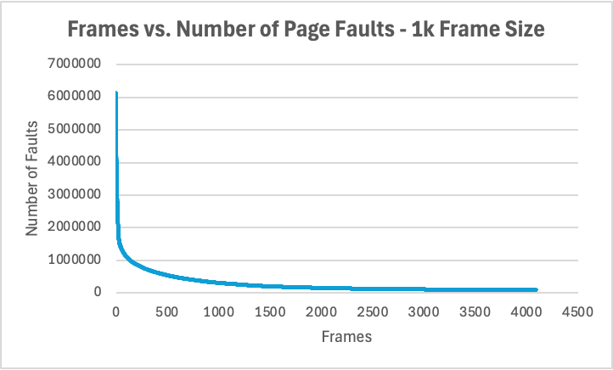
1 KB Frames — Page Faults (1.5 pts)

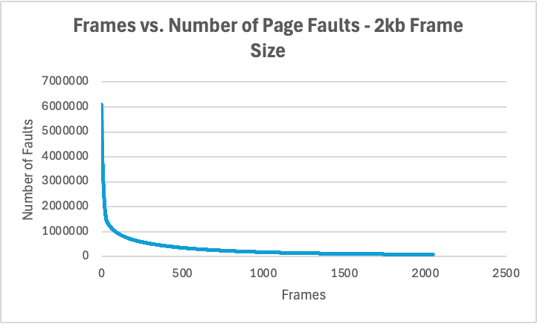
2 KB Frames — Page Faults (1.5 pts)

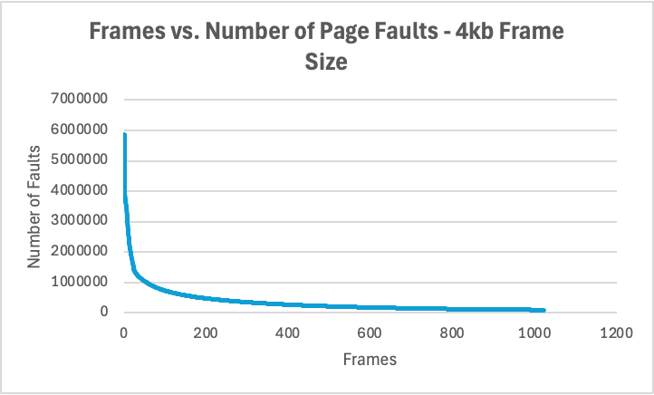
4 KB Frames — Page Faults (1.5 pts)

4. Frames vs. Page-Fault Rate — 4 charts (6 pts)

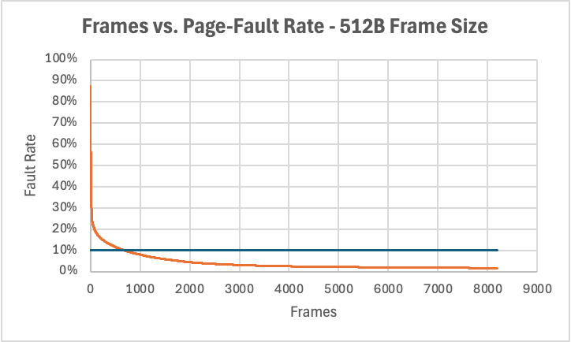
512 B Frames — Fault Rate (1.5 pts)

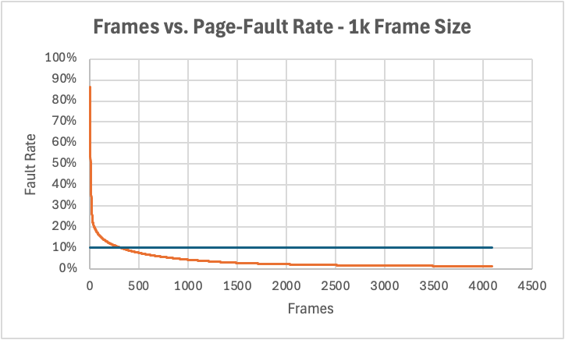
1 KB Frames — Fault Rate (1.5 pts)

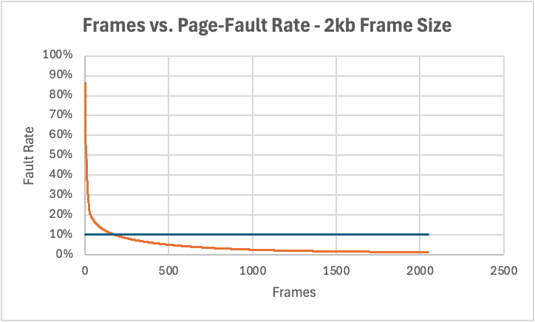
2 KB Frames — Fault Rate (1.5 pts)

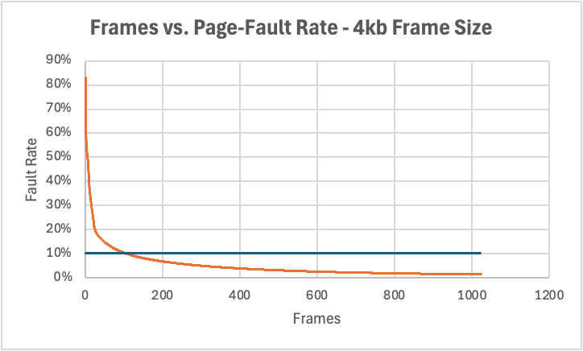
4 KB Frames — Fault Rate (1.5 pts)

5. Curve Shape and Working Set Analysis (5 pts)
The fault rate curve in these charts acts similarly to a negative fractional power function, dropping quickly initially and then rapidly flattening. Each chart has a point, similar to an inflection point, where the rate of decrease rapidly levels out - the slope never becomes negative so it’s not a true inflection point, but the effect is similar. This point gives an indication as to the size of the working set; it is the point at which the optimal working set is nearly entirely stored within the resident pages. At this point, adding additional frames produces a diminishing return because additional pages are rarely or never accessed. The chart does keep approaching 0, as eventually there are enough frames to hold every single accessed page.

6. Frame Size and Fault Rate Tradeoffs (5 pts)
Increasing frame size reduces the number of distinct pages, which can lead to greater efficiency. However, it also increases internal fragmentation, as pages are more likely to take up more space than necessary, leading to wasted internal space. Data usage was estimated by multiplying frame size by minimum frames to reach 10%. This metric is smallest for 1KB frame size, and highest for 4KB frame size, indicating that increasing frame size past 1KB point quickly leads to higher wasted memory through internal fragmentation. Therefore, the data supports a preference for frame sizes on the smaller end.

