PEX3 Analysis Report: LRU Page Replacement Simulation
CS 483 — Operating Systems — Spring 2026
Name: Peter Ye Section: M3 Date: 23 April

Documentation Statement
I received no outside help on the report portion of this assignment.

1. Optimum Frame Size Recommendation (4 pts)
The best choice would be to use the 1KB frame size with 318 frames. This is since the page fault rate is below 10% while also being most efficient in memory use compared to the other frame to memory ratios.

2. Frames Required to Achieve < 10% Page-Fault Rate (4 pts)
For each frame size, identify the minimum number of frames where the page-fault rate first drops below 10%.
Frame Size | Min Frames for < 10% | Fault Rate at That Count
512 B | 689 | 9.9996%
1 KB | 318 | 9.9937%
2 KB | 179 | 9.9777%
4 KB | 106 | 9.9938%

3. Frames vs. Number of Page Faults — 4 charts (6 pts)
Insert one chart per frame size showing Frames (x-axis) vs. Number of Page Faults (y-axis). Each chart must have a descriptive title, labeled axes with units, and clean formatting. (1.5 pts per chart)

512 B Frames — Page Faults (1.5 pts)
[Insert 512 B Page Faults chart here]
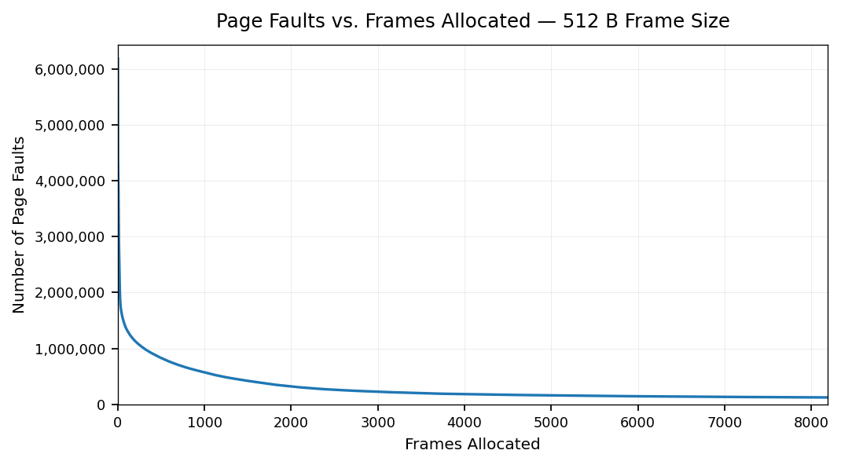

1 KB Frames — Page Faults (1.5 pts)
[Insert 1 KB Page Faults chart here]
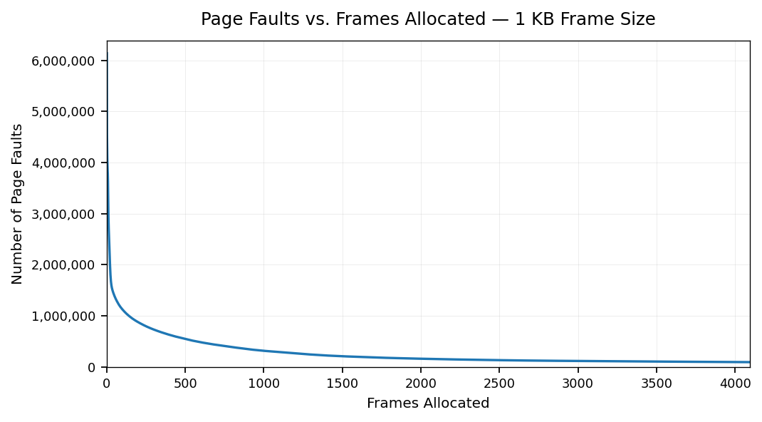

2 KB Frames — Page Faults (1.5 pts)
[Insert 2 KB Page Faults chart here]
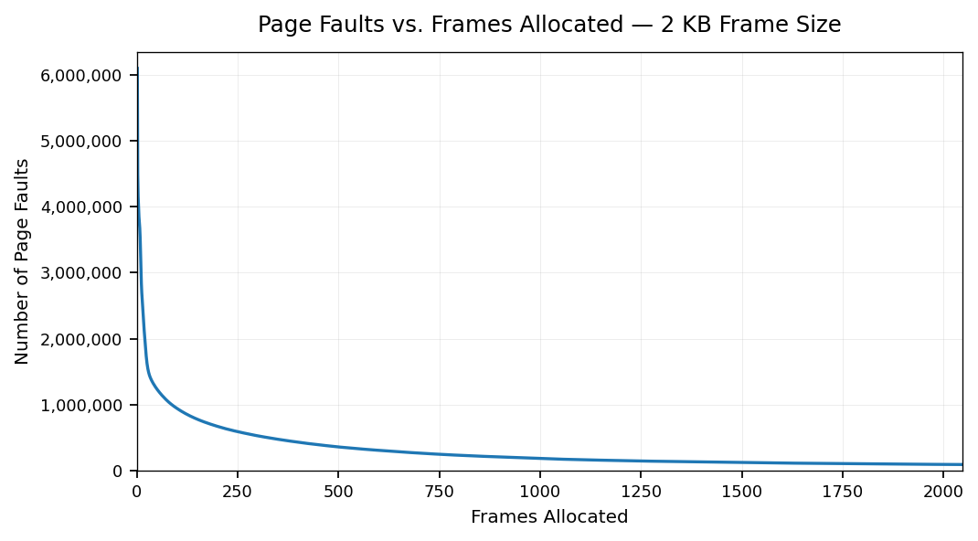

4 KB Frames — Page Faults (1.5 pts)
[Insert 4 KB Page Faults chart here]
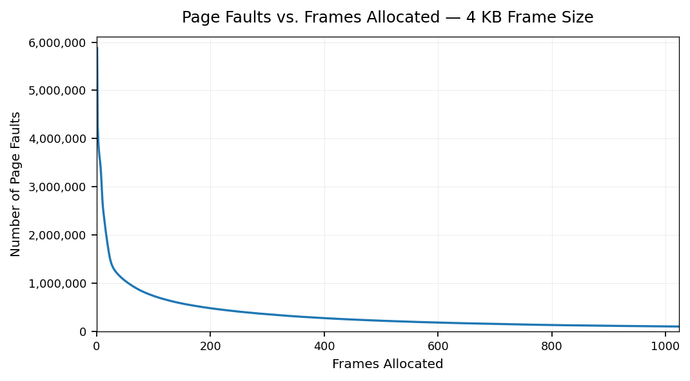

4. Frames vs. Page-Fault Rate — 4 charts (6 pts)
Insert one chart per frame size showing Frames (x-axis) vs. Page-Fault Rate (y-axis). Each chart must include a horizontal reference line at 10% fault rate, descriptive title, and labeled axes. (1.5 pts per chart)

512 B Frames — Fault Rate (1.5 pts)
[Insert 512 B Fault Rate chart here — include 10% reference line]
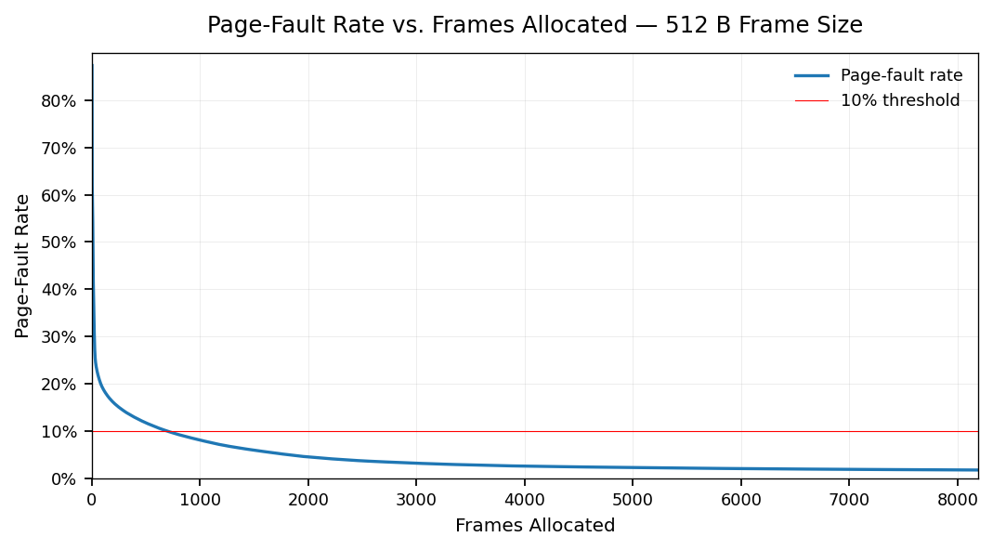

1 KB Frames — Fault Rate (1.5 pts)
[Insert 1 KB Fault Rate chart here — include 10% reference line]
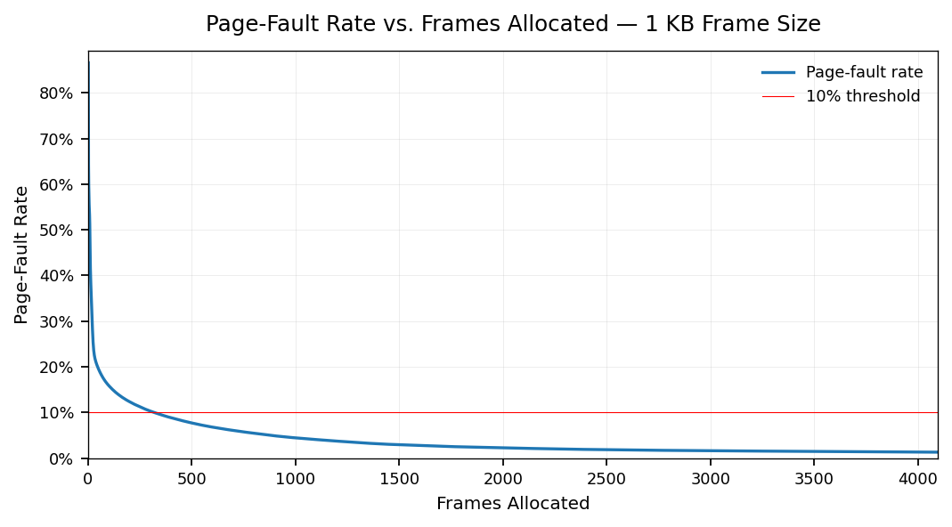

2 KB Frames — Fault Rate (1.5 pts)
[Insert 2 KB Fault Rate chart here — include 10% reference line]
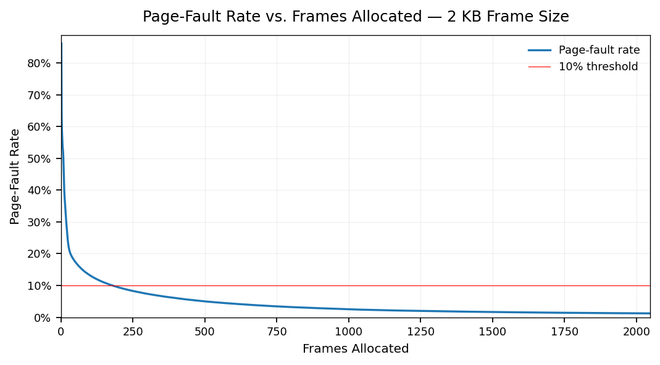

4 KB Frames — Fault Rate (1.5 pts)
[Insert 4 KB Fault Rate chart here — include 10% reference line]
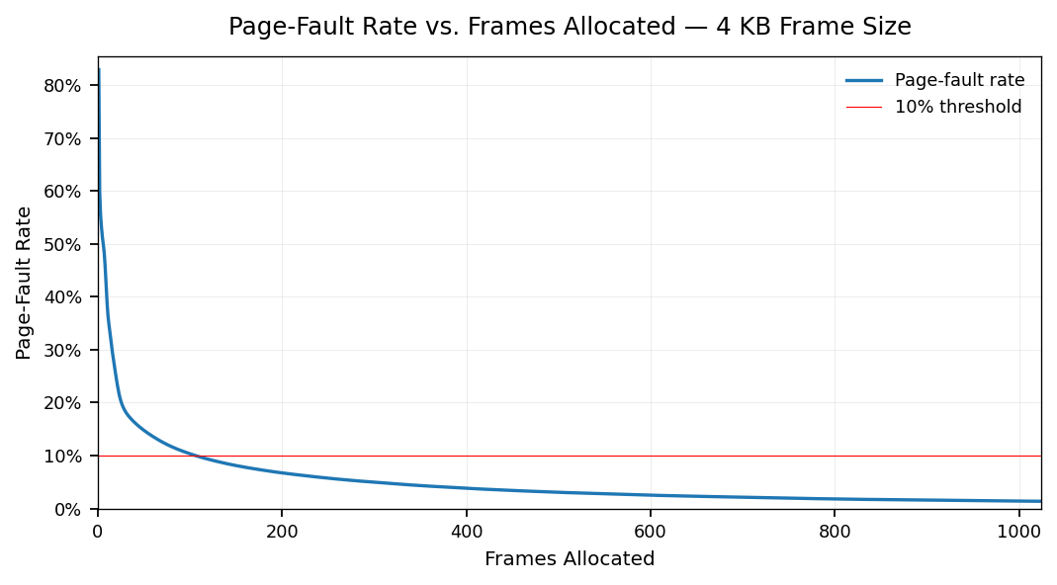

5. Curve Shape and Working Set Analysis (5 pts)
Each curve starts with a steep drop before flattening out at about the 10% threshold. As the process has more space to keep pages open in memory, the less loading and reloading occurs. The flattening and inflection point show the approximate working set size of the process, after which additional frames do not provide much benefit. This diminishing return visualizes how having more frames only provides so much more efficiency.

6. Frame Size and Fault Rate Tradeoffs (5 pts)
Generally, larger frames reduce the number of page faults as each frame can hold more and more data, reducing the number of times switching occurs. In the data, larger frames can hit the 10% threshold faster as they can store more data from the working set. However, internal fragmentation becomes a greater issue as the frames get larger as unused space becomes an issue. This is less of a problem with smaller frames as they tend to be more full, but the trade off becomes sheer number of frames. This data supports a preference for a middle ground of a 1KB frame which shows that the optimal solution is neither the largest or smallest frame.

