PEX3 Analysis Report: LRU Page Replacement Simulation
CS 483 — Operating Systems — Spring 2026
Name: _________Gavin Smith _______________ Section: ___M3_____ Date: ________23 APR 2026____

Documentation Statement
[Replace this text with your documentation statement per the course syllabus. List all help received, references consulted, and AI tools used. A documentation statement is also required in main.c. Missing documentation from either location results in a 5% (4 pt) deduction.]
C2C Tanner Woodring and I discussed excel issues and how to fix them. He also verified the correct setup of my graphs.

1. Optimum Frame Size Recommendation (4 pts)
[State which frame size and how many frames you recommend to keep the page-fault rate below 10%. Justify your recommendation using your simulation data. Consider both memory overhead and fault-rate performance.]
The optimum Frame size is 1 KB. 1KB frame size requires a minimum of 318 frames to achieve <10% fault-rate. At 318 frames, 1KB frame size has a rate of 0.099937 which ranks 3rd out of 4 for fault rates, however it only requires a 318KB of memory overhead, whereas 424KB or 352.768KB for either of the two. Only increasing the fault rate by a small fraction if taken for multiple KBs.

2. Frames Required to Achieve < 10% Page-Fault Rate (4 pts)
For each frame size, identify the minimum number of frames where the page-fault rate first drops below 10%.
Frame Size | Min Frames for < 10% | Fault Rate at That Count
512 B | 689 | 0.09996
1 KB | 318 | 0.099937
2 KB | 179 | 0.099777
4 KB | 106 | 0.099938

3. Frames vs. Number of Page Faults — 4 charts (6 pts)
Insert one chart per frame size showing Frames (x-axis) vs. Number of Page Faults (y-axis). Each chart must have a descriptive title, labeled axes with units, and clean formatting. (1.5 pts per chart)

512 B Frames — Page Faults (1.5 pts)
[Insert 512 B Page Faults chart here]

1 KB Frames — Page Faults (1.5 pts)
[Insert 1 KB Page Faults chart here]

2 KB Frames — Page Faults (1.5 pts)
[Insert 2 KB Page Faults chart here]

4 KB Frames — Page Faults (1.5 pts)
[Insert 4 KB Page Faults chart here]

4. Frames vs. Page-Fault Rate — 4 charts (6 pts)
Insert one chart per frame size showing Frames (x-axis) vs. Page-Fault Rate (y-axis). Each chart must include a horizontal reference line at 10% fault rate, descriptive title, and labeled axes. (1.5 pts per chart)

512 B Frames — Fault Rate (1.5 pts)
[Insert 512 B Fault Rate chart here — include 10% reference line]
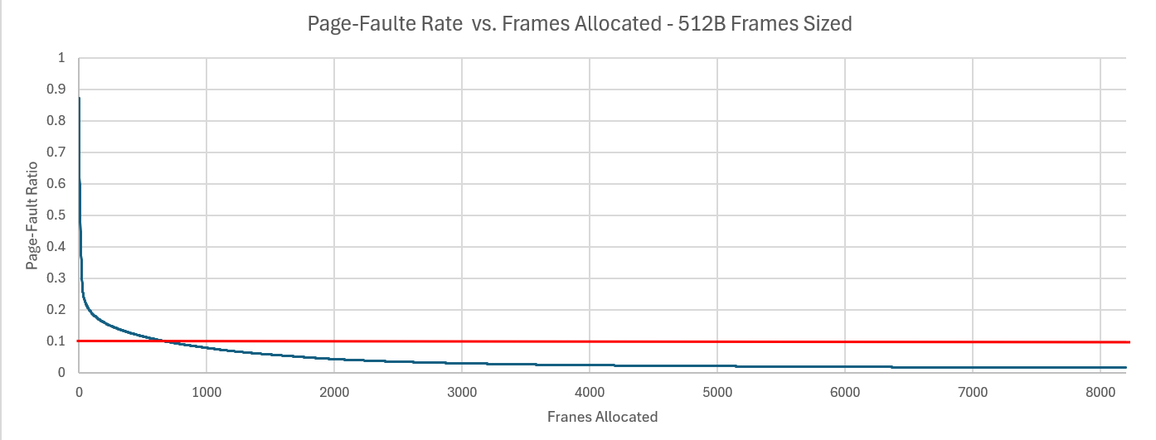

1 KB Frames — Fault Rate (1.5 pts)
[Insert 1 KB Fault Rate chart here — include 10% reference line]
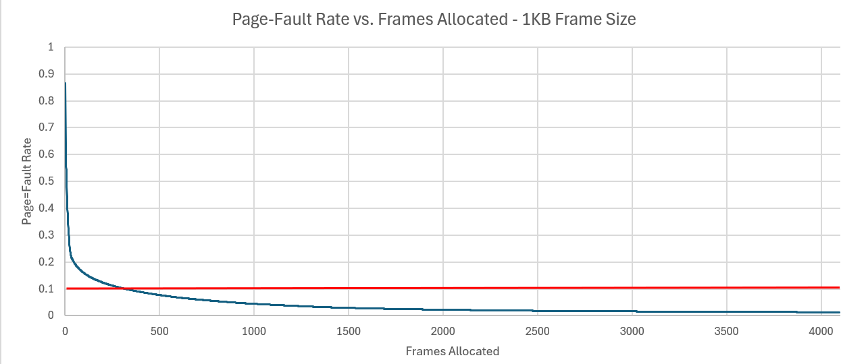

2 KB Frames — Fault Rate (1.5 pts)
[Insert 2 KB Fault Rate chart here — include 10% reference line]
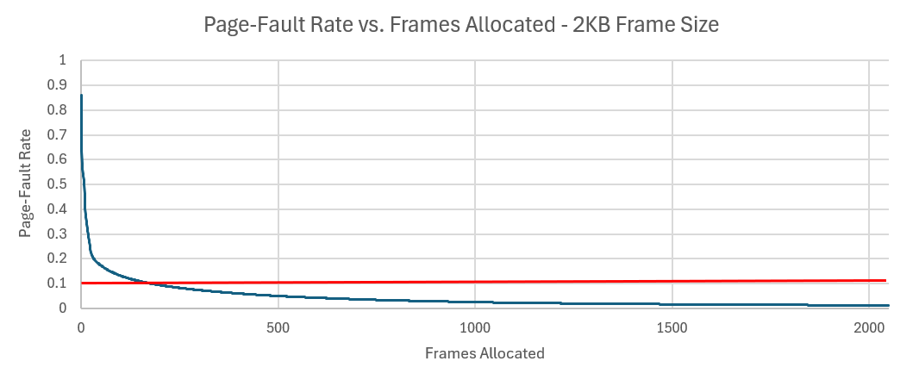

4 KB Frames — Fault Rate (1.5 pts)
[Insert 4 KB Fault Rate chart here — include 10% reference line]
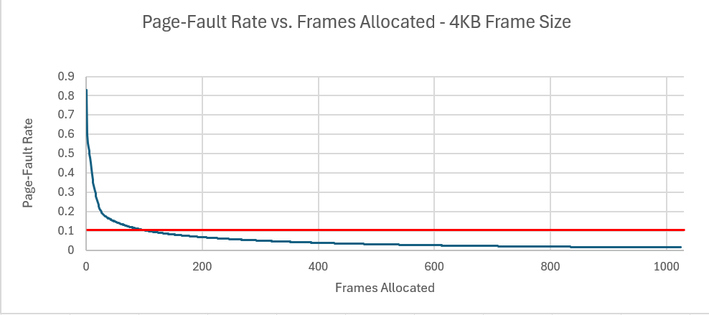

5. Curve Shape and Working Set Analysis (5 pts)
[Describe the shape of your fault-rate curves. Note the steep initial drop followed by flattening. Where does the inflection point occur for each frame size? What does the inflection point tell you about the process's working set size? Discuss any other interesting features you observe in the graphs.]
The inflection point for each frame size occurs around the .20 rate. Meaning the working set size of the process is around 26-81 frames depending on the frame size. It is interesting that there is such a steep decline into a flat clearing among each of the graphs showing that the LRU algorithm is capable of finding the optimum number of frames for a process by using the one-time pass.

6. Frame Size and Fault Rate Tradeoffs (5 pts)
[Discuss how larger frames reduce the number of distinct pages but increase internal fragmentation. Does your data support a preference for larger or smaller frames? What is the tradeoff between fewer faults (larger frames) and wasted memory (internal fragmentation)?]
Larger frames reduce the number of distinct pages because they allow for more storage in each page/frame however, when a frame is not used to compacity or if the page cannot fit inside the rest of the frame, then there is more room for internal fragmentation inside each frame. The data supports larger frame size showing that only 106 frames is needed for 0.099938 on 4KB frame size. However, there is a lot more memory overhead for larger frame size, of which will have more internal fragmentation then that of lower frame sizes. Hence, the 2KB frame size is the optimum choice.

