PEX3 Analysis Report: LRU Page Replacement Simulation
CS 483 — Operating Systems — Spring 2026
Name: Ray Soldini Section: M4 Date: 4/15/2026

Documentation Statement

Used this website for using calloc: https://www.tutorialspoint.com/c_standard_library/c_function_calloc.htm.

Used this for troubleshooting the debugger: https://www.reddit.com/r/vscode/comments/j0n2wi/how_to_pass_arguments_to_c_from_debug/

Used DLL code from CS220

1. Optimum Frame Size Recommendation (4 pts)
From the collected page-fault data across four frame sizes of 512B, 1KB, 2KB, and 4KB, the 1KB frame size produced the smallest total memory space required to achieve a fault rate below 10%, at 316 frames and 323584KB of memory.

2. Frames Required to Achieve < 10% Page-Fault Rate (4 pts)
Frame Size | Min Frames for < 10% | Fault Rate at That Count
512 B | 689 | 0.09996 (708379 faults)
1 KB | 316 | 0.099937 (708216 faults)
2 KB | 179 | 0.099777 (707079 faults)
4 KB | 106 | 0.099938 (708224 faults)

3. Frames vs. Number of Page Faults — 4 charts (6 pts)

512 B Frames — Page Faults (1.5 pts)
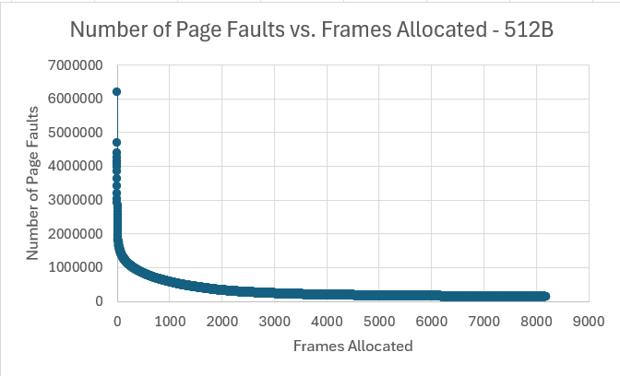

1 KB Frames — Page Faults (1.5 pts)
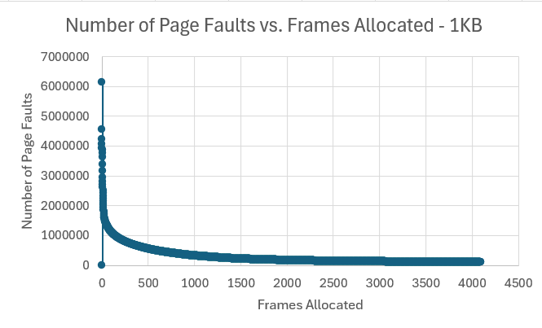

2 KB Frames — Page Faults (1.5 pts)
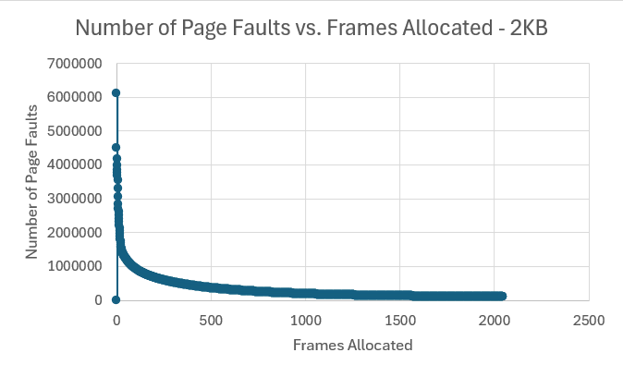

4 KB Frames — Page Faults (1.5 pts)
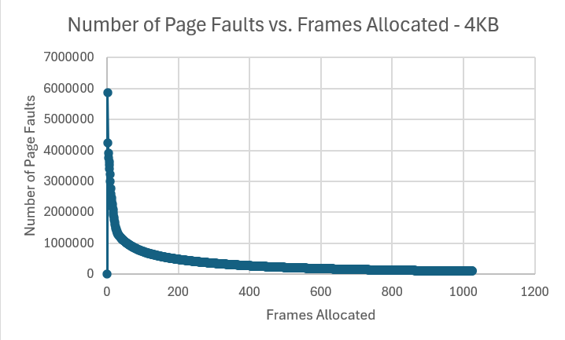

4. Frames vs. Page-Fault Rate — 4 charts (6 pts)

512 B Frames — Fault Rate (1.5 pts)
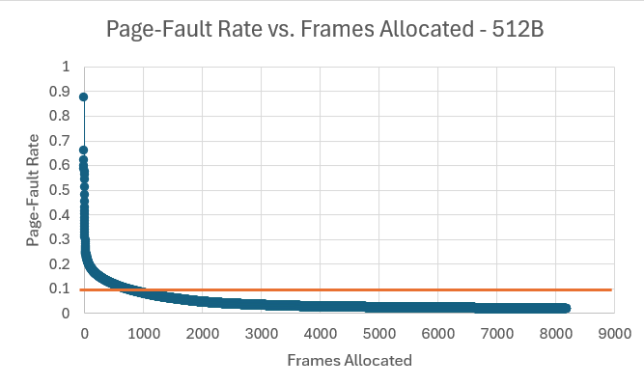

1 KB Frames — Fault Rate (1.5 pts)
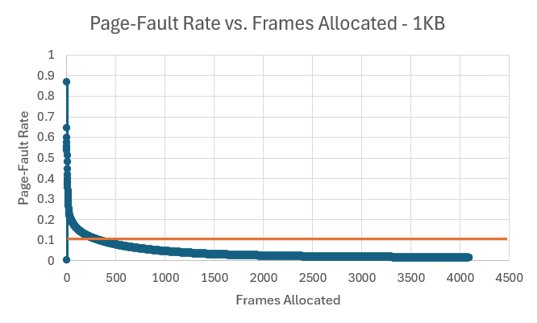

2 KB Frames — Fault Rate (1.5 pts)
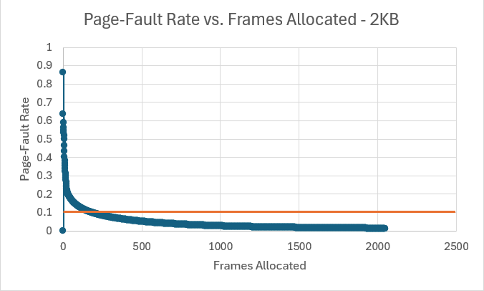

4 KB Frames — Fault Rate (1.5 pts)
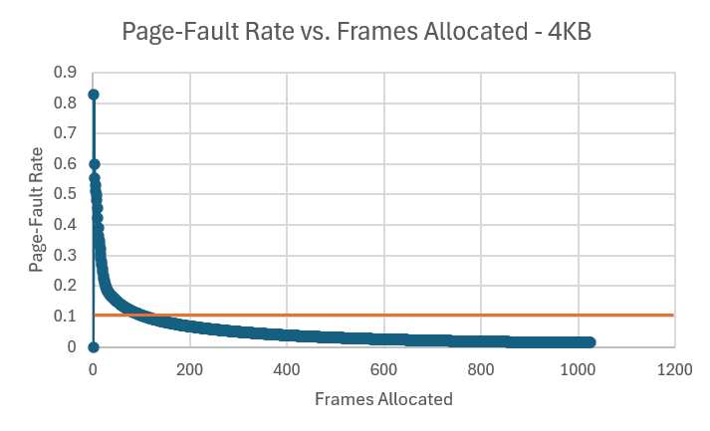

5. Curve Shape and Working Set Analysis (5 pts)
For all four frame sizes, the Page-Fault Rate has an initial sharp drop as the number of frames allocated increases, until around the 10% mark where the curve flattens out. This is because as the number of frames allocated approaches the number of pages that need to be mapped to a frame, there will naturally be a smaller number of page faults. The initial drop-off feature of the graphs represents the range in which having more frames allocated has the most significant effect on the Page-Fault Rate.
As the frame size increases, this inflection point (in terms of number of frames allocated) goes down, decreasing the working set size. This happens because the larger frames can hold more space, so the likelihood of a page hit is much higher with the same number of larger frames than smaller frames.

6. Frame Size and Fault Rate Tradeoffs (5 pts)
When the frame sizes are larger, fault rate is reduced significantly as mentioned above. While this reduces the computational cost associated with each page fault, a larger frame size also leads to internal fragmentation, leading to wasted memory space. According to the page fault data collected, the total space allocated at the minimum number of frames required for less than 10% fault rate is as follows:
Frame Size | Min Frames for < 10% | Total space allocated at min frames (Frame Size x Min Frames)
512 B | 689 | 352768
1 KB | 316 | 323584
2 KB | 179 | 366592
4 KB | 106 | 434176

Due to this, there is a general preference towards smaller frames, with the 1KB frame size being the least amount of space required to achieve a fault rate below 10%, with relatively small variance between 512B and 2KB sizes and a sharper incline for the 4KB frame size.

Grading Rubric (delete this page before submitting)

Point Breakdown (30 pts total)
Component | Points
Optimum Frame Size Recommendation | 4
Frames for < 10% Target Table | 4
Page Fault Charts (4 charts x 1.5 pts) | 6
Fault Rate Charts (4 charts x 1.5 pts) | 6
Curve Shape / Working Set Analysis | 5
Frame Size Tradeoffs | 5
TOTAL | 30

General Deductions (applied at grader discretion)
The following may result in point deductions from any section where the issue appears:
Issue | Deduction | Description
Insufficient technical depth | up to -3 pts | Analysis should reflect understanding of virtual memory, page replacement, and working set concepts — not just restate numbers from the data.
Unprofessional presentation | up to -3 pts | The report should read as a polished technical document suitable for a professional audience. Sloppy formatting, missing chart labels, or inconsistent style will result in deductions.
Spelling and grammar errors | up to -2 pts | Proofread carefully. Use a spell checker. Technical writing demands precision in language as well as content.
Use of first person | up to -2 pts | Do not use "I," "we," "my," or "our." Write from an objective, third-person perspective throughout.
Passive voice | up to -1 pt | Use active voice. Write "LRU reduces the fault rate" rather than "The fault rate is reduced by LRU."
Verbose or unclear writing | up to -2 pts | Be direct and concise. Every sentence should contribute meaningful analysis. Avoid filler, redundancy, and vague statements such as "the results were interesting."

Submission Checklist
- All 8 charts embedded directly in the document (not linked)
- Each chart has a descriptive title (e.g., "Page-Fault Rate vs. Frames — 4KB")
- Axes labeled with units on every chart
- 10% reference line on all 4 fault-rate charts
- Minimum 250 words of written analysis
- No first person; active voice; concise language
- No spelling or grammar errors
- Report stands alone — readable without consulting CSV files
- Documentation statement completed in both main.c and this report
- File saved as .docx and committed to GitHub repo

