PEX3 Analysis Report: LRU Page Replacement Simulation
CS 483 — Operating Systems — Spring 2026
Name: Darshan Kiran Koushik Section: M3 Date: 21 Apr 2026

Documentation Statement

I utilized my own code from PEX3 CS220 to help with writing the doubly linked list along with other given course materials.

1. Optimum Frame Size Recommendation (4 pts)
I recommend 4KB frame size with 106 frames. This is because it gets the page-fault rate below 0.1/10% with the smallest number of frames allocated. This means that with the same fault-rate performance (under 10%), it has the lowest memory overhead.

2. Frames Required to Achieve < 10% Page-Fault Rate (4 pts)
For each frame size, identify the minimum number of frames where the page-fault rate first drops below 10%.
Frame Size | Min Frames for < 10% | Fault Rate at That Count
512 B | 689 | 0.09996
1 KB | 318 | 0.099937
2 KB | 179 | 0.099777
4 KB | 106 | 0.099938

3. Frames vs. Number of Page Faults — 4 charts (6 pts)
Insert one chart per frame size showing Frames (x-axis) vs. Number of Page Faults (y-axis). Each chart must have a descriptive title, labeled axes with units, and clean formatting. (1.5 pts per chart)

512 B Frames — Page Faults (1.5 pts)
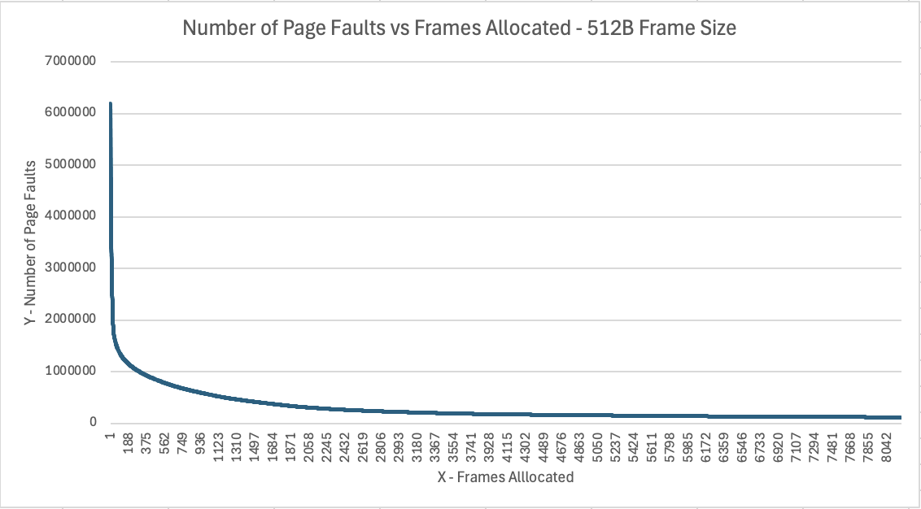

1 KB Frames — Page Faults (1.5 pts)
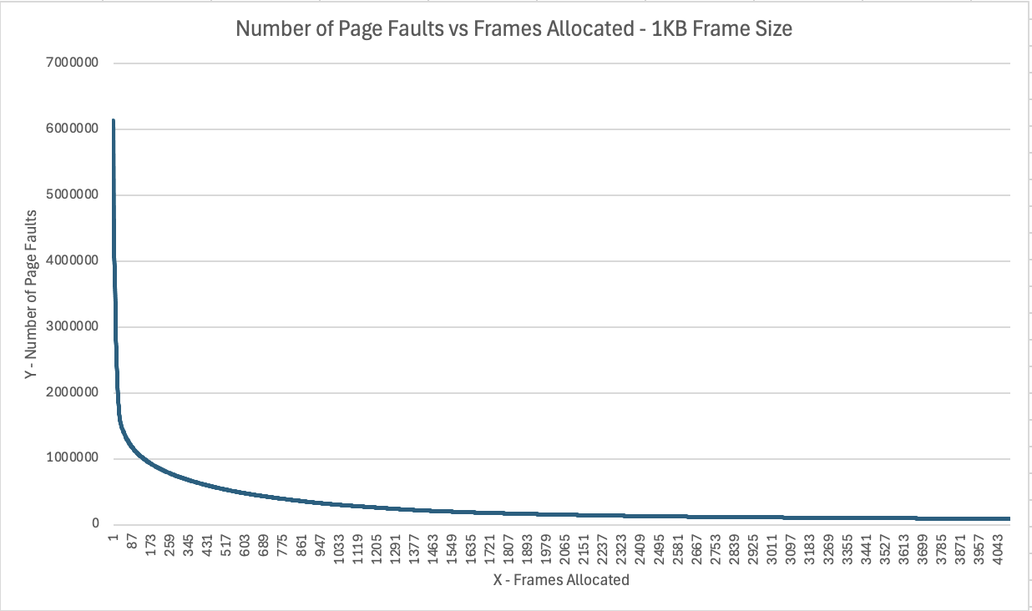

2 KB Frames — Page Faults (1.5 pts)
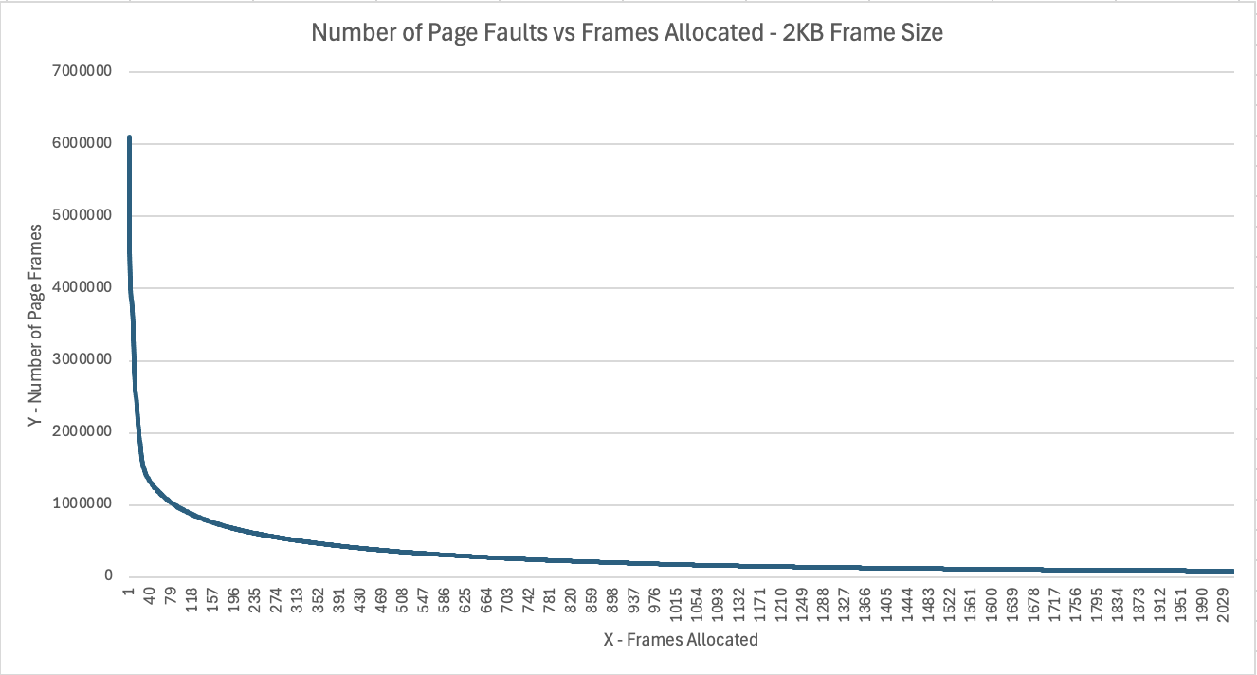

4 KB Frames — Page Faults (1.5 pts)
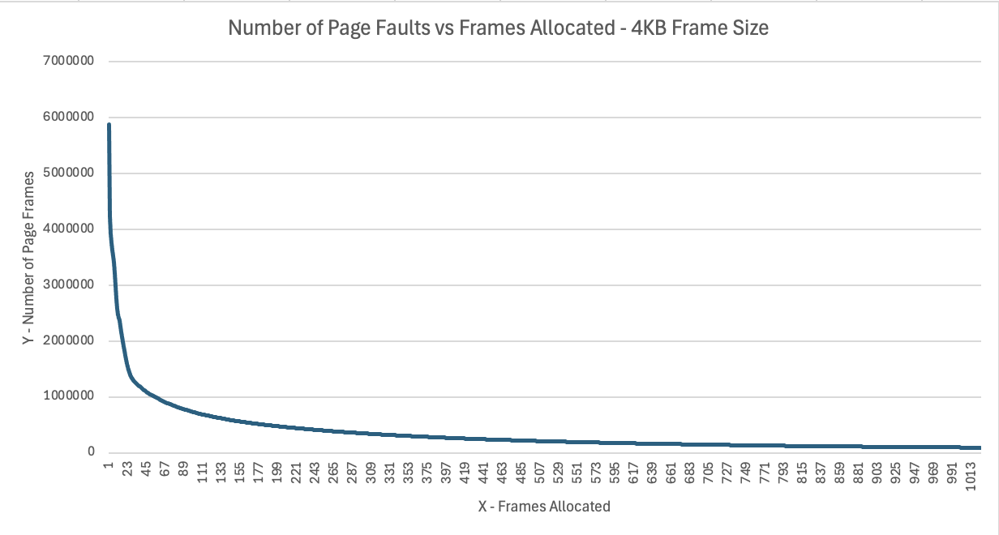

4. Frames vs. Page-Fault Rate — 4 charts (6 pts)
Insert one chart per frame size showing Frames (x-axis) vs. Page-Fault Rate (y-axis). Each chart must include a horizontal reference line at 10% fault rate, descriptive title, and labeled axes. (1.5 pts per chart)

512 B Frames — Fault Rate (1.5 pts)
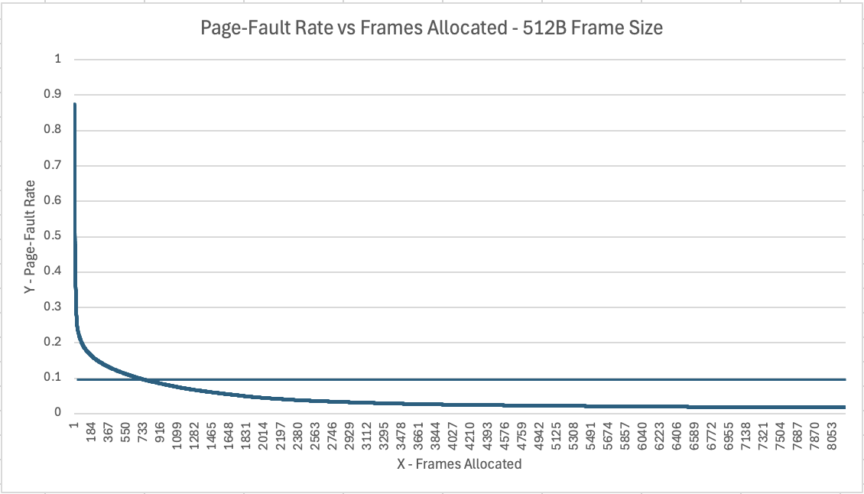

1 KB Frames — Fault Rate (1.5 pts)
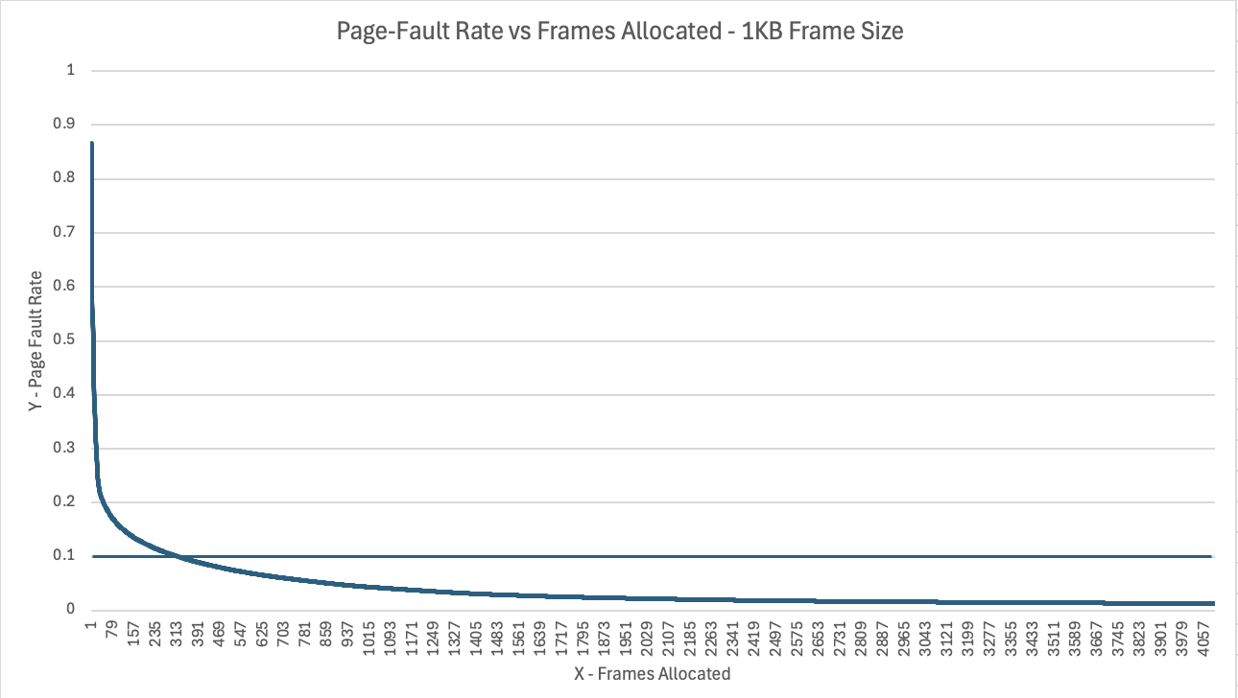

2 KB Frames — Fault Rate (1.5 pts)
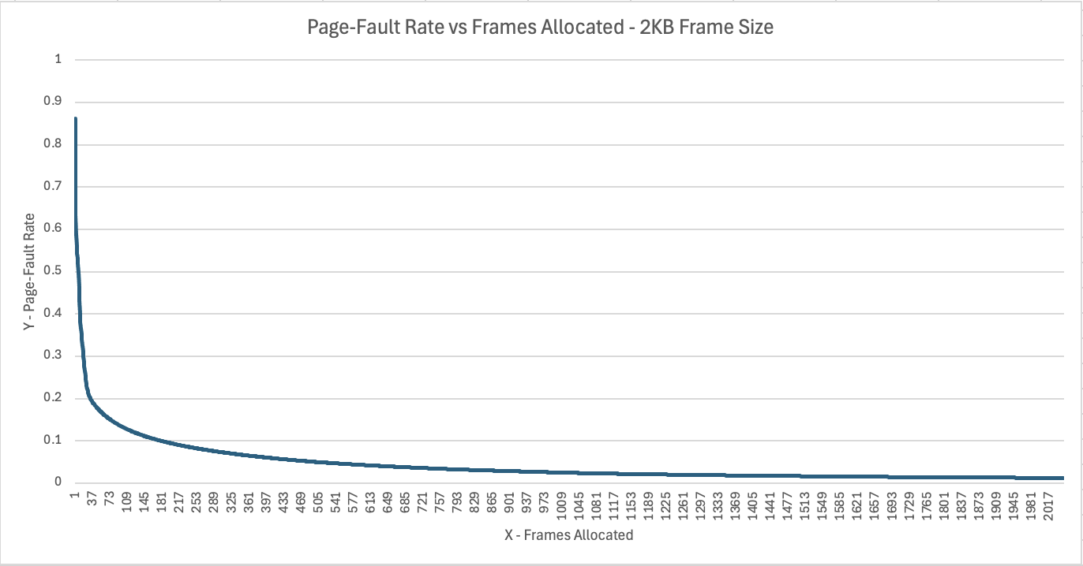

4 KB Frames — Fault Rate (1.5 pts)
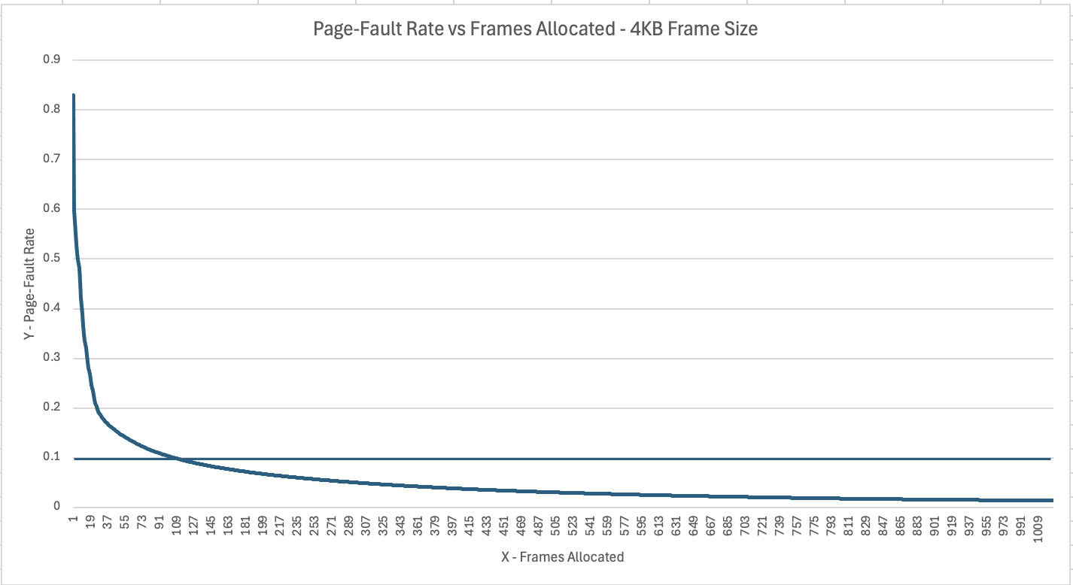

5. Curve Shape and Working Set Analysis (5 pts)
The curves show a steep initial drop followed by flattening. The inflection point for 512B is at 689 frames, for 1KB it is at 318 frames, for 2KB it is at 179 frames, and at 4KB it is at 106 frames. The inflection points tell me the working set size for each frame size. At this point, however, once the process has those frames to hold the working set, the page-fault rate stops dropping so quickly and you see that flattening behavior.

6. Frame Size and Fault Rate Tradeoffs (5 pts)
[Discuss how larger frames reduce the number of distinct pages but increase internal fragmentation. Does your data support a preference for larger or smaller frames? What is the tradeoff between fewer faults (larger frames) and wasted memory (internal fragmentation)?]
The larger frames reduce the number of distinct pages but increase internal fragmentation as if a process doesn’t use every byte within a 4KB page, the unused space is taking up physical memory. My data supports a preference for the larger 4KB frame size, because it reached the required <0.10/10% page-fault rate while needing the fewest frames. In this scenario, for tradeoff, the fewer faults (larger frames) outweighs the wasted memory.

