PEX3 Analysis Report: LRU Page Replacement Simulation
CS 483 — Operating Systems — Spring 2026
Name: Samuel Lavoie Section: M4 Date: 04/23/2026

Documentation Statement
Used https://www.geeksforgeeks.org/dsa/program-for-least-recently-used-lru-page-replacement-algorithm/ to help with understanding the algorithm. Used https://www.cs.csustan.edu/~john/Classes/CS3750/Notes/Chap10/10_VirtualMemory.html and https://www.cs.cornell.edu/courses/cs4410/2021fa/assets/material/lecture16_memory_management_5.pdf to help understand the tradeoffs of different frame sizes.

1. Optimum Frame Size Recommendation (4 pts)
A frame size of 1kb allocated over 318 frames would be the best solution in this case. The four frame sizes reach the 10% threshold at the following total memory allocations: 512 B x 689 frames = 344.5 KB; 1 KB x 318 frames = 318.0 KB; 2 KB x 179 frames = 358.0 KB; and 4 KB x 106 frames = 424.0 KB. The 1 KB configuration reaches the target using 26.5 KB less memory than 512 B frames, 40 KB less than 2 KB frames, and 106 KB less than 4 KB frames. First, 512 B frames subdivide the working set into too many distinct page numbers, inflating the number of compulsory misses and forcing more frames. The 4kb frames are too big for this problem. The frame could possibly cover memory that is only partially referenced. This wastes allocation capacity on unused bytes. The 1kb frame balances the two extremes.

2. Frames Required to Achieve < 10% Page-Fault Rate (4 pts)
For each frame size, identify the minimum number of frames where the page-fault rate first drops below 10%.
Frame Size | Min Frames for < 10% | Fault Rate at That Count
512 B | 689 | 0.099960
1 KB | 318 | 0.099937
2 KB | 179 | 0.099777
4 KB | 106 | 0.099938

3. Frames vs. Number of Page Faults — 4 charts (6 pts)
Insert one chart per frame size showing Frames (x-axis) vs. Number of Page Faults (y-axis). Each chart must have a descriptive title, labeled axes with units, and clean formatting. (1.5 pts per chart)

512 B Frames — Page Faults (1.5 pts)
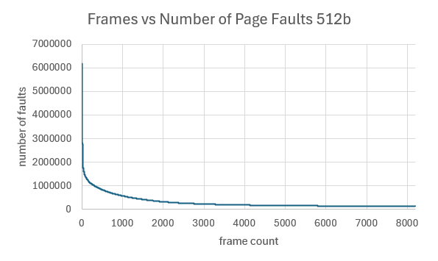

1 KB Frames — Page Faults (1.5 pts)
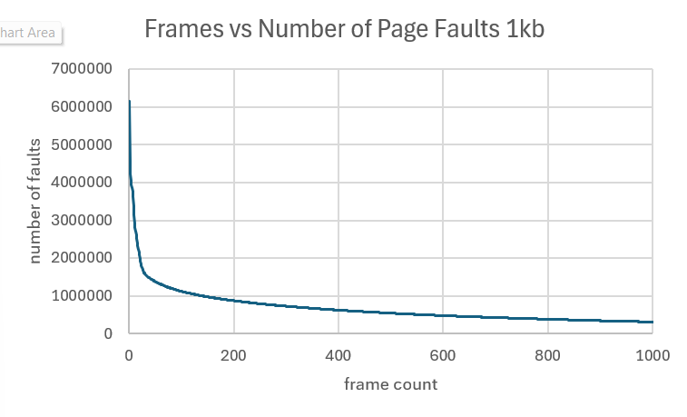

2 KB Frames — Page Faults (1.5 pts)
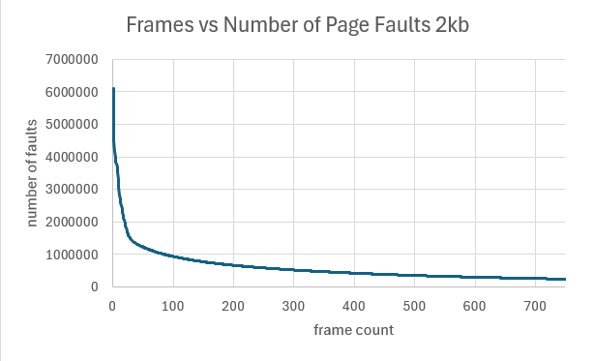

4 KB Frames — Page Faults (1.5 pts)
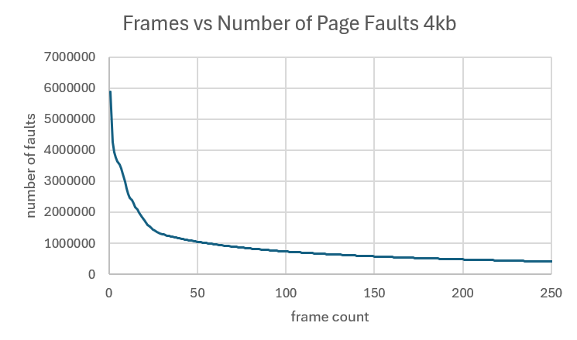

4. Frames vs. Page-Fault Rate — 4 charts (6 pts)
Insert one chart per frame size showing Frames (x-axis) vs. Page-Fault Rate (y-axis). Each chart must include a horizontal reference line at 10% fault rate, descriptive title, and labeled axes. (1.5 pts per chart)

512 B Frames — Fault Rate (1.5 pts)
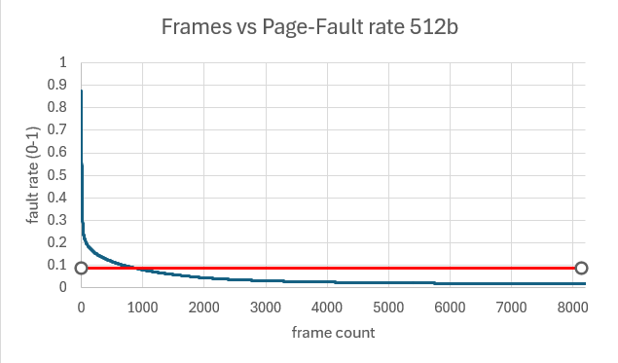

1 KB Frames — Fault Rate (1.5 pts)
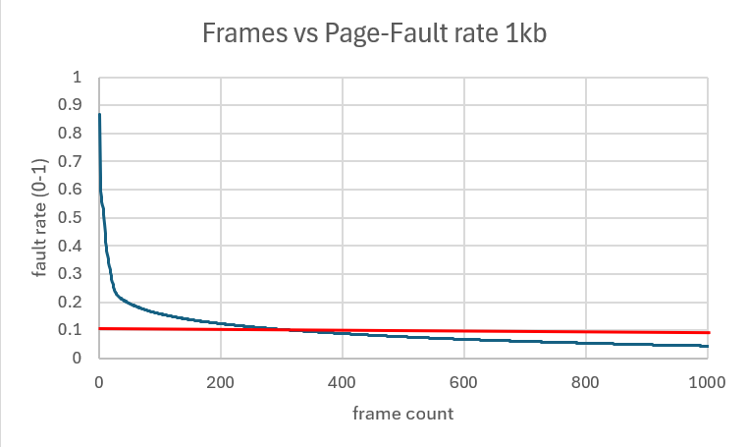

2 KB Frames — Fault Rate (1.5 pts)
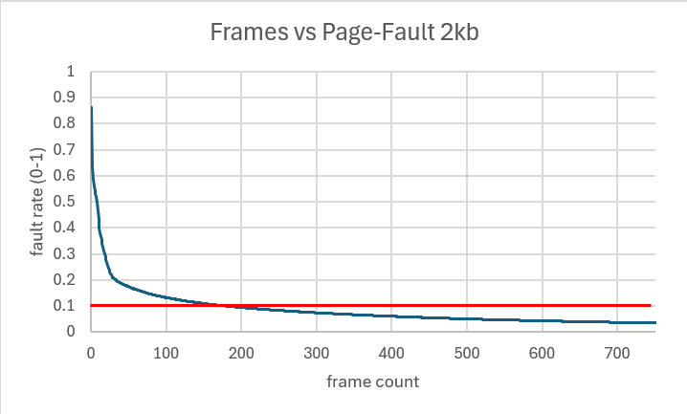

4 KB Frames — Fault Rate (1.5 pts)
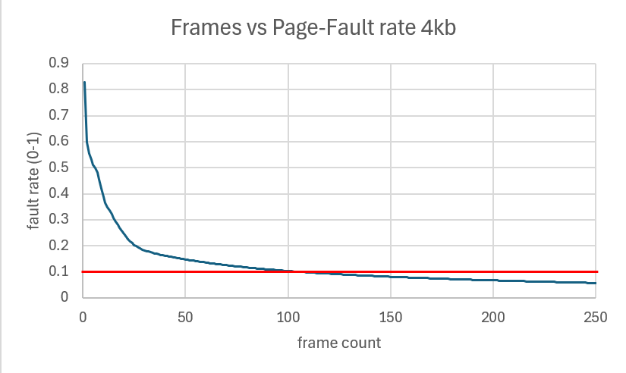

5. Curve Shape and Working Set Analysis (5 pts)

All four fault-rate curves share the same characteristic shape, which is a steep initial drop across the first few hundred frames, a distinct knee, and a long, slowly flattening tail that approaches a floor. At one frame, the fault rate sits between 0.829 and 0.873 depending on frame size, meaning every reference misses. The rate then falls rapidly as the first handful of frames capture the most heavily reused pages. The inflection point where the curve transitions from steep decline to gradual improvement falls in a narrow memory range across all four frame sizes. The knee consistently lands near 235-315 KB of total memory regardless of frame size. Beyond the knee, the curves flatten dramatically. Going from 1024 frames to 3072 frames at the 1 KB size only reduces the fault rate from 0.043 to 0.016. This means that tripling the memory allocation yields less than a 3-percentage-point improvement. This may mean that the first reference to any distinct page must fault regardless of allocation size.

6. Frame Size and Fault Rate Tradeoffs (5 pts)
Frame size influence’s fault rate through two competing mechanisms. Larger frames pack more bytes per page, reducing the total number of distinct pages the process must reference but each allocated frame covers a fixed range regardless of how much of that range is used, producing internal fragmentation that wastes memory on unreferenced bytes. Smaller frames eliminate most fragmentation but multiply the distinct page count, forcing the replacement algorithm to manage a larger working set and increasing misses. The data supports a preference for moderately sized frames in the 1-2 KB range. At every memory budget from 512 KB through 3072 KB, 1 KB frames produce the lowest fault rate. Both extremes underperform because 512 B frames lose consistently due to excessive page-table pressure, while 4 KB frames waste capacity on unreferenced bytes within each frame. That is why it is so critical to choose a frame size that balances the tradeoffs of each extreme.

