PEX3 Analysis Report: LRU Page Replacement Simulation
CS 483 — Operating Systems — Spring 2026
Name: John Rust III Section: M4 Date: 23 April 2026

Documentation Statement
I compared my output graph (like the one in the report) with C1C Watson and they matched. If they did not match, I would have continued to refine my code. No copying occurred and this was within the help policy. I used this website for how to use calloc: https://www.geeksforgeeks.org /c/dynamic-memory-allocation-in-c-using-malloc-calloc-free-and-realloc/.
I utilized Claude to make a python script to make my graphs since it was within the boundaries of AI use per the help policy. I did not use it to analyze the graphs but since the instructions for making a graph were already outlined, I felt that taking that and having Claude make a python script would be the same. The chat I had with Claude (after giving it the help policy) is linked here: https://claude.ai/share/97aac2fd-acd5-46e2-b7d0-7566883b15ce.
No AI was used in the actual coding of main.c or in pagequeue.c. No copying of code from anyone but Jack's previous self-occurred (and it was his Euchre final project in which he made a double linked list prior to even learning about it).
AI was not used to write the paragraph of analysis of this report, and no copying of other’s reports occurred. Google searches were consulted with how to not use passive voice.

1. Optimum Frame Size Recommendation (4 pts)
The optimum frame size with the goal of keeping the page-fault rate below ten percent is the two-kilobyte memory (2 KB) frame size option. Using the LRU simulation, the 2 KB option took 179 frames to achieve a 9.978 percent page fault rate (Table 1). The 2 KB option utilized approximately 358 KB of allocated memory (Equation 1).

$$Total Memory Usage = 2 KB * 179 = 358 KB$$
Equation 1. Example Calculation for Total Memory Usage for 2 KB Option

The criteria for determining the optimum frame size includes the total memory cost of each option, the fragmentation per-frame, and the minimum number of frames to reach below the ten percent criteria. In terms of total memory cost of each option, the 1 KB option utilizes the least amount of allocated memory at 318 KB, the 512-byte (B) option uses 344.5 KB, the 2 KB uses 358 KB, and the 4 KB uses the most at 424 KB. While the 2 KB option ranks third overall, it is only 40 KB away from the minimum usage of the 1 KB option, a 12.6 percent difference. What sets the 2 KB apart from the 1 KB option is that the number of frames required to reach the ten percent standard. The 2 KB takes 179 frames while the 1 KB takes 318 frames (Table 2), a 139-frame difference creating an approximate 44 percent decrease in the required number of frames. The fewer number of frames, the smaller the page lookup table overhead, and the fewer page faults the operating system (OS) has to handle.
Inspecting the 512 B and 4 KB options, both are easily eliminated as optimum candidates. The 512 B option requires 689 frames and the most amount of allocated memory. The 4 KB option uses the fewest frames, at 106, but suffers from memory fragmentation within each page (due to unused portions within the large, allocated memory space) and uses more allocated memory than the 1 KB and 2 KB options.
Thus, the 2 KB option is the middle balance of all four options. It is large enough that spatial locality within a page reduces the fault frequency at a meaningful interval but is not too large that memory fragmentation within the page increases to a significant scale, making the 2 KB option the optimum frame size and the recommendation of this report.

2. Frames Required to Achieve < 10% Page-Fault Rate (4 pts)
Frame Size | Min Frames for < 10% | Fault Rate at That Count
512 B | 689 | 9.996%
1 KB | 318 | 9.994%
2 KB | 179 | 9.978%
4 KB | 106 | 9.994%
Table 1. Frames Required to Achieve <10% Page Fault Rate

3. Frames vs. Number of Page Faults — 4 charts (6 pts)

512 B Frames — Page Faults (1.5 pts)
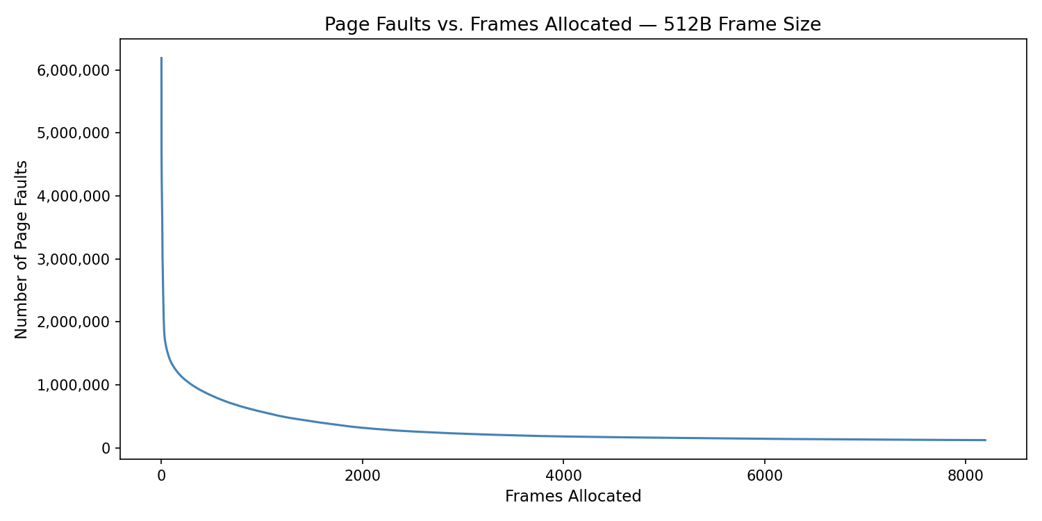
Figure 1. Frames vs Number of Page Faults for 512 Byte Frame

1 KB Frames — Page Faults (1.5 pts)
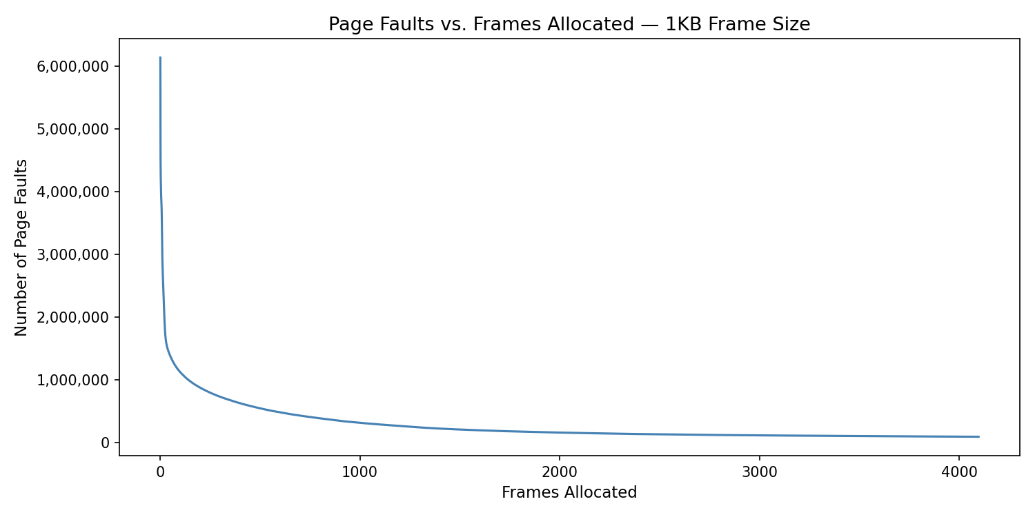
Figure 2. Frames vs Number of Page Faults for 1 K-Byte Frame

2 KB Frames — Page Faults (1.5 pts)
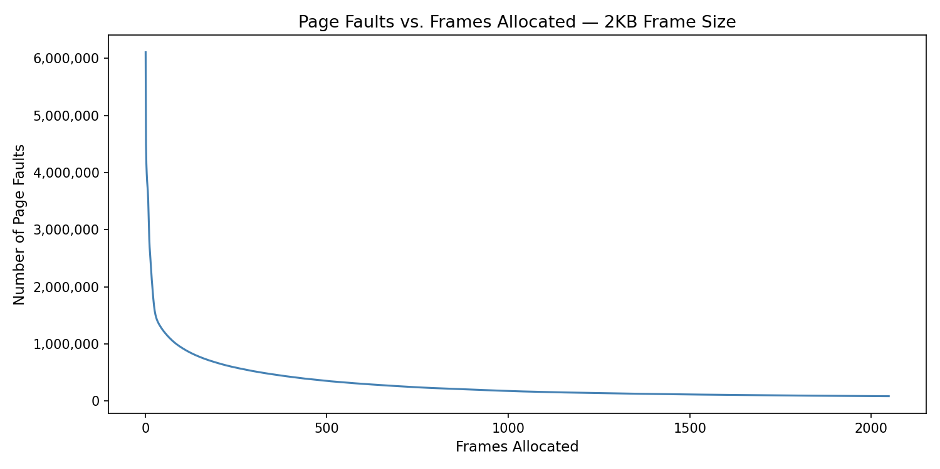
Figure 3. Frames vs Number of Page Faults for 2 K-Byte Frame

4 KB Frames — Page Faults (1.5 pts)
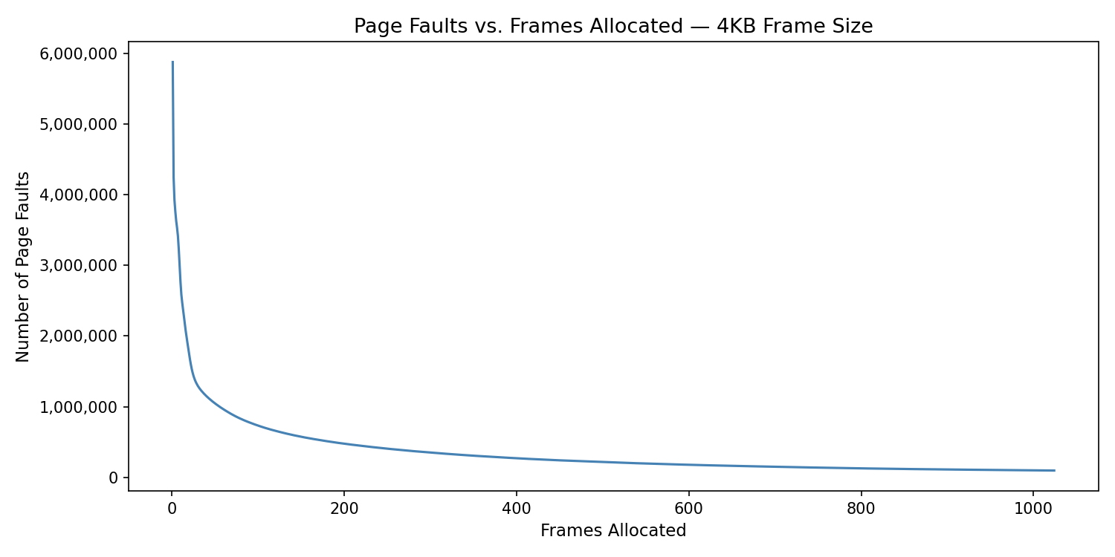
Figure 4. Frames vs Number of Page Faults for 4 K-Byte Frame

4. Frames vs. Page-Fault Rate — 4 charts (6 pts)

512 B Frames — Fault Rate (1.5 pts)
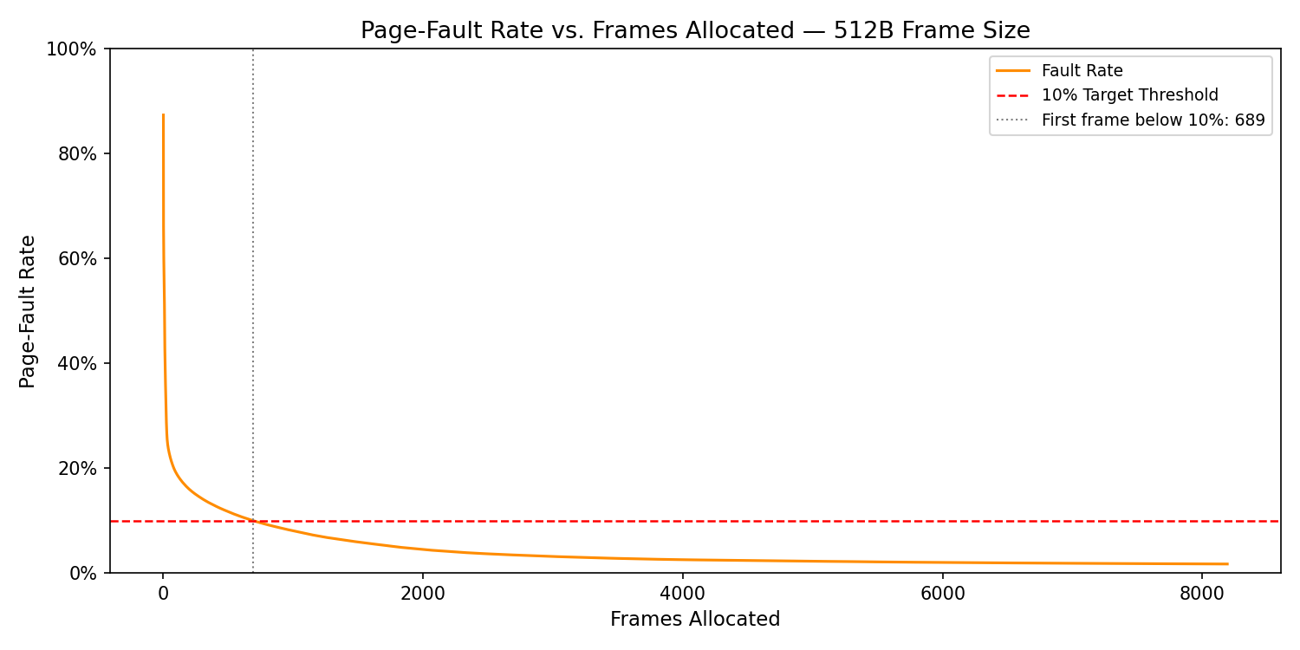
Figure 5. Frames vs Page Fault Rate for 512 Byte Frame

1 KB Frames — Fault Rate (1.5 pts)
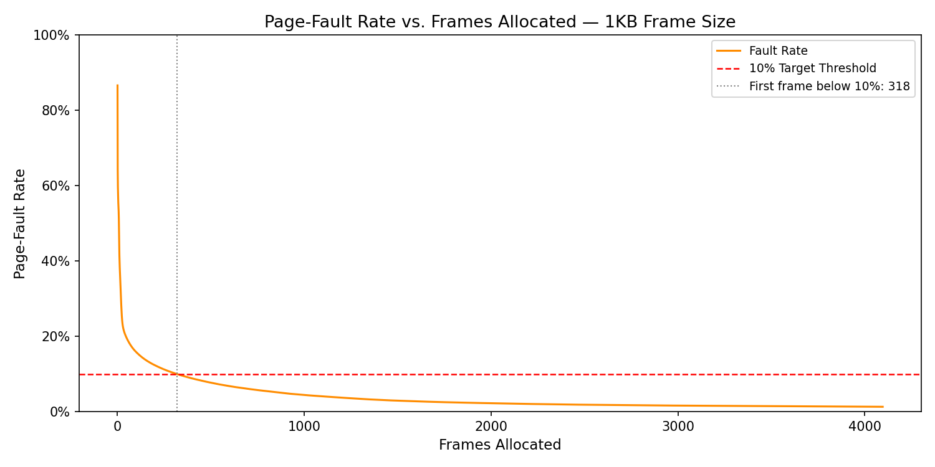
Figure 6. Frames vs Page Fault Rate for 1 K-Byte Frame

2 KB Frames — Fault Rate (1.5 pts)
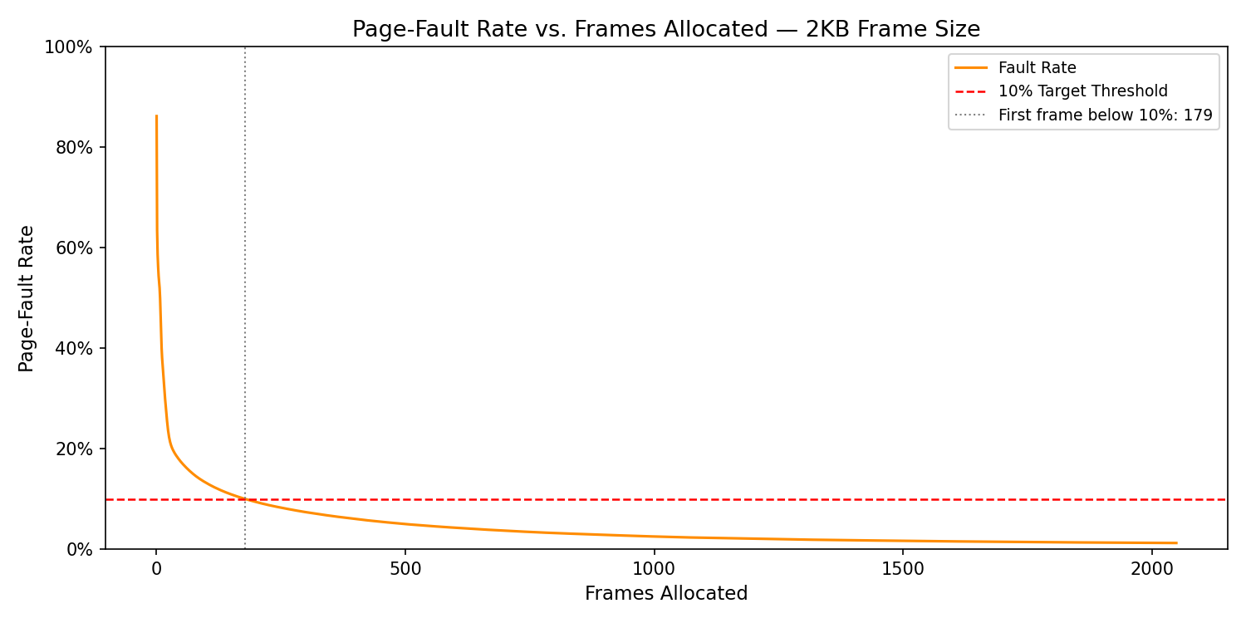
Figure 7. Frames vs Page Fault Rate for 2 K-Byte Frame

4 KB Frames — Fault Rate (1.5 pts)
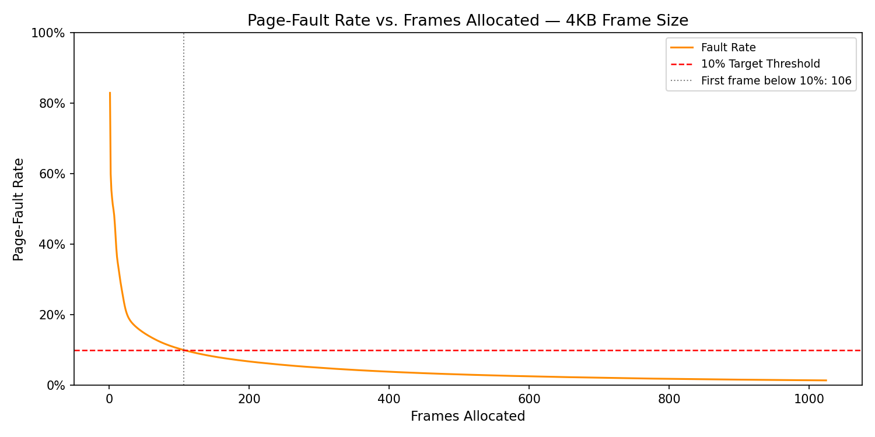
Figure 8. Frames vs Page Fault Rate for 4 K-Byte Frame

5. Curve Shape and Working Set Analysis (5 pts)
All four of the fault curves share the same shape, an initial drop-in fault rate as the number of frames increases followed by a gradual flattening toward a floor value that never reaches zero. The first frames filling up the empty LRU queue cause the initial steep drop with nearly every reference being a miss. As the queue expands over time, the high utilization pages are now within the queue, and the fault rate drops sharply. The elbow in each curve represents the point where the allocated frames in the queue capture the most requested pages. For the 512 B option, the inflection frame is approximately 28 at a 26.20 percent fault rate. For the 1 KB option, the inflection frame is approximately 27 at a 23.59 percent fault rate. For the 2 KB option, the inflection frame is approximately 28 at a 21.35 percent fault rate. Finally, for the 4 KB option, the inflection frame is approximately 27 at a 19.33 percent fault rate. While the inflection frame for each is essentially the same, the fault rate when each occur depicts a trend that supports the optimum frame size recommendation above. The decrease in fault rates at each inflection point supports the spatial locality argument, meaning larger frame sizes meet the ideal point at a lower fault rate with the same number of frames.
An additional interesting feature is that the graphs never reach zero. This occurs because some pages appear only once or so infrequently, guaranteeing a first access miss regardless of memory size.

6. Frame Size and Fault Rate Tradeoffs (5 pts)
Larger frames reduce the number of overall distinct pages because each frame covers more address space, leveraging spatial locality. With fewer distinct pages, there are fewer unique entries in the LRU queue, reducing the fault frequency (Table 1). However, larger frame sizes increase internal fragmentation because processes rarely utilize the full frame, leaving portions of each individual frame wasted and unused. The simulation data demonstrates how the 4 KB option uses the most amount of total allocated memory despite needing the fewest frames, reflecting the fragmentation cost of the option. Smaller frames minimize the wasted space in each frame but require significantly more frames, increasing the page table size and the OS load. The LRU simulation data supports a middle ground option, such as 2 KB or 1 KB, where fragmentation remains manageable and frame count stays within an acceptable range. Neither of the extreme options, 512 B or 4 KB, balances the use of allocated memory and the fault rate performance required by this simulation.

