PEX3 Analysis Report: LRU Page Replacement Simulation
CS 483 — Operating Systems — Spring 2026
Name: mark alano Section: m3 Date: 24 apr 2026
Documentation Statement
Citations are on site plus my Claude log https://claude.ai/share/8d1c9cbe-3e87-484e-bf4b-20fe55826e31
1. Optimum Frame Size Recommendation (4 pts)
4k achieves < 10% at 380 frames, which is the earliest out of the 4. The next best is 2k at 685, a 55.474% later achievement. If resources are tight, go with the 2k, otherwise, 4k is the recommendation. The other two end up in the thousands, a significant jump.
2. Frames Required to Achieve < 10% Page-Fault Rate (4 pts)
For each frame size, identify the minimum number of frames where the page-fault rate first drops below 10%.
Frame Size | Min Frames for < 10% | Fault Rate at That Count
512 B | 2974 | 0.09999
1 KB | 1319 | 0.099995
2 KB | 685 | 0.099946
4 KB | 380 | 0.099904
3. Frames vs. Number of Page Faults — 4 charts (6 pts)
Insert one chart per frame size showing Frames (x-axis) vs. Number of Page Faults (y-axis). Each chart must have a descriptive title, labeled axes with units, and clean formatting. (1.5 pts per chart)
512 B Frames — Page Faults (1.5 pts)
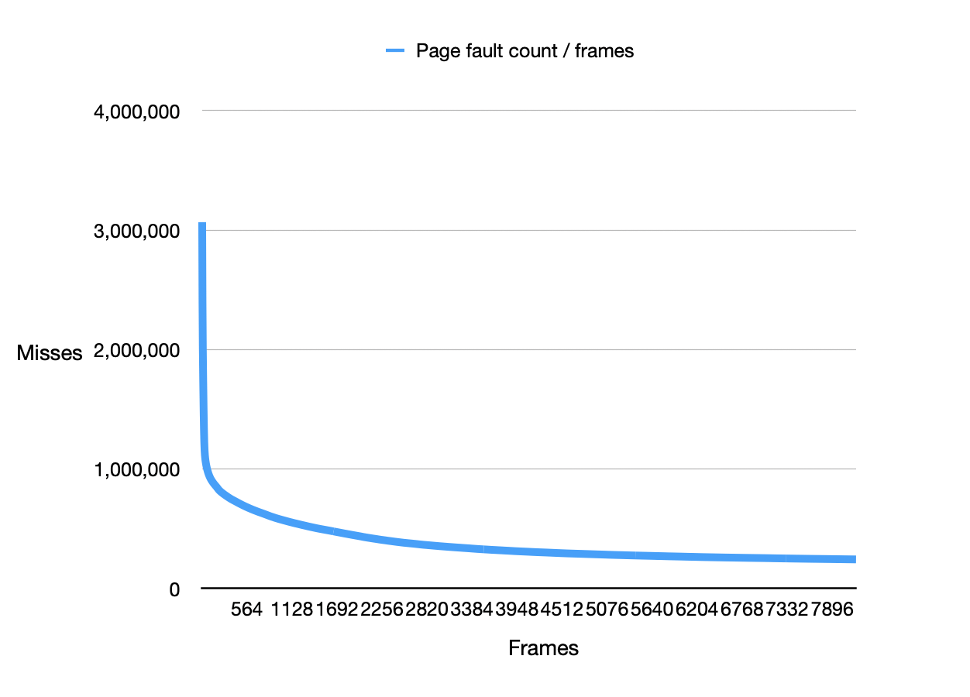
1 KB Frames — Page Faults (1.5 pts)
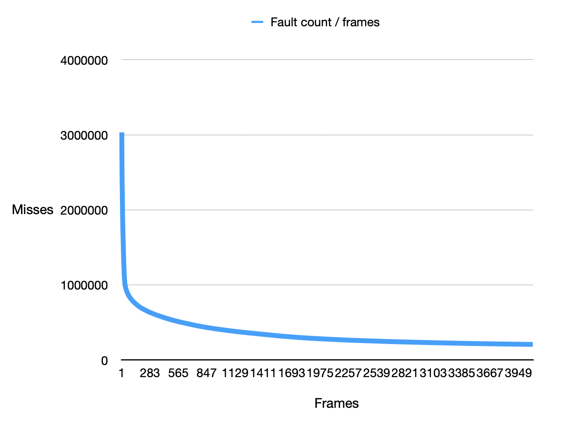
2 KB Frames — Page Faults (1.5 pts)
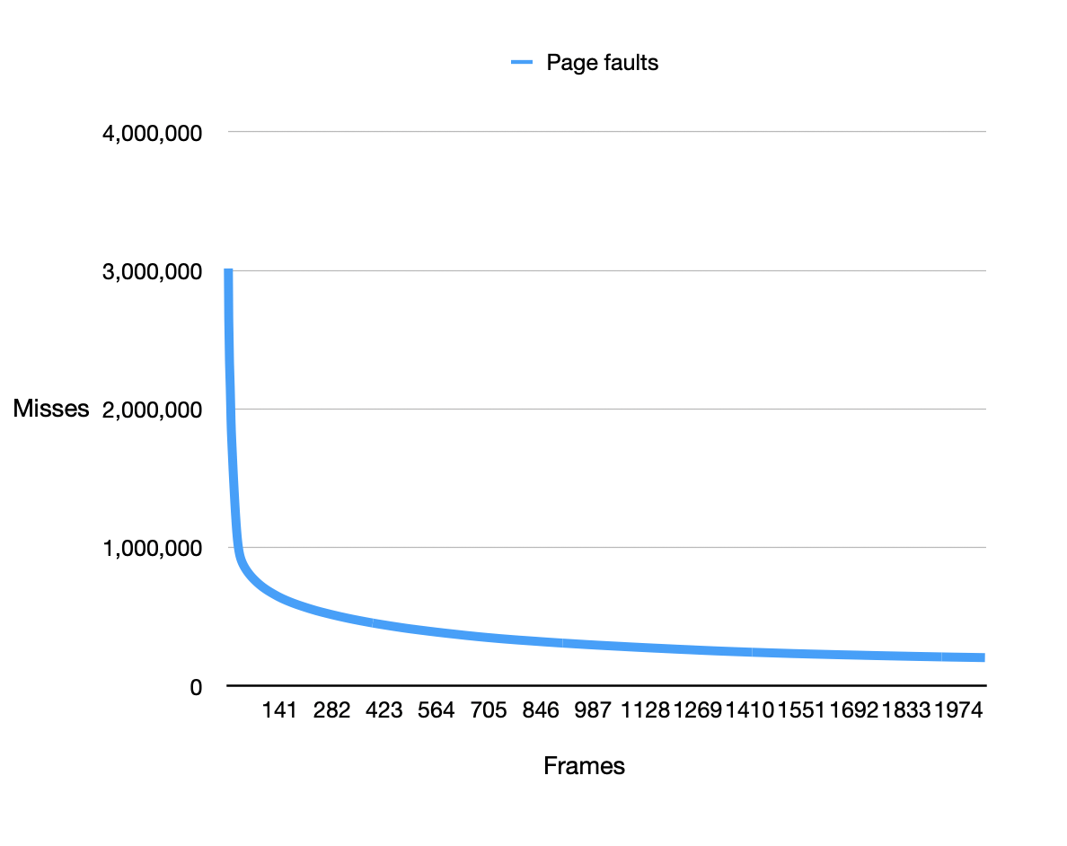
4 KB Frames — Page Faults (1.5 pts)
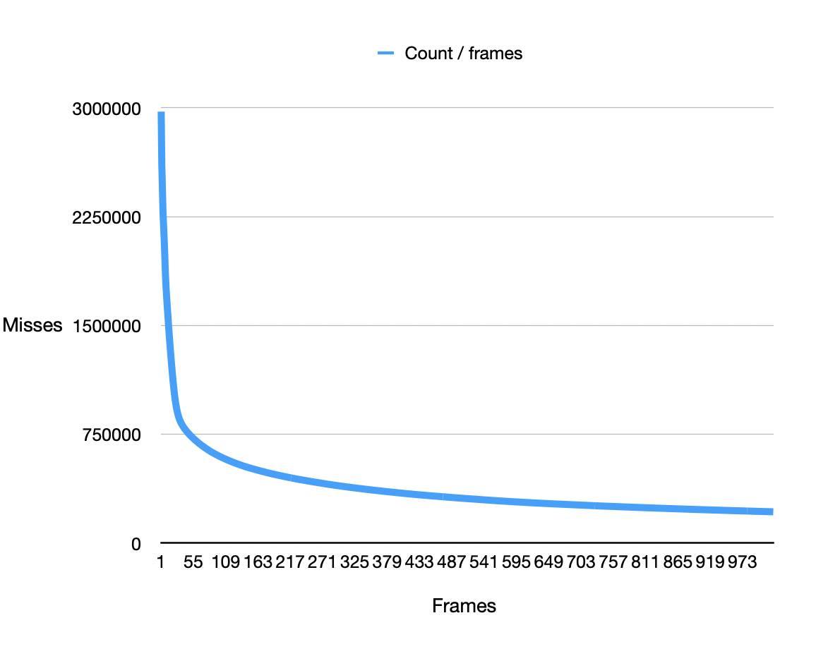
4. Frames vs. Page-Fault Rate — 4 charts (6 pts)
Insert one chart per frame size showing Frames (x-axis) vs. Page-Fault Rate (y-axis). Each chart must include a horizontal reference line at 10% fault rate, descriptive title, and labeled axes. (1.5 pts per chart)
512 B Frames — Fault Rate (1.5 pts)
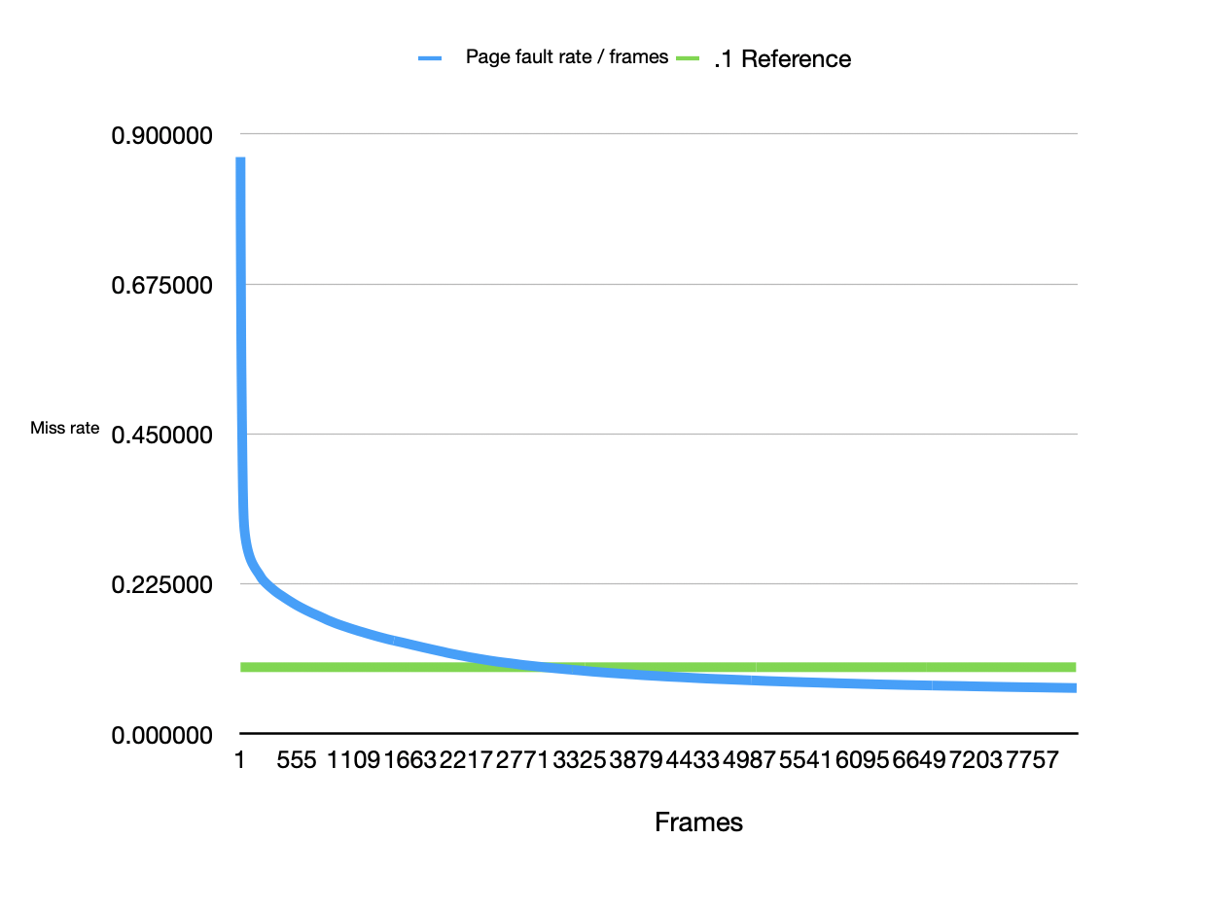
1 KB Frames — Fault Rate (1.5 pts)
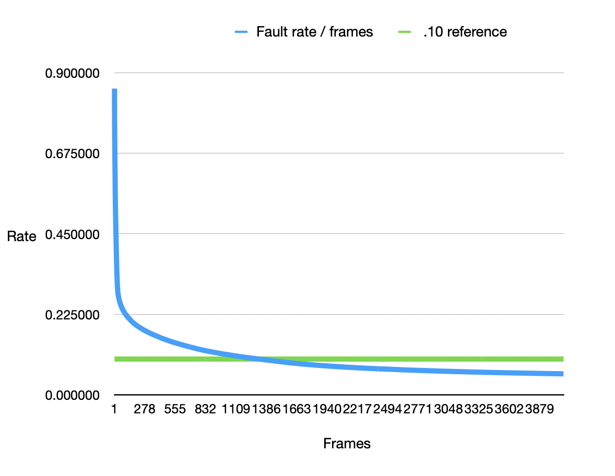
2 KB Frames — Fault Rate (1.5 pts)
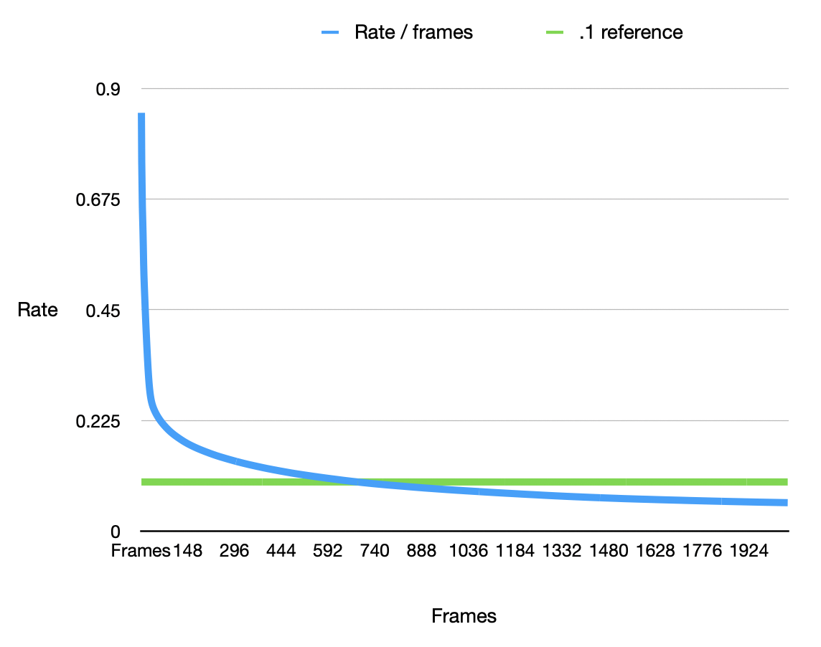
4 KB Frames — Fault Rate (1.5 pts)
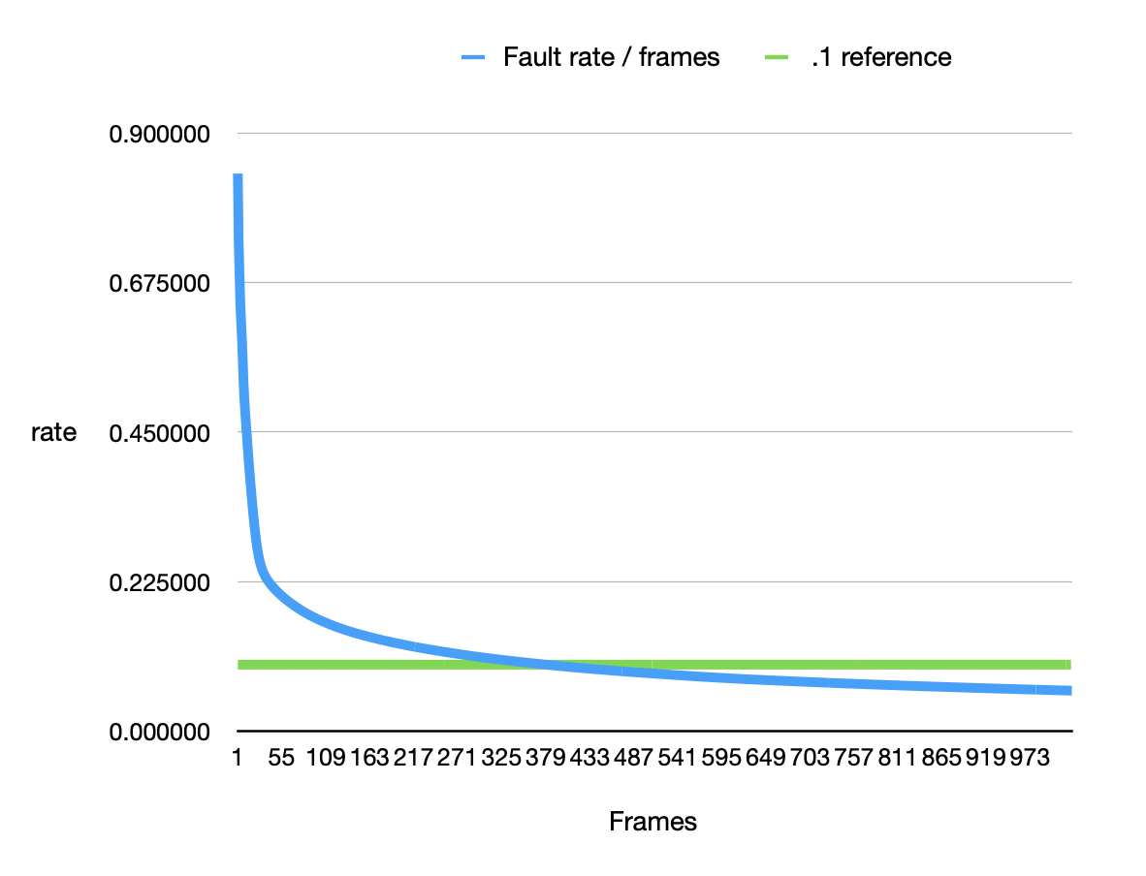
5. Curve Shape and Working Set Analysis (5 pts)
The shape is asymptotic relative to the x-axis as it approaches infinite frames. The graphs start very high, miss-wise, then taper off. Beyond the inflection point, frames start to decrease returns.
6. Frame Size and Fault Rate Tradeoffs (5 pts)
Larger frames mean more address collisions, reducing the faults. With more memory allocation and utilization comes more efficient performance.
Doc stmt: references are on site

