PEX3 Analysis Report: LRU Page Replacement Simulation
CS 483 — Operating Systems — Spring 2026
Name: _________________Mohamed Metwally_______ Section: ___M4_____ Date: ________4/10/2026____

Documentation Statement
None

1. Optimum Frame Size Recommendation (4 pts)
The recommended frame size is 1 KB, while the recommended number of frames is 318. This configuration achieves the required page-fault (below 10 percent) rate with the least total required memory (1 KB * 318 = 325,632 B). Any additional increase in memory will decrease the page-fault rate, though it won’t decrease significantly because the curve begins to flatten out after this point. As a result, this configuration strikes a good balance between minimizing memory overhead and page-fault rate

2. Frames Required to Achieve < 10% Page-Fault Rate (4 pts)
Frame Size | Min Frames for < 10% | Fault Rate at That Count
512 B | 689 | 0.09996
1 KB | 318 | 0.099937
2 KB | 179 | 0.099777
4 KB | 106 | 0.099938

3. Frames vs. Number of Page Faults — 4 charts (6 pts)

512 B Frames — Page Faults (1.5 pts)
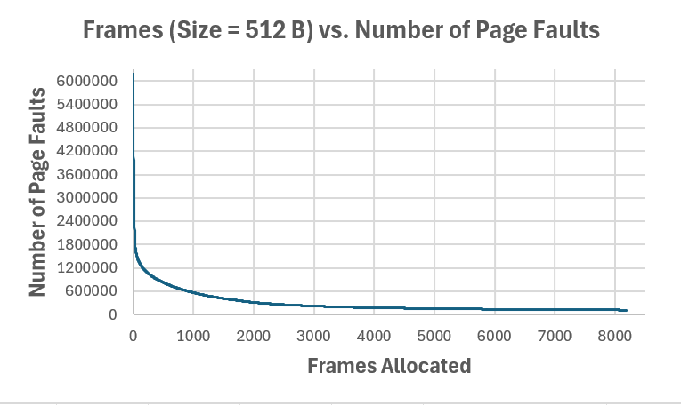

1 KB Frames — Page Faults (1.5 pts)
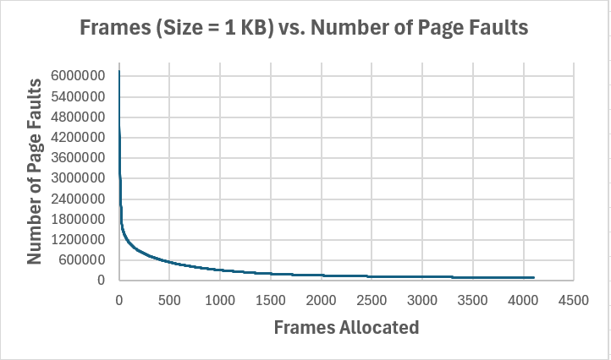

2 KB Frames — Page Faults (1.5 pts)
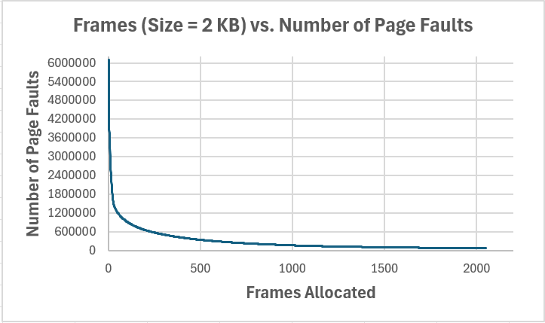

4 KB Frames — Page Faults (1.5 pts)
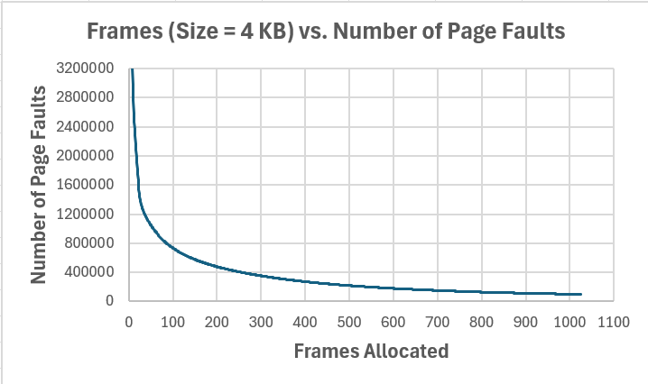

4. Frames vs. Page-Fault Rate — 4 charts (6 pts)

512 B Frames — Fault Rate (1.5 pts)
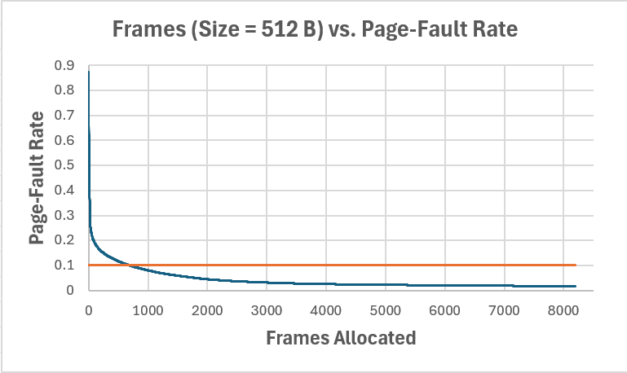

1 KB Frames — Fault Rate (1.5 pts)
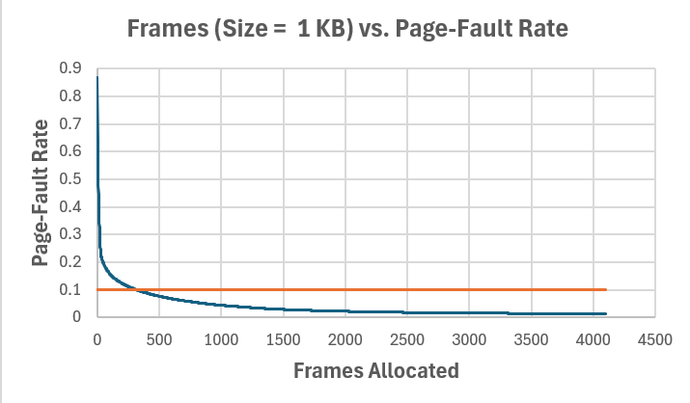

2 KB Frames — Fault Rate (1.5 pts)
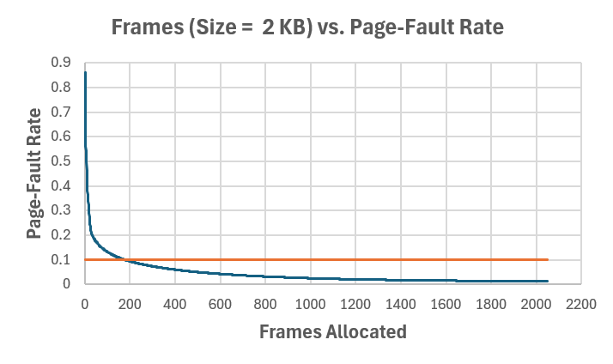

4 KB Frames — Fault Rate (1.5 pts)
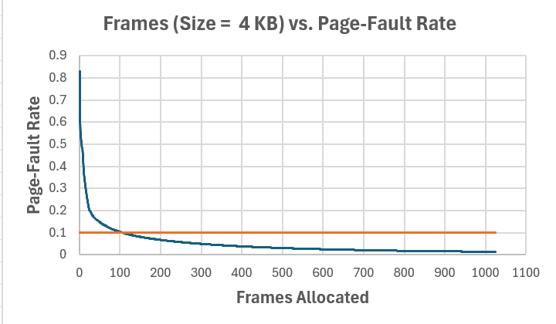

5. Curve Shape and Working Set Analysis (5 pts)
All graphs feature a steep initial drop followed by flattening. The initial drop occurs because there is not enough memory allocated to hold the memory pages that the program constantly uses. This results in a high fault-rate, where the OS is constantly kicking pages off the memory and replacing them with other pages. Afterward comes the inflection point, where improvement in fault-rate slows down. This is where the working set of the program is located, meaning enough memory has been allocated for the most frequently used pages. The working set is estimated to be between 1000-1500 of the 1 KB frame size, for a total memory requirement of 1000-1500 KB. Additionally, the curve begins to flatten out little after the inflection point, so any further increase in memory size results in minor improvement. This indicates that most of the actively used pages are already resident in memory.

6. Frame Size and Fault Rate Tradeoffs (5 pts)
Larger frames decrease the number of distinct pages because each page encapsulates larger portion of memory. This could lead to lower page-fault rate, as fewer pages are needed to represent the same amount of memory. This is evident in section 2, as fewer pages are required to achieve the same fault-rate when larger frames are used.
However, larger frames result in larger internal fragmentation, increasing memory overhead. While fewer page-faults are needed for larger frame sizes, internal fragmentation becomes more of an issue because pages may contain unused memory that still needs to be allocated by the OS.
Therefore, larger frames don’t necessarily improve the overall performance, which is to minimize both memory overhead and fault-rate. The data suggests using moderate frame sized, which balances between the two-performance metrics. 1 KB frame size achieves the required fault-rate percentage with the lowest memory usage, making it the optimal choice for this program.

