PEX3 Analysis Report: LRU Page Replacement Simulation
CS 483 — Operating Systems — Spring 2026
Name: Parker Douglas Section: M4 Date: 23 April 2026

Documentation Statement
None.

1. Optimum Frame Size Recommendation (4 pts)
The 4 KB frame size is recommended due to its page-fault rate below 10% with only 106 frames, compared to 179 frames for 2 KB, 318 frames for 1 KB, and 689 frames for 512 B. While larger frame sizes increase wasted memory, the significant reduction in frames required to achieve a sub-10% page fault rate outweighs this cost. 4 KB frames offer the best fault-rate to efficiency balance.

2. Frames Required to Achieve < 10% Page-Fault Rate (4 pts)
For each frame size, identify the minimum number of frames where the page-fault rate first drops below 10%.
Frame Size | Min Frames for < 10% | Fault Rate at That Count
512 B | 689 | 9.9960%
1 KB | 318 | 9.9937%
2 KB | 179 | 9.9777%
4 KB | 106 | 9.9938%

3. Frames vs. Number of Page Faults — 4 charts (6 pts)

512 B Frames — Page Faults (1.5 pts)
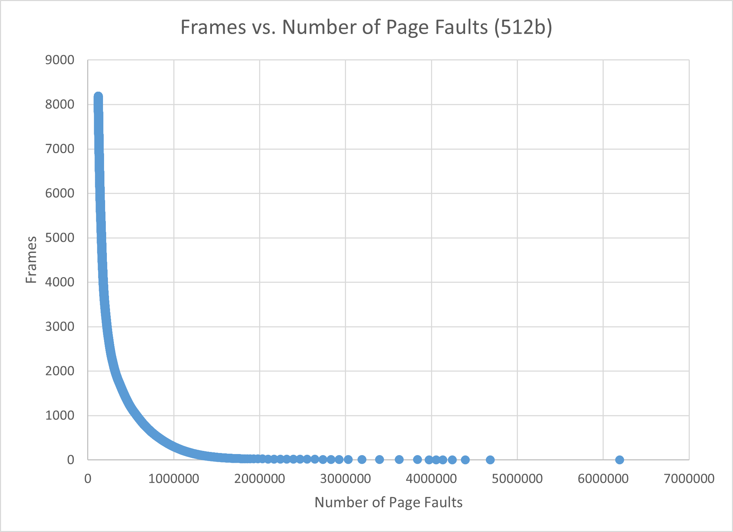
Figure 1: Frames vs. Number of Page Faults for 512b

1 KB Frames — Page Faults (1.5 pts)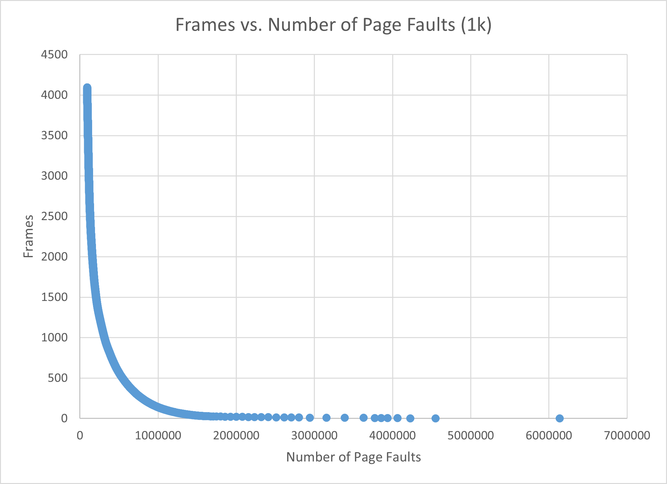
Figure 2: Frames vs. Number of Page Faults for 1k

2 KB Frames — Page Faults (1.5 pts)
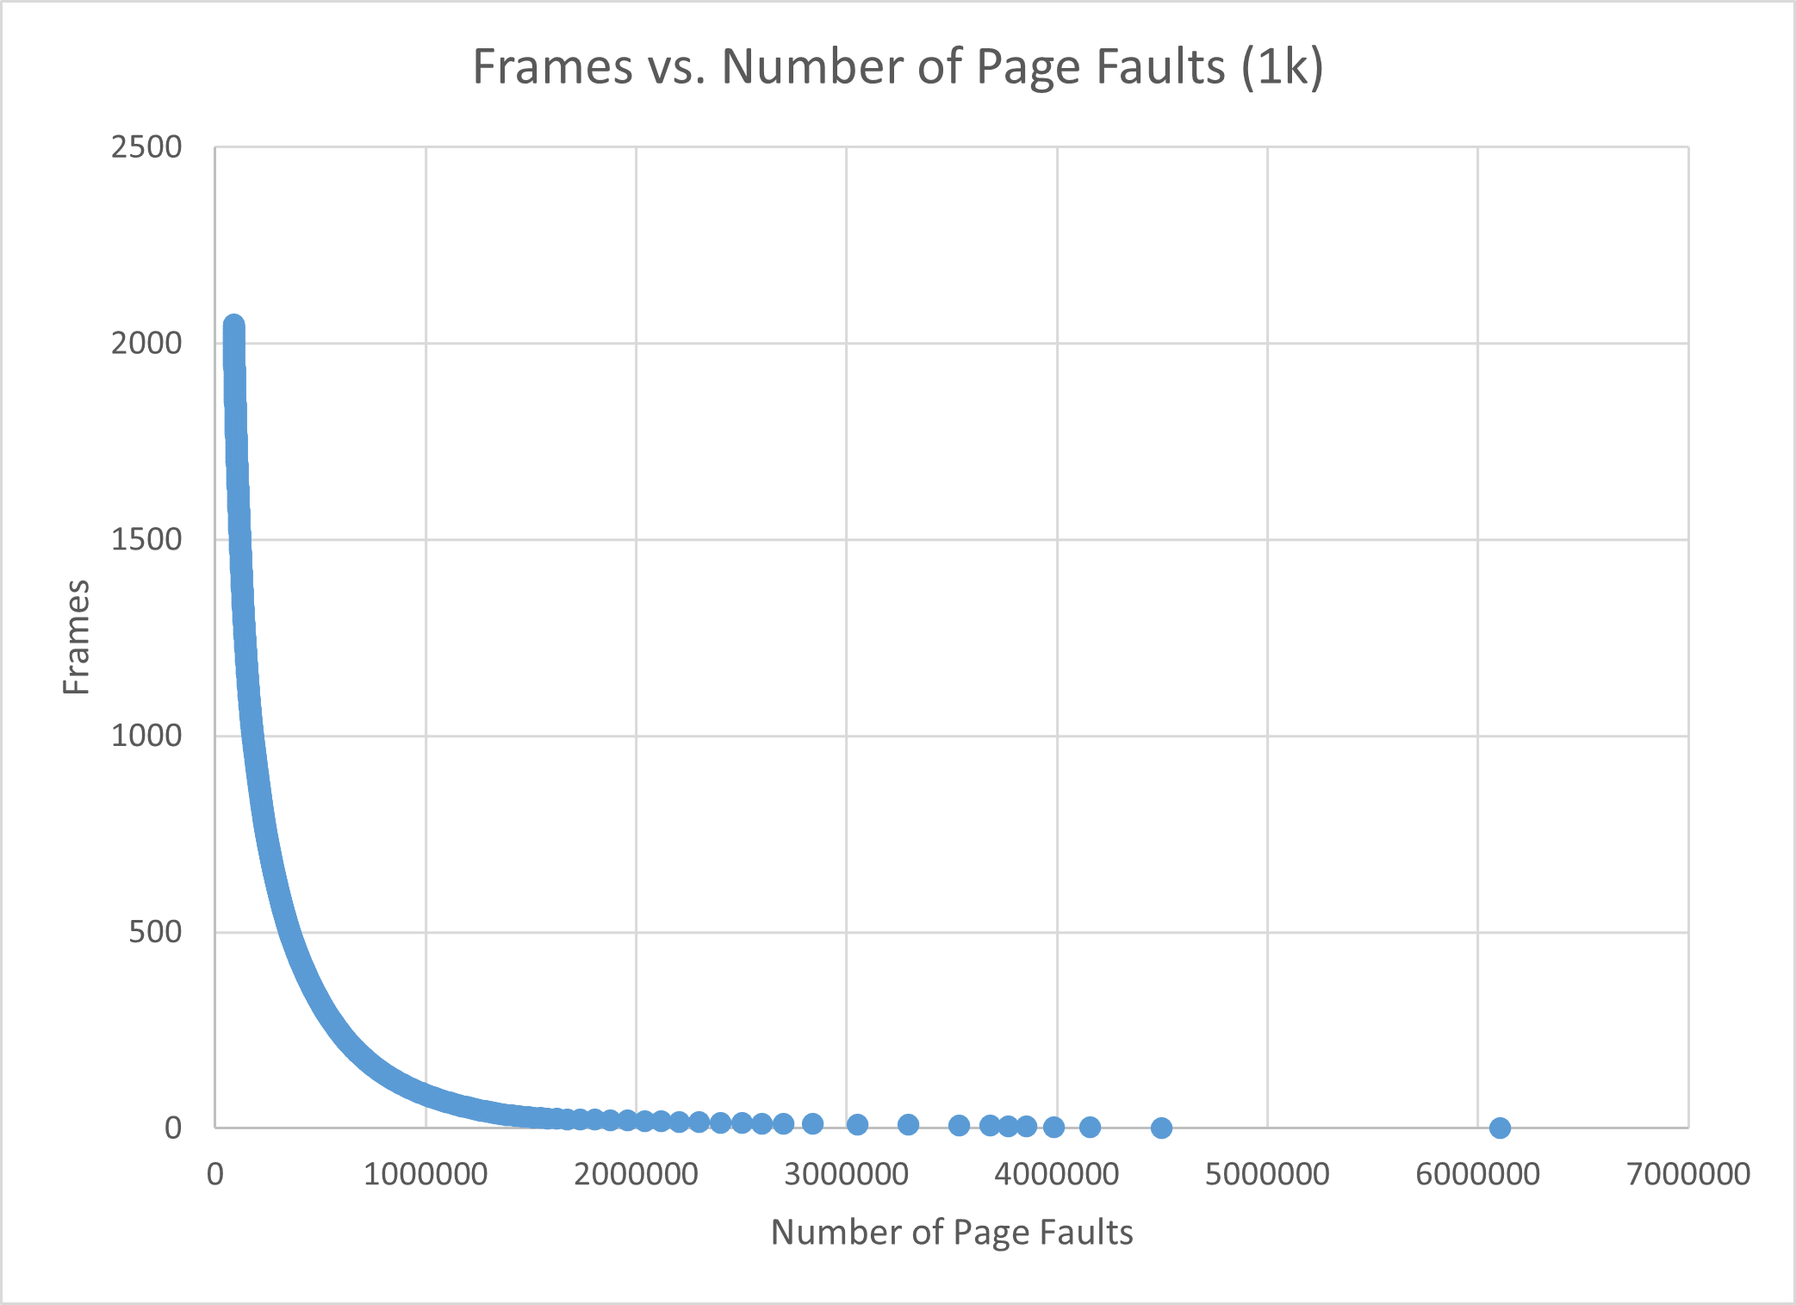Figure 3: Frames vs. Number of Page Faults for 2k

4 KB Frames — Page Faults (1.5 pts)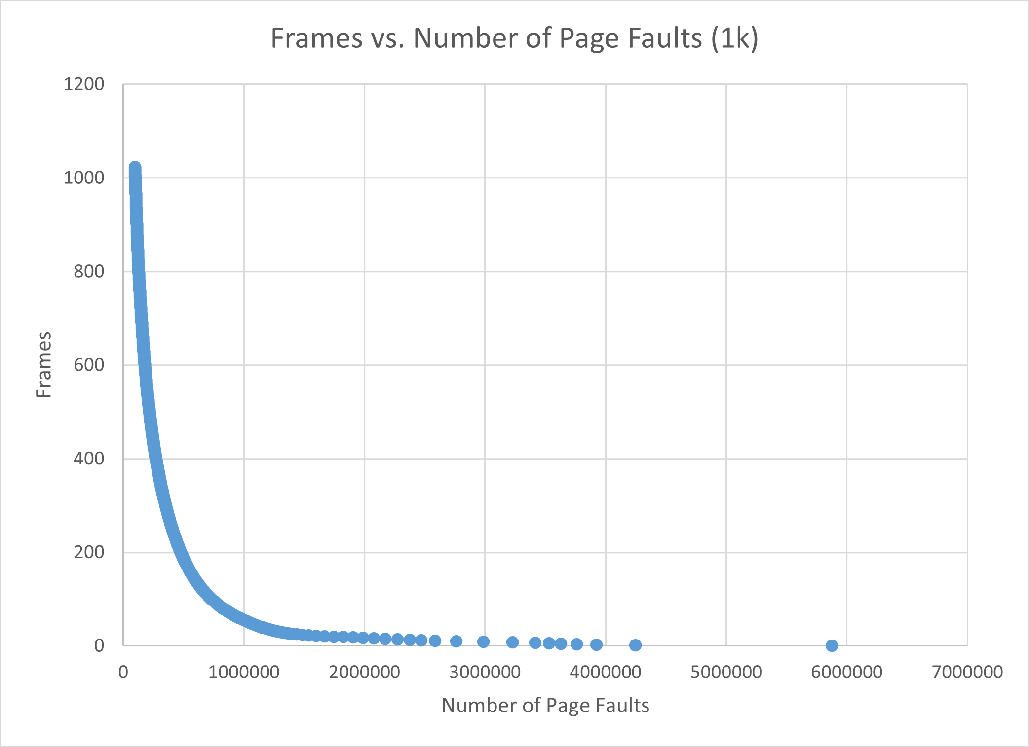
Figure 4: Frames vs. Number of Page Faults for 4k

4. Frames vs. Page-Fault Rate — 4 charts (6 pts)

512 B Frames — Fault Rate (1.5 pts)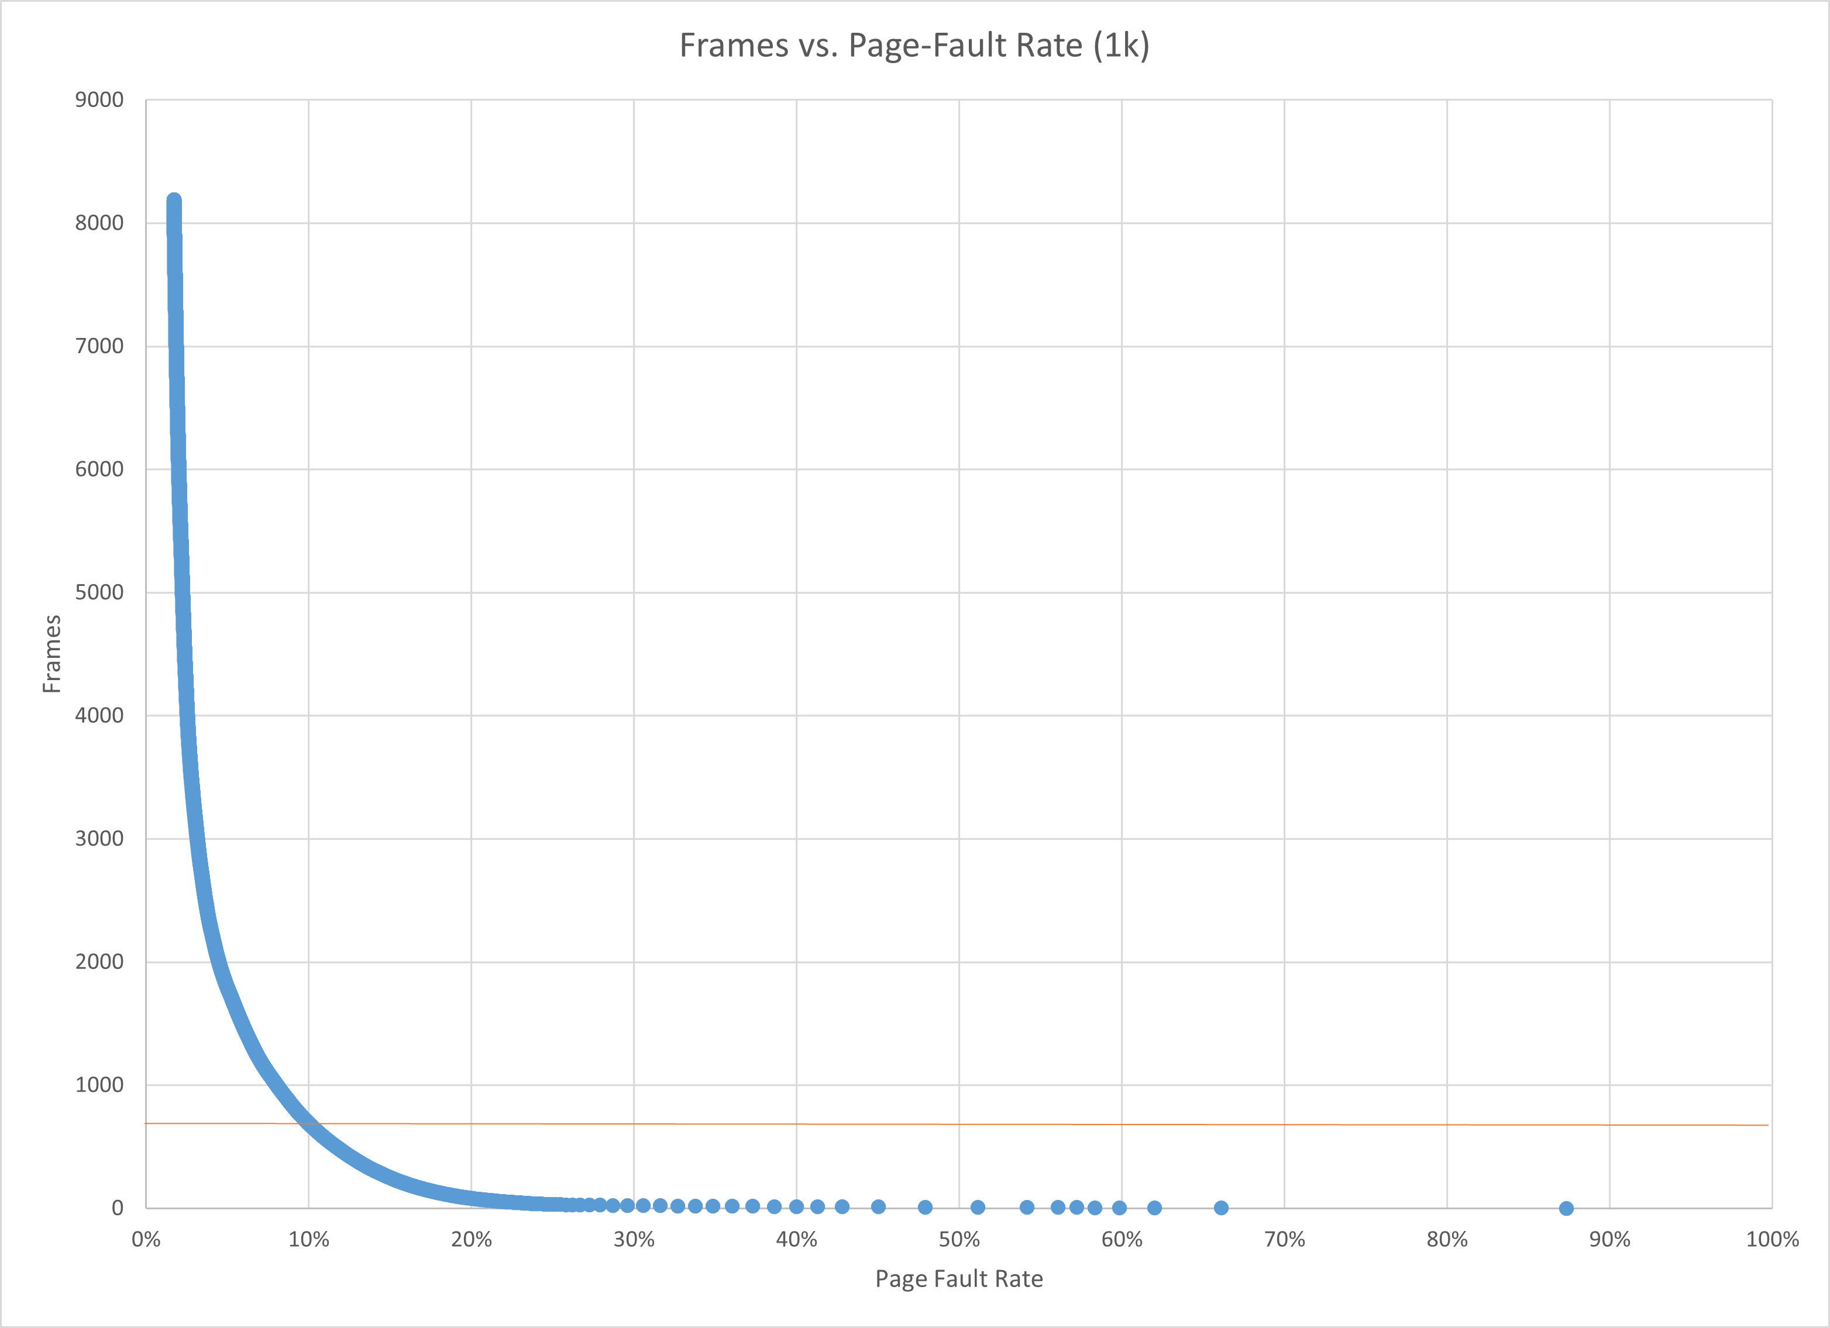
Figure 5: Frames vs. Page-Fault Rate for 512b

1 KB Frames — Fault Rate (1.5 pts)
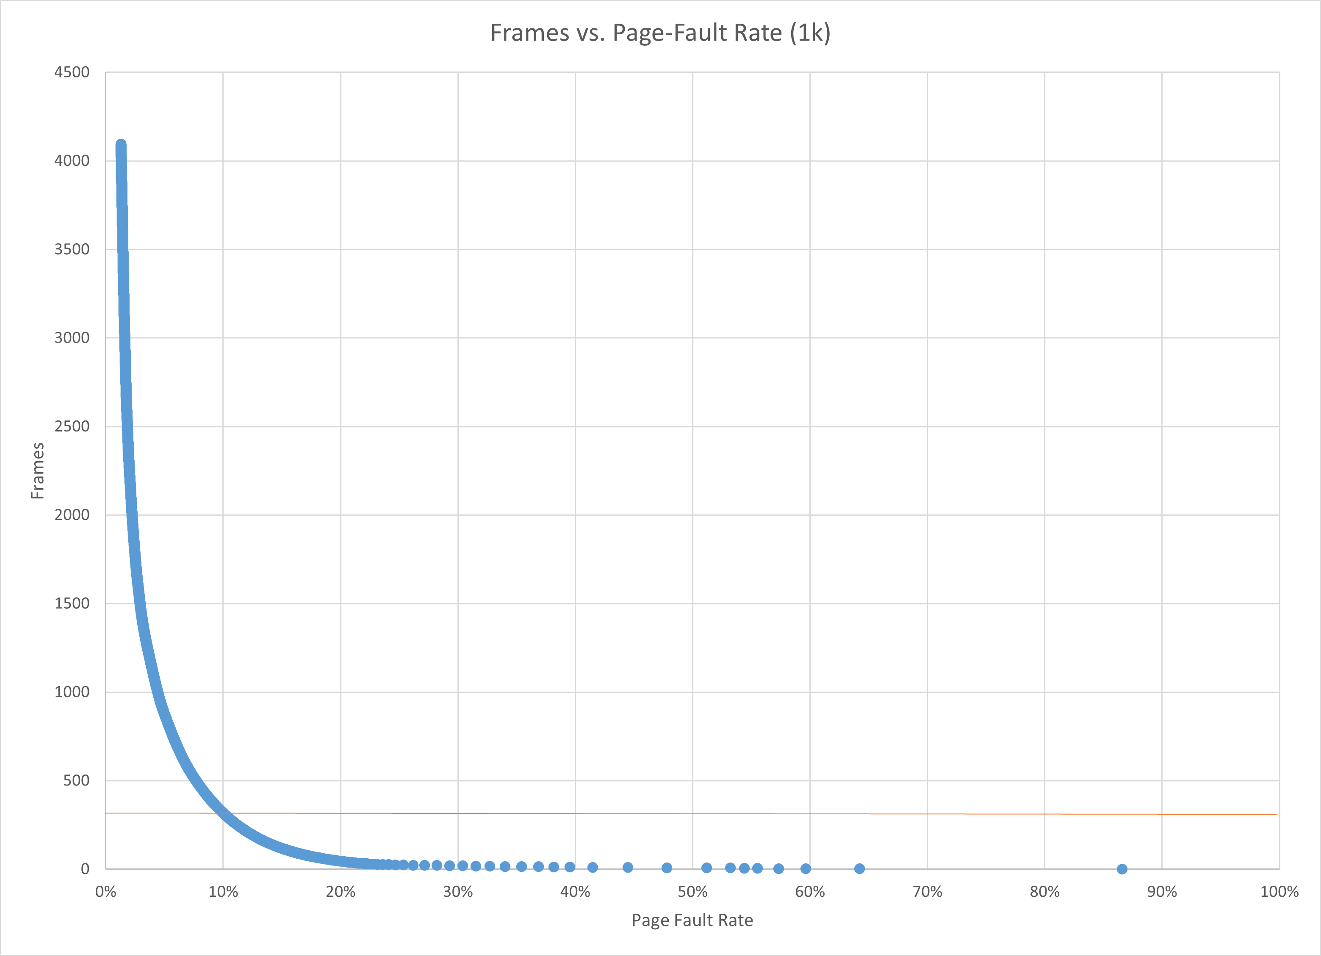Figure 6: Frames vs. Page-Fault Rate for 1k

2 KB Frames — Fault Rate (1.5 pts)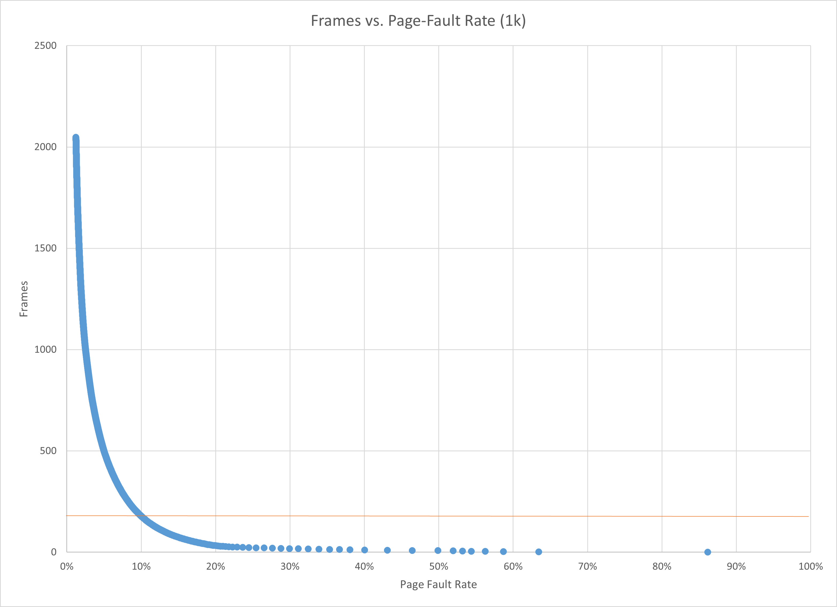
Figure 7: Frames vs. Page-Fault Rate for 2k

4 KB Frames — Fault Rate (1.5 pts)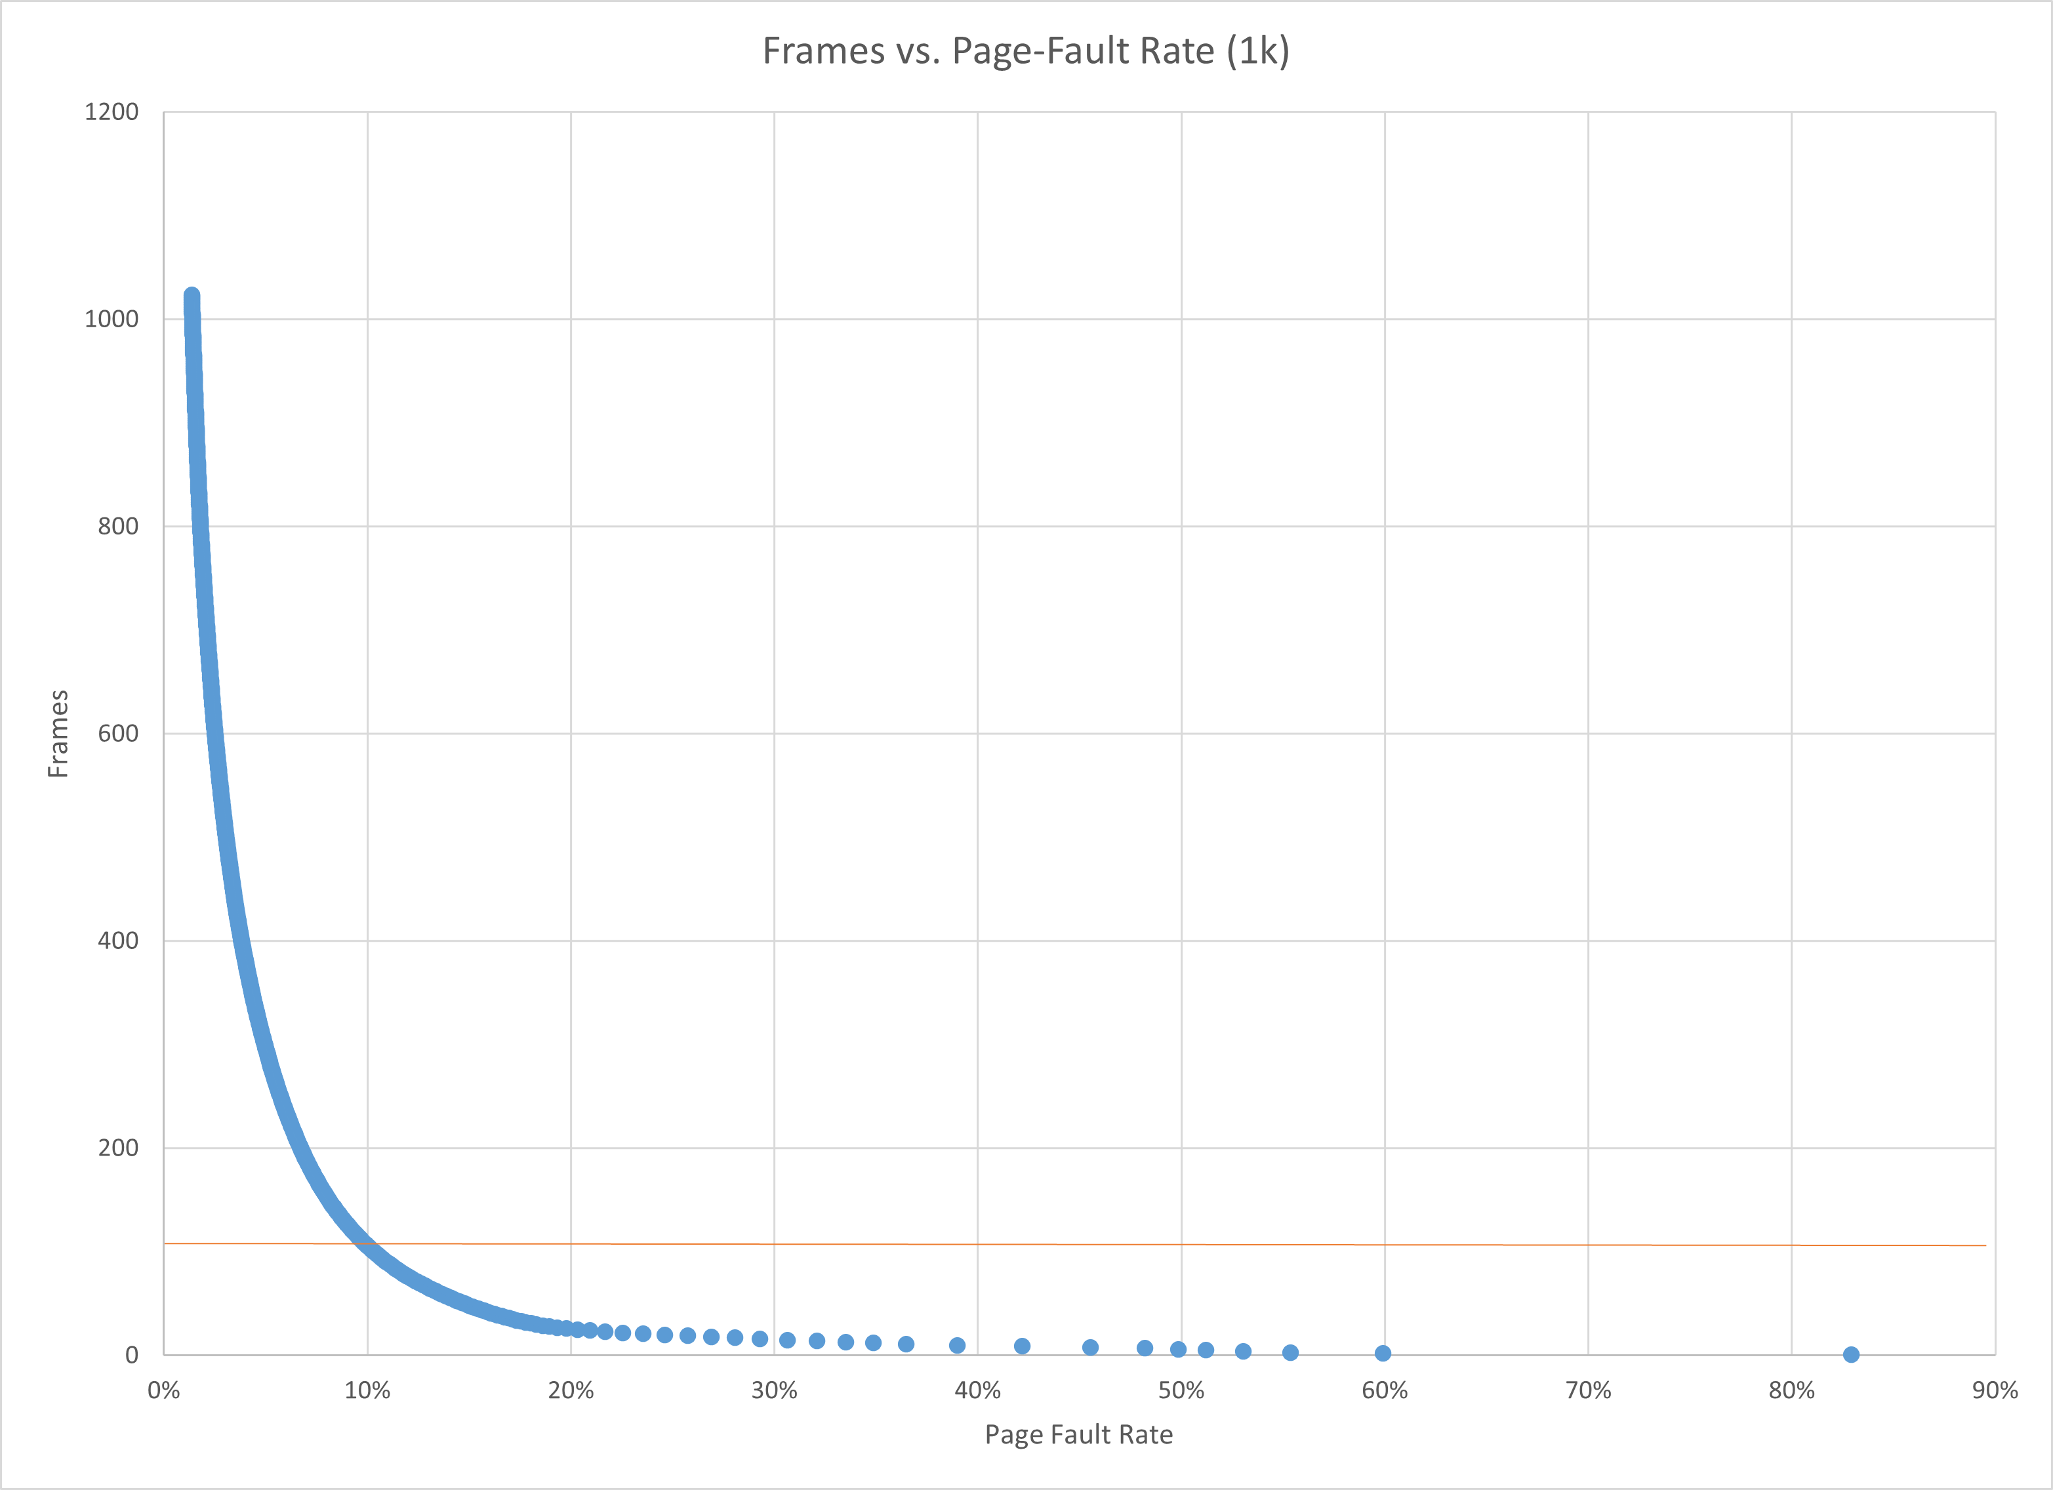
Figure 8: Frames vs. Page-Fault Rate for 4k

5. Curve Shape and Working Set Analysis (5 pts)
All eight curves show an exponential decrease in frames with respect to number of page faults and page fault rates, followed by relatively insignificant decrease in frames. The inflection point is located at approximately 700 frames for 512 B, 300 frames for 1 KB, 200 frames for 2 KB, and 100 frames for 4 KB. The inflection point demonstrates the point at which the working set is contained in the available memory. Larger frame sizes have an inflection point at lower frame numbers because each frame requires more memory, requiring a larger portion of the working set per frame.

6. Frame Size and Fault Rate Tradeoffs (5 pts)
Larger frames reduce the total number of pages, thus fewer pages need to be managed and replaced. A 4 KB frame requires more memory on average because a process’s memory is more likely to not divide evenly into the required memory per frame. This data suggests that larger frames minimize the fault rate. However, the fault rates for high frame counts have less disparity. When wasted memory is not a primary concern, larger frames are ideal. However, smaller frames reduce wasted memory with the tradeoff of a higher fault rate.

Grading Rubric (delete this page before submitting)

Point Breakdown (30 pts total)
Component | Points
Optimum Frame Size Recommendation | 4
Frames for < 10% Target Table | 4
Page Fault Charts (4 charts x 1.5 pts) | 6
Fault Rate Charts (4 charts x 1.5 pts) | 6
Curve Shape / Working Set Analysis | 5
Frame Size Tradeoffs | 5
TOTAL | 30

General Deductions (applied at grader discretion)
The following may result in point deductions from any section where the issue appears:
Issue | Deduction | Description
Insufficient technical depth | up to -3 pts | Analysis should reflect understanding of virtual memory, page replacement, and working set concepts — not just restate numbers from the data.
Unprofessional presentation | up to -3 pts | The report should read as a polished technical document suitable for a professional audience. Sloppy formatting, missing chart labels, or inconsistent style will result in deductions.
Spelling and grammar errors | up to -2 pts | Proofread carefully. Use a spell checker. Technical writing demands precision in language as well as content.
Use of first person | up to -2 pts | Do not use "I," "we," "my," or "our." Write from an objective, third-person perspective throughout.
Passive voice | up to -1 pt | Use active voice. Write "LRU reduces the fault rate" rather than "The fault rate is reduced by LRU."
Verbose or unclear writing | up to -2 pts | Be direct and concise. Every sentence should contribute meaningful analysis. Avoid filler, redundancy, and vague statements such as "the results were interesting."

Submission Checklist
- All 8 charts embedded directly in the document (not linked)
- Each chart has a descriptive title (e.g., "Page-Fault Rate vs. Frames — 4KB")
- Axes labeled with units on every chart
- 10% reference line on all 4 fault-rate charts
- Minimum 250 words of written analysis
- No first person; active voice; concise language
- No spelling or grammar errors
- Report stands alone — readable without consulting CSV files
- Documentation statement completed in both main.c and this report
- File saved as .docx and committed to GitHub repo

