PEX3 Analysis Report: LRU Page Replacement Simulation
CS 483 — Operating Systems — Spring 2026
Name: Sweta Chandra Mohan Section: M3 Date: April 23, 2026

Documentation Statement
Used my 220 doubly linked list lab to complete the code.
https://www.cl.cam.ac.uk/teaching/2021/OpSystems/pdf/07-Paging.pdf used this to explain internal fragmentation and the relationship between paging and memory management.

1. Optimum Frame Size Recommendation (4 pts)
The optimum frame size is 4KB. This frame size requires 106 frames to keep the fault rate below ten percent while other options require significantly more frames. The simulation showed that 512B pages required 689 frames, 1KB pages required 318 frames, 2KB pages required 179 frames, and 4KB pages required only 106 frames to reach approximately the same miss rate. This shows there is greater efficiency as the frame size increases.

2. Frames Required to Achieve < 10% Page-Fault Rate (4 pts)

Frame Size | Min Frames for < 10% | Fault Rate at That Count
512 B | 689 | 0.09996
1 KB | 318 | 0.099937
2 KB | 179 | 0.099777
4 KB | 106 | 0.099938

3. Frames vs. Number of Page Faults — 4 charts (6 pts)

512 B Frames — Page Faults (1.5 pts)
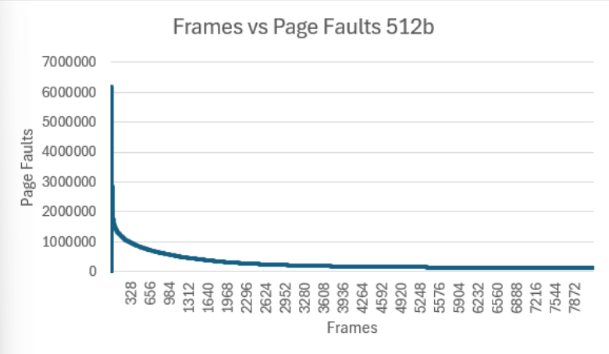

1 KB Frames — Page Faults (1.5 pts)
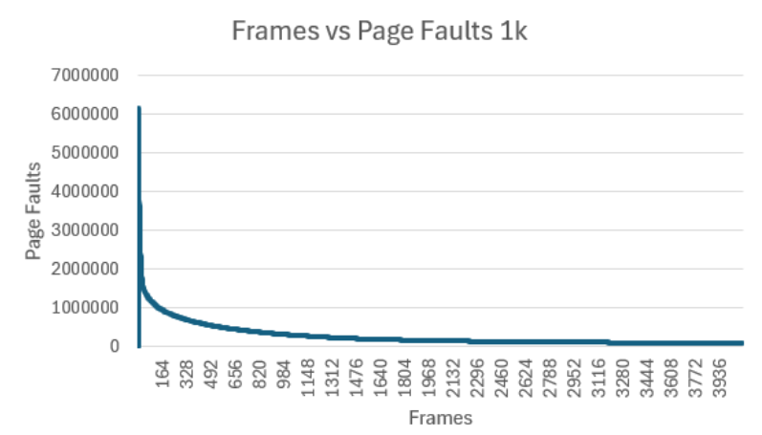

2 KB Frames — Page Faults (1.5 pts)
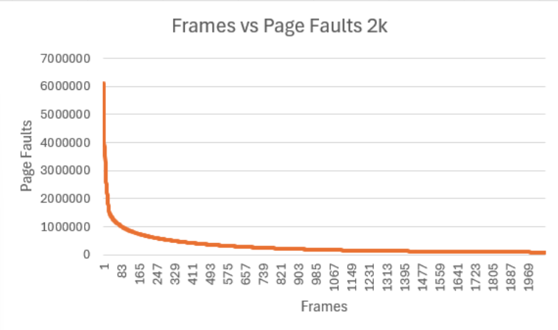

4 KB Frames — Page Faults (1.5 pts)
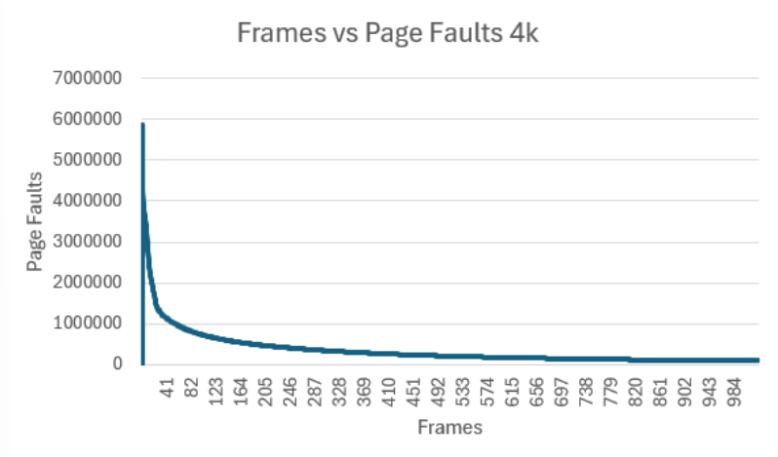

4. Frames vs. Page-Fault Rate — 4 charts (6 pts)

512 B Frames — Fault Rate (1.5 pts)
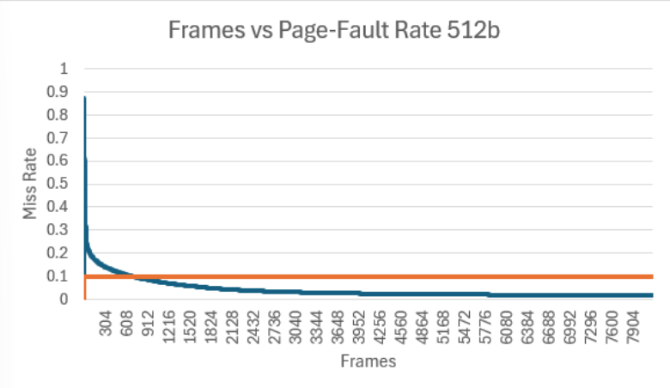

1 KB Frames — Fault Rate (1.5 pts)
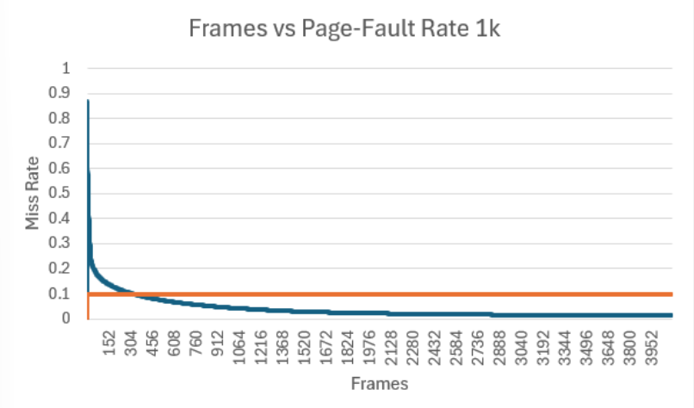

2 KB Frames — Fault Rate (1.5 pts)

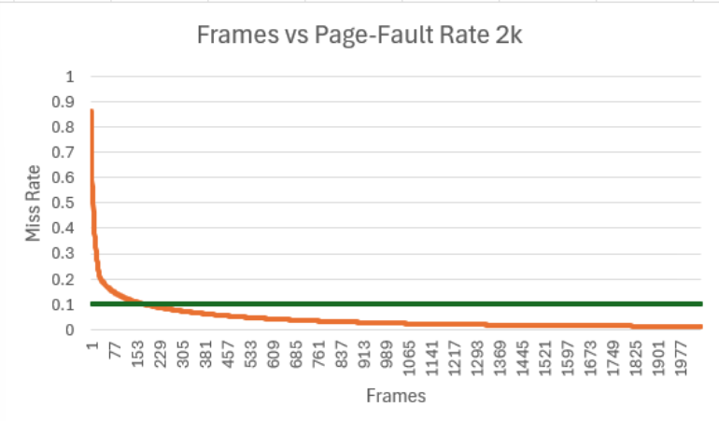

4 KB Frames — Fault Rate (1.5 pts)
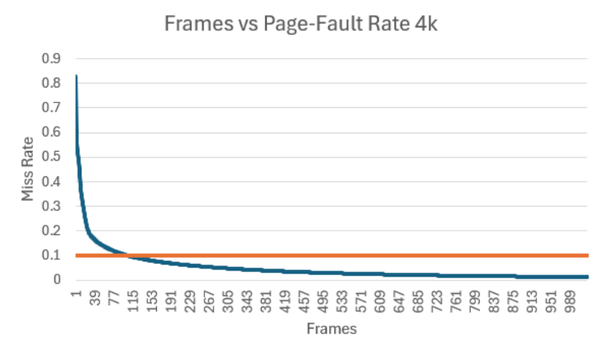

5. Curve Shape and Working Set Analysis (5 pts)

The fault rate curves start around an 85 percent miss rate and show a steep initial drop before gradually flattening. This occurs because adding frames reduces repeated page faults, but once enough frames are available, the improvement becomes less significant. The point where the curve transitions from a steep decline to a gradual decrease represents the working set size, where most actively used pages fit in memory. Adding more frames beyond this point does not significantly impact the fault rate.

6. Frame Size and Fault Rate Tradeoffs (5 pts)
Larger frame sizes reduce the number of necessary pages and therefore decrease page faults. This is supported by the data, as 4KB frames reach the target fault rate the fastest. However, larger frames also waste memory due to internal fragmentation while smaller frames use memory more efficiently but require more pages. This creates a tradeoff between memory usage and page fault rate. In this case, the reduction in page faults outweighs the wasted memory, so larger frames are more effective for overall system performance.

