PEX3 Analysis Report: LRU Page Replacement Simulation
CS 483 — Operating Systems — Spring 2026
Name: __Tanner Woodring_______ Section: ____M3____ Date: ___4/23/2026___

Documentation Statement
Documentation: I looked up on tutorialspoint what the parameters are for calloc() and how to use it to allocate the faults array. I also used ChatGPT to help debug the segmentation faults that I was experiencing. I found that I wasn't updating the old tail/head to point away from the current node when it was moved. I also didn't consider cases where the queue was empty or had a single node, and that these cases mattered as well. No other sources were considered.

1. Optimum Frame Size Recommendation (4 pts)
I recommend using a 1 KB frame size because it has the least amount of memory overhead compared to the other three frame sizes. The space required to use a frame size of 1 KB is 325632 bytes, the next frame size is 512 B because it takes more memory than 1 KB at 352768. The final two frame sizes have a memory requirement of 366592 and 434176 for 2 KB and 4 KB respectively. Looking at the page fault rate and keeping it below 10%, all the frame sizes get close to 10%. However, maximizing the frame size to achieve a fault rate below 10% will not produce a significant difference because they all achieve a fault rate that is extremely close to 10%. This difference would not be noticeable unless the data set is very large.

2. Frames Required to Achieve < 10% Page-Fault Rate (4 pts)
For each frame size, identify the minimum number of frames where the page-fault rate first drops below 10%.
Frame Size | Min Frames for < 10% | Fault Rate at That Count
512 B | 689 | 0.099960
1 KB | 318 | 0.099937
2 KB | 179 | 0.099777
4 KB | 106 | 0.099938

3. Frames vs. Number of Page Faults — 4 charts (6 pts)
Insert one chart per frame size showing Frames (x-axis) vs. Number of Page Faults (y-axis). Each chart must have a descriptive title, labeled axes with units, and clean formatting. (1.5 pts per chart)

512 B Frames — Page Faults (1.5 pts)
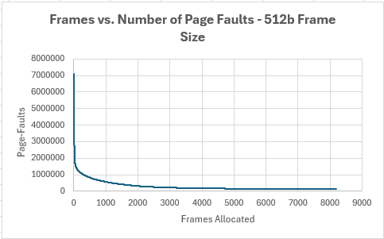

1 KB Frames — Page Faults (1.5 pts)
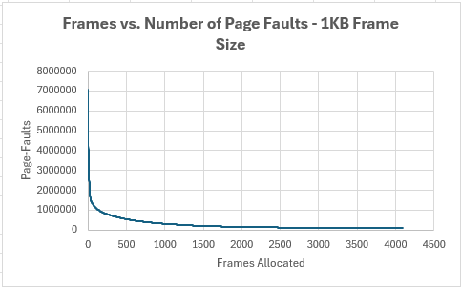

2 KB Frames — Page Faults (1.5 pts)
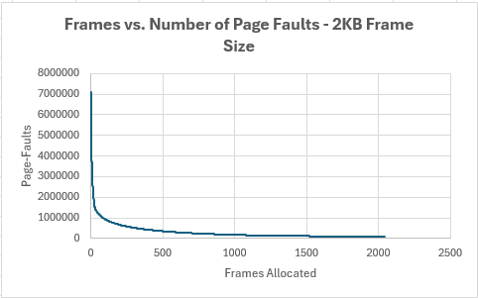

4 KB Frames — Page Faults (1.5 pts)
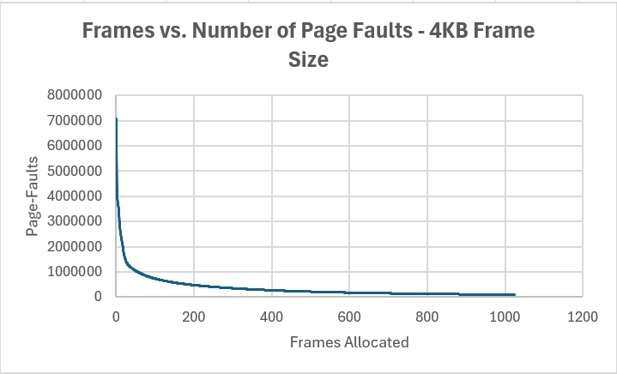

4. Frames vs. Page-Fault Rate — 4 charts (6 pts)
Insert one chart per frame size showing Frames (x-axis) vs. Page-Fault Rate (y-axis). Each chart must include a horizontal reference line at 10% fault rate, descriptive title, and labeled axes. (1.5 pts per chart)

512 B Frames — Fault Rate (1.5 pts)
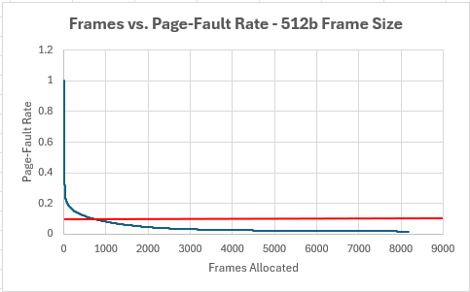

1 KB Frames — Fault Rate (1.5 pts)
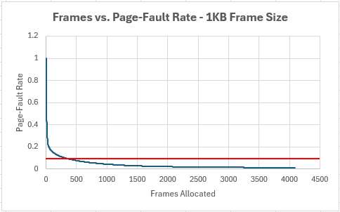

2 KB Frames — Fault Rate (1.5 pts)
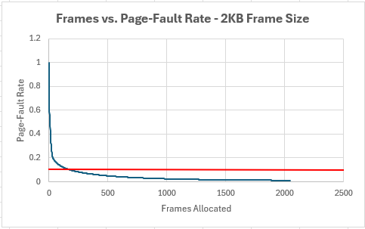

4 KB Frames — Fault Rate (1.5 pts)
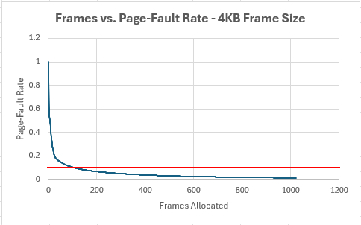

5. Curve Shape and Working Set Analysis (5 pts)
While each graph is scaled differently, the shape of each curve is the same. There is initially a high fault rate if there are very few frames allocated. This means that the value of adding one more frame is worth the memory overhead experienced. After allocating the frames, the line begins to flatten rapidly. This means that adding one additional frame does not achieve a significant decrease in the fault rate. There exists an inflection point in the graphs that once it is reached, unless a significantly low fault rate is necessary, adding one more frame is no longer beneficial when considering balancing the cost of memory overhead and the benefits of a lower fault rate.

6. Frame Size and Fault Rate Tradeoffs (5 pts)
Using a larger frame size reduces the total number of distinct pages but increases the internal fragmentation. This inverse relationship implies that there needs to be a frame size to balance the number of distinct pages and the amount of internal fragmentation experienced. In this case, the data in this report suggests that a smaller fame size is more beneficial than a larger frame size. Using a larger frame size would decrease the number of pages used, but the size of memory required, and the internal fragmentation experienced would render large frame sizes inefficient compared to smaller frame sizes.

