FY23 HRH Inventory Briefer - Tanzania

GH/OHA/SPS/HWF

10 July, 2024

## Automated reports at OU level

This provides a detailed summary of the FY23 HRH Inventory dataset for Tanzania. These reports help summarize staffing investments and trends at the country level to inform current programming, and facilitate HRH planning.

## USAID and CDC HRH Inventory Submission Rate

This shows the number of mechanisms that submitted both ER and HRH templates to better understand the overall completeness/reliability of the HRH inventory.

Submission Rate by Agency

| Funding Agency | No. of HRH Submissions | No. of ER Submissions | HRH Expenditure Amount (USD) | ER Expenditure Amount (USD) | Overall Submission Rate (%) |
| --- | --- | --- | --- | --- | --- |
| CDC | 16 | 17 | $94,176,325 | $96,480,420 | 98% |
| USAID | 25 | 25 | $58,550,852 | $57,641,353 | 102% |
| Other | 2 | 4 | $15,963,312 | $16,514,797 | 97% |
| Total | 43 | 46 | $168,690,489 | $170,636,570 | 99% |

## Initial Summary of PEPFAR vs USAID HRH Staffing footprint

This table provides a summary of USAID’s staffing size relative to PEPFAR in Tanzania. Relative to PEPFAR, this shows USAID’s relative staffing footprint (individual count and FTE), the % going towards staffing, and the amount spent by local prime implementation partners

FY23 HRH Summary: By The Numbers

| Funding Agency | HRH Staffing Expenditure | Individual Count | Total FTE (Full-Time Equivalence) | % of Total Expenditures Spent Towards HRH | Local Partner HRH Staffing Expenditure |
| --- | --- | --- | --- | --- | --- |
| PEPFAR | $171,786,058 | 55,875 | 37,628 | 41% | $104,206,530 |
| USAID | $61,412,956 | 31,960 | 18,093 | 29% | $27,474,902 |

## FY23 Staffing Footprint by Funding Agency

Breakdown of HRH expenditure and number of individual staff supported by each agency

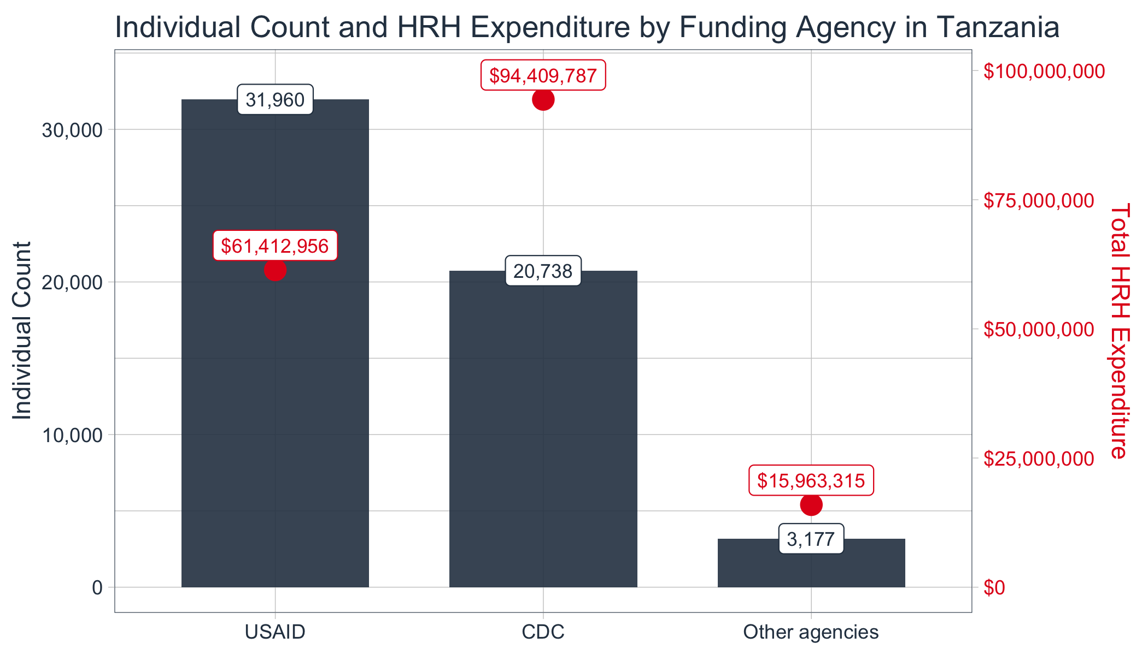

## FY23 Staffing Breakdown by Program Area

Breakdown of total HRH expenditure and number of individual staff by program area

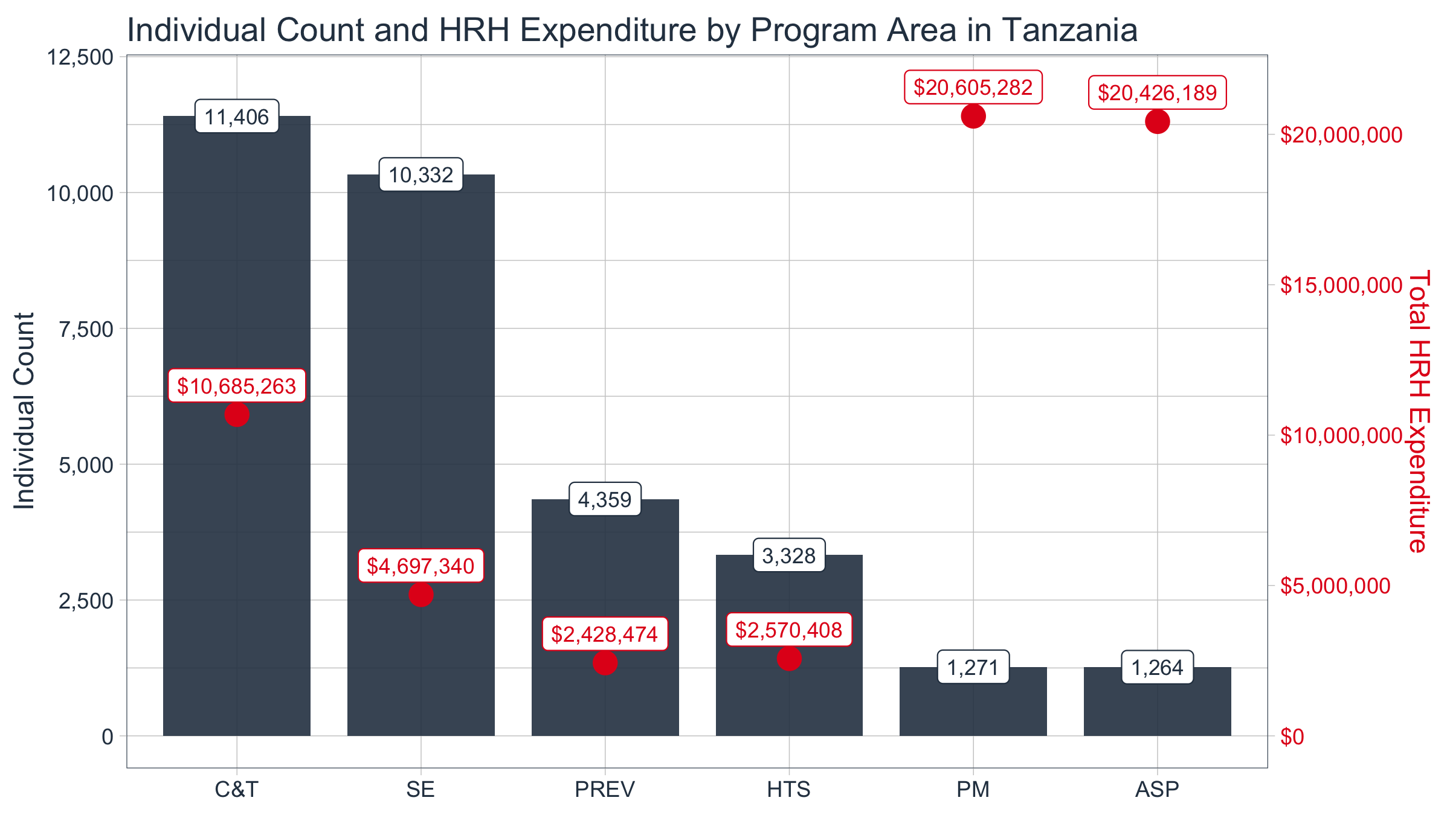

## FY23 Top Employment Titles (by count)

Breakdown of total HRH expenditure and number of individual staff by highest count

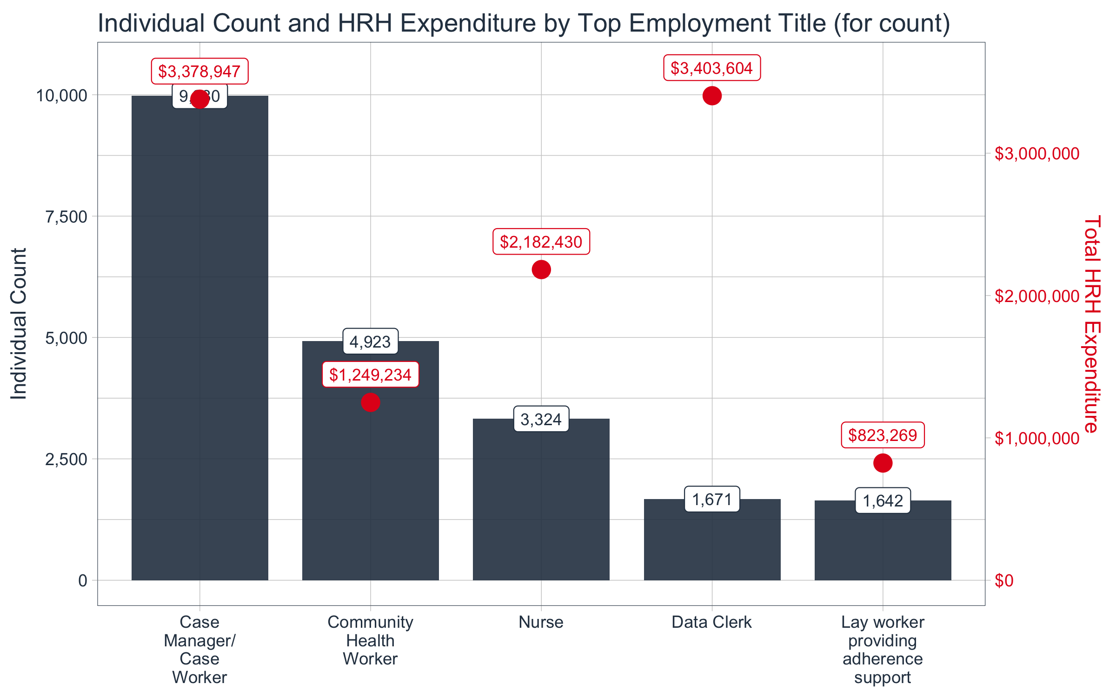

## FY23 Top Employment Titles (by expenditure)

Breakdown of total HRH expenditure and number of individual staff by the highest expenditure

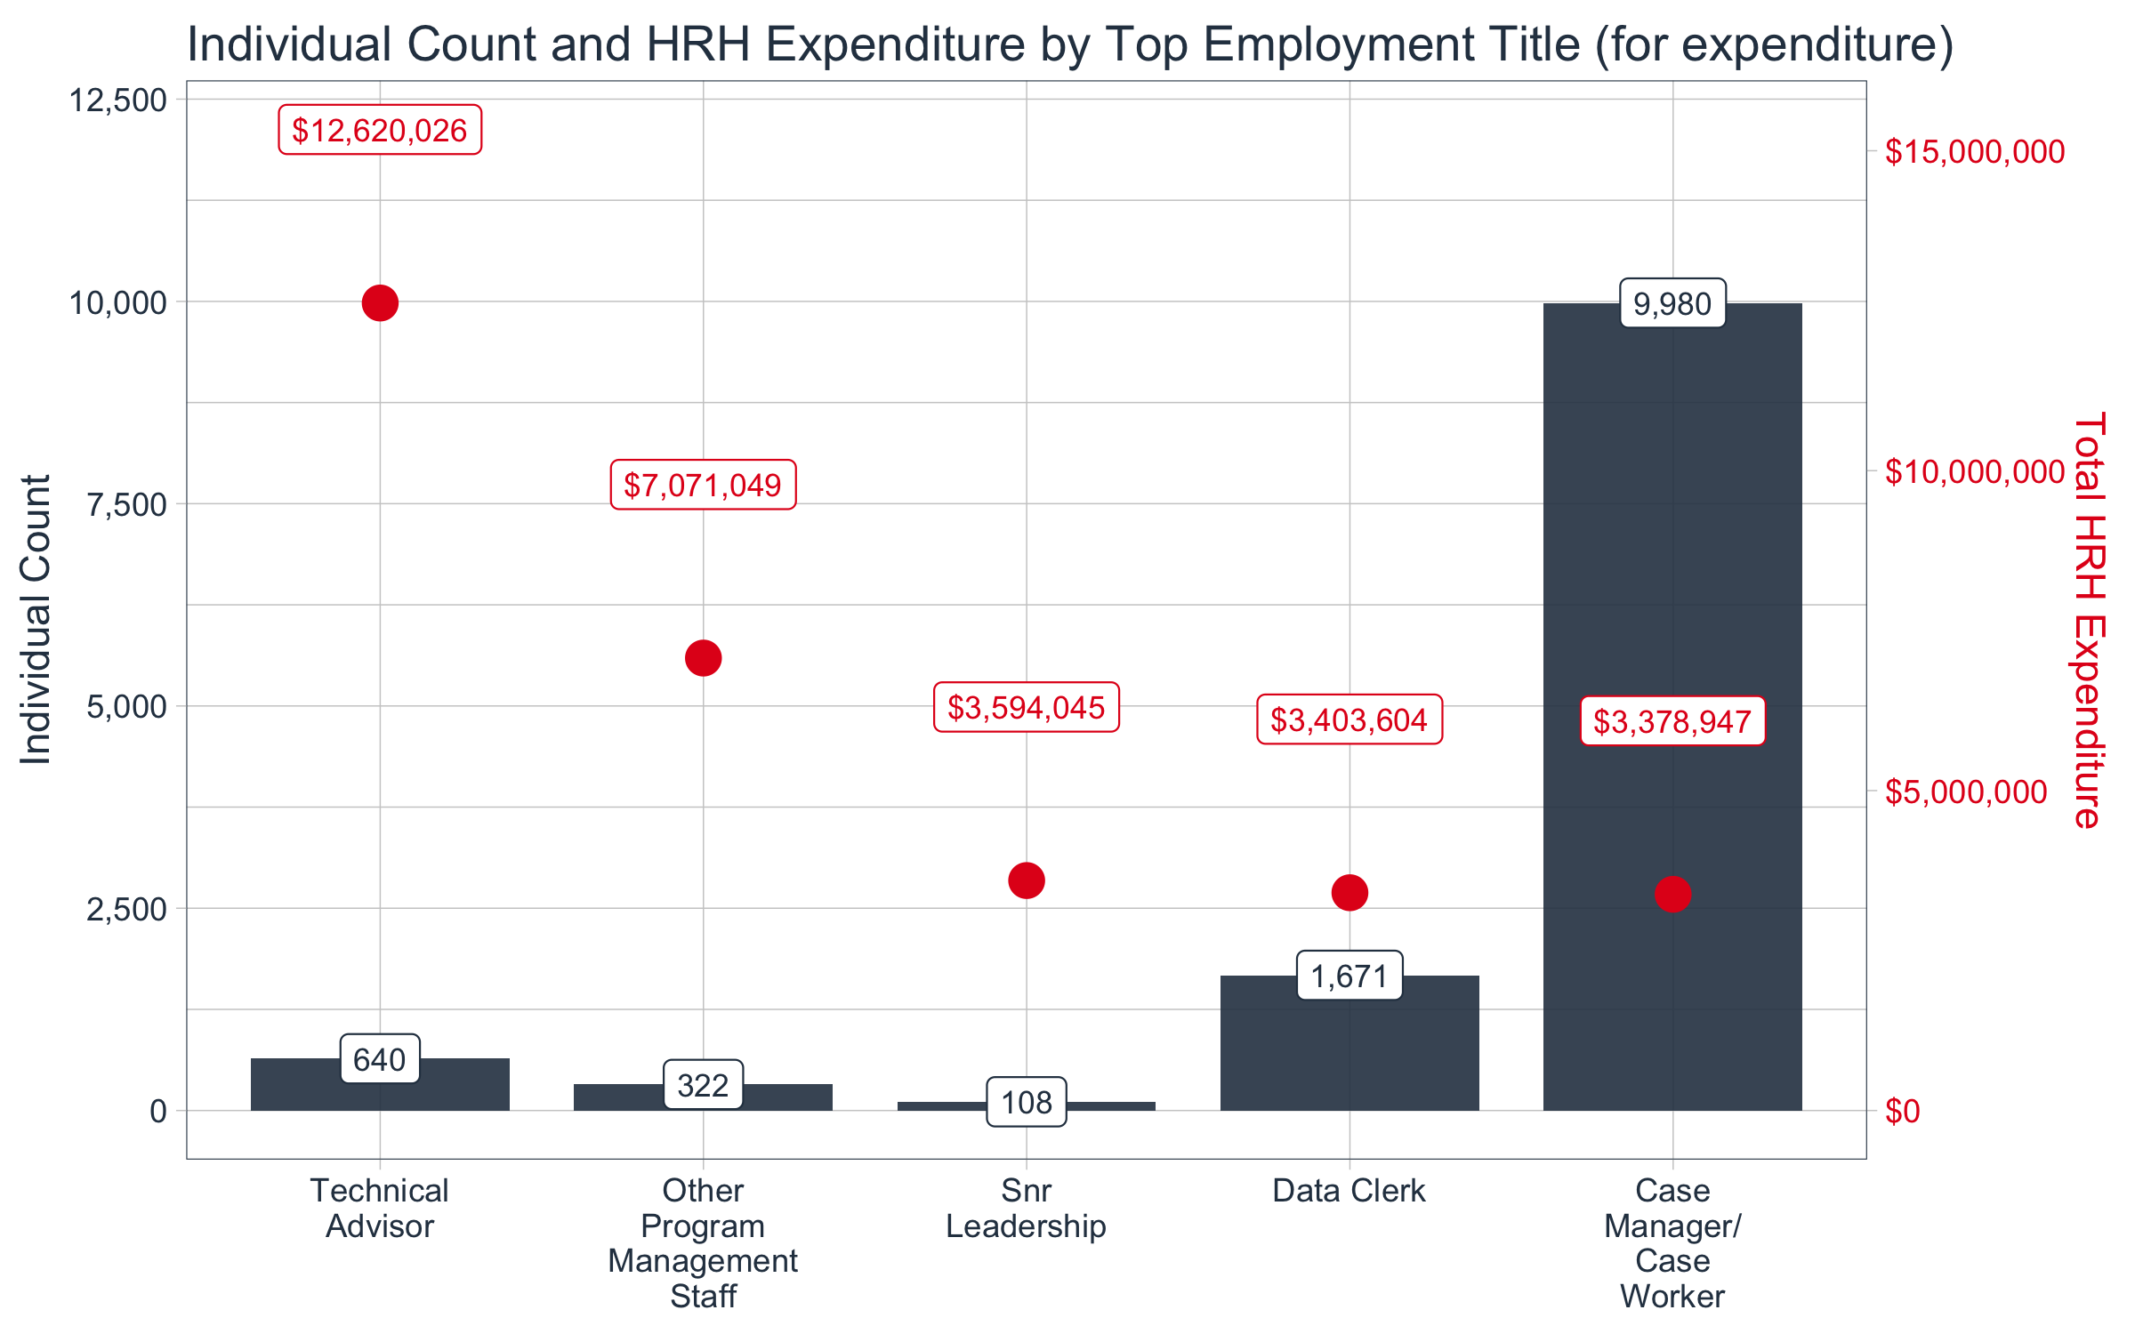

## FY23 Median Annual Remuneration

This box plot shows the range of annual remuneration (i.e. annual salary) of the top employment titles

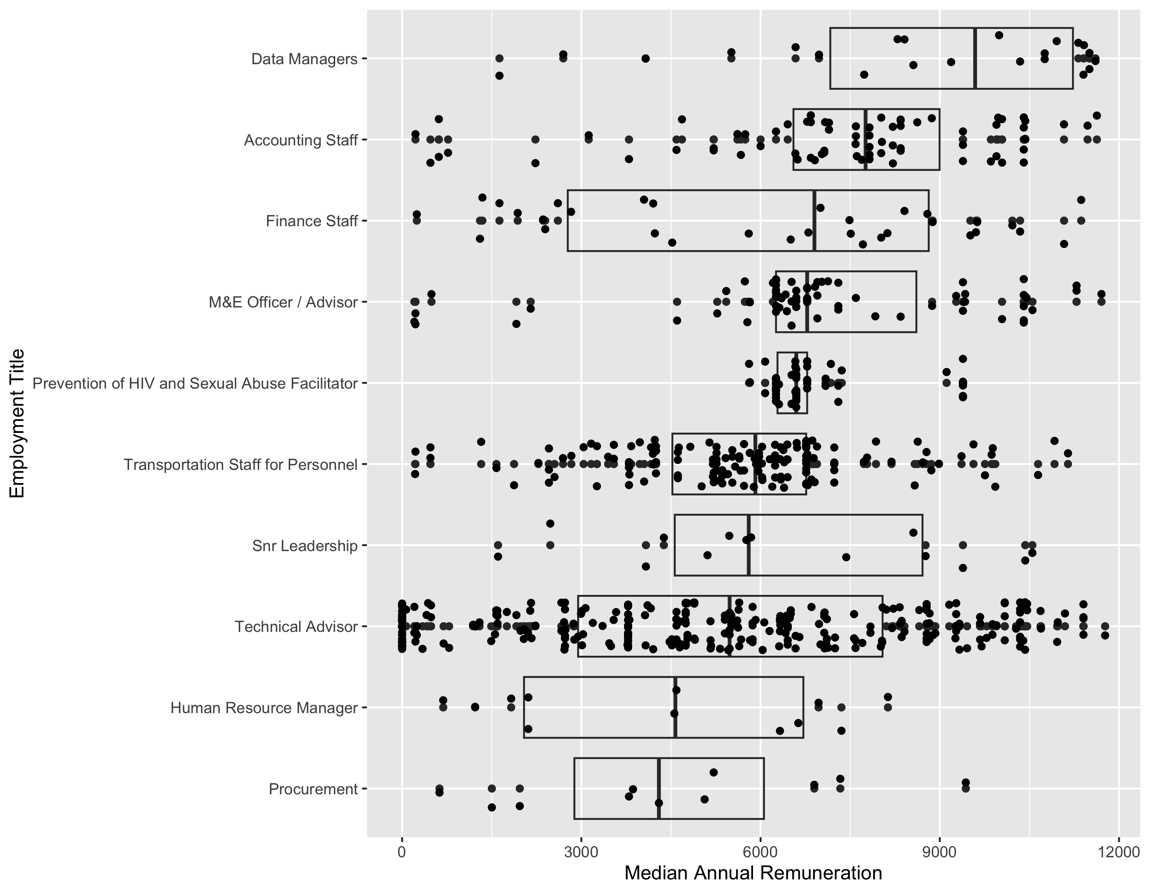

## FY23 Local Partner Staffing Expenditures by Program Area

