FY24 Human Resources for Health (HRH) Inventory Summary - Lesotho

GH/OHA/SPS/HWF

17 December, 2024

## Background

This HRH Inventory Briefer provides a detailed summary of the FY24 HRH Inventory for Tanzania. This report will summarize the HRH inventory templates submitted by prime implementation partners to help Mission teams better monitor and understand their PEPFAR-supported staffing footprint.

Missions should use these briefers to review their staffing investments and trends at the OU level to inform programming and facilitate HRH planning. If there are questions on the summary info provided here, please reach out to the HRH Reporting Helpdesk ([hrh-reporting-helpdesk@usaid.gov](mailto:hrh-reporting-helpdesk@usaid.gov))

## FY24 HRH Inventory Completeness and Data Quality

This table shows the number of mechanisms (and their associated staffing expenditure) in Lesotho that submitted both the ER and HRH inventory templates for FY24. This allows us to better understand the overall completeness of the HRH inventory in terms of the number of mechanisms that were submitted, and the total dollar value that was reported to HRH compared to ER.

The total staffing expenditure reported in HRH and ER by USAID, CDC, and other agencies should closely match each other. The reported HRH and ER staffing expenditures will not always exactly match each other, but are still expected to be aligned. HRH and ER reporting from each implementing partner must collaborate together to ensure alignment of reported staffing expenditure. If there are mechanisms that submitted staffing expenses in their Expenditure Report, but did not submit their HRH inventory template, please follow up with partners accordingly to ensure timely submissions in the next reporting cycle.

Submission Rate by Agency

| Funding Agency | No. of HRH Submissions | No. of ER Submissions | HRH Expenditure Amount (USD) | ER Expenditure Amount (USD) | HRH Expenditure as % of ER Expenditure |
| --- | --- | --- | --- | --- | --- |
| USAID | 8 | 8 | $20,783,764 | $20,695,102 | 100% |
| CDC | 7 | 7 | $11,953,751 | $11,829,547 | 101% |
| Other | 0 | 1 | $0 | $539,372 | 0% |
| Total | 15 | 16 | $32,737,515 | $33,064,021 | 99% |

## FY24 PEPFAR vs USAID HRH Staffing footprint

This provides a summary of USAID’s staffing size relative to the overall PEPFAR program in Lesotho. This shows USAID’s staffing footprint relative to the full PEPFAR staffing footprint (individual count and full time equivalence), the % of spending going towards staffing, and the amount spent by local prime implementation partners. This serves as an indicator for USAID’s level of staffing investment in the country relative to other implementing agencies.

HRH Summary: By The Numbers

| Funding Agency | HRH Staffing Expenditure | Individual Count | Total FTE (Full-Time Equivalence) | % of Total Expenditures Spent Towards HRH | Local Partner HRH Staffing Expenditure |
| --- | --- | --- | --- | --- | --- |
| PEPFAR | $34,106,745 | 6,067 | 3,493 | 54% | $0 |
| USAID | $21,859,865 | 4,151 | 2,519 | 59% | $0 |

## Funding Agency

Breakdown of HRH expenditure and number of individual staff supported by USAID, CDC, and other agencies. This provides a summary of the total staffing expenditure and total headcount that are being supported by each agency to implement their FY24 program activities.

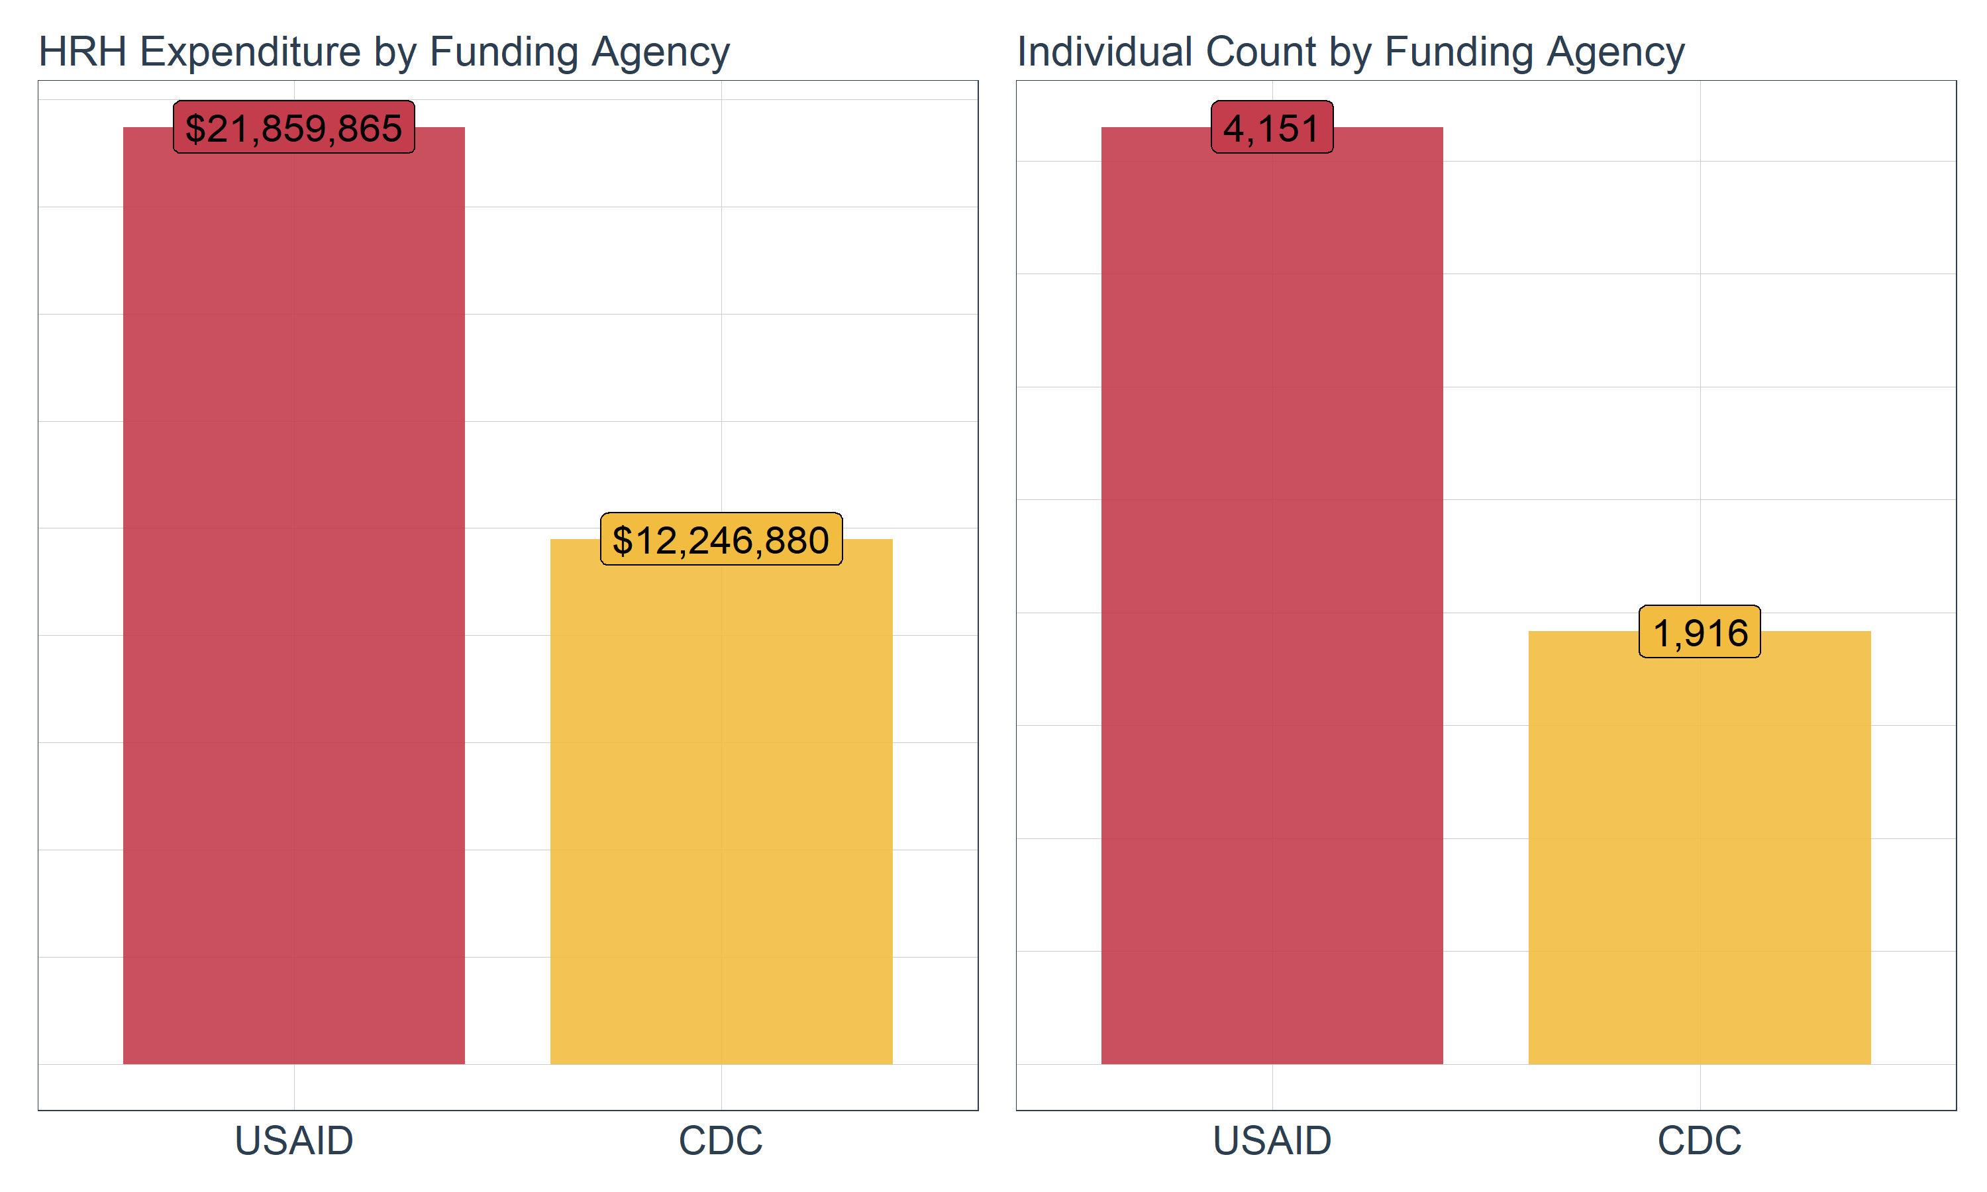

## Primary Program Areas

Breakdown of total HRH expenditure and number of individual staff by primary program area for USAID. This shows a general view of which program areas that staff are ‘primarily’ working on. Note that the HRH inventory collects data on ‘primary’ program areas where staff can only be categorized towards one program area that accounts for most of their worker time. While staff may be working on multiple program areas, staff can only be categorized towards one program area in the HRH inventory.

With this in mind, we typically see higher Program Management (PM) and Above Service Programming (ASP) staffing expenditures while seeing lower staffing expenditures for Prevention (PREV), Socioeconomic (SE), or HIV Testing (HTS). This may indicate that non-service delivery staff may be higher cost (though lower by staff count) compared to service delivery staff working at community level (with higher staff count, but lower cost)

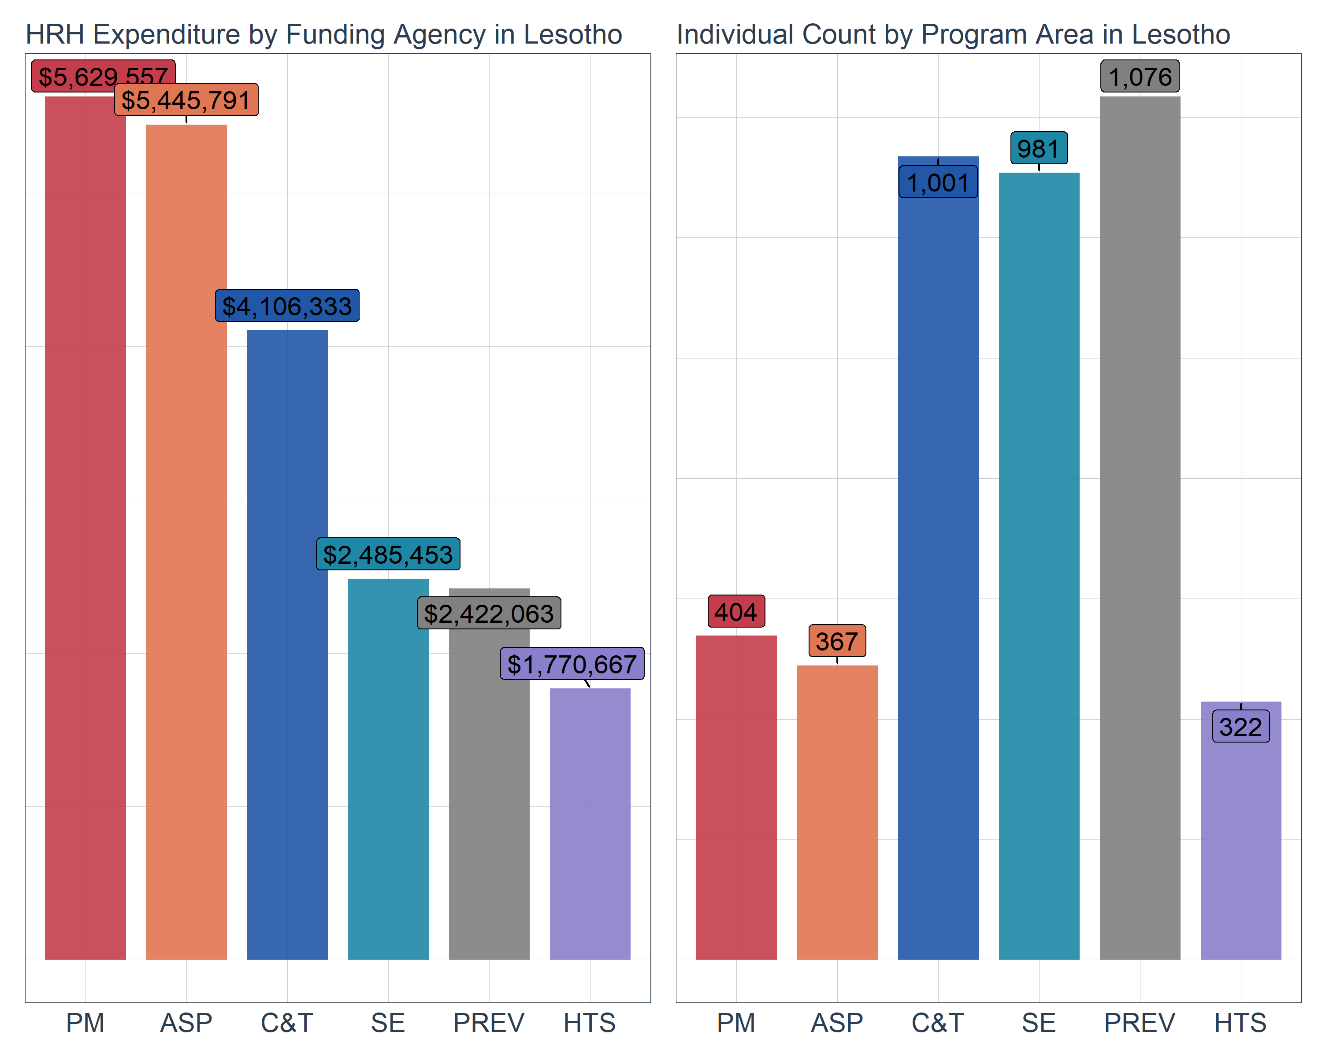

## Top Employment Titles Based on Individual Count

This shows the top 5 employment titles supported by PEPFAR USAID based on individual count. The most common employment titles with the highest staff count are typically community-based staff providing direct service delivery.

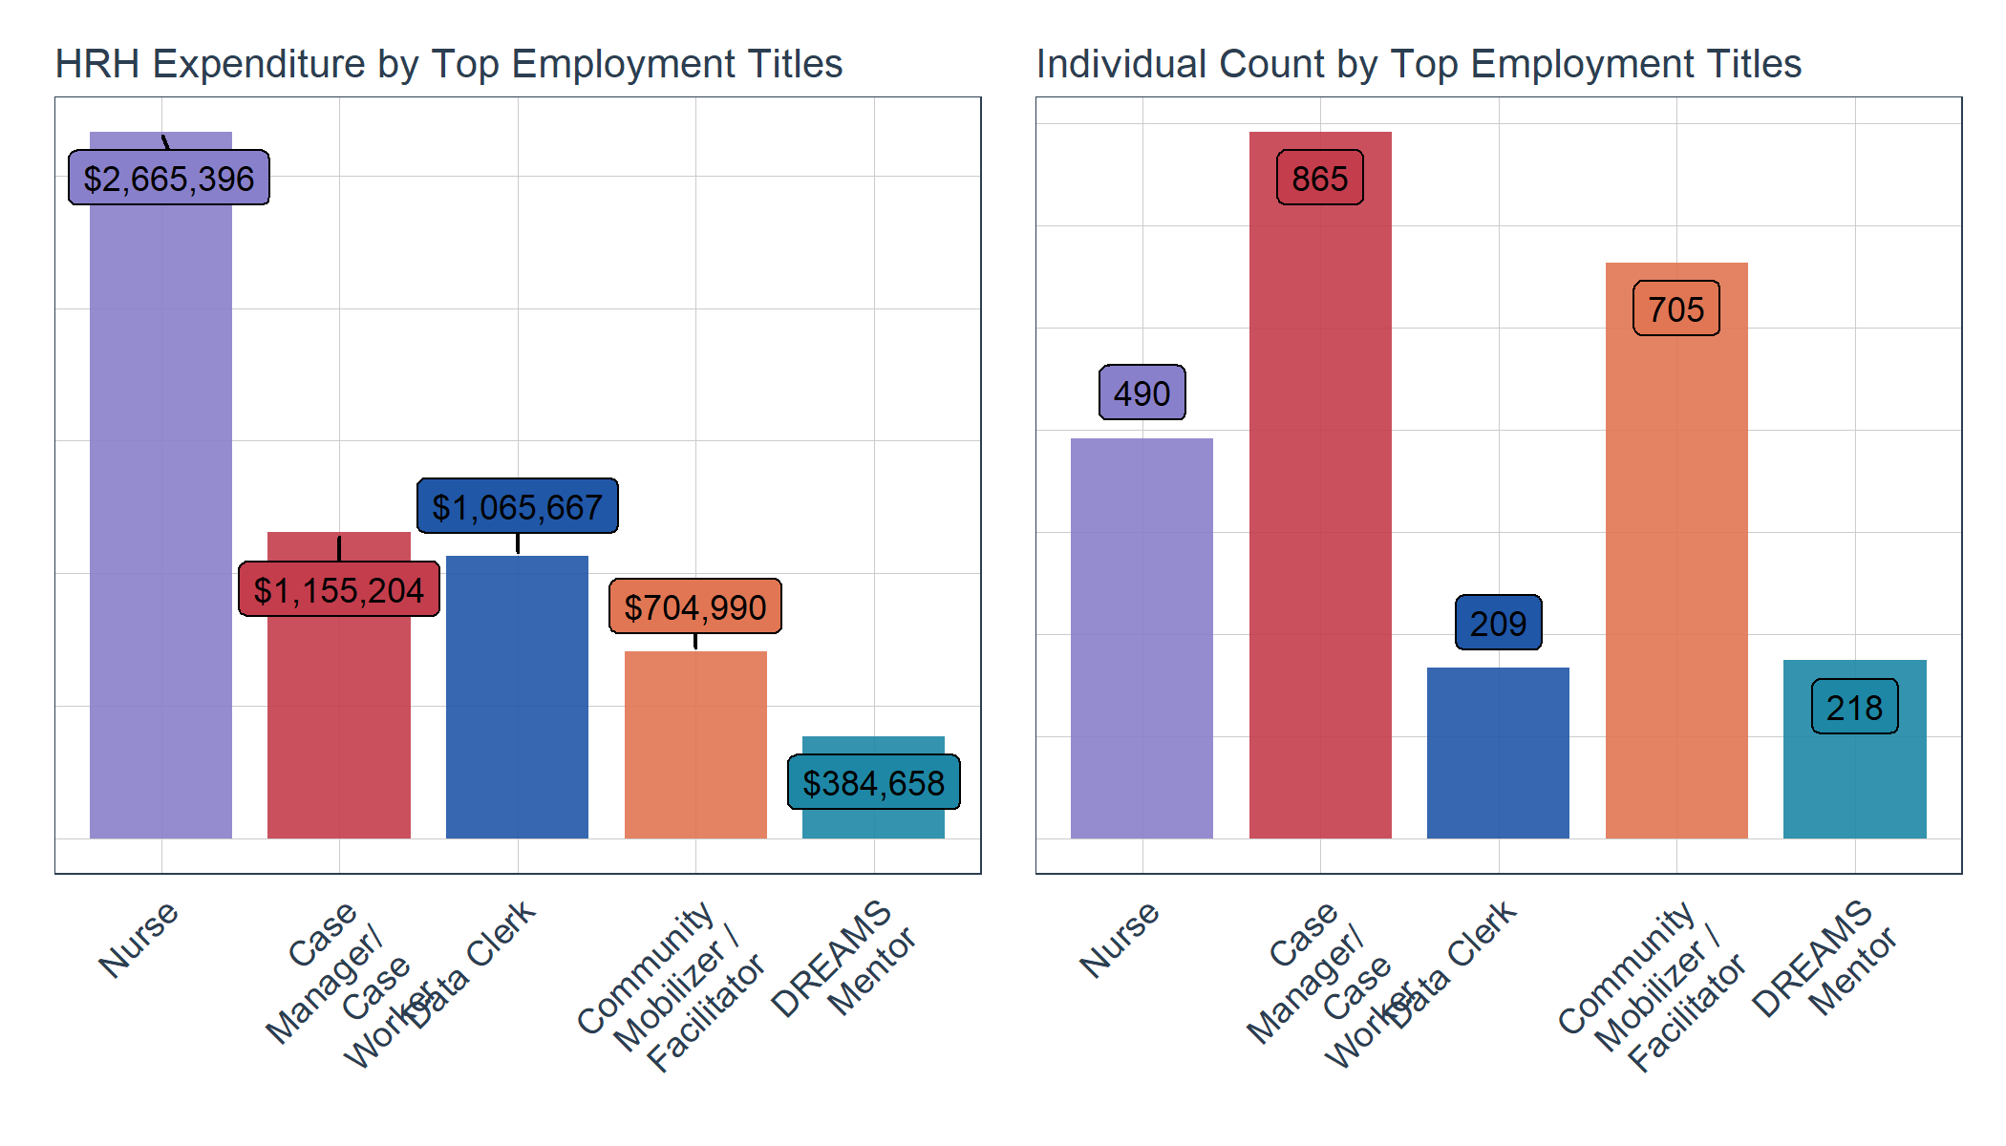

## Top Employment Titles Based on HRH Expenditure

This shows the top 5 employment titles supported by PEPFAR USAID based on HRH expenditure. The most common employment titles with the highest HRH expenditure are typically above site, non-service delivery staff

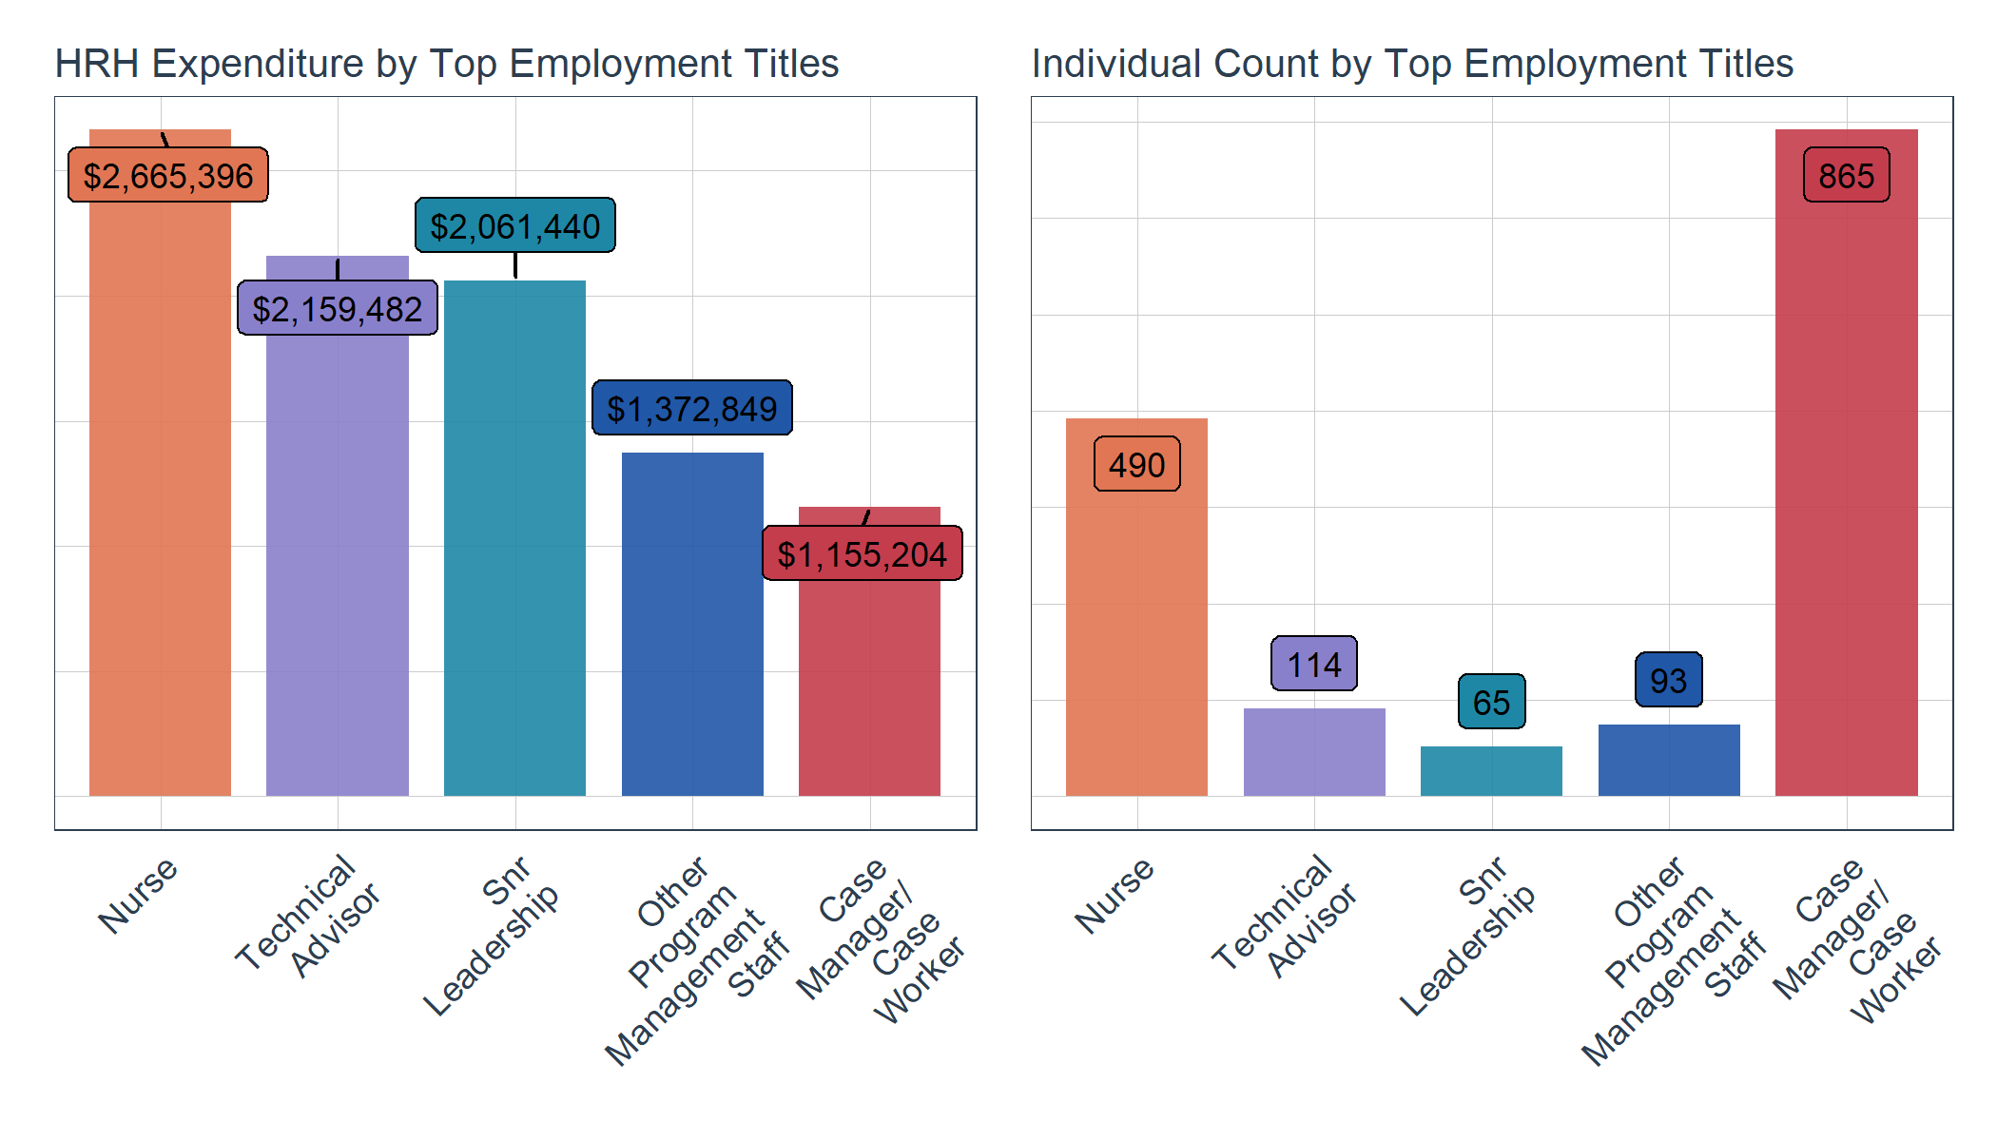

## Median Annual Remuneration

This scatter plot shows the median annual remuneration (i.e. estimated annual salary) of the top 10 employment titles among USAID IPs. This graph shows the range of remuneration for each employment title where each dot represents an individual’s estimated annual remuneration.

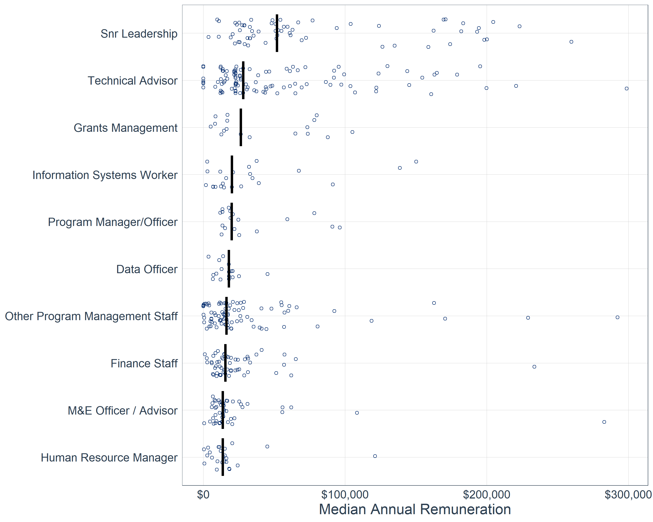

## Local Partners

This shows how much of USAID’s HRH expenditure is channeled through prime local partners for each primary program area. Note that Local Partners here are defined as local organizations that were awarded as the prime partner, and not as sub-awardees/subrecipients. If a local organization is a subrecipient while the prime partner is an international organization for a given mechanism, then the subrecipient’s staffing expenditures will be considered as non-local. This should provide a picture of the level of local partner involvement in implementing PEPFAR USAID program activities prime partners.

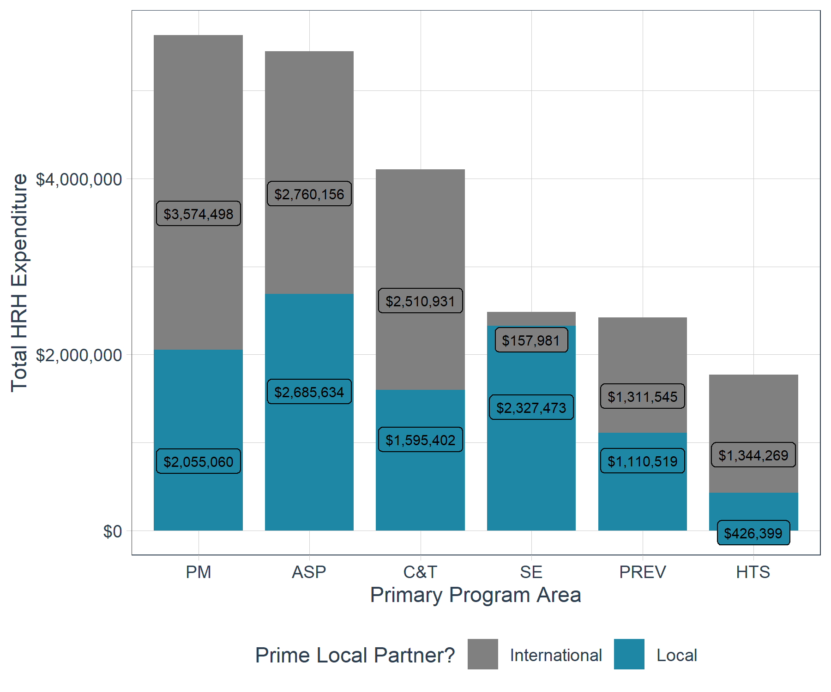

## Work Location

This shows the work location of USAID staff in terms of HRH expenditure and individual count. Examine to identify where most staff are located and if this is reflective of the program.

Above site staff are defined as personnel that are not directly interacting or providing services to beneficiaries (e.g. TA personnel or support staff based mostly in offices). Roving staff are direct service delivery staff that are providing services in multiple facilities.

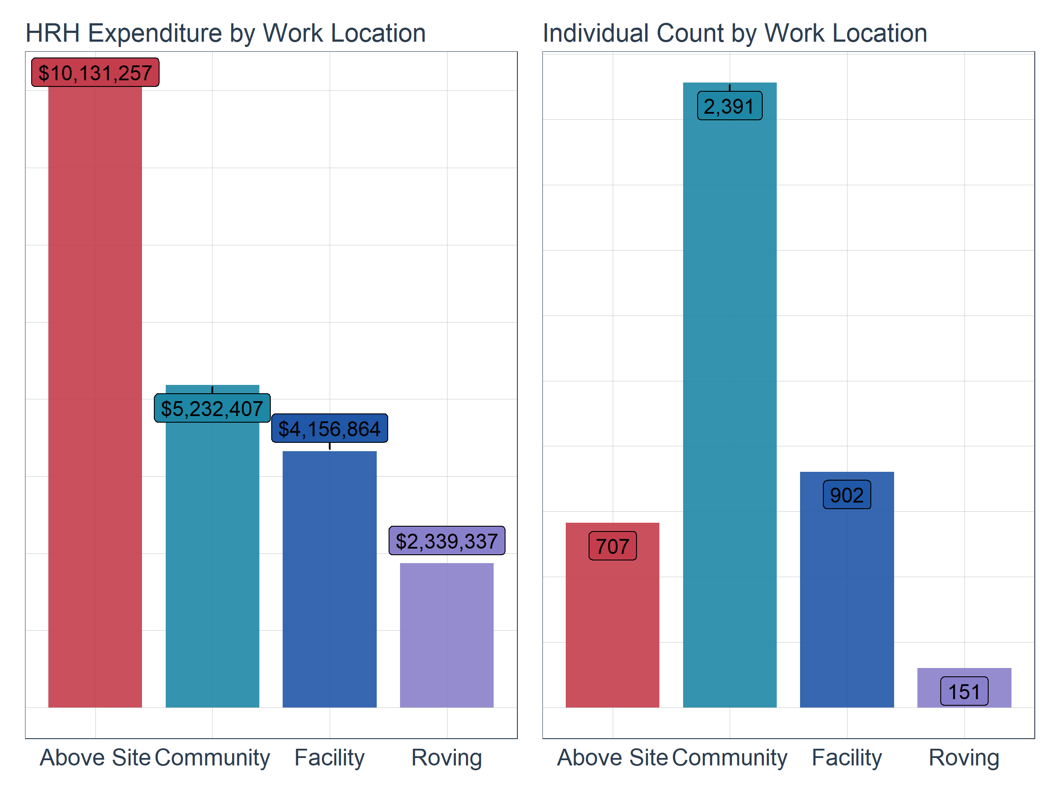

## Top Employment Titles for Community-Based Staff

This shows the most common employment title for community-based staff by count

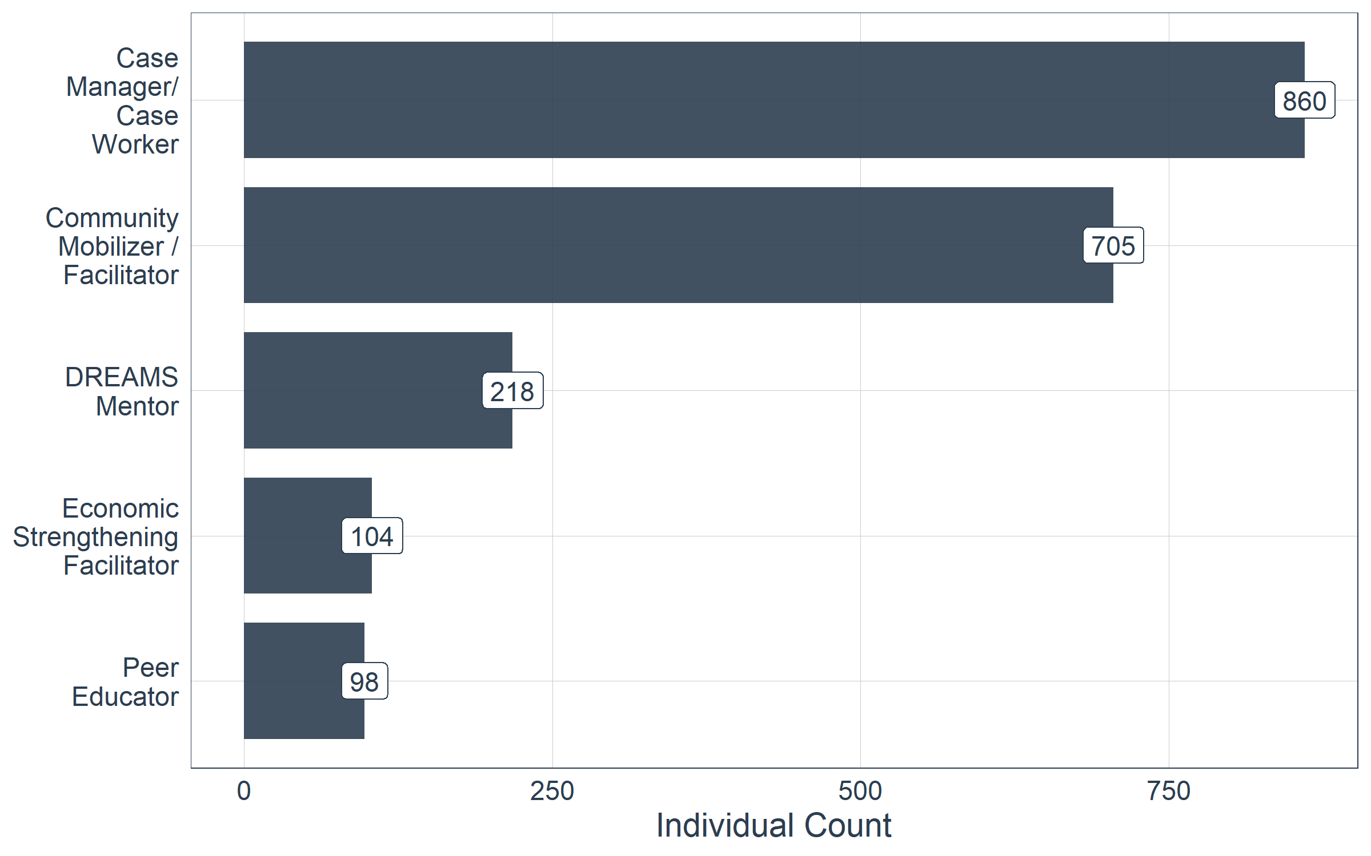

## Top Primary Beneficiaries for Community-Based Staff

This shows the top primary beneficiaries supported by community-based staff by count

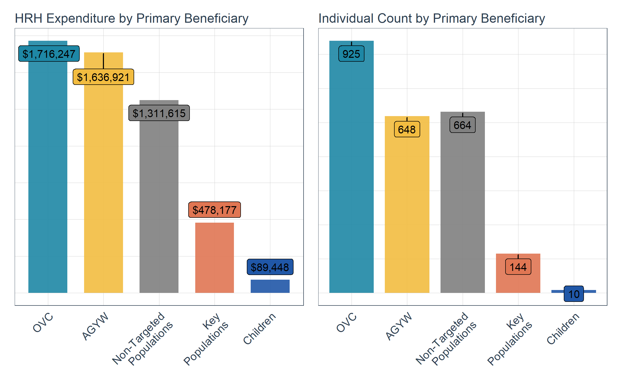

## Top Prime Implementation Partners

This shows the top 5 prime partners with the highest staffing footprint in terms of HRH expenditure. Each prime partner is disaggregated by primary program area to indicate the program activities that each partner is primarily engaged in. If requested, we can also provide a deeper dive review of each top implementation partner to better describe their staffing composition.

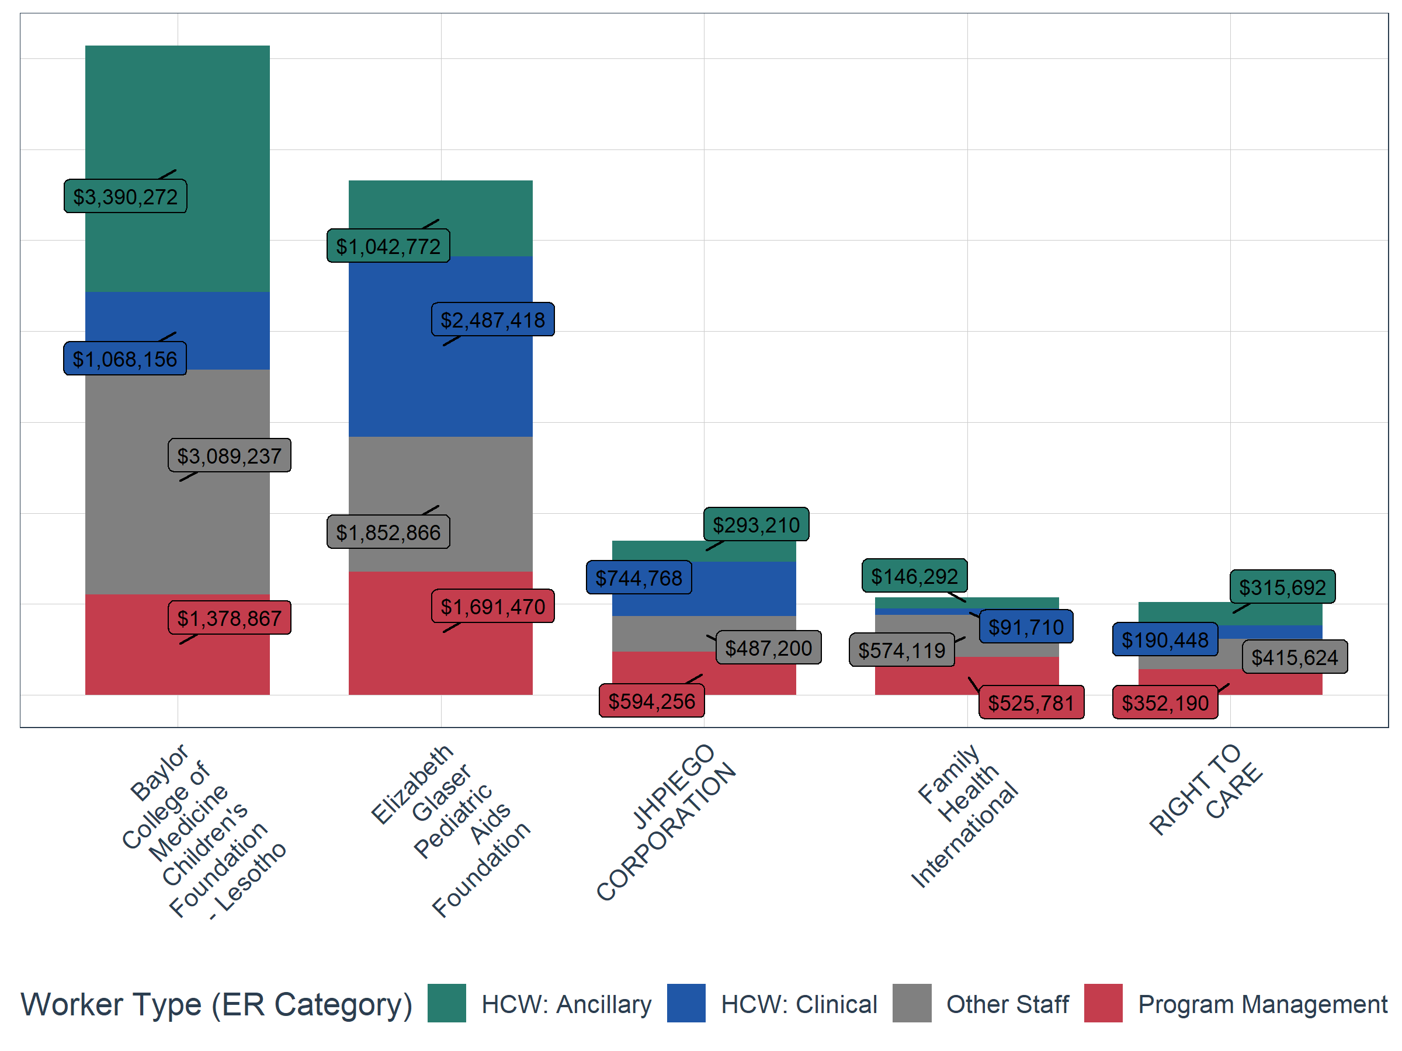

For more detailed analysis of the FY24 HRH Inventory dataset, please contact the HRH Reporting Help Desk ([hrh-reporting-helpdesk@usaid.gov](mailto:hrh-reporting-helpdesk@usaid.gov)). This may include program-specific deep dives of C&T, DREAMS, OVC, and/or KP mechanisms or reviewing the data using more customized visuals.