Mock Data Viz Markdown file

Prasann Ranade

04/19/2023

# Test Markdown Document to display visual alongside script

## Read in data

df <- si_path() %>%   
 return_latest("FY48-49") %>%   
 read_csv()

## ℹ Latest file in 'Data' matching 'FY48-49': 'FY48-49_MilkyWay_Cascade_data (1).csv'  
## Rows: 96 Columns: 10  
## ── Column specification ────────────────────────────────────────────────────────  
## Delimiter: ","  
## chr (5): planet, region, indicator, indicator_description, disaggregate  
## dbl (5): fiscal_year, qtr1, qtr2, qtr3, qtr4  
##   
## ℹ Use `spec()` to retrieve the full column specification for this data.  
## ℹ Specify the column types or set `show_col_types = FALSE` to quiet this message.

get_metadata()

## ℹ Latest file in 'Data' matching 'OU_IM_FY21': 'MER_Structured_Datasets_OU_IM_FY21-23_20230210_v1_1.txt'  
## ℹ metadata is now stored as a global object and metadata items can be accessed via `metadata$...`

## Filter data

df_tx <- df %>%  
 filter(planet == "Saturn",  
 disaggregate == "Total Numerator") %>%   
 group_by(planet, region, indicator, fiscal_year) %>%   
 summarise(across(c("qtr1","qtr2","qtr3","qtr4"), sum, na.rm = TRUE)) %>%  
 ungroup()

## Warning: There was 1 warning in `summarise()`.  
## ℹ In argument: `across(c("qtr1", "qtr2", "qtr3", "qtr4"), sum, na.rm = TRUE)`.  
## ℹ In group 1: `planet = "Saturn"`, `region = "Dione"`, `indicator = "HTS_TST"`,  
## `fiscal_year = 2048`.  
## Caused by warning:  
## ! The `...` argument of `across()` is deprecated as of dplyr 1.1.0.  
## Supply arguments directly to `.fns` through an anonymous function instead.  
##   
## # Previously  
## across(a:b, mean, na.rm = TRUE)  
##   
## # Now  
## across(a:b, \(x) mean(x, na.rm = TRUE))

## `summarise()` has grouped output by 'planet', 'region', 'indicator'. You can  
## override using the `.groups` argument.

## Visualize data

df_viz <- ggplot(df_tx) +  
 geom_col(data = df_tx, aes(x = indicator, y = qtr1, fill = indicator)) +  
 geom_col(data = df_tx, aes(x = indicator, y = qtr2, fill = indicator)) +  
 si_style_xgrid()  
  
plot(df_viz)

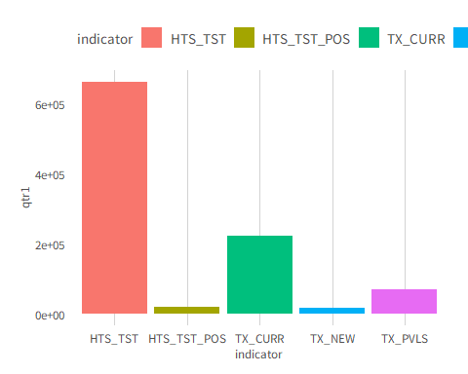

#save plot  
si_save("Images/md_plot.png")  
#si_save("Graphics/md_plot.svg")

This is a description of the plot as a sample write-up in markdown.