**Assessment Strategy**

Appendix List:

* Resume review instructions ("Reviewing Resumes")
* Understanding the SME-QA Process
* Developing Core Competencies
* Rating Guide
* Interview Rating Template

**Multiple-Hurdle Assessment Process**

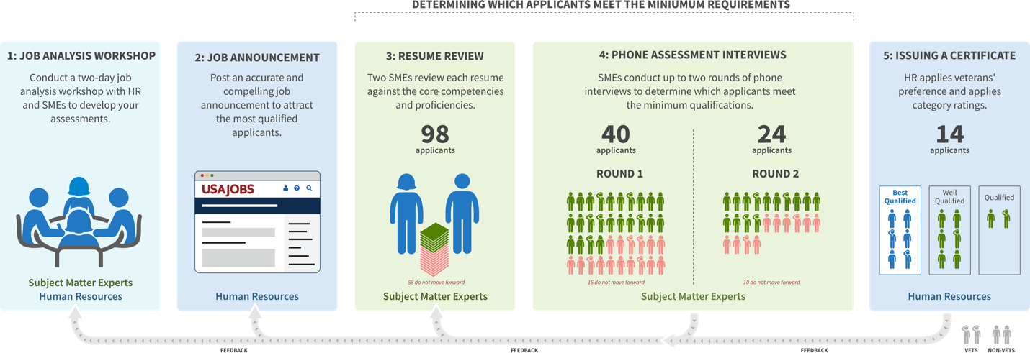

**Job Analysis**

Based on job tasks performed in these positions at {AGENCY} SMEs, HR, and Hiring Managers will come together to professionally develop the competencies, proficiency levels, and structured interview questions that will define the assessments. SMEs will use this package to conduct technical evaluation during the process.

See "Developing Core Competencies" (Appendix) for details on creating the job analysis package.

**[Customize this section if the job posting is for multiple parentheticals]**

{AGENCY} will hire for {JOB GRADE} positions across multiple parentheticals. They will share SMEs across the parentheticals to determine which core competencies are required for all positions. In addition, the SMEs for each parenthetical will develop one additional competency, required proficiency level, and interview questions (one each for breadth and depth interviews) required for that parenthetical.

All SMEs will assess all competencies in the resume review step and breadth interview. However, only the SME for a specific parenthetical will conduct the depth interview for applicants who choose that parenthetical. If the applicant chooses more than one parenthetical, multiple SMEs (one from each parenthetical) may be required for the depth interview.

**Job Announcement**

The Job Announcement (JOA) will inform applicants that only the first {NUMBER} pages of their resume will be reviewed. However, SMEs can use the first {NUMBER} pages of work experience should work experience not be listed until page two based on the use of USAJobs Resume Builder technology or another formatting issue.

**(Customize this content if the job announcement is for multiple parentheticals)**

During the application process, applicants will choose from a list of four parentheticals (including {GENERALIST ROLE NAME}). They will be told to choose no more than two, but if they choose more, they will only be considered for the first two selected (in the order listed on the USA Jobs posting). Applicants will then only be evaluated for up to two parentheticals, and thus can only be deemed qualified for up to two parentheticals.

**(Customize this content if the job announcement will be pulled early for any reason)**

This DE job announcement will close on midnight the day the number of applicants reaches 100, thus total applicants may exceed 100.

**Pre-Qualification Resume Review**

HR will review all resumes to remove applicants whose applications are ineligible for federal employment due to U.S. citizenship and requirements.

For remaining applicants, their resumes will be reviewed by two to three SMEs. Two SMEs will each give a rating of **Move Forward** or **Does Not Move Forward**. A third SME may be needed to break a tie between the first two SME assessments. The appendix includes documents explaining the process by which applicants either move forward to passing score assessments or are screened out.

**See Appendix for resume review instructions ("Reviewing Resumes") and the Rating Guide.**

**HR Resume Review**

When the SME resume review is complete, HR will not be conducting a separate qualifications review to validate the SME decision. HR will instead ensure SMEs have provided necessary justification, as per the Resume Review Instructions document and SME resume review training. If any documentation is lacking, HR will work to ensure SMEs complete their notes.

After resume review, HR may choose to conduct quick phone calls with each applicant who has moved forward to the next stage. The purpose of this call is to ensure the applicant is aware of key job details including location, salary, and background check. HR can also achieve this by emailing this information to the applicants along with their invitation to interview.

Finally, when the scheduler emails the applicants instructions on how to schedule a time slot for their interview, the applicants will be told that the first round of phone interviews must take place within a given timeframe (e.g. 8 business days) in order for the applicant to be considered for the position. In addition, applicants will be instructed that they should respond within two business days to schedule their appointment, and if they don’t schedule the interview within one week of the email notice, they will be removed from consideration.

**Passing Score Assessments**

**See Appendix for Understanding the SME-QA Process and how to use the Rating Guide.**

The passing score assessments examine which applicants meet the competencies and proficiency levels to determine who is qualified.

As explained in "Understanding the SME-QA Process," the agency's SMEs will conduct the assessment hurdles and select which applicants do not move forward based on professionally developed assessments. Anyone an SME determines is unqualified based on the pre-determined technical competencies will not be added back after each round. Instead, HR will adjudicate and apply Veterans’ preference only to applicants who achieve the overall passing score after the second interview.

During each phone interview, one SME will assess the competencies and proficiency levels defined during job analysis. The SME will write thorough notes about the applicant’s answers in the structured interview question guide.

The SME assessing the applicant will provide an assessment rating based on the competencies and proficiency levels in the Rating Guide provided in the Appendix.

**HR Interview Assessment Review**

After each interview round, HR will review each SME's analysis within the interview template to ensure the SME provided the necessary justification. If any documentation is lacking, HR will work to ensure SMEs complete their notes. HR will transfer the rating into the final score using the provided transmutation table found in the Rating Guide.

**Certificate**

When the list of applicants who have achieved an overall passing score is complete, HR will assign those applicants to a quality category using SME interview assessment scores and apply veterans’ preference. HR will also ensure that the applicants who appear on the certificate are eligible at the grade level being hired for before issuing the certificate. Hiring Managers may choose to conduct additional interviews after receiving the certificate, or they can make immediate selections based on the resumes and interview transcripts.