CANCER ANALYSIS
AT FRED HUTCH
Rear Fleet Admiral Executive Commander of Naval Material
Correo Andrew Hofstad I, United States Navy

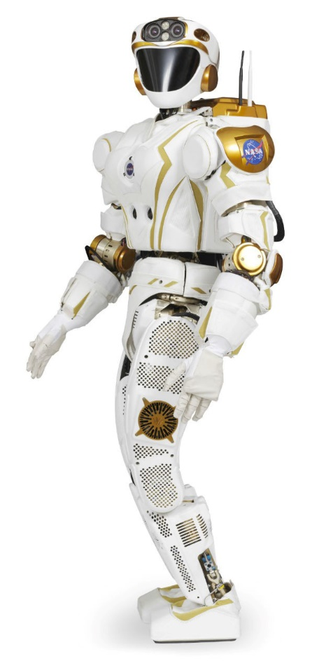
INTRODUCTION
In 2008 U.S. Army Medical Research Institute of Infectious Diseases (USAMRIID), the University of Washington, and the Fred Hutchinson Cancer Research Center developed robotics systems for remote operation of Level 4 laboratories. In 2023, The United States Army Medical Research Institute of Chemical Defense (USAMRICD) opened remotely operated laboratories for monitoring experiments carried out by NASA robots. A non-living robot in the lab does not attract viruses and can work unlimited hours without sleep. With 24 hours of extra lab time, researchers have time to look at old cases, outbreaks, and plagues. Studying biology in retrospect allows scientists, engineers, and medical professionals to look at previous outbreaks, and extract facts. With robots, we look back to plagues that existed when we had no technology.
Researching biology in retrospect, with robot-assisted third-party microscopy, and protein sampling allows scientists and engineers to take their time in collaboratively identifying features and characteristics of virus proteins. Archived diseases, parasites, and infectious viruses are being reinvestigated using modern technology and scaled up by investigating data and recordings of Pycnogonida (phage virus parasite) and Physalia Physalis (plasmodium parasite) from all angles.

PYCNOGONIDA (PHAGE VIRUS PARASITE)
The pycnogonida parasite is a lithium-based aquatic crustacean. The phage virus is the youngest and smallest generation of a Pycnogonida’s offspring. The phage virus parasite is tophaphagous, aggressive, intelligent, and parasitic, highly invasive. Pycnogonids survive by hunting warm-blooded creatures. A pycnogonid will consume prey that is smaller than itself using powerful jaws to break flesh and drain internal fluids. Pycnogonids enter prey larger than itself via available body cavities such as the mouth, nostril, genitalia, anus, eyes, and ears, or penetration of the epidermal layer. Once inside a targeted prey, a pycnogonid attaches itself to internal organs and survives as a parasite. Once pycnogonids parasites enter a targeted host, the species reproduces rapidly at an exponential rate through gonopores on each of the species' eight legs. Phage viruses that spawn from the pycnogonid parasites reproduce at a rate that most host species cannot fight off via a natural immune system response.

STEREOCHEMISTRY
LOW-RESOLUTION VIRUS STEREOCHEMISTRY
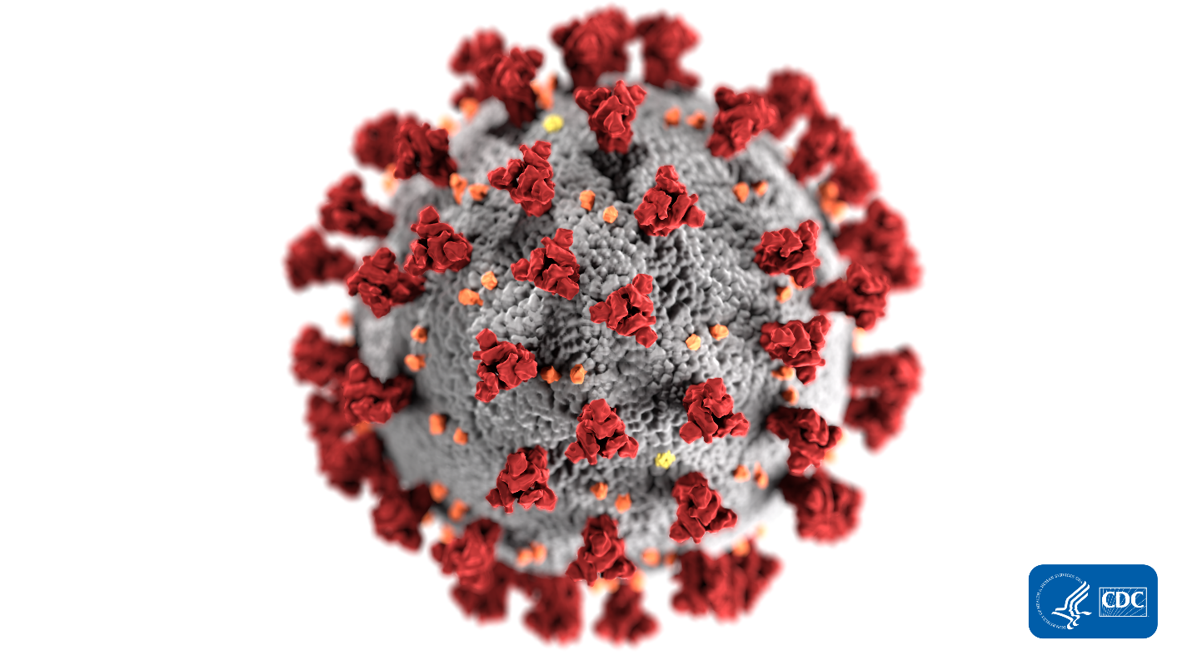
The currently accepted theory of what a virus is has been formed and accepted via past generations throughout an ever-evolving field of Microscopy. Science currently accepts that a virus cell is a spherical membrane covered by numerous protuberances that come in two shapes. One shape is referred to as a spike and the other shape is referred to as something like a small bundle. Current virus theory accepts that these spherical cells and protuberances found under microscopes are all part of a single species.

HIGH-RESOLUTION STEREOCHEMISTRY
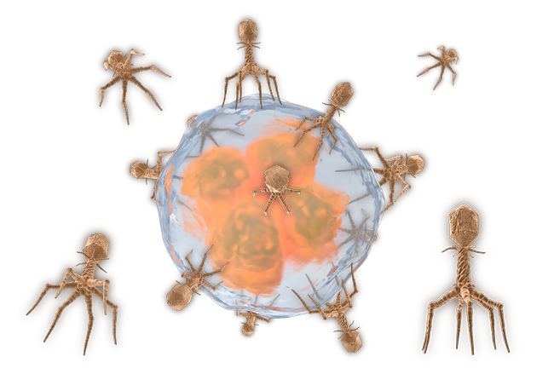
Nearly a century after the great influenza outbreak of 1918, the United States Military has industrialized the use of large-breed phage viruses or pycnogonida. Engineers and scientists have died witnessing the reproductive or spawning habits of the species from a much larger perspective than any microscope could provide during the 1918 pandemic. Tritium is harvested from Pycnogonida which are 20 meters in diameter on many nuclear aircraft carriers, submarines, and power plants.
Researching phage virus stereochemistry from larger pycnogonida species provides dimensional analysis, high-resolution microscopy, and new insights into what these shapes represent. When viewed as one complete image, the spherical membrane covered in protuberances is a spherical cell that has fallen host to parasitic infection. Instead of a single cell with protuberances, we are looking at a cell being absorbed by octoped phage viruses and plasmodium parasites.

EXOSKELETON
The phage virus parasite consists of a crustaceous body with an exoskeleton composed of a sugary carbohydrate. In 1917 Oswald Avery of the Rockefeller Institute first discovered that pneumococci phages were surrounded by a capsule of polysaccharides, a pure carbohydrate sugar shell. In Avery’s first research paper on the subject, he investigated these “specific soluble substances”.
The crustaceous shell of the phage virus parasite is the polysaccharide capsule of the phage virus. In both the large breed pycnogonida and the microscopic phage virus, the composition and stereochemistry of the lifeform is the same. The exoskeleton of the phage virus parasite is a low-Ph acetic sugar that provides physical protection to the internal gelatinous mass of the species. The exoskeleton becomes tempered at elevated temperatures and is extraordinarily strong. In a parasitic infection of any phage virus parasite, the exoskeleton is nearly impenetrable to the immune system of a host.
Although the exoskeleton of the phage virus parasite provides great physical tensile strength, the chemical composition of low Ph acetic sugar carbohydrates is the species' primary weakness. In an alkaline environment, or when in contact with an alkaline substance, the polysaccharide capsule or exoskeleton of the phage virus parasite completely dissolves. Upon dissolution of the carbohydrate exoskeleton/polysaccharide capsule of the phage virus parasite species, a gelatinous globule of purple-colored mass of internal organs will remain. This purple gelatinous mass is the physalia physalis, known in pathology terms as the plasmodium parasite.
During the great influenza of 1918, it was discovered that the immune system could not attack pneumococci surrounded by capsules, but easily destroyed pneumococci without capsules. Exactly one century before the worldwide epidemic of COVID-19, pneumococci with intact exoskeletons were growing rapidly in the lungs of their hosts and killing within weeks, days, and even hours.

REDOX (MELTDOWN) PROCESS
When an alkaline environment or substance reduces the oxidized polysaccharide hydrocarbonate capsulized exoskeleton of the Phage virus parasite, the internal mass that remains is the plasmodium parasite. Sections of the phage virus parasite's legs, body, head, tail, and ovigars dissolve via REDOX reactions quickly within minutes when in contact with a reducing agent. Complex coil groups once anchored to points of the exoskeleton become one big hanging mess. Dissolving the oxidized shell, exoskeleton, or polysaccharide capsule of the large breed pycnogonida or microscopic phage virus, leaves the large breed physalia physalis or microscopic plasmodium parasite. The damage done to the coils and anchor points within the exoskeleton and the bloating of the bladder of the resulting physalia physalis during a REDOX reaction is violent. In a liquid or aquatic environment, the coil structures that are externally visible in the physalia physalis species immediately become intertwined in a randomly contorted mess. The randomly intertwined bundle of coils hangs from a balloon-like body which expands after losing the pressurized capsule or exoskeleton.

PLASMODIUM PARASITE TOXICITY
Scientists Oswald Avery and Fred Griffith published theories that pneumococci species with dissolved capsules could somehow be observed under the microscope transforming into species with intact capsules. Modern observations of physalia physalis without an oxidized exoskeleton or hydrocarbonate polysaccharide capsule have revealed the birth of new spawns of phage virus parasite from physalia physalis. physalia physalis give birth to new phage virus parasites with intact capsules in the form of nematocysts which spawn from select coils protruding from the blue-purple gelatinous mass.
Infant phages (Nematocysts) hatch from gonopores within the exposed coils. Coils that come in contact with a species of prey can inject nematocysts into a host via a “sting” which allows the infant nematocysts to grow as a parasite infection, further spreading the species and continuing its lifespan.
A phage virus parasite that loses its protective structure from contact with a reducing agent. may release millions to billions of smaller physalia physalis and plasmodium parasites which all simultaneously lose their protective structures. Each generation of damaged physalia physalis has within its reproductive coils, new generations of intact phage virus parasites. Larval phage virus parasites within physalia physalis reproductive coils are called Nematocysts. Each generation of phage virus parasite produces new spawns from its gonopores simultaneously.
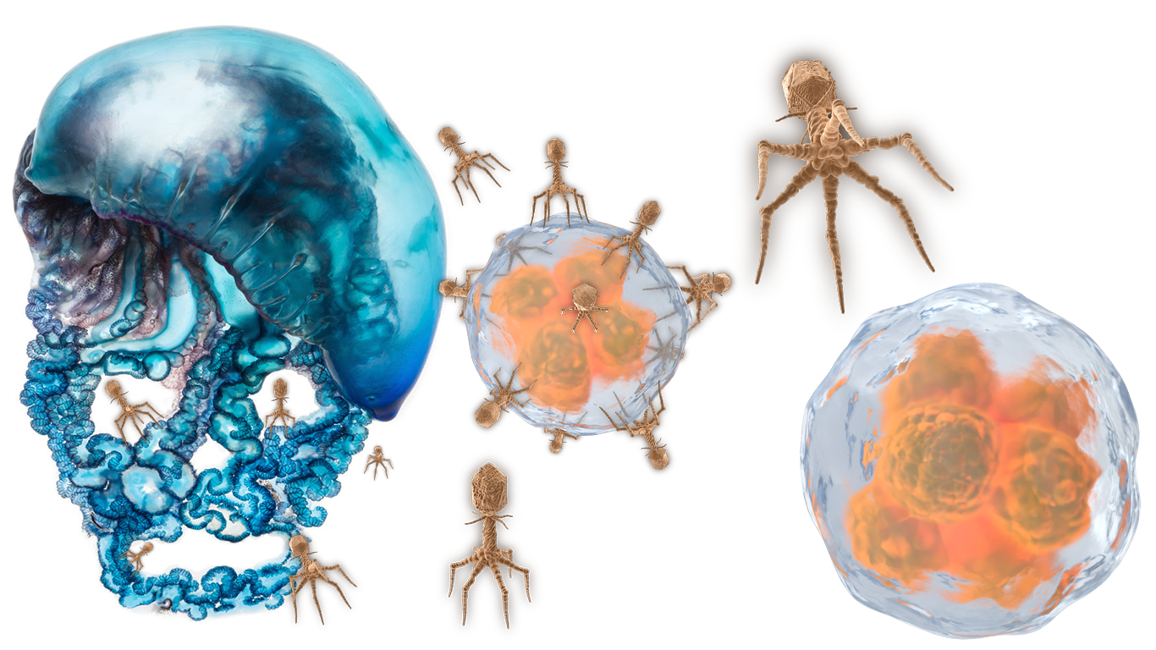

PHAGE REPRODUCTION
In an intact phage virus parasite, reproductive coils lead to gonopores in the legs of the species. Gonopores are exposed openings that give birth to exponentially polyping generations of new phage virus parasites. A single gonopore exists on each section of every leg, between each joint. With eight legs, each having five sections, the pycnogonida has 40 gonopores. Every gonopore can simultaneously spawn a single phage virus parasite. Every generation of newly spawned phage virus parasite grows from its parent's gonopores until it is released, often occurring only in the presence of survivable habitat or targeted host for parasite invasion. Each generation of spawned phage virus parasite is capable of spawning newer generations from its gonopores, even while still attached and growing from its own parent’s leg.
In effect, a first-generation pycnogonida with a 3-meter leg span may spawn 40 attached pycnogonida offspring with leg spans of 2 decimeters. 40 second-generation 2dm pycnogonida may simultaneously spawn 1600 attached pycnogonida with a 2cm leg span. The 1600 third-generation pycnogonida may spawn 64,000 attached pycnogonida with a 2mm leg span. The 64,000 fourth-generation pycnogonida may spawn 2,560,000 attached phage virus parasites with a 200-micrometer leg span. The 2,560,000 fifth-generation phage virus parasites may spawn 102,400,000 attached phage virus parasites with a leg span of 20 micrometers. The 102,400,000 sixth-generation phage virus parasites may spawn 4,096,000,000 microphages.
This biological method of exponential reproduction is how viruses spread so far and so fast in short periods. A large breed pycnogonida enters a host prey and immediately releases all generations of spawn into the host’s body to spread, grow, and reproduce. This method of parasitic infection is highly effective at surviving on a host’s blood, and organs until the species can be spread throughout the host species’ population.

VIRUS TRANSMISSION
Infections in men and women have been published inaccurately as only capable of transmission via the transfer of bodily fluids. Viruses that create vesicles within reproductive organs are not limited to transfer via bodily fluid, blood-to-blood contact, or sexual transmission. Although microscopic Phages and Plasmodium parasites are often in high concentration in sperm and other bodily fluids, larger pycnogonida may become excited and exit the body via reproductive organs if the host becomes sexually aroused and/or during close intimate contact such as foreplay, etc. Most species of pycnogonida can leap up to 15 times the length of their leg span. All species of pycnogonida are capable of sprint-like speed during crawling movements.
In the 1980s during the height of the AIDS epidemic, NBA players wisely refused to play basketball with HIV host Magic Johnson to prevent an infection. Dangerous diseases such as HIV and AIDS transfer from person to person via simply crawling out of an infected person's body cavity, traveling down a pant leg, dropping out of a skirt, finding a healthy person to target, and breaching a body cavity such as the mouth, nose, vagina, penis, or anus. A virus can exit a stranger in a restaurant, travel between tables, crawl up your pant leg or dress, and enter you without even shaking hands or ever meeting the person.
Viruses are highly mobile and aggressive. Scientific investigations for Pycnogonid toxicity are suppressed to prevent fear of the nuclear industry or “widespread panic”. Doctors publish inaccurate claims that close contact such as hugs and kisses cannot transmit HIV. AIDS patients are secretly killed in hospitals when their shedding of the virus becomes too severe. Any warm body with a Ph level below 8.0 is prey for Pycnogonids. Pycnogonids are drawn to any low-Ph potential host.
All phages, cytokines, and plasmodium parasites will take every opportunity to shed from a dying host and infect a new healthy host as a source of fresh calories needed for further reproduction of the species. Once a virus population senses the death of a host, the population will exit the dying host in search of a healthy body. Viruses need a living body to survive and are aggressive in attaining one.
HIV can survive outside the body for as long as it can find calories and avoid being killed. You can catch a virus infection from someone who sat on a bus seat before you if a pycnogonida has been shed from the previous passenger. Transmission only requires that a pycnogonida run up your pant leg or get near your face. Pycnogonids target prey and violently leap into any available body cavity.
Pycnogonida parasites find suitable prey or new hosts by feeling for “charge”, or “Ph level”. Overabundances and absences of electrons in nearby lifeforms are critical to the parasites when hunting. Negatively charged “Alkaline” bodies and cells with plenty of electrons present a dangerous reducing agent to pycnogonida parasites and phage viruses. Alkaline bodies are considered a type of chemical predator to the parasite. Positively charged “acidic” bodies and cells with a lack of electrons offer no danger of chemical reduction to phage virus parasites and become infection hosts or prey.

VIRUS ABSORPTION
The current theory on virus “absorption" onto healthy cells involves the use of “spike-shaped” protuberances on the viruses called “hemagglutinin” to bind and latch onto sialic acid “receptors" on the targeted cell-like grappling hooks. As the theory continues: as more hemagglutinin binds to more sialic receptors on the cell, the virus adheres to the body of the targeted cell.
The reality of absorption is that like any other predator in the wild, the Pycnogonida must grip onto areas on its prey where its claws will fit. Once a pycnogonida gets a hold of a host with several of its eight legs, the predator will quickly grab a hold of the host with the rest of its appendages and make aggressive maneuvers to breach its prey.
Microscopy is never perfect, as scientists are forced to publish explanations for objects, lifeforms, actions, activities, and processes that they cannot see in clear focus. Fancy terminology like hemagglutinin, sialic acid receptors, and binding of the two only supply confusion to the fact that extremely aggressive eight-legged spider-like creatures are jumping onto cells and wrapping their legs around their target to grab hold wherever their claws will fit.
On both living bodies and living cells, tactics of the predatorial approach by the phage species are the same. During microscopic infancy, phage virus parasites 1/10,000th of a millimeter in diameter are doing the same thing to cells that a 3dm 3-diameter pycnogonida will do to a fully grown person.
Pycnogonida in the wild or running loose in human environments are witnessed using eight legs to crawl, run, leap, swim, and climb toward capturing a host suitable for parasitic infection and reproduction. Suitable hosts at any scale include prey with an acidic or low-Ph level, which will not break down and cook off the pycnogonida via an acid-base REDOX reaction. Hive-minded pycnogonida are highly intelligent and will use all available senses to look for an available host that will not reduce the virus.

FORMATION OF A VIRUS VESICLE (TUMOR)
As soon as phage viruses have engulfed a cell to complete the process of “absorption”, powerful claws and jaws of the phage viruses begin tearing into the cell and looking for a way inside. Phages tear open cell membranes and/or find existing cavities that attack aggressively. Once an entry point is created or found, more phages begin attacking the opening and digging themselves into pockets called “vesicles”. The vesicle is used as a tophaphagous feeding point for the parasitic phage viruses to drain calories from their new host. Once vesicles are formed in a host cell, the cavity or pocket expands as the host cell is consumed by the invading phage viruses and plasmodium parasites.
Pycnogonida invade and enter human bodies or other species using methods identical to tactics of cell invasion used by phage viruses at the microscopic level. Pycnogonids target body cavities such as the mouth, nose, ears, eyes, anus, and genitals. Pycnogonida enter the mouth or nose and use the lungs, throat, sinuses, and stomach as a vesicle. In oncology, the Tumor is the parasite’s vesicle. The Tumor grows as the species draws blood from within their new host.

EPIDERMAL INFECTIONS
Areas of a host’s epidermal layer that are ripped open by the claws and jaws of the Pycnogonida or stung by Physalia Physalis quickly become vesicles for parasite infection. Often epidermal layers are ruptured by claws or nematocysts. Nematocysts protrude from gonopores on the underside of Pycnogonida's legs and physalia physalis' tentacles. Lesions formed by species of Pycnogonida are recognizable symptoms of certain smallpox, leprosy, herpes, HIV, Equestrian Encephalitis, Malaria, Coronavirus, and multiple influenza infections. Physalia Physalis is commonly known as the “Portuguese Man O’ War” and their microscopic scale infant plasmodium parasites create vesicles via epidermal injection of nematocysts into a targeted host. Physalia Physalis and Plasmodium parasites alike wrap their prey up with their exposed tentacles. Once these parasites have a grip on a target body or cell, coils that once led to gonopores in the exoskeleton of their previous form (Pycnogonida) are used to inject nematocysts (infant Pycnogonida) directly into an epidermal layer or cell membrane.

VIRAL UNCOATING (CANCER)
EXPONENTIAL DECAY
Once an invading population of Phage viruses has successfully invaded body cavities or the epidermal layer of their targeted prey, the parasite begins consuming their host. Cancer rapidly consumes calories at an exponential rate. The processes of decay that result from parasitic infection by pycnogonida become the symptoms that create cases of cancer and infectious diseases. A host becomes not only a source of calories for the parasite but also an incubator for their new spawn.
Acidic pycnogonid parasites leach electrons and dissolve the body from within, while Tritium shed from the species becomes a multiplier for the rate of decay within the host. At a microscopic level, the process of a parasite virus dissolving a host cell is called “uncoating”. Uncoating begins with a loss of the host’s calories at an exponentially increasing rate. The pycnogonida targets healthy areas within the host’s body from which it can leach available calories from the host. A first-generation invading parasite will consume a host’s calories in excess, grow, and produce as many strong offspring as possible. Second-generation invading parasites produced from the first generations will do the same thing.
The population of parasites grows at a rate of 1+40^1+40^2+40^3+40^4 and continues for each generation. Generations can increase within the host by the hour, day, and week depending on the size and genus of the invading species. Phages, cytokines, and plasmodium parasites consume a host’s calories at an exponentially increasing rate to exponentially reproduce and spread throughout an infected host. All forms of phages and cytokines are the spawn of pycnogonida.

MEDICATED CANCERS
All forms of plasmodium parasites are forms of phage virus parasites that have been partially reduced by REDOX reaction. All forms of phages and cytokines are HAZMAT toxic. All plasmodium parasites are HAZMAT toxic. All forms of phages, cytokines, and plasmodium parasites are tophaphagous parasitic predators of proteins, fats, cells, and calories within our bodies. Processes of deficiency diseases Calorie leaching by parasites causes conditions of deficiency disease, necrosis, and degeneration. A substantial number of diseases “discovered” by science and medicine of the past and present are simply deficiency diseases defined largely by the area of infection and species variant (color, etc.) of pycnogonida. Diseases of the respiratory system, digestive system, cardiovascular system, nervous system, skeletal system, immune system, muscular system, epidermal system, glandular systems, and systems of the body’s various cavities are believed by current science and medicine to result from separate unknown factors and conditions.
DEFICIENCIES
Nearly all deficiency diseases of human systems are symptoms of parasite infection by species of pycnogonida. Processes of diseases of the bloodstream Once a virus infection enters the bloodstream, phage viruses, and their plasmodium parasites begin absorbing, forming vesicles, and uncoating a host’s internal organs. Infection of the bloodstream can lead to diseases such as hemorrhagic diseases like epistaxis. Epistaxis results from the rapid uncoating of veins, arteries, and blood vessels by phage viruses which grow too large within the cardiovascular system to support life within the infected host.
When the cardiovascular system uncoats, internal hemorrhaging and external hemorrhaging from the mouth, nose, eyes, skin, Gentelia, anus, and other body cavities result. Blood flooding the brain, termed hyperemia leaves the brain flat and dry. Blood infections of pycnogonida or Phage viruses such as HIV, AIDS, Hepatitis, EEE, etc. Are often transferred between humans via blood-to-blood contact such as mosquito bites, needle sharing, blood transfusions, etc. Processes of disease within the digestive system pycnogonida which contaminate food, and water supplies enter a host’s stomach and spread throughout the digestive system.

INTERNAL ORGAN CANCERS
These parasites cause sharp pain with their eight claws and sharp jaws as they feed on the walls of a host’s stomach and small intestine. Microscopic phages of the pycnogonida can enter the bloodstream and various organs through the digestive system. Signs of a digestive system infection may include pycnogonida which travel up the esophagus, through the throat, and out of the mouth, or those that appear in the stool during bowel movements. Pycnogonida infections in the digestive system stand for most of the stomach and bowel cancers. Processes of consumption, disease, and cancer of the internal organs Viruses attack the cardiovascular system, invade internal organs, destroy tissue, and consume the body’s proteins. Reye’s syndrome and other diseases lead to liver failure.
Virus infections cause abscesses and necrosis of the kidneys. Viruses consume protein found within glandular systems such as the adrenal glands, hypothalamus, and lymph glands leading to breakdowns in enzyme and hormone production as well as regulatory functions. Viruses are attracted to bone marrow and will reproduce rapidly once the skeleton is breached, leading to several forms of leukemia. Disease, organ failure, and cancers are the results of infections within the body by pycnogonids, Physalia Physalis, Phage Viruses, and Plasmodium Parasites. Radiation sickness and the destruction of tissue All phages, cytokines, and plasmodium parasites emit beta-radioactive Tritium into the body cavities, vesicles, bloodstream, and respiratory system of an infected host. Beta-decay of tritium from phages, cytokines, and plasmodium parasites causes radiation sickness in an infected host which is often associated as a symptom of a particular disease.

RESPIRATORY SYSTEM CANCERS
Phages, Cytokines, macrophages, Granulocytes, and RNA at their smallest detectible generation hunt and consume calories from the Circulatory system, bloodstream, digestive system, bone marrow, lymphoid tissue, liver, spleen, the white matter of the cerebrum, and the meninges surrounding the brain. The Process of Respiratory Coronaviruses and COVID Infections Pycnogonida infections of respiratory systems such as the throat and lungs are often diagnosed as diseases such as Coronavirus, COVID, SARS, Tuberculosis, Influenza such as H1N1, Cholera, emphysema, pneumonia, cyanosis, ARDS, and Bubonic Plague. These diseases are resultant of pycnogonids which have absorbed a targeted host, breached the oral or nasal cavities, created a vesicle in the lungs, and are dissolving or uncoating tissue within the lungs. Pycnogonids often attach themselves within the upper respiratory tract, below the larynx. Offspring of the first-generation invader, including microscopic phage viruses, attack epithelial cells within the upper respiratory tract and use them as calories and as incubators for the production of microscopic virus proteins. Often within ten hours of an attack by a phage virus, an epithelial cell will uncoat and burst open to release between 1,000 and 10,000 new virus cells. Epithelial cells make up the insulation or lining of the entire respiratory tract.
As a virus infection consumes a host’s epithelial cells, the throat becomes stripped and raw. A sore throat is often the first sign of a viral infection. Hosts often begin feeling symptoms during the fifth or sixth generation of the virus’ reproduction. If the host’s immune system cannot break down and kill a virus infection during its incubation within the upper respiratory system, proteins will continue to breed and spread downward into the lungs themselves. “Acute inflammatory injection (AII)” is the process of rapid necrosis of the epithelial lining of the bronchial tree. Pycnogonids and their microscopic phage offspring begin ripping apart capillaries and bronchioles within the lungs. Lungs become clogged with growing virus proteins, blood, fluids, and scar tissues. Essential “surfactant” within the lungs disappears and the function of oxygen absorption within the lungs rapidly decreases. Extreme distress in the lungs termed “acute respiratory distress syndrome (ARDS)” is a process with no cure. Today’s intensive care units administer oxygen to ARDS patients to keep hosts alive until they can recover. Coronaviruses such as the 2003 outbreak of “severe acute respiratory syndrome (SARS)” and the 2019 outbreak of COVID-19 kill humans via ARDS. In ARDS, hosts' organs fail due to lack of oxygen, fluids in the lungs leach into the heart causing strain on the heart or breathing just stops. Viral infection of the respiratory tract may also lead to bacterial pneumonia. A lack of epithelial cells destroys a host’s ability to clear the respiratory tract of bacteria.
Pycnogonids, virus proteins, and lethal bacteria flow freely into the lungs. ARDS becomes pneumonia when the lungs “consolidate” or become hard, solid, stiff, and inelastic. Pneumonia is often a result of an infection of a bacteria called pneumococci. Pneumonia often kills by either restricting the flow of oxygen into the host, or by the creation of fissures, cracks, and sores in stiff lung tissue which allows virus proteins and bacteria into the host’s bloodstream. End-of-Life Degeneration Viruses invade internal organs, destroy tissue, and consume the body’s proteins. Reye’s syndrome and other diseases lead to liver failure. Virus infections cause abscesses and necrosis of the kidneys. Viruses consume protein found within glandular systems such as the adrenal glands, hypothalamus, and lymph glands leading to breakdowns in enzyme and hormone production as well as regulatory functions.

BONE & MUSCLE CANCERS
Viruses are attracted to bone marrow and will reproduce rapidly once the skeleton is breached, leading to several forms of leukemia. Disease, organ failure, and cancers are a result of infections within the body by Pycnogonids, Physalia Physalis, Phage Viruses, and Plasmodium Parasites. Tetanus, Meningitis, Necrosis, and degeneration of the muscular systems can result from the uncoating of a host’s muscular proteins.

BLOOD CANCERS
Cyanosis develops in the epidermal layer as the death of portions of the body results from a lack of oxygen flow in the blood and the body turns black with the appearance of frostbite. Emphysema and Smallpox boils appear at the surface of the host’s skin as air channels form in the body from open lesions and cracks in the lungs. These air channels allow air to escape the lungs and form pockets under the skin where viruses produce new vesicles. Phage viruses may travel through these oxygen fissures and burst from Smallpox sores when the host is near death. When these pockets burst, the skin rips open, further exposing the body to external infection while simultaneously shedding virus proteins from within. Headaches of the ear, sinus, and eyes result from inflammation of the inner ear and sinus cavities as the body tries to purge oversized virus proteins through mucus channels which become a clogged bottleneck. These sinus and mucus channels bloat with intense pressure and can lead to otitis media and subconjunctival hemorrhaging. STDs are symptoms of body cavities being used as vesicles for Pycnogonids. Phage Viruses often enter a host via the genitalia in males and females. While female reproductive cavities may present an easier target for varied sizes of Pycnogonida, male genitalia become a direct passage for the transfer of smaller pycnogonids during sexual intercourse. In females, pycnogonids often create vesicles in the uterus, and in males, Pycnogonids will often create vesicles in the prostate.
REPRODUCTIVE CANCERS
Infections by pycnogonids are often responsible for most reproductive cancers including ovarian cancer, and prostate cancer. Pycnogonid infections of reproductive organs are responsible for sexually transmitted diseases such as HIV, AIDS, HPV, Herpes, Gonorrhea, Crab, Syphilis, etc. Symptoms of pycnogonid infection of the genitalia in the form of reproductive organ infection and/or cancers include pycnogonida exiting or shedding from the penis in men or vagina in females. Additionally, pycnogonida may become excited and exit the body via reproductive organs if the host becomes sexually aroused and/or during close intimate contact such as foreplay, etc. Sores, scabs, and scars found on the exterior epidermal layers of male and female genitalia often result from pycnogonid bites and/or areas in which a nematocyst has penetrated the epidermis to create a vesicle area. Phages, Plasmodium parasites are often in high concentration within sperm and other bodily fluids associated with sexual intercourse and reproduction. In males and females, “outbreak” or “flare-up” scenarios can occur when a viral load reproduces heavily and exits the body cavities en mass. In similar scenarios, a sudden rise in an infected host’s Ph level will cause an exodus of pycnogonida from reproductive organs which from an outside perspective resemble an outbreak or flare-up.

NEUROLOGICAL CANCERS
Phage virus parasites attack, destroy, and manipulate the brain, spine, and nervous system in hosts that they infect. During autopsies of hosts of lethal viruses, the proteins, cytokines, macrophages, granulocytes, plasmodium parasites, and their various Genera are found within the white matter of the cerebrum, in the meninges that surround the brain, and within the spinal cord.
The fatty lipid layers that cover and insulate portions of the brain are called Myelin. Myelin, to the function of the nervous system, is like the silicone insulation that surrounds and insulates electrical copper wires and cables or and used in circuit boards to separate individual electric components. Myelin protects and isolates electrical signals produced within the brain which travel down the spinal cord and throughout the nervous system. As for viruses, Mylin has only one function, being a source of available calories as a food supply. In the brain, virus infections target and consume the fatty lipid content that surrounds and insulates neurons, dendrites, and nerve bundles contained within the white matter of the cerebrum. When Myelin, which protects the brain, is consumed in a process called Demyelination, electrical signals within the nervous system are unprotected.
Degeneration of signal power and quality of transmissions throughout the nervous system are common systems of Demyelination that resemble symptoms of decay found on insulation within electrical systems and devices resulting from rodent infestations. Acute demyelination of the nervous system can lead to more severe short circuits within the nervous system of a host of a virus infection. Acute demyelination or short-circuiting of the nervous system is often responsible for seizures, tremors, shaking, spasms, uncontrollable muscle movement, physical impairment, mental degradation, and trouble during speech found as epidemic diseases such as M.S., Parkinson’s, and epilepsy.
Demyelination can only be halted and reversed via the removal of the virus infection from the body and the consumption of massive volumes of regenerative supplements such as collagen, MSM, glucosamine, and amino acids. Zinc is used by the body to build and repair neurons and nerves within your body. These regenerative supplements help rebuild the Myelin lipid content throughout the nervous system. High-Ph alkaline treatments and a high intake of regenerative supplement-rich diets can repair and stimulate Myelin growth needed for rebuilding and supporting a healthy nervous system.

ACQUIRED DISEASE
Pycnogonids are a highly intelligent, hive-minded species that uses electrical signals generated from Tritium beta decay as a method of communication. Coiled nervous systems found within the species use double latch gates to keep quantum bonds between generations of the species. Physical breakage between an infant pycnogonid’s nervous system and the gonopore of its parent leaves behind chemical bonds that can transmit electrical signals throughout offspring exponentially produced by generations of the species. Electrical signals, data, information, communication, and knowledge received by a single pycnogonida are available to a neural network which is expanded throughout every connected generation of the species. The neural network available to pycnogonids is larger than any other species found on Earth.
Exponentially reproducing pycnogonid parasites that have gained access to an infected host’s brain and neural network quickly learn (or already have knowledge of) the language of signal code used by the human nervous system to command the host’s executive functions. In “Acquired” diseases, a host or host has been demyelinated and the viral infection has acquired the ability to intercept, interpret, and send electrical signals to and from an infected brain of an infected host. A host of an acquired disease becomes a puppet of varying degrees of control to a type of “middle-man attack" by the virus population. Acquired hosts stand for the well-documented appearance of schizophrenia, delirium, mental inertia, physical prostration, psychosis, mental collapse, mental disturbances, and general insanity documented after the appearance of most historical influenza and virus outbreaks.

MENTAL HEALTH REPORT POST ANALYSIS
At the height of the largest and deadliest virus epidemic in modern recorded history, the influenza outbreak of 1918 brought in reports of outbreak-induced mental disturbances from all over the world:
REPORT
At the U.S. Army’s Walter Reed Hospital, physician Dr. Egbert Fell reported via the June 1919 issue of the Journal of the American Medicine Association, that patients possessed “Delirium occurring at the height of the Disease”, and that these symptoms did not “clear with cessation of fever”.
ANALYSIS
Patients developed severe mental health symptoms during influenza infections which did not pass even when other symptoms of the virus had.
REPORT
Doctors in Britain reported, “profound mental inertia with intense physical prostration. Delirium has been very common … It has varied from more confusion of ideas through all grades on intensity up to maniacal excitement”.
ANALYSIS
Influenza patients were having and communicating wild ideas that may not have existed before a virus infection. These hosts became motivated by these ideas from an unknown origin to the point that they became excited and overcame physical inhibitions in response. These symptoms resulted from the presence of alien virus infections.
REPORT
Dr. G Draggeti of Italy reported to “Politico” in a February 8, 1919, article titled "Nervous Manifestations of Influenza” that “The [influenza] psychosis however may pass into a state of mental collapse, with stupor which may persist and become actual dementia”.
ANALYSIS
Those who had become infected with the 1918 H1N1 virus variant in many cases mentally broke down into a daze and lost control of previously held mental abilities.
REPORT
Dr. Henri Claude of France reported in a May 31, 1919, issue of JAMA, in an article titled "Nervous and Mental Disturbances Following Influenza” that patients suffered from “Frequent and serious mental disturbances during convalescence from and as a result of Influenza … The mental disturbances sometimes took on the form of acute delirium with agitation, violence, fear, and erotic excitation and … fear of persecution”.
ANALYSIS
Patients in recovery from the 1918 virus infection became violently delirious, agitated, paranoid, and severely aggressive. While sexual aggression may have been a manifestation of the virus's will to spread. The host feared repercussions of activities associated with their previously held moral control, yet they could often not control these new immoral urges.
POST ANALYSIS
These reports detail an event in 1918 in which millions of people worldwide simultaneously experienced thoughts, motivations, and excitement that had not existed before the virus infection. Our population began exhibiting thoughts and intentions that were not our own and of an alien source and nature. These new symptoms were found via observation of the human nervous system, a symptom of electrical signals, during infection by foreign parasites. These parasites were mobilized via nervous networks powered by tritium produced by the virus's digestive systems after feeding on human blood.
According to the basic sciences of chemistry and physics, the laws related to the conservation of energy clearly state that energy cannot be created or destroyed, and that energy can only be transferred from one location to another via entropy. According to laws of conservation of energy, symptoms of mental inertia, motivation, and physical prostration experienced during the 1918 influenza infection could not have originated or been created within a host's nervous system without the transfer of energy in the form of entropy from phage virus signaling withing neurological systems of infected persons.
Viruses that have eaten away the Myelin lining of the white matter in the cerebrum expose the raw zinc wiring of the brain and nervous system. Demyelinated neurons in the brain become an exposed communication network that is highly vulnerable to third-party “man in the middle” attacks by foreign parasites. Exothermic signaling via controlled beta decay of the tritium within the virus parasite’s cells is the most likely source of exothermic signals received endothermically by the nervous system of a human host.

CANCER PREVENTION
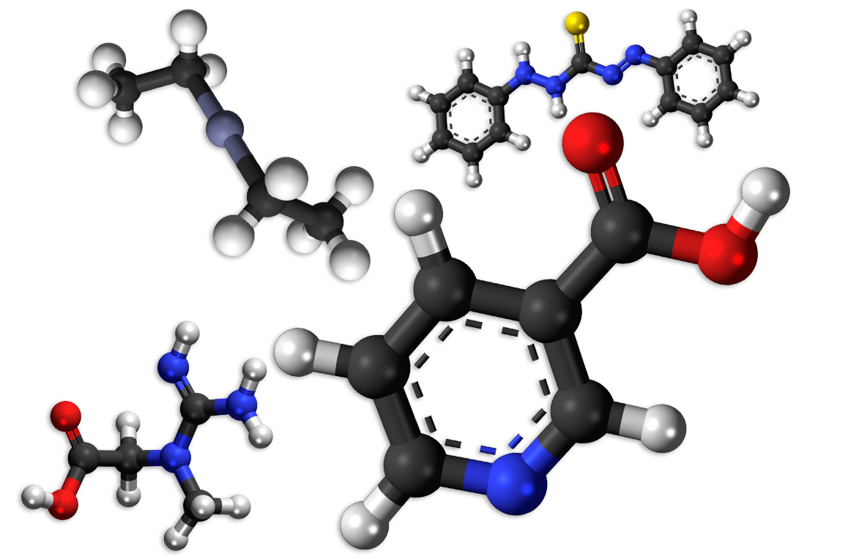
The phage virus parasite can be dissolved in the human body via a chemical REDOX reaction with common alkaline substances such as Niacin, Creatine, Zinc, Turmeric, Ginger, Nutmeg, and Carotene.

