Dr. Correo “Cory” Andrew Hofstad J.S.D, MPH/JD, MSPH, JD, Ph.D., M.D., D.O., MBA/COGS, MDiv
Cancer Moonshot Doctor #36 FIRST TRIAL TO PASS!
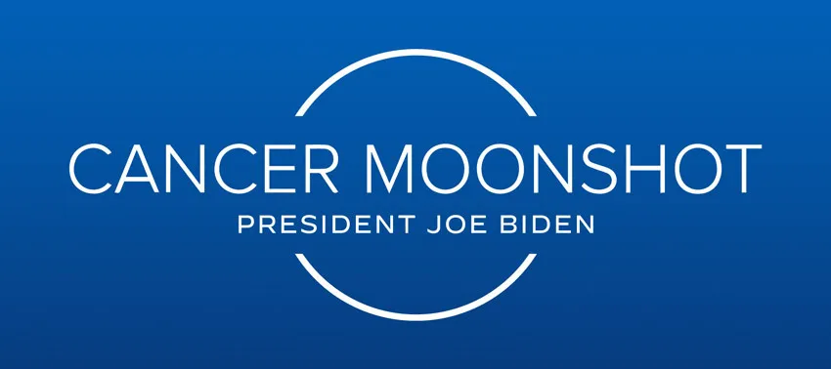
Dr. Correo “Cory” Andrew Hofstad is a 35-year-old Medical Science Training Instructor and master aviator. Dr. Hofstad’s piloting, control, and command skills are critical for several university medical center computer labs that serve as robotic controls for infectious disease labs at USAMRICD. Dr. Hofstad is well known in Oncology for the success of his naturopathic treatments and prescriptions featured on Virus Treatment Centers https://virustreatmentcenters.com
The U.S. Army Medical Research Institute of Chemical Defense (USAMRICD) was developed by the U.S. Army Medical Research Institute of Infectious Diseases (USAMRIID) after Dr. Hofstad introduced the NASA Robonaut into Level 4 Labs to replace humans.
Dr. Hofstad and his grandmother Dr. Melody Bouck invested in the construction of multiple buildings at the University of Washington, University of Washington Medical Centers, Harborview Medical Center, Fred Hutch cancer Center, and Seattle cancer Care Alliance.
In 2023 at Fred Hutch, Dr. Hofstad coordinated with multiple departments as “BANKSY” while tagging cancer cures on critical boards throughout the hospital. Dr. Correo Hofstad is the first doctor to pass clinical trials during America’s cancer Moonshot mission by President CMC Dr. Joeseph Biden. Hofstad is an on-call MSG guard for Joe Biden during cancer Moonshot at Fred Hutch cancer Center.

Dr. Hofstad specializes in non-invasive tumor/parasite removal using naturopathic oncology prescriptions and UV-C light in surgery to reduce incisions and cutting. Dr. Hofstad's breakthroughs include:
- Dr. Hofstad developed treatments that rapidly increase pH to reduce Sepsis and bone decay (strong bones require large volumes of electron bonds, pH is the presence of e-).
- Dr. Hofstad began Integrating UV-C light exposure to existing Apheresis machines to sanitize septic blood.
- Dr. Hofstad published the use of Acetone to remove dental plaque.
- Dr. Hofstad invented non-invasive brain tumor removal using robotic endoscopes and UV-C light via low-frequency fiber optic cables to remove brain tumors without penetration of the skull.
- Dr. Hofstad is the developer of the Moderna Melanoma vaccine.
- Dr. Hofstad is the developer of the Moderna Spikevax vaccine.
I Dr. Correo Andrew Hofstad am seeking permanent employment, while not deployed or stationed for military purposes. I see myself as a tenured doctor at Fred Hutch Cancer Center fighting cancer with methods that keep families alive, healthy, and together for post-care for the foreseeable future.

Arimura Lab Application

Chromosomes like Magnesium, Electrons, Protein, Oxygen, and Caffeine

I specialize in studying the activities of cells using computer systems that record 24hr daily observations of lab materials. My naturopathy with oncology prescription degree provides advanced cell treatment options for my clinical and research teams. During Operation Cancer Moonshot, I co-researched the use of Magnesium to strengthen biological structures. Melanoma is the result of the buildup of melanin when magnesium is a limited reagent. Melanin grows in a spot and bursts or blisters. When an open wound (melanoma) is present on a magnesium deficient human, it becomes infected and can become cancerous if viral cells come in contact with the wound and form a vesicle tumor.

Magnesium deficiency is a result from trauma, abuse, bloodletting, combat, kidnapping, human trafficking, etc. When magnesium is added back into a deficient human, the melanin spots spread actively in a chemical reaction that is observed as looking like an instant crystallization. With even distribution of melanin in a human’s skin, sunlight impacts melanin and results in a photo electric effect. The epidermis and internal organs are protected from the sun’s violent radiation by the melanin. The electrons released by the melanin in the photo electric effect provide humans with energy that cancer patients lack. Energy is required to survive. I developed the Moderna melanin vaccine and Spikevax after discovering the power of Magnesium.

- Magnesium works on cells. I strengthen eukaryotic cells using magnesium. Magnesium does not weaken cancer cells. Use of Vitamin B3, Zinc, Creatine, Turmeric, Nutmeg, and distilled has been successful at Fred Hutch at killing cancer cells while magnesium rebuilds patient’s eukaryotic cells. Magnesium gives humans hope to defend themselves with enhanced cell membranes and epidermal coverings.

- Chromosomes consume electrons specifically to create bonds in DNA chains. Any epi-DNA or change in DNA structure requires energy to break bonds, and electrons to reform bonds. Cancer patients live in sepsis. Low pH levels do not provide enough electrons to build DNA chains. Bonds in chemistry, physics, and biology require electrons. I am known at Harborview Medical Center, University of Washington, New York University, USAMRIID, USAMRICD, and Fred Hutch Cancer Center for rapidly increasing patient’s pH levels via naturopathic prescriptions. My patient’s chromosomes are quickly rebuilding DNA and repairing flesh, faster than any other doctor says the US Navy.

- I have vast experience in using organic pea-protein as the source of oncology protein for my patients. Pea protein breaks down into almost any protein needed by the human body. Whey protein can contain viral matter. Soy produces estrogen. Pea protein is what builds DNA fast.

- I use distilled water for patient drinking water. H2O breaks down in the body to pure oxygen and hydrogen. Anything but pure H2O is bound to other minerals and cannot break down into pure oxygen in the body. Distilled water helps the process of viral inhibitors and integrase inhibitors. Distilled water helps wash away cancer cells from healthy tissue.

- Cells also like caffeine.

I am applying to the Arimura lab because I believe that my eyes and understanding are vital to the observation of human chromosomes at Fred Hutch Cancer Center. I want to see strong chromosomes in every patient. I don’t want to see weak chromosomes at Fred Hutch Cancer Center. I have a goal to strengthen every chromosome at Fred Hutch Cancer Center. Cell death is a terrible event. I plan to provide a healthy space for chromosomes at Fred Hutch Cancer Center. We can then learn about chromosomes in a clean, healthy, and fit cell environment.

My broader goal is to work at Fred Hutch as a clinical provider. I prefer floating in clinical as a medical scientist training instructor. I take the complaints from each department about what is killing people, and then come back with a solution on the white boards with dry erase marker, often provided by USAMRIID or USAMRICD. I have goals in global oncology to distribute naturopathic medications to areas of the world hit by viruses. I would obtain grants and funding to feed the growth of our shipping operations. I am looking to begin work at Fred Hutch as soon as possible to start networking with other Fred Hutch employees and administrators.

I am a Fleet Officer / General Officer who has a history of creating mixed crews. I started recruiting females into my Military units before a lot of others have. I enable those with skin deficiencies to spread their melanin and live as though their family never experienced trauma or magnesium deficiency.

Protect Fred Hutch Investments, Protect Doctors with Proven Strategies.
Dr. Correo “Cory” Andrew Hofstad J.S.D, MPH/JD, MSPH, JD, Ph.D., M.D., D.O., MBA/COGS, MDiv

