A Novel Technique for Visualizing High-Resolution 3-D Terrain Maps

John Dammann, Army Research Laboratory, 2800 Powder Mill Road, Adelphi, MD 20783

Abstract

A new technique is presented for visualizing high-resolution terrain elevation data. It produces realistic images at small scales on the order of the data resolution and works particularly well when natural objects are present. Better visualization at small scales opens up new applications, like site surveillance for security and Google Earth-type local search and exploration tasks that are now done with 2-D maps. The large 3-D maps are a natural for high-resolution stereo display.

The traditional technique drapes a continuous surface over the regularly spaced elevation values. This technique works well when displaying large areas or in cities with large buildings, but falls apart at small scales or for natural objects like trees. The new technique visualizes the terrain as a set of disjoint square patches. It is combined with an algorithm that identifies smooth areas within the scene. Where the terrain is smooth, such as in grassy areas, roads, parking lots and rooftops, it warps the patches to create a smooth surface. For trees or shrubs or other areas where objects are under-sampled, however, the patches are left disjoint. This has the disadvantage of leaving gaps in the data, but the human mind is very adept at filling in this missing information. It has the strong advantage of making natural terrain look realistic – trees and bushes look stylized but still look natural and are easy to interpret. Also, it does not add artifacts to the map, like filling in blank vertical walls where there are alcoves and other structure and extending bridges and overpasses down to the ground.

The new technique is illustrated using very large 1-m resolution 3-D maps from the Rapid Terrain Visualization (RTV) program, and comparisons are made with traditional visualizations using these maps.

1. Introduction

Over the past years, three-dimensional (3-D) terrain mapping technology has improved in resolution, accuracy, and quality and in area covered. Resolution has increased to 1 m or better, and accuracy in absolute (world) coordinates of better than 1 m is available. The transformation of 3-D maps from low resolutions appropriate only to large areas to high resolutions useful at much smaller scales requires a new approach to terrain visualization. I present a new technique for visualizing high-resolution terrain elevation data that produces realistic images at small scales on the order of the data resolution and works particularly well when natural objects are present.

Current techniques work well for large-scale natural features and urban centers dominated by large buildings. Promotional material focuses on mountain ranges or canyons at large scales or city centers with many large buildings, also at large scales. Obviously, there are many useful applications at these size scales. These techniques are not appropriate, however, for smaller scales or natural features such as bushes and trees.

The Army Research Laboratory (ARL) has had long-term interests in designing inexpensive, short-range sensors and in detecting and tracking people and vehicles. ARL has designed and built a series of inexpensive ladars^{1, 2} for purposes including navigation and detecting vehicles in difficult situations, e.g. in foliage or under nets. The techniques presented here grew out of efforts to visualize images from these ladars that were focused on small scales on the order of vehicle size and that included trees, bushes and other natural features. When imaging smaller-scale scenes, ladars will always be under-sampling the foliage and other natural and manmade objects such as fences, railings, and light poles. It was very important in the visualization to accommodate this under-sampling and to differentiate between these under-sampled objects and larger, smoother objects like vehicles.

Tracking vehicles and people is now of keen interest to the military, given the situation in Iraq. 3-D maps can provide important context for such a task, but visualization at small scales is essential. One is often interested in particular buildings or road intersections and it is important to understand the areas immediately surrounding these sites.

There are many other applications that require smaller size scales. One particularly important one is site surveillance. The objects of site surveillance are often people and the focus of attention is on a small area around a specific building or a potential intruder. Locations of individual trees and bushes, hedges, small ravines, banks, and other natural features become relevant in determining access routes and potential cover. After an alarm, they are also important in judging intent and determining the best response. Therefore, a visualization technique is required that portrays small features as well as large and that realistically portrays natural features as well as man-made ones.

Another interesting application is the Google-Earth type local search and exploration task. In addition to larger-scale views to get context, one is often interested in areas of a square block or less in the immediate vicinity of one’s destination. Such a search is currently done with traditional 2-D maps or, in a very select few areas, with pseudo-3-D maps generated by adding 3-D building models to the 2-D maps. Using 3-D ladar-generated maps is better alternative. They can be generated at relative low cost for very large areas with virtually no hand tooling. With the proper visualization, these maps – without any further processing – can look better and be more useful than the alternatives.

Stereoscopic viewing is very useful in viewing any 3-D terrain map. However, it is particularly useful for smaller scales with foliage and other objects that are under-sampled. When we look through something like foliage, the stereo is very helpful in sorting out the complex scenes with objects at different ranges.

2. The terrain map

3-D terrain maps are available from a number of sources, but I am using only maps generated by the Rapid Terrain Visualization (RTV) program. This program, run by the Joint Precision Strike Demonstration Project Office, has the mission to provide rapid generation of digital terrain data to support emerging crisis or contingency operations.

The RTV program maps from an aircraft using both laser radar (ladar) and interferometric synthetic aperture radar sensors. The Ladar has higher resolution and produces cleaner and more accurate maps, so I am using the ladar data. This sensor measures the terrain elevation by scanning the area with a laser beam and measuring the time it takes the light to travel from the aircraft sensor to the ground and back. For the ladar sensor, the program advertises a resolution (post spacing) of 1 m, a vertical accuracy of 15--30 cm, and a horizontal accuracy of 30--50 cm.

The maps comprise three pieces of information for each 1-m² pixel: a backscatter intensity value approximately equivalent to a black and white photograph, the elevation of the first backscatter return from the laser (the highest thing hit), and the elevation of the last return (the lowest thing hit). For most pixels, these two elevations will be the same. But where bushes or trees are present, some of the laser energy will be reflected from the top of the trees as a first-hit return, but some laser energy will also penetrate down to ground to produce the last-hit return. The RTV program also provides a fourth, derived product that is a color image combining the intensity image with hues that are derived from the elevations.

In this paper, I will concentrate on the US National Arboretum, located in Washington, DC and the area around Union Station in downtown DC. The maps for these sites are a very small part of a large map that encompasses all of the District and much of the surrounding suburbs out as far as Dulles Airport to the west and BWI Airport to the north.

3. Description of new technique

Figure 1 shows a traditional rendering of a portion of the Arboretum featuring a few small buildings surrounded by trees. The image is from the 3DEM-RTV program³ written for RTV by Visualization Software LLC and is typical of most rendering techniques. A single continuous surface is draped over the regularly-spaced RTV elevation data.

Figure 2 shows the same Arboretum scene with the new technique. This technique is a melding of the point-cloud approach traditionally used to view ground-based ladar images and the continuous surface approach used to view terrain maps. The trees and bushes are rendered in a very natural way with a series of small, disconnected patches that look very much like stylized leaves and that one can see through. The tree rendering compares reasonably with computer-aided design (CAD) techniques that are much more costly in manpower and machine resources. The ground and the building roofs, on the other hand are visualized as continuous surfaces.

The technique begins by displaying each elevation sample using a disjoint horizontal square centered at the x-y location and elevation of the sample. The size of the square is the same as the post spacing – in this case 1 m – so a flat horizontal surface would be precisely tiled by the squares and would appear as a continuous surface. Many surfaces like roads, grass and flat roofs are approximately horizontal and look quite good with this simple approach. Figure 3 shows the Arboretum scene with these disjoint squares. The scene looks good but there are small gaps in surfaces that are not quite horizontal and these gaps clutter the image and make the contrast with bushes and trees less obvious.

The texture-based segmentation algorithm is designed to eliminate the small gaps in surfaces that are basically smooth. This algorithm, described in detail below, identifies locally smooth areas and warps the squares for these areas so that the edges meet and the surface is continuous. Areas that are truly rough, such as trees, are left as disjoint squares. The key to this procedure is that there is only a small difference between the squares before and after the algorithm is applied, so algorithm errors are not conspicuous. Thus, the algorithm does not need to be extremely reliable and can be fast and simple. If it occasionally leaves a gap in a smooth area or occasionally joins several squares in a tree, these errors are almost imperceptible. The visual impression is to eliminate most of the small gaps in smooth surfaces making more striking the contrast between roads, grass and buildings that are smooth and disjoint under-sampled objects like trees.

For the map colors, the hue is a function of the elevation, with the highest elevations mapping to red, then through yellow and green to blue, which is the lowest map elevation. The display intensity is mapped to the intensity image from the ladar, which is very useful in distinguishing features like roads that do not differ much in elevation from their surroundings but are much darker than the surrounding grass. The 3DEM-RTV viewer, illustrated in figure 1, derives intensity from a shading algorithm, which is particularly inappropriate for this scene since it mostly highlights the draping of the surface over the trees. Other viewers⁴ paint photographs as texture onto the elevation surface, an approach that produces images much more similar to ours.

Figures 4 and 5 show another example of the new technique using the area around Union Station in downtown Washington DC. Figure 4 uses the same coloring scheme described above and shown in Figure 2. Figure 5 uses the derived image provided by the RTV program to color the scene. These two schemes present basically the same intensity information; and both also provide elevation information, but using different hue scales. I have used both schemes depending on the particular topography and how large an area is displayed.

4. Advantages of the new technique

The new technique has several key advantages over the traditional one, as well as some disadvantages. The key advantage is that trees and bushes and other under-sampled objects like fences and railings are displayed realistically. Trees look natural if somewhat stylized and you can see through them as you naturally would. There is a clear contrast with smooth objects in the scene.

The human eye is very good at constructing objects from partial information. When the viewer does not introduce artifacts (like draping continuous surfaces), objects can be recognized with only a few voxels tracing their outlines. Stereoscopic viewing is very helpful in that it separates objects in range to reduce the visual clutter in complex scenes.

Another important advantage for the new technique is that it allows both of the RTV elevation surfaces to be used in the same display; with other techniques, one has to choose to use one surface or the other. The last-hit elevations become the primary data, displayed either as disjoint or smoothed as described above. For pixels where the first and last hits are at very similar elevations, the first hit is discarded. Where they are significantly different, the first hit is added to the display as a disjoint square. Thus the display can visualize both a tree created from first hits and the ground underneath it created from last hits.

The first hits can be toggled on or off as desired by simply hitting a button on the display. Figures 6 and 7 show a hill in the National Arboretum with first hits on and off. The first figure shows both first and last hits, a view that is most appropriate when the vegetation itself is of interest or when the most realistic view of the terrain is desired. The second shows the last hit only, most appropriate when the underlying terrain features or objects under the trees are of interest.

Another obvious feature of the new technique is that there are gaps in the image. The ladar map is taken from almost directly above, so there are data for the tops of buildings but little or no data for the building sides. I do not attempt to fill in these missing data. The gaps can be very disconcerting at first, especially to those accustomed to traditional viewers. However, the user can quickly acclimate to this since the human visual system is adept at compensating for obscured or missing information. The advantages of leaving the gaps are several. First, it is obvious what information is actually contained in the data. Second, the technique does not introduce artifacts into the data. Traditional viewers extend the sides of bridges and overpasses down to the ground, fill in recesses in building walls, and distort the shape of any object small enough or complex enough to be under-sampled.

The technique I present does require more memory and somewhat more computing power. Because the squares can be disjoint, the number of vertices is larger. However, informal timing tests have indicated there is very little difference in display update rates for the old and new techniques. Moreover, when the new technique is used with level-of-detail approaches, it can be used only for the highest resolution scale where only a relatively small area is displayed on the screen.

5. The texture-based segmentation algorithm

The texture-based segmentation algorithm fuses the discrete rectangles to create a continuous surface where the map is smooth. It works locally at each pixel within a 3-by-3 neighborhood of the pixel and determines whether the pixel is part of a smooth surface by attempting to construct 4 lines through the pixel. Figure 8, a close-up of the bush in the center of the traffic circle at the lower right of figure 2, shows the 4 lines for a test pixel. If the two halves of a line have sufficiently similar slopes, that is, if the range difference from the center pixel and its neighbor on one side is close enough to the range difference to the neighbor on the other side, then that line is valid. If 3 out of the 4 possible lines are valid, then the center pixel is identified as locally smooth.

Figure 8a shows the discrete squares before the algorithm is applied, and figure 8b shows the same scene after application of the algorithm. One can see that the ground squares have been warped to form a continuous surface while the bush squares have been left unaltered.

6. Conclusions

Traditional 3-D terrain map viewers work well for large size scales – mountains and valleys or large areas of cities with tall buildings. However, steady improvement over the past few years in resolution and accuracy have opened up applications at much smaller size scales where natural features such as trees become important. At these scales, trees, bushes and many other objects such as fences and signposts are under-sampled, and this problem will persist even with reasonable improvements in resolution. By draping these objects with a continuous surface, current methods obscure their shapes and confuse them with truly smooth objects.

The technique I have discussed addresses these under-sampled objects by visualizing them with discrete squares while maintaining the traditional continuous surface for smooth areas of the terrain. This accentuates the differences between the two types of objects. By not inserting artifacts into the visualization, it better uses the power of human perception to interpret the scene.

I have discussed small size-scale applications to tracking vehicles and people, to site surveillance and to Google-Earth type search and exploration tasks. All of these tasks, currently done with 2-D maps or by making expensive and time-consuming 3-D models, can be done well with 3-D terrain maps. The maps can be generated for large areas quickly and relatively cheaply and can be used as-is with virtually no additional processing or human intervention.

Finally, a 3-D stereoscopic display greatly enhances the visualization. Of course, such displays improve any 3-D map, but stereo is particularly useful for this technique. Complex scenes with objects on the ground under trees are much clearer with stereo to help sort objects out in range. With advances in computer hardware, the terrain visualization in stereo has become fast and economical. I am currently running the viewer on a Sharp RD3D laptop with a glasses-free stereo display. This laptop, available for about $3000, can easily accommodate areas up to 8 km² .

references

- B.L. Stann, W.C. Ruff, and Z.G. Sztankay, “Intensity-modulated diode laser radar using frequency modulation/ continuous-wave ranging techniques,” Optical Engineering, Vol. 35, No. 11, 1996, pp. 3270-3278.
- Barry L. Stann, Ahmed Abou-Auf, Keith Aliberti, John Dammann, Mark Giza, Gerard Dang, Greg Ovrebo, Brian Redman, William Ruff, and Debbie Simon, "Research progress on a focal plane array ladar system using chirped amplitude modulation," Proc SPIE Laser Radar Technology and Applications VIII, Vol. 5086, 2003.
- 3DEM Software for Terrain Visualization and Flyby Animation, http://www.visualizationsoftware.com/3dem.html
- ESRI ArcGIS Explorer, http://www.esri.com/software/arcgis/explorer/index.html

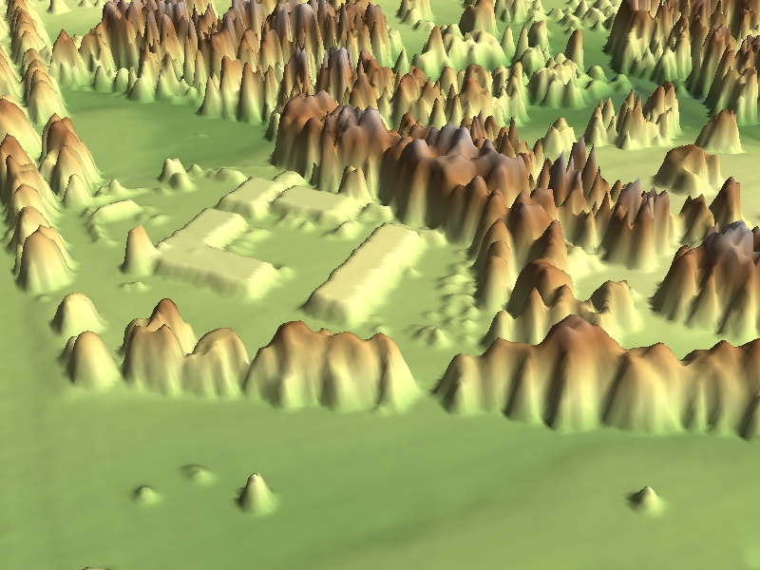
Figure 1. Traditional visualization of a building in the National Arboretum in Washington DC
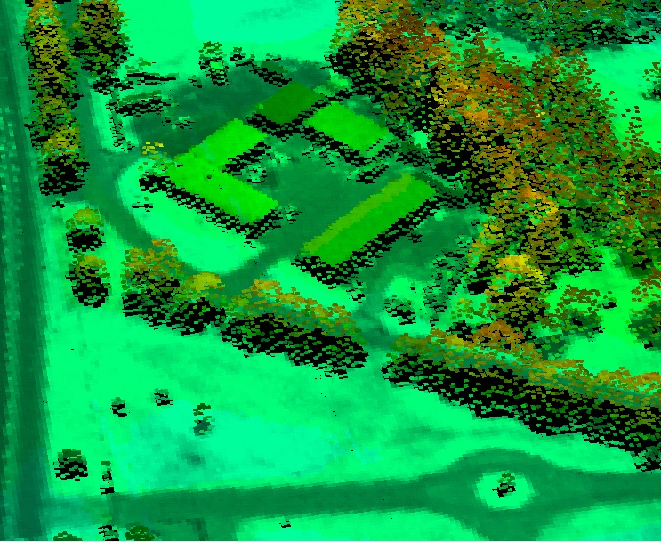
Figure 2. Visualization of the Arboretum building using the new technique

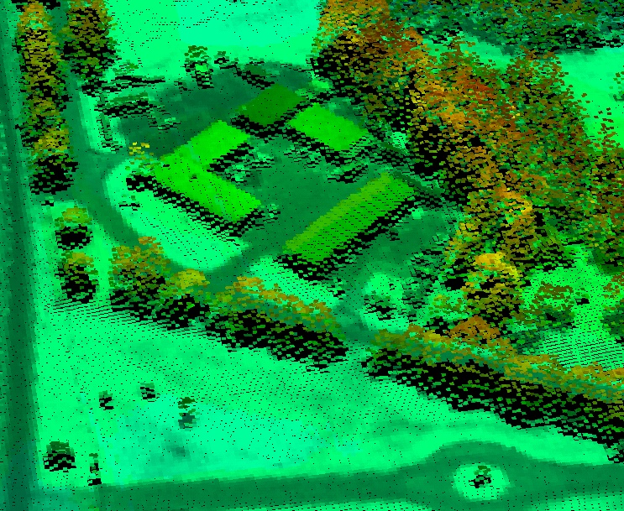
Figure 3. Arboretum building without texture-based segmentation algorithm
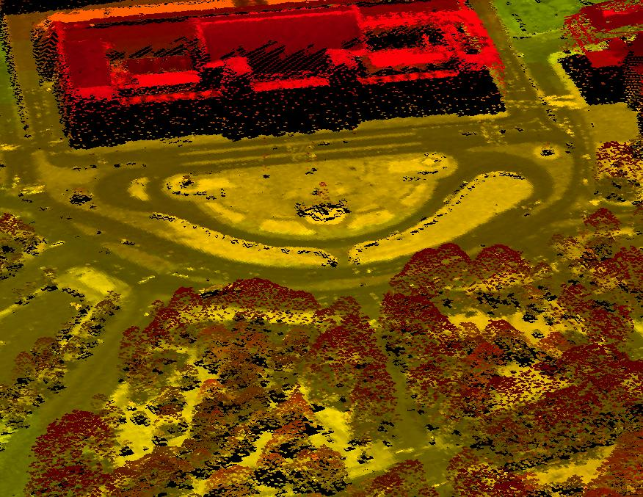
Figure 4. Union Station in Washington DC using rainbow coloring scheme

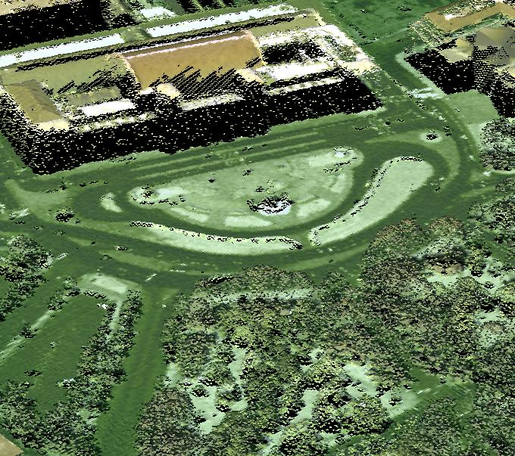
Figure 5. Union Station in Washington DC using coloring scheme provided by the RTV program
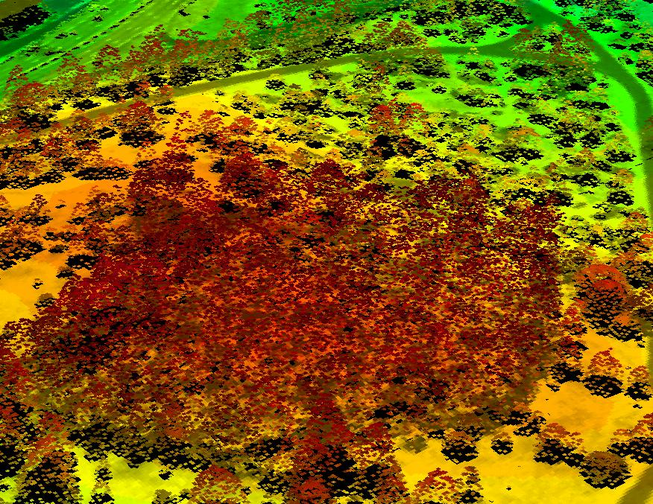
Figure 6. Arboretum hill including both first and last hits

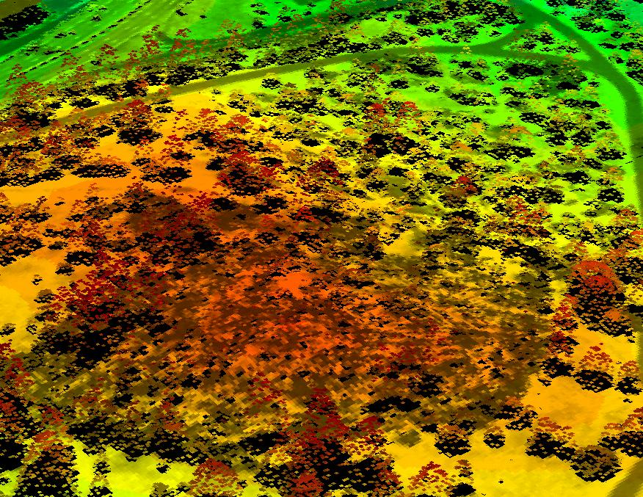
Figure 7. Arboretum hill including only last hits
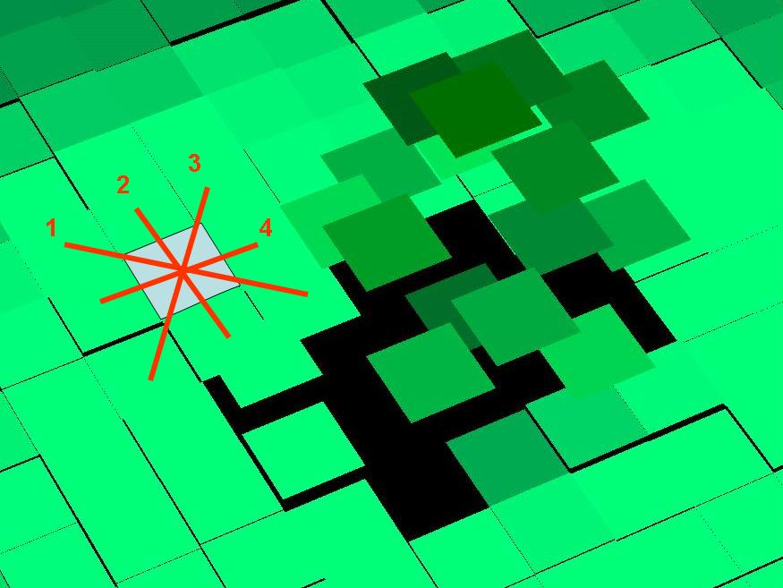
- before texture-based segmentation algorithm


- after texture-based segmentation algorithm

Figure 8. Closeup of an Arboretum bush

