AT commands

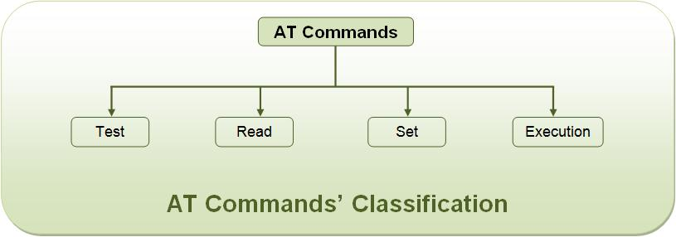

List of AT commands:
The AT commands for both, GSM module and the mobile phone, are listed below. Some of these commands may not be supported by all the GSM modules available. Also there might be some commands which won’t be supported by some mobile handsets.

Testing :
Command | Description
AT | Checking communication between the module and computer.

Call control :
Command | Description
ATA | Answer command
ATD | Dial command
ATH | Hang up call
ATL | Monitor speaker loudness
ATM | Monitor speaker mode
ATO | Go on-line
ATP | Set pulse dial as default
ATT | Set tone dial as default
AT+CSTA | Select type of address
AT+CRC | Cellular result codes

Data card Control :
Command | Description
ATI | Identification
ATS | Select an S-register
ATZ | Recall stored profile
AT&F | Restore factory settings
AT&V | View active configuration
AT&W | Store parameters in given profile
AT&Y | Select Set as power up option
AT+CLCK | Facility lock command
AT+COLP | Connected line identification presentation
AT+GCAP | Request complete capabilities list
AT+GMI | Request manufacturer identification
AT+GMM | Request model identification
AT+GMR | Request revision identification
AT+GSN | Request product serial number identification (IMEI)

Phone control :
Command | Description
AT+CBC | Battery charge
AT+CGMI | Request manufacturer identification
AT+CGMM | Request model identification
AT+CGMR | Request revision identification
AT+CGSN | Request product serial number identification
AT+CMEE | Report mobile equipment error
AT+CPAS | Phone activity status
AT+CPBF | Find phone book entries
AT+CPBR | Read phone book entry
AT+CPBS | Select phone book memory storage
AT+CPBW | Write phone book entry
AT+CSCS | Select TE character set
AT+CSQ | Signal quality

Computer data interface :
Command | Description
ATE | Command Echo
ATQ | Result code suppression
ATV | Define response format
ATX | Response range selection
AT&C | Define DCD usage
AT&D | Define DTR usage
AT&K | Select flow control
AT&Q | Define communications mode option
AT&S | Define DSR option
AT+ICF | DTE-DCE character framing
AT+IFC | DTE-DCE Local flow control
AT+IPR | Fixed DTE rate

Service :
Command | Description
AT+CLIP | Calling line identification presentation
AT+CR | Service reporting control
AT+DR | Data compression reporting
AT+ILRR | DTE-DCE local rate reporting

Network Communication parameter :
Command | Description
ATB | Communications standard option
AT+CBST | Select bearer service type
AT+CEER | Extended error report
AT+CRLP | Radio link protocol
AT+DS | Data compression

Miscellaneous :
Command | Description
A/ | Re-execute command line
AT? | Command help
AT*C | Start SMS interpreter
AT*T | Enter SMS block mode protocol
AT*V | Activate V.25bis mode
AT*NOKIATEST | Test command
AT+CESP | Enter SMS block mode protocol

SMS Text mode :
Command | Description
AT+CSMS | Select message service
AT+CPMS | Preferred message storage
AT+CMGF | Message format
AT+CSCA | Service centre address
AT+CSMP | Set text mode parameters
AT+CSDH | Show text mode parameters
AT+CSCB | Select cell broadcast message types
AT+CSAS | Save settings
AT+CRES | Restore settings
AT+CNMI | New message indications to TE
AT+CMGL | List messages
AT+CMGR | Read message
AT+CMGS | Send message
AT+CMSS | Send message from storage
AT+CMGW | Write message to memory
AT+CMGD | Delete message

SMS PDU mode :
Command | Description
AT+CMGL | List Messages
AT+CMGR | Read message
AT+CMGS | Send message
AT+CMGW | Write message to memory

