Module 5 Homework
  - Analyze the songs we cleaned in class
In class, we prepare a songs table. At home, use that same table to compare artists with groupby and .agg, create two plots, and explain your findings. Work individually in module05_songs.ipynb and submit the completed notebook on Gradescope. This replaces the Ralphs homework; you do not need to do both.

Open your notebook
Use module05_songs.ipynb in your YA 05-wrangle repository. Run uv sync in that folder and select its .venv Python as the notebook kernel. Keep the notebook beside lyrics_api.py and the data folder. Finish Part A in class, then continue with Part B at home.
Use the twelve-row offline sample for the required work. These are fictional songs with original classroom verses and invented durations. Keep USE_LIVE_API = False; the optional live API demonstration is separate. The API helper is supplied setup, not exam material.

What we prepare in class
Keep the source table raw unchanged. Clean artist names into artist_clean, then convert added_on in playlist_info with pd.to_datetime early in class. This is a playlist date, not a release date. Next, handle unavailable lyrics without inventing values and create word_count with a scalar function and map. A word count here means the number of whitespace-separated tokens; punctuation stays attached to its token. Missing or whitespace-only lyrics should have a missing word count, not zero.
Finally, merge the prepared playlist information by song_id into enriched, keeping every song. The converted dates come with it. The notebook has a separate cell for each step.

Using Codex
You may ask for hints, explanations, or feedback on your attempt. Write a prediction first and ask about one step at a time. You write the analysis code and explain the results; do not ask for a completed notebook.

1 Check your starting table
Continue with enriched, the table you cleaned in class. Display song ID, song, artist_clean, duration_seconds, word_count, status, and playlist_group. Confirm one row per song ID and the same row count as raw. Report how many word counts are missing. Keep those songs in the starting table; missing word counts are not zero.

2 Summarize by artist
Use groupby and .agg to create artist_summary, with one row per artist_clean and these four columns:
- total_songs: number of songs, including songs without lyrics.
- songs_with_text: number of non-missing word_count values.
- mean_words: mean of the available word counts.
- mean_duration_seconds: mean duration of all songs with known duration.
Display the summary sorted from highest to lowest mean_words. Explain why total_songs and songs_with_text can differ and which count is the denominator for mean_words. Do not fill missing word counts before computing the mean.

3 Plot the artist comparison
Create a bar chart from artist_summary showing mean_words for each artist, ordered from highest to lowest. Label the artist axis and the mean word count axis, and give the chart an informative title. Show songs_with_text beside the chart in a small displayed table or in the chart labels.
Below it, identify the artist with the largest mean in this dataset. Cite the mean and the number of available texts supporting it. Demo texts are short classroom verses, not full-song lyrics.
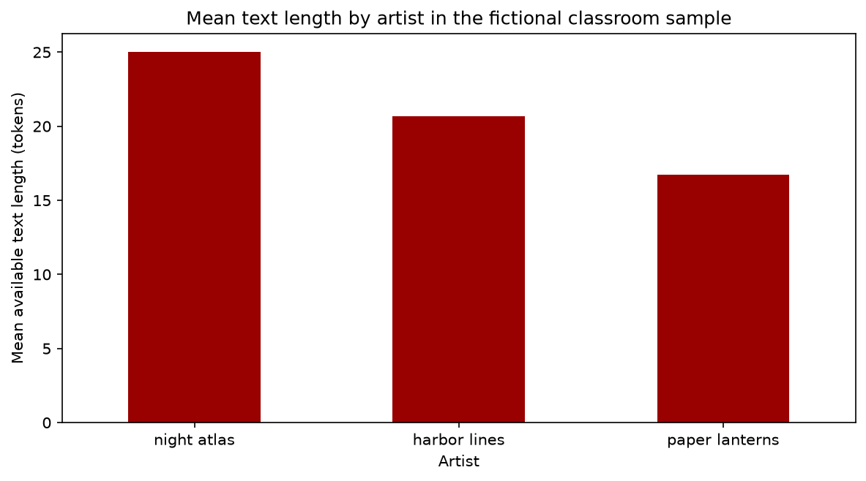
Reference plot for Question 3. Create your own plot with code; colors and styling may differ.

4 Plot individual songs
Create a scatter plot from the song-level enriched table, not the artist summary. Put duration_seconds on the horizontal axis and word_count on the vertical axis. Use only rows where both values are known; report the number of included and excluded songs. Label both axes and title the plot.
Describe whether longer durations consistently go with larger word counts in these records. Cite two songs that support or complicate your observation. Do not claim a causal relationship. Demo durations are invented metadata and the texts are short verses, so this plot cannot establish a real music trend.
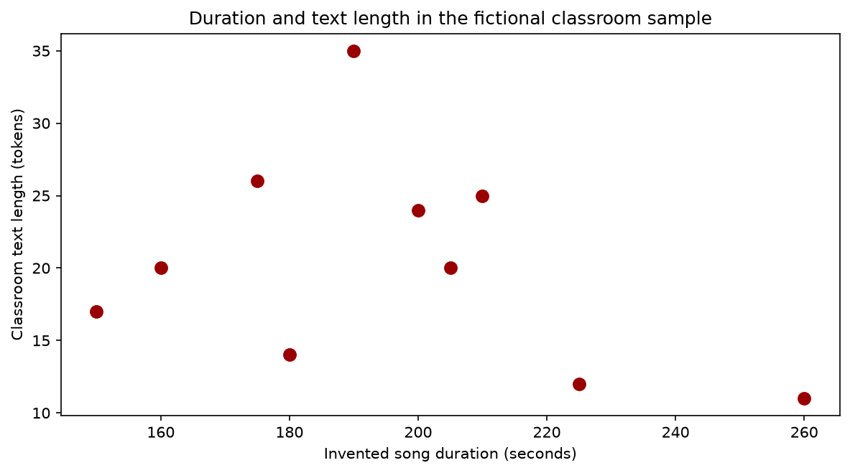
Reference plot for Question 4. Create your own plot with code; colors and styling may differ.

5 Explain and check your findings
Choose one artist. Display its song-level word counts and independently check its mean using only the available values. Show the numerator and denominator, then compare with your summary.
Write three to five sentences answering: What did the two plots help you see? How could missing lyrics affect the comparison? Why does this small playlist not represent an artist's entire catalog?
End with an assistance note: whether you used Codex, one hint you received, and how you checked your work. If you did not use it, say so.

Finish and submit
Submit one file, module05_songs.ipynb, to the Module 5 homework assignment on Gradescope. Include your in-class cleaning cells, homework code, displayed summary, both plots, explanations, and assistance note. Restart the kernel, run all cells in order, and save with outputs visible. Keep USE_LIVE_API = False for the required assignment so it can run without network access. Remove any optional outputs containing downloaded commercial lyrics before submitting. No separate CSV, image, or PDF upload is required. Use the posted course calendar for the deadline. Do not push student work to the shared repository.

