Project Proposal

Information system Integration

Present to

Leon Cavalli

ICT342 Course Coordinator

Project Team

Rana Khan - 1109942

Prabin Pun - 1116878

Sukrit Gautam - 1076100

Jhaysand Bonilla - 1122677

Semester 1, 2021

University of Sunshine Coast - USC

Table of Contents

Business Problem 3

• Problem Definition 3

• Business Requirements 3

Evaluation of solutions 3

• Literature Review 3

Proposed Solution 3

• Rational for why solution 3

• Description of solution and prototype of solution 4

• Technology stack and rational for using it 8

• Project governance – stakeholder, progress reporting, project plan 8

• Risk management 9

• How can we prevent the data breaching? 9

• The outcome of the Project 10

• How will the objectives be measured? 10

• Team Roles and objectives 10

Conclusion 11

# Business Problem

## Problem Definition

The client’s (Leon Cavalli) work involves working with multiple datasets. He has developed a software that transforms non-standardized columns of the datasets to standardized columns, for the purpose of analysis and evaluation. The client’s workplace at the moment does not have a system that supports a consistent user experience and access to common tools to amend and create dataset with the standardized columns.

## Business Requirements

A web server environment to be developed that can integrate .csv files which provide data and instructions of how and in which form it will be needed. The environment will create or amend .csv files which will be automatically updated to the correct standardized columns. The .csv files in the system will be available for download at any time.

# Evaluation of solutions

## Literature Review

Aspects of project management, system integration and programming will be utilised for the project.

# Proposed Solution

## Rational for why solution

The goal requires designing a prototype and develop an implementation of a technological solution utilising AJAX technologies for building a multilayer web interface. This document intent to specify, design and describe the implementation of a website with a backend database which reads, corrects, and writes over .csv files; creating new .csv files under a determined structure; hold a record of dataset processes and creates a .csv file of it if required.

The project will be divided in four major sections, which will divide later into sub-sections.

1. AJAX: This is a technological solution that will manage the system behaviour such as when, who, how and what instructions apply. Additionally, it will allow to exchange, update, and retrieve data in a faster manner and updating parts of the web interface.
2. Object Oriented Program: Applying this methodology aids to divide in modules an information system where each module combines data and process according to structure and behaviour desired for the system. Using this offer to add future modules in the system or easy modification of current modules.
3. Data Base Architecture: Designing, developing, and implementing a database to meet needs of client would be aided to store and organize defined data for the system, avoiding double records and typing.
4. Web Interface of the system: Integrating a website to system backend would improve data integrity to users on real-time and removing the manual data entry process.

## Description of solution and prototype of solution

The application will be separated in 4 basic layers. The first layer will control the logic in the system. The second layer will handle XML web services and HTML responses. The third layer manages the database connection, and the fourth layer will contain the presentation of data and where users interact (Figure1).



Web Interface of the sytem

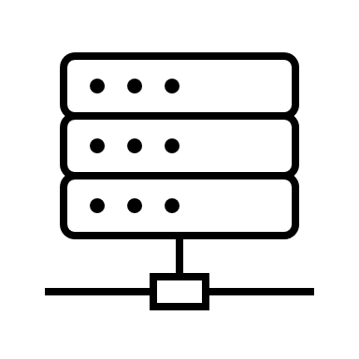

Ajax FrameworLayerd

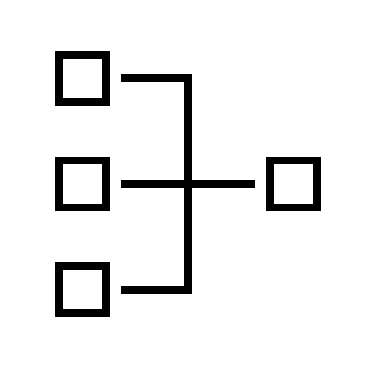

Server Side Logic Layer

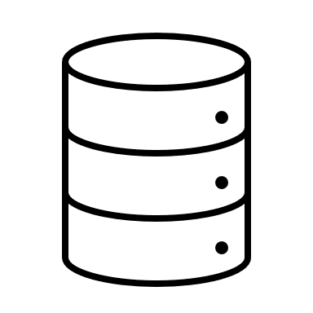

Data Base



Data Acces Layer

Ajax XML service web

Service request

Stablish Connection

Figure 1. System Architectural Diagram

1. Control logic layer: System will develop solution for the five user cases (Figure 2).

Figure 2. User cases

iagram

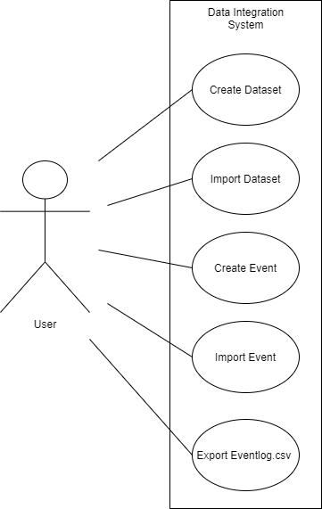

1. AJAX layer: Basically, this layer will content a basic control of AJAX methodology (Figure 4). The activity of section is register below

* User selects an event (click button or load page).
* XMLHttpRequest object is created and it sends a request to web server.
* Server process requests and responds back to web page.
* Response is being read and specific instruction is performed.



XMLHttoRequest

object

Send request

Send data requested

Process data.

Update page content

Figure 3. AJAX system work

iagram

1. Interface layer:

During developing the system interface a web template was added into the system. Using this template following pages and sections would be developed. Figures 6, 7, 8 and 9 are showing some wireframes of interface events and how it will be its behaviour.

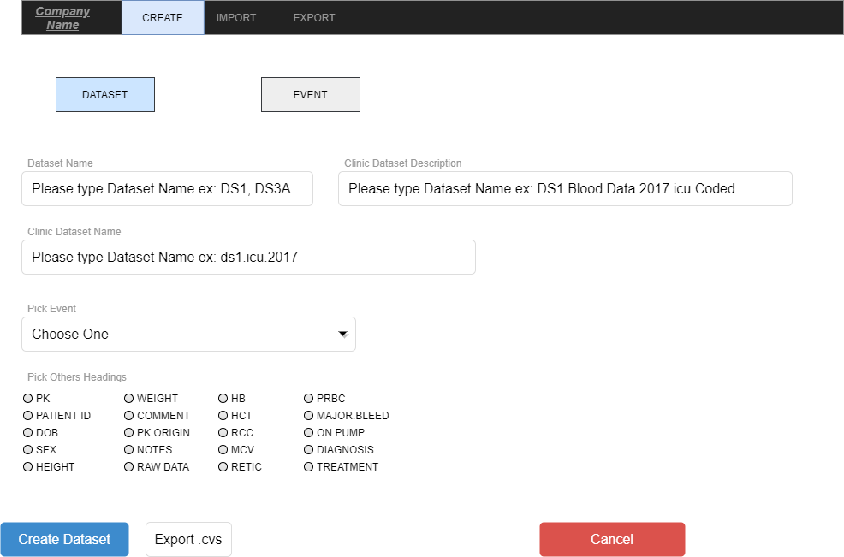

Figure 4. Create New Dataset file interface

iagram

Figure 7. Create New Event file interface

iagram

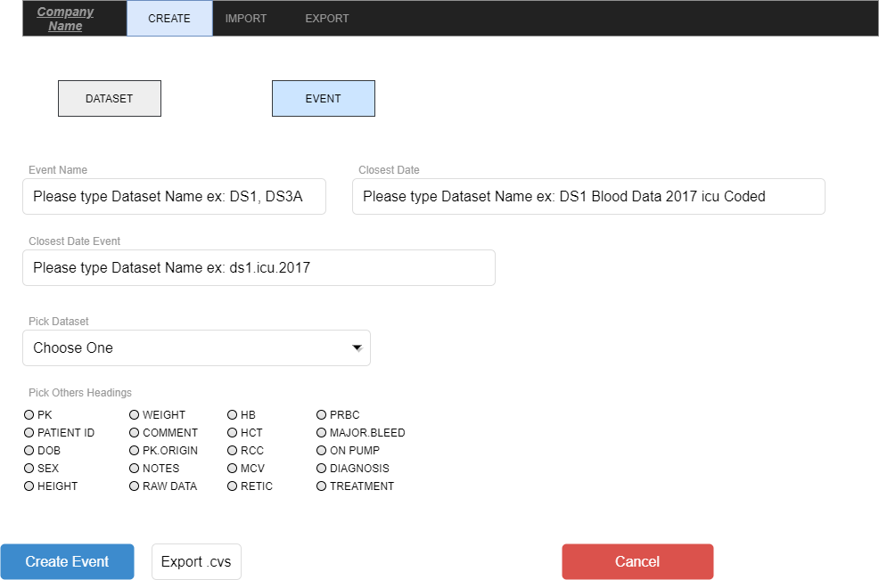

Figure 5. Create New Event file interface

iagram

Figure 9. Import Event file interface

iagram

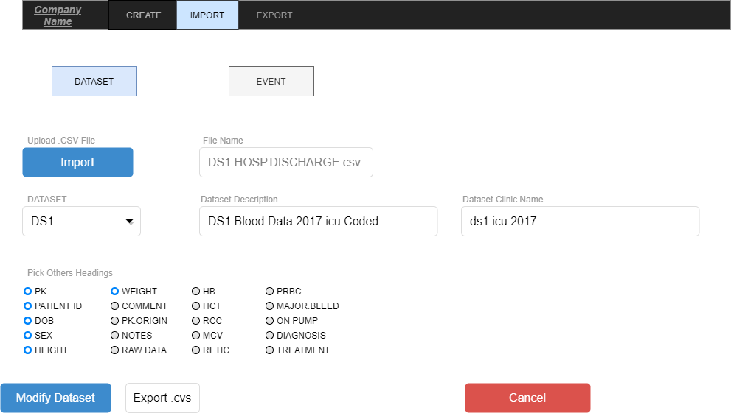

Figure 6. Create New Event file interface

iagram

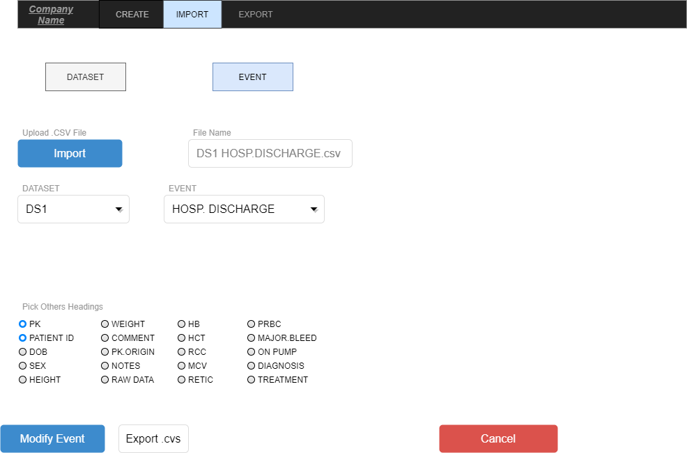

Figure 7. Create New Event file interface

iagram

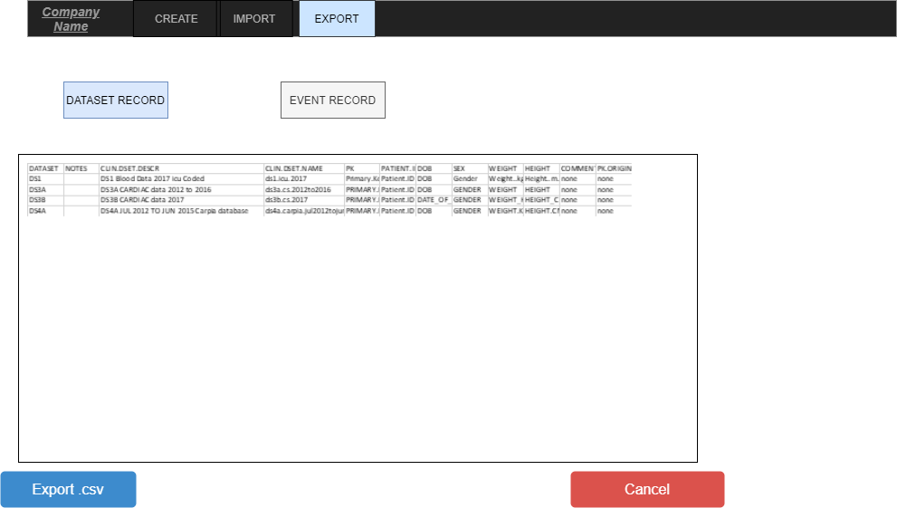

Figure 8. Export Data/Event record file interface

iagram

## Technology stack and rational for using it

A technology stack is a crucial piece of building up any web or application. The combination of programming languages, frameworks, database, front end tools and back end tools and use of different software working behind the developed project like a back end interface is known as technology stack.

People, who are using the app or web can only see what is appearing on the screen, but there is a whole system consists of programming and software working behind the screen.

In this project Ajax, HTML, CSS, and JavaScript are playing the part of technology stack, rational of using this technology stack is that’s what going to help translate, or process user’s demand of editing and overriding the data in Microsoft word excel files without editing manually.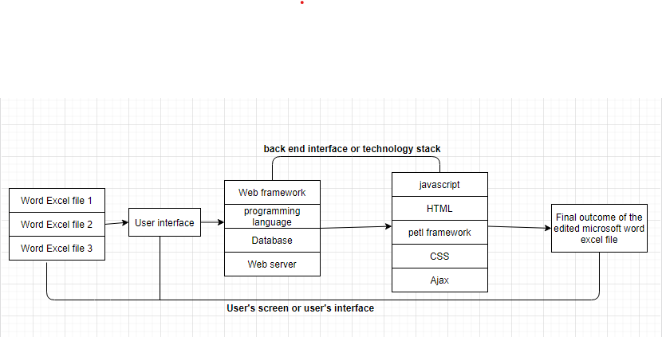

*Image 9: showing a rough example of technology stack of this project.*

## Project governance – stakeholder, progress reporting, project plan

Project governance is the system for how project choices are made. It mentions what activities the association does, and who is responsible. In this project the group of four people are making all the choices and each one of them is responsible, but the client also has a main influence in this project, the team is conducting weekly meetings to discuss the project milestones.

A stakeholder is a gathering that has an interest in an organization or a project and can either influence or be influenced by the business or the project. Investors, employees, customers, suppliers, and clients are the usual stakeholders. In this project the stakeholder is the client because he has the main influence on this project.

A progress reporting is a record that shows the progress that a group is making towards finishing a project.

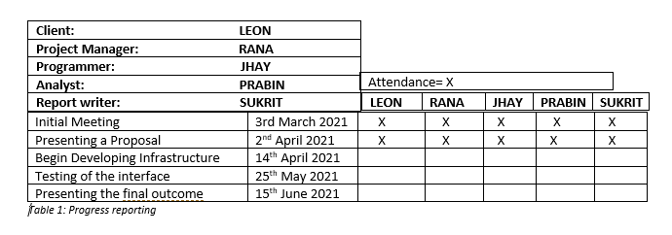

A project plan is a formal, approved document used to guide project execution.

|  |  |
| --- | --- |
| Client Meeting | We meet and learn about client’s requirements. |
| Conduct Research | We brainstormed our past projects and studies within the group so we can produce a unique and best solution possible. |
| Sketch out ideas | We sketch out different concepts and ideas and choosing the ones that suits client’s needs the most |
| Presenting a Proposal | We presented a proposal which described what can be done and how it will work when completed. |
| Create variation of concepts | Here we create variation of each concept to suit multiple platforms. |
| Present finalised concept for feedback | We present the finalised concept to the client explaining the rationale behind the concept and why would it be successful, client then provide us much needed feedback |
| Test the interface | We test the created interface multiple times with different sets of data. |
| Deliver and Launch | Once everything is done and finalised, we send all the files to the client. |

*Table 2: Project Plan*

## Risk management

Risk management is the identification, evaluation and prioritization of risks followed by coordinated and economical application of resources to minimize, monitor, and control the probability or impact of unfortunate events or to maximize the realization of opportunities. Risk with databases usually are the malicious data, SQL injection, SCRF, cross-site scripting, credential brute force attack and Dos/DDoS attacks.

## How can we prevent the data breaching?

Strong password protection strategies, including the staff awareness about the importance of protecting the credentials can greatly reduce the case of data breach. Periodically resetting the password, considering the length and character of password, discouraging reusing the same password over different accounts by the staff can reduce the risk of confidential compromises.

## The outcome of the Project

By the end of the project the client will be provided with a web interface where he will be easily able to select, edit or download the files that require. This will be done by using different languages like AJAX, Java, or Python.

## How will the objectives be measured?

The objectives will be measured based on SMART-

Specific- the goal of the project is to create a web-based interface for the client where he will be able to edit it.

Measurable- the project will be divided during the period and the team performs on the requirement.

Achievable- the team will require to use their skill and determination to overcome the project.

Relevant- the team gets to work on the real project of the client with the opportunity to gather experience and knowledge for the future.

Time-bound- the project is expected to be completed before the week 12 of semester 1.

## Team Roles and objectives

|  |  |
| --- | --- |
| ***Team Roles*** | ***Objectives*** |
| Project Sponsor - Client | Obtain a technology solution which meet project requirements and objectives. Ensuring availability of resources and a good communication the project's goal to project team. |
| Project Manager | Develop and manage project plan to accomplish deliverables expect; following project schedule and methodology, providing regular updates to project Sponsor. |
| Project Analyst | Assist in defining the project and requirement from client. Verify that project deliverables meet requirements. Test solutions to validate objectives. |
| Project Team members | Develop an efficient and productivity solution that its performance according to project requirements and client compliance. |

# Conclusion

Nowadays data is the most asset in a company. New technologies such as cloud computing and its infrastructure provide useful tools to generate virtual systems which allows access from different devices located in a large distance. The integration of enterprise information supply technologies improves easier data accessing and transferring and it also provides more data accuracy. Applying these technologies to the Client Business would deliver a cohesive system that protects the data within the benefit of delivery standardize data easier to be analysed. Additionally, it would cover the need of a faster response and access to this large range of data and keeping it secure with backups. Moreover, EAI offers a solution for a friendly and complete environment and platform for the different users in the system.