Internal Use MPI Wrappers for BGQ

Bob Walkup (walkup@us.ibm.com), April 29, 2013

Quick Start.

To collect MPI timing data with no hardware-counter support :

    - link your application with libmpitrace.a
    - run the code
    - look at the text outputs that are produced, using the editor of your choice

To collect MPI timing data along with cumulative hardware-counter data, link with one library chosen from the list below, depending on your programming model:

    - MPI-only (no threading) : libmpihpm.a
    - MPI + OpenMP : libmpihpm_smp.a
    - MPI + pthreads : libmpihpm_r.a

When using any of the libraries with hardware-counter support, it is necessary to also link with the system-provided BGPM (BlueGene performance monitor) library:

/bgsys/drivers/ppcfloor/bgpm/lib/libbgpm.a

After building the executable, run a job and examine the text outputs, using an editor of your choice. More details on the hardware-counter implementation are described in the section on hardware counters.

To do program-sampling with hardware counters on BGQ :

    - link with libhpmprof.a and /bgsys/drivers/ppcfloor/bgpm/lib/libbgpm.a
    - run the code
    - analyze histogram data : bfdprof your.exe hpm_histogram.jobid.rank >profile.jobid.rank

Link-order is important. The wrapper library must come after all .o files or user libraries that contain references to MPI, and before the system-provided MPI library. It is recommended to use mpi* compile/link scripts (mpicc, mpixlc_r, mpixlf95_r, etc.). With that approach the wrapper library can be added to the end of the list of objects and libraries passed to the linker. Outputs are written to the working directory during the call to MPI_Finalize(), so it is crucial for the application to call MPI_Finalize().

Current snapshots for the libraries and sources are available on IBM Watson and Rochester systems:

bgqfen1.watson.ibm.com:~walkup/mpi_trace/bgq
bgqfen6.rchland.ibm.com:/bgusr/walkup/mpi_trace/bgq

An example of the MPI timing summary for the Sequoia benchmark SPHOT is shown below.

Data for MPI rank 0 of 1024
Times and statistics from MPI_Init() to MPI_Finalize().
-----------------------------------------------------------------
MPI Routine #calls avg. bytes time(sec)
-----------------------------------------------------------------
MPI_Comm_size 3 0.0 0.000
MPI_Comm_rank 5 0.0 0.000
MPI_Send 1023 192.0 0.005
MPI_Irecv 5115 206.4 0.003
MPI_Waitall 5 0.0 1.668
MPI_Bcast 3 62125.3 0.001
MPI_Barrier 3 0.0 0.000
MPI_Reduce 4 3925.0 0.001
MPI_Allreduce 5 15.2 0.000
-----------------------------------------------------------------
MPI task 0 of 1024 had the maximum communication time.
total communication time = 1.677 seconds.
total elapsed time = 38.647 seconds.
heap memory used = 38.844 Mbytes.

In this particular case the total amount of time spent in MPI is a small fraction of the elapsed time, and the parallel efficiency is very high.

As a result of experience with running jobs at very large process counts, changes were made to
limit the memory used by the MPI wrappers. There are a few arrays in the standard build that are dimensioned by the number of MPI ranks, which can be over 6 million for the full Sequoia system. There is now a “lite” branch, which does not use any arrays dimensioned by the number of ranks, and will retain a very modest memory footprint independent of scale. The “lite” build supports most of the features, but cannot provide information about hops on the torus network, and does not include a summary line from every MPI rank. It is expected that the normal build, with full features, will be usable for almost all situations, with the possible exception of jobs that use 32 or 64 ranks per node with more than 16 racks of BGQ. The “lite” version is expected to handle those cases.

Interpretation of MPI timing data requires some care. The most common issue is sorting out the effects of process synchronization and actual message transmission. To do this, it helps to have access to basic information, such as ping-pong times as a function of message size for processes that are either on the same node, or on different nodes. Similarly, basic information on the performance of collective MPI routines is useful. For example, if an application spent 100 seconds making 4000 calls to MPI_Allreduce using 8-byte messages, then that time must be essentially all process synchronization time, because if the processes were in sync, the network time required for each 8-byte MPI_Allreduce would be very roughly in the 10-100 microsecond range, depending on the communicator, reduction operator, etc. It is very common that the majority of the time spent in MPI is related to process synchronization instead of the latency or bandwidth characteristics of the network.

A sample makefile for an application using MPI + OpenMP might look like this:

CC = mpixlc_r

TRACE = /path/to/libmpihpm_smp.a /bgsys/drivers/ppcfloor/bgpm/lib/libbgpm.a

CFLAGS = -g -O3 -qsmp=omp -qsimd=noauto

LDFLAGS = -g -qsmp

OBJS = your list of .o files ...

your.exe : $(OBJS)
$(CC) $(LDFLAGS) -o your.exe $(OBJS) $(TRACE)

%.o : %.c
$(CC) -c $(CFLAGS) $<

If you directly use one of the compiler commands such as bgxlc_r for the linking step, then you must explicitly include the system's MPI libraries; and the MPI wrapper library must come just before the system's MPI libraries. It is recommended that you use some form of convenience script for the linking step, such as mpixlc_r, mpixlf95_r, etc. Then the system's MPI libraries are automatically included, and it is sufficient to add $(TRACE) at the end of the list of items to link.

Introduction.

The MPI specification provides profiling entry points for MPI routines. This enables end users to replace the normal MPI entry-points with their own wrappers, which call PMPI routines. This can be useful for performance analysis and sometimes for debugging purposes. For example, you can use a wrapper for MPI_Recv() that has this outline:

int MPI_Recv(void * rbuf, int count, MPI_Datatype type, int src, int tag,
MPI_Comm comm, MPI_Status status)
{
int rc;
time1 = get_timer();
rc = PMPI_Recv(rbuf, count, type, src, tag, comm, status);
time2 = get_timer();

log_the_event(...);
return rc;
}

With the approach sketched above, it is simple to keep track of the total amount of time spent in MPI routines, and there are many such tools that can do this. It is preferable if the overhead required to keep track of timing information can be kept to a minimum. This usually requires a trade-off because it often takes extra time to obtain more detailed information. With the MPI wrappers for BlueGene, options are set via environment variables that are picked up in the wrapper for MPI_Init() or MPI_Init_thread(), and timing data is written when the application calls MPI_Finalize(). It is possible to control the region of code that is sampled … more on that later … but it is crucial for the application to eventually call MPI_Finalize(), so that you can get the timing data that was collected.

On BlueGene systems, most (but not all) applications use MPI; and so the MPI entry points can be used to make other kinds of tools such as hardware counters and traditional Unix-based profilers more accessible and/or control-able in a parallel environment. For example, when profiling parallel applications with the -pg option, it is convenient to use the MPI entry points to limit profiler output to a few selected MPI ranks … one does not normally want to get a gmon.out file from each of say 2000000 MPI ranks. Similarly, for hardware counters, it is possible to do some data reduction in the wrapper for MPI_Finalize() to provide derived metrics, without requiring a post-processing step. The MPI profiling entry points make it convenient to collect a considerable amount of performance data from large-scale parallel applications.

For BlueGene/Q, there are several libraries, all in a development state. Source code and libraries can be found on BM Watson and Rochester BGQ front-ends:

bgqfen1.watson.ibm.com:~walkup/mpi_trace/bgq/src
bgqfen6.rchland.ibm.com:/bgusr/walkup/mpi_trace/bgq/src

Due to the implementation of hardware-counters on BGQ, it is preferable to have separate libraries to get hardware-counter data from applications that use pure MPI vs. a mix of MPI plus OpenMP or pthreads. To use any one of these libraries, you need to include it in the linking step for the application. BlueGene systems use the GNU loader (ld command), which is sensitive to link order; and so to properly pick up the altered MPI entry points, the wrapper library must come after all of the user's .o files and libraries, and before the system's MPI library. This approach works well for statically-linked applications, but a different approach would be better for dynamically-linked executables. On other platforms, the MPI library is normally provided in dynamic form. This makes it possible to instrument applications at run time, by pre-loading a shared library. On BlueGene systems, statically-linked executables are still the norm, and so it is generally necessary to re-build the executable (just re-do the linking step) to get an instrumented version.

Features.

The MPI wrappers for BlueGene have a number of optional features that can be controlled by setting environment variables. The default behavior is to collect a timing summary indicating the total elapsed time spent in MPI routines, the total number of calls for each MPI function, and a crude histogram of message-sizes (for routines where that applies). This data is intended to give you a rough picture of the breakdown of time in the application: computation vs. communication. However, it is important to keep in mind that the timing data includes all of the time spent in MPI routines, not just the time required to move data over the network. Time in spent in MPI is frequently “wait” time, where one process has finished it's computational phase, and is waiting in an MPI routine to receive data from another process. It is expected that the default options for the MPI wrappers should be sufficient for most uses, but one can obtain additional data at the expense of some extra overhead. For example, an application might spend a large amount of time in MPI _Wait() … but there may be many such calls … so how do you find out which calls are performance-sensitive? You can set an environment variable, PROFILE_BY_CALL_SITE=yes. That will make the MPI wrappers obtain the call-stack for every MPI function call. Then, when the program calls MPI_Finalize(), you get a breakdown of time per call-site in the code. That clearly adds overhead, but it can be very useful for identifying performance-critical sections of the code. The call-stack consists of instruction-addresses, and so you will need to use the -g option when you compile and link your code, in order to properly associate source-files and line-numbers with the instruction addresses.

An example of a call-site section in the mpi_profile text files is shown here:

-----------------------------------------------------------------
Profile by call site, traceback level = 0
-----------------------------------------------------------------
Use addr2line to map the address to source file and line number.
Ensure -g is used for compilation and linking.
-----------------------------------------------------------------

communication time = 66.358 sec, call site address = 0x010f625c
MPI Routine #calls time(sec)
MPI_Waitall 2203906 66.358

communication time = 25.804 sec, call site address = 0x010f6974
MPI Routine #calls time(sec)
MPI_Allreduce 226151 25.804

communication time = 18.498 sec, call site address = 0x010f619c
MPI Routine #calls time(sec)
MPI_Wait 1180478 18.498
...

The “communication time” is just the total elapsed time spent in the MPI routine(s) that are associated with the given call-site address. To locate the source-file and line number for one of these routines, you have to use the addr2line utility … check the man page for addr2line for details. An example would be :

addr2line -e your.exe 0x010f625c

The -g option is needed to allow translation from instruction address to source-file and line number. It is generally not necessary to use the BGQ-specific version, powerpc64-bgq-linux-addr2line, which is in the driver's gnu-linux/bin directory; the front-end version, /usr/bin/addr2line, is sufficient. Instead of translating addresses one at a time, you can translate them all in one shot:

grep “site address” mpi_profile.#.rank | awk '{print $10}' | addr2line -e your.exe

If you want to tag the elapsed time with a call-site higher up the call chain, then you have to set TRACEBACK_LEVEL to an appropriate value when you run the application. This may be necessary when the application has its own messaging layer, where MPI calls are limited to that layer instead of appearing directly in the application code. For example, in some applications MPI_Wait() is always called from a user-level routine such as myWait().

BlueGene systems have a torus network, and the locality of communication as measured by the average number of hops can be of interest. For technical reasons it is simplest to check the locality for point-to-point messages that use some flavor of MPI send. If you set the env variable TRACE_SEND_PATTERN=yes, then for each message sent, the MPI wrappers will identify the source and destination torus coordinates, and keep track of the total number of byte-hops for each destination rank. With that environment variable, you get data on the average number of hops for all ranks.

Sometimes it is really beneficial to get a time-resolved picture of the communication and computational phases. This “event-tracing” capability is also supported, however one has to be careful to limit the total volume of trace data, to keep it manageable. Event tracing is described in a later section.

It is often very valuable to collect standard Unix-based profiling data, using either the -pg option or an equivalent method. The MPI wrappers for BlueGene have features to support that … see the section on Unix-based profiling.

Hardware-counters can provide very valuable insight into the performance characteristics of applications, and so hardware-counter access has been built into the MPI wrappers for BlueGene … see the section on hardware-counters.

Controlling the region of code that is profiled.

With the MPI wrappers, it is always convenient to collect timing data from MPI_Init() to MPI_Finalize() … but sometimes one needs to focus on the MPI communication in a specific section of code. To do that it is necessary to instrument the code with calls to start and stop the collection of MPI summary data:

C example:
summary_start();
do_work();
summary_stop();

Fortran example:
call summary_start()
call do_work()
call summary_stop()

The first call to summary_start() zeroes out any data collected up to that point in the code, and summary_stop() temporarily stops the collection of MPI timing data. The start/stop calls can be inside a loop … one will get the aggregate timing data for the code block(s) that are bracketed by the start/stop calls. The start/stop routines are implemented in C, and so to use them in a C++ setting, you need to specify extern “C” linkage:

// C++ declarations
extern “C” void summary_start(void);
extern “C” void summary_stop(void);

The extern “C” qualifier is not needed when the calls are added to C code, and Fortran does not require an interface specification. Note that similar extern “C” qualifiers are needed for other functions that are used to control various options provided by the MPI wrappers.

Controlling Output.

The MPI wrappers produce plain text output that contains cumulative performance data. The default is to save all data from MPI rank 0, and the ranks that had the minimum, median, and maximum times in MPI. That way one can get a pretty good idea about most applications, without generating a large number of files. The MPI data is in files with names:

mpi_profile.jobid.rank

where jobid is a unique number for each job. The file for MPI rank 0 is special … it contains a summary of data from all other MPI ranks. If you really want to save a separate output file for each MPI rank, you can set an env variable:

export SAVE_ALL_TASKS=yes.

You can also save data from a specific list of MPI ranks by setting another env variable like this:

export SAVE_LIST=0,2,4,6,8,10

which in this example will result in output from MPI ranks (in the MPI_COMM_WORLD communicator) of 0, 2, 4, 6, 8, and 10.

These output methods apply to other types of output, including hardware-counter output, and Unix-based profiler outputs. All outputs are written in the wrapper for MPI_Finalize(), and so it is crucial that the application calls MPI_Finalize().

The MPI rank that spent the least amount of time in MPI is often of particular interest because that rank has often done the most work, and other MPI ranks must wait for that one before they can continue. As a result, the rank with the minimum time in MPI is less affected by synchronization time than the other MPI ranks. There tends to be an inverse correlation between time spent in MPI vs. time spent doing computation, and so the rank with the minimum time in MPI is a particularly good candidate for Unix-based profiling.

Normally output will be written in the working directory for the application. Sometimes, applications use temporary working directories that are deleted upon job completion. In a case like that you probably want to send the profiling output to some other directory. You can do that by setting an env variable:

export TRACE_DIR=/path/to/your/profile/files

and then the mpi_profile.jobid.rank files should be written in the TRACE_DIR directory upon completion of MPI_Finalize().

Obtaining the memory footprint.

The MPI wrappers use an SPI routine, Kernel_GetMemorySize(), to retrieve the maximum amount of heap memory used by the application. This routine is particularly useful, so a brief description is provided here:

#include <spi/include/kernel/memory.h>
uint64_t heap;
Kernel_GetMemorySize(KERNEL_MEMSIZE_HEAPMAX, &heap);

This function is meant to be in-lined, and I suggest using powerpc64-bgq-linux-gcc for compilation. You would need include paths :

-I/bgsys/drivers/ppcfloor -I/bgsys/drivers/ppcfloor/spi/include/kernel/cnk

There are other options for the memory-query routine, described in the memory.h header file in the include path listed above. The two main measurements of interest are the maximum value of heap memory, and the amount of heap memory that is currently available. The MPI wrappers use the code above to obtain memory utilization data. The overall maximum heap memory utilized by the application, and the overall minimum value for the available heap memory are reported in the profile for MPI rank 0.

Unix-based Profiling.

Traditional Unix-based profiling remains popular for a good reason: it can provide very useful insight into the computational aspects of an application. The simplest method is to use the -pg option, preferably along with -g. You have choices: you can compile with the options -g -pg and link with -g -pg, and you will get call-graph data along with function-level profiling data. That imposes a significant amount of overhead per function-call, because when you add -pg as a compiler option, the compiler inserts a call to a routine that tracks the call-stack and the number of calls, etc., for every compiled function. It is often preferable to add -g as a compiler option (not -pg), and then specify both -g and -pg when you link. That way you get all of the function-level (and statement-level) profiling data, without the overhead associated with collecting call-graph information. This second method uses only the interrupt at 100 times-per-second to check the position of the program counter, or instruction address. The basic profile data is then a histogram showing how many interrupts occurred for each instruction address in the program text section. The standard profiling mechanism uses a buffer of unsigned short integers (range 0 – 65535) to keep track of the number of hits in each histogram bin. Since timer interrupts come at 100 per second, it is generally safe to profile for up to 10 minutes (600 seconds) without worrying about buffer overflow. Most applications have time spent in a large number of places and can be safely profiled for longer time periods without overflow … but one should be aware that buffer overflow can occur if the measurement interval is long enough. Also, sampling at 100 interrupts per second is quite coarse given that instructions are zipping through the cores at rates of ~10^9 instructions per second … so the limited sampling statistics needs to be kept in mind when interpreting profile data.

You can control the region of code that is profiled using the moncontrol() routine. In C, it would look like this:

int main(int argc, char * arg[])
{
moncontrol(0); // turn off profiling
initialization_code();
…
moncontrol(1); // turn on profiling
do_work();
moncontrol(0); // turn off profiling
...
}

For Fortran applications, and XL compilers, you need to let the compiler know that the moncontrol() routine uses an argument passed by value, not by reference; so in Fortran the sketch above would look like this:

program main
call moncontrol(%val(0)) ! turn off profiling
call initialization()
…
call moncontrol(%val(1)) ! turn on profiling
call do_work()
call moncontrol(%val(0)) ! turn off profiling
…
end

The MPI wrappers have a call to the mondisable() routine to automatically control the generation of gmon.out files. Recently some control over the generation of gmon.out files has also been built in to the underlying system software. The MPI wrappers for BGQ have code to check to see if the user has set the env variable BG_GMON_RANK_SUBSET. If that variable is set, it will determine which ranks will provide profiler output, otherwise you will get profiler output (gmon.out files) from the same ranks that provide MPI timing outputs.

Normally, profiling on BGQ gives you information about the master thread. If you want to enable
profiling on all threads, except comm threads, you can set an env variable
“BG_GMON_START_THREAD_TIMERS=nocomm”, which should work with the -pg profiling
method to profile all threads except comm threads. BGQ has some additional functions to control profiling vi the -pg option. For example, one can call a routine “gmon_start_all_thread_timers();” to start profiling on all threads, or one can call “gmon_thread_timer(1);” to enable profiling on a specific
thread. A post from Lynn Boger with a description of BGQ-specific profiling features is listed below.
----------------------------------------------------------------------------------------------------------------------------
from BGQ issue 6436:

<02/14/2012 12:30:56 PM CST Lynn Boger/Rochester/IBM>
Changes in gmon usage in toolchains built after today:
1) Reduced number of gmon.out.n files
A change was made to reduce the number of gmon.out files generated by default when running on
BGQ. The default will be to generate only gmon.out.0 - gmon.out.31. A new environment variable has
been added called BG_GMON_RANK_SUBSET which will allow you to specify a range of ranks in
which to generate gmon.out files for. Note that all nodes will still start the profiling timer and collect
profile data so that the nodes are not out of sync. Here are the possible combinations:
BG_GMON_RANK_SUBSET=N This will only generate gmon.out.N
BG_GMON_RANK_SUBSET=N:M This will generate the gmon.out files for ranks N->M
BG_GMON_RANK_SUBSET=N:M:S This will generate gmon.out files for ranks N->M but skipping
over every S ranks. For example 0:32:16 will generate gmon.out.0, gmon.out.16, and gmon.out.32.
2) Ability to disable the profiling timer on comm threads
Another change in today's toolchain is a new value for the
BG_GMON_START_ALL_THREAD_TIMERS to indicate that instead of starting the timers on all
threads, the timers can be started on all but the comm threads. This is important in cases where threads
might be oversubscribed.
BG_GMON_START_THREAD_TIMERS=all Any thread created using pthread_create will have its
profiling timer enabled.
BG_GMON_START_THREAD_TIMERS=nocomm Any thread created using pthread_create unless it
is a comm thread will have its profiling timer enabled.

The gmon.out files are normally processed by powerpc64-bgq-linux-gprof, but there are other tools that could be used. IBM's toolkit includes “Xprof”, normally installed in /opt/ibmhpc/ppedev.hpct/bin. The “Xprof” tool is an X-windows application, formerly knows as xprofiler. More recently I have developed a character-mode tool, bfdprof, which can be used to analyze the histogram data obtained via -pg or other methods. More information about that is provided in the following sections.

Alternative profiling tools are available that make use of the user-callable profil() routine, which works via the same interrupt method as profiling via -pg. The “bfdprof” and “cprof” utilities can produce annotated source-files, showing clock-ticks associated with each line of source-code, with output saved in simple text-file format. The “cprof” profiler is from Sandia National Labs as the character-mode tool from their “vprof” package. It was written to work with basic histogram data obtained by profiling, but it uses its own file formant, not gmon.out format. In essence, the file-format required for cprof is much more compact … only the instruction addresses with >0 hits are saved. The “vprof” package is not widely used, nor is it actively maintained, even though it is a very useful package. Recently I put together a simpler character-mode statement-level profiling tool, “bfdprof”, which uses the file format from the vprof/cprof package, and that is what I recommend on BGQ and other platforms. The “bfdprof” utility relies on support provided by GNU binutils. It is easy to build “bfdprof” for any system that has a working GNU binutils, and it is easy to extend it to analyze histogram data obtained by other means, such as interrupts triggered by hardware counters.

Support for profiling using the profil() routine and “vprof” format is built in to the MPI wrappers. The API to control profiling using this format is:

C example:
…
vprof_start(); // start profiling
do_work();
vprof_stop(); // stop profiling

Fortran example:
…
call vprof_start() ! start profiling
call do_work()
call vprof_stop() ! stop profiling

If you add vprof_start()/vprof_stop() calls to your code, the wrapper for MPI_Finalize() will write out any profile data that has been collected, in vmon.out format. You can use the bfdprof (or cprof) utility to analyze the output. The current snapshot of bfdprof for BGQ is available on IBM Watson and Rochester systems:

bgqfen1.watson.ibm.com:~walkup/bin
bgqfen6.rchland.ibm.com:/bgusr/walkup/bin

and typical use would be:

bfdprof your.exe vmon.out.n > profile.n &

In order to get useful data from bfdprof, it helps if all sources are compiled with -g, and that any intermediate files used during compilation are saved in directories that are accessible when bfdprof is used, so that source-file annotation can be as complete as possible. An example of annotated source-code is shown below:

------------------------------------------------------------------------------
tics | source-code
------------------------------------------------------------------------------
| do i = ibeg, iend
| do m=1,n_stack
2| temp = (0.0,0.0)
| do i_diff=-m_gyro,m_gyro-i_gyro
878| temp = temp+&
| w_gyro(m,i_diff,i,p_nek_loc,is)*hh(m,i+i_diff)
3| enddo ! i_diff
| gyro_h(m,i,p_nek_loc,is) = temp
1| enddo ! m
| enddo ! i

In this example, the vast majority of the clock-ticks hit on the statement in the innermost loop. Since clock-ticks have a frequency of 100 per second, the data above shows about 8.8 seconds spent in this innermost loop. One should keep in mind that the optimizer mixes instructions over a range of source statements, and that interrupt sampling is quite coarse grained. So one should use judgment when interpreting the profiling data. Although one cannot expect exact line-by-line correlation when using optimized code, the experience has been that the statement-level information provides a very useful guide for optimization and tuning work.

If you want to start profiling in MPI_Init() and stop profiling in MPI_Finalize() using the vmon.out format, it is not necessary to add calls to your code. You can simply set an env variable:

export VPROF_PROFILE=yes

and you should get vmon.out files written during the wrapper for MPI_Finalize(). Setting that env variable just calls vprof_start() in the wrapper for MPI_Init() and vprof_stop() in the wrapper for MPI_Finalize().

Since bfdprof/cprof processes same histogram data as traditional Unix-based profiling via -pg and gprof, it should be possible to use them interchangeably. I have a primitive utility that can read a gmon.out file, extract the histogram data and write it in vmon.out format. That way you can use the -pg profiling method, optionally with moncontrol(), and still make use of the nice source-file annotation provided by bfdprof or cprof. This is experimental, but if you are really interested, you can check code in:

bgqfen6.rchland.ibm.com:~walkup/tools/gmon2vmon

There is a README in that directory with more information. A project for the future is to build in support for gmon.out format directly into the bfdprof utility.

Hardware-counters.

Hardware counters for BGQ can provide very useful insight into application behavior, and some basic counter functionality has been built in to the MPI wrappers, using libraries:

mpi_trace/bgq/lib/libmpihpm.a : for pure MPI applications
mpi_trace/bgq/lib/libmpihpm_smp.a : for mixed OpenMP + MPI applications
mpi_trace/bgq/lib/libmpihpm_r.a : for mixed MPI + pthreads applications

When using these libraries, you also need to link with the basic counter library:

/bgsys/drivers/ppcfloor/bgpm/lib/libbgpm.a

These libraries for BGQ use only the A2 counters, up to 24 counters per core, which are normally hardware-thread specific, and the L2 counters, which are shared across the node. The counters are accessed using the BGPM layer, which comes with some constraints. It is normally desirable to collect counter data on rather large blocks of code, and it is usually sufficient to look at the aggregate counts on a per-process basis. The counter data can be obtained on a per-hardware-thread basis … more on that later … but it is normally aggregated at the process or node level. This aggregation is normally accomplished using the hardware-distributed mode provided by the BGPM layer. With this mode, one defines a mask that describes which hardware-threads “belong” to a given process, and those hardware-threads are attached to a “handle” that enables the master thread to read those counters. With hardware-distributed mode, the mask is normally set to aggregate the counts from all hardware threads that belong to the process, but it is possible to set an arbitrary mask. If you want to collect data separately for each hardware threads, that would require use of the software-distributed mode of BGPM, which comes with other trade offs. For more information about the BGPM counter interface, see the documentation in :

/bgsys/drivers/ppcfloor/bgpm/docs/html

Although the default versions of the counter libraries mentioned above use the hardware-distributed mode in order to obtain aggregate counts at the process or node level, you may want to see counter values at the thread level. That approach is enabled for the libraries included in the “swdistrib” directory.

The default settings for the libraries with hardware-counter support are to use a predefined group of A2 counters, plus a set of L2 counters, and automatically provide aggregate counts on a per-node basis (not per-process). The reason for looking at aggregate counts on a per-node basis is that the L2 counters are shared across the node, and so interpretation of those counters makes sense at the node level. The default set of A2 counters is:

// HPM_GROUP=0, a good basic set, can count 1-4 threads/core
static unsigned int mySet[6] = { PEVT_LSU_COMMIT_LD_MISSES, // 0
PEVT_LSU_COMMIT_CACHEABLE_LDS, // 1
PEVT_L1P_BAS_MISS, // 2
PEVT_INST_XU_ALL, // 3
PEVT_INST_QFPU_ALL, // 4
PEVT_INST_QFPU_FPGRP1}; // 5

With those counters one can get the instruction counts for the integer and floating-point pipelines, total floating-point operations, and useful information about L1 D-cache misses and misses for the prefetch buffer. When combined with data from the L2 counters, a useful picture can be obtained. By default, the hardware-counter outputs will include a section with both the raw counts, summed over processes on a given node, and some derived metrics.

The default settings, namely HPM_GROUP=0, HPM_SCOPE=node, have one limitation to be aware of. MPI is used to do counter aggregation over all processes that share a node, and that can deadlock unless all of the processes on any given node make the same sequence of calls to HPM_Start()/HPM_Stop(). If your application has different categories of workers, where each category makes different calls to HPM_Start()/HPM_Stop(), then you need to set HPM_SCOPE=process as an env variable when you run the job. That will provide counter aggregation at the process level, not the node level, and should be deadlock free. In such cases, the interpretation of node-shared counters (L2 and memory) will be challenging to say the least, but the interpretation of the A2 counters should be clear.

When you use one of these libraries, you should get output files:

hpm_process_summary.#.rank
hpm_job_summary.#.rank

where the rank is the MPI rank in MPI_COMM_WORLD … the same output file controls are used for the mpi_profile.#.rank files … but the hpm_process_summary files normally contain data summed over all processes that shared the node with the specified MPI rank. Example output is shown here:

======================================================================
Hardware counter report for BGQ - sum for node <0,0,0,0,0>.
cores in use = 16, active threads per core = 4.
======================================================================
----------------------------------------------------------------
mpiAll, call count = 1, avg cycles = 61829628876, max cycles = 61835872069 :
-- Counter values summed over processes on this node ----
0 16279923298 Committed Load Misses
0 146867542314 Committed Cacheable Loads
0 15953740380 L1p miss
0 476269353705 All XU Instruction Completions
0 224066635616 All AXU Instruction Completions
0 444560789965 FP Operations Group 1
-- L2 counters (shared for the node) -----------------
100 61653146465 L2 Hits
100 383554 L2 Misses
100 190738 L2 lines loaded from main memory
100 368363 L2 lines stored to main memory

Derived metrics for code block "mpiAll" averaged over process(es) on node <0,0,0,0,0>:
Instruction mix: FPU = 31.99 %, FXU = 68.01 %
Instructions per cycle completed per core = 0.7079
Per cent of max issue rate per core = 48.14 %
Total weighted GFlops for this node = 11.503
Loads that hit in L1 d-cache = 88.92 %
L1P buffer = 0.22 %
L2 cache = 10.86 %
DDR = 0.00 %
DDR traffic for the node: ld = 0.000, st = 0.001, total = 0.001 (Bytes/cycle)

This particular case was from the Sequoia benchmark SPHOT, using 8 MPI ranks per node, and 8 OpenMP threads per process. The section that describes data source for loads needs some explanation. The counters provide the total number of loads and the loads that missed in the L1 D-cache; so one can get the fraction of loads that hit in L1 D-cache from that data. When a load misses in the L1 D-cache, the next place to look is the L1P prefetch buffer; if there is a miss at that level, the request goes to L2, and if there is an L2 miss, the request goes to DDR. So the section that describes load “hits” refers to demand loads. In contrast, the total DDR traffic includes all activity, which is often dominated by stream prefetching rather than demand loads. It may be that the fraction of loads that hit in DDR is quite small, and yet the total DDR traffic can be very large due to prefetch activity.

The “hpm_job_summary” files contain the A2 counters summed over all processes that belong to the reporting group for the job. These files can provide data such as the aggregate Flops for the job when using the default group HPM_GROUP=0. Normally there is just one reporting group, which corresponds to MPI_COMM_WORLD. However, one could have different classes of processes within a job, where each class makes a distinctly different sequence of calls to HPM_Start()/HPM_Stop(). In that case there will be one job summary for each distinct class of processes, containing aggregate counts for the reporting group. Note that one should set HPM_SCOPE=process in such cases to limit aggregation to the process level. That setting will prevent deadlock. Remember that the default behavior is set HPM_SCOPE=node and MPI is used to collect aggregate counts for all processes that share a node, which works when all processes on a given node make the same sequence of counter start/stop calls.

It is useful to examine the counter output as a function of the number of hardware threads used per core. One example is shown here: SPHOT, where the main performance problem is that the code has branches with fairly long sets of dependent calculations that cannot be pipelined effectively. The multiple hardware threads on BGQ provide an excellent way to increase the instruction throughput, and the cache behavior is very favorable:

SPHOT threads/core 1 2 4
--------------------------------------------------------------------------
Instructions per cycle completed per core = 0.2283 0.4345 0.7079
Per cent of max issue rate per core = 22.83 29.53 48.14 %
Total weighted GFlops for this node = 3.520 6.895 11.503
Loads that hit in L1 d-cache = 92.18 92.14 88.92 %
L1P buffer = 0.55 0.22 0.22 %
L2 cache = 7.28 7.64 10.86 %
DDR = 0.00 0.00 0.00 %
Total DDR traffic (Bytes/cycle): ld = 0.000 0.000 0.000
st = 0.000 0.000 0.001
total = 0.000 0.001 0.001

For SPHOT you can see that there is a very good speedup from 1 to 4 hardware threads per core … the GFlops increased by a factor of ~3.3. You can see that when going from 2 threads/core to 4 threads/core, there is some contention for L1 D-cache … there are fewer hits in L1 D-cache and more hits at the L2 level, which carries with it a much longer load latency. That is one of the reasons that the speed-up with 4 threads is not perfect. To obtain data like this, it is of course necessary to run multiple jobs, using 1-4 hardware threads per core. Overall for SPHOT at 4 hardware threads/core, each A2 core is cranking out instructions at about 48% of the theoretical limit … which is a good issue rate.

With the libraries that include hardware counters, you should always get total counts for the code region from MPI_Init() to MPI_Finalize() … that code block is labeled “mpiAll” in the hpm summary text files. You can optionally instrument your code with calls to HPM_Start/HPM_Stop to record counts for other code blocks. These calls should be made in a non-threaded section of code, or perhaps by just the master thread, due to use of the hardware-distributed mode of the BGPM layer. These calls take a character-string label:

C example:
HPM_Start(“timesteps”);
do_timesteps();
HPM_Stop(“timesteps”);

Fortran example:
call hpm_start('timesteps')
call do_timesteps()
cal hpm_stop('timesteps')

The HPM_Start/HPM_Stop calls can be nested, the only requirement is that for each call to HPM_Start, there should be one call to HPM_Stop with a matching label argument. Also … since the default method is to aggregate the counts over all processes that share a node, interpretation will be challenging (to say the least) unless all MPI ranks on a given node make the same sequence of HPM_Start/HPM_Stop calls.

For C++ applications, these routines need to be declared as having extern “C” linkage:

extern “C” void HPM_Start(char *);
extern “C” void HPM_Stop(char *);

If you want to use other groups of A2 counters, you can specify some predefined groups by setting an environment variable. There are 24 hardware-counters per A2 core, and most are hardware-thread specific. If you want to use the same set of counters for all 4 hardware threads, then you are limited to six counters. In some cases you may want to count using just one hardware thread, in which case you can use up to 24 counters. For example, if you wanted to count all FPU-related instructions you could set an environment variable:

export HPM_GROUP=2

and the resulting hpm_process_summary.#.rank file should show just the counts for that process, with no derived metrics. Similarly, if you want to count using just one hardware thread, and get data for all
possible integer/load/store instructions, you can set:

export HPM_GROUP=5.

The sets of counters may change over time … you can check the source file hpm.c in directory:

bgqfen1.watson.ibm.com:~walkup/mpi_trace/bgq/src
bgqfen6.rchland.ibm.com:/bgusr/walkup/mpi_trace/bgq/src

for the groups that are currently defined. The default group, HPM_GROUP=0 is sufficient for many purposes.

The hardware-counters can be used in a software-distributed mode, and libraries for that are included in the “swdistrib” directory. With software-distributed mode, every thread must initialize their own A2 counters, and read operations can be made only by the thread that initialized a given counter. With that approach, the HPM_Start()/HPM_Stop() routines are meant to be used in a non-threaded code region, and those functions must create an OpenMP parallel region so that every thread can read its counters. In contrast, the “hardware-distributed” method is designed to enable the master thread to read values from all hardware threads attached to that process, so that method does not require an OpenMP parallel region inside the HPM_Start()/HPM_Stop() routines. In some cases, one might want to start/stop hardware counters inside an OpenMP parallel region. With the software-distributed mode, you can do that using HPM_Start_thd(“label”)/HPM_Stop_thd(“label”), where “label” is the name that you assign to that code block. Each thread that makes such calls will update its thread-specific counter values. Those routines include an OpenMP critical region, and so there is overhead involved. To enable hardware-thread-specific counting with the “swdistrib” libraries, you need to set HPM_SCOPE=thread, and if you want derived metrics along with thread-specific counter values, you need to also set HPM_METRICS=yes. The “swdistrib” libraries support HPM_SCOPE=[node, process, thread], which controls the level of counter aggregation, and the default “scope” remains HPM_SCOPE=node. With the hardware-distributed approach, one can also start/stop counting within an OpenMP parallel region, but the calls to the HPM_Start()/HPM_Stop() routines must be limited to the master thread, and the counters are automatically summed at the process level.

There is a “pthreads” directory with libmpihpm_r.a for applications that use a mix of pthreads and MPI, and the “hardware-distributed” mode to collect counter data at the process level. For that library, any calls to HPM_Start/HPM_Stop should be made by the master thread. For the “pthreads” version, the default mask is to enable counting for all of the hardware threads that belong to the process. However, you can optionally set a mask to select which hardware threads will be used for counter aggregation. For example, suppose you have an application using eight MPI ranks per node. Each rank gets two cores and a total of eight hardware threads. If you wanted to count just the master thread, you could set an env variable :

HPM_MASK=10000000

or if you wanted to count all of the possible worker threads, excluding the master, the appropriate mask would be :

HPM_MASK=01111111

More generally, HPM_MASK can be set to an arbitrary string of 0's and 1's, where there is one digit for each potential hardware thread slot (four digits for 16 ranks/node, 8 digits for 8 ranks/node, 16 digits for 4 ranks/node, etc.). This should provide very flexible control over which hardware-threads are enabled for counting … but remember that in hardware-distributed mode, only the master thread can make calls to HPM_Start/HPM_Stop.

Program-sampling via hardware counters.

The BGQ hardware counters can be used to trigger interrupts, and this method provides a very good way to do program sampling. To use this method:

    - link with libhpmprof.a and /bgsys/drivers/ppcfloor/bgpm/lib/libbgpm.a
    - run the code
    - analyze histogram data : bfdprof your.exe hpm_histogram.jobid.rank >profile.jobid.rank

At the present time, interrupts are enabled on the master thread only, so you will get program-sampling on just the master thread. The default sampling method uses the cycle-counter event with a threshold value of 1600000. That corresponds to regular time-sampling with 1000 samples/sec. The "hits" are
saved as integer values, which should not overflow. There are several advantages of using this method for program-sampling instead of -pg or the profil() routine. The hardware-counter approach can provide better sampling statistics, it does not suffer from the limitation of <65536 hits at any particular instruction-address, and you can choose from a wide variety of events to trigger the interrupts. For example, you can choose events such as “stall cycles”, L1 D-cache misses, or L1P misses to trigger the counters. To control the counter event and threshold value, you can set two env variables :

    - HPM_PROFILE_EVENT=number
    - HPM_PROFILE_THRESHOLD=number

where the event number is any of the A2 or L2 events listed in the BGPM event tables :

/bgsys/drivers/ppcfloor/bgpm/docs/html/bgpm_events.html
/bgsys/drivers/ppcfloor/spi/include/upci/events.h

It is normally a good idea to aim for 10^4 to 10^5 events, because that is sufficient for good sampling statistics. If you choose a specific hardware-counter event, it is generally a good idea to measure the aggregate counts first, using one of the libraries mentioned earlier, so that you can know how to choose a suitable threshold value. Some some potentially interesting events to look at include :

PEVT_LSU_COMMIT_LD_MISSES = 82 ; L1 D-cache miss
PEVT_L1P_BAS_MISS = 146 ; L1P miss
PEVT_CYCLES = 211 ; clock cycles
PEVT_IU_AXU_FXU_DEP_HIT_CYC = 40 ; stall cycles due to dependency

After you run your job, there should be histogram data in files : hpm_histogram.jobid.rank. These files have the histogram data in binary format, and are meant to be analyzed with the “bfdprof” utility :

bfdprof your.exe hpm_histogram.jobid.rank > profile.job.d.rank

The main objective is to get statement-level profile data. For that to work, you need to ensure that -g was used as one of the options for compilation and linking, and the source files that were passed to the compiler need to be available on your file system.

When you link with libhpmprof.a, the default is to begin program sampling in MPI_Init() and stop in MPI_Finalize(). You can control the code region that is sampled by calling start/stop routines:

C/C++ :
HPM_Prof_start();
do_work();
HPM_Prof_stop();

Fortran :

call hpm_prof_start()
call do_work()
call hpm_prof_stop()

As for the other start/stop routines, these need to be declared with extern “C” linkage when using them in C++: extern “C” void HPM_Prof_start(void); etc. The start/stop routines for program-sampling take no arguments, because their output-space is the whole of the program text section of the executable file. These calls cannot be nested, but the start/stop routines can be called in a loop, and the resulting histogram data will have the hits accumulated from all start/stop pairs.

Event-tracing.

The idea for event tracing is to obtain insight into the time-dependent nature of messaging between various MPI processes. It is often possible to visually spot problems such as load imbalance, or coding issues that can result in effective serialization, or less than ideal parallelization in the code. The most common display is an x-y plot with time as the x-axis and MPI rank as the y-axis, using colored rectangles to represent each MPI event. There have been many similar tools in use for MPI applications for many years, such as jumpshot and vampire trace. A key problem has been that it is really easy to generate an unwieldy amount of data. The approach taken here is to be as selective as possible about event tracing, in order to keep the data volume manageable, and then use a lightweight viewer that can relate each MPI event back to source code. To activate event-tracing in your code, the preferred mechanism is to insert calls:

C example:
trace_start(); // start event-tracing
do_work();
trace_stop(); // stop tracing

Fortran example:
call trace_start() ! start tracing
call do_work()
call trace_stop() ! stop tracing

If you have an application that makes regular time-steps or iterations of some kind, it is usually sufficient to trace a few iterations or time-steps, because the pattern should repeat. Also, in most MPI applications, many of the MPI ranks are ostensibly doing the same kind of thing … so it is possible to get insight into the time-dependent behavior by looking at a subset of MPI processes.

Instead of instrumenting your code with trace_start()/trace_stop() calls, you can tell the MPI wrappers to start event tracing in the wrapper for MPI_Init(), by setting an environment variable:

export TRACE_ALL_EVENTS=yes

When event tracing is enabled, each call to an MPI function takes 48 bytes, and a small buffer is reserved in memory to hold these event records on each MPI rank. The default buffer size is enough to hold records for 50000 MPI calls, which takes 2.4*10^6 bytes of memory. Once the trace buffer is full, additional event records are discarded … so you can get a maximum of 50000 events saved in the trace buffer on each rank. If that is not sufficient, you can set the buffer size at run-time with an environment variable:

export TRACE_BUFFER_SIZE=4800000 (for example)

where the value is in bytes … the example above would be sufficient for 10^5 MPI calls per rank. It is best if the total volume of trace data can be kept to less than a few hundred MB, otherwise trace visualization will be unmanageable, so keep that limitation in mind when setting the buffer size. If the trace-buffer overflows, you will get a warning message when the application calls MPI_Finalize(). The trace-buffer limitation applies both to selective tracing using trace_start()/trace_stop() and to tracing that starts in MPI_Init() via the TRACE_ALL_EVENTS environment variable.

Some applications make very frequent calls to routines such as MPI_Iprobe(), which is often called in a loop, waiting for a message to come in. Such frequently-called routines can quickly overflow any reasonable-sized trace buffer, so it may be necessary to disable event-tracing for such MPI routines. You can do this by setting an environment variable:

export TRACE_DISABLE_LIST=MPI_Iprobe,MPI_Comm_rank (for example)

using a comma-separated list of MPI routines that you want to exclude from the event tracing … those routines will still be included in the overall timing summary files, mpi_profile.#.rank.

Since the graphical display is an x-y plot with MPI rank as the y-axis, it is most convenient to display data for MPI ranks ranging from 0 to some maximum value. Experience has been that it is often sufficient to examine ranks 0-255, so this is set as the default range. You can set an environment variable TRACE_MAX_RANK=N, which sets the limiting rank to N, that is you get trace data for ranks 0 through N-1 saved in the aggregate trace file, written when the application calls MPI_Finalize(). You could optionally set TRACE_ALL_TASKS=yes, if you really want to save events from all MPI ranks, but that would be asking for trouble (too much data) for very large-scale parallel jobs.

The output from event-tracing is a binary file “events.trc”, which contains the concatenated records (48 bytes each) for all of the events saved, ordered by rank in MPI_COMM_WORLD. There is a primitive trace visualization tool, traceview, for display of this data. The traceview utility is written using OpenGL, and it is intended to be used locally on your laptop or workstation, because graphics-intensive applications work best that way. It is also possible to use a version built for a Linux front-end, and use X-windows to display the data. That would require an X-server on your local display with the OpenGL extensions … but it is highly recommended to use a local copy of traceview. This utility uses “glut” and “glui” software layers which are broadly available, and so traceview has been built on Windows, cygwin, Linux-x86, Linux-on-power, AIX, and Apple OS X.

Typical use of traceview would be:

traceview events.trc

There is a help button which describes most of the things that you need to know, including the key assignments for controlling the viewing region. Some example screen shots are shown below.

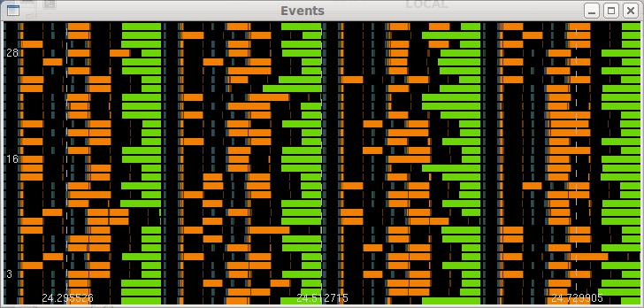
In this display the x-axis is elapsed time in the job, and the y-axis is MPI rank from 0-31, taken from a 2048-way parallel job using the MILC NSF benchmark. MILC uses a conjugate-gradient solver, and the code was instrumented with calls to trace_start()/trace_stop() in order to capture a few iterations. The colored bars correspond to MPI routines : orange is MPI_Wait, green is MPI_Allreduce. This data was recorded on BlueGene/P during an early stage of system-software development. The relatively long times that are sometimes spent in MPI_Wait() were due to errors in the messaging layers for BGP … the messaging software was not properly handling multiple outstanding non-blocking calls to MPI_Isend()/MPI_Irecv(). In this example, the code was attempting to overlap computation and communication by using a sequence of steps like this:

call MPI_Isend/MPI_Irecv for the first set of messages
do some work
call MPI_Isend/MPI_Irecv for a second set of messages
call MPI_Wait for the first set of messages
do more work
call MPI_Wait for the second set of messages

Unfortunately, some of the MPI_Wait() calls for the first set of messages did not return until some of the MPI_Wait() calls for the second set of messages completed. The result was poor parallel performance … some MPI ranks were stuck waiting for others to finish computational steps before they could proceed. In this case the defect was reported, but it was possible to re-structure the code to avoid the problem:

do some work
call MPI_Isend/MPI_Irecv/MPI_Wait for the first set of messages
do more work
call MPI_Isend/MPI_Irecv/MPI_Wait for the second set of messages

This second approach makes no attempt to overlap computation and communication, but it did avoid the problem with message-completion. A display of the MPI trace file for the modified code is shown below.

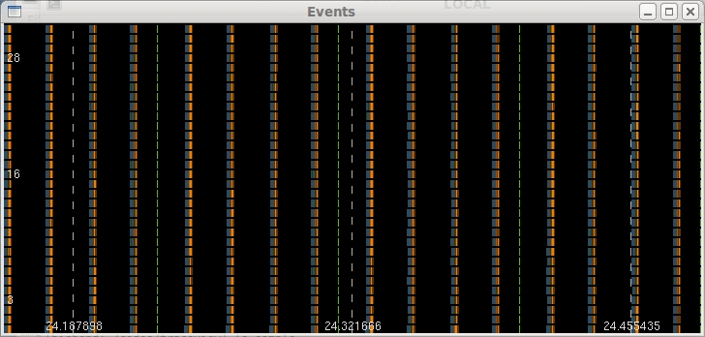
Black corresponds to computation, and one can see that now all of the MPI ranks are in sync, and the MPI events take a very small fraction of the elapsed time. The image above is a good example of a well-behaved parallel application … all of the MPI ranks are busy working concurrently, the load is beautifully balanced … there are no ranks unduly waiting on others to finish some stage of the work, and the fraction of time spent in MPI is small.

A key feature of the trace viewer is the ability to map MPI events back to the source-code location. Each trace record includes the instruction-address for the MPI routine and the grandparent, going up the call-stack. When you click (left-mouse button) on an MPI event, the details for that event will be displayed, and then you can use the addr2line utility to translate from instruction address to source-file and line-number. This requires -g as one of your options for compilation and linking. Example output from clicking on an MPI event is shown here:

task id = 62, event = MPI_Barrier
tbeg = 45.193914, tend = 45.229736, duration = 35.823 msec
parent address = 0x0115648c
grandparent address = 0x01139150

In this example, the MPI routine was MPI_Barrier, and you can find the source-file and line-number from the instruction addresses, using the addr2line utility. The event records include destination-ranks for flavors of MPI_Send, source ranks for flavors of MPI_Recv, and message-sizes where that information is available. The key information, however, is the instruction-address.

An example of an application with inherent load imbalance is shown below:

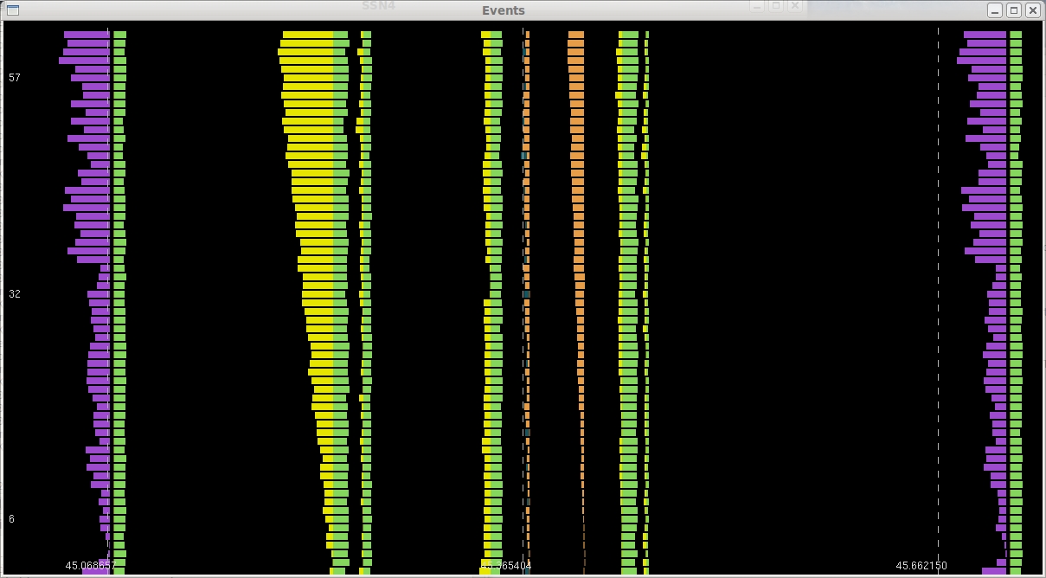
In this example the time spent in MPI_Barrier (the yellow rectangles) increases roughly linearly with MPI rank, and a similar pattern occurs for MPI_Bcast (light orange rectangles). In this application (the GFS code from the US National Weather Service), the load imbalance arises naturally from the parallel decomposition strategy. At this scale, load imbalance, not network latency or bandwidth, is what limits the parallel efficiency.

Sometimes applications have their own messaging layers … for example MPI_Isend() might always be called from an application routine “my_send()”. In cases like that you may need to look at the grandparent address, or even deeper into the call-stack for deeply layered cases. You can save instruction address data starting at any point in the call stack, by setting the environment variable TRACEBACK_LEVEL to the appropriate value … but you have to set that when you record the trace data because each event record has space for just two entries (called parent and grandparent) for instruction addresses.

In some cases it would be better to display performance metrics in a format that reflects the physical problem for the simulation. One example is shown below, from a cubed-sphere model of the earth's atmosphere:

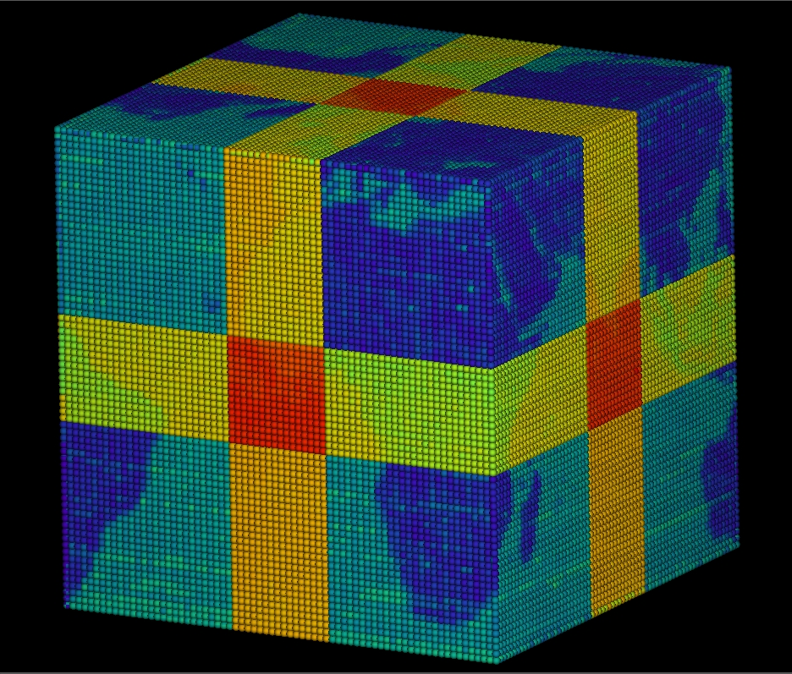
The data in this figure is the total amount of time spent in MPI routines, for each of 31104 MPI ranks, from a BlueGene/P job. Dark blue corresponds to the smallest time spent in MPI, and red corresponds to the largest time spent in MPI. The data looks like a gift-wrapped planet earth, and the timing variations are all due to load imbalance. The code uses a 2D decomposition for each of the six faces of the cube. In this case there were 72x72 MPI ranks for each face, and a total of 2000 grid points in each of the two dimensions. The yellow stripe occurs because the number of grid points (2000) is not evenly divisible by 72 … the MPI ranks in the yellow stripe have one less grid point. As a result, they finish their computation sooner, and wait in MPI longer. The MPI ranks in the red square have one fewer grid point in each of two dimensions, so they do the least amount of work, and wait in MPI the longest. Finally, MPI ranks that are positioned on a land mass have some extra work to do, relative to ranks positioned over the ocean … so ranks over the ocean must wait for the ones over land to finish their extra work … ranks over land have the most work, and do the smallest amount of waiting in MPI.

It would be possible to use similar kinds of displays for time-dependent data, such as event tracing, but this kind of approach is clearly dependent on the nature of the simulation, and so there is not much in the way of general tools that map performance data back to the physical simulation domain.

