Changes from last revision

|  |  |  |
| --- | --- | --- |
| Date | User | Edits |
| 12/27/2019 | Ce Yang | Specifications; Schematic and description of testbench; Design examples; |
|  |  |  |

Subsystem or block descriptions

|  |  |
| --- | --- |
| Design name | Delay Lock Loop (DLL) in TSMC 28nm CMOS |
| The Top-level cell name | Dll_schematic_28nm.scs |
| Designer | Ce Yang |
| Organization | University of Southern California |

**Overview**

*A DLL includes the voltage control delay line (VCDL), phase and frequency detector (PFD) and charge pump (CP). PFD and CP are used to provide the controlling voltage for VCDL in the circuit.*

**Block Specifications and Compliance**

|  |  |  |  |
| --- | --- | --- | --- |
| Spec Name | Min | Max | Note |
| Dead zone (ps) | 0 | 1 | Dead zone of the DLL after the controlling voltage becomes stable. |
| Fmin (GHz) | - | 6.5 | Maximum of the VCDL tuning range lower bound |
| Fmax (GHz) | 7 | - | Minimum of the VCDL tuning range upper bound |
| Power (mW) | 3.5 | 4 | Power consumption of VCDL |
| VDD (Volt) | 0.8 | 1 | Supply VDD |

**Block diagram**

The block diagram representation of the design is as follows:

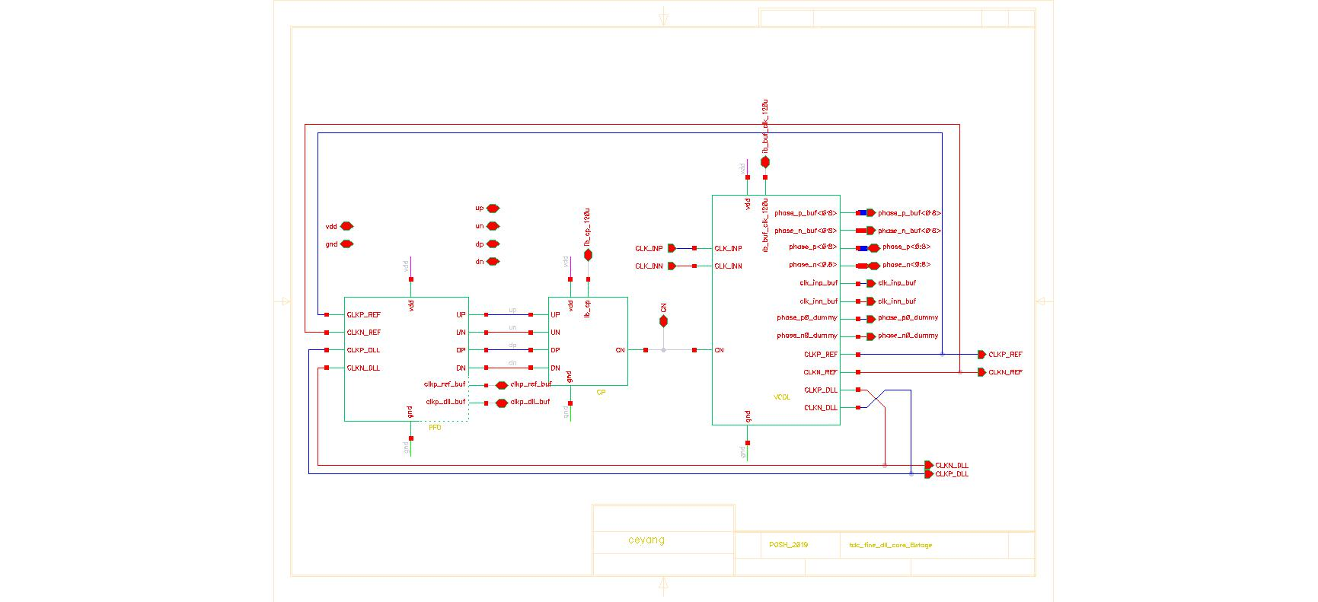

Figure 1: Architecture of DLL with AMPSE

|  |  |  |  |  |
| --- | --- | --- | --- | --- |
| Main analog modules | Regression models | | | |
| DLL main stage | model_dll_28.json | reg_dll_28.h5 | scX_dll_28.pkl | scY_dll_28.pkl |
| VCDL stage | model_vcdl_28.json | reg_vcdl_28.h5 | scX_vcdl_28.pkl | scY_vcdl_28.pkl |

***Signal list***

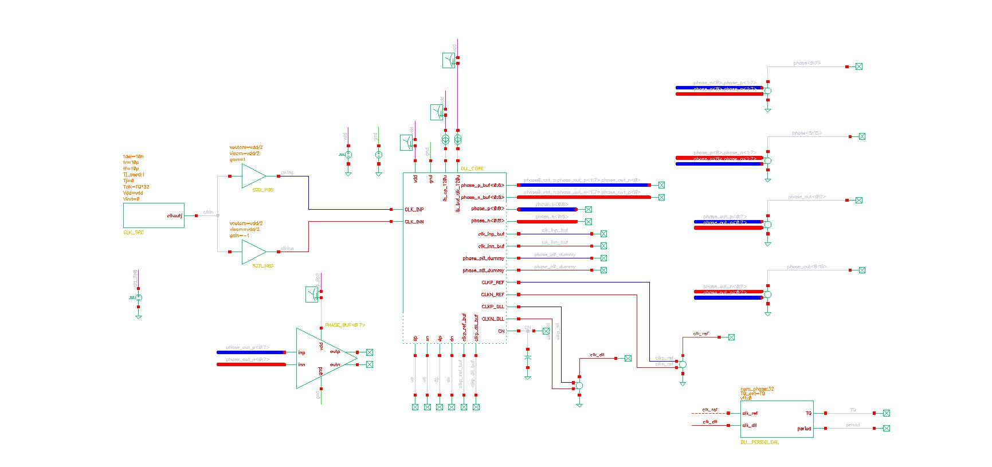

Figure 2: Symbol of the Top-Level of the DLL

|  |  |  |  |  |
| --- | --- | --- | --- | --- |
| Signal Pins | Direction  (I/O) | Type  (supply, ground, analog current, analog voltage, digital voltage) | Max Voltage  (core, IO or max voltage) | Specification |
| vdd | I | Supply | Core | Power Supply |
| gnd | I | Ground | Core | Ground |
| CLK_INP,  CLK_INN | I | Analog voltage | Core | Input clock |
| CLKP_REF,  CLKN_REF | I/O | Analog voltage | Core | Output signal of DLL,  Input signal of PFD |
| CLKP_DLL,  CLKN_DLL | I/O | Analog voltage | Core | Output signal of DLL,  Input signal of PFD |
| Ib_xx | I | Analog Current | Core | Bias current |
| phase_n,phase_p<0:8> | O | Analog voltage | Core | VCDL output |
| phase_n_buf,phase_p_buf<0:8> | O | Analog current | Core | DLL output |
| up,un,dp,dn | I/O | Analog current | Core | Input of CP |
| Others | I/O | Analog current | Core | Internal Nodes |

**Design Hierarchy**

The tabular description below corresponds to design hierarchy:

|  |  |  |  |
| --- | --- | --- | --- |
| Category | Cell Name | Description | Figure |
| DLL | VCDL | VCDL only | Figure. A1 |
| DLL | DLL including VCDL, PFD and CP | Figure. A2 |

**Test Bench**



Figure 3: The Test Bench Used for the top-level DTC

|  |  |  |
| --- | --- | --- |
| Cell Name | Note | |
| vcdl_schematic_28nm | Transient simulation for   1. VCDL tuning range 2. VCDL power range | ------ |
| dll_schematic_28nm | Transient simulation for   1. DLL dead zone 2. DLL power | ------ |

**Simulations & Design Example:**

|  |  |  |  |
| --- | --- | --- | --- |
| Conditions/parameters | Values | Conditions/parameters | Values |
| Process corner | TT | Temperature(°C) | 27 |

After running the different modules regressors and building the graph of the whole block, we get the candidate values of the parameters and the list of the expected metrics per module in order to achieve the required specs and their given constraints.

|  |  |  |  |  |  |
| --- | --- | --- | --- | --- | --- |
| Example - VCDL | | | | | |
| Parameters | | Metrics from AMPSE | | Metrics from SPICE | |
| vcdl_n_width (nm) | 494 | fmin (GHz) | 4.796 | fmin (GHz) | 4.27 |
| vcdl_p_width (nm) | 880 | fmax (GHz) | 8.358 | fmax (GHz) | 8.41 |
| tc_n_width (nm) | 1168 | pmin (mW) | 2.25 | pmin (mW) | 3.31 |
| tc_p_width (nm) | 1708 | pmax (mW) | 3.75 | pmax (mW) | 3.48 |
| Vdd(V) | 0.894 |  |  |  |  |

|  |  |  |  |  |  |
| --- | --- | --- | --- | --- | --- |
| Example - DLL | | | | | |
| Parameters | | Metrics from AMPSE | | Metrics from SPICE | |
| CP_out_width (nm) | 880 | Dead zone (ps) | 0.488 | DTC Gain (ps) | 1.15 |
| nor_n_width (nm) | 256 | Power (mW) | 4.4 | DTC Offset (ps) | 4.5 |
| nor_n_width (nm) | 412 |  |  |  |  |
| tspc_n_width (nm) | 256 |  |  |  |  |
| tspc_n_width (nm) | 430 |  |  |  |  |
| Vdd(V) | 0.894 |  |  |  |  |

**Appendix**

The schematics of the two modules used within the are shown below

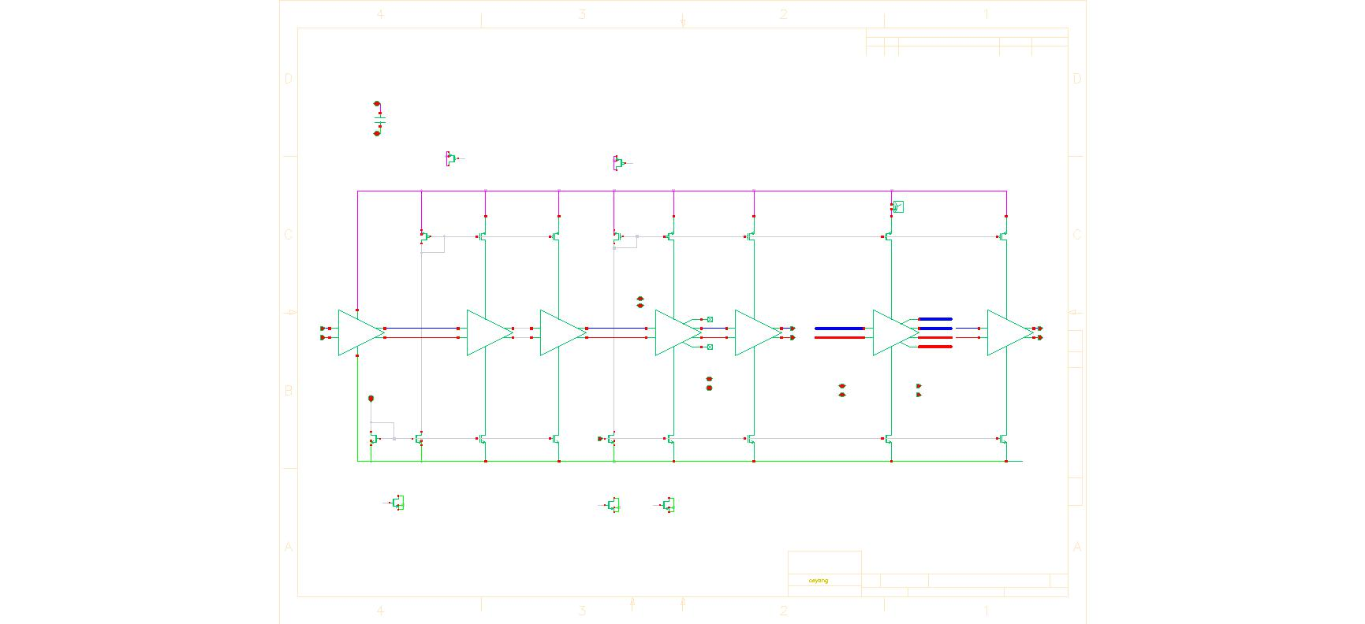

Figure A.1: The Circuit Schematic of the VCDL stage



Figure A.2: The Circuit Schematic of DLL main stage

AMPSE Modules descriptions

|  |  |  |
| --- | --- | --- |
| Module Name | Class name in Netlist_Database.py | Class name in AMPSE_Graph.py |
| VCDL | vcdl_spice | vcdl |
| DLL | dll_spice | dll |

*All the regression files are in /regfiles*

VCDL:

|  |  |  |  |  |
| --- | --- | --- | --- | --- |
| Parameters | min | max | step | Description |
| vcdl_n_width (nm) | 450 | 550 | 25 | Width of each finger in the inverter nmos |
| vcdl_p_width (nm) | 720 | 880 | 40 | Width of each finger in the inverter pmos |
| tc_n_width (nm) | 1170 | 1430 | 65 | Width of each finger in the tail current nmos |
| tc_p_width (nm) | 1710 | 2090 | 95 | Width of each finger in the tail current pmos |
| Vdd(V) | 0.8 | 1 | 0.1 | Supply voltage |

|  |  |
| --- | --- |
| Metrics | Description |
| fmin | Lower bound of tuning range |
| fmax | Upper bound of tuning range |
| pmin | Power of fmin |
| pmax | Power of fmax |

DLL:

|  |  |  |  |  |
| --- | --- | --- | --- | --- |
| Parameters | min | max | step | Description |
| CP_out_width (nm) | 720 | 880 | 80 | Width of output stage of CP |
| nor_n_width (nm) | 225 | 275 | 25 | Width of each finger in the nor gate nmos |
| nor_n_width (nm) | 360 | 440 | 40 | Width of each finger in the nor gate pmos |
| tspc_n_width (nm) | 225 | 275 | 25 | Width of each finger in the tspc nmos |
| tspc_n_width (nm) | 360 | 440 | 40 | Width of each finger in the tspc pmos |
| Vdd(V) | 0.8 | 1 | 0.1 | Supply voltage |

|  |  |
| --- | --- |
| Metrics | Description |
| Dead zone | Dead zone of DLL |
| Power | Power of whole DLL |



Figure A.3: The Graph Used to Model the Two Modules Together