Changes from last revision

|  |  |  |
| --- | --- | --- |
| Date | User | Edits |
| 12/14/2019 | Mostafa Ayesh | Specifications; Schematic and description of testbench; Design examples; |
|  |  |  |

Subsystem or block descriptions

|  |  |
| --- | --- |
| Design name | RF Front-End in TSMC 28nm CMOS |
| The Top-level cell name | RF_FrontEnd.scs |
| Designer | Mostafa Ayesh |
| Organization | University of Southern California |

**Overview**

*A Common Source Low Noise Amplifier (LNA) with an Inductive Load followed by a source follower RF buffer. The output signal from the LNA block is then forwarded to a bootstrapped sample-and-hold circuit to sample it and do the frequency conversion.*

**Block Specifications and Compliance**

|  |  |  |  |
| --- | --- | --- | --- |
| Spec Name | Min | Max | Note |
| Center Frequency (GHz) | 25 | 28 | \ |
| S/H Tracking BW (GHz) | 20 | 35 | \ |
| SFDR (dB) | 40 | 70 | \ |
| ENOB (bit) | 4 | 9 | \ |
| Power Consumption (mW) | 11 | 16 | \ |

**Block diagram**

The block diagram representation of the design is as follows:

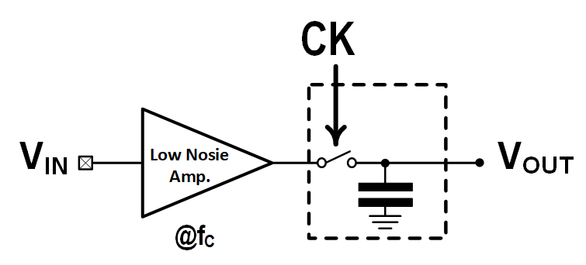

Figure 1: Architecture of the RF Front-End with AMPSE

|  |  |  |  |  |
| --- | --- | --- | --- | --- |
| Main analog modules | Regression models | | | |
| LNA | model_lna28.json | reg_lna28.h5 | scX_lna28.pkl | scY_lna28.pkl |
| Track and Hold | model_sh28.json | reg_sh28.h5 | scX_sh28.pkl | scY_sh28.pkl |

***Signal list***

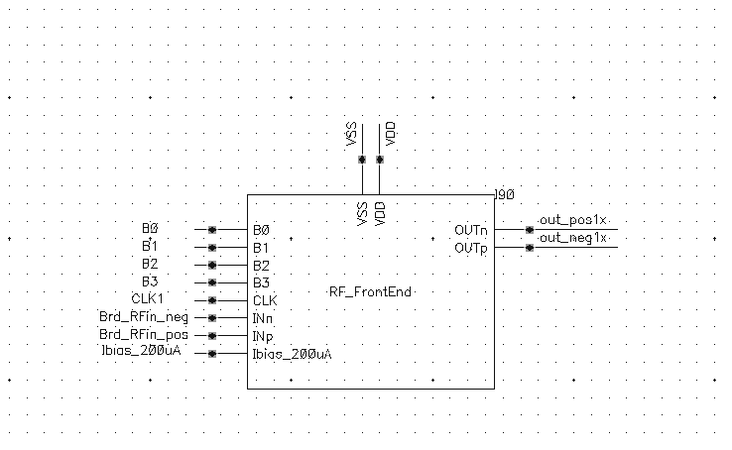

Figure 2: Symbol of the Top-Level of the RF Front-End

|  |  |  |  |  |
| --- | --- | --- | --- | --- |
| Signal Pins | Direction  (I/O) | Type  (supply, ground, analog current, analog voltage, digital voltage) | Max Voltage  (core, IO or max voltage) | Specification |
| VDD | I | Supply | Core | Power Supply, 1.0 V |
| VSS | I | Ground | Core | Ground |
| CLK | I | Analog voltage | Core | Input Clock |
| INn, INp | I | Analog voltage | Core | Differential Analog Input |
| Ibias_200uA | I | Analog Current | Core | Input Bias Current |
| OUTn, OUTp | O | Analog voltage | Core | Differential Analog Output |
| B<0:3> | I | Digital voltage | Core | Setting Biasing Current |

**Design Hierarchy**

The tabular description below corresponds to design hierarchy:

|  |  |  |  |
| --- | --- | --- | --- |
| Category | Cell Name | Description | Figure |
| RF_FrontEnd_v1 | LNA_28 | Low Noise Amplifier | Figure. A1 |
| SH_28 | Bootstrapped S/H | Figure. A2 |

**Test Bench**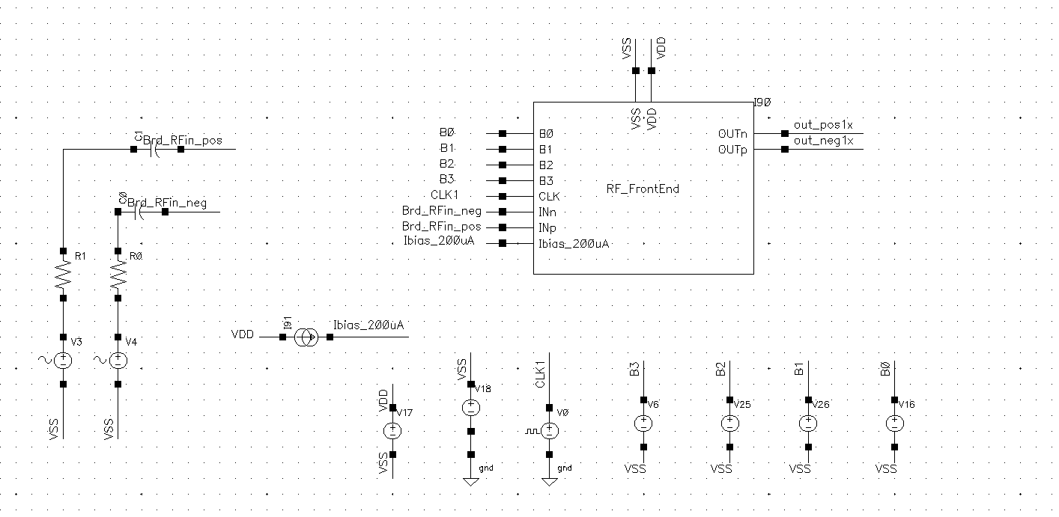 Figure 3: The Test Bench Used for the top-level RF-Front End

|  |  |  |
| --- | --- | --- |
| Cell Name | Note | |
| test_SH28 | Transient simulation for   1. SNR 2. SFDR 3. ENOB 4. Average Power Consumption 5. Peak-to-peak Output Voltage | AC simulation for:   1. Tracking Bandwidth |
| test_LNA28 | Transient simulation for   1. SNR 2. SFDR 3. ENOB 4. Average Power Consumption | AC simulation for:   1. Bandwidth 2. Center Frequency 3. Gain   Rout |

**Simulations (test_** **RF_FrontEnd_v1):**

|  |  |  |  |  |  |
| --- | --- | --- | --- | --- | --- |
| Conditions/parameters | Values | Conditions/parameters | Values | Conditions/parameters | Values |
| Process corner | TT | B<0:3> | 1111 | L_Radius(um) | 15 |
| Temperature(°C) | 27 | W_nMos_Follower | 15 | fin_gnd_1 | 2 |
| VDD(V) | 1 | W_pmos_in | 30 | fin_gnd_2 | 10 |
| Input amplitude(V) | 400m | fin_battery_cap | 80 | fin_main_sw | 4 |
| Input common mode voltage | AC-coupled input. | fin_sampling_cap | 4 | Fin_vdd_1 | 2 |
| Fin_nmos_bootstrapped_clk_1 | 10 | Fin_pmos_bootstrapped_clk_1 | 6 | fs (GHz) | 3.2 |

After running the different modules regressors and building the graph of the whole block, we get the candidate values of the parameters and the list of the expected metrics per module in order to achieve the required specs and their given constraints.

|  |  |  |  |  |  |  |  |  |
| --- | --- | --- | --- | --- | --- | --- | --- | --- |
| Example – 1 | | | | | | | | |
| LNA Parameters | | LNA Metrics | | SH Parameters | | SH Metrics | | Overall Expected Specs |
| Wpmos_in | 24.577 | Center Freq. (Hz) | 30.86G | fin_main_sw | 8.185 | SH_Power (W) | 109.37u | Are shaded in green |
| L_Radius(m) | 9.455u | Rout (Ohm) | 42.14 | fin_sampling_Cap | 76.84f | Output PP Amplitude (V) | 0.955 |
| Cin_OD(F) | 76.84f | LNA_Power (mW) | 13.92 | frf(Hz) | 30.86G | Tracking Bandwidth (GHz) | 18.96 |
| Wnmos_follower | 20.187 | Gain (dB) | -0.8 | fin_battery_cap | 49.86 | ENOB (bit) | 7.21 |
|  |  | SFDR (dB) | 54 | Rout_LNA (Ohm) | 42.14 | SNR (dB) | 44.1 |
|  |  | SNR (dB) | 57.9 |  |  | SFDR (dB) | 44.77 |
|  |  | ENOB (bit) | 9.27 |  |  |  |  |

|  |  |
| --- | --- |
| Example – 1: Verifying Using Cadence Virtuoso® | |
| Overall Achieved Metrics | |
| Overall Power Consumption (W) | 13.85m |
| Output PP Amplitude (V) | 370m |
| Tracking Bandwidth (GHz) | 23.5 |
| ENOB (bit) | 7.53 |
| SNR (dB) | 47.11 |
| SFDR (dB) | 48 |
| Center Frequency (GHz) | 30.55 |

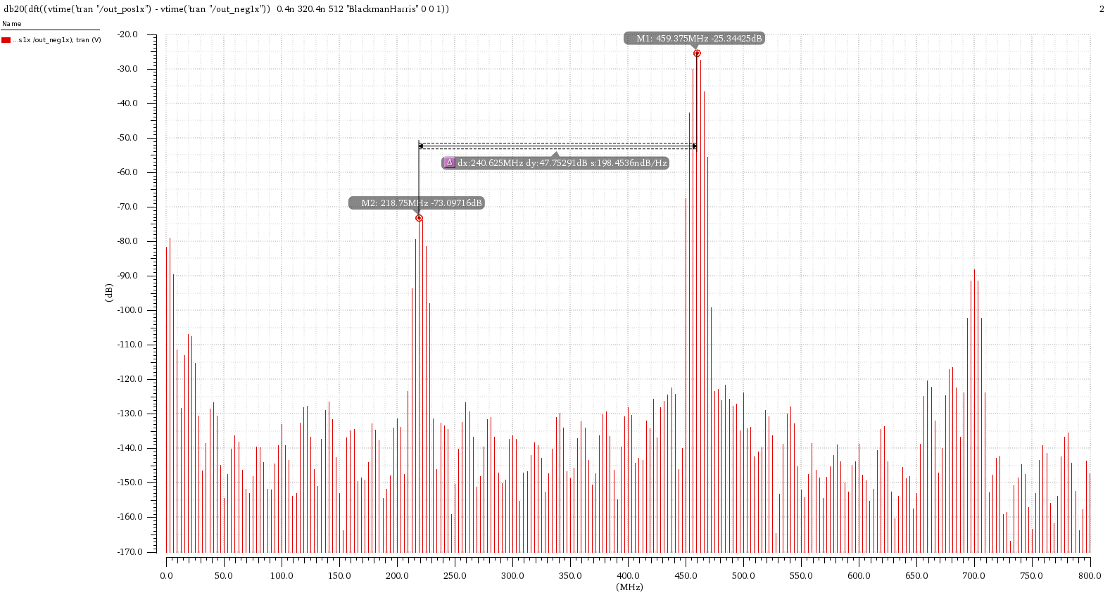The resulted metrics out from Cadence seems to give a quite matched result from the AMPSE. Simulations in Cadence Virtuoso were done in a moderate mode and using aps++, this might add some inaccuracy to the results.

**Appendix**

The schematics of the two modules used within the RF-frontend are shown below

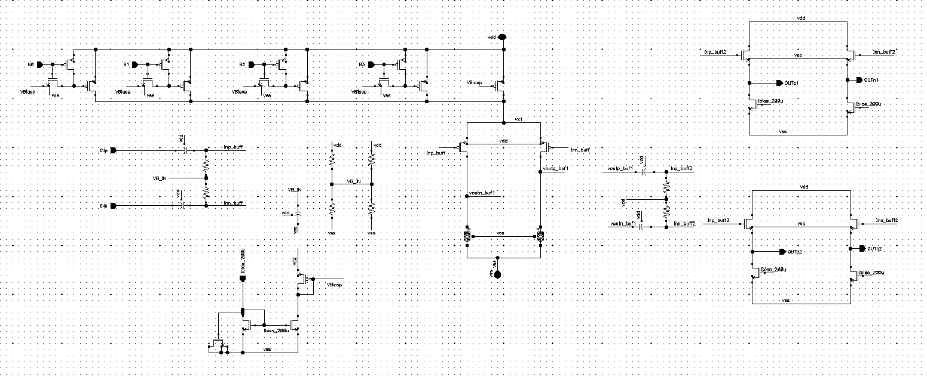

Figure A.1: The Circuit Schematic of the LNA

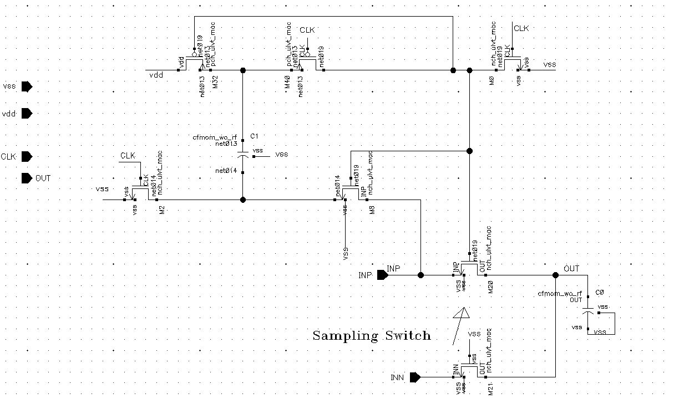

Figure A.2: The Circuit Schematic of the Bootstrapped Sample-and-Hold circuit

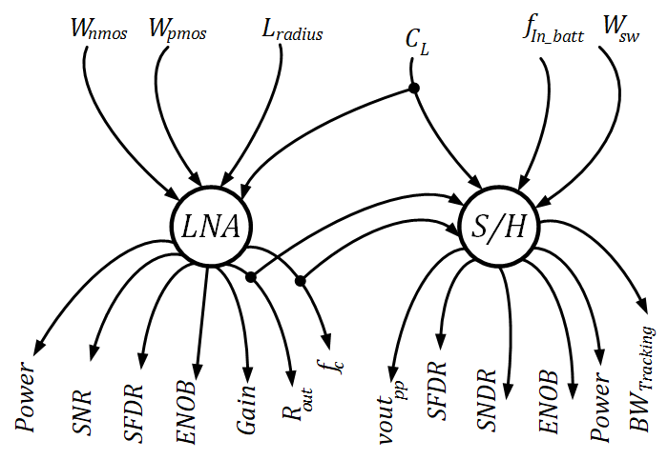

Figure A.3: The Graph Used to Model the Two Modules Together

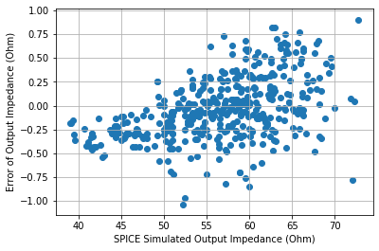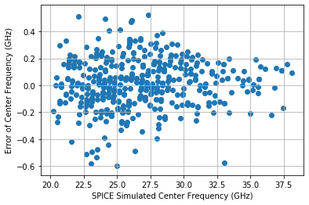**The error range of the LNA Model:**

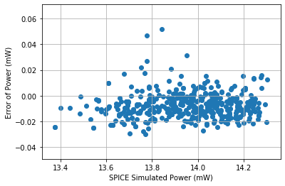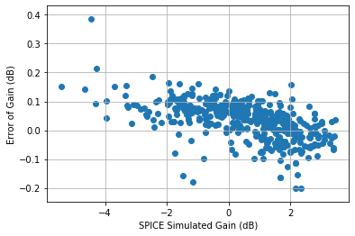

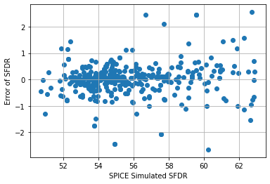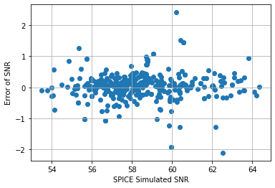

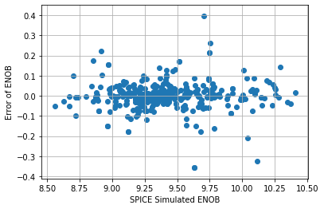

Figure A.4: The Error in Different Metrics of the LNA

**The error range of the bootstrapped-SH Model:**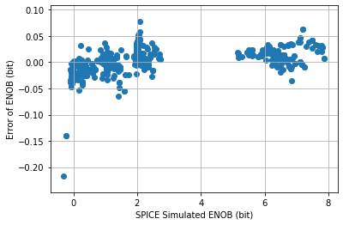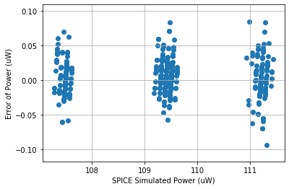

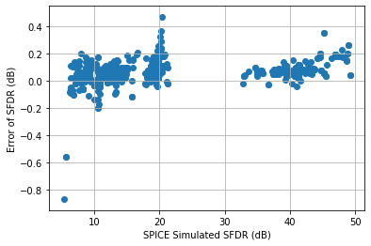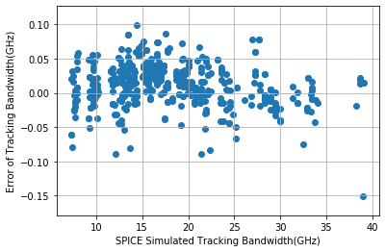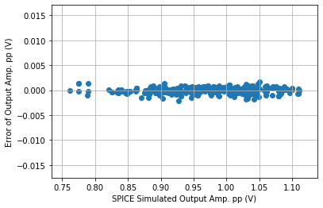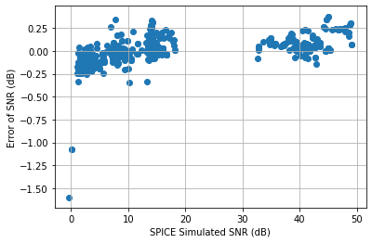

Figure A.5: The Error in Different Metrics of the Bootstrapped S/H