**KGD: Asynchronous SAR ADC in PTM**

1. **Introduction**

In this design a 2-GS/s / 6-bit SAR ADC has been implemented. ADC is a commonly used design block for converting analog signal into digital domain. The block diagram representation of the design is as follows:

**ADC Architecture:**

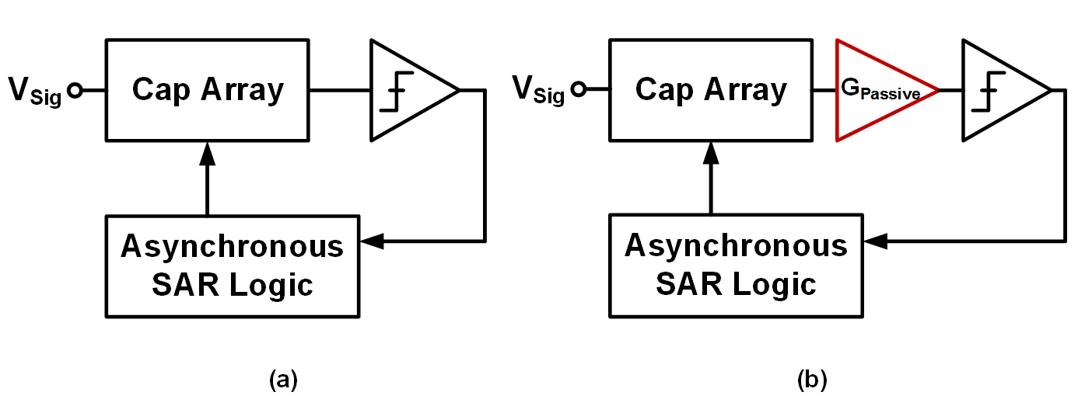

Figure 1: Architecture of Known Good Design (KGD) of SAR ADC

The major blocks in the design are:

* Track-and-hold network
* Comparator
* SAR logic / Clock generator

**Description:**

**The Top-level cell:** Asynch_SAR_ADC_6b2GSPS – A 2GHz / 6-bit SAR ADC.

Pin Configuration:

|  |  |
| --- | --- |
| **Pin Name** | **Specification** |
| VDD | Power Supply, 0.8V |
| VSS | Ground |
| CLK | Sampling clock 2GHz |
| REFP/REFN | Reference voltage |
| IP/IN | Analog Input < 1GHz |
| DOUT<5:0> | 6-bit Digital output |

The input pins are: CLK (Sampling Clock), VDD (Power Supply), VSS (ground), REFP/REFN (Differential reference voltage), and IP/IN (Analog differential Input signal). The output pins are DOUT<5:0> binary digital output.

**Description of the Cell Library:**

The tabular description below corresponds to the structure of the design library as seen in Cadence.

|  |  |  |  |
| --- | --- | --- | --- |
| **#** | Category | **CellName** | **Description** |
| 1 | TOP_CELL | Asynch_SAR_ADC_6b2GSPS | 6-bit 2GS/s SAR ADC |
|  |  | SUB1_CDAC_6b_diff | Track-and-Hold sampling network |
|  |  | SUB2_COMP_DUPLEX | Dual comparator pair |
|  |  | SUB3_CLK1 | Master clock generator (Sampling / conversion) |
|  |  | SUB3_CLK2 | Asynchronous clock generator |
|  |  | SUB5_SEQ_TOP_6b_v2 | Sequential State machine and Bit Cache |
| 2 | SUB1_SH_DAC | SUB1_CDAC_6b | Single-ended Top-plate sampling network 6b |
|  |  | SUB1_CDAC_SW | Reference switch + Unit capacitor |
| 3 | SUB2_COMP | SUB2_COMP_DynamicAMP | 1st Stage comparator (Gain stage) |
|  |  | SUB2_COMP_DynamicLAT | 2nd stage comparator (Latch) |
|  |  | SUB2_RDYgen | Ready-signal generator |
| 4 | SUB3_CLK_GEN | SUB3_CLK1 | Master clock generator (Sampling / conversion) |
|  |  | SUB3_CLK2 | Asynchronous clock generator |
| 5 | SUB4_SAR_LOGIC | SUB4_SAR_TOP | SAR logic top |
|  |  | SUB4_SAR2_DFF | DFF for SAR Logic to drive ref. switch |
|  |  | SUB4_SAR3 | DFF for SAR Logic for the last digital output |
| 6 | SUB5_SEQ | SUB5_SEQ_6b | Sequencer for 6bit SAR |

The complete schematic of the design is:

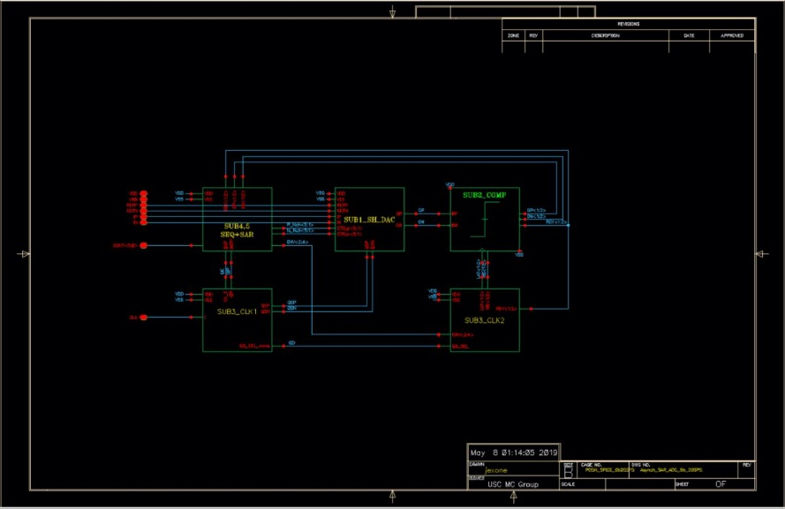

The schematic of the modules are as follows:

Track-and-hold network:

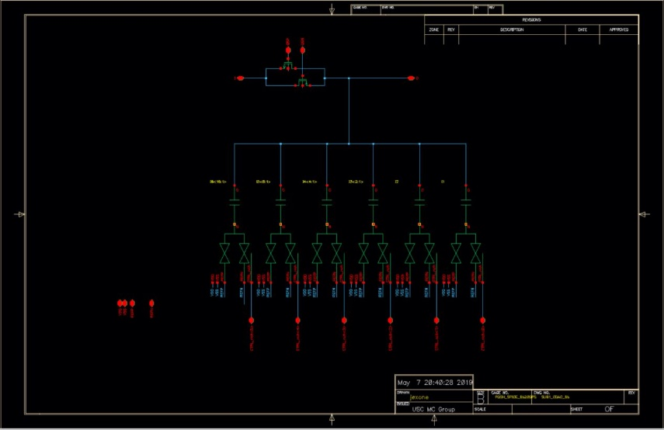

Dual comparator:

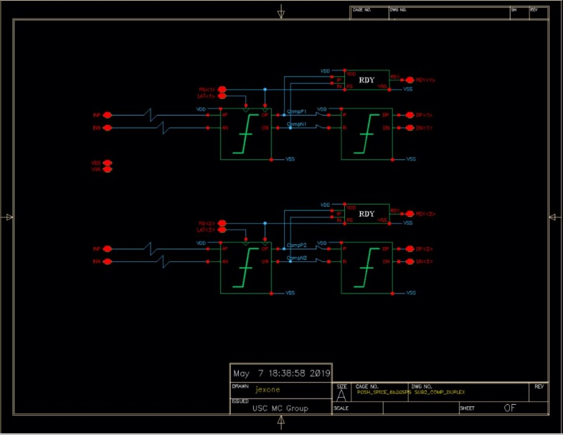

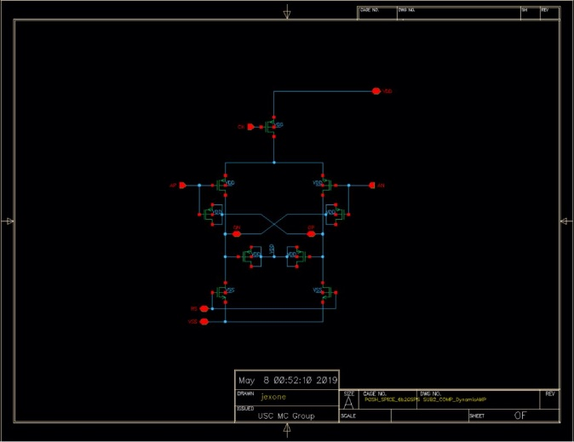 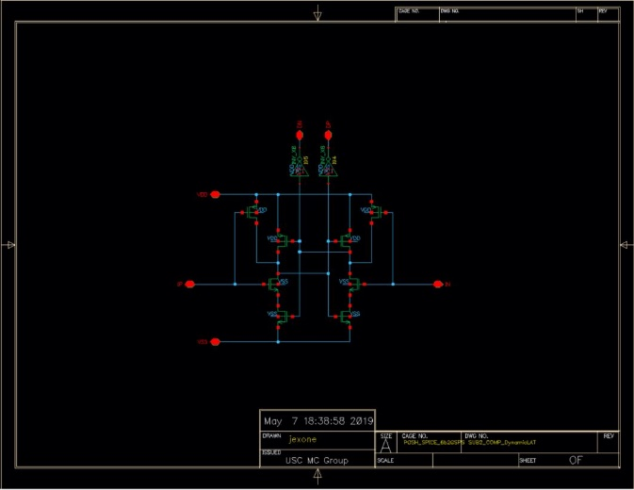

1st and 2nd stage comparator

Sequencer and SAR Logic:

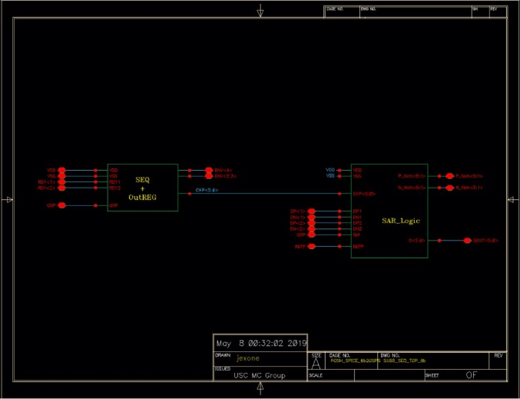 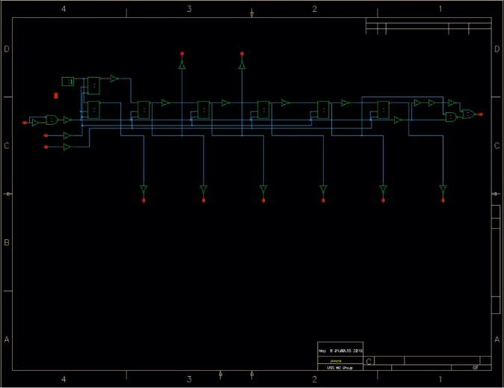

Clock generator / Asynch. Clocking circuit:

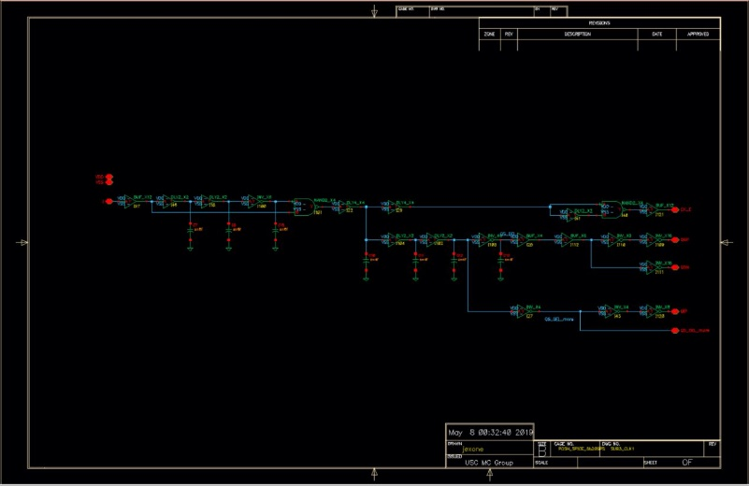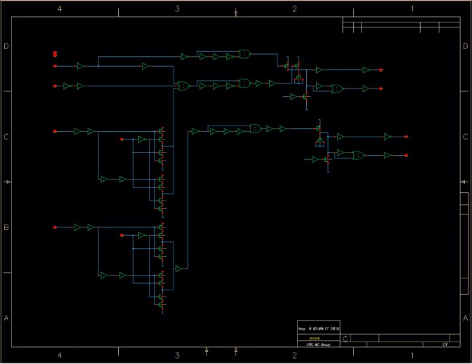

**Test Bench:**

**Dynamic performance evaluation with Sinusoidal input:**

Testbench for ADC dynamic performance using transient analysis.

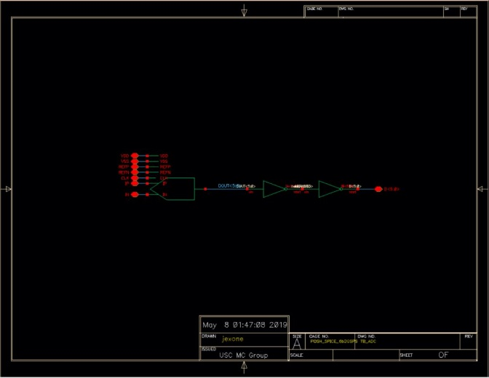

**Simulation Results: Power dissipation: 560uW**

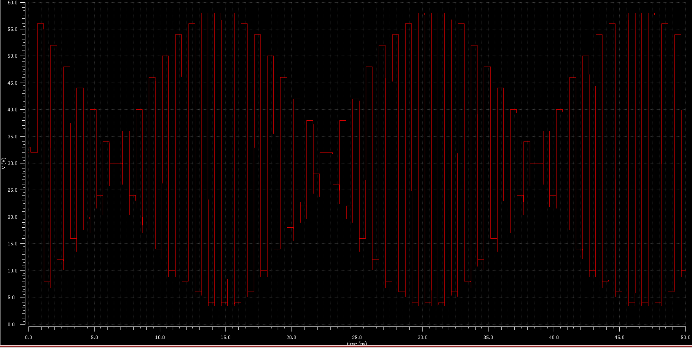

Transient waveform with Nyquist input frequency

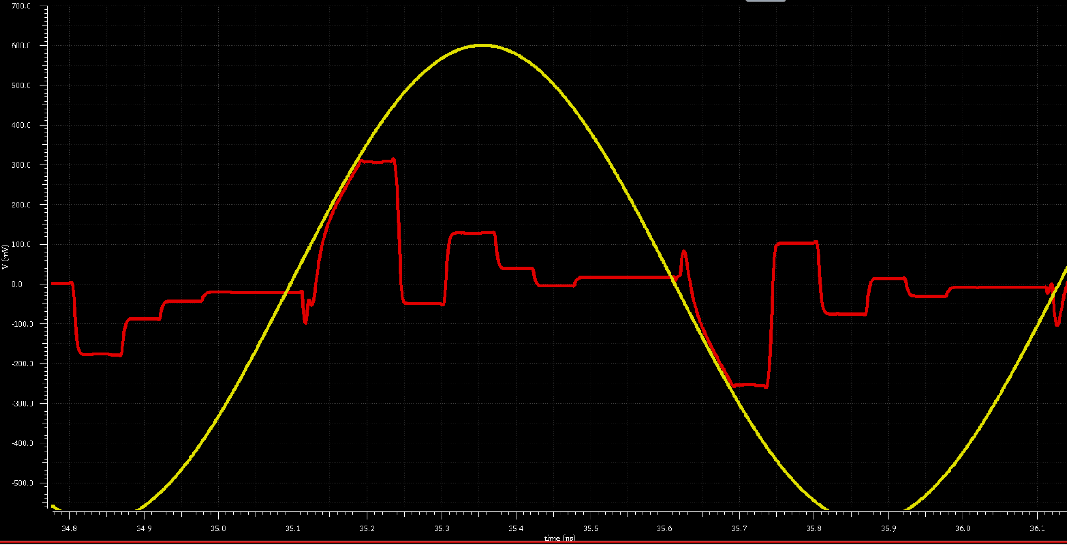

Transient waveform with Nyquist input frequency (Red: SAR Residue / Yellow: Input signal)