Submitted By: Anchal Kapoor

USC ID: 2650399913

Steps followed:

1. Downloaded and set up a Linux virtual machine with Java paths set up.
2. Downloaded and installed Apache Solr-6.5.0 on a Linux Virtual Machine.
3. Downloaded and indexed the LATimes data from the google drive link provided.
4. Started the solr server using command bin/solr start. The server is started on port 8983.
5. Created a new core using command bin/solr create -c myexample
6. Added the following 2 parameters to the managed-schema file:

<fieldType name="external" keyField="id" defVal="0" class="solr.ExternalFileField" valtype="pfloat" />

<field name="pageRankFile" type="external" stored="false" indexed="false" />

1. Indexed the data using command:

bin/post -c myexample -filetypes html /home/anchalkap/LATimesData/LATimesDownloadData

1. Downloaded and installed Java Jsoup library and wrote a Java class ExtractLinks to build a files edgesList.txt using the csv file mapLATimesDataFile.csv
2. Used Python Network-X library and took edgelist file as input to calculate the pagerank

Parameters used are : alpha=0.85, personalization=None, max_iter=30, tol=1e-06, nstart=None, weight='weight',dangling=None. This generated the page rank file external_PageRankFile.

1. Add the following listeners to solarconfig.xml



1. Client side code: From github cloned the solr-php-client code and modified it to create a UI with search box, 2 radio buttons.
2. Copy the external_pageRankFile to data directory under solr core.
3. Add the parameter ‘sort’=>’pagerank desc’ to the php code for query search using page rank algorithm. This sorts the results in descending order of page rank. The search results are clickable links.
4. The 8 queries are run for Lucene and PageRank and the results are pasted below.

Q. Why some pages have higher PageRank values?

Ans: Some pages have higher page rank value because many pages have are referring these pages i.e. the no of incoming edge links to these pages are higher as compared to other pages.

**Queries:**

1. **Brexit**

Lucene:

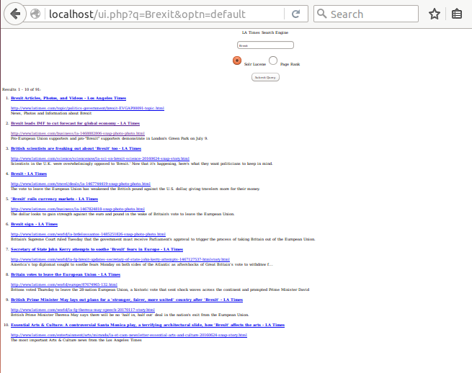

1. Brexit Articles, Photos, and Videos - Los Angeles Times

http://www.latimes.com/topic/politics-government/brexit-EVGAP00091-topic.html

News, Photos and Information about Brexit

1. Brexit leads IMF to cut forecast for global economy - LA Times

http://www.latimes.com/business/la-1468882806-snap-photo-photo.html

Pro-European Union supporters and pro-"Brexit" supporters demonstrate in London's Green Park on July 9.

1. British scientists are freaking out about 'Brexit' too - LA Times

http://www.latimes.com/science/sciencenow/la-sci-sn-brexit-science-20160624-snap-story.html

Scientists in the U.K. were overwhelmingly opposed to 'Brexit.' Now that it's happening, here's what they want politicians to keep in mind.

1. Brexit - LA Times

http://www.latimes.com/travel/deals/la-1467744419-snap-photo-photo.html

The vote to leave the European Union has weakened the British pound against the U.S. dollar, giving travelers more for their money.

1. 'Brexit' roils currency markets - LA Times

http://www.latimes.com/business/la-1467824818-snap-photo-photo.html

The dollar looks to gain strength against the euro and pound in the wake of Britain's vote to leave the European Union.

1. Brexit sign - LA Times

http://www.latimes.com/world/la-brdelossantos-1485251826-snap-photo-photo.html

Britain's Supreme Court ruled Tuesday that the government must receive Parliament's approval to trigger the process of taking Britain out of the European Union.

1. Secretary of State John Kerry attempts to soothe 'Brexit' fears in Europe - LA Times

http://www.latimes.com/world/la-fg-brexit-updates-secretary-of-state-john-kerry-attempts-1467127537-htmlstory.html

America’s top diplomat sought to soothe fears Monday on both sides of the Atlantic as aftershocks of Great Britain’s vote to withdraw f...

1. Britain votes to leave the European Union - LA Times

http://www.latimes.com/world/europe/87674965-132.html

Britons voted Thursday to leave the 28-nation European Union, a historic vote that sent shock waves across the continent and prompted Prime Minister David

1. British Prime Minister May lays out plans for a 'stronger, fairer, more united' country after 'Brexit' - LA Times

http://www.latimes.com/world/la-fg-theresa-may-speech-20170117-story.html

British Prime Minister Theresa May says there will be no ‘half in, half out’ deal in the nation's exit from the European Union.

1. Essential Arts & Culture: A controversial Santa Monica play, a terrifying architectural slide, how 'Brexit' affects the arts - LA Times

http://www.latimes.com/entertainment/arts/miranda/la-et-cam-newsletter-essential-arts-and-culture-20160624-snap-story.html

The most important Arts & Culture news from the Los Angeles Times

PageRank:

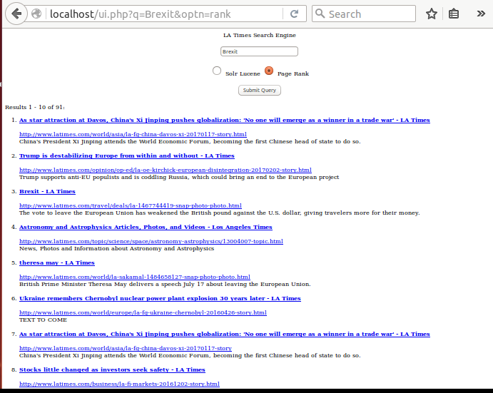

1. As star attraction at Davos, China's Xi Jinping pushes globalization: 'No one will emerge as a winner in a trade war' - LA Times

http://www.latimes.com/world/asia/la-fg-china-davos-xi-20170117-story.html

China's President Xi Jinping attends the World Economic Forum, becoming the first Chinese head of state to do so.

1. Trump is destabilizing Europe from within and without - LA Times

http://www.latimes.com/opinion/op-ed/la-oe-kirchick-european-disintegration-20170202-story.html

Trump supports anti-EU populists and is coddling Russia, which could bring an end to the European project

1. Brexit - LA Times

http://www.latimes.com/travel/deals/la-1467744419-snap-photo-photo.html

The vote to leave the European Union has weakened the British pound against the U.S. dollar, giving travelers more for their money.

1. Astronomy and Astrophysics Articles, Photos, and Videos - Los Angeles Times

http://www.latimes.com/topic/science/space/astronomy-astrophysics/13004007-topic.html

News, Photos and Information about Astronomy and Astrophysics

1. theresa may - LA Times

http://www.latimes.com/world/la-sakamal-1484658127-snap-photo-photo.html

British Prime Minister Theresa May delivers a speech July 17 about leaving the European Union.

1. Ukraine remembers Chernobyl nuclear power plant explosion 30 years later - LA Times

http://www.latimes.com/world/europe/la-fg-ukraine-chernobyl-20160426-story.html

TEXT TO COME

1. As star attraction at Davos, China's Xi Jinping pushes globalization: 'No one will emerge as a winner in a trade war' - LA Times

http://www.latimes.com/world/asia/la-fg-china-davos-xi-20170117-story

China's President Xi Jinping attends the World Economic Forum, becoming the first Chinese head of state to do so.

1. Stocks little changed as investors seek safety - LA Times

http://www.latimes.com/business/la-fi-markets-20161202-story.html

Investors made a small move back to safer assets Friday afternoon after the government's November jobs report showed continued hiring but weak wages. Indexes finished little changed.

1. Europe elections - LA Times

http://www.latimes.com/world/europe/la-efhernandez-1480712176-snap-photo-photo.html

Norbert Hofer, presidential candidate of Austria's right-wing Freedom Party, arrives for a campaign rally Dec. 2 in Vienna.

1. Revelers bid adieu to a year of conflicts, celebrity deaths - LA Times

http://www.latimes.com/world/la-fg-new-year-celebrations-20161231-story.html

As 2016 draws to a close, revelers around the world are bidding a weary adieu to a year filled with political surprises, prolonged conflicts and deaths of legendary celebrities.

1. **NASDAQ:**

Lucene

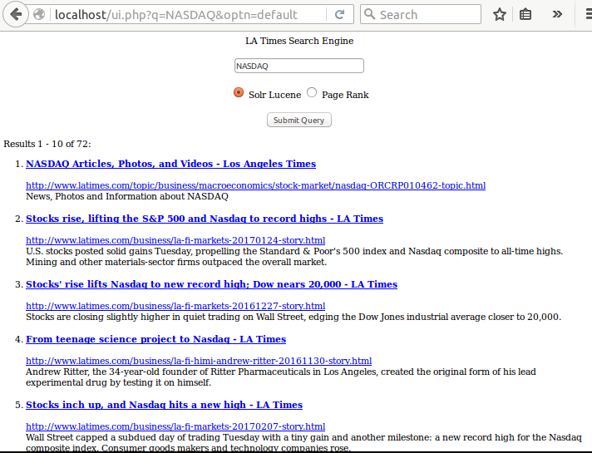

1. NASDAQ Articles, Photos, and Videos - Los Angeles Times

http://www.latimes.com/topic/business/macroeconomics/stock-market/nasdaq-ORCRP010462-topic.html

News, Photos and Information about NASDAQ

1. Stocks rise, lifting the S&P 500 and Nasdaq to record highs - LA Times

http://www.latimes.com/business/la-fi-markets-20170124-story.html

U.S. stocks posted solid gains Tuesday, propelling the Standard & Poor's 500 index and Nasdaq composite to all-time highs. Mining and other materials-sector firms outpaced the overall market.

1. Stocks' rise lifts Nasdaq to new record high; Dow nears 20,000 - LA Times

http://www.latimes.com/business/la-fi-markets-20161227-story.html

Stocks are closing slightly higher in quiet trading on Wall Street, edging the Dow Jones industrial average closer to 20,000.

1. From teenage science project to Nasdaq - LA Times

http://www.latimes.com/business/la-fi-himi-andrew-ritter-20161130-story.html

Andrew Ritter, the 34-year-old founder of Ritter Pharmaceuticals in Los Angeles, created the original form of his lead experimental drug by testing it on himself.

1. Stocks inch up, and Nasdaq hits a new high - LA Times

http://www.latimes.com/business/la-fi-markets-20170207-story.html

Wall Street capped a subdued day of trading Tuesday with a tiny gain and another milestone: a new record high for the Nasdaq composite index. Consumer goods makers and technology companies rose.

1. Oracle Corp. Articles, Photos, and Videos - Los Angeles Times

http://www.latimes.com/topic/business/oracle-corp.-ORCRP011497-topic.html

News, Photos and Information about Oracle Corp.

1. Solid bank earnings push stocks mostly higher - LA Times

http://www.latimes.com/business/la-fi-financial-markets-20170113-story.html

Banks led U.S. stock indexes mostly higher, propelling the Nasdaq composite to its fourth record high this week. Investors welcomed earnings from JPMorgan Chase, Bank of America and Wells Fargo.

1. S&P Dow Jones Indices Articles, Photos, and Videos - Los Angeles Times

http://www.latimes.com/topic/business/s%26p-dow-jones-indices-ORCOM00067-topic.html

News, Photos and Information about S&P Dow Jones Indices

1. Stocks drift mostly lower, but Dow ekes out another gain - LA Times

http://www.latimes.com/business/la-fi-markets-20170126-story.html

The Dow Jones industrial average inched further into record territory Thursday, eking out a gain while the broader U.S. market indexes drifted lower.

1. Bank stocks’ jump pushes U.S. indexes higher; bond yields rise - LA Times

http://www.latimes.com/business/la-fi-markets-20170214-story

Bank stocks jumped Tuesday on hopes that bigger profits are ahead, and U.S. indexes again pushed to record highs.

PageRank

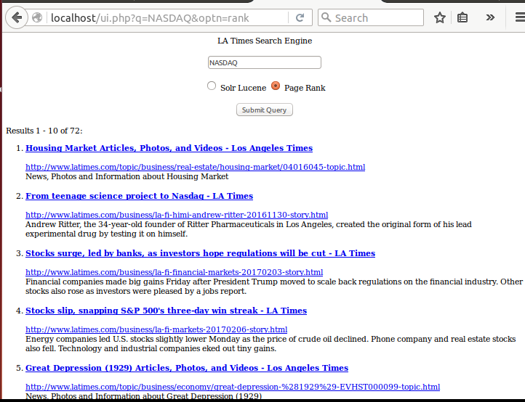

1. Housing Market Articles, Photos, and Videos - Los Angeles Times

http://www.latimes.com/topic/business/real-estate/housing-market/04016045-topic.html

News, Photos and Information about Housing Market

1. From teenage science project to Nasdaq - LA Times

http://www.latimes.com/business/la-fi-himi-andrew-ritter-20161130-story.html

Andrew Ritter, the 34-year-old founder of Ritter Pharmaceuticals in Los Angeles, created the original form of his lead experimental drug by testing it on himself.

1. Stocks surge, led by banks, as investors hope regulations will be cut - LA Times

http://www.latimes.com/business/la-fi-financial-markets-20170203-story.html

Financial companies made big gains Friday after President Trump moved to scale back regulations on the financial industry. Other stocks also rose as investors were pleased by a jobs report.

1. Stocks slip, snapping S&P 500's three-day win streak - LA Times

http://www.latimes.com/business/la-fi-markets-20170206-story.html

Energy companies led U.S. stocks slightly lower Monday as the price of crude oil declined. Phone company and real estate stocks also fell. Technology and industrial companies eked out tiny gains.

1. Great Depression (1929) Articles, Photos, and Videos - Los Angeles Times

http://www.latimes.com/topic/business/economy/great-depression-%281929%29-EVHST000099-topic.html

News, Photos and Information about Great Depression (1929)

1. Stocks little changed as investors seek safety - LA Times

http://www.latimes.com/business/la-fi-markets-20161202-story.html

Investors made a small move back to safer assets Friday afternoon after the government's November jobs report showed continued hiring but weak wages. Indexes finished little changed.

1. Stocks inch up, and Nasdaq hits a new high - LA Times

http://www.latimes.com/business/la-fi-markets-20170207-story.html

Wall Street capped a subdued day of trading Tuesday with a tiny gain and another milestone: a new record high for the Nasdaq composite index. Consumer goods makers and technology companies rose.

1. Financial companies lead stocks down; oil rises - LA Times

http://www.latimes.com/business/la-fi-markets-20170112-story.html

Banks and other financial companies led U.S. stocks modestly lower Thursday, wiping out much of the market's Wednesday gains. Phone companies, real estate, utilities and healthcare stocks rose.

1. Most stocks fall, but oil lifts Dow to a new record high - LA Times

http://www.latimes.com/business/la-fi-markets-20161212-story.html

Stocks mostly fell Monday, but a spurt in oil prices helped push the energy sector higher and the Dow Jones industrial average to another record.

1. Google's latest project: reinventing cities - LA Times

http://www.latimes.com/business/technology/la-fi-tn-google-sidewalk-labs-20150611-story.html

Google’s Chief Executive Larry Page has announced the tech giant’s latest moonshot, a new company whose mission is to revolutionize urban life. Sidewalk Labs, based in New York, said it will develop new technologies to make transportation more efficient, lower the cost of living, reduce energy...

1. **NBA:**

Lucene

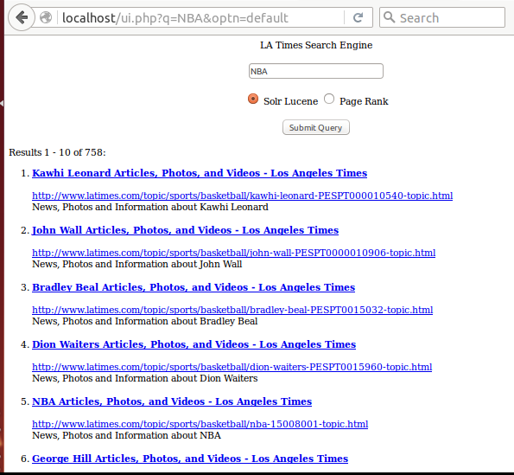

1. Kawhi Leonard Articles, Photos, and Videos - Los Angeles Times

http://www.latimes.com/topic/sports/basketball/kawhi-leonard-PESPT000010540-topic.html

News, Photos and Information about Kawhi Leonard

1. John Wall Articles, Photos, and Videos - Los Angeles Times

http://www.latimes.com/topic/sports/basketball/john-wall-PESPT0000010906-topic.html

News, Photos and Information about John Wall

1. Bradley Beal Articles, Photos, and Videos - Los Angeles Times

http://www.latimes.com/topic/sports/basketball/bradley-beal-PESPT0015032-topic.html

News, Photos and Information about Bradley Beal

1. Dion Waiters Articles, Photos, and Videos - Los Angeles Times

http://www.latimes.com/topic/sports/basketball/dion-waiters-PESPT0015960-topic.html

News, Photos and Information about Dion Waiters

1. NBA Articles, Photos, and Videos - Los Angeles Times

http://www.latimes.com/topic/sports/basketball/nba-15008001-topic.html

News, Photos and Information about NBA

1. George Hill Articles, Photos, and Videos - Los Angeles Times

http://www.latimes.com/topic/sports/basketball/george-hill-PESPT0000010780-topic.html

News, Photos and Information about George Hill

1. Kemba Walker Articles, Photos, and Videos - Los Angeles Times

http://www.latimes.com/topic/sports/basketball/kemba-walker-PESPT00008681-topic.html

News, Photos and Information about Kemba Walker

1. Gordon Hayward Articles, Photos, and Videos - Los Angeles Times

http://www.latimes.com/topic/sports/basketball/gordon-hayward-PESPT0000010774-topic.html

News, Photos and Information about Gordon Hayward

1. Andre Drummond Articles, Photos, and Videos - Los Angeles Times

http://www.latimes.com/topic/sports/basketball/andre-drummond-PESPT0015919-topic.html

News, Photos and Information about Andre Drummond

1. Brooklyn Nets Articles, Photos, and Videos - Los Angeles Times

http://www.latimes.com/topic/sports/basketball/brooklyn-nets-ORSPT000194-topic.html

News, Photos and Information about Brooklyn Nets

PageRank

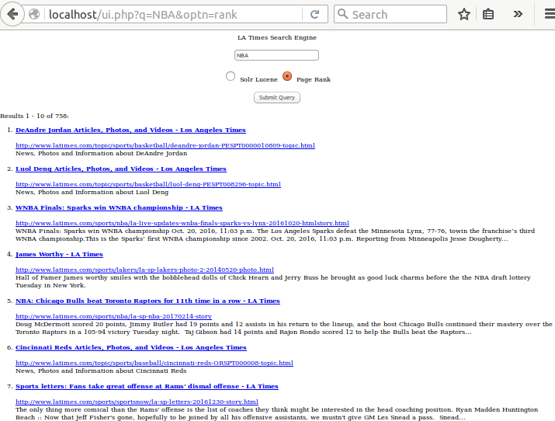

1. DeAndre Jordan Articles, Photos, and Videos - Los Angeles Times

http://www.latimes.com/topic/sports/basketball/deandre-jordan-PESPT0000010809-topic.html

News, Photos and Information about DeAndre Jordan

1. Luol Deng Articles, Photos, and Videos - Los Angeles Times

http://www.latimes.com/topic/sports/basketball/luol-deng-PESPT008296-topic.html

News, Photos and Information about Luol Deng

1. WNBA Finals: Sparks win WNBA championship - LA Times

http://www.latimes.com/sports/nba/la-live-updates-wnba-finals-sparks-vs-lynx-20161020-htmlstory.html

WNBA Finals: Sparks win WNBA championship Oct. 20, 2016, 11:03 p.m. The Los Angeles Sparks defeat the Minnesota Lynx, 77-76, towin the franchise’s third WNBA championship.This is the Sparks’ first WNBA championship since 2002. Oct. 20, 2016, 11:03 p.m. Reporting from Minneapolis Jesse Dougherty...

1. James Worthy - LA Times

http://www.latimes.com/sports/lakers/la-sp-lakers-photo-2-20140520-photo.html

Hall of Famer James worthy smiles with the bobblehead dolls of Chick Hearn and Jerry Buss he brought as good luck charms before the the NBA draft lottery Tuesday in New York.

1. NBA: Chicago Bulls beat Toronto Raptors for 11th time in a row - LA Times

http://www.latimes.com/sports/nba/la-sp-nba-20170214-story

Doug McDermott scored 20 points, Jimmy Butler had 19 points and 12 assists in his return to the lineup, and the host Chicago Bulls continued their mastery over the Toronto Raptors in a 105-94 victory Tuesday night. Taj Gibson had 14 points and Rajon Rondo scored 12 to help the Bulls beat the Raptors...

1. Cincinnati Reds Articles, Photos, and Videos - Los Angeles Times

http://www.latimes.com/topic/sports/baseball/cincinnati-reds-ORSPT000008-topic.html

News, Photos and Information about Cincinnati Reds

1. Sports letters: Fans take great offense at Rams' dismal offense - LA Times

http://www.latimes.com/sports/sportsnow/la-sp-letters-20161230-story.html

The only thing more comical than the Rams' offense is the list of coaches they think might be interested in the head coaching position. Ryan Madden Huntington Beach :: Now that Jeff Fisher's gone, hopefully to be joined by all his offensive assistants, we mustn't give GM Les Snead a pass. Snead...

1. Luol Deng is becoming comfortable with Lakers' offense - LA Times

http://www.latimes.com/sports/lakers/la-sp-lakers-report-20170107-story.html

One day after his first missed game of the season, Luol Deng put together perhaps his best game as a Laker. His game against the Miami Heat didn’t mark his highest scoring output of the season, but showed an increased comfort in the Lakers’ offense. “I’m just getting comfortable with how we’re...

1. Brandon Ingram is a raw rookie but also a window to a bright Lakers future - LA Times

http://www.latimes.com/sports/lakers/la-sp-lakers-ingram-elliott-20170214-story

Brandon Ingram’s duties as a Lakers rookie sometimes include carrying a veteran player’s bags. In a year or two, Ingram might be asked to carry the entire team. Ingram on Tuesday made his fourth straight start at small forward, a significant moment for the No. 2 pick in last year’s draft. Earlier...

1. Clippers vs. Nuggets - LA Times

http://www.latimes.com/visuals/photography/la-sp-clippers-nuggets-20161220-pictures-photogallery.html

Clippers and Nuggets play in an NBA game.

1. **Snapchat:**

Lucene

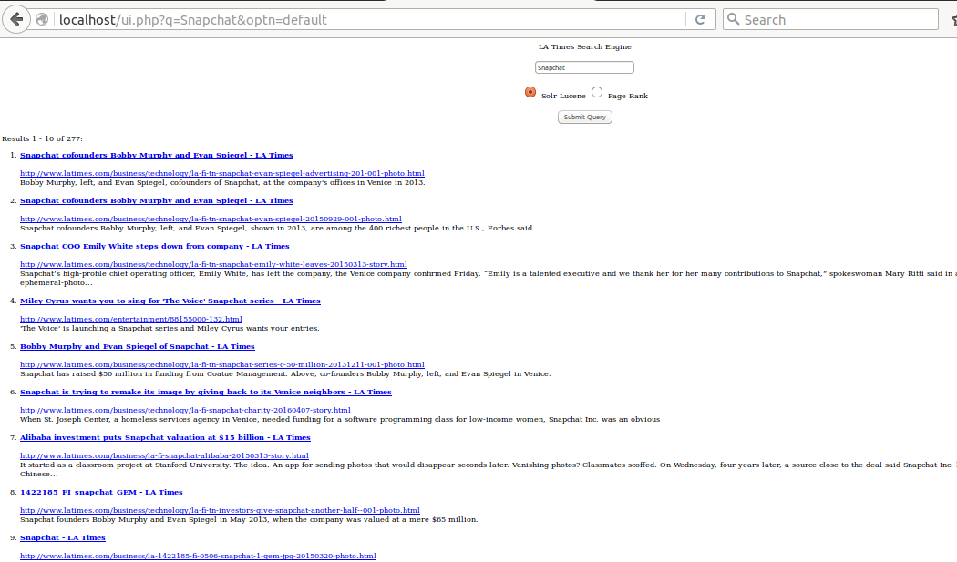

1. Snapchat cofounders Bobby Murphy and Evan Spiegel - LA Times

http://www.latimes.com/business/technology/la-fi-tn-snapchat-evan-spiegel-advertising-201-001-photo.html

Bobby Murphy, left, and Evan Spiegel, cofounders of Snapchat, at the company's offices in Venice in 2013.

1. Snapchat cofounders Bobby Murphy and Evan Spiegel - LA Times

http://www.latimes.com/business/technology/la-fi-tn-snapchat-evan-spiegel-20150929-001-photo.html

Snapchat cofounders Bobby Murphy, left, and Evan Spiegel, shown in 2013, are among the 400 richest people in the U.S., Forbes said.

1. Snapchat COO Emily White steps down from company - LA Times

http://www.latimes.com/business/technology/la-fi-tn-snapchat-emily-white-leaves-20150313-story.html

Snapchat’s high-profile chief operating officer, Emily White, has left the company, the Venice company confirmed Friday. “Emily is a talented executive and we thank her for her many contributions to Snapchat,” spokeswoman Mary Ritti said in an emailed statement. White was a big hire for the ephemeral-photo...

1. Miley Cyrus wants you to sing for 'The Voice' Snapchat series - LA Times

http://www.latimes.com/entertainment/88155000-132.html

'The Voice' is launching a Snapchat series and Miley Cyrus wants your entries.

1. Bobby Murphy and Evan Spiegel of Snapchat - LA Times

http://www.latimes.com/business/technology/la-fi-tn-snapchat-series-c-50-million-20131211-001-photo.html

Snapchat has raised $50 million in funding from Coatue Management. Above, co-founders Bobby Murphy, left, and Evan Spiegel in Venice.

1. Snapchat is trying to remake its image by giving back to its Venice neighbors - LA Times

http://www.latimes.com/business/technology/la-fi-snapchat-charity-20160407-story.html

When St. Joseph Center, a homeless services agency in Venice, needed funding for a software programming class for low-income women, Snapchat Inc. was an obvious

1. Alibaba investment puts Snapchat valuation at $15 billion - LA Times

http://www.latimes.com/business/la-fi-snapchat-alibaba-20150313-story.html

It started as a classroom project at Stanford University. The idea: An app for sending photos that would disappear seconds later. Vanishing photos? Classmates scoffed. On Wednesday, four years later, a source close to the deal said Snapchat Inc. had pulled in a $200-million investment from Chinese...

1. 1422185_FI_snapchat_GEM - LA Times

http://www.latimes.com/business/technology/la-fi-tn-investors-give-snapchat-another-half--001-photo.html

Snapchat founders Bobby Murphy and Evan Spiegel in May 2013, when the company was valued at a mere $65 million.

1. Snapchat - LA Times

http://www.latimes.com/business/la-1422185-fi-0506-snapchat-1-gem-jpg-20150320-photo.html

Bobby Murphy, left, Snapchat's chief technology officer, and Evan Spiegel, chief executive. In 2013, co-founder Reggie Brown sued his former colleagues and venture capitalists, alleging breach of contract.

1. Snapchat - LA Times

http://www.latimes.com/business/technology/la-fi-tn-snapchat-emily-white-coo-20131203-001-photo.html

Snapchat co-founders Bobby Murphy, left, and Evan Spiegel have hired Instagram's Emily White to be Snapchat's chief operating officer.

PageRank:

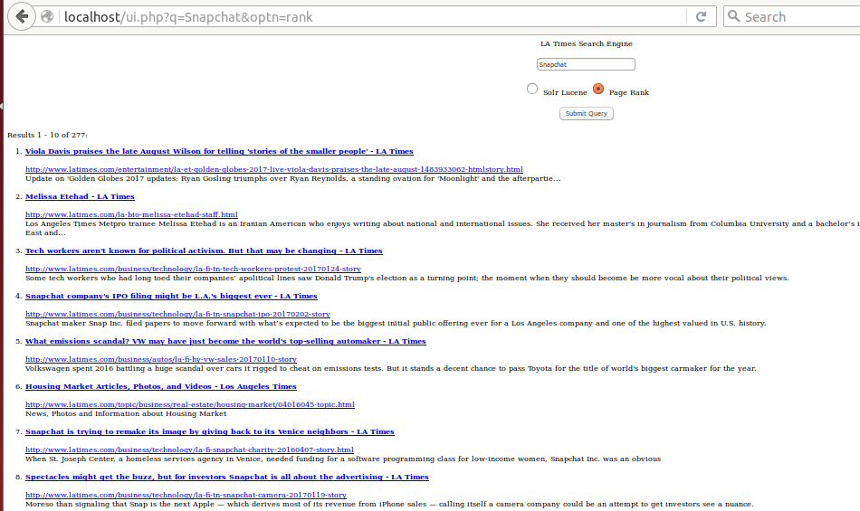

1. Viola Davis praises the late August Wilson for telling 'stories of the smaller people' - LA Times

http://www.latimes.com/entertainment/la-et-golden-globes-2017-live-viola-davis-praises-the-late-august-1483933062-htmlstory.html

Update on 'Golden Globes 2017 updates: Ryan Gosling triumphs over Ryan Reynolds, a standing ovation for 'Moonlight' and the afterpartie...

1. Melissa Etehad - LA Times

http://www.latimes.com/la-bio-melissa-etehad-staff.html

Los Angeles Times Metpro trainee Melissa Etehad is an Iranian American who enjoys writing about national and international issues. She received her master's in journalism from Columbia University and a bachelor’s in international affairs from UC San Diego and has reported from the Middle East and...

1. Tech workers aren't known for political activism. But that may be changing - LA Times

http://www.latimes.com/business/technology/la-fi-tn-tech-workers-protest-20170124-story

Some tech workers who had long toed their companies’ apolitical lines saw Donald Trump's election as a turning point; the moment when they should become be more vocal about their political views.

1. Snapchat company's IPO filing might be L.A.'s biggest ever - LA Times

http://www.latimes.com/business/technology/la-fi-tn-snapchat-ipo-20170202-story

Snapchat maker Snap Inc. filed papers to move forward with what’s expected to be the biggest initial public offering ever for a Los Angeles company and one of the highest valued in U.S. history.

1. What emissions scandal? VW may have just become the world's top-selling automaker - LA Times

http://www.latimes.com/business/autos/la-fi-hy-vw-sales-20170110-story

Volkswagen spent 2016 battling a huge scandal over cars it rigged to cheat on emissions tests. But it stands a decent chance to pass Toyota for the title of world's biggest carmaker for the year.

1. Housing Market Articles, Photos, and Videos - Los Angeles Times

http://www.latimes.com/topic/business/real-estate/housing-market/04016045-topic.html

News, Photos and Information about Housing Market

1. Snapchat is trying to remake its image by giving back to its Venice neighbors - LA Times

http://www.latimes.com/business/technology/la-fi-snapchat-charity-20160407-story.html

When St. Joseph Center, a homeless services agency in Venice, needed funding for a software programming class for low-income women, Snapchat Inc. was an obvious

1. Spectacles might get the buzz, but for investors Snapchat is all about the advertising - LA Times

http://www.latimes.com/business/technology/la-fi-tn-snapchat-camera-20170119-story

Moreso than signaling that Snap is the next Apple — which derives most of its revenue from iPhone sales — calling itself a camera company could be an attempt to get investors see a nuance.

1. Verizon chops unlimited data plans: Big users can switch or be disconnected - LA Times

http://www.latimes.com/business/la-fi-tn-verizon-unlimited-data-20170111-story.html

Verizon customers who have unlimited data plans and use more than 200 gigabytes a month will be required to switch to a capped data plan by Feb. 16 or be disconnected from service.

1. Flipagram acquired by China's Toutiao - LA Times

http://www.latimes.com/business/technology/la-fi-tn-flipagram-toutiao-20170201-story.html

Toutiao purchased Flipagram for an undisclosed amount, the companies announced Wednesday.

1. **Illegal Immigration:**

Lucene

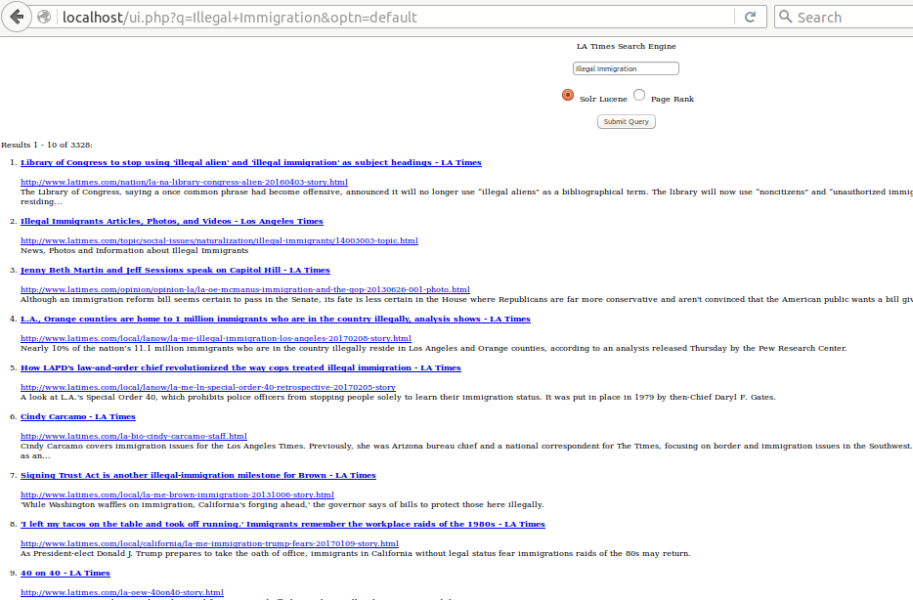

1. Library of Congress to stop using 'illegal alien' and 'illegal immigration' as subject headings - LA Times

http://www.latimes.com/nation/la-na-library-congress-alien-20160403-story.html

The Library of Congress, saying a once common phrase had become offensive, announced it will no longer use “illegal aliens” as a bibliographical term. The library will now use “noncitizens” and “unauthorized immigration” when referring to individuals and the larger phenomenon of people residing...

1. Illegal Immigrants Articles, Photos, and Videos - Los Angeles Times

http://www.latimes.com/topic/social-issues/naturalization/illegal-immigrants/14003003-topic.html

News, Photos and Information about Illegal Immigrants

1. Jenny Beth Martin and Jeff Sessions speak on Capitol Hill - LA Times

http://www.latimes.com/opinion/opinion-la/la-oe-mcmanus-immigration-and-the-gop-20130626-001-photo.html

Although an immigration reform bill seems certain to pass in the Senate, its fate is less certain in the House where Republicans are far more conservative and aren't convinced that the American public wants a bill giving illegal immigrants a path to citizenship. Above: Jenny Beth Martin, left,...

1. L.A., Orange counties are home to 1 million immigrants who are in the country illegally, analysis shows - LA Times

http://www.latimes.com/local/lanow/la-me-illegal-immigration-los-angeles-20170208-story.html

Nearly 10% of the nation’s 11.1 million immigrants who are in the country illegally reside in Los Angeles and Orange counties, according to an analysis released Thursday by the Pew Research Center.

1. How LAPD's law-and-order chief revolutionized the way cops treated illegal immigration - LA Times

http://www.latimes.com/local/lanow/la-me-ln-special-order-40-retrospective-20170205-story

A look at L.A.'s Special Order 40, which prohibits police officers from stopping people solely to learn their immigration status. It was put in place in 1979 by then-Chief Daryl F. Gates.

1. Cindy Carcamo - LA Times

http://www.latimes.com/la-bio-cindy-carcamo-staff.html

Cindy Carcamo covers immigration issues for the Los Angeles Times. Previously, she was Arizona bureau chief and a national correspondent for The Times, focusing on border and immigration issues in the Southwest. A Los Angeles native, she has reported in Argentina and Mexico during her time as an...

1. Signing Trust Act is another illegal-immigration milestone for Brown - LA Times

http://www.latimes.com/local/la-me-brown-immigration-20131006-story.html

'While Washington waffles on immigration, California's forging ahead,' the governor says of bills to protect those here illegally.

1. 'I left my tacos on the table and took off running.' Immigrants remember the workplace raids of the 1980s - LA Times

http://www.latimes.com/local/california/la-me-immigration-trump-fears-20170109-story.html

As President-elect Donald J. Trump prepares to take the oath of office, immigrants in California without legal status fear immigrations raids of the 80s may return.

1. 40 on 40 - LA Times

http://www.latimes.com/la-oew-40on40-story.html

Forty prominent Angelenos and Southern Californians sound off about policing, illegal immigrants and the LAPD.

1. The man behind Mansoor - LA Times

http://www.latimes.com/tn-dpt-0815-mansoor-20100814-story.html

Costa Mesa mayor is known for his hard stance on illegal immigration. Now, he seeks higher office in state Assembly.

PageRank

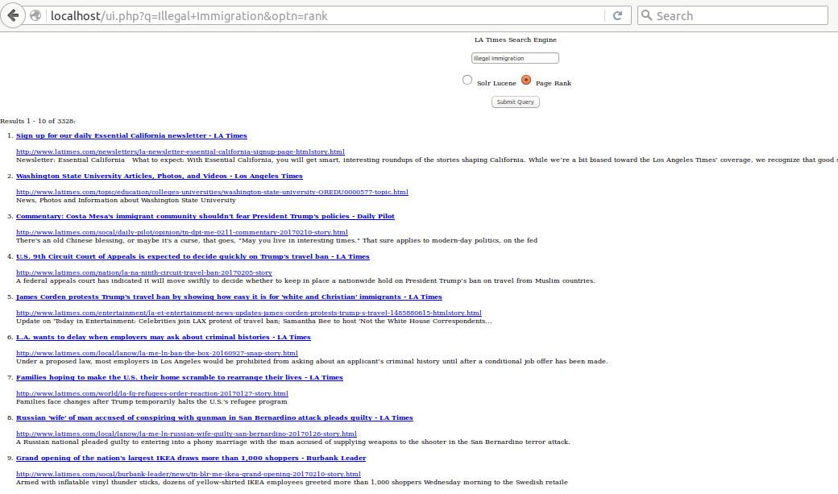

1. Sign up for our daily Essential California newsletter - LA Times

http://www.latimes.com/newsletters/la-newsletter-essential-california-signup-page-htmlstory.html

Newsletter: Essential California What to expect: With Essential California, you will get smart, interesting roundups of the stories shaping California. While we’re a bit biased toward the Los Angeles Times’ coverage, we recognize that good stories come from a variety of sources, so we’ll do our...

1. Washington State University Articles, Photos, and Videos - Los Angeles Times

http://www.latimes.com/topic/education/colleges-universities/washington-state-university-OREDU0000577-topic.html

News, Photos and Information about Washington State University

1. Commentary: Costa Mesa's immigrant community shouldn't fear President Trump's policies - Daily Pilot

http://www.latimes.com/socal/daily-pilot/opinion/tn-dpt-me-0211-commentary-20170210-story.html

There's an old Chinese blessing, or maybe it's a curse, that goes, "May you live in interesting times." That sure applies to modern-day politics, on the fed

1. U.S. 9th Circuit Court of Appeals is expected to decide quickly on Trump's travel ban - LA Times

http://www.latimes.com/nation/la-na-ninth-circuit-travel-ban-20170205-story

A federal appeals court has indicated it will move swiftly to decide whether to keep in place a nationwide hold on President Trump’s ban on travel from Muslim countries.

1. James Corden protests Trump's travel ban by showing how easy it is for 'white and Christian' immigrants - LA Times

http://www.latimes.com/entertainment/la-et-entertainment-news-updates-james-corden-protests-trump-s-travel-1485880615-htmlstory.html

Update on 'Today in Entertainment: Celebrities join LAX protest of travel ban; Samantha Bee to host 'Not the White House Correspondents...

1. L.A. wants to delay when employers may ask about criminal histories - LA Times

http://www.latimes.com/local/lanow/la-me-ln-ban-the-box-20160927-snap-story.html

Under a proposed law, most employers in Los Angeles would be prohibited from asking about an applicant’s criminal history until after a conditional job offer has been made.

1. Families hoping to make the U.S. their home scramble to rearrange their lives - LA Times

http://www.latimes.com/world/la-fg-refugees-order-reaction-20170127-story.html

Families face changes after Trump temporarily halts the U.S.'s refugee program

1. Russian 'wife' of man accused of conspiring with gunman in San Bernardino attack pleads guilty - LA Times

http://www.latimes.com/local/lanow/la-me-ln-russian-wife-guilty-san-bernardino-20170126-story.html

A Russian national pleaded guilty to entering into a phony marriage with the man accused of supplying weapons to the shooter in the San Bernardino terror attack.

1. Grand opening of the nation's largest IKEA draws more than 1,000 shoppers - Burbank Leader

http://www.latimes.com/socal/burbank-leader/news/tn-blr-me-ikea-grand-opening-20170210-story.html

Armed with inflatable vinyl thunder sticks, dozens of yellow-shirted IKEA employees greeted more than 1,000 shoppers Wednesday morning to the Swedish retaile

1. California actually benefits a lot from trade with China - LA Times

http://www.latimes.com/business/la-fi-china-trump-california-20161024-snap-story.html

China, vilified by Donald Trump in the U.S. presidential election, has actually lifted many California workers with its investment and trade.

1. **Donald Trump:**

Lucene

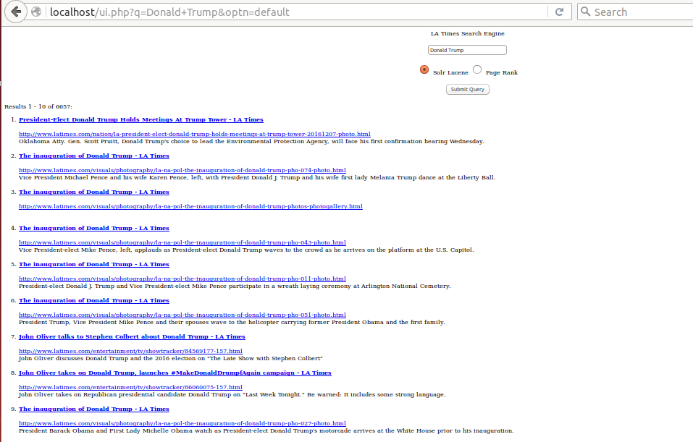

1. President-Elect Donald Trump Holds Meetings At Trump Tower - LA Times

http://www.latimes.com/nation/la-president-elect-donald-trump-holds-meetings-at-trump-tower-20161207-photo.html

Oklahoma Atty. Gen. Scott Pruitt, Donald Trump's choice to lead the Environmental Protection Agency, will face his first confirmation hearing Wednesday.

1. The inauguration of Donald Trump - LA Times

http://www.latimes.com/visuals/photography/la-na-pol-the-inauguration-of-donald-trump-pho-074-photo.html

Vice President Michael Pence and his wife Karen Pence, left, with President Donald J. Trump and his wife first lady Melania Trump dance at the Liberty Ball.

1. The inauguration of Donald Trump - LA Times

http://www.latimes.com/visuals/photography/la-na-pol-the-inauguration-of-donald-trump-photos-photogallery.html

1. The inauguration of Donald Trump - LA Times

http://www.latimes.com/visuals/photography/la-na-pol-the-inauguration-of-donald-trump-pho-043-photo.html

Vice President-elect Mike Pence, left, applauds as President-elect Donald Trump waves to the crowd as he arrives on the platform at the U.S. Capitol.

1. The inauguration of Donald Trump - LA Times

http://www.latimes.com/visuals/photography/la-na-pol-the-inauguration-of-donald-trump-pho-011-photo.html

President-elect Donald J. Trump and Vice President-elect Mike Pence participate in a wreath laying ceremony at Arlington National Cemetery.

1. The inauguration of Donald Trump - LA Times

http://www.latimes.com/visuals/photography/la-na-pol-the-inauguration-of-donald-trump-pho-051-photo.html

President Trump, Vice President Mike Pence and their spouses wave to the helicopter carrying former President Obama and the first family.

1. John Oliver talks to Stephen Colbert about Donald Trump - LA Times

http://www.latimes.com/entertainment/tv/showtracker/84569177-157.html

John Oliver discusses Donald Trump and the 2016 election on "The Late Show with Stephen Colbert"

1. John Oliver takes on Donald Trump, launches #MakeDonaldDrumpfAgain campaign - LA Times

http://www.latimes.com/entertainment/tv/showtracker/86060075-157.html

John Oliver takes on Republican presidential candidate Donald Trump on "Last Week Tonight." Be warned: It includes some strong language.

1. The inauguration of Donald Trump - LA Times

http://www.latimes.com/visuals/photography/la-na-pol-the-inauguration-of-donald-trump-pho-027-photo.html

President Barack Obama and First Lady Michelle Obama watch as President-elect Donald Trump's motorcade arrives at the White House prior to his inauguration.

1. Fact Check: Donald Trump falsely claims he was endorsed by ICE - LA Times

http://www.latimes.com/nation/91674552-132.html

Fact Check: Donald Trump falsely claims he was endorsed by ICE

PageRank:

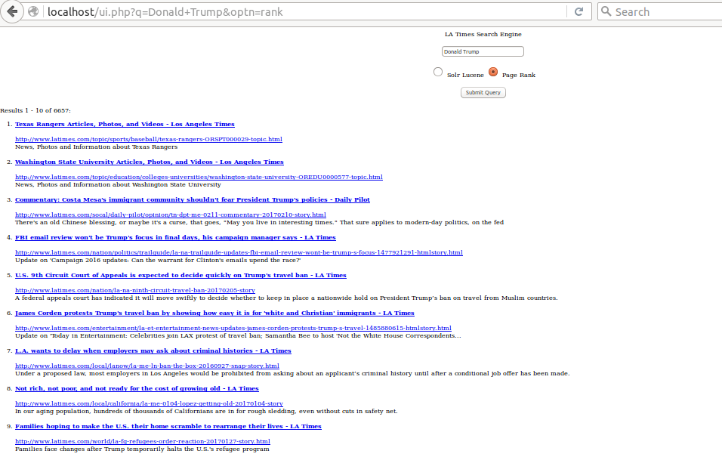

1. Texas Rangers Articles, Photos, and Videos - Los Angeles Times

http://www.latimes.com/topic/sports/baseball/texas-rangers-ORSPT000029-topic.html

News, Photos and Information about Texas Rangers

1. Washington State University Articles, Photos, and Videos - Los Angeles Times

http://www.latimes.com/topic/education/colleges-universities/washington-state-university-OREDU0000577-topic.html

News, Photos and Information about Washington State University

1. Commentary: Costa Mesa's immigrant community shouldn't fear President Trump's policies - Daily Pilot

http://www.latimes.com/socal/daily-pilot/opinion/tn-dpt-me-0211-commentary-20170210-story.html

There's an old Chinese blessing, or maybe it's a curse, that goes, "May you live in interesting times." That sure applies to modern-day politics, on the fed

1. FBI email review won't be Trump's focus in final days, his campaign manager says - LA Times

http://www.latimes.com/nation/politics/trailguide/la-na-trailguide-updates-fbi-email-review-wont-be-trump-s-focus-1477921291-htmlstory.html

Update on 'Campaign 2016 updates: Can the warrant for Clinton's emails upend the race?'

1. U.S. 9th Circuit Court of Appeals is expected to decide quickly on Trump's travel ban - LA Times

http://www.latimes.com/nation/la-na-ninth-circuit-travel-ban-20170205-story

A federal appeals court has indicated it will move swiftly to decide whether to keep in place a nationwide hold on President Trump’s ban on travel from Muslim countries.

1. James Corden protests Trump's travel ban by showing how easy it is for 'white and Christian' immigrants - LA Times

http://www.latimes.com/entertainment/la-et-entertainment-news-updates-james-corden-protests-trump-s-travel-1485880615-htmlstory.html

Update on 'Today in Entertainment: Celebrities join LAX protest of travel ban; Samantha Bee to host 'Not the White House Correspondents...

1. L.A. wants to delay when employers may ask about criminal histories - LA Times

http://www.latimes.com/local/lanow/la-me-ln-ban-the-box-20160927-snap-story.html

Under a proposed law, most employers in Los Angeles would be prohibited from asking about an applicant’s criminal history until after a conditional job offer has been made.

1. Not rich, not poor, and not ready for the cost of growing old - LA Times

http://www.latimes.com/local/california/la-me-0104-lopez-getting-old-20170104-story

In our aging population, hundreds of thousands of Californians are in for rough sledding, even without cuts in safety net.

1. Families hoping to make the U.S. their home scramble to rearrange their lives - LA Times

http://www.latimes.com/world/la-fg-refugees-order-reaction-20170127-story.html

Families face changes after Trump temporarily halts the U.S.'s refugee program

1. Why read a 5-year-old book about ExxonMobil now? Two words: Rex Tillerson - LA Times

http://www.latimes.com/books/jacketcopy/la-ca-jc-private-empire-20170127-story.html

Rex Tillerson was at ExxonMobil for four decades, and is poised to bring the company's culture to the State Department

1. **Russia:**

Lucene

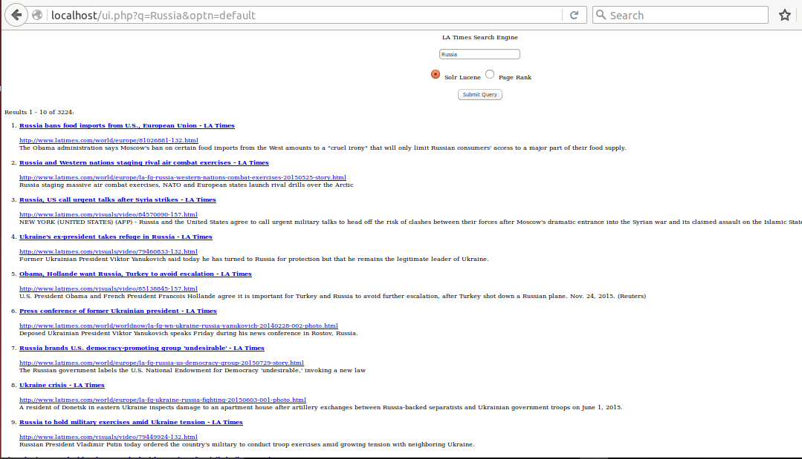

1. Russia bans food imports from U.S., European Union - LA Times

http://www.latimes.com/world/europe/81026881-132.html

The Obama administration says Moscow's ban on certain food imports from the West amounts to a "cruel irony" that will only limit Russian consumers' access to a major part of their food supply.

1. Russia and Western nations staging rival air combat exercises - LA Times

http://www.latimes.com/world/europe/la-fg-russia-western-nations-combat-exercises-20150525-story.html

Russia staging massive air combat exercises, NATO and European states launch rival drills over the Arctic

1. Russia, US call urgent talks after Syria strikes - LA Times

http://www.latimes.com/visuals/video/84570090-157.html

NEW YORK (UNITED STATES) (AFP) - Russia and the United States agree to call urgent military talks to head off the risk of clashes between their forces after Moscow's dramatic entrance into the Syrian war and its claimed assault on the Islamic State group.

1. Ukraine's ex-president takes refuge in Russia - LA Times

http://www.latimes.com/visuals/video/79460833-132.html

Former Ukrainian President Viktor Yanukovich said today he has turned to Russia for protection but that he remains the legitimate leader of Ukraine.

1. Obama, Hollande want Russia, Turkey to avoid escalation - LA Times

http://www.latimes.com/visuals/video/85138845-157.html

U.S. President Obama and French President Francois Hollande agree it is important for Turkey and Russia to avoid further escalation, after Turkey shot down a Russian plane. Nov. 24, 2015. (Reuters)

1. Press conference of former Ukrainian president - LA Times

http://www.latimes.com/world/worldnow/la-fg-wn-ukraine-russia-yanukovich-20140228-002-photo.html

Deposed Ukrainian President Viktor Yanukovich speaks Friday during his news conference in Rostov, Russia.

1. Russia brands U.S. democracy-promoting group 'undesirable' - LA Times

http://www.latimes.com/world/europe/la-fg-russia-us-democracy-group-20150729-story.html

The Russian government labels the U.S. National Endowment for Democracy 'undesirable,' invoking a new law

1. Ukraine crisis - LA Times

http://www.latimes.com/world/europe/la-fg-ukraine-russia-fighting-20150603-001-photo.html

A resident of Donetsk in eastern Ukraine inspects damage to an apartment house after artillery exchanges between Russia-backed separatists and Ukrainian government troops on June 1, 2015.

1. Russia to hold military exercises amid Ukraine tension - LA Times

http://www.latimes.com/visuals/video/79449924-132.html

Russian President Vladimir Putin today ordered the country's military to conduct troop exercises amid growing tension with neighboring Ukraine.

1. Ukraine says deal has been reached with Russia to free jailed pilot - LA Times

http://www.latimes.com/world/la-fg-ukraine-russia-pilot-20160419-story.html

Ukraine and Russia have reached a deal to free jailed Ukrainian pilot Nadezhda Savchenko, President Petro Poroshenko said

PageRank:

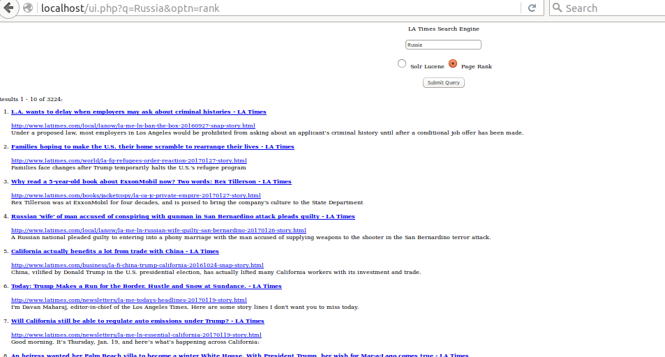

1. L.A. wants to delay when employers may ask about criminal histories - LA Times

http://www.latimes.com/local/lanow/la-me-ln-ban-the-box-20160927-snap-story.html

Under a proposed law, most employers in Los Angeles would be prohibited from asking about an applicant’s criminal history until after a conditional job offer has been made.

1. Families hoping to make the U.S. their home scramble to rearrange their lives - LA Times

http://www.latimes.com/world/la-fg-refugees-order-reaction-20170127-story.html

Families face changes after Trump temporarily halts the U.S.'s refugee program

1. Why read a 5-year-old book about ExxonMobil now? Two words: Rex Tillerson - LA Times

http://www.latimes.com/books/jacketcopy/la-ca-jc-private-empire-20170127-story.html

Rex Tillerson was at ExxonMobil for four decades, and is poised to bring the company's culture to the State Department

1. Russian 'wife' of man accused of conspiring with gunman in San Bernardino attack pleads guilty - LA Times

http://www.latimes.com/local/lanow/la-me-ln-russian-wife-guilty-san-bernardino-20170126-story.html

1. A Russian national pleaded guilty to entering into a phony marriage with the man accused of supplying weapons to the shooter in the San Bernardino terror attack.

California actually benefits a lot from trade with China - LA Times

http://www.latimes.com/business/la-fi-china-trump-california-20161024-snap-story.html

China, vilified by Donald Trump in the U.S. presidential election, has actually lifted many California workers with its investment and trade.

1. Today: Trump Makes a Run for the Border. Hustle and Snow at Sundance. - LA Times

http://www.latimes.com/newsletters/la-me-todays-headlines-20170119-story.html

I'm Davan Maharaj, editor-in-chief of the Los Angeles Times. Here are some story lines I don't want you to miss today.

1. Will California still be able to regulate auto emissions under Trump? - LA Times

http://www.latimes.com/newsletters/la-me-ln-essential-california-20170119-story.html

Good morning. It’s Thursday, Jan. 19, and here’s what’s happening across California:

1. An heiress wanted her Palm Beach villa to become a winter White House. With President Trump, her wish for Mar-a-Lago comes true - LA Times

http://www.latimes.com/nation/la-na-winter-white-houses-2017-story.html

The federal government returned Mar-a-Lago to the Marjorie Merriweather Post Foundation in 1980 after presidents showed little interest in using it.

1. SeaWorld eliminates hundreds of jobs - LA Times

http://www.latimes.com/business/la-fi-seaworld-layoffs-20161206-story.html

SeaWorld Entertainment Inc. announced Tuesday it is eliminating 320 jobs, part of an ongoing effort to sharply cut its costs.

1. Russia denies that intelligence agents were in contact with Trump's campaign team - LA Times

http://www.latimes.com/politics/washington/la-na-essential-washington-updates-russia-denies-that-intelligence-agents-1487166625-htmlstory.html

Update on 'Lawmakers call for investigation into Flynn's contacts with Russia'

1. **NASA:**

Lucene

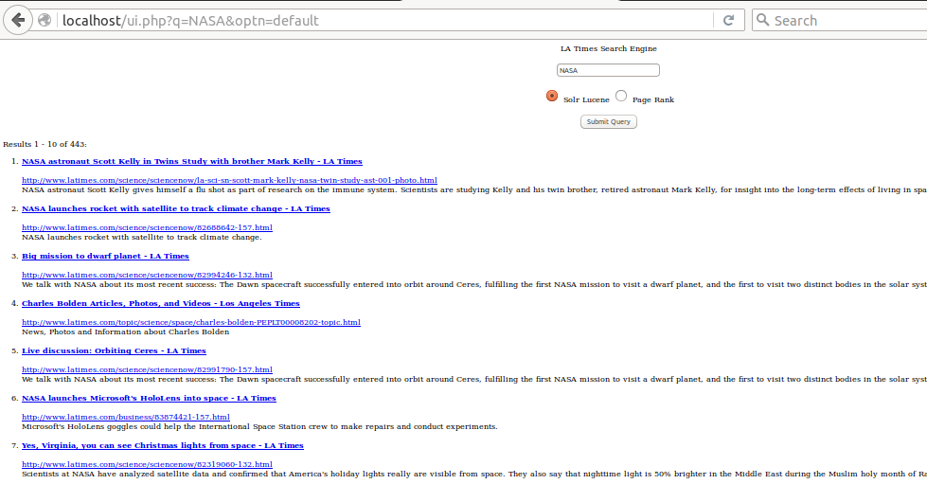

1. NASA astronaut Scott Kelly in Twins Study with brother Mark Kelly - LA Times

http://www.latimes.com/science/sciencenow/la-sci-sn-scott-mark-kelly-nasa-twin-study-ast-001-photo.html

NASA astronaut Scott Kelly gives himself a flu shot as part of research on the immune system. Scientists are studying Kelly and his twin brother, retired astronaut Mark Kelly, for insight into the long-term effects of living in space.

1. NASA launches rocket with satellite to track climate change - LA Times

http://www.latimes.com/science/sciencenow/82688642-157.html

NASA launches rocket with satellite to track climate change.

1. Big mission to dwarf planet - LA Times

http://www.latimes.com/science/sciencenow/82994246-132.html

We talk with NASA about its most recent success: The Dawn spacecraft successfully entered into orbit around Ceres, fulfilling the first NASA mission to visit a dwarf planet, and the first to visit two distinct bodies in the solar system.

1. Charles Bolden Articles, Photos, and Videos - Los Angeles Times

http://www.latimes.com/topic/science/space/charles-bolden-PEPLT00008202-topic.html

News, Photos and Information about Charles Bolden

1. Live discussion: Orbiting Ceres - LA Times

http://www.latimes.com/science/sciencenow/82991790-157.html

We talk with NASA about its most recent success: The Dawn spacecraft successfully entered into orbit around Ceres, fulfilling the first NASA mission to visit a dwarf planet, and the first to visit two distinct bodies in the solar system.

1. NASA launches Microsoft's HoloLens into space - LA Times

http://www.latimes.com/business/83874421-157.html

Microsoft's HoloLens goggles could help the International Space Station crew to make repairs and conduct experiments.

1. Yes, Virginia, you can see Christmas lights from space - LA Times

http://www.latimes.com/science/sciencenow/82319060-132.html

Scientists at NASA have analyzed satellite data and confirmed that America's holiday lights really are visible from space. They also say that nighttime light is 50% brighter in the Middle East during the Muslim holy month of Ramadan.

1. NASA's saucer-shaped experimental flight vehicle is prepared for a Range Compatibility Test at the US Navy's Pacific Missile Range Facility in Kaua'i, Hawaii. - LA Times

http://www.latimes.com/science/sciencenow/la-sci-sn-nasa-flying-saucer-ldsd-preview-2014-002-photo.html

NASA's saucer-shaped experimental flight vehicle is prepared for a Range Compatibility Test at the U.S. Navy's Pacific Missile Range Facility in Kauai, Hawaii.

1. NASA Articles, Photos, and Videos - Los Angeles Times

http://www.latimes.com/topic/science/space/nasa-ORGOV000098-topic.html

News, Photos and Information about NASA

1. What are the long-term health effects of living in space? NASA is studying twins Mark and Scott Kelly to find out - LA Times

http://www.latimes.com/science/la-sci-nasa-twin-study-20160707-snap-story.html

A look at NASA's unusual twin study involving astronauts Mark and Scott Kelly.

PageRank:

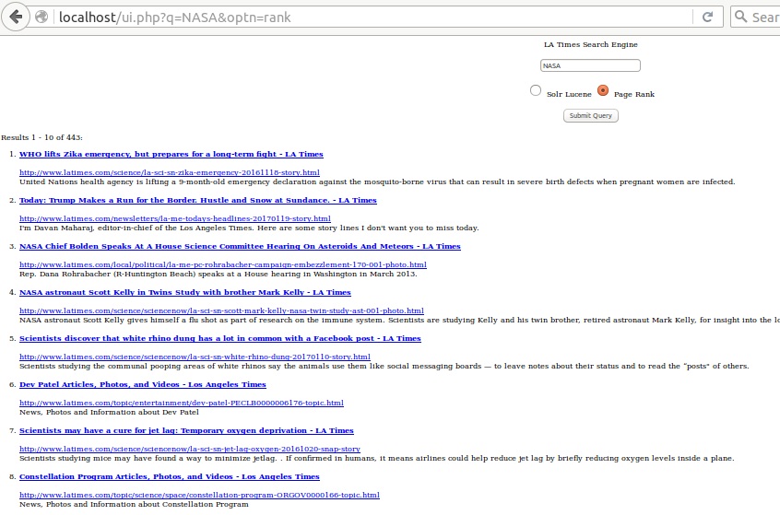

1. WHO lifts Zika emergency, but prepares for a long-term fight - LA Times

http://www.latimes.com/science/la-sci-sn-zika-emergency-20161118-story.html

United Nations health agency is lifting a 9-month-old emergency declaration against the mosquito-borne virus that can result in severe birth defects when pregnant women are infected.

1. Today: Trump Makes a Run for the Border. Hustle and Snow at Sundance. - LA Times

http://www.latimes.com/newsletters/la-me-todays-headlines-20170119-story.html

I'm Davan Maharaj, editor-in-chief of the Los Angeles Times. Here are some story lines I don't want you to miss today.

1. NASA Chief Bolden Speaks At A House Science Committee Hearing On Asteroids And Meteors - LA Times

http://www.latimes.com/local/political/la-me-pc-rohrabacher-campaign-embezzlement-170-001-photo.html

Rep. Dana Rohrabacher (R-Huntington Beach) speaks at a House hearing in Washington in March 2013.

1. NASA astronaut Scott Kelly in Twins Study with brother Mark Kelly - LA Times

http://www.latimes.com/science/sciencenow/la-sci-sn-scott-mark-kelly-nasa-twin-study-ast-001-photo.html

NASA astronaut Scott Kelly gives himself a flu shot as part of research on the immune system. Scientists are studying Kelly and his twin brother, retired astronaut Mark Kelly, for insight into the long-term effects of living in space.

1. Scientists discover that white rhino dung has a lot in common with a Facebook post - LA Times

http://www.latimes.com/science/sciencenow/la-sci-sn-white-rhino-dung-20170110-story.html

Scientists studying the communal pooping areas of white rhinos say the animals use them like social messaging boards — to leave notes about their status and to read the “posts" of others.

1. Dev Patel Articles, Photos, and Videos - Los Angeles Times

http://www.latimes.com/topic/entertainment/dev-patel-PECLB0000006176-topic.html

News, Photos and Information about Dev Patel

1. Scientists may have a cure for jet lag: Temporary oxygen deprivation - LA Times

http://www.latimes.com/science/sciencenow/la-sci-sn-jet-lag-oxygen-20161020-snap-story

Scientists studying mice may have found a way to minimize jetlag. . If confirmed in humans, it means airlines could help reduce jet lag by briefly reducing oxygen levels inside a plane.

1. Constellation Program Articles, Photos, and Videos - Los Angeles Times

http://www.latimes.com/topic/science/space/constellation-program-ORGOV0000166-topic.html

News, Photos and Information about Constellation Program

1. 'Hidden Figures' may feature NASA's history, but it resonates in the present - LA Times

http://www.latimes.com/science/sciencenow/la-sci-sn-hidden-figures-nasa-20170107-story

NASA Administrator Charles Bolden, the first African American to head the agency, explains why he encouraged his employees to go see "Hidden Figures."

1. Hot Jupiter KELT-4Ab has three suns, astronomers say - LA Times

http://www.latimes.com/science/sciencenow/la-sci-sn-kelt-4ab-three-sun-planet-20160404-001-photo.html

This artist's rendition shows what a sunset might look like from a moon around a planet in a triple-star system. Astronomers say they've found a hot Jupiter in just such a system. Although for the newly discovered KELT-4Ab, the two most distant "suns" would look like little more than stars.

No. Of Overlaps: Bar Chart

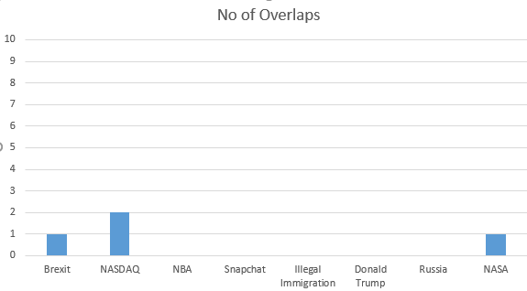

Flow:

The initial query page looks like:

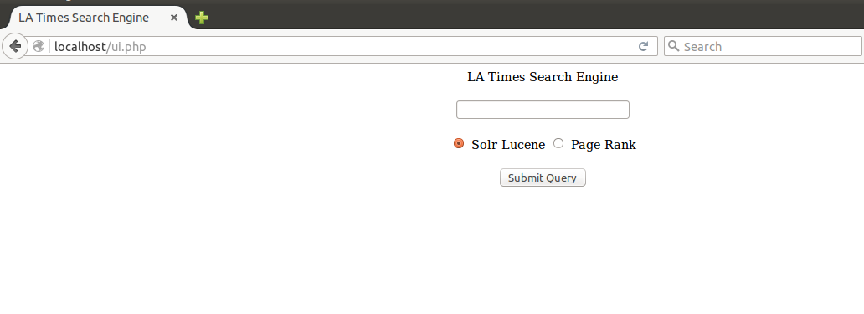

Now, For example we want to search for query = “Brexit”. After searching with Solr Lucene algorithm the page looks like:

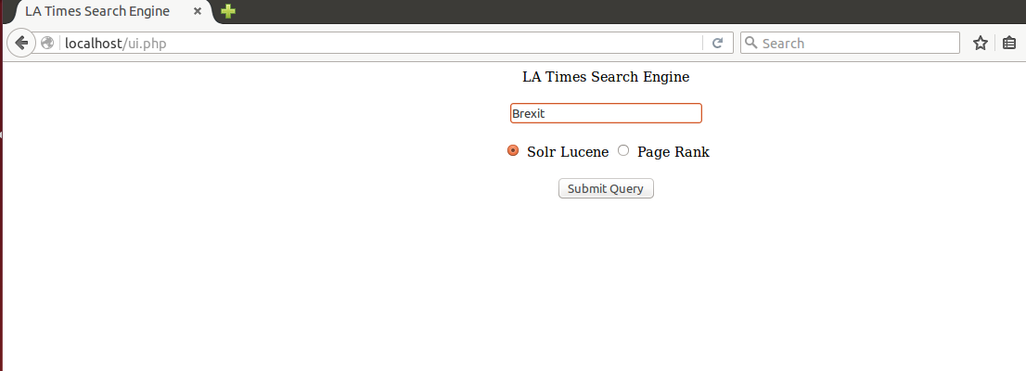

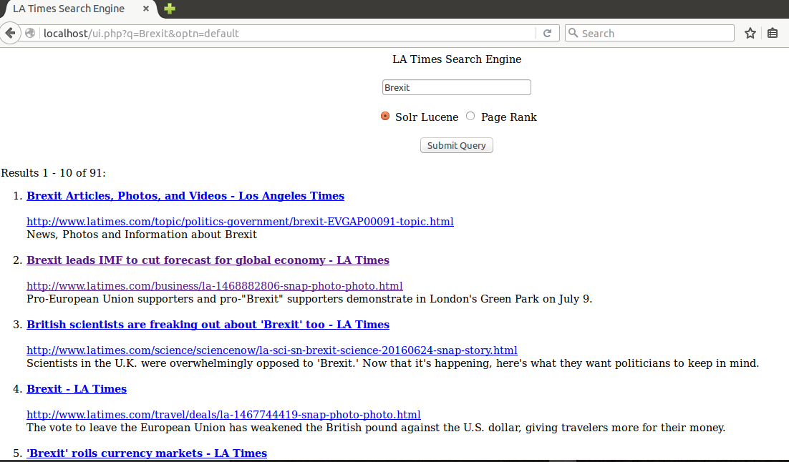

Also. searching for query=”Brexit” for algorithm PageRank:

