Part2

1. Logistic Regression
2. Run and result:

We implemented the SKLearn version of Logistic Regression and compared the difference.

Run: python skLearnLogistic.py [file_name]

The result is a four dimension of weight:

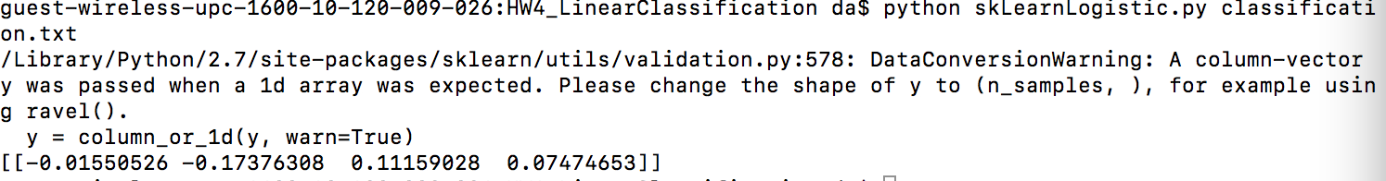

1. Difference:

The major idea of SKlearn Logistic Regression is same with us, however, the result of weight is not same. We think the main difference is that SKlearn implemented it with using regularization, the parameter named penalty could choose whether used L1-Regularization or L2-Regularization.

From online search, we found regularization is useful.It is a *technique*used in an attempt to solve the overfitting problem in machine learning models. So that we could get more precise prediction by using it.

1. Linear Regression
2. Run and result:

Run: python skLearnLinearRegression.py [file_name]

The result is a three-dimension weight:  
 

1. Difference:

The result is same with us. The main difference is that it has normalization.

But the default value of it is false, so we could get same result with it.