1. Run python NN.py (the data should be in the same folder)

The first line output the accuracy of training data, and then the predictions on the test data with trained model, and then the accuracy of test data

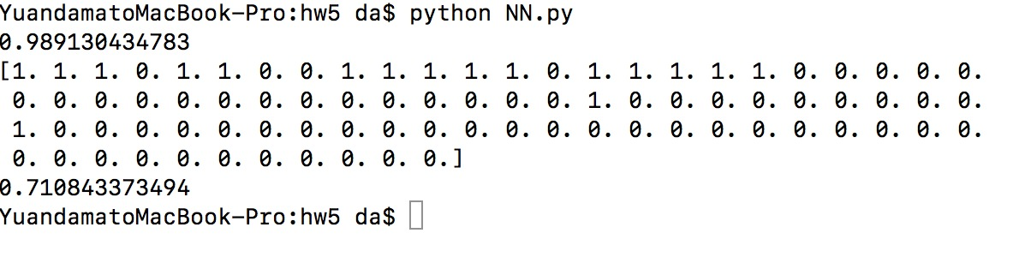

1. Data Structures used
2. Used a class to encapsulate the neural network
3. Used numpy array, python built-in list
4. Code-level optimizations
5. Used matrix to compute the Σ in the equations
6. Read .pmg files with using openCV
7. Challenges
8. It took us lots of time to find bugs when implemented the equations. We should find the dimension of each first
9. numpy.multipy is different with numpy.dot
10. We also spent some time on tuning the parameters, including the learning rate and the initial value of weights
11. At last we find that the model maybe over fitted, because the acc is extremely high in training data and low in test data. We think it is possible that the amount of training data is little.