2.2. Governing diffusion equation

The model considers two-dimensional transport of several gases in the air-filled leaf domain and boundary layer near the leaf surface. It neglects deformations of the intracellular space, and pneumatic effects are not considered.
The governing gas transport equation is
for gas transport in the vertical leaf cross-section and in the boundary layer near the leaf surface. Here g is the gas content, mol per m³; x is the horizontal coordinate, m; z is the vertical coordinate measured upward from a reference plane, m; t is time, sec; and D_{g} is the gas molecular diffusion coefficient in air, m² s⁻¹.
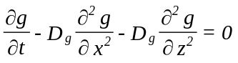 (2.1)

2.3. Uptake of CO2 on leaf cell surfaces

Carbon dioxide assimilation by mesophyll cells is simulated using a model based on the kinetics of a single enzyme, Rubisco (Farquhar et al., 1980; Harley and Tenhunen, 1991). The rate of carbon dioxide assimilation per unit of cell surface, A, mol m⁻² s⁻¹, is described in the model as
Here W_{c} is the Rubisco-limited rate of carboxylation, W_{j} is the RuBP-limited rate of carboxylation when RuBP regeneration is limited by electron transport and R_{d} is respiration, all these variables are in mol m⁻² s⁻¹. These three rates are calculated as
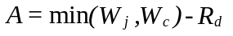 (2.2)
where Γ is the CO₂ compensation point in the absence of mitochondrial respiration,
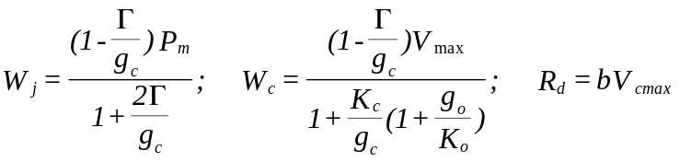 (2.3)
mL L⁻¹,
V_{cmax} is the rate of RuBP carboxylation, mol m⁻² s⁻¹; C_{i} and O are internal CO₂ and O₂ concentrations, respectively, mL L⁻¹; K_{c} and K_{o} are Michaelis-Menten constants for carboxylation and oxygenation, respectively, mL L⁻¹ ; P_{m} mol m⁻² s⁻¹, is the parameter introduced by Harley and Tenhunen (1991) to describe a light dependency of carboxylation as
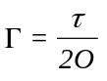 (2.4)
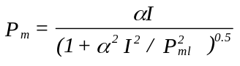 (2.5)
Here I is photosynthetic photon flux density incident on the leaf upper surface, mol(photons) m⁻² s⁻¹, α is the quantum use efficiency (on the incident-light basis) and P_{ml} is the rate of photosynthesis that occurs at CO₂- and light saturation, mol m⁻² s^{-1.}
2.4. Temperature- dependent parameters of gas transport and uptake
The gas diffusion coefficient, D_{g}, depends on temperature, T, ºK, as follows

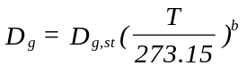 (2.6)
where D_{g,st} is the molecular diffusion coefficient at 760 mm Hg atmospheric pressure and 273.15ºK and b is a parameter ranging from 1.75 to 2 (American Institute of Physics Handbook, 1972). Dependencies of P_{lm} , K_{c} , K_{o}, and R_{d} on temperature are assumed to obey Arrenius-type equations as suggested by Harley and Tenhunen (1991).
The temperature dependency of P_{ml} is described as follows:
where T_{k} is leaf temperature, ºK, R is gas constant (0.0083 J ºK⁻¹ mol⁻¹), ΔH_{a} is the Rubisco activation energy, ΔH_{d} the energy of deactivation, ΔS is an entropy term and c is a scaling constant. The temperature dependencies of K_{c}, K_{o}, and R_{d} may each be described by an exponential function
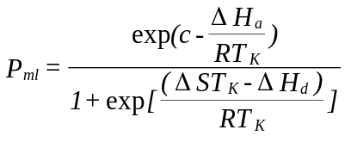 (2.7)
where Parameter may represent K_{c}, K_{o}, and R_{d} and c and ΔH_{a} are the scaling constant and activation energy, respectively, for each parameter.
(2.8)

2.5. Boundary conditions

Boundary conditions for CO₂ transport at the cell surfaces are the carbon assimilation equations (2.3). Boundary conditions are defined also by constant values of [CO₂], [O₂] and water vapor pressure at the outer border of the boundary layer and by saturated water vapor pressure on the cells' surfaces.

