3. NUMERICAL SOLUTION OF THE GAS TRANSPORT EQUATION

3.1. Space discretization

The governing equation of gas transport (1) is solved numerically to obtain spatial and temporal distributions of the gas concentration g within the leaf cross-section domain. The Galerkin finite element method with linear basis functions and triangular elements is used.
The air-filled domain of the leaf cross-section is divided into a network of triangular elements. Nodal points represent corners of elements. For the example of grid shown in Fig. 2a, one possible subdivision is shown in Fig. 2b. The gas concentration in the element is approximated by a linear combination of nodal concentration values:
where N_{n} is the total number of nodes, φ_{n}(x,z) are basis functions for node n, and g_{n} is the gas concentration at node n. Basis functions may be derived from interpolation functions accepted for the elements. The triangular element shown in Fig. 3, has the following interpolation functions (Istok, 1989):
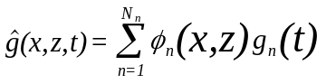 (3.1)

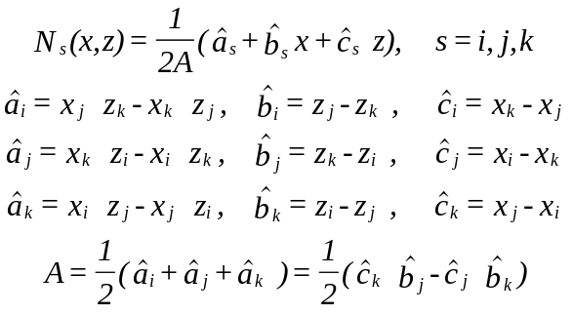 (3.2)
where A is the area of the element.
The Galerkin method is used to obtain equations for nodal values of g. Area-averaged weighted residuals of Eq. (3.1) must equal zero. This must be true for every φ_{n} taken as a weight. Consequently, for the whole air-filled leaf cross-section domain

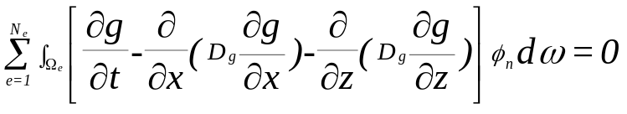 (3.3)

where Ω_{e} designates area of the element e, and N_{e} is the total number of elements. After replacing g by _ and using Green's first identity, one has:

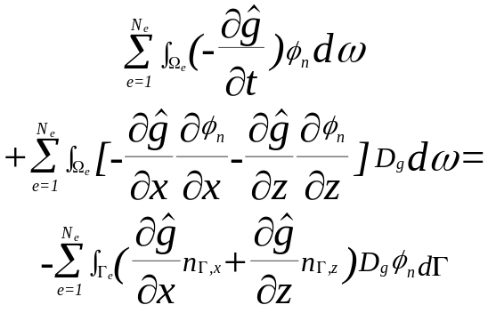 (3.4)
where Γ_{e} is the border of the element e, and n_{Γ,x}, n_{Γ,z} designate components of the vector which has unit length and is normal to the border.
Further simplifications are based on the assumption that nodal gas concentration changes may be found as weighted averages of gas concentration changes over the element according to the mass-lumping technique (Istok, 1989).
This assumption leads to a system of first-order ordinary differential equations for the concentration values:
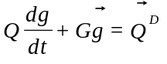 (3.5)
where vector g includes all nodal g values . Matrices Q and G have elements
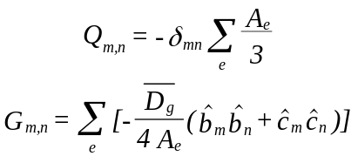 (3.6)
where summation involves elements that have the nodes m and n among their corner nodes.
Vector Q ^{D} has non-zero components only for boundary nodes. It represents the total gas flux per boundary segment related to the boundary node. The value of Q^{D} is positive when the flux is directed to the air-filled domain from the cells. If the concentration is constant at the boundary, then dg_{n}/dt=0 and, in accordance with
Eq. (3.6),
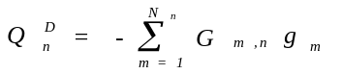 (3.7)

We consider only steady-state gas concentration distributions, and the derivatives of gas concentrations on time together with matrix Q are excluded from (3.6) and (3.8) for further considerations.
3.2. Iterative processes
The system of equations (3.6) is nonlinear since boundary flux Q^{D} depends nonlinearly on CO₂ concentration. To solve it we use Newton's method. Let g_{i}^{(k)} and g_{i}^{(k+1)} be values of gas concentration for two consecutive iterations. Then the differences Δg_{i}^{(k)}=g_{i}^{(k+1)}-g_{i}^{(k)} have to obey the system of equations:
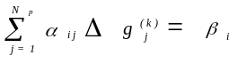 (3.8)
where
In the nodes where gas concentrations are constant we have
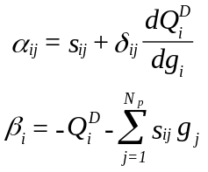 (3.9)
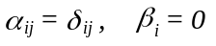 (3.10)
instead of (3.8) and (3.9).
For the Harley-Tenhunen model described on p. 6
where w_{i} is the length of the boundary related to the boundary node i.
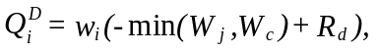 (3.11)
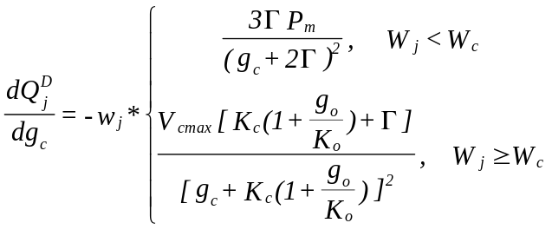 (3.12)
Derivatives dQ^{D}/dg_{c} for two branches of the dependence of Q^{D}-on-g_{c} are:
The flux of gas diffusing through the outer edges of the boundary layers is compared with the total gas flux on cell surfaces to decide whether iterations must continue. When the relative difference between the fluxes is less then 0.001 for each gas, the iterations stop. The flux of gas diffusion over the edges of the boundary layers is calculated using finite differences which include concentrations on the outer edges and on the horizontal grid lines next to the edges. The total gas flux on cell surfaces is calculated by summation of values Q^{D} an the nodes on cell surfaces

