Avirulence genes of Magnaporthe oryzae are a pathogen defense arsenal shaped by cognate rice resistance genes in the field

Xueyan Wang^{1,2}, Grant T. Billings³, Amanda M. Hulse-Kemp⁴, Quentin D. Read⁵, Yulin Jia², Melissa H. Jia,² Yixiao Huang², Yeshi Wamishe,¹ and Barbara Valent⁶
1. Rice Research and Extension Center, University of Arkansas, Stuttgart, AR 72160
2. Dale Bumper National Rice Research Center, USDA, ARS, Stuttgart, AR 72160
3. Crop and Soil Sciences Department, North Carolina State University, Raleigh, NC 27695
4. Genomics and Bioinformatics Research Unit, USDA, ARS, Raleigh, NC 27695
5. Southeast Area, USDA, ARS, Raleigh, NC 27606
6. Kansas State University, Manhattan, KS 66506

Corresponding author: Yulin Jia (Email: yulin.jia@usda.gov)
Summary
- We examined the frequency of and variation in 8 avirulence (AVR) genes from 840 Magnaporthe oryzae field isolates collected from the Southern U.S. relative to rice resistance (R) genes deployed from 1959 to 2017. Little coding or non-coding variation was detected in AVR-Pi9, AVR-Pib, ACE1 and AVR-Pizt, which correspond to R genes not used in the US.
- In the U.S., AVR-Pik, corresponding to rice R gene Pi-k alleles deployed at varying levels since the late 1960s, was present in 37% of the isolates over six decades. AVR-Pita, corresponding to Pi-ta deployed in the late 1990s, reached a low point in the five-year period following Pi-ta deployment and then recovered to 99% in recent years.
- Our results suggest a fitness penalty for M. oryzae isolates carrying non-functional AVR variants, and provide concrete data on how changes in plant R gene composition can impact pathogen populations. These findings will inform localized strategies for R gene usage and durable control of blast disease.
- AVR frequencies differ over time between U.S. and Global samples for AVR-Pik, AVR-Pi9, AVR-Pii, and AVR-Pita1. Further whole genome analysis including additional U.S. samples is necessary to confirm if the U.S. is a geographically isolated population.
Key words: Avirulence gene, Resistance gene, Rice blast fungus, Oryza sativa.
Introduction
Rice (Oryza sativa L.) is a major staple crop that feeds over half of the world population. Blast disease of rice caused by the fungus Magnaporthe oryzae (T.T. Hebert) M.E. Barr (synonym of Pyricularia oryzae Cavara) is one of the foremost constraints to secure stable rice production. M. oryzae (Mo) is a highly adaptable pathogen with a genome containing abundant mobile elements, and some strains contain dispensable supernumerary chromosomes (Dean et al., 2005; Peng et al., 2019). In the U.S. in the 2020s, blast in rice is managed using an integrated approach: the use of host resistance (R) genes which are then coupled with fungicides and cultural practices such as management of paddy flood level. In the US, where only 1 to 2% of global rice is grown, $70 million USD is estimated to be required annually in the mid-south alone to suppress the disease (Nalley et al., 2016). Globally, a loss of $66 billion USD is estimated due to blast, equivalent to an amount that is enough to feed 60 million people (Pennisi, 2010). The use of R genes in rice is the most economic and sustainable method to manage blast disease. To date, nearly 100 major R genes have been identified from cultivated and wild rice relatives, of which 36 have been molecularly characterized worldwide (Wang et al., 2017a; Zhao et al., 2018,). In the US, R genes, Pi-a, Pi-b, pi-d, Pi-i, Pi-km/Pi-ks, Pi-ta, and Pi-z, have been deployed (Wang et al., 2017b).
The major blast R genes in rice and corresponding avirulence (AVR) genes in the fungus follow a “gene-for-gene” interaction, in which the effectiveness of any R gene depends on the expression of the corresponding AVR alleles encoding the recognized pathogen effector (Siluê et al., 1992). The presence of an R gene in a host imposes a fitness cost on the pathogen’s corresponding AVR genes by arresting infection (Vera Cruz et al., 2000; Leach et al., 2001; Figueroa et al., 2016). In the absence of the associated R gene, a fitness penalty (reduced aggressiveness and lack of persistence) for the pathogen could lead to increased durability for that R gene (Vera Cruz et al., 2000; Leach et al., 2001). For example, the rice Xa7 gene confers resistance to the bacterial blight pathogen Xanthomonas oryzae, through a gene-for-gene interaction with the AVR gene AvrXa7. It has been shown that X. oryzae mutants lacking avirulence activity are less aggressive in both laboratory and field studies, and they fail to persist in field populations, suggesting that Xa7 should provide good disease control over time through a fitness penalty mechanism (Cruz et al., 2000). In the rice-M. oryzae pathosystem, deletion of entire AVR genes is a common mechanism for the pathogen to evade host R genes. However, analysis of AVR gene deletion mutants has failed to identify loss of aggressiveness phenotypes or candidates for durable R genes in this rice-blast pathosystem. Deletion of AVR genes has facilitated the cloning processes of AVR-Pita1, AVR-Pia, AVR-Pii, and AVR-Pik/km/kp (Orbach et al., 2000; Miki et al., 2009; Yoshida et al., 2009).
To date, 12 AVR genes including PWL2, AVR1-CO39, AVR-Pita, ACE1, AVR-Pia, AVR-Pii, AVR-Pik/km/kp, AVR-Pizt, AVR-Pi9, AVR-Pib, PWT3 and PWT4 in M. oryzae have been characterized from pathogen isolates originating in rice and non-rice hosts (Orbach et al., 2000; Yoshida et al., 2009; Kang et al., 1995; Sweigard et al., 1995; Farman et al., 1998; Fudal et al., 2005; Li et al., 2009; Ribot et al., 2013; Wu et al., 2015; Zhang et al., 2015; Inoue et al., 2017).
AVR-Pita encodes a predicted metalloprotease that directly recognizes the product of cognate R gene Pi-ta (Jia et al., 2000). The function of Pi-ta requires the Ptr gene, an armadillo type R gene. Together, these genes constitute the highly resistant gene cluster Pita/Pita2/Ptr (Zhao et al., 2018; Meng et al., 2020). AVR-Pita belongs to a small gene family and was renamed to AVR-Pita1 (Khang et al., 2008). The DNA sequences of AVR-Pita1 alleles are highly diverse, with previous reports indicating high nucleotide diversity in the coding regions (Huang et al., 2014; Singh et al., 2014). All functional AVR-Pita1 haplotypes were identified from avirulent isolates, and they genetically interact with the only known functional Pi-ta allele. Deletion of large DNA fragments or insertion of transposable elements within AVR-Pita1 in these isolates causes a gain in virulence activity (Singh et al., 2014; Zhou et al., 2007; Dai et al., 2010; Xing et al., 2013).
In contrast, AVR-Pik/km/kp encodes a predicted MAX effector (De Guillen et al., 2015). The AVR-Pik haplotypes determined resistance specificity towards R alleles, Pi-km, Pi-kh, Pi-kp, and Pi-ks at the Pi-k locus (Yoshida et al., 2009; Kanzaki et al., 2012; Wu et al.,2014; Li et al., 2019). Complete deletion of the AVR-Pik gene causes rice cultivars with cognate R genes to become susceptible (Yoshida et al., 2009). Loss of AVR-Pia and AVR-Pii also alter host disease resistance to susceptibility (Yoshida et al., 2009; Miki et al., 2009).
Rice blast AVR gene dynamics determine the efficiencies of the R genes deployed in rice fields. Many snapshots of AVR gene composition have documented the complexities and variation between pathogen populations at different locations (Li et al., 2014; Selisana et al., 2017; Xing et al., 2017). Two independent studies using 131 isolates (Lopez et al., 2019) and 77 isolates from different rice growing areas in the Philippines (Selisana et al., 2017) reported presence frequencies of 81.50% vs 21.9% for AVR-Pik, 64.16% vs 0% for AVR-Pita, 47.98% vs 84.9% for AVR-Pii, 19.08% vs 2.7% for AVR-Pizt and 5.20% vs 0% for AVR-Pia, respectively. Zhang et al rapidly analyzed AVR-Pia, AVR-Pii, AVR-Pizt, and AVR-Pik in 232 isolates from 1975-2009 using PCR (Zhang et al., 2020). Because AVR gene frequencies can differ between locations, it is crucial to understand the dynamic pathogen populations. Additionally, pathogen AVR repertoire information should be sufficient to predict R gene efficacy for that region at that point in time. Longitudinal data is needed to model and project R gene durability in response to changing M. oryzae AVR genes across locations over time.
We previously reported that analysis of the U.S. Mo population with neutral markers showed remarkable diversity relative to worldwide diversity. In our previous work, most variation was apparent over time rather than across geographic regions, although Mo is under asexual reproduction in the field (Wang et al., 2017b). Here, we tried to test against our expectations from the gene-for-gene hypothesis, i.e. rice host resistance is a major driving force for genetic variability in the blast fungus. We directly test this hypothesis by characterizing 8 AVR genes in 840 U.S. field isolates collected from 1959 to 2017. We analyzed historical rice production records for this same time period in order to understand the relationship of the AVR genes with their cognate R genes in the field. Little variation, either in AVR gene presence or protein haplotype variation, occurred for 4 AVR genes lacking cognate R genes in the field. Two AVR genes corresponding to R genes widely deployed in the late 1960s and 1970s have been rarely detected in the U.S. pathogen population since then. Among the AVR genes examined in the present study, only AVR-Pita1 and AVR-Pik had diversity in amino acid sequences, with 37 and 7 variants, respectively. AVR-Pita1 gene frequency recovered to high levels after removal of Pi-ta from the field, with rare isolation of the single pathotype lacking avirulence activity. AVR-Pik gene frequency also increased after frequency of Pi-km declined. The findings in the changes of AVR genes correlated with the deployed cognate R genes over six decades suggesting the AVR genes in Mo are an evolving defense arsenal. This knowledge is useful for developing rice varieties with the desired resistance to control blast disease. Understanding regional AVR gene dynamics adds valuable information for predicting and deploying durable resistance to blast disease.
Materials and methods
Fungal materials and detection and DNA sequencing of the AVR genes
A total of 840 field isolates of M. oryzae were collected from 1959 to 2017 across the U.S. rice production areas (AR, TX, LA, FL, MS, MO - Table S2). Due to low sample numbers, samples from FL were grouped with TX, and MO/TN were grouped with AR. Samples from before 1974 were excluded from the change over time analysis due to very low sample number, although they were included in evolutionary analyses. The archived M. oryzae isolates before 2000 were collected by Dr. Toni Marchetti (ARS, Beaumont, Texas). From 2000 onwards, different individuals collected the isolates.
For AVR gene detection (Table S2), several sets of AVR gene specific primers were used to ensure that the absence of amplification was not due to non-structural, sequence variation at primer sites (Table S1). Except for AVR-Pia and AVR-Pii all AVR gene-specific primers were used for DNA sequencing of the entire open reading frame (ORF), plus 5’ and 3’ untranslated regions (UTR) of the AVR genes. The polymerase chain reaction (PCR) products were purified by ExoSAP methods and Sanger sequenced at USDA-ARS Genomics and Bioinformatics Research Unit (Stoneville, Mississippi, U.S.). Specific fluorescence primers for AVR-Pia (GenBank accession number: AB498873.1) were designed using Primer-BLAST (Ye et al., 2012) (Table S1), and specific fluorescence primers for AVR-Pii were designed by Zhang et al (Zhang et al., 2020, Table S1) for rapid detection. DNA of M. oryzae in Dataset S2 was extracted following a protocol described by Jia et al (Jia et al., 2014) with modifications which follow. Briefly, a piece of filter paper containing blast mycelia was put in a 0.2 mL tube with 100 μL lysis buffer (100 mM Tris-HCl, 2 mM EDTA, pH 8.0). The sample was heated at 95 °C for 10 min and centrifuged at 3000 rpm for 1 min. The solution was then diluted 1:3 with Tris-EDTA (TE) buffer. PCR was conducted as described previously (Wang et al., 2017). Annealing temperatures used for AVR-Pia and AVR-Pii were 67 °C and 55 °C respectively.
AVR genes were detected in publicly available resequencing datasets (see “DNA sequence analysis” for further detail) using a primer sequencematch counting approach (Dataset S2). The `locate` subcommand in seqkit v2.9.0 was used to count the instances of exact matches to each of the fast-detection primer pairs in the quality-trimmed fastq files. An AVR gene was declared “present” if both primer sequences were observed at least five times in a library and absent otherwise.
Changes in the AVR gene frequency were plotted using the R package `ggplot2` v3.5.2 (Wickham, 2016). Smooth predictions of the AVR gene frequency by year, along with the standard errors for the point-in-time estimates, on the response (probability) scale were generated with a cubic spline using the `gam` and `predict.gam` functions in the R package mgcv v1.9-1 (Wood, 2011). Pathogen AVR gene detections were grouped by year and treated as a binomial response in a generalized linear model (details follow).
AVR and R gene frequency analyses
The acreages of 160 rice varieties in four states (AR, TX, LA, and MS) along with their R genes were collected from available documentary sources (Tables S3 and S4). Due to sparsity problems (no data for AR 1960-1963; AR, LA, MS, or TX for 1974; LA, MS, and TX for 1977-1989 and 2000; MS for 2014), values were interpolated before statistical modeling (Dataset S3). Varieties not listed in a particular year for a state were set to zero acres. For LA, MS, and TX, acreages of each rice variety were copied forward from 1976 to 1977-1981 and copied backward from 1990 to 1985-1989. Then, the `approx` function, which uses linear interpolation, in R v4.4.3 was used for linear interpolation for all years having missing acreage.
The R gene’s frequency in each state and year were estimated using the interpolated rice acreage values along with the R gene presence/absence status collected from the literature. The R gene frequency was calculated using the following formula:
$$P\left(R_{j}∨State,Year\right)=\frac{\sum_{i=1}^{160}{A_{State,Year}}\left(i\right)×I_{R_{j}}\left(i\right)}{\sum_{i=1}^{160}{A_{State,Year}}\left(i\right)×I_{R_{j}}\left(i\right)+\sum_{i=1}^{160}{A_{State,Year}}\left(i\right)×I_{S_{j}}\left(i\right)}$$
Where P(R_{j}|State,Year) is the probability of a randomly sampled field or plot to contain a resistance gene j in a specific state and year. I_{Rj} is an indicator variable that takes value 1 if the rice variety is known to contain the R gene j, and 0 otherwise. I_{Sj} is an indicator variable that takes value 1 if the rice variety is known not to contain the R gene j, and 0 otherwise. Rice varieties with unknown R gene status were entirely excluded (i.e, did not contribute to the denominator) from this analysis.
We hypothesized that R genes could impact the frequency of AVR genes in the field in a lagged fashion. For this reason, we first did some model selection for each AVR gene and their corresponding R genes to determine which continuous time interval in prior years to use to predict AVR gene frequencies. A time series lag was constructed by averaging the R gene frequencies in each state, starting from N years back and going up to U years before the current year. For instance, if N=5 and U=3 and the focal year was 2000, then the R gene frequencies for 1995, 1996, and 1997 were average for form the new predictor. The lagged time series that had the lowest p-value for the linear term in the following generalized linear mixed model was selected for the next stage of modeling :
$$logit\left(p_{AVR_{j},k,l}\right)=1+S_{k}+β×p\left(R_{j,kl}\right)$$
Where the response is the log-odds of the proportion of samples containing a given AVR gene j in state k with lagged l R-gene proportion R in that same state k. The state S was treated as a random effect because we want to generalize about what could happen in new localities if R-gene frequencies were manipulated there as well. A single slope β was modeled because we expect the AVR gene frequencies to respond the same way to changes in R-gene frequencies regardless of locality. An uninformative Gaussian prior, with mean 0 and standard deviation 5 on the log-odds scale, was set on the slope term to ensure model convergence. The global intercept captures the predicted AVR gene frequency in an average state with no R-gene present.
The model was fit using the R package glmmTMB v1.1.11.9000 (Brooks et al, 2017). Model predictions for changes in AVR gene frequency in response to changes in R gene frequency were made using the `predict` function, and visualized on the response (proportion, not log-odds) scale. For AVR-Piks, which has two cognate R-genes (Pi-ks and Pi-km) both R gene frequencies were used as predictors, and the results were visualized as a slice over different frequencies of Pi-km.
DNA sequence analysis
The Pyricularia oryzae ‘70-15’ v3.0 (Dean et al, 2005) genome assembly and annotation files were downloaded from MycoCosm (Grigoriev et al, 2014). All the pathogen (P. oryzae) shotgun sequencing samples with collection dates, locations, and with “rice” listed as host were downloaded from the NCBI Sequence Read Archive (329 samples). Reads were trimmed using fastp v0.23.4 (Chen, 2023) and then aligned to the reference genome sequence using bwa-mem2 v2.2.1 (Vasimuddin et al, 2019). Alignments were sorted using samtools v1.20 and then fed through the bcftools v1.21-106-g2d84e07e mpileup-call pipeline (Danecek et al, 2021) to generate joint reference and variant calls at every reference genome position for all resequencing libraries.
The “all-sites” bcf file was used to estimate the population genetics quantities nucleotide diversity ($\hat{π}$) and Tajima’s D (D) using a small R package written for this project (genomicpp – available in the project GitHub) that could handle multiallelic sites. It uses the methods presented in the pixy publication (Korunes and Samuk, 2021). The statistics were estimated using data across all places and collection periods in exon, intron, and intergenic (likely neutral) segments of the genome. These data were used to generate an empirical null distribution on the distribution of these two statistics. We then used the same methods to estimate nucleotide diversity and Tajima’s D for AVR-Pita1 and AVR-Pik for which we had Sanger-sequenced alleles available and applied the empirical null distribution from the Global population to estimate the statistical significance of these values.
The read alignment (binary alignment map; BAM) files were re-used for separate variant calling only in the AVR-Pita1 and AVR-Pik gene regions. GATK v4.6.1.0 (McKenna et al, 2010) HaplotypeCaller and GenotypeGVCFs were used on each sample independently and then converted into pseudo-genome assembly sequences using bcftools consensus. Separate variant calling for these two genes was necessary because bcftools did not handle overlapping, complex variants well, so we determined each sample needed to be genotyped independently. These sequences were added to the newly sequenced gene sequences described below.
The draft DNA sequence data of the AVR genes from the sequencing facility (as outlined above in ‘DNA sequencing of the AVR genes’) were assembled with Vector NTI software (Life Technologies Corporation, Carlsbad, CA). DNA sequence assemblies of the ORF were aligned with Clustal Omega (Sievers et al, 2011). PCR products of AVR-Pi9, AVR-Pizt, AVR-Pib, and ACE1 were determined to be identical to published sequences. The ORFs of AVR-Pita1 and AVR-Pik in isolates consisting of 132 and 151 samples, respectively, were analyzed along with 109 published ORF sequences of AVR-Pita1 and 11 AVR-Pik from GenBank resulting in 241 AVR-Pita1 and 168 AVR-Pik sequences, respectively. Together with the sequences derived from aligned of short reads to the Mo reference genome assembly, AVR-Pita1 had 343 global and 125 U.S. sequences, and AVR-Pik had 289 global and 151 U.S. sequences (Datasets S4 and S5).
Multiple sequence alignments for the AVR-Pita1 and AVR-Pik CDS and peptide sequences were generated using ClustalW2 v2.1 (Larkin et al, 2007). Phylogenetic trees for the peptide sequences were created using PhyML-mpi v3.3.20241207 (Guindon et al, 2010). Although included in the analysis, alleles containing early stop codons (i.e., having truncated peptide sequences) were excluded from phylogenetic trees. Trees were plotted using R packages `ape` v5.8-1 (Paradis and Schliep, 2019).
Population structure was inferred for the pathogen SSR data with the `find.clusters` and `dapc` functions in the R package adegenet v2.1.11 (Jombart, 2008; Jombart and Ahmed, 2011). The membership probabilities were plotted against the presence/absence of the AVR genes using a modified version of the code from the R package `ggcompoplot` (Zamvar et al, 2015).
To further integrate the U.S. collection here with publicly available resequencing libraries, we attempted to call SSR genotypes using the same approach as the AVR genes. However, we were unable to align the SSR band lengths to those acquired in this study. The results are still included for completeness in the supplement but they will not be discussed due to the difficulty in interpreting the results (Dataset S7).
Results
AVR genes in the U.S. and Global Mo population over six decades, and population structure of the U.S. population
We first investigated the presence or absence (P/A) of eight AVR genes in U.S. Mo isolates collected over six decades using AVR gene-specific primers (Tables S1 and S2) and using a sequence-counting approach for publicly available resequencing datasets (Dataset S2).
Analysis of eight putatively neutral SSR markers with Discriminant Analysis of Principal Components (DAPC) revealed 5 primary subpopulations in the U.S (Figure 1A). We attempted to include the Global samples by deriving expected SSR band sizes by indels calls from short reads, but we found it extremely difficult to match band sizes, so they were not included in this analysis. There was no clear correspondence between AVR gene presence/abensce and DAPC clusters, suggesting that AVR gene gain and loss are not co-occurring purely within clonal lineages (Figure 1).
In the Global Mo samples (Figures 2A and 3A), AVR-Piks and AVR-Pizt stayed highly prevalent (>75%) from the 1960s to the 2010s, and AVR-Pia stayed rare (<15%). ACE1 had a small increase in prevalence but was close to 100% over the same time period. AVR-Pii started close to 50% prevalent and has disappeared almost entirely. AVR-Pita1 has experienced a slow decline of around 5% per decade, now (as of 2020) around 50% prevalence globally. AVR-Pi9 increased from in the early 1980s, dipped slightly to 75% in the late 2010s, and is now close to 100% prevalence again, and AVR-Pib has remained around 75% prevalence (Figure S1A).
The trends for ACE1, AVR-Pia, and AVR-Pizt are qualitatively similar between the U.S. and Global Mo isolates. Unlike in the Global samples where AVR-Pii started off at moderate frequency and trended down, AVR-Pii started off and has remained nearly completely absent in the U.S. population. AVR-Pita1 has experienced a different trend in the U.S. compared to the Global samples, experiencing growth until the 1990s followed by a sharp decline to <50% prevalence in the early 2000s before rebounding to nearly 100% prevalence in the 2010s. AVR-Piks prevalence has been similarly dynamic, detected in >50% of isolates before 1990 after which point it almost entirely disappeared in the mid 2000s, bounced back to ~50% in the early 2010s and then crashed down again. AVR-Piks showed essentially no change in the global population. AVR-Pi9 has remained highly prevalent in the U.S. since sampling began, unlike in the World where it has generally trended upward (Figure S1A/B). The cognate R gene, Pi9, has not been deployed in the U.S., which could explain the different trend for this AVR gene.
Correspondence of deployed Pi-ta and Pi-km/Pi-ks (Pi-k#) with P/A of AVR-Pita and AVR-Pik
To determine if deployed R genes influenced the observed molecular changes in the AVR genes in the pathogen population, we analyzed deployed R genes in the Southern U.S. since 1960 (Figures 2C and 3C, Datasets S2 and S3).
The frequency of rice R gene Pi-ta in the U.S. rice fields increased since the late 1980s, reached a peak in the late 1990s, and then it decreased until there was almost no deployment in the late 2000s (Figure 2C). After Pi-ta-containing varieties were deployed, the frequency of AVR-Pita1 in Mo was gradually reduced. The Mo population shifted to isolates without AVR-Pita1 and/or with more AVR-Pita1 protein variants differing in a few amino acids sequentially after Pi-ta was deployed. After 5-6 years of Pi-ta maximal deployment in the mid 1990s the frequency of AVR-Pita1 decreased to the lowest point in the early 2000s. Overall, the subsequent increased frequency of AVR-Pita1 coincided with a reduction in Pi-ta in the field. The lowest presence of AVR-Pita1 was 5-10 years after Pi-ta reached its highest peak. Based on modeling of the AVR-Pita1 response to changes in Pi-ta frequencies, a background prevalence of the R gene ~80% is expected to be reduced to <10% at 50% Pi-ta frequency, indicating this AVR gene is highly sensitive to the potent Pi-ta resistance gene (Figure 2D).
Many rice varieties grown in the U.S. since 1960 carry Pi-ks, and since 1965 they carry Pi-km (Table S3). We use Pik# to refer to the frequency of Pi-km + Pi-ks to avoid confusion with the Pi-k allele. Since Pi-ks and Pi-km have been deployed for a long time, the frequencies of Pi-km and Pi-ks showed multiple peaks over decades resulting in multiple reductions in the frequency of AVR-Pik (Figure 4A-C). The maximal deployment of Pi-km occurred in the 1980s (Figure S2, and Table S3). There was a rapid loss of AVR-Pik between the late 1980s and early 1990s after heavy deployment of Pi-km. The same pattern occurred in the early 2000s, when Pi-km frequency reached another peak, the frequency of AVR-Pik decreased to its lowest level in the late 2000s. These findings suggest that AVR-Pik in the pathogen was influenced by Pi-km, about half a decade after Pi-km and Pi-ks were heavily deployed. Further analysis showed that the prevalence of AVR-Pik was best predicted if the average Pik# frequency in the preceding –9 to –2 years was used. A joint model was needed to account for the effects of both R genes on the AVR gene frequency (Figure 3D). Although the impact of Pi-km on AVR-Pik prevalence depends on the background frequency of Pi-ks, Pi-km appears to have a weaker impact on the prevalence of AVR-Piks as compared to the corresponding dynamics for AVR-Pita1 (Figure 3D).

Evolutionary relationships among nucleotide variants of AVR-Pita1 and AVR-Pik
There were 109 nucleotide haplotypes for AVR-Pita1 from 26 segregating sites, and 21 haplotypes for AVR-Pik from 12 segregating sites (Datasets S4 and S5, Figure 4A/D). There was some bias in the representation of clonal lineages for AVR-Piks, with the large group represented by variant V002 having only representation in the Global samples but the group represented by V008 having nearly only representation in the U.S. samples. The picture was much less clear for AVR-Pita1, with one lineages related to V102 and V080 only being represented in the Global samples set, and lineages related to V061 and V014 being strongly over-represented in the U.S. set.
We highlighted four critical amino acid residues for each of the AVR proteins and noted each time we observed them in the U.S. and Global sample sets (Figure 4B/C and 4E/F). For the most part, once new variants of AVR-Pita1 or AVR-Pik were observed, they stayed around for the duration of sampling. The variant of AVR-Pita1 that was pathogenic to resistance protein Pita1, NQCR, was was first detected in the U.S. in the late 1980s, after which point one more derivative variants was observed only in the U.S. – NQCK in the early 2000s. Two AVR-Pik variants without known cognate Pi-k allelic variants, HADM and NADK, were found much more commonly in the U.S. than in the World samples (4/4 and 12/14, respectively), where Pi-k# has been widely deployed.
We further attempted to contextualize the nucleotide variation observed at these two loci relative to other coding and non-coding sequence features in the Mo genome. We used genome-wide values for Tajima’s D and nucleotide diversity ($\hat{π}$) to determine how different AVR-Pita1 and AVR-Pik were compared to the genetic background in the blast population. [FILL]
Validation of interaction specificity of AVR genes with their cognate R genes
Gene for gene theory predicts that major blast R genes are effective in preventing the infections of Mo strains with their corresponding AVR genes. To determine the specificity of interaction between AVR-Pita1 and Pi-ta, rice varieties Katy and M202 with and without the Pi-ta gene, were challenged with the isolates carrying different AVR-Pita variants (Figure 6). Rice variety M202 lacks Pi-ta and was susceptible to all AVR-Pita1 haplotypes as expected. Katy with Pi-ta was resistant to all AVR-Pita1 haplotypes except V26 (Figure 3C).
To determine the specificity of interaction between AVR-Pik and Pik#, the IRRI monogenic lines carrying Pi-1, Pi-km, Pi-kh, Pi-kp and Pik, were challenged with the isolates carrying different AVR-Pik variants. The isolate carrying V3 (AVR-Pik D) showed moderate avirulence activity with R gene Pi-km and Pi-kh (Figure 4C). Amino acid changes from H to N or from G to D of V3 resulted in the new variants V1 or V6 in the 1970s, respectively. V1 is avirulent to Pi-km and Pi-kh, while V6 is avirulent to Pi-1, Pi-km, Pi-kh, Pi-kp and Pi-k. A change from G in V1 to D resulted in V7, and change from P in V7 to A resulted in V4. Both V7 and V4, with 2 amino acid changes, were avirulent to Pi-km, and Pi-kh. Variant V5 with change of N in V4 to H, isolated in the 1970s, lacked avirulence activity and was virulent to all Pi-k alleles. The V2 variant with M in V4 replaced by K, found in the late 1980s, was also virulent with all Pi-k alleles.
To determine if AVR genes are good indicators for the efficacy of their cognate R genes for blast control, we selected 64 isolates with different AVR genes from recent blast collections, and inoculated them onto IRRI monogenic rice lines carrying cognate R genes and differential rice lines (Figure 6, Dataset S5). We showed that line IRBLzt-T carrying Pi-zt was resistant to 96.38% isolates, line Pi-no.5 (Pi-ta) was resistant to 93.75% of isolates, cultivar Katy carrying Pi-ta and Pi-ks was resistant to 87.5% of isolates, and line IRBLb-B carrying Pi-9 was resistant to 81.25% of isolates. The corresponding AVR genes, AVR-Pizt, AVR-Pita1, and AVR-Pi9, were found with high frequency in the field. Pi-km and Pi-ks have been used for six decades by the U.S. rice breeders. In recent years, Pi-km was still resistant to 35% of isolates and Pi-ks was only resistant to 1.69% of isolates. As expected, due to lack of AVR-Pii and AVR-Pia in the M. oryzae field population, few isolates were incompatible with mono-genetic lines carrying Pii and Pia.
Discussion
The majority of rice grown in the U.S. is of domestic origin with many different varieties developed through breeding programs and selection over the years to meet the specific needs of U.S. growers and consumers. These M. oryzae isolates collected over a 56-year period from commercial rice fields are ideal to investigate evolution and adaptation of a pathogen concurrent to changes in resistance genes deployed in host plants. We provided evidence that changes in R gene composition in rice were followed by genetic change in the M. oryzae, with changes taking 5 to 10 years depending on the AVR-R pair; and these changes were quite different from the patterns seen in Global samples (Figures 2A/B and 3A/B) There were both changes in AVR presence/absence and haplotype diversity.
The most stark changes were apparent in AVR-Pita1 and AVR-Piks. In both cases, increase in the R gene prevalence corresponded to a decreased frequency of the cognate AVR gene 5-10 years after broad R gene deployment. The frequency of AVR-Pik has been increasing again with declining Pi-km deployment. Additionally, AVR-Pia and AVR-Pii, corresponding to R genes that were widely deployed in the 1960s and the early 1970s (Dataset S3), were very rare in the U.S. Mo population. Widespread presence and sequence conservation of AVR-Pib, AVR-Pi9, AVR-Pizt, and ACE1 through the decades is consistent with absence of their cognate R genes. This result suggests that the R genes Pi-b, Pi9, Pizt, and Pi33 can be stacked to provide durable and effective blast resistance (Mundt, 2018).
Out of 37 AVR-Pita protein variants tested, only one, V26, failed to trigger Pita-mediated resistance (Figure 3C). For the AVR-Pik protein, two of seven variants failed to trigger resistance towards any Pik# gene (Figure 6). It is worth noting that the variant H09 in Yunnan, China, conferred avirulence to Pi-km/kh/kp/k, but the same variant V5 in the present study conferred virulence to these R genes (Li et al., 2019). The variant H02 conferred avirulence to Pi-kh (Li et al., 2019), but the same variant V4 in the present study conferred avirulence to Pi-km and Pi-kh. These discrepancies could occur because our isolates could not separate Pi-km and Pi-kh, and/or suggest that other unknown factors in our isolates influenced the outcomes of disease reaction under the greenhouse conditions. Nevertheless, amino acid sequence variation in AVR proteins appears to be a less efficient way to overcome R genes than total gene deletion.
A pathogen fitness penalty may result from mutation of an AVR gene due to loss of avirulence, which is necessary to overcome an R gene. This fitness penalty in the pathogen is hypothesized to correspond to durable resistance for that R gene (Leach et al., 2001). Losses of avirulence causing lower spore productions that have been reported in rust pathogen Melampsora lini (Thrall et al., 2003), oilseed rape phoma stem canker pathogen Leptosphaeria maculans (Huang et al., 2010), and potato late blight pathogen Phytophthora infestans (Montarry et al., 2010). In the rice blast fungus, reduced aggressiveness associated with loss of any particular AVR gene has been recently implied in laboratory studies (Gao et al., 2021). The fitness cost imposed by AVR gene mutations can also be determined if there is persistence or decline in frequency of a particular virulence gene (mutated AVR gene) when the corresponding R gene is gone from the field (Bahri et al., 2009). Non-avirulent, functioning AVR-Pita1 variant V26 was detected in the late 1980s and was present but rare in the late 2000s and 2010s (compared to 13 avirulent haplotypes in the late 2010s). Additionally, the population rapidly regained an AVR-Pita1 gene after the Pita/Pita2/Ptr region (Jia et al., 2012) was removed from the field (Figure 2B/C). Similarly, for AVR-Pik, nonfunctional variant V2 was rarely found from the late 1990s to early 2010s, and not found in the recent Mo field population (Figure 4B), and V5 has also been isolated at low frequency. The presence of AVR-Pik is correlated with levels of Pi-km in the field, with AVR-Pik levels rising again as the R gene levels decrease (Figure 4A). These results suggest that the virulence alleles of these AVR genes might impose fitness costs on the pathogen.
The continuing absence of AVR-Pia and AVR-Pii after Pi-a and Pi-i were not deployed in the field suggests that there is not a fitness penalty associated with total loss of these AVR genes, or that near-total loss prevented the gene frequency from returning. If only virulence alleles of AVR genes in pathogen carry fitness penalties, the frequencies of avirulence alleles of AVR should be increased. However, some rare avirulent haplotypes of AVR-Pita1 only appeared in a short time span, even after almost no Pi-ta deployed in the field. For example, Hap_94, Hap_95 and Hap_96 was only present once in the Mo population in the early 2010s when the frequency of Pi-ta was only 7.5% in the field. The results support the idea that AVR-Pita1 gene mutation to new AVR alleles also carries a fitness penalty, which can be observed by a reduction of pathogen fitness on the host without the R gene (Leach et al., 2001). Widespread deletion and sequence variation of AVR-Pita was not a surprise because this AVR gene is a member of a subtelomeric gene family (Orbach et al., 2000; Khang et al., 2008; Chuma et al., 2011). In addition to variation in amino acid sequence and presence/absence polymorphism in different strains, AVR-Pita1 shows variable location at subtelomeric locations on different core chromosomes in different field isolates (Chuma et al., 2011). Specifically, avirulent AVR-Pita alleles are located near the ends of chromosomes 1, 3, 4, 5, 6, 7, or in supernumerary chromosomes in different rice-infecting isolates and other host-specific strains. This gene movement, termed multiple translocations, is suggested to be a mechanism for the fungus to regain deleted AVR genes, although at different chromosomal locations. Transposable elements, shown to directly contribute to emergence of virulent AVR-Pita isolates (Singh et al., Zhou et al., 2007), are also implicated in multiple translocations of AVR-Pita1 (Chuma et al., 2011). Understanding the molecular mechanisms underpinning AVR gene dynamics and structural variability should be an important focus for future research.
Once new R genes are deployed, pathogen strains with their cognate AVR genes are short lived-in commercial fields. Generally, such pathogens either impose nucleotide variation or deletion of AVR genes to overcome barriers caused by R genes in the host. Once an R gene in the host decreases or disappears, the pathogens benefit from the cognate AVR gene. One earlier study suggests that the host R gene influenced the deletion of the AVR genes. Xing et al. collected 28 M. oryzae field isolates from the Pita-containing cultivars and 75 isolates from the non-Pita-containing cultivars. They identified 8 and 6 virulent isolates to Katy (Pi-ta containing cultivar) from 28 and 75 field isolates, respectively. A chi-square test showed an association of virulent isolates with the Pi-ta gene (Xing et al., 2013).
Co-evolution between Pi-k# and AVR-Pik is a classic example of an “arms race,” which is interpreted as Pi-k# having developed multiple resistant alleles gradually to deal with newly evolved AVR-Pik genes ( Kanzaki et al., 2012; Wu et al., 2014). Pi-km and Pi-ks have been used for over four decades in the southern U.S. and are still used intensively in breeding programs (Anna McClung, personal communication). Pi-km has a broader disease spectrum than that of Pi-ks. Nevertheless, even though there appears to be some fitness benefit associated with AVR-Pik, heavy deployment of Pi-km/Pi-kh has already negated the beneficial effect of AVR-Pik and suggests that Pi-km/kh may not be effective in the future in the Southern US.
In contrast to Pi-k#, co-evolution between Pi-ta and AVR-Pita1 follows “trench warfare,” based on one Pi-ta resistance allele fighting with fast evolving AVR-Pita1. In the Southern US, Pi-ta occurs in a large linkage block on Chromosome 12, which was bred into a dozen rice varieties in the U.S. (Zhao et al., 2018). The linkage block including Pi-ta, Pi-ta2, and Ptr has existed in almost all Pi-ta containing cultivars in the US. Ptr also confers broader spectrum blast disease resistance than Pi-ta (Zhao et al., 2018; Jia et al., 2012). However, Pi-ta containing rice varieties thus far have not been competitive in yield to those without it. Consequently, Pi-ta containing rice varieties were not widely deployed (Fig 2C), because genetic components related to low yield are located in the same linkage block (Wang et al., 2015). Hence, most Mo isolates in the U.S. still carry AVR-Pita1 suggesting that there exists an opportunity for developing high-yielding rice varieties with the Pi-ta gene.
Analysis of 886 isolates of rice blast fungus from 152 sites in 51 countries including 76 U.S. isolates revealed three lineages and one recombining group (Thierry et al., 2022). The U.S. isolates examined were in the clonal lineage group 2. We previously demonstrated that the U.S. blast was under asexual reproduction and is remarkably diverse relative to worldwide population with most variation happening over time (Wang et al., 2017b). We did not detect correspondence between P/A markers of AVR genes and SSR markers (Figure 1A/B). Therefore, we cannot determine if or when selection against any AVR genes may have also influenced the clonally-linked genome. Previously, phylogenetic correlations with P/A of the effector genes of M. oryzae were demonstrated using high density genetic markers and many more effector genes (Latorre et al., 2020; Thierry et al. 2022). Lack of correspondence in our study may be explained by limited numbers of SSR markers and AVR genes used. Further analysis of whole genome sequences of our U.S. blast isolates will help understand the molecular mechanism of origin and evolution of rice blast fungus.
Rice blast disease is the most disastrous disease for rice production globally. M. oryzae is a highly unstable fungus showing rapid changes in AVR genes. This study uncovered a sophisticated co-evolutionary mechanism of R genes in rice and AVR genes in M. oryzae. We showed that M. oryzae strains undergo mutations and even total deletion of AVR genes to overcome the pressure imposed by the corresponding R gene. The most recent field isolates have AVR-Pi9, ACE1, AVR-Pib, AVR-Pizt, and AVR-Pita1, suggesting that the corresponding R genes, Pi-9, Pi-b, Pi-33, Pi-zt, and Pi-ta are still effective in the US. Our analysis of the genetic changes in AVR genes in 840 isolates from commercial rice fields in the U.S. over 58 years suggests that R gene stacking and recycling can be used to achieve the durability of blast resistance. The information obtained here is useful to understand how to develop effective strategies to manage rice blast disease in commercial fields of the Southern US.
Our study shows the value of tracking of AVR gene dynamics relative to the complement of R genes deployed in farmers’ fields regionally. Rapid recovery of AVR-Pita in the southern U.S. population after removal of Pi-ta from the field suggests that this AVR gene may provide a field fitness advantage on rice lacking this R gene. Therefore, efforts to separate Pita-mediated resistance from its associated yield penalty in U.S. germplasm would be beneficial. In contrast, AVR-Pita occurs at low levels in other pathogen populations (Selisana et al., 2017), indicating that each population has been shaped by its own local history. For the population we studied, lack of diversity in AVR-Pi9, ACE1, AVR-Pib, and AVR-Pizt is correlated with lack of deployment of their corresponding R genes. Although these R genes would currently be useful for combating the Southern U.S. pathogen population, strategic deployment and continuous tracking of AVR gene dynamics are warranted. While we found evidence to potentially suggest the U.S. population is quite isolated from worldwide populations as seen with the differing pattern of AVR gene frequencies additional studies resequencing the U.S. samples would be necessary to further investigate the relationships.
This study provides some evidence for management of rice blast in the future. We suggest that continuous tracking of AVR loss and recovery in regional populations provides the best insight on potential population level fitness for that particular AVR gene, which is a characteristic associated with predicting durable resistance genes for blast disease. Diverse sampling should be undertaken with enough density to track the relationship between the pathogen-host deployed resistance genes and can show when it is likely that pathogens are overcoming the resistance gene and how quickly an additional allele may be necessary to be deployed.
Acknowledgments
This project is supported by Agricultural and Food Research Initiative Competitive grant number 2013-68004-20378 (Blast Integrated Project (BIP) from the USDA, National Institute of Food and Agriculture, and USDA Agricultural Research Service in house project ‘No. 6225-21220-004-00D: Using Genetic Approaches to Reduce Crop Losses in Rice Due to Biotic and Abiotic Stress’ and ‘No. 6066-21310-006-00D: Integrative Applied Agricultural 'Omics and Bioinformatics Research’. The authors thank Dr. D. Groth (Louisiana State University, LSU AgCenter, Crowley, LA), Dr. X.-G. Zhou (Texas A&M Agrilife, Beaumont, TX, USA), Dr. A. McClung (USDA ARS DB NRRC, Stuttgart, AR, USA), Dr. T. Gebremariam, Mr. T. Mulaw (University of Arkansas Cooperative Extension Center, Stuttgart, AR, USA), Ms. T. Bianco, Mr. M. Lin, for collecting blast in rice fields and Brenda Lawrence and Heather Box (DB NRRC) for PCR and blast storage and Drs. A McClung and A. Famoso (Louisiana State University AgCenter, Rayne, LA, USA) for verification of R genes in U.S. rice varieties. For blast collection from 1960-2000, we thank Dr. T. Marchetti (retired from USDA ARS Rice Research Unit, Beaumont and deceased), from 2000-2009, we thank Dr. FN Lee (retired from University of Arkansas Rice Research and Extension Center and deceased), for reference isolates we thank Dr. J. Correll (University of Arkansas-Fayetteville), for DNA sequencing we thank Dr. Brian Scheffler and Xiaofen Liu. We thank Dr. F. Chumley for his role as the project coordinator for BIP. This is contribution number 21-065-J from the Kansas Agricultural Experiment Station. The USDA is an equal opportunity provider and employer. This research used resources provided by the SCINet project of the USDA Agricultural Research Service, ARS project number 0500-00093-001-00-D for working with the resequencing data.
Supporting Information
All code necessary to reproduce the figures and statistics presented in this study are available at the following GitHub repository:
https://github.com/USDA-ARS-GBRU/Rice_PathogenDefenseArsenal
Variant calling data for the 329 NCBI SRA entries are available at AgDataCommons FigShare under this private link for review: https://figshare.com/s/a10bc0296cbd4f1c42a8.
Competing interests:
Any opinions, findings, conclusions, or recommendations expressed in this publication are those of the author(s) and do not necessarily reflect the view of the U.S. Department of Agriculture.
Author contributions
Y.J., Y.W. and B.V. designed research; X.W., Y.J., M.H.J, Y.H. and Y.W. performed research; X.W., G.T.B., A.M.H-K., Q.D.R., and Y.J. analyzed data; and X.W., G.T.B., A.M.H-K., Y. J. and B.V. wrote the paper; and Q.D.R., M.H.J, Y.H, and Y.W. edited and approved the manuscript.
ORCID
Xueyan Wang https://orcid.org/0000-0002-5635-126X
Grant Billings https://orcid.org/0000-0002-4368-0670
Amanda Hulse-Kemp https://orcid.org/0000-0001-9670-9433
Quentin Read https://orcid.org/0000-0003-4315-5582
Yeshi Wamishe https://orcid.org/0000-0002-4647-8603
Barbara Valent http://orcid.org/0000-0002-5088-3345
Yulin Jia https://orcid.org/0000-0002-2132-0498
Melissa Jia https://orcid.org/0000-0003-0484-0608
Yixiao Huang https://orcid.org/0000-0003-1104-4730

References
Bahri B, Kaltz O, Leconte M, de Vallavieille-Pope C, Enjalbert J. 2009. Tracking costs of virulence in natural populations of the wheat pathogen, Puccinia striiformis f. sp. tritici. BMC Evolutionary Biology 9: 26.
Brooks ME, Kristensen K, van Benthem KJ, Magnusson A, Berg CW, Nielsen A, Skaug HJ, Maechler M and Bolker BM. 2017. glmmTMB Balances Speed and Flexibility Among Packages for Zero-inflated Generalized Linear Mixed Modeling. The R Journal, 9(2), 378-400. doi: 10.32614/RJ-2017-066.
Chen S. 2023. Ultrafast one-pass FASTQ data preprocessing, quality control, and deduplication using fastp. iMeta 2: e107. https://doi.org/10.1002/imt2.107
Chuma I, Isobe C, Hotta Y, Ibaragi K, Futamata N, Kusaba M, Yoshida K, Terauchi R, Fujita Y, Nakayashiki H, Valent B. 2011. Multiple translocation of the AVR-Pita effector gene among chromosomes of the rice blast fungus Magnaporthe oryzae and related species. PLoS Pathogens 7: e1002147.
Dai Y, Jia Y, Correll J, Wang X, Wang, Y. 2010. Diversification and evolution of the avirulence gene AVR-Pita1 in field isolates of Magnaporthe oryzae. Fungal Genetics and Biology 477: 973-980.
Danecek P, Bonfield J K, Liddle J, Marshall J, Ohan V, Pollard M O, Whitwham A, Keane T, McCarthy S A, Davies R M, Li H. 2021. Twelve years of SAMtools and BCFtools. GigaScience 10(2), giab008. https://doi.org/10.1093/gigascience/giab008
de Guillen, K., Ortiz-Vallejo, D., Gracy, J., Fournier, E., Kroj, T. and Padilla, A. 2015. Structure analysis uncovers a highly diverse but structurally conserved effector family in phytopathogenic fungi. PLoS Pathogens 11: e1005228.
Dean RA, Talbot NJ, Ebbole DJ, Farman ML, Mitchell TK, Orbach MJ, Thon M, Kulkarni R, Xu JR, Pan H, Read ND. 2005. The genome sequence of the rice blast fungus Magnaporthe grisea. Nature 434: 980- 986.
Farman ML, Leong, S.A. 1998. Chromosome walking to the AVR1-CO39 avirulence gene of Magnaporthe grisea: discrepancy between the physical and genetic maps. Genetics 150: 1049-1058.
Figueroa M, Upadhyaya NM, Sperschneider J, Park RF, Szabo LJ, Steffenson B, Ellis JG, Dodds PN. 2016. Changing the game: using integrative genomics to probe virulence mechanisms of the stem rust pathogen Puccinia graminis f. sp. tritici. Frontiers in Plant Science 7: 205.
Fudal I, Böhnert HU, Tharreau D, Lebrun MH. 2005. Transposition of MINE, a composite retrotransposon, in the avirulence gene ACE1 of the rice blast fungus Magnaporthe grisea. Fungal Genetics and Biology 42: 761-72.
Gao M, He Y, Yin X, Zhong X, Yan B et al. 2021. Ca2+ sensor-mediated ROS scavenging suppresses rice immunity and is exploited by a fungal effector. Cell 184: 5391-5404.
Grigoriev IV, Nikitin R, Haridas S, Kuo A, Ohm R, Otillar R, Riley R, Salamov A, Zhao X, Korzeniewski F, Smirnova T, Nordberg H, Dubchak I, & Shabalov I. 2014. MycoCosm portal: gearing up for 1000 fungal genomes. Nucleic Acids Research, 42(D1), D699–D704. https://doi.org/10.1093/nar/gkt1183
Guindon S, Dufayard JF, Lefort V, Anisimova M, Hordijk W, Gascuel O. 2010. New Algorithms and Methods to Estimate Maximum-Likelihood Phylogenies: Assessing the Performance of PhyML 3.0. Systematic Biology, 59(3), 307–321. https://doi.org/10.1093/sysbio/syq010
Hall T A. 1999. BioEdit: a user-friendly biological sequence alignment editor and analysis program for Windows 95/98/NT. Nucleic Acids Symposium Series 41: 95-98.
Huang J, Si W, Deng Q, Li P, Yang S. 2014. Rapid evolution of avirulence genes in rice blast fungus Magnaporthe oryzae. BMC Genetics 15: 45.
Huang YJ, Balesdent MH, Li ZQ, Evans N, Rouxel T, Fitt BD. 2010. Fitness cost of virulence differs between the AvrLm1 and AvrLm4 loci in Leptosphaeria maculans (phoma stem canker of oilseed rape). European Journal of Plant Pathology 126: 279.
Inoue Y, Vy TT, Yoshida K, Asano H, Mitsuoka C, Asuke S, Anh VL, Cumagun CJ, Chuma I, Terauchi R, Kato K. 2017. Evolution of the wheat blast fungus through functional losses in a host specificity determinant. Science 357: 80-83.
Jia Y, Jia MH, Wang X, Liu G. 2012. Indica and japonica crosses resulting in linkage block and recombination suppression on rice chromosome 12. PLoS One 7: e43066.
Jia Y, McAdams SA, Bryan GT, Hershey HP, Valent B. 2000. Direct interaction of resistance gene and avirulence gene products confers rice blast resistance. The EMBO Journal 19: 4004-4014.
Jia Y, Wamishe YA, and Zhou B. 2014. An expedited method for isolation of DNA for PCR from Magnaporthe oryzae stored on filter paper. Crop J. 2: 267–271.
Jombart T. 2008. adegenet: a R package for the multivariate analysis of genetic markers. Bioinformatics, 24, 1403–1405. https://doi.org/10.1093/bioinformatics/btn129
Jombart T, Ahmed I. 2011. adegenet 1.3-1: new tools for the analysis of genome-wide SNP data. Bioinformatics. https://doi.org/10.1093/bioinformatics/btr521
Kamvar ZN, Larsen MM, Kanaskie AM, Hansen EM, Grünwald NJ. 2015. Spatial and Temporal Analysis of Populations of the Sudden Oak Death Pathogen in Oregon Forests. Phytopathology, 105(7), 982–989. https://doi.org/10.1094/PHYTO-12-14-0350-FI
Kang S, Sweigard JA, Valent B. 1995. The PWL host specificity gene family in the blast fungus Magnaporthe grisea. Molecular Plant-Microbe Interactions 8: 939-948.
Kanzaki H, Yoshida K, Saitoh H, Fujisaki K, Hirabuchi A, Alaux L., Fournier E. Tharreau, D, Terauchi R. 2012. Arms race co‐evolution of Magnaporthe oryzae AVR‐Pik and rice Pik genes driven by their physical interactions. The Plant Journal 72: 894-907.
Khang CH, Park SY, Lee YH, Valent B, Kang S. 2008. Genome organization and evolution of the AVR-Pita avirulence gene family in the Magnaporthe grisea species complex. Molecular Plant-Microbe Interactions 21: 658-670.
Korunes KL, Samuk K. 2021. pixy: Unbiased estimation of nucleotide diversity and divergence in the presence of missing data. Mol Ecol Resour, 21(4), 1359–1368. https://doi.org/10.1111/1755-0998.13326
Larkin MA, Blackshields G, Brown NP, Chenna R, McGettigan PA, McWilliam H, Valentin F, Wallace IM, Wilm A, Lopez R, Thompson JD, Gibson TJ, Higgins DG. 2007. Clustal W and Clustal X version 2.0. Bioinformatics, 23(21), 2947–2948. https://doi.org/10.1093/bioinformatics/btm404
Latorre S, Reyes-Avila CS, Malmgren A. et al. 2020. Differential loss of effector genes in three recently expanded pandemic clonal lineages of the rice blast fungus. BMC Biology 18:88.
Leach JE, Vera Cruz CM, Bai J, Leung H. 2001.Pathogen fitness penalty as a predictor of durability of disease resistance genes. Annual Review of Phytopathology 39: 187– 224.
Li J, Lu L, Jia Y, Li C. 2014. Effectiveness and durability of the rice Pi-ta gene in Yunnan Province of China. Phytopathology 104: 762-768.
Li J, Wang Q, Li C, Bi Y, Fu X, Wang R. 2019. Novel haplotypes and networks of AVR-Pik alleles in Magnaporthe oryzae. BMC Plant Biology 19: 204.
Li W, Wang B, Wu J, Lu G, Hu Y, Zhang X, Zhang Z, Zhao Q, Feng Q, Zhang H, Wang Z. 2009. The Magnaporthe oryzae avirulence gene AvrPiz-t encodes a predicted secreted protein that triggers the immunity in rice mediated by the blast resistance gene Piz-t. Molecular Plant-Microbe Interactions 22: 411- 420.
Lopez ALC, Yli-Matilla T, Cumagun CJR. 2019. Geographic distribution of avirulence genes of the rice blast fungus Magnaporthe oryzae in the Philippines. Microorganisms 7: 23.
Longya A, Chaipanya. Franceschetti M, Maidment JHR, Banfield MJ, Jantasuriyarat C. 2019. Gene duplication and mutation in the emergence of a novel aggressive allele of the AVR-Pik effector in the rice blast fungus. Molecular Plant- Microbe Interactions 32: 740-749.
McKenna A, Hanna M, Banks E, et al. 2010. The Genome Analysis Toolkit: a MapReduce framework for analyzing next-generation DNA sequencing data. Genome Res, 20(9), 1297–1303. https://doi.org/10.1101/gr.107524.110
Meng X, Xiao G, Telebanco-Yanoria MJ, Siazon PM, Padilla J, Opulencia R, Bigirimana J, Habarugira G, Wu J, Li M, Wang B. 2020. The broad-spectrum rice blast resistance (R) gene Pita2 encodes a novel R protein unique from Pita. Rice 13: 19.
Miki S, Matsui K, Kito H, Otsuka K, Ashizawa T, Yasuda N, Fukiya S, Sato J, Hirayae K, Fujita Y, Nakajima T. 2009. Molecular cloning and characterization of the AVR-Pia locus from a Japanese field isolate of Magnaporthe oryzae. Molecular Plant Pathology 10: 361-374.
Montarry J, Hamelin FM, Glais I, Corbière R, Andrivon, D. 2010. Fitness costs associated with unnecessary virulence factors and life history traits: evolutionary insights from the potato late blight pathogen Phytophthora infestans. BMC Evolutionary Biology 10: 283.
Mundt CC. 2018. Pyramiding for resistance durability: theory and practice. Phytopathology 108: 792-802.
Nalley L, Tsiboe F, Durand-Morat A, She A, Thoma G. 2016. Economic and environmental impact of rice blast pathogen (Magnaporthe oryzae) alleviation in the United States. PLoS One 11: e0167295.
Orbach MJ, Farrall L, Sweigard JA, Chumley FG, Valent B. 2000. A telomeric avirulence gene determines efficacy for the rice blast resistance gene Pi-ta. Plant Cell 12:2019-2032.
Paradis E, Schliep K. 2019. ape 5.0: an environment for modern phylogenetics and evolutionary analyses in R. Bioinformatics, 35, 526–528. https://doi.org/10.1093/bioinformatics/bty633
Peng Z, Oliveira-Garcia E, Lin G, Hu Y, Dalby M, Migeon P, Tang H, Farman M, Cook D, White FF, Valent B. 2019. Effector gene reshuffling involves dispensable mini-chromosomes in the wheat blast fungus. PLOS Genetics 15: e1008272.
Pennisi E. 2010. Armed and dangerous. Science 327: 804-805.
Ribot C, Césari S, Abidi I, Chalvon V, Bournaud, C., Vallet J, Lebrun MH, Morel JB, and Kroj T. 2013. The Magnaporthe oryzae effector AVR1-CO39 is translocated into rice cells independently of a fungal-derived machinery. The Plant Journal 74: 1- 12.
Rozas J, Sánchez-DelBarrio JC, Messeguer X, Rozas R. 2003. DnaSP, DNA polymorphism analyses by the coalescent and other methods. Bioinformatics 19: 2496-2497.
Selisana SM, Yanoria MJ, Quime B, Chaipanya C, Lu G, Opulencia R, Wang GL, Mitchell T, Correll J, Talbot NJ, Leung H. 2017. Avirulence (AVR) gene-based diagnosis complements existing pathogen surveillance tools for effective deployment of resistance (R) genes against rice blast disease. Phytopathology 107: 711-720.
Sievers F, Wilm A, Dineen D, Gibson TJ, Karplus K, Li W, Lopez R, McWilliam H, Remmert M, Söding J, Thompson JD, Higgins DG. 2011. Fast, scalable generation of high-quality protein multiple sequence alignments using Clustal Omega. Mol Syst Biol, 7, 539. https://doi.org/10.1038/msb.2011.75
Silué D, Notteghem JL, Tharreau D. 1992. Evidence of a gene-for-gene relationship in the Oryza sativa-Magnaporthe grisea pathosystem. Phytopathology 82: 577-580.
Singh PK, Thakur S, Rathour R, Variar M, Prashanthi SK, Singh AK, Singh UD, Sharma V, Singh NK, Sharma TR. 2014. Transposon-based high sequence diversity in Avr-Pita alleles increases the potential for pathogenicity of Magnaporthe oryzae populations. Functional and Integrative Genomics 14: 419.
Sweigard JA, Carroll AM, Kang S, Farrall L, Chumley FG, Valent B. 1995. Identification, cloning, and characterization of PWL2, a gene for host species specificity in the rice blast fungus. Plant Cell 7: 1221-1233.
Thierry M, Charriat F, Milazzo J, Adreit H,Ravel S, Cros-Arteil S, et al. (2022) Maintenance of divergent lineages of the Rice Blast Fungus Pyricularia oryzae through niche separation, loss of sex and post-mating genetic incompatibilities. PLoS Pathog 18(7): e1010687.
Thrall PH, Burdon JJ. 2003. Evolution of virulence in a plant host-pathogen metapopulation. Science 299: 1735- 1739.
Vasimuddin Md, Misra S, Li H, Aluru S. 2019. Efficient Architecture-Aware Acceleration of BWA-MEM for Multicore Systems. IEEE Parallel and Distributed Processing Symposium (IPDPS).
Vera Cruz CM, Bai J, Oña I, Leung H, Nelson RJ, Mew TW, Leach JE. 2000. Predicting durability of a disease resistance gene based on an assessment of the fitness loss and epidemiological consequences of avirulence gene mutation. Proceedings of the National Academy of Sciences of the United States of America 97: 13500-13505.
Wang BH, Ebbole DJ, Wang ZH. 2017. The arms race between Magnaporthe oryzae and rice: diversity and interaction of Avr and R genes. Journal of Integrative Agriculture 16: 2746–2760.

Wang X, Jia MH, Ghai P, Lee FN, Jia Y. 2015. Genome-wide association of rice blast disease resistance and yield related components of rice. Molecular Plant-Microbe Interactions 28: 1382-1392.

Wang X, Jia Y, Wamishe Y, Jia MH, Valen B. 2017. Dynamic changes in the rice blast population in the United States over six decades. Molecular Plant-Microbe Interactions 30: 803-812.

Wickham H. 2016. ggplot2: Elegant Graphics for Data Analysis. Springer-Verlag New York.

Wood SN. 2011. Fast stable restricted maximum likelihood and marginal likelihood estimation of semiparametric generalized linear models. Journal of the Royal Statistical Society (B) 73(1):3-36

Wu J, Kou Y, Bao J, Li Y, Tang M, Zhu X, Ponaya A, Xiao G, Li J, Li C, Song MY. 2015. Comparative genomics identifies the Magnaporthe oryzae avirulence effector AvrPi9 that triggers Pi9-mediated blast resistance in rice. New Phytologist 206: 1463-1475.
Wu W, Wang L, Zhang S, Li Z, Zhang Y, Lin F, Pan Q. 2014. Stepwise arms race between AvrPik and Pik alleles in the rice blast pathosystem. Molecular Plant-Microbe Interactions 27: 759-769.
Xing J, Jia Y, Correll JC, Lee FN, Cartwright R, Cao M, Yuan L. 2013. Analysis of genetic and molecular identity among field isolates of the rice blast fungus with an international differential system, Rep-PCR, and DNA Sequencing. Plant Disease 97: 491- 495.
Xing J, Jia Y, Peng Z, Shi Y, He Q, Shu F, Zhang W, Zhang Z, Deng H. 2017. Characterization of molecular identity and pathogenicity of rice blast fungus in Hunan province of China. Plant Disease 101: 557-561.
Ye J, Coulouris G, Zaretskaya I. et al. 2012. Primer-BLAST: A tool to design target-specific primers for polymerase chain reaction. BMC Bioinformatics 13:134.
Yoshida K, Saitoh H, Fujisaw S, Kanzaki H, Matsumura H, Yoshida K, Tosa Y, Chuma I, Takano Y, Win J, Kamoun S. 2009. Association genetics reveals three novel avirulence genes from the rice blast fungal pathogen Magnaporthe oryzae. Plant Cell 21: 1573-1591.
Zhang S, Wang L, Wu W, He L, Yang X, Pan Q. 2015. Function and evolution of Magnaporthe oryzae avirulence gene AvrPib responding to the rice blast resistance gene Pib. Scientific Reports 5: 1642.
Zhang Z, Jia Y, Wang Y, Sun G. 2020. A rapid survey of avirulence genes in field isolates of Magnaporthe oryzae. Plant Disease 104: 717-723.
Zhao H, Wang X, Jia Y, Minkenberg B, Wheatley M, Fan J, Jia MH, Famoso A, Edwards JD, Wamishe Y, Valent B. 2018. The rice blast resistance gene Ptr encodes an atypical protein required for broad-spectrum disease resistance. Nature communications 9: 2039.
Zhou E, Jia Y, Singh P, Correll JC, Lee FN. 2007. Instability of the Magnaporthe oryzae avirulence gene AVR-Pita alters virulence. Fungal Genetics and Biology 44: 1024-1034.

Supporting information
Methods S1 Purification, isolation, and storage of M. oryzae
Methods S2 Plant growth and pathogenicity assays
Methods S3 Gene specific primers
Methods S4 Fungal DNA extraction, PCR amplification and purification

Table S1 Primers used for detecting or sequencing the AVR genes
Table S2 Single spore isolate of M. oryzae along with sequencing identifiers, year and state from which sample was collected, race identifier if available, and presence/absence of 8 AVR genes.
Table S3 Rice acreage by variety, year, and U.S. state.
Table S4 R gene status for rice varieties grown in the U.S. during the study period.

Dataset S1 Single-spore field isolates of M. oryzae used in the present study and presence/ absence of each AVR gene - source data for Fig 1. This dataset only contains the isolates with SSR data and AVR presence/absence data and also includes assigned population groups from discriminant analysis of principal components.
Dataset S2 AVR gene presence absence determined from public resequencing data and from the rapid identification of AVR genes in the present study- source data for Fig. 2A, 2B, 3A, and 3B.
Dataset S3 Interpolated values for rice R gene prevalence by U.S. State and year - source data for Fig. 2C and 3C.
Dataset S4 Nucleotide polymorphisms in AVR-Pita1 in the present study - source data for Fig. 4A.
Dataset S5 Nucleotide polymorphisms in AVR-Piks in the present study - source data for Fig. 4B.
Dataset S6 Pathogenicity assay of M. oryzae isolates on the mono genetic lines with indicated blast resistance genes - source data for Fig 5.
Dataset S7 Predicted SSR fragment sizes for public Mo resequencing libraries.
Figure legends
Fig. 1. Population structure and AVR gene presence/absence of 383 single-spore isolates from the U.S. Mo population. (A) The entire population was grouped into five subpopulations using SSR markers with discriminant analysis of principal components (DAPC). Pathogen isolates are grouped first by decade of collection and then by cluster assignment. Five colors represent the clusters (populations) inferred by SSR marker data. (B) The AVR gene presence/absence status for each isolate is displayed below for each corresponding sample.
Fig. 2. Evolutionary dynamics of AVR genes, ACE1, AVR-Pia, AVR-Pii, AVR-Pita1, and AVR-Pizt, in the Global (n=383) and U.S. (n=832) Mo populations in response to corresponding cognate R genes, pi-d, Pi-a, Pi-i, Pi-ta/Pi-ta2/Ptr, Pi-z, frequency changes. Information for corresponding AVR gene and cognate R gene can be found by scanning left to right. Predicted prevalence of AVR genes is shown by year for Global (A) and U.S. (B) Mo isolates. The gray and purple dots correspond to isolates with and without one of the five AVR genes respectively, detected by either resequencing (Global) or PCR (B) detection methods. The red line is the trend line estimated from the binary occurrence data estimated using a spline, and the gray ribbon is the standard error for the predictions at each point in time. (C) The proportion of rice acreage in each year and state having cognate R genes, with years having no rice varieties with known R gene composition filled in using linear interpolation. The colored lines are loess-smoothed trends for the proportion of U.S. rice acreage having each of the five R genes. (D) Model predictions for the effect of changes in rice R gene frequency on the pathogen AVR gene arsenal, with the red line being the marginal prediction for the AVR prevalence at a given R gene frequency. Lagged R gene frequencies for state of isolate collection were used as the predictor in the model, with the average of some previous number of years given in the strip of text above each facet. The best R gene lag to predict the AVR gene prevalence at a point in time was identified using an exhaustive search of all continuous ranges of years 0 to 15 years prior to a pathogen isolate collection, with the best R gene lag corresponding to the predictor with the lowest p-value in a generalized linear mixed model to predict AVR gene prevalence.
Fig. 3. Evolutionary dynamics of AVR gene, AVR-Piks, in the Global (n=383) and U.S. (n=832) Mo populations in response to cognate R genes, Pi-km and Pi-ks, frequency changes. Predicted prevalence of AVR-Piks by year for Global (A) and U.S. (B) Mo isolates. The gray and purple dots correspond to isolates with and without AVR-Piks respectively, detected by either resequencing (Global) or PCR (B) detection methods. The red line is the trend line estimated from the binary occurrence data estimated using a spline, and the gray ribbon is the standard error for the predictions at each point in time. (C) The proportion of rice acreage in each year and state having cognate R genes Pi-km or Pi-ks, with years having no rice varieties with known R gene composition filled in using linear interpolation. The colored lines are loess-smoothed trends for the proportion of U.S. rice acreage having each of the 2 cognate R genes. (D) Model predictions for the effect of changes in rice R gene frequency, Pi-km, on the pathogen AVR gene arsenal, with the red line being the marginal prediction for the AVR prevalence changing Pi-km frequency at fixed Pi-ks frequencies given in the strip title (0, 0.17, 0.33, 0.50, 0.67, and 1). Lagged R gene frequencies for state of isolate collection were used as the predictor in the model, with the average of some previous number of years given in the strip of text above each facet. The best lag was chosen using the same method as for the other five R genes. There are six panels because the effect of one R gene on the AVR gene depends on the frequency of the other cognate R gene.
Fig. 4. Evolutionary mechanisms of 2 AVR genes, AVR-Pita1 and AVR-Pik, in the Mo populations. Haplotype network representing stepwise changes in nucleotide composition of AVR-Pita1 (A - n_{Global}=343, n_{U.S.}=125) and AVR-Pik (D - n_{Global}=289, n_{U.S.}=151). Each labeled variant, such as V001, corresponds to a unique haplotype sequence for that gene. Variants are ordered such that highly related haplotypes are connected by a gray line. The pie chart shows the proportion of individual haplotype sequences coming from the Global (light blue) or U.S. (salmon) isolates. Occurrences of each protein haplotype, grouped by four key residues, are also shown in a time-line view (B and E) along with the corresponding amino acids at these codon positions (C and F).
Fig. 5. A genome-wide view at Mo genetic diversity in 329 publicly available resequencing libraries. All features are grouped by annotation information into exon, intron and intergenic space as shown. A) Tajima’s D statistic, B) Nucleotide Diversity (Pi), and C) curve of cumulative number of features showing particular nucleotide diversity levels.
Fig. 6. Validation of the efficacy of AVR genes as an indicator for the resistance reaction of their cognate R genes. A) Blast disease symptoms of the representative rice varieties. The Mo race IB49 (isolate ML1_2014) was used for inoculation. B) Distribution of disease scores. The X axis indicates scores of disease reactions where 0-2 represents resistance and 3-5 susceptibility, respectively. The Y axis indicates IRRI monogenic lines and R gene differential lines and the susceptible control LTH. A total of 64 blast strains (Dataset S6) with different AVR genes were used to inoculate indicated rice genotypes.
Fig S1. Evolutionary dynamics of AVR genes AVR-Pi9 and AVR-Pib, with cognate rice R gene Pi-b. See Figures 2 and 3 for an in-depth description.

Table legend
Table 1. Sequence variations and evolutionary patterns of the AVR-Pita1 and AVR-Pik genes

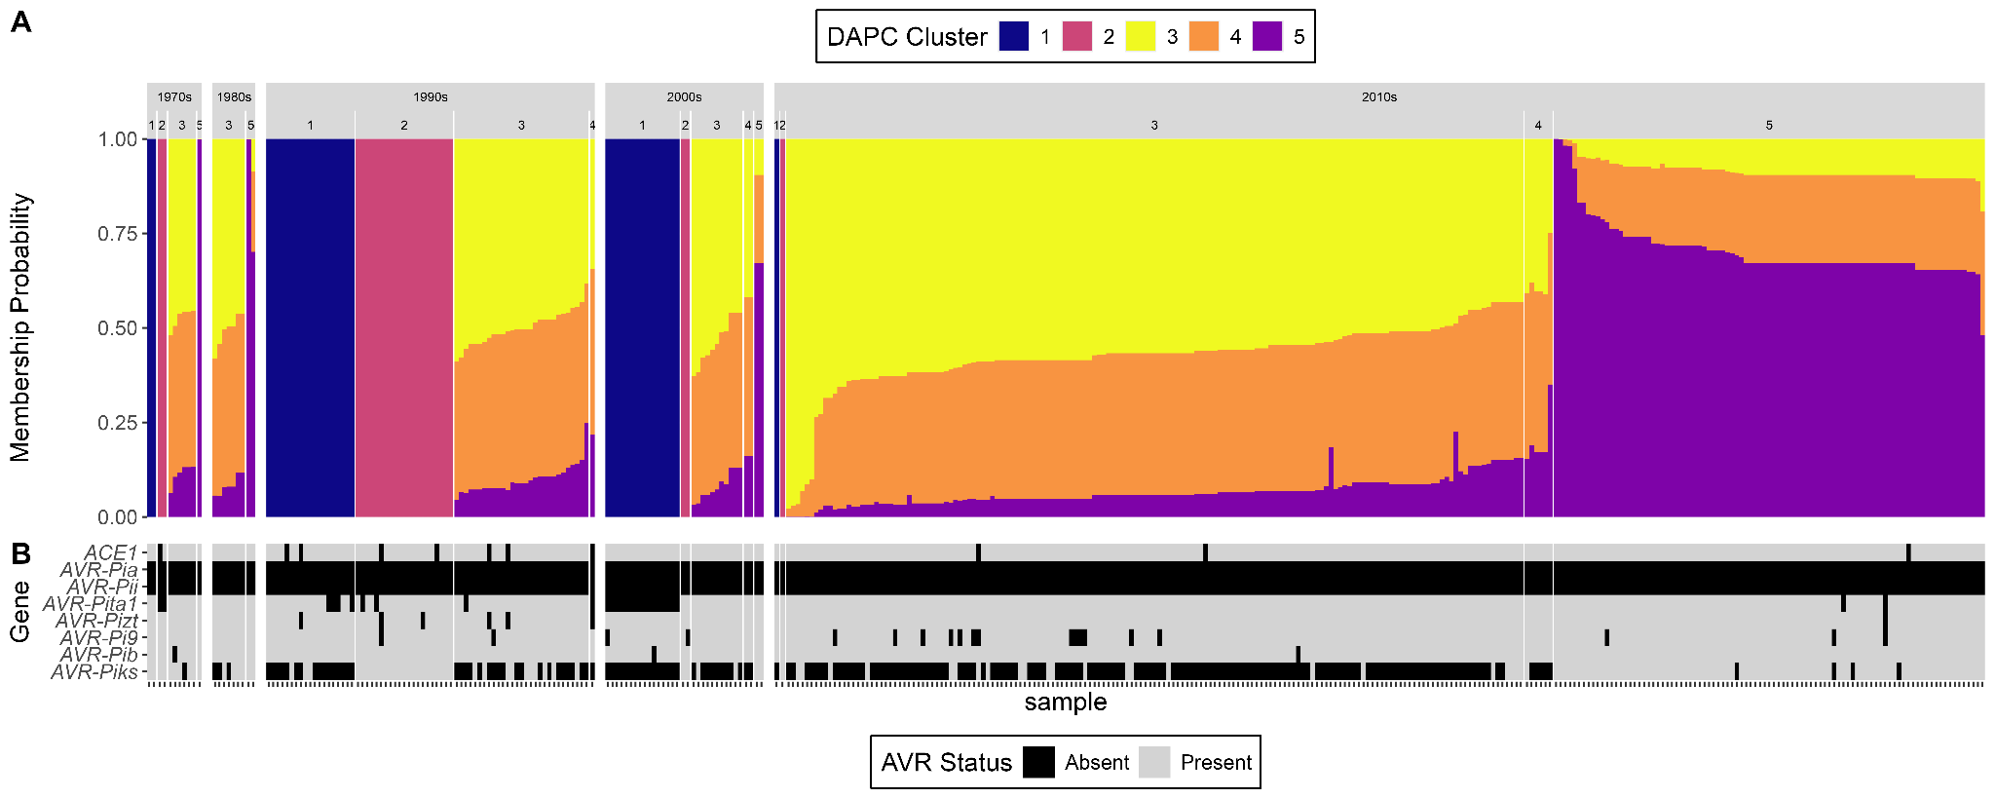
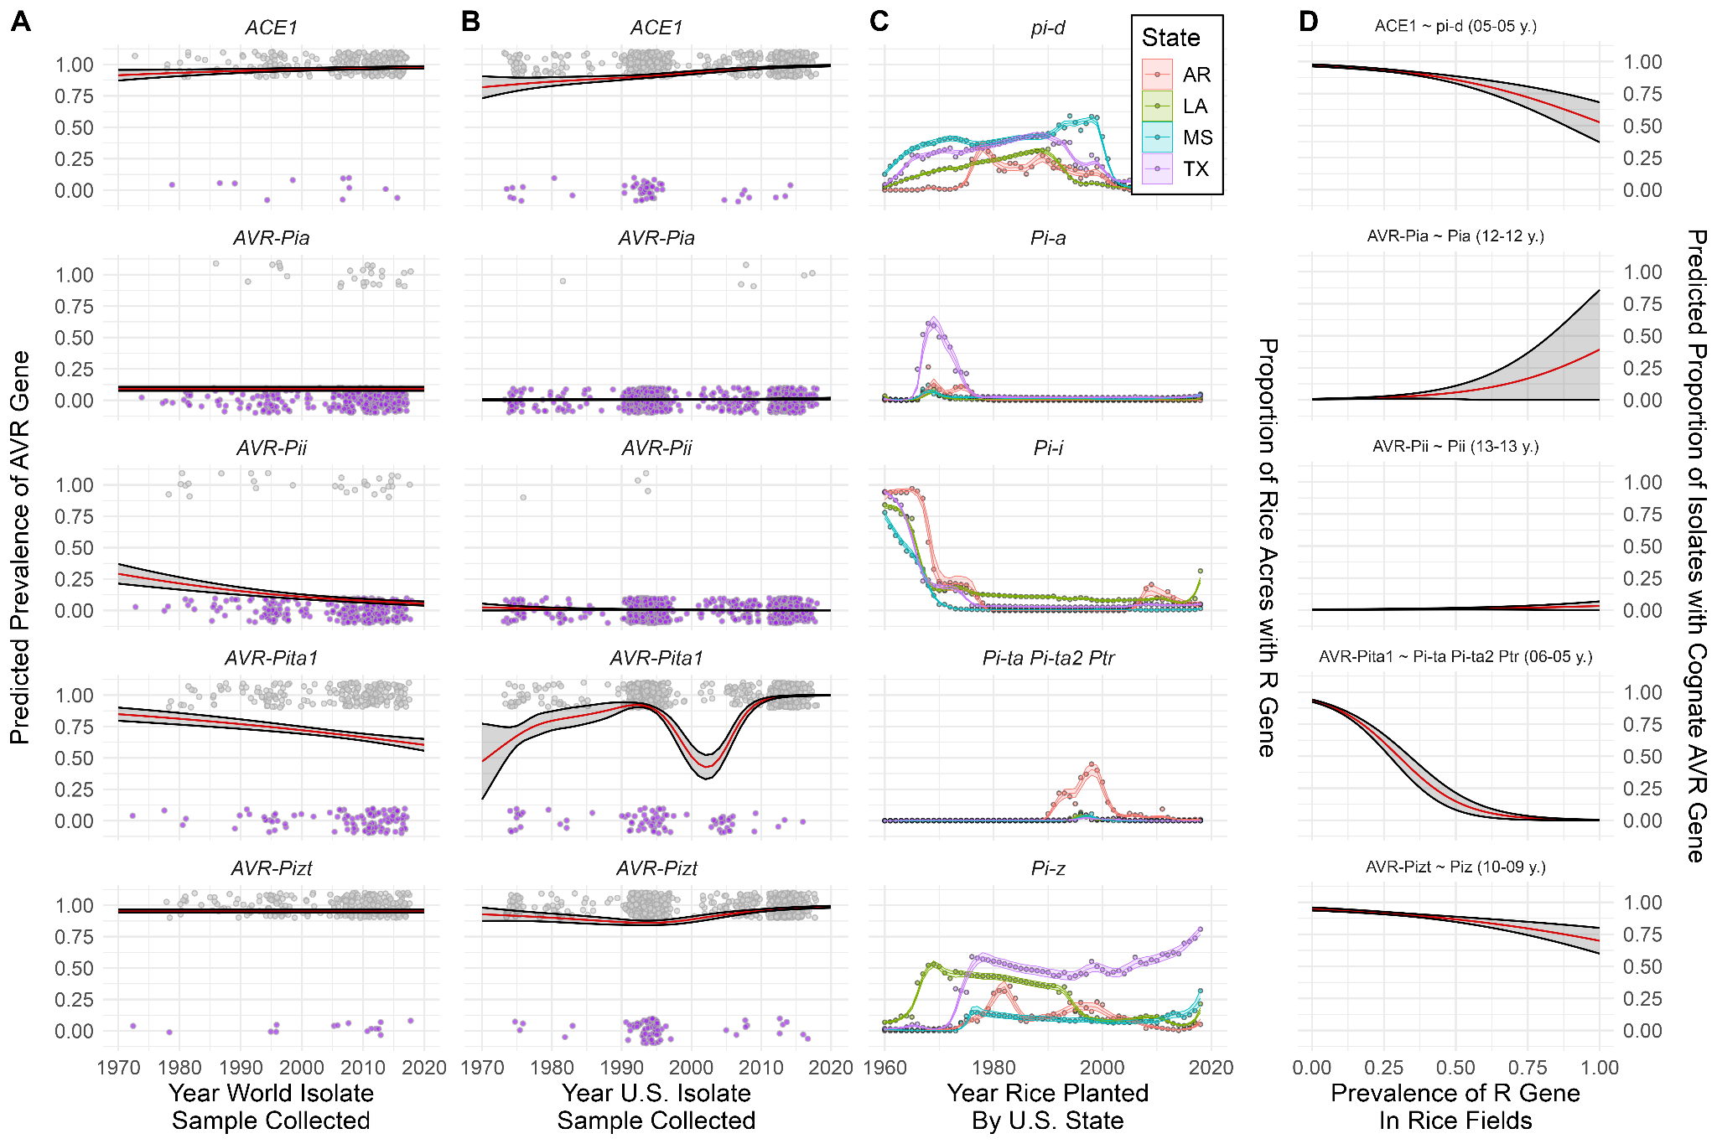
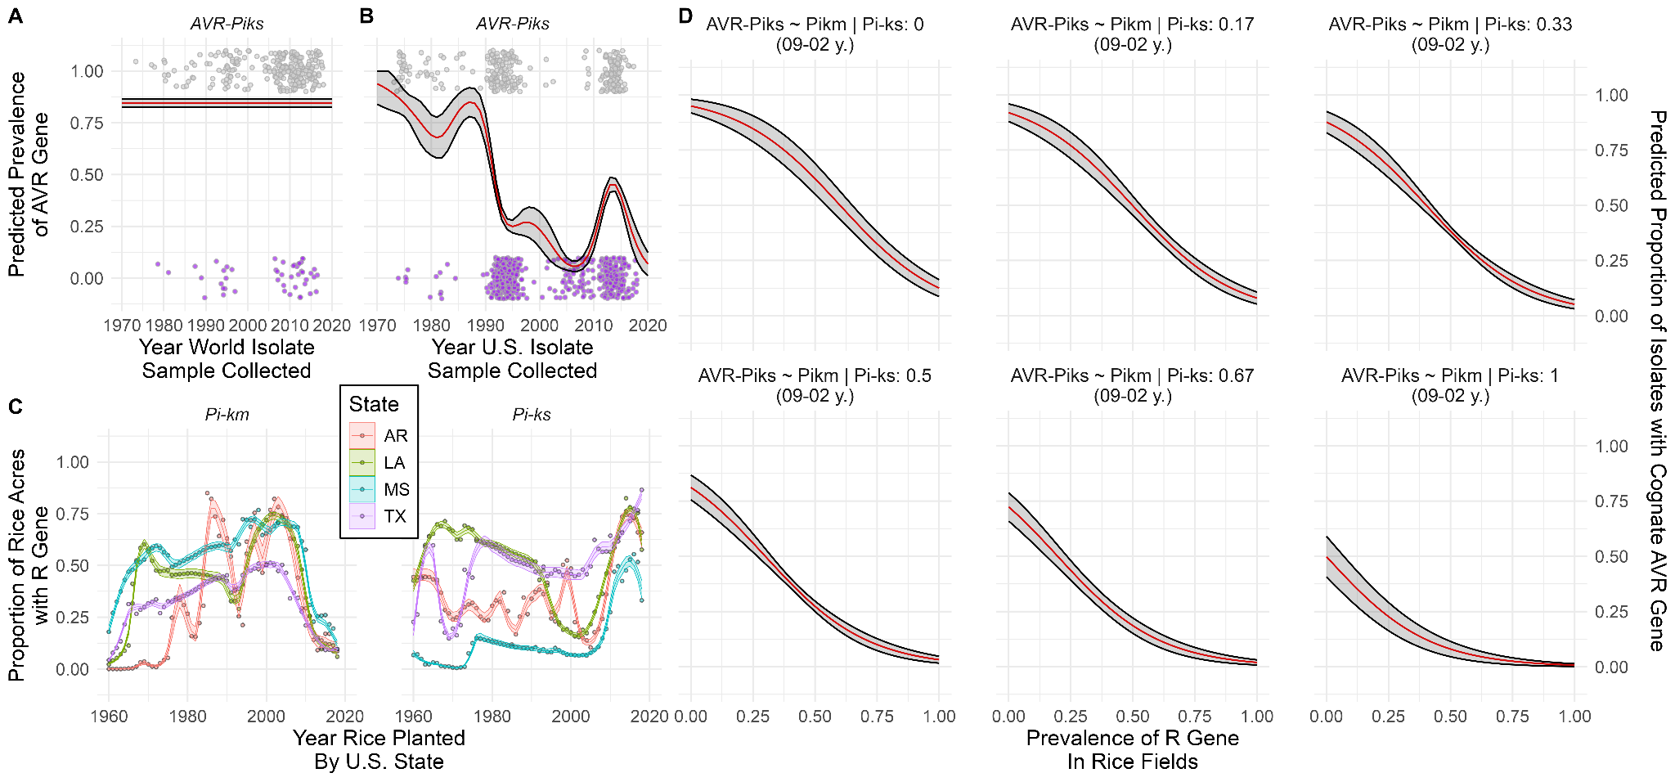

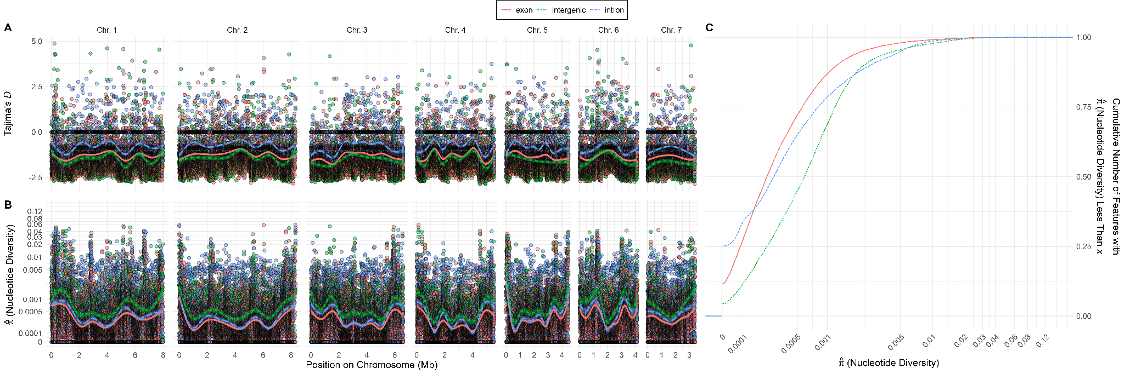
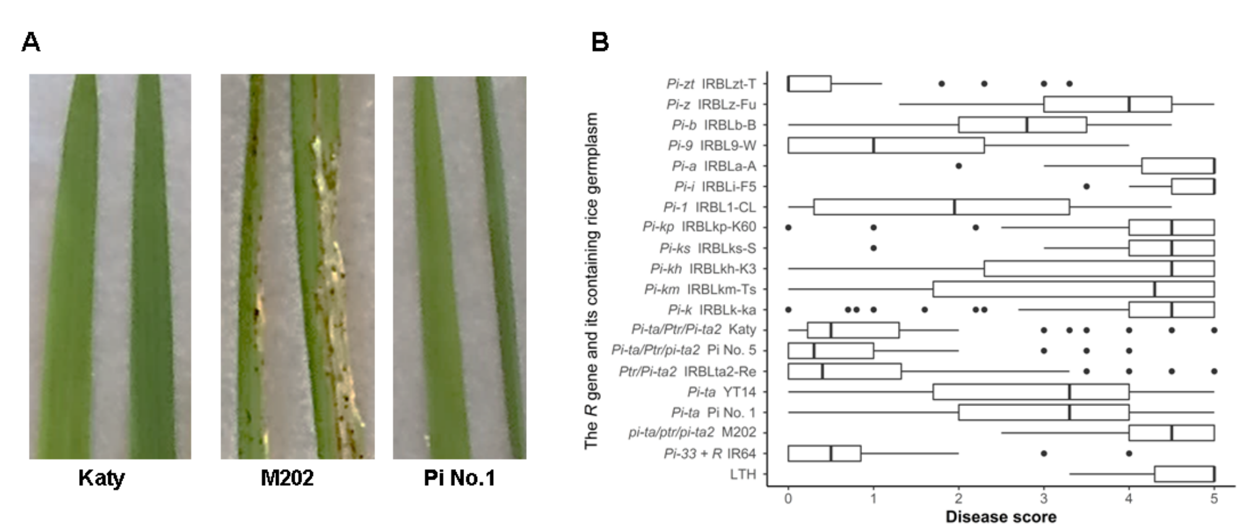
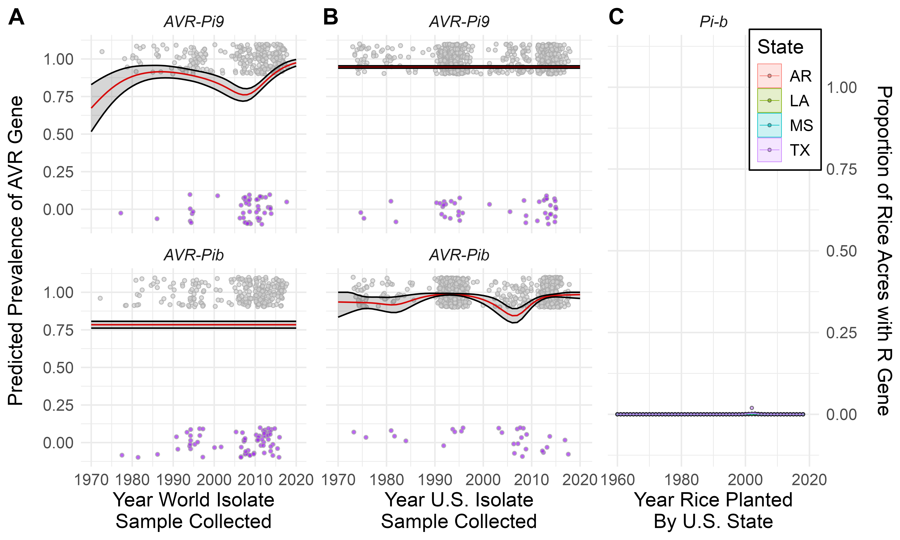
Tables
Table 1 - would like to show Tajima’s D in Global vs U.S. isolates, relative to empirical distribution of these two parameters in the Global isolates (across other exons).
Supplemental Methods
SI Purification, isolation, and storage of M. oryzae
The rice leaves or panicles with the symptoms of blast disease were sampled from rice fields. The diseased plant tissues were placed in petri dishes on top of the prewetted filter papers for 24 h under light for producing spores from mycelia at room temperature (RT, 24 ℃). A small piece of water agar (approximately 2 cm2) was used to touch the surface of leaves with fungal spores under a dissecting microscope. The spores attached on the water agar were sub-cultured in a water agar medium for 3-5 d at RT under continuous light. The hyphal tips approximately 2 mm2 were isolated from the edge of mycelia containing water agar and transferred to an oatmeal medium plate for 5-7 d in the fungal incubator at 22℃ (Percival, Perry, IA). To isolate a single spore, spores from each purified sample were suspended with sterilized deionized water and uniformly distributed on water agar plate for 24 h under continuous lights at room temperature. Single spores were picked along with water agar under the microscope, and were placed on the surface of oatmeal plate for 5-7 d in the fungal incubator at 22 °C. Sporated mycelia approximately 2 mm2 derived from a single spore were tipped onto a sterilized filter paper (7cm, Cat No, 1001-070, Whatman, Pittsburgh, PA) over oatmeal media for growth until grey spores occupied the entire filter paper in the fungal incubator. The filter paper with sporulated mycelia and spores was removed into a sterilized petri dish and set in a drier with desiccators until the filter paper completely dried. The desiccated filter papers with mycelia and spores were cut into small pieces (0.5cm × 0.5cm) and stored in sterilized glass jars at -20 °C.
S2 Plant growth and pathogenicity assays
Each plant accession was grown in an insert with 5-8 seedlings at 25 ℃ with 8-h light and 16-h dark in a greenhouse as described (Chen et al., 2019). M. oryzae isolates were grown in the fungal chamber at 22℃, and 39% relative humidity. At the 3-4 leaf stage, rice seedlings were inoculated with the fungal suspension as detailed (Wang et al., 2015). The 0-5 rating system was used to evaluate disease reaction whereas 0 to 2 as resistant and 3-5 susceptible, respectively. Race of each isolate was identified using the international race differential system (Atkins et al., 1967).
S3 Gene specific primers
Two sets of primers for each AVR gene were used for either PCR detection or sequencing. For PCR detection, the sizes of PCR amplicons ranged from 341 to 868 bp. For sequencing, the full length of each gene including partial sequences of the 5’ leader and 3’ trailer was amplified. The published primers were initially used. If these primers failed to amplify, new primers from the conservative regions in the exons or 3 and 5 untranslated regions of the genes were designed (Table S1).
S4 Fungal DNA extraction, PCR amplification and purification
M. oryzae DNA was directly isolated from desiccated filters (Jia et al., 2014). Specifically, DNA was diluted into ddH2O in ratio of 1:4 for PCR. The PCR mixture for a 96-well plate contained: 989 µL home-made cocktail buffer, 43 µL polyvinylpyrrolidone, 50 µL bovine serum albumin, 43 µL each primer (10 µM) and 21 µL Taq polymerase. The final PCR amplification per reaction is 25 µL consisting of 13 µL ddH2O, 10 µL PCR mixture, and 2 µL DNA of each sample. The PCR program was as following: 95 °C for 5 mins; 95 °C for 30 s; 57- 63 °C for 30 s; 72 °C for 1 min; repeat step 2 to 4 for 34 times followed by 72 °C for 5 mins. A total of 840 samples were used for analysis (Dataset S1). For AVR gene detection, two technical repeats were performed. Samples without a PCR amplicon after 2 repeats were retested using the sequencing primers to ensure that the absence of amplification was not due to sequence variation at the primer sites. The PCR products were separated in a 1% Tris-acetate-EDTA (TAE) agarose gel, and visualized by a BioRad ChemiDoc MP (BioRad, Hercules, CA).
PCR products were purified with the ExoSAP method following the manufacturer’s instructions. Specifically, for each 96-plate, the following chemicals were mixed in a 1.5 µL tube: 22 µL 10 X AP buffer, 22µL Exonuclease I (NEB #M0293L), 22 µL Antarctic Phosphatase (NEB #M0289L), and 374 µL distilled deionized (dd) H2O. Four µL mixture and 4 µL PCR product were used for each reaction. The plate was incubated at 37 °C for 15 min, 80°C for 15 min and held at 15°C in a PCR machine, and then was vacuum dried at room temperature and sent out for sequencing. DNA was sequenced at the USDA-ARS MSA Genomics Laboratory at Stoneville, MS, using Big Dye version 3.1 Cycle Sequencing chemistry and an ABI 3730XL DNA Analyzer using 0.5 ll BigDye v3.1.
Table S1. Primers used for detecting or sequencing the AVR genes
Primer names | Primer sequences (5'-3') | Function | Amp. size | Note
YL149 | TGACCGCGATTCCCTCCATT | Sequencing AVR-Pita | 1078 bp | Zhou et al., 2007
YL169 | CGACCCGTTTCCGCC
AVR Pita 1 | GCGTTGTTATAAAATCGACCCGT | Fast detection of AVR-Pita | 745 bp | this study
AVR Pita 2 | CCGGCAGTAATTTCCCTGCT
AVR Pik XW1F | TTCCCCCTATGGCTCCGAAT | Sequencing AVR-Pik | 1167 bp | this study
AVRPikXW1R | CCGTCAACCAAGCGTAAA CC
AVRPik FD | ACAGCTCTTGGAAAATGGACAT | Fast detection of AVR-Pik | 532 bp | this study
AVRPik FD | CCAGTTTGGACCAACTTTCA
AVR Pi9-BZ F | CTGCTCCATCTTGTTTGGCC | Sequencing AVR-Pi9 | 1000 bp | Jia et al., 2014
AVR Pi9-BZ R | CACTAGTACAAGCACTAACC
AVR Pi9-YJ F | ATCCCCATCC ACAGGATTCC | Fast detection of AVR-Pi9 | 600 bp | this study
AVR Pi9-YJ R | GTG CTT ACT ACT TAG TAT AA
AVR Pizt-XWF | ATGAGCGCATCTGAGTAGGC | Sequencing AVR-Pizt | 1300 bp | this study
AVR Pizt-XWR | CTGGTTGGGCTGGACCTAAG
ZZ21 | AATCCCGTCACTTTCATTCTCCA | Fast detection of AVR-Pizt | 637 bp | Zhang et al., 2020
ZZ22 | GTCGCAAGCCTCGTACTACCTTT
AVR Pib F1 | GGACAAGGGAGGCAAATCTAAC | Sequencing AVR-Pib | 1351 bp | Zhang et al., 2015
AVR Pib R1 | ATGCCGACAATGCGAGGTAT
AVR Pib F1 | TGGAGAAGACTTTGATGC | Fast detection of AVR-Pib | 314 bp | Zhang et al., 2015
AVR Pib R2 | GAACGCATAATGGCAACTA
ACE1 F | CCCAGAGTTGGCGATGATGC | Fast detection of Ace1 | 661 bp | this study
ACE1 R | ATGTGGCGGTGACAGAGGAC
ZZ41 | TGCAGGCCCAAATCCGTAGGAA | Fast detection of AVR-Pii | 508 bp | Zhang et al., 2020
ZZ42 | ACTGTCCGCCGCTCGTTTGG
AVR PiaF1 | TGCGTTATCCACAGGCAGGT | Fast detection of AVR-Pia | 497 bp | This study
AVR PiaR1 | GCTGGCGGGTAGGGATACTG

