Contents

INTRODUCTION 2

**Objective:** 2

**Background:** 2

DATA MODELS 3

**Common Land Unit** 3

**HEL Frozen Soils** 3

**Elevation Data** 5

TOOL SETUP AND INSTALLATION 7

**Download the Tool** 7

**Install the NRCS HEL Determination Toolbox** 8

**MS Access Preparation** 9

**ArcMap Customization** 12

**Customizing Tool Parameters** 12

**Data Preparation and Distribution** 14

**Deployment** 15

**Deployment Checklist** 15

REFERENCES 17

Appendix A– Creating the HEL Frozen Soils Layer 18

Appendix B – NRCS Elevation Web Services 21

Appendix C – Sample Documents 22

Appendix D – Tool Design Decisions 31

INTRODUCTION

The Administrator Guide is provided for the Natural Resources Conservation Service (NRCS) state specialist (Tool Administrator) to prepare data and deploy the NRCS HEL Determination Tool (tool). The companion User Guide provides field staff step-by-step instructions for making HEL determinations using the tool.

**Objective:** The objective of this tool is to provide field staff with an unbiased, efficient, and consistent method for making HEL determinations. This is an automated tool that produces offsite determination decisions and documentation using an efficient and nationally standardized methodology. Note: This tool is not suitable for use on fields with extensive constructed practices that significantly alter the landscape and hydrography, such as terraces.

**Background:** The 1985 Food Security Act, as amended, established the Highly Erodible Land (HEL) Conservation provisions as a condition of eligibility for USDA Program benefits. The NRCS follows guidance from the National Food Security Act Manual, Fifth Edition, which gives the conditions under which fields will be determined HEL or NHEL.

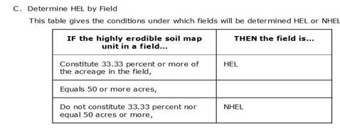

The Soil Erodibility Index (EI) for a soil map unit is determined by dividing the potential erodibility for the soil map unit by the soil loss tolerance (T) value established in the FOTG as of January 1, 1990 [7CFR Section 12.21]. A soil map unit with an EI of 8 or greater is considered to be highly erodible.

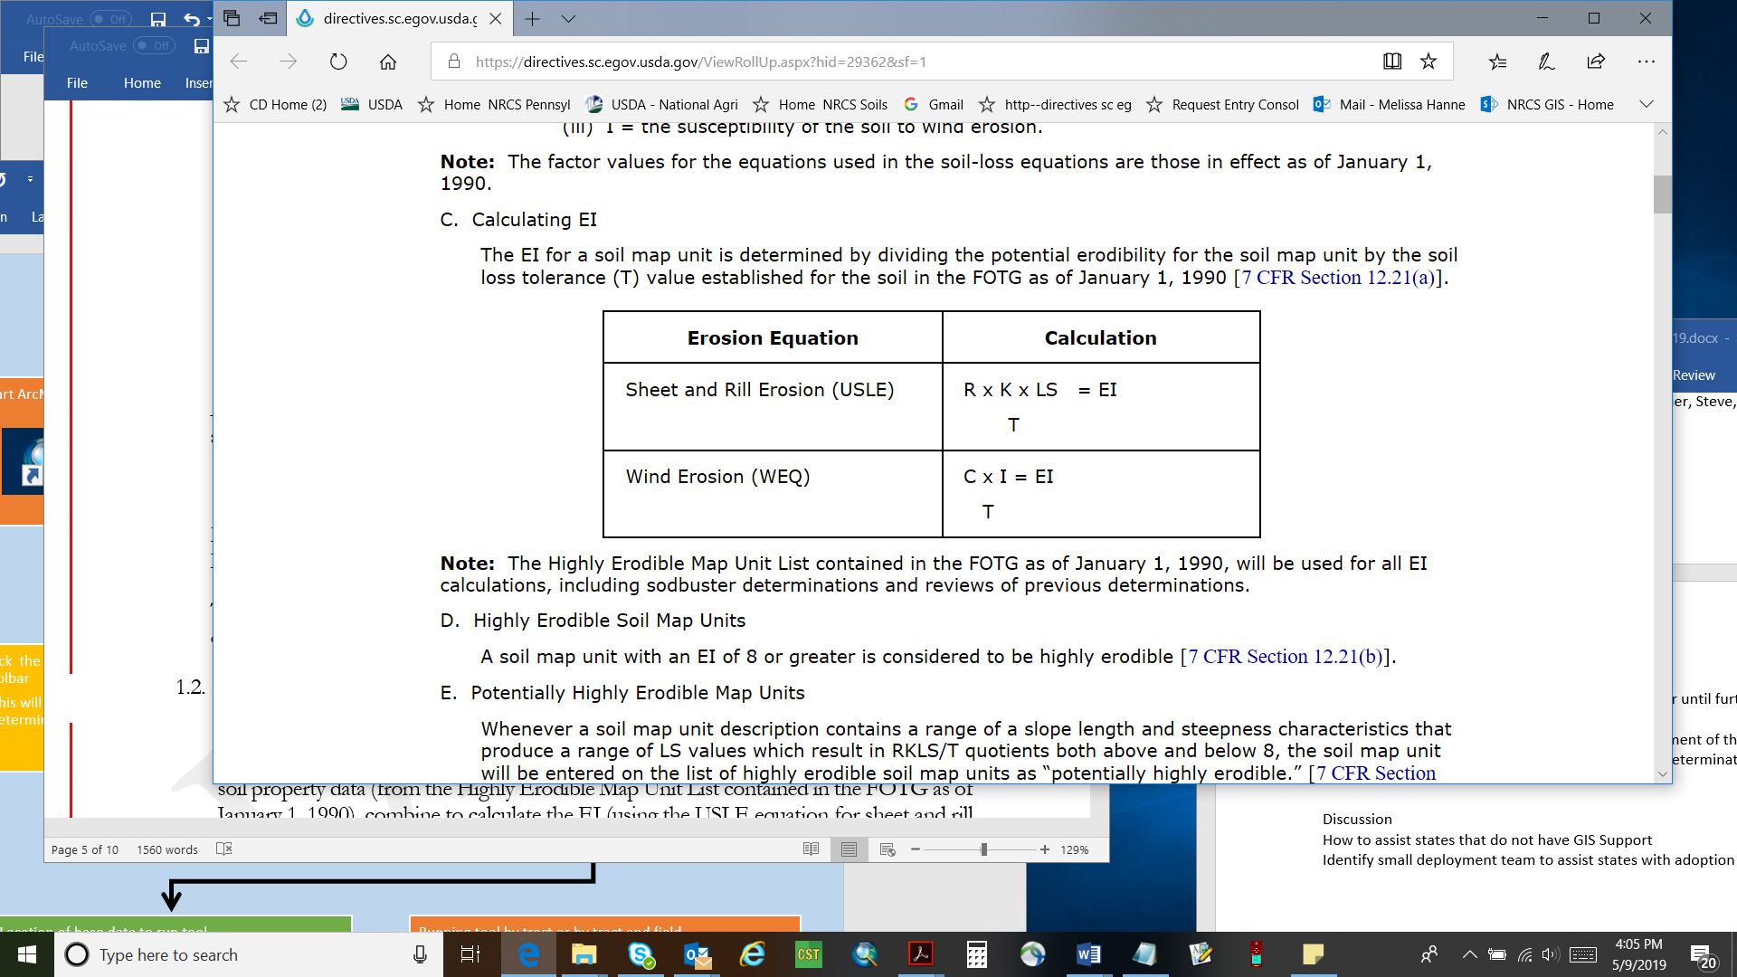

A soil map unit is listed as *potentially highly erodible* (PHEL) whenever a soil map unit contains a range of LS values which result in RKLS/T quotients both above and below 8. Potentially highly erodible soil map units (PHEL) are evaluated on a field-by-field basis as part of the determination process and assigned a highly erodible or non-highly erodible rating.

The December 7, 2018 update to the regulations at 7CFR12 and provides for the offsite evaluation of PHEL soil map units using offsite methods.

For a complete description of the HEL Soil Erodibility Index, refer to M_180_NFSAM_511. Calculation of the topographic factor (LS) is described in the USDA Agriculture Handbook No. 537.

DATA MODELS

This section describes the geospatial data required to run the tool. The Tool Administrator should review the information to develop and distribute the necessary data for field staff to use the tool.

**Common Land Unit**

**Description:** The Farm Service Agency (FSA) assumes primary responsibility at the national, State, and local level for the creation and maintenance of the Common Land Unit (CLU) layer. The CLU polygon boundary is the smallest unit of land that has a: contiguous boundary; common owner; common producer association. FSA only manages field boundaries for crop land cover and provides general boundaries for other land cover types. Boundaries for building sites, pastures, grasslands, water and forest for example are not actively managed by FSA and are often combined when contiguous. Information regarding the data model and mapping standards are available in FSA Handbook 8-CM Common Land Unit (USDA FSA 2015). Standard Attribute Schema for the CLU is determined by FSA.

**Attribute Schema:** The following attributes are required for the input CLU layer. Please note that field names may be case sensitive for the automatic forms portion of this tool.

|  |  |  |  |
| --- | --- | --- | --- |
| Field Name: | Data Type: | Length/ | Value Description: |
| Precision |
| STATECD | String | 2 | State code where a field is located (ex 02) |
| COUNTYCD | String | 3 | Fips code where a field is located (ex 003) |
| CLUNBR | Long integer | 7 | FSA field number |
| TRACTNBR | Long integer | 7 | FSA tract number |
| FARMNBR | Long integer | 7 | FSA farm number |
| CALCACRES | Double | 9 | field acreage derived spatially |

**HEL Frozen Soils**

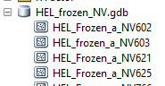**Description**: The recommended format is the File Geodatabase (FGDB) Feature Class. Refer to **Appendix A** for guidance on creating a HEL Frozen Soils layer. The tool will also accept a shapefile or a feature class with the minimum attributes outlined in the schema below. The recommended FGDB and feature class (or shapefile) naming conventions are:   
  
FDGB: HEL_frozen_<ST>.gdb  
  
AND  
  
FC: HEL_Frozen_a_<stssaid> or HEL_Frozen_a_<stnnn>

**Attribute Schema:** The following attributes are required for the input HEL Frozen Soils layer. Please note that field names may be case sensitive for the automatic forms portion of this tool.

|  |  |  |  |  |
| --- | --- | --- | --- | --- |
| Field Name: | Data Type: | Length/ Precision | Values | Value Description: |
| AREASYMBOL | String | 20 |  | Soil Survey Area symbol |
| SPATIALVER | Long Integer | 9 |  | Version of the Soil Survey Dataset used |
| MUSYM | String | 8 |  | Original Frozen Map Unit Symbol |
| MUNAME (optional) | String | 254 |  | Map Unit Name |
| MUHELCL | String | 4 | HEL; NHEL; PHEL; NA | HEL classification for map unit |
| MUWATHEL (optional) | String | 4 | HEL; NHEL; PHEL; NA | Water Erosion HEL class for map unit |
| MUWNDHEL (optional) | String | 4 | HEL; NHEL; PHEL; NA | Wind erosion HEL class for map unit |
| T | Short | 7 | 1 to 5. Will not allow NULL. Default to 0. | Soil Erosion Tolerance value. (Required for PHEL mapunits only.) |
| K | float | 9 | 0.64; 0.55; 0.49; 0.43; 0.37; 0.32; 0.28; 0.24: 0.20; 0.17; 0.15; 0.10; 0.02; 0.05. Will not allow NULL. Default to 0. | Soil erodibility factor corresponds to the Kw value. (Required for PHEL mapunits only.) |
| R | Short | 7 | 10-700 in increments of 5. Will not allow NULL. Default to 0 | Rainfall erosivity factor based on rainfall intensity and amount. (Required for PHEL mapunits only.) |

**Attribute Values**

**MUHELCL:** The tool requires the [MUHELCL] field to be populated for each [MUSYM]. **Use “NA” if no values are assigned (Ex. water, quarry, mud, etc.).** The tool excludes “NA” and “NHEL” values from the field calculations. The HEL determination is based on FSA CLU field boundary as described in policy (see background p.2). **WATER or WIND erosion**: The Eastern United States typically use only WATER erosion values. They will populate the [MUHELCL] with their water erosion values. The Western United States typically use only WIND erosion values. They will populate the [MUHELCL] with their wind erosion values.

States, counties, or Soil Survey Areas (SSA) that have BOTH wind and water values should **assign the most restrictive HEL value to the [MUHELCL] for each MUSYM:**

|  |  |  |
| --- | --- | --- |
| Wind HEL | Water HEL | MUHELCL |
| HEL | HEL, PHEL or NHEL | HEL |
| NHEL | HEL | HEL |
| NHEL | PHEL | PHEL (needs T, K, R values) |
| NHEL | NHEL | NHEL |

In the example below, the [MUHELCL] for MUSYM 221 is PHEL and the [MUHELCL] for MUSYM 225 is HEL.

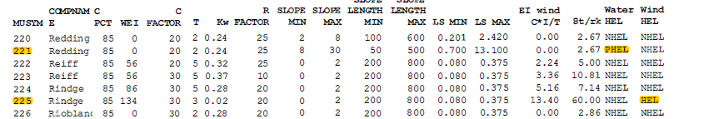

**T, K, R****:** T, K, and R attribute values are derived from the FOTG section II frozen soil lists. T, K, and R attribute values are required for map units that are “PHEL”. For HEL and NHEL map units, the T, K and R attributes may be set to zero. **Review Appendix A for further detail and when multiple K or C factors are used across a county for the same map unit.**

**Elevation Data**

**Description:** This tool utilizes elevation data analysis in cases where PHEL soils are significant to the results. LiDAR (Light Distance and Ranging) based elevation data is available from a variety of public and private sources. To facilitate HEL determinations being completed in a consistent manner nationally in cases where LiDAR elevation data is needed, the tool configures input elevation data to use a 3-meter resolution during analysis. This resolution was selected as a balance between smoothing out microtopography details in sharper resolution data and not smoothing so much that significant elevation changes over short distances would be unduly minimized. How the LiDAR data is provisioned to the NRCS field office staff will vary by state. Alternately, the *Download DEM from NRCS Service* tool provided in the *Utilities* section of the toolbox can obtain a site-specific DEM from an NRCS elevation web service for use as an input to the tool.

**Data Format:** 3-meter resolution DEM data, or better, can be provided as an input to the tool. The tool will adjust any input DEM that is better than 3-meter resolution to a temporary 3-meter resolution DEM file when it runs.

**Attribute Schema:** DEM data stores vertical heights or elevations.

**Source Datasets**

**The NRCS Elevation Web Services:** The NRCS high-resolution elevation raster services are hosted at <https://geodata.sc.egov.usda.gov/arcgis/services>. These services are composed of raster derivatives from LiDAR projects collected from 2002 to the present. Rasters from individual projects are added to a mosaic dataset. Height values (Z-values) are converted to meters to create a consistent elevation layer. Coordinate systems are adjusted to match the national coordinate system. Some collections were made with resolution in feet, not exactly matching resolution in meters. Datasets that are equal to or smaller than 1.2 Meters resolution are included in the 1M layer. Datasets that are between 1.3 and 2 meters or greater are placed in the 2M service. The web services are updated periodically as new LiDAR data is acquired. To determine the origin of the DEM published by the USGS in various services the Spatial Metadata and 3DEP Data Glossary should be used. These can be located here: <https://www.usgs.gov/media/files/3dep-spatial-metadata-glossary> <https://www.usgs.gov/core-science-systems/ngp/3dep/3dep-product-metadata>

**Locally Provisioned Elevation Data:** If LiDAR elevation data from the NRCS Elevation Web Services is not available in the area of analysis, then local data would be the only other options. Data from local sources will vary in coordinate system, horizontal and vertical units, provenance, tile size, and raster format. Local DEM data must use a projected coordinate system to be accepted by the tool, preferably based in the NAD 1983 or WGS 1984 datums. The tool can process an input DEM with different horizontal and vertical units and projections. It is particularly important for users to populate the vertical units parameter in the tool when the vertical units of an input DEM differ from its horizontal units. Failure to apply the correct vertical units as an input could lead to improper results. Not specifying vertical units will cause the tool to treat them the same as the horizontal units of the input DEM by default, which could also lead to improper results. A *Merge Local DEM Data* tool is also available in the *Utilities* toolset for combining multiple DEMs, if needed.

**Accuracy Standard:** Original input elevation raster data will be 3m by 3m cell size or better. Input data with a resolution larger than 3 meters will be rejected and not processed. The absolute vertical accuracy will meet the Quality Level (QL) 3 standard for nonvegetated root mean square error (z) less than or equal to 0.20 m. (Heidemann 2018). There are no hydrologic or hydraulic modeling requirements related to this field extent analysis that would require hydro-flattening or hydro conditioning.

TOOL SETUP AND INSTALLATION

**Download the Tool**

Download the *HEL.zip* file for the most current version from the [*2019 HEL* folder](https://usdagcc.sharepoint.com/:f:/s/nrcs_ssra/gis/EoVoSneyXo9FsHgVEJ7lRSIBPocHcRstJTXdpiUflIZbQg?e=l3BtMn), found under the *Shared Documents and Tools 🡪 Tools* section of the [NRCS GIS SharePoint site](https://usdagcc.sharepoint.com/sites/nrcs_ssra/gis/SitePages/Home.aspx).

To receive updates about new releases, highlight the “—Folder Updates --.txt” file line and then click the *Actions* button (three vertical dots) for it. Next, click the select *Alert me* from the list of actions that appears.

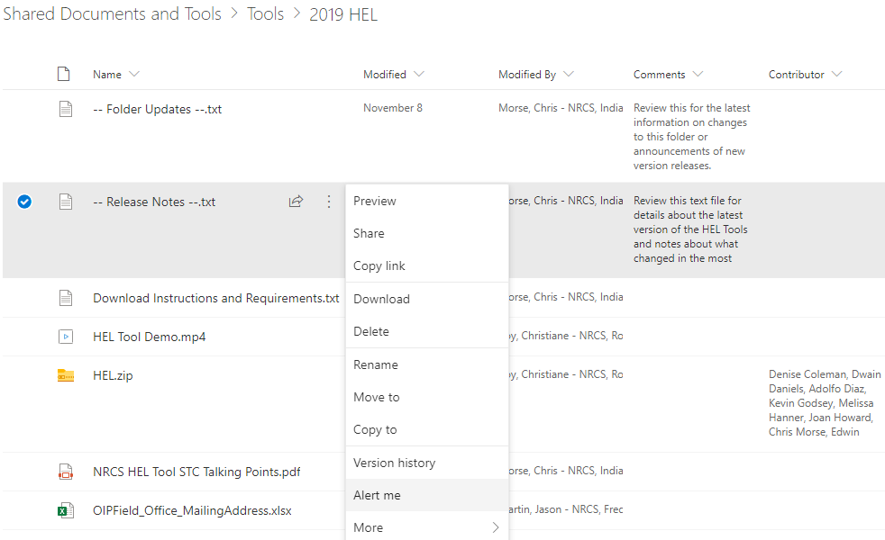

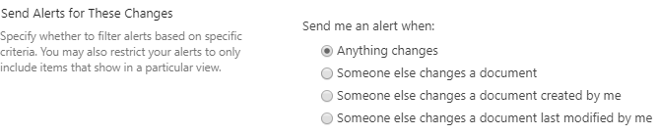Fill out the Alerts form for how you want to receive update notifications about the tool. The recommended *Change Type* is for “Anything changes”. Change the rest of the alert form options according to personal preference. Note: If you were previously setup to receive Alerts from the entire *2019 HEL* folder, you can edit those settings under *Manage My Alerts* for the *2019 HEL* folder, itself, and delete that old Alert.

After downloading the tool, it must be extracted or saved directly to the C:\ drive. **The resulting folder should be *C:\HEL***. This is required for all functions of the tool to perform properly.

**Install the NRCS HEL Determination Toolbox**

The HEL Determination Tool is provided as an ArcToolbox and a Python Add-In Toolbar.

**Install the Add-In Toolbar**

****Browse to *C:\HEL* and double-click the Addin_NRCS_HEL file. Click the Install Add-In button in the window that appears and then click OK on the completion message.

Open or restart ArcMap to see the toolbar. Move or dock the toolbar, as needed.

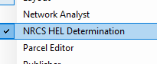  
If the toolbar is not visible, make sure it is available and active in ArcMap’s toolbars list. It is named *NRCS HEL Determination*.  
Note: The Add-In for the toolbar might need to be re-installed after tool updates are released in the future.

For troubleshooting or deleting the Add-In, it can be found at the following path in the Documents folder:

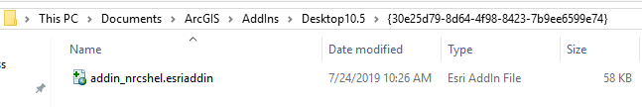

**Install the Toolbox**  
  
Open ArcMap and open ArcToolbox.

If you do not already have the “—NRCS HEL Determination” toolbox, add it to ArcToolbox:

* Right-click the ArcToolbox header and select Add Toolbox.
* Navigate to *C:\HEL*.

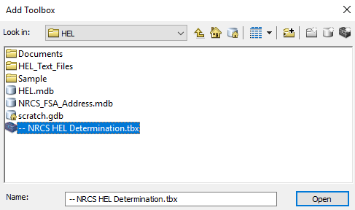

* Select and open the “—NRCS HEL Determination” toolbox file
* 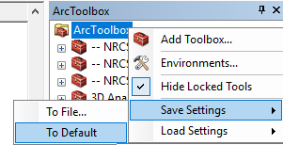Right-click the ArcToolbox header and select *Save Settings 🡪 To Default*.

If you already have the “—NRCS HEL Determination” toolbox, make sure you are using the correct toolbox and the latest python script:

* Right-click the NRCS HEL Determination toolbox and open Properties.
* 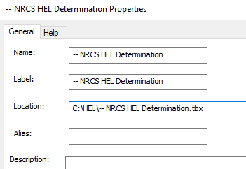Confirm the Location is *C:\HEL\--NRCS HEL Determination.tbx*.
* Next, right-click the NRCS HEL Determination Tool and open Properties.
* 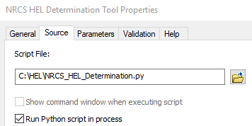On the Source tab, confirm the script file path is:  
  *C:\HEL\NRCS_HEL_Determination.py*.

**Customizing the Tool**  
  
The tool can be used without customizations if supporting input data is available which meets the specifications outlined in this guide. However, some customizations at the state level may be helpful to avoid field office staff needing to perform redundant tasks, particularly for populating the NRCS-FSA Address database. State level customizations should be performed by the Tool Administrator prior to distributing the tool within a state. Common customizations to consider are building the address table, configuring the map template, and adjusting deployment files.

**MS Access Preparation**

Prior to statewide distribution, the Tool Administrator should update the address table within the *NRCS_FSA_Address.mdb* database that comes with the tool. This table should be populated with USDA office addresses to be used on forms and letters. You can get addresses and phone numbers from the NRCS field locator (OIP database) web page at: <https://offices.sc.egov.usda.gov/locator/app?agency=nrcs>.  
  
This database is located at *C:\HEL*.

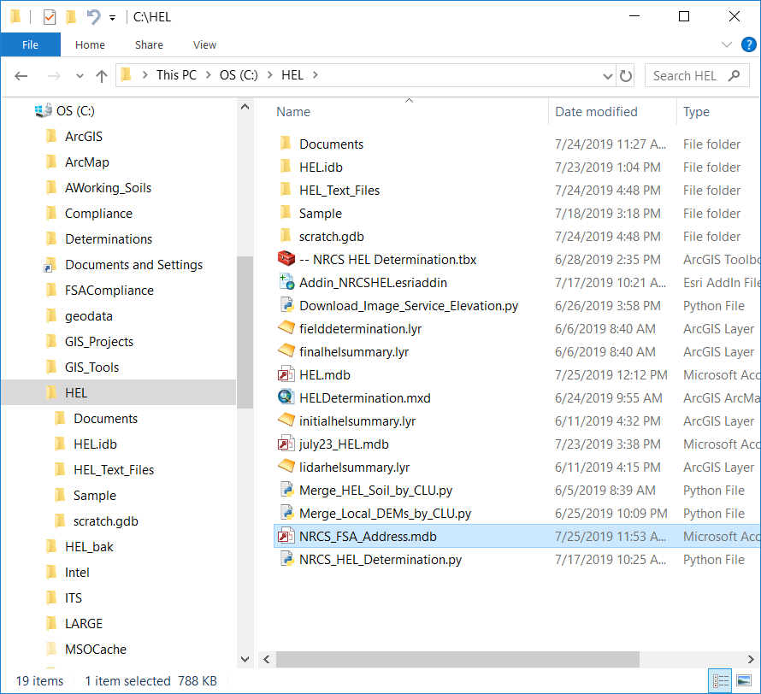

**TOOL UPDATES:** It is sometimes necessary to repopulate a new NRCS FSA Address.mdb’s table with new tool versions. You should always make a backup copy of the NRCS_FSA_Address.mdb file and/or export its address table to an Excel file **before** downloading any new versions or updates of the HEL Tool. This information can then be used with one of the procedures in the next section to quickly repopulate the table in the new file.

When populating data, the **NRCSFIPS** must be a 3-digit code that matches the county FIPS code for the servicing NRCS office. Also, the **FSAFIPS** must be a 3-digit code that matches the county FIPS code for the servicing FSA office. For example, the NRCSFIPS entry for an office located in a county with FIPS code “045” should actually be “045”. Do not enter “45”. Note: If one administrative office covers multiple counties, the same administrative office’s address and phone information can be entered for the different FIPS codes for each covered county. Currently the tool does not systematically address a single county with multiple service centers and local customization of the address table may be needed in each respective office in that case.

One way to populate the address book table is by using the Address Entry form available directly in the database as shown below. Simply fill out the information and then click Save Record when done. The entered information will be added to the table and then you can create another one. Note: You can check the box for *Same as NRCS Address* on this form if the information for the FSA office is the same, prior to saving the record.

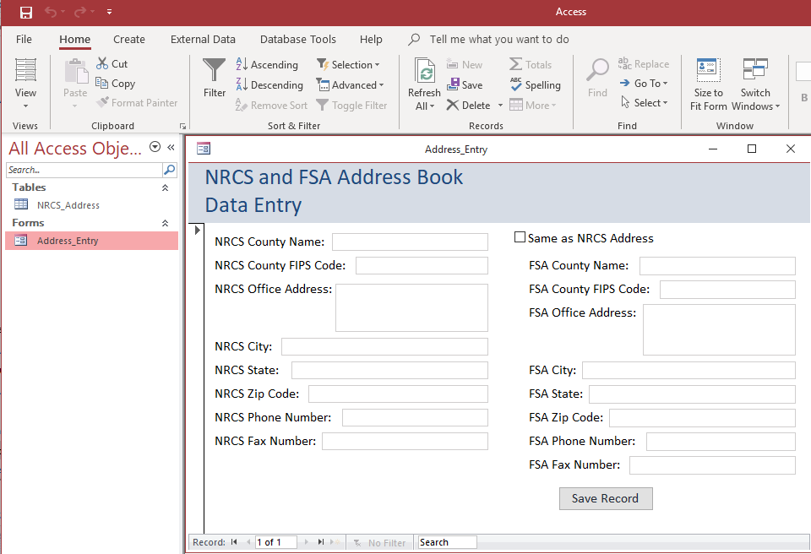

A second method is to open the NRCS_Address table within the database and edit it directly.  
  
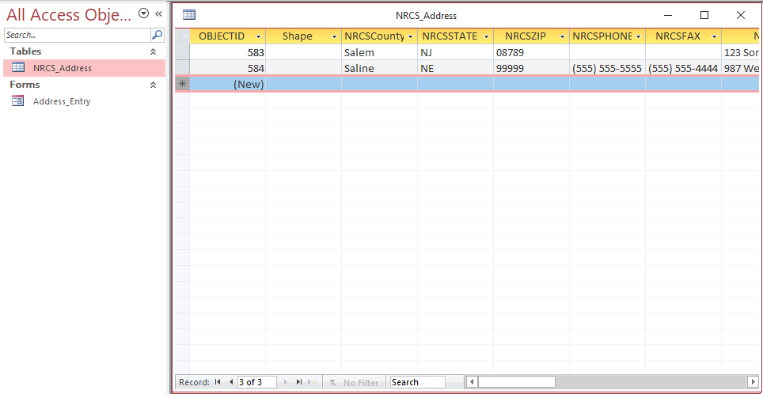

The third method is to build your table in Excel and then copy the results into the database table. To do this, open the NRCS_Address table and select a record. Right-click the record and select Copy.  
  
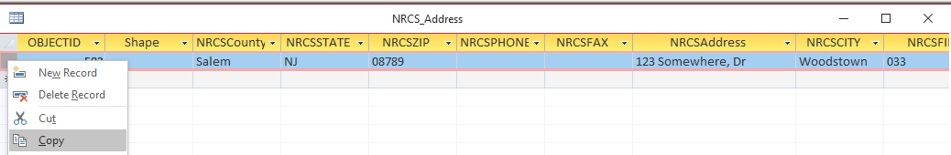

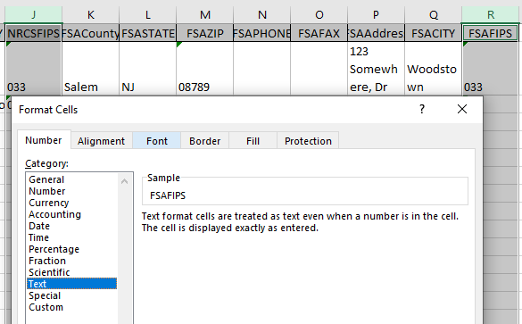Paste the record into a blank Excel worksheet. This transfers the column headings and one row of example data to Excel. Highlight the columns for NRCSFIPS and FSAFIPS in Excel and format them as Text. This will help you to include the leading “0” on 3-digit county codes that begin with 0. If you don’t do this, Excel will change the codes back to 1- or 2-digit entries for any counties with FIPS codes between 001 and 099.

Fill out a row for each office in Excel. Do not enter an OBJECTID or Shape entry for the records. Delete the first row(s) of example data from the worksheet. When finished, select the completed rows in Excel including the blank OBJECTID and Shape columns.

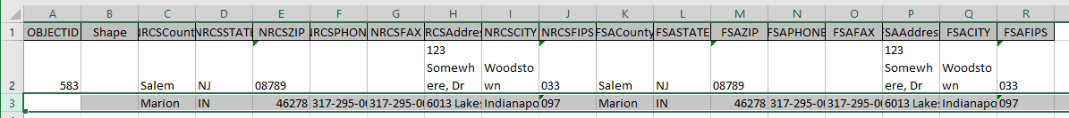

Go back to the NRCS_Address table in the database and paste the new records. OBJECTID will auto-populate.

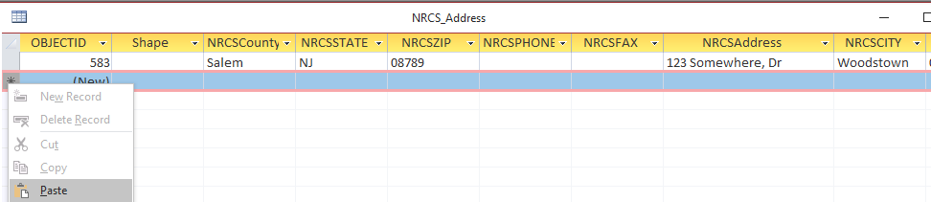

Prior to distribution, the Tool Administrator should also delete any extra address records in the NRCS_Address table that come with the downloaded database (example records). This can be done by selecting the unneeded records in the table and deleting them.

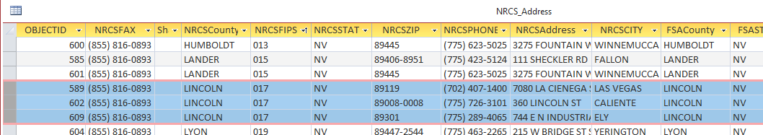

After the NRCS_Address table is complete, it is recommended to save a copy of the table for future use when tool updates are released.

**ArcMap Customization**

This section describes steps to customize the toolbox and template MXD files for distribution in a state. The User Guide contains additional instructions to customize parameters or templates even further at the local level.

**Customizing Tool Parameters**

Customizing tool parameters is useful to set common defaults and can only be done in the ArcToolbox version of the tool. If a Tool Administrator makes customizations to the script parameters in the NRCS HEL Determination toolbox, they will carry over to current Add-In toolbar. If a Tool Administrator creates new scripts or tools in the toolbox, they will not carry over to the Add-In toolbar and therefore such new developments are not recommended.

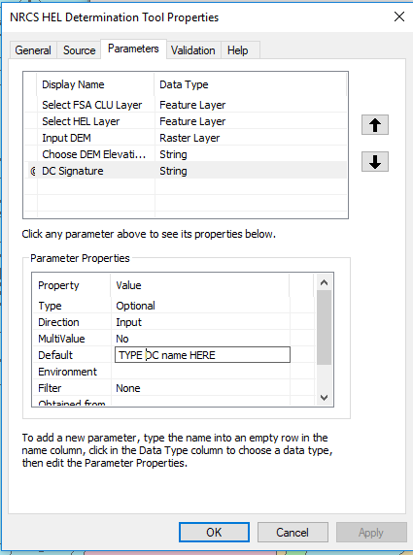If a Tool Administrator elects to change any default parameters at the statewide level, it can be done by viewing the Properties of any given tool or script in the NRCS HEL Determinations toolbox within ArcToolbox. Typically, changes will be limited to the *Default* option under any given parameter. Changes to parameters go with the toolbox (.tbx) file.  
  
Default parameters to consider at a statewide level are:

* HEL Frozen Soil layer
* Input DEM layer (maybe be possible in small states)
* DC Signature (if work has been centralized, otherwise leave blank)

Note that setting a default for these layers is most practical if the data is available in a statewide layer. Otherwise, leaving these defaults blank is advised.

**Customizing ArcMap Templates**

The HEL tool comes with template MXD file called “HEL_Template”. The HEL Template file contains a simple layout based on conservation plan map standards, but also has some built in automation when working with the HEL Tool. The following items are automated to update on the layout in the provided HEL_Template.mxd file when the HEL tool runs:

* Farm Number and Tract Number
* County and State for the actual tract location
* Customer Name(s) (if entered in the tool parameters)

The following sections have details for the three ways the tool can be used and includes building custom templates from the HEL_Template.mxd file, importing the HEL_Template.mxd layout into an existing project MXD, and running the tool from any MXD.

The following recommendations and notes apply to building or modifying map templates for the tool:

* Do not save over the HEL_Template.mxd file in the *C:\HEL* folder. Instead, do *File 🡪 Save As…* and save any custom templates to the *C:\HEL* folder but give them a different name.
* If starting with the HEL_Template.mxd file to build a template, the project’s data frame will adopt the coordinate system of the first layer added.

**Building a Custom ArcMap Template**

This is an optional step that is typically better left for users to customize at their level of coverage for a service center or office (see the User Guide). A state’s Tool Administrator may want to build templates as a starting point in things such as commonly used geodata files are provided. Alternately, a Tool Administrator may want to modify the layout or use a different one entirely (not recommended). If a Tool Administrator builds a custom template for their state or counties, please observe the following items during construction:

* Start with the HEL_Template.mxd file provided in the *C:\HEL* folder, if possible, particularly to retain automated population of some of the map layout items. If you don’t use this template, you may want to at least import its layout (see the next section). If the HEL Template is not used or imported, the automatic item population for farm, tract, county, and customer will not work; but the tool will still run.
* Limit any customizations to things that are common for all projects.
* Steer away from county customizations unless building a series of county-based templates.
* If altering the HEL_Template’s layout, try to only move and modify existing layout features. Bigger changes could break some or all the automatically populated items.
* The Location text box on the layout is intended for use with the Public Land Survey System (PLSS). It can be safely deleted if such a system is not present in your state.
* Any custom templates should be placed in the distribution folder that will go to field offices.

**Importing the HEL Template Layout**

This section describes an optional method where you replace the layout in an existing project with the layout from the HEL Template file that comes with the tool installation. This might be done with a local MXD file that already contains all the data needed for the tool and is useful for importing the automated layout population features of the HEL tool. This can be helpful for tool updates or if one needs to restore the automatic population of a determination’s tract, farm, county, and customer information in a project. This procedure ***will completely replace*** the existing map layout in any given MXD file, so use it with care.

* Open an existing MXD file.
* Switch to Layout View.
* Activate the Layout toolbar in ArcMap, if not already available.
* Use the Change Layout function on the Layout toolbar.
* Click the Browse folder in the bottom right corner of the Select Template window.
* Navigate to *C:\HEL*.
* Select and Open HEL_Template.mxd.
* Accept all defaults (if any) in the Data Frame Order window and click Finish.
* Double-click the Legend (bottom-right corner) to view its properties.
* On the General Tab, remove all layers from the Legend Items list. The tool will automatically re-add the determination related layers to the legend after it runs. Click OK to exit Legend Properties.

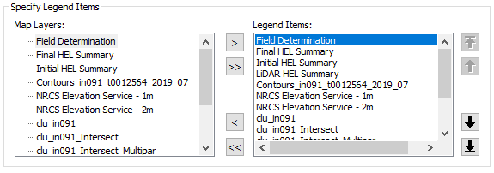

* Add, remove, or adjust any needed layers in the project.
* Save and exit the template (use *File 🡪 Save As…* to rename the template if needed).

**Running the Tool from Any Template**

The tool still works if it is run after adding the toolbar or toolbox to any ArcMap project or template, but the ability to automatically update the text boxes for the Farm, Tract, County, and Customer information on the layout will not work.

**User Documents and Guides**

A step-by-step User Guide and Quick Guide are located within the C:\HEL\Documents folder. You have the option to remove the Administrative Guide from your distribution copy of the HEL folder prior to deployment to your field offices and users. The field office users will only need to refer to the User Guide and Quick Guide.

**Data Preparation and Distribution**

Geodata files needed to support the tool do not have to reside in the C:\HEL folder and can be deployed as you see fit within your state’s current geodata management structure. Although it is not mandatory, it is recommended for optimal performance to replicate required layers for this tool from the F:\ geodata directory structure onto users’ local computers (such as in C:\geodata) whenever possible.

**Required Layers***Common Land Unit* – The HEL tool requires the CLU layer used by field offices for conservation planning and matches the schema described in the above Data Model.  
Source: F:\geodata\common_land_unit\

*HEL Frozen Soils* - Review the Data Model section of this document for naming convention and schema. See ***Appendix A*** for more information on developing this dataset.  
Source: F:\geodata\soils\

**Optional Layers** *Elevation* - The DEM elevation data is only utilized by the HEL tool to evaluate PHEL map units. Review the ***Data Model*** section of this document for more information on potential sources for this data. This kind of data is typically large in terms of storage space. Where available, states might be distributing this data to field offices using existing geodata management methods or external hard drives. Alternatively, the DEM may be downloaded from NRCS Elevation Web Servicesusing the *Download DEM from NRCS Service* tool found in the *Utilities* section of the toolbox, subject to coverage extents of the services (see ***Appendix B*** for more details).

*Other Layers –* Additional layers that are useful for HEL determinations should be accessible for users to add to their maps. Examples include but are not limited to: cadastral (PLSS), ortho imagery, roads, and hillshade.

**Deployment**

It is recommended to develop and distribute any required data and customized version of the tool using the existing deployment methods already in place in your state.

For best results, the HEL folder should be placed at the C:\ drive level on users’ systems (resulting in C:\HEL).

**Deployment Checklist**

* Download the tool
* Configure required geodata layers
* Configure the installed Access Database for NRCS/FSA Addresses
* Install ArcMap Add-In Toolbar Version
* Install the ArcToolbox Version
* Create a state level ArcMap Template (Optional)
* Test your configured data and local customizations in the tool
* Distribute the required geodata layers and the customized toolbox to field offices

**Troubleshooting**

This section describes some of the troubleshooting resources available to you and known problems if you have issues running the tool.

1. Open ArcCatalog and verify the contents of the HEL.mdb match the figure below. If additional rasters are present in the database, delete them from within ArcCatalog.

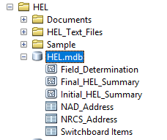

1. If multiple ArcMap sessions are open, including applications such as ArcCatalog, ArcGlobe, or ArcScene, close them and try the tool again.
2. Turn on the CLU, HEL and DEM (if applicable) to confirm the data layers overlap.
3. Check the attributes of the CLU. Some counties or states may use a FGDB CLU that does not have the required CLU Schema required by the tool.
4. Review the Attributes of the HEL Frozen layer to make sure no values are missing. Assign missing MUHELCL values with an attribute of “NA”. The T, K, R attribute fields must be present, and any empty values must be assigned an attribute of “0.”
5. If the client letter does not display mailing information, check that the NRCS_FSA_Address database has the correct and matching FIPS information in the [COUNTYCD] and [NRCSFIPS] columns.
6. Every time the tool is run, it writes a text file to the *C:\HEL\HEL_Text_Files* folder. When contacting a tool programmer for support, you should include a copy of this file in your email.

For tool errors that occur in ArcMap, contact [adolfo.diaz@usda.gov](mailto:adolfo.diaz@usda.gov), [chris.morse@usda.gov](mailto:chris.morse@usda.gov), and [christiane.roy@usda.gov](mailto:christiane.roy@usda.gov).

For tool errors that occur in the MS Access forms and letters, contact [edwin.muniz@usda.gov](mailto:edwin.muniz@usda.gov) and [christiane.roy@usda.gov](mailto:christiane.roy@usda.gov).

Note: An actively managed troubleshooting guide is available in the *2019 HEL* folder on the *NRCS GIS SharePoint*. That separate troubleshooting document will be the primary location for troubleshooting tips because it is easier to update separately rather updating the full administrator’s or user’s guide for every new bug that may emerge over time.

REFERENCES

Heidemann, Hans Karl, 2018, Lidar base specification (ver. 1.3, February 2018): U.S. Geological Survey Techniques and Methods, book 11, chap. B4, p. 101.

USDA-FSA, 2015, Common Land Unit 8-CM(Rev. 1) Amend. 5.

USDA-NRCS, 2010, National Food Security Act Manual, Fifth Edition.  
  
USDA, 1978, Predicting Rainfall Erosion Losses: Agricultural Handbook No. 537.  
  
USDA-NRCS, 2018, Notification of Release of Circular 180-19-1 “Highly Erodible Land and Wetland Conservation Compliance, NB 180-19-2-CPA.

HEL Tool Development Team

Denise Coleman, State Conservationist, PA

Jason Outlaw, National Wetland/HEL Compliance Specialist, NRCS-NHQ

Chris Morse, State GIS Specialist, Indianapolis, IN

Melissa Hanner, Soil Scientist, Harrisburg, PA

Christiane Roy, GIS Specialist, Rochester, MN

Joan Howard, Soil Scientist, ENTSC, Greensboro, NC

Kevin Godsey, Soil Scientist, Marble Hill, MO

Edwin Muniz, Soil Scientist, Somerset, NJ

Fred Schrank, Agronomist, Weatherford, TX

Adolfo Diaz, Geospatial Specialist, Madison, WI

Dwain Daniels, Geospatial Specialist, CNTSC, Fort Worth, TX

APPENDICES

Appendix A– Creating the HEL Frozen Soils Layer

This file geodatabase (FGDB) polygon feature class represents the Soil Survey Area map unit boundaries and corresponding HEL factor values from the local Field Office Technical Guide (FOTG) as of January 1, 1990 (7 CFR 610.14). Carefully evaluate potential sources of data to determine if they are consistent with the January 1, 1990 “frozen” soil lists and associated linework. The State Soil Scientist is responsible for the development of this product.

Some initial soil surveys were still in progress or had not been started as of January 1, 1990. For these soil survey areas, the instructions below describe how to create a Frozen HEL Soils layer using the best available soil survey map unit boundaries and the amended or new HEL soil map unit lists. See the National Food Security Act Manual, Part 511.3 ( <https://directives.sc.egov.usda.gov/RollupViewer.aspx?hid=29362> ).

**States that already have HEL Frozen Soils data**

Create a new file geodatabase named "HEL_Frozen_<st>”. Review the Data Model and Schema at the beginning of this Administrator Guide. Remember to name the feature classes within the database as “HEL_Frozen_a_<stssaid>” or “HEL_Frozen_a_<stnnn>”.

Import the existing Soil Survey Area HEL shapefiles or feature classes into the FGDB. Adjust the field names to adhere to HEL Frozen Soils schema for the tool. Rename fields as necessary using the ArcCatalog layer properties or add fields to match the Schema. The T, K, and R attribute values may be set to a default of 0 for NHEL and HEL map units. PHEL map units require attribute values for T, K, and R.

**States that do not have Frozen HEL Soils data**

1. Begin with the CLU layer, and extract only fields with the criteria CLUSCD = 2. These are FSA crop fields. This will help identify priority areas or counties.
2. Review the options below to identify the digital survey that is closest to what was in place as of January 1, 1990.
   1. Most Version 1 soil surveys are available for download from the following site:

\\AIOTXFTW3FP6\DATA\shared2\AllShare_NGCE\outgoing\Soils\SSURGO-Version-1

Note: As of 10/1/2019, the above link is offline due to a hardware failure. Restoration of data is in still in progress as of publication of this document on 12/20/2019, and an updated link will be made available as soon as it is provided by staff working on the data restoration. In the interim, the only historical data available is whatever is in the Data Warehouse (see the next page).

Note: Some surveys obtained at the above site may already contain update mapping in whole or in part and may not be consistent with the January 1, 1990 “frozen” soil lists. In this case, apply items 1c, 1d, 1e, or 1f below to any given survey prior to importing it to the HEL_Frozen_a_SSA file geodatabase.

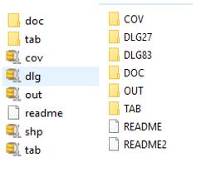

* 1. Three different datasets are available. Download a file in this order of preference.
     1. Zipped shapefile
     2. Zipped coverage folder
     3. Coverage folder unzipped
  2. Unzip and import each coverage or shapefile into the file geodatabase. For now, maintain the original file name.
  3. Depending on the eFOTG table, create Summary Statistics for each coverage. Use these to add the required T, K, R, MUWatHEL, MUWndHEL, and MUHELCL attribute fields. Optionally, you may be able to join the MUSYM fields.
  4. If your survey is not available, work with your State Soil Scientist to download the oldest SSURGO version in the Data Warehouse through the staging server and import this into data into a file geodatabase.

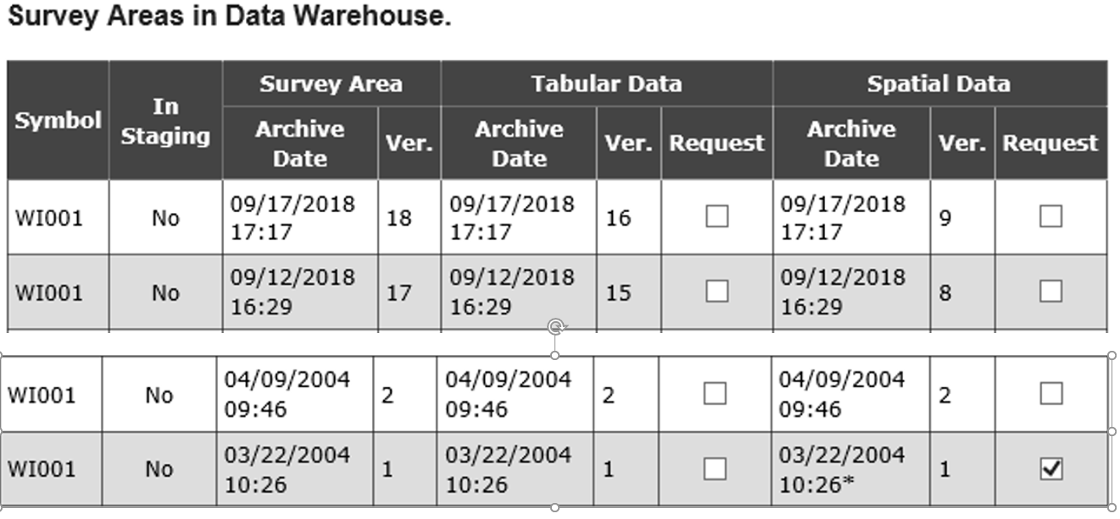

* 1. If you cannot find a digital soil survey that is consistent with the pre-1990 version, use the earliest digital data available after final correlation was completed. You may be able to create a digital product from locally archived data to import to the file geodatabase.
  2. Evaluate the soil survey linework to determine if differences exist between the version in place as of January 1, 1990. If linework has not changed, a crosswalk legend between the digital product and the frozen HEL legend can be created. If linework has changed, values from the frozen HEL lists may need to be assigned to each musym on a case by case basis.

* 1. Optionally, the digital product linework can be adjusted to match the version in place as of January 1, 1990. Any modification of existing boundaries or creating new features should meet the SSURGO data integrity standards including: Polygon boundaries will have no overlaps or gaps and polygons intersecting the border of a project area shall be closed along the border.
  2. If a suitable product consistent with the frozen HEL soil lists is not attainable, a state may pursue options such as having older soil survey products digitized and attributed with the frozen HEL list factors.

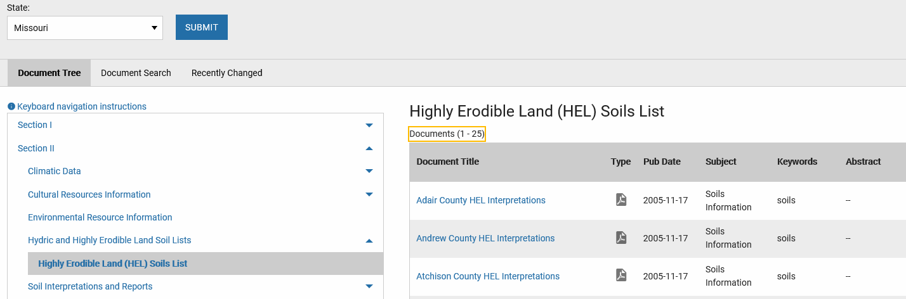

1. Download the frozen HEL list from the Field Office Technical Guide <https://efotg.sc.egov.usda.gov/#/> . The list must contain the MUSYM and the MUHELCL fields, where MUHELCL is the combined wind and water HEL determination for each map unit. Some frozen lists may also contain unique wind [MUWNDHEL] and water [MUWATHEL] values. The schema allows for additional fields to be present, such as MUNAME, C, or I. For additional information, review the data model and schema sections of the Administrator Guide. *Note.* *There is a great deal of variation in eFOTG products across states. One of the HEL tool developers may be able to help your state determine the best solution.*
2. Import the spreadsheet into ArcMap and join it to the polygon feature class.
3. Export the data to make the join in the attribute table permanent. Name the new feature class “HEL_Frozen_a_<stssaid>, where <stssaid> is the survey code or use HEL_Frozen_a_<stnnn> where <stnnn> is the state and fips code.

Ideally, states will create a statewide HEL Frozen Soils coverage. However, some states may need to create coverages for priority cropland areas first. The tool can be initially deployed for a small area until additional coverage areas are completed.

Appendix B – NRCS Elevation Web Services

NRCS hosts elevation web service data suitable for use with this tool at: <https://geodata.sc.egov.usda.gov/arcgis/services>  
Note: This link is not a web page, but an ArcMap server address.

The recommended service layers for use are the Bare Earth 1m and Bare Earth 2m in the elevation folder, both of which store vertical data values in meters. Layer files have been created and deployed with the HEL Tool for users to easily add either of these services directly to any map.

To add this data:

* Click Add Data.
* Navigate to *C:\HEL*.
* Select and add the NRCS Elevation Service – 1m (or 2m) layer file.

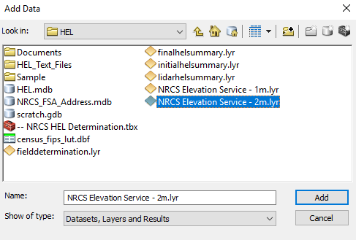

* Turn on the layer and view it to see if it has coverage for your area. Remove it and try the other one if it does not. If neither layer has coverage, you will need to seek out local elevation data options with the State GIS Specialist.
* Save your map.

Appendix C – Sample Documents

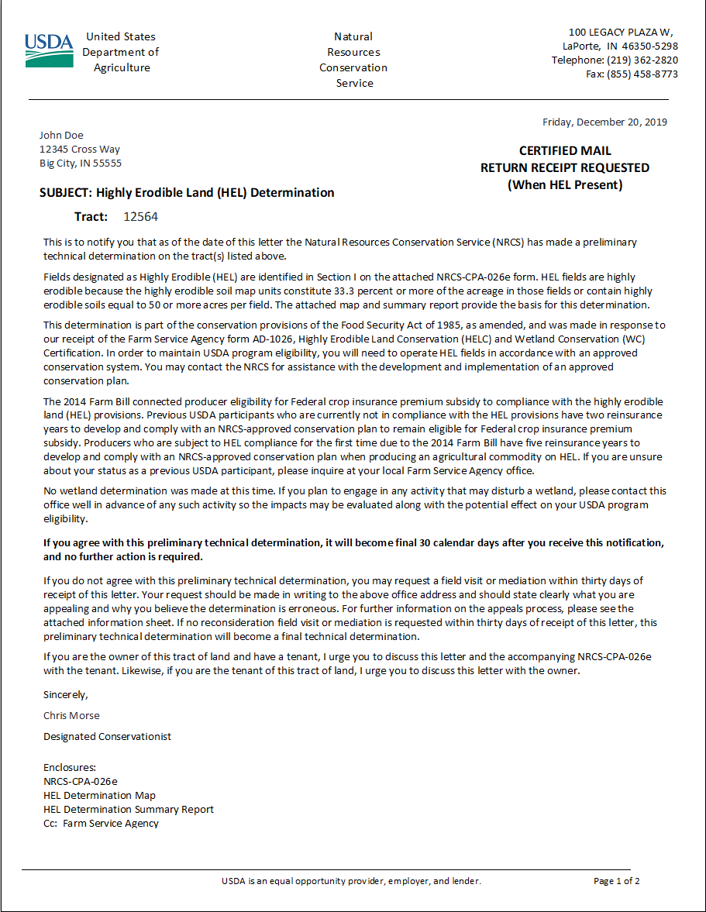Preliminary Determination Letter

*The Client Letter produced by the Main Switchboard of the HEL Determination Tool.*

**Preliminary Determination – Appeals Option**

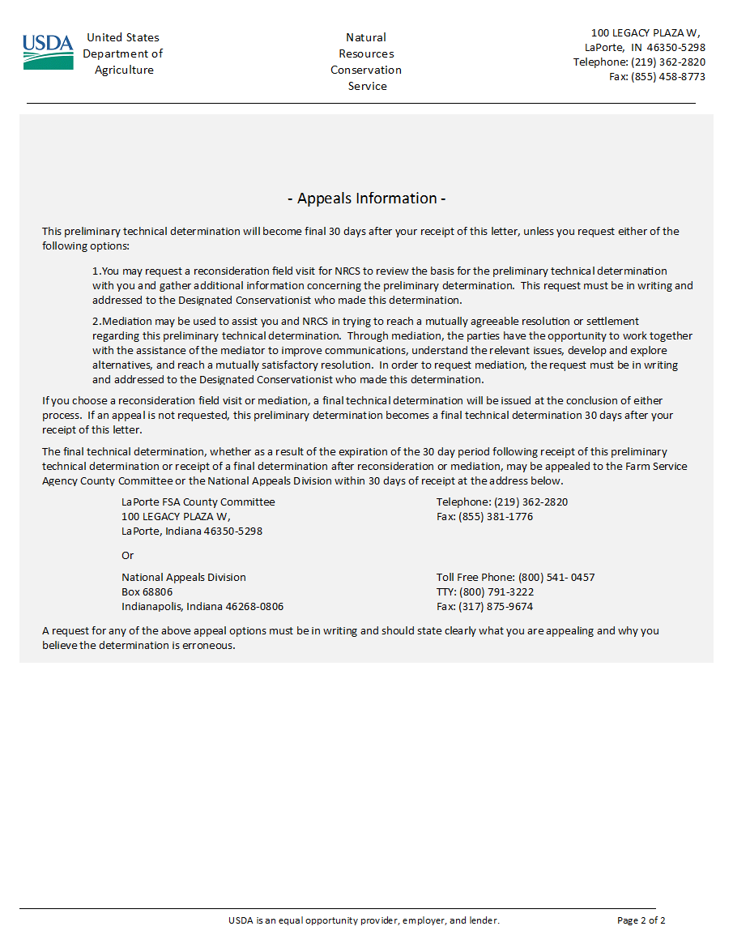

*Page 2 of the auto-generated Client Letter provides Appeals options.*

**Form NRCS-CPA-026e**

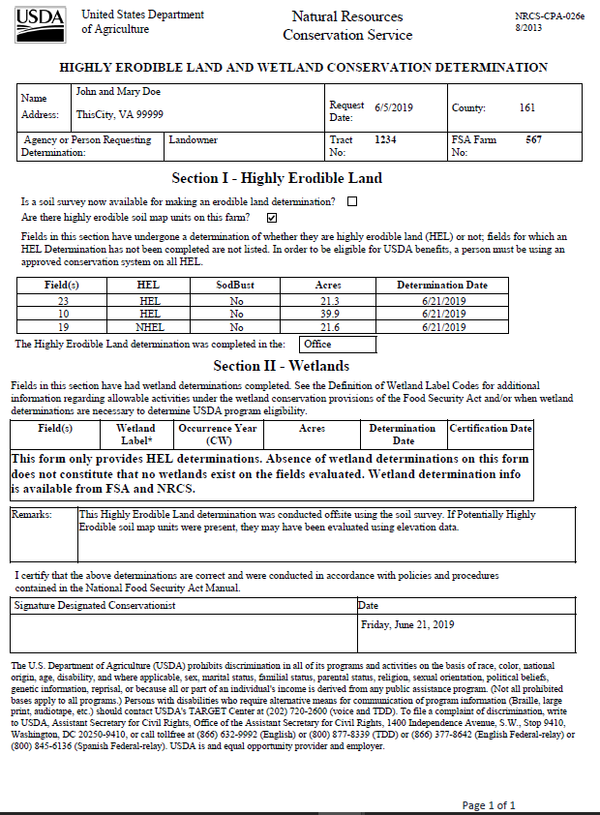

*The CPA_026e is generated through the Main Switchboard of the HEL Determination Tool.*

**Client Summary Report**

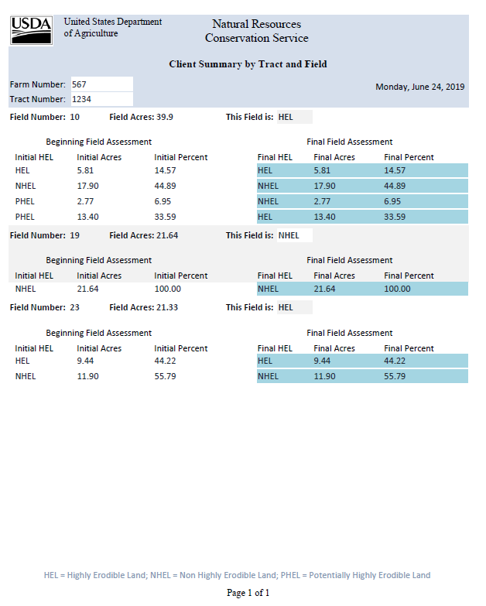

*The Client Summary Report is produced in the Main Switchboard of the HEL Determination Tool. PHEL map units are predominantly HEL or NHEL based on the LIDAR analysis.*

**HEL Determination Map**

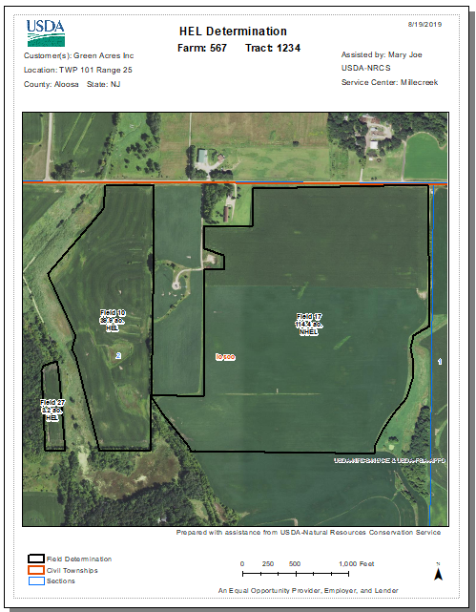

*The HEL Determination Map is provided to the Client.*

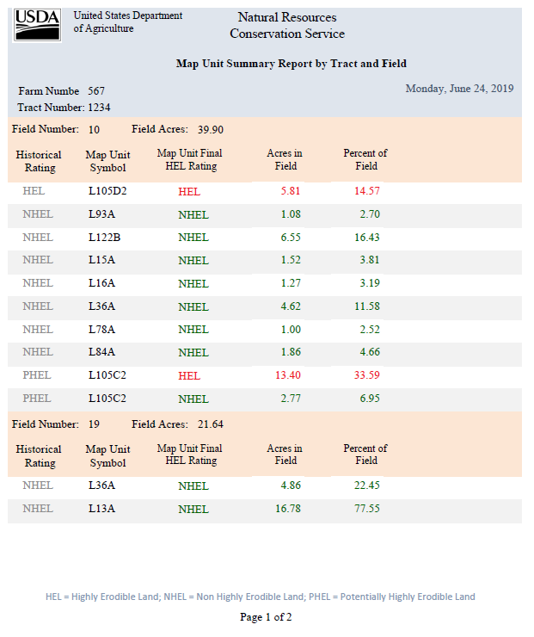**Planner Map Unit Summary Report**

*The Map Unit Summary Report is retained for the NRCS Case File.*

**Initial HEL Summary Map**

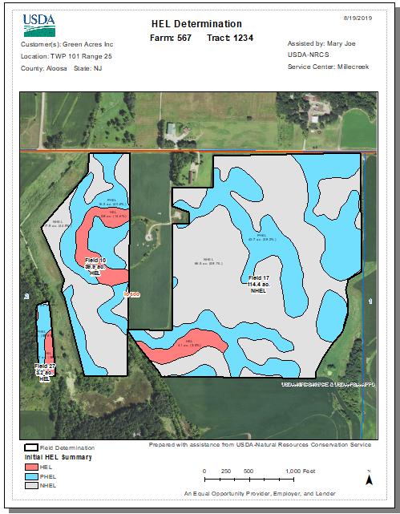

*This map displays the initial map unit HEL class (MUHELCL) for each frozen map unit.*

**LIDAR HEL Summary Map**

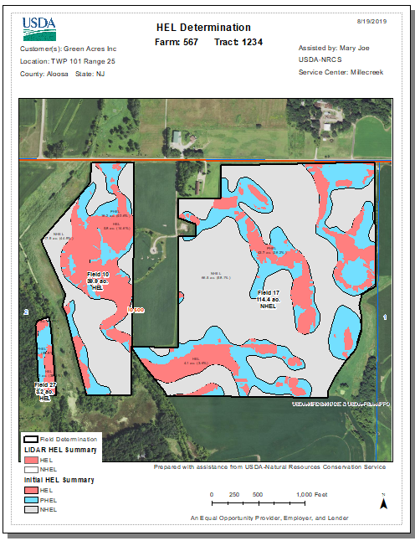

*The LIDAR HEL summary displays the HEL (red) portion of the PHEL map unit. The tool uses the DEM elevation layer provided by the user to calculate the locations within a PHEL mapunit that meet the HEL criteria EI > 8.*

**Final HEL Summary Map**

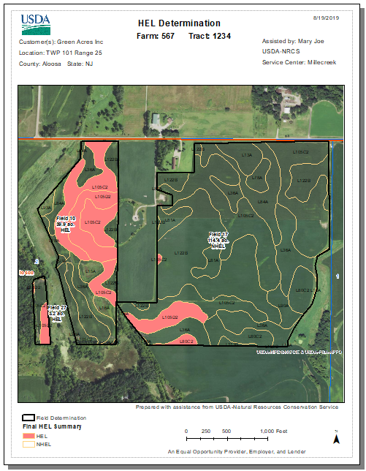

*The Final HEL Summary layer shows if a PHEL map unit is predominantly HEL or NHEL. If the map unit is predominantly HEL, the entire PHEL map unit displays as red.*

Appendix D – Tool Design Decisions

The tool was developed to provide field staff with an unbiased, efficient, and consistent method for making HEL determinations. It is intended to be a simple tool with broad national application. Below are some of the considerations and decisions made during the creation of the tool.

**Tool Development Guidelines**

* Produce same output as a field HEL determination but allow for greater consistency and efficiency.
* Calculate whether the field contains 33.3% HEL soils or greater than 50 acres of HEL soils.
* Use 3-meter DEMs (when PHEL applies), the FSA CLU, and frozen soil lines with 1990s frozen K, T, R attributes.
* Additional attribute is included within frozen soils data for wind erosion.
* Allow the selection of one field or multiple fields within a single tract.
* Complete site-specific determinations based on AD-1026 requests.
* Must use the CLU fields identified in the AD-1026, and not an arbitrary Area of Interest (AOI).
* Creation of county or statewide-wide determinations is efficient, but it is not supported in policy.
* Flow length method most closely approximates transect based methods used by field staff to measure slope and slope length in the field. Use of DEM analysis is intended to mitigate potential subjectivity or bias of onsite transect methods.
* The Flow Length analysis using LiDAR generated DEMs is determined to be the most efficient and accurate tool that targets field or tract specific analysis as described by policy. The tool uses flow length to approximate slope length. However, it is known that this method may not apply to 100% of landscapes. It is intended particularly for fields without extensive hydrology alterations through significant structural practices such as Terraces.
* Excerpt from AH-703 “…In field measurements, slope length is the factor that involves the most judgement, and length determinations made by users vary greatly.” This tool effectively averages the infinite number of slope lengths that users could potentially measure for the represented area in a PHEL map unit.
* Pre-set as many parameters as possible to minimize inputs for the user, and limit parameters as much as possible to maintain simplicity and efficiency of operation.
* Build on standard ArcMap and MS Access software.
* Programmed in Python and delivered as an ArcToolbox and ArcMap Toolbar.
* Redeterminations to be conducted in the field.

**Tool Products**

* The Client letter with appeals information will be developed by the national headquarters.
* Auto-population of map information, the CPA-026e, and client letter to increase efficiency and minimize user error.
* Auto-generation of products does not eliminate the requirement for the user to understand the documents that are produced and review them for correctness.
* A user-friendly Switchboard will be developed in MS Access to guide the user through the production of the CPA_026e and Client Letter.
* HEL Map template provided to meet basic national conservation planning mapping standards, including USDA logo and header information.
* MS Access will create a Client Summary and Planner Summary to explain the field-level determination by summarizing the acres and percent HEL, NHEL, and PHEL map units in each field.
* Comprehensive Instructions to included Administrator Guide, User Guide, Quick Guide and Videos.
* Tool instructions to reference policy guidelines.

**Tool Administration and Distribution**

* Tool and instructions will be downloadable from the GIS SharePoint.
* The State GIS Specialist will be responsible for statewide administration and distribution of the tool.
* The State Soil Scientist will be responsible for development of the required HEL Frozen Soils layer.
* File management (naming conventions and saving documents) left to state discretion.
* Some parameters will be preset and locked by state administrator.
* State administrators have ability to lock-down MS Access database.
* State administrator must update NRCS Address database prior to statewide distribution.

**Soils Data**

* Use 1990 Frozen Soil Map polygons and T, K, and R values, or a as close as possible.
* If T, K and R values were updated, use the values that are consistent with 1990 if possible.
* Some state erroneously used current soil lines joined with frozen T, K, and R values. For consistency, this same method should be used when adopting the automated tool.
* Create statewide file geodatabase (.gdb) with feature classes for each county or soil survey area. Shapefile will also be supported in initial release.
* Tool excludes “NA” and “NHEL” values from the field calculations. If a field has 100% NHEL map units, then it is 0% HEL and will be marked as NHEL.
* States with both Water and Wind Erosion values should assign the MUHELCL the most restrictive HEL value for each MUSYM.
* Tool does not accept null values in the MUHELCL, T, K, and R fields.

**Elevation Data**

* LiDAR is not required for basic operation (fields without significant PHEL map units).
* First calculate the acres and percentage of HEL and NHEL soils to make a determination.
* Use optional LIDAR-based, 3-meter DEM elevation data for evaluation of PHEL soils.
* Enable capability to resample higher resolution LIDAR to 3-meter DEM.
* Provide utility tool to clip LIDAR from the NRCS Web Service.
* Provide utility tool to merge multiple DEMS for tracts that span multiple counties.
* Process input DEM with different horizontal and vertical units and projections. The user needs to populate the vertical units parameter when the vertical units differ from the horizontal units.

**Coding Details**

* Input elevation data will be smoothed with Focal Statistics Mean prior to analysis, to reduce the noise and influence of microtopography present in high resolution DEM products derived from LiDAR.
* Elevation data processed with the Fill command using a vertical limit of 1-ft to remove minor sinks or irregularities.
* Flow length results are processed through a Focal Statistics Max function to mitigate resetting flow lengths to 0 for any remaining microtopography in the middle of other landscape features (such as hillsides, or any other landform features with similar characteristics in a contiguous extent).
* Tool uses 3-meter pixels (9 m²).
* Assign entire PHEL map unit within a given field as HEL or NHEL, based on the predominant condition. Predominance is set to >50%. If >50% of the PHEL map unit pixels within a field are HEL, the individual PHEL map unit within the field is assigned HEL.
* Topographic factor (LS) of 72.6 comes from the formula in the USDA Agriculture Handbook No. 537.
* Use an ESRI Python Add-In for toolbar distribution and installation.
* Set buffer clip of 0.25 miles beyond field boundary. Buffer is only for DEM analysis purposes.
* Some outputs adjusted to use temporary scratch workspace within the HEL install folder instead of memory due to processing issues on multiple ArcMap versions.

**Other**

* Define and use a consistent data schema for setup of DEMs, Soils, and CLU layers to help with simple, minimal input design.
* Build outputs in a personal geodatabase (.mdb) to leverage existing capabilities for report writing in MS Access. Personal geodatabases will continue to function, as is, through ArcMap 10.7, but a replacement solution will need to be developed for ArcGIS Pro.
* ArcMap layers will be produced by the tool and displayed in the Table of Contents. This includes the Final Determination, Summary of Map Units (HEL, PHEL, NHEL), and LIDAR Summary displaying the evaluation of PHEL map units.
* The tool overwrites the data each time it is run. Maps and forms should be printed or saved before running the tool again.
* Based on tester feedback, “blue” was selected for PHEL symbology.
* Selection of “Client” in place of landowner or operator.

**Marked for further review and possible implementation**

* Begin with a simple HEL tool, then explore other tools (ie. wetland tool).
* Auto-archive determination shapefiles, especially sodbuster, in a GIS layer.
* Develop utilities or options to address regional complexity, such as terraces or areas with multiple R and C factors in close proximity.
* Develop utilities to address a variety of C and I factors in states with Wind erosion.
* Upload files from desktop and sweep to Area or State Office Server.
* Generate PDF and bypass MS Access.
* Future version may utilize the GeoPortal.
* Future version migrating to ArcPro; ArcGIS Report Writer will generate a PDF report.
* Utilize batch (.bat) files or a git system for routine updates and maintenance.
* Include Spanish language version of Client letter.
* Add multiple addresses to Client letter.