This document describes the test dataset and ArcGIS Pro Toolbox for working with ArcGIS Pro/SQLite and SSURGO downloads (tabular and spatial). Steve Peaslee 2021-02-19

1. Development of these materials used ArcGIS Pro 2.7 and the "**Soil Data Development Toolbox SQLite2.tbx”.** Similar tools exist and have been used for ArcMap and the gSSURGO file geodatabase development.
2. Also included is an ArcGIS Pro project file "SQLite_Kansas_Tests.aprx". In File Explorer, you can double click on the .aprx file to open ArcGIS Pro and bring up the project. You **may** receive warning messages if you are using a version of ArcPro besides 2.7. I received these messages when using ArcGIS 2.6 but I just clicked “OK” on both and the project opened.

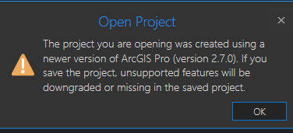

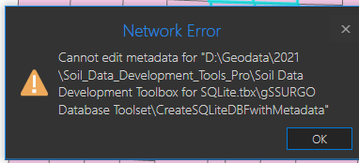

You should see a shapefile showing all soil survey areas in the state of Kansas once ArcGIS Pro has opened.

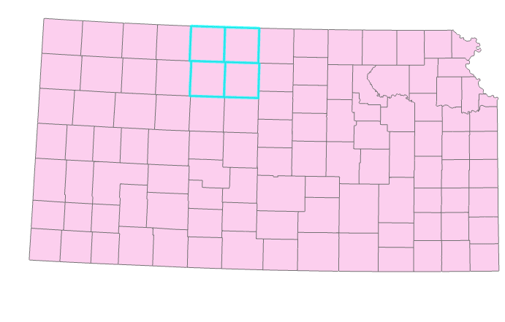

1. The project file Map document references a single shapefile, which what you are seeing in the map. In ArcPro, if you click on the “View” ribbon and click on “Contents”, you will see the file name and controls for turning on and off the dispaly.

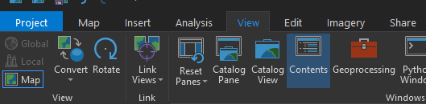

You should see a dialog box appear, usually it will be docked on the left hand side of your application.

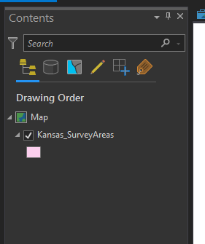

1. An SQLite database named “MD_Tables.sqlite” is included in the SQLite_Tests>MetaData_DB directory. This database contains just the SSURGO metadata tables. Within ArcGIS, you can browse to this sqlite database and add and view tables by clicking on the “Map” ribbon and then clicking “Add Data”. You don’t need to add the tables to the project but you will be able to see the contents of the database.

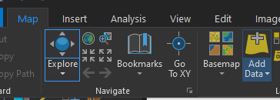

Alternatively you can click on the “View” ribbon and click on “Catalog Pane”. You may need to right click on the Folders and add folder location. This will allow you to view what’s in the SQLite database without adding the tables to Contents.

This “Kansas_SurveyAreas” map layer can be used as a reference and to help drive a couple of the Tools,

specifically "Download SSURGO by Map" and "Create SQLite DB by Map".

Some of the tools in this toolbox have not been updated to work with ArcGIS Pro and Python 3.6, but many have not.

The three tools in the “**Download SSURGO Toolset”** can be used to perform batch SSURGO downloads from Web Soil Survey. You can view the tools in the Catalog Pane by clicking on the “Toolboxes”.

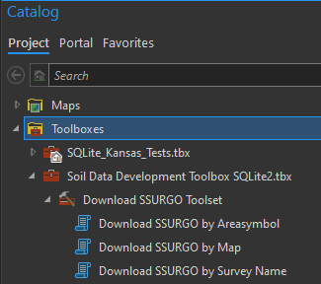

Once SSURGO data has been downloaded to your local machine, it can be imported into an SQLite or other Template database. Once a SSURGO dataset has been downloaded it normally does not have to be downloaded again. I would recommend that a single folder such as ‘SSURGO_Downloads’ be created to store these files.

Double Click on Download SSURGO by Map to execute the tool. Choose your new SSURGO_Downloads as the Output Folder. Because only 4 survey areas are selected in the shapefile, only four appear in the list. Click run to download the SSURGO data.

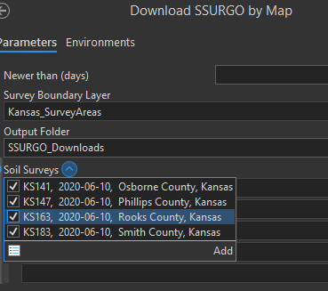

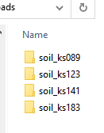Once completed, you should see these four survey areas in your SSURGO downloads folder.

There are also three tools in the “**gSSURGO Database Toolset**”…

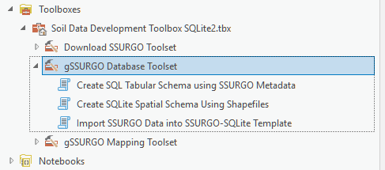

1. “**Create SQLite Spatial Schema Using Shapefiles”** – run this tool after ‘Create Template DB Using SSURGO Metadata”. It will generate empty tables with the appropriate geometry types for each of the SSURGO spatial data types. I would consider this an experimental-development tool.
2. “**Import SSURGO Data into SSURGO-SQLite Template**” – This production-type tool can be used to populate a copy of the Template database (created by #1 and #3). Input data are the SSURGO downloads. This is the functional equivalent of the ‘Import’ macro in the old SSURGO Template database (.mdb).
3. “**Create SQL Tabular Schema using SSURGO Metadata**” – this tool uses the “MetaData_DB\ MD_Tables.sqlite” database to generate and execute the ‘CREATE TABLE’ queries to build and empty template SSURGO-SQLite database (less the spatial tables). I would consider this an experimental-development tool.

The screenshot below shows the ArcGIS Pro application with the Catalog-Toolboxes on the left, Map Display of the Kansas soil survey areas in the center and the Map’s Table of Contents on the right. ArcGIS Pro does allow different parts of the interface to be moved around, so it won’t always look like this.

