**-- Select by areasymbol only**

SELECT areasymbol, areaname, CONVERT(varchar(10), [saverest], 126) AS saverest FROM sastatusmap WHERE areasymbol LIKE 'A%' ORDER BY areasymbol;

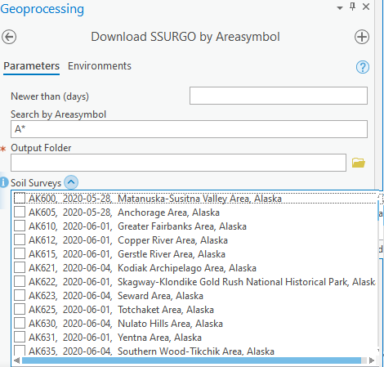

The code used to query Soil Data Access and generate the ‘Soil Surveys’ choicelist is imbedded in the form menu. After the user has checked-the-boxes for any soil surveys they wish to download, another script is executed which parses each of those choice lists to generate the URL for each of the SSURGO Download zip files. The SSURGO cache is currently located at <https://websoilsurvey.sc.egov.usda.gov/DSD/Download/Cache/SSA/>.

In the Web Soil Survey screenshot below, notice that the file-naming convention for the SSURGO download files incorporates the **areasymbol** and **saverest** dates. Once the base url and the zip filenames are known, it is a simple matter to automate the retrieval of those files.

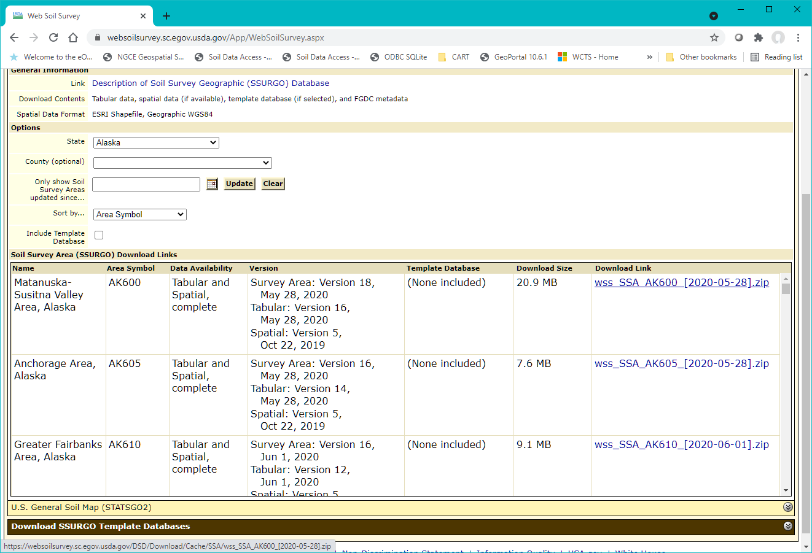

**-- Select by areasymbol where publication date was less than 100 days ago**

SELECT areasymbol, areaname, CONVERT(varchar(10), [saverest], 126) AS saverest FROM sastatusmap WHERE areasymbol LIKE 'A%' AND saverest > '2021-01-16' ORDER BY saverest DESC, areasymbol;

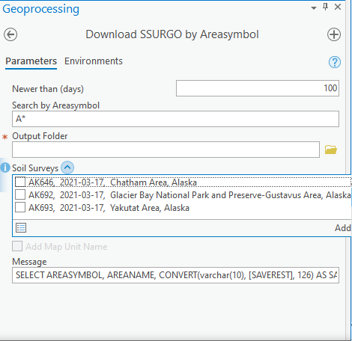

**-- Select by areaname**

SELECT areasymbol, areaname, CONVERT(varchar(10), [saverest], 126) AS saverest FROM sastatusmap WHERE areaname LIKE 'L%' ORDER BY areasymbol;

