**Creating a Desktop shortcut for the built-in Python script editor (IDLE)**

The .BAT file for opening the script editor can be found here, along with the icon file:

*C:\Program Files\ArcGIS\Pro\bin\Python\envs\arcgispro-py3\Lib\idlelib\idle.****bat***

C:\Program Files\ArcGIS\Pro\bin\Python\envs\arcgispro-py3\Scripts\idle.exe

*C:\Program Files\ArcGIS\Pro\bin\Python\envs\arcgispro-py3\Lib\idlelib\Icons\idle.ico*

**Creating an ArcGIS Pro connection to the built-in Python script editor (IDLE)**

ArcGIS Pro allows the user to specify which IDE is opened when they click on an ArcTool and select ‘Edit’. Use the ArcGIS Pro Options to set the default script editor to IDLE or one of the other 64-bit IDEs such as Pyscripter: *C:\Program Files\ArcGIS\Pro\bin\Python\envs\arcgispro-py3\Scripts\idle****.py***

Step 1. Open ArcGIS Pro and click on the **‘Project’** tab.

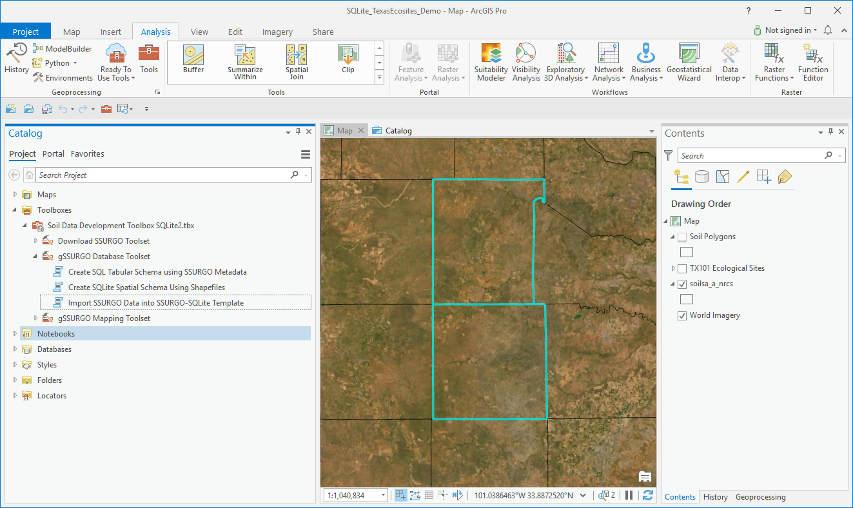

Step 2. On the left side bar, click on ‘**Options**’.

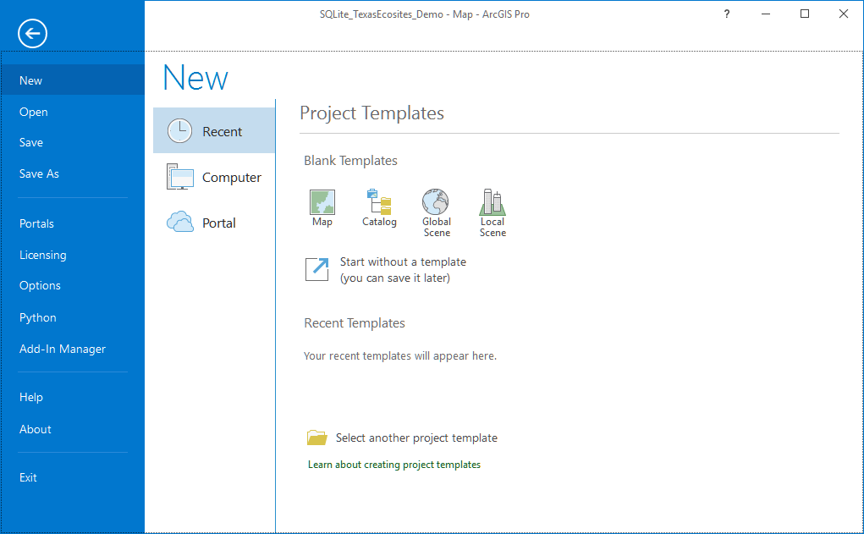

Step 3. On the left bar of the Options menu, click on ‘**Geoprocessing**’. Enter the path to the script editor of choice. In this example it has been set to the path for idle.exe under the ArcGIS Pro installation.

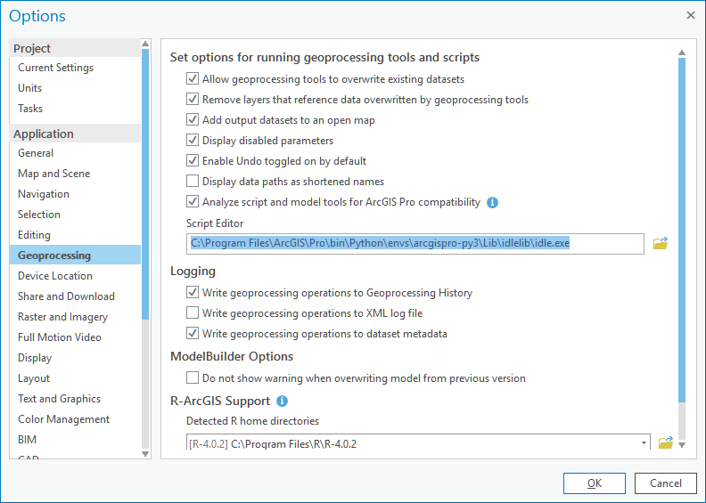

**ArcGIS Pro SDK for MS .NET - home page**

ESRI has a lot of documentation for developing with the ArcGIS Pro SDK and setting up Visual Studio.

<https://pro.arcgis.com/en/pro-app/latest/sdk/>

**Using Pyscripter 3.6 with ArcGIS Pro**

You may need to set Pyscripter to use the 64-bit version of Python. When both ArcGIS Desktop and ArcGIS Pro are installed on a computer, both Python 2.7 and 3.6 or 3.7 are installed. Only the 3.x version will work with Pro. If you try to open Pyscripter from within ArcGIS Pro it will open, but then immediately close without a warning or error message. If this happens, open Pyscripter outside of ArcGIS Pro and set the Python version by clicking the left-hand icon on the Python Versions toolbar.

