Forest Resource Report:  
Fishlake,  
2010-2019

Rocky Mountain Research Station, Forest Inventory and Analysis | May 2021

## 

Photo from Fishlake.

# Summary

The area of Fishlake located in is 1,401,254 acres with 69 percent of the area classified as forest land, 27 percent classified as nonforest land, and 4 percent as water.

Estimates are calculated using the Forest Inventory ESTimation and Analysis (FIESTA) R package (Frescino et al. 2015) and are based on FIA’s standard ‘Green Book’ estimators (Bechtold and Patterson, 2005). Data for this report were extracted from the Forest Inventory and Analysis (FIA) database for years 2010-2019 (Woudenberg et al. 2010). The estimates are based on state-level population data. There are a total of 464 FIA plots within the population. All percent sampling errors are reported at 68% confidence level.

# EST1 - Number of live trees (>= 1.0 in dia) per acre by forest type group table.

Table 1. Number of live trees (>= 1.0 in dia) per acre by forest type group, Fishlake, 2010-2019.

|  |  |  |
| --- | --- | --- |
| Forest-Type Group | Estimate | Percent Sampling Error |
| Pinyon / juniper group | 135.38 | 18 |
| Douglas-fir group | 369.35 | 24 |
| Ponderosa pine group | 185.72 | 18 |
| Fir / spruce / mountain hemlock group | 437.95 | 11 |
| Lodgepole pine group | 778.39 | 14 |
| Aspen / birch / group | 436.88 | 12 |
| Woodland hardwoods group | 723.16 | 0 |
| Nonstocked | 5.54 | 85 |

# EST1 - Number of live trees (>= 1.0 in dia) per acre by forest type group barplot.

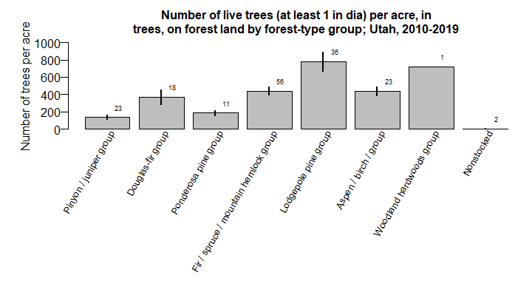 Figure 1. Number of live trees (>= 1.0 in dia) per acre by forest type group, Fishlake, 2010-2019.

# EST2 - Number of growing-stock trees (>= 5.0 in dia) per acre by forest type group table.

Table 2. Number of growing-stock trees (>= 5.0 in dia) per acre by forest type group, Fishlake, 2010-2019.

|  |  |  |
| --- | --- | --- |
| Forest-type Group | Estimate | Percent Sampling Error |
| Pinyon / juniper group | 8.20 | 47 |
| Douglas-fir group | 118.00 | 17 |
| Ponderosa pine group | 89.17 | 14 |
| Fir / spruce / mountain hemlock group | 123.31 | 7 |
| Lodgepole pine group | 259.16 | 11 |
| Aspen / birch / group | 153.29 | 15 |
| Woodland hardwoods group | 30.09 | 0 |
| Nonstocked | 5.54 | 85 |

# EST2 - Number of growing-stock trees (>= 5.0 in dia) per acre by forest type group barplot.

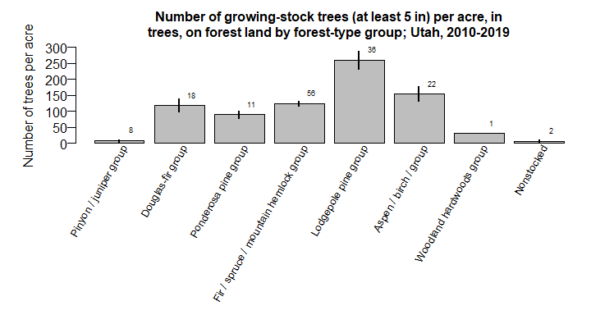 Figure 2. Number of growing-stock trees (>= 5.0 in dia) per acre by forest type group, Fishlake, 2010-2019.

# EST3 - Basal area (square feet) of live trees (>= 1.0 in dia) per acre by forest type group table.

Table 3. Basal area (square feet) of live trees (>= 1.0 in dia) per acre by forest type group, Fishlake, 2010-2019.

|  |  |  |
| --- | --- | --- |
| Forest-Type Group | Estimate | Percent Sampling Error |
| Pinyon / juniper group | 92.01 | 13 |
| Douglas-fir group | 81.64 | 15 |
| Ponderosa pine group | 73.05 | 18 |
| Fir / spruce / mountain hemlock group | 80.99 | 7 |
| Lodgepole pine group | 112.61 | 8 |
| Aspen / birch / group | 75.07 | 14 |
| Woodland hardwoods group | 49.71 | 0 |
| Nonstocked | 1.11 | 89 |

# EST3 - Basal area (square feet) of live trees (>= 1.0 in dia) per acre by forest type group barplot.

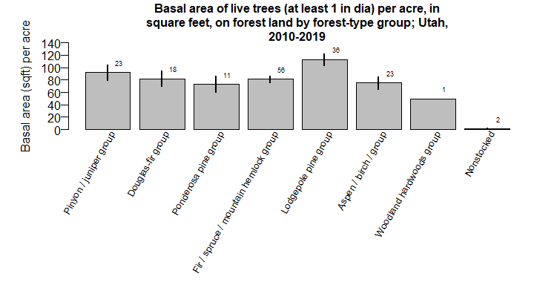 Figure 3. Basal area (square feet) of live trees (>= 1.0 in dia) per acre by forest type group, Fishlake, 2010-2019.

# EST4_v1 - Number of live seedlings (< 1.0 in dia) per acre by forest type group table.

Table 4. Number of live seedlings (< 1.0 in dia) per acre by forest type group, Fishlake, 2010-2019.

|  |  |  |
| --- | --- | --- |
| Forest-Type Group | Estimate | Percent Sampling Error |
| Pinyon / juniper group | 255.54 | 43 |
| Douglas-fir group | 418.76 | 26 |
| Ponderosa pine group | 289.41 | 31 |
| Fir / spruce / mountain hemlock group | 1,426.80 | 16 |
| Lodgepole pine group | 979.54 | 22 |
| Aspen / birch / group | 1,504.97 | 19 |
| Woodland hardwoods group | 1,275.03 | 0 |
| Nonstocked | 0.00 | 0 |

# EST4_v1 - Number of live seedlings (< 1.0 in dia) per acre by forest type group barplot.

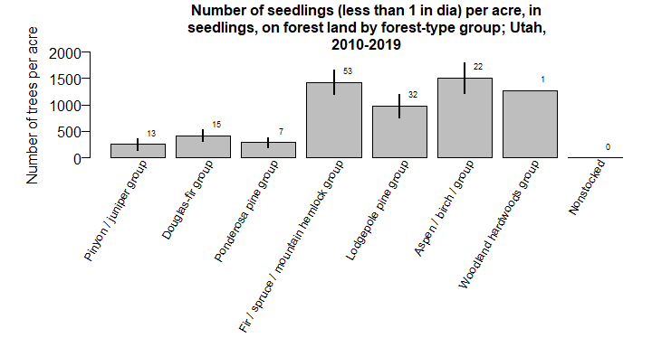 Figure 4. Number of live seedlings (< 1.0 in dia) per acre by forest type group, Fishlake, 2010-2019.

# EST4_v2 - Number of live quaking aspen seedlings (< 1.0 in dia) per acre by forest type group table.

Table 5. Number of live quaking aspen seedlings (< 1.0 in dia) per acre by forest type group, Fishlake, 2010-2019.

|  |  |  |
| --- | --- | --- |
| Forest-Type Group | Estimate | Percent Sampling Error |
| Pinyon / juniper group | 96.08 | 101 |
| Douglas-fir group | 113.61 | 59 |
| Ponderosa pine group | 93.53 | 42 |
| Fir / spruce / mountain hemlock group | 171.94 | 42 |
| Lodgepole pine group | 292.88 | 40 |
| Aspen / birch / group | 976.89 | 21 |
| Woodland hardwoods group | 525.01 | 0 |
| Nonstocked | 0.00 | 0 |

# EST4_v2 - Number of live quaking aspen seedlings (< 1.0 in dia) per acre by forest type group barplot.

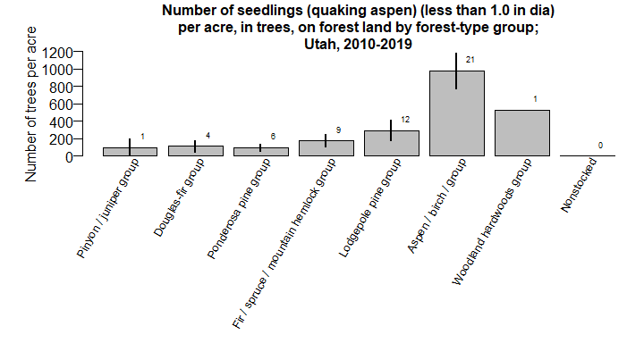 Figure 5. Number of live quaking aspen seedlings (< 1.0 in dia) per acre by forest type group, Fishlake, 2010-2019.

# EST5 - Net merchantable bole volume (cubic feet) of live trees (>= 5.0 in dia) per acre by forest type group table.

Table 6. Net merchantable bole volume (cubic feet) of live trees (>= 5.0 in dia) per acre by forest type group, Fishlake, 2010-2019.

|  |  |  |
| --- | --- | --- |
| Forest-Type Group | Estimate | Percent Sampling Error |
| Pinyon / juniper group | 672.04 | 13 |
| Douglas-fir group | 1,263.23 | 19 |
| Ponderosa pine group | 1,292.45 | 21 |
| Fir / spruce / mountain hemlock group | 1,519.73 | 10 |
| Lodgepole pine group | 1,758.65 | 12 |
| Aspen / birch / group | 1,102.28 | 22 |
| Woodland hardwoods group | 664.72 | 0 |
| Nonstocked | 5.84 | 104 |

# EST5 - Net merchantable bole volume (cubic feet) of live trees (>= 5.0 in dia) per acre by forest type group barplot.

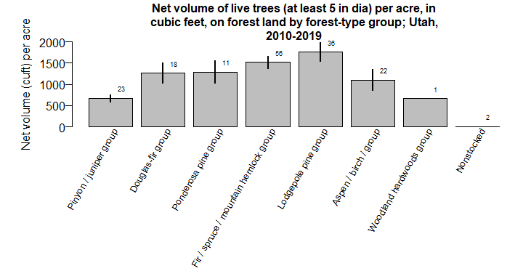 Figure 6. Net merchantable bole volume (cubic feet) of live trees (>= 5.0 in dia) per acre by forest type group, Fishlake, 2010-2019.

# EST6 - Net merchantable bole volume (cubic feet) of live trees (>= 5.0 in dia) per acre by species table.

Table 7. Net merchantable bole volume (cubic feet) of live trees (>= 5.0 in dia) per acre by species, Fishlake, 2010-2019.

|  |  |  |
| --- | --- | --- |
| Species | Estimate | Percent Sampling Error |
| white fir | 21.36 | 61 |
| subalpine fir | 59.44 | 25 |
| Utah juniper | 40.70 | 32 |
| Rocky Mountain juniper | 9.06 | 30 |
| Engelmann spruce | 369.66 | 15 |
| common or two-needle pinyon | 38.55 | 33 |
| lodgepole pine | 424.76 | 16 |
| limber pine | 3.27 | 45 |
| ponderosa pine | 87.09 | 31 |
| Douglas-fir | 171.02 | 21 |
| curlleaf mountain-mahogany | 0.08 | 103 |
| quaking aspen | 88.69 | 32 |
| narrowleaf cottonwood | 0.63 | 103 |

# EST6 - Net merchantable bole volume (cubic feet) of live trees (>= 5.0 in dia) per acre by species barplot.

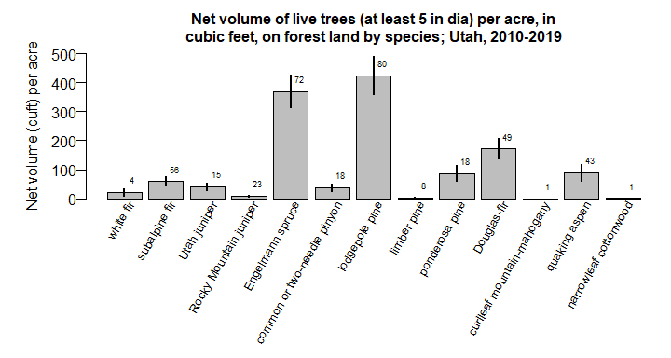 Figure 7. Net merchantable bole volume (cubic feet) of live trees (>= 5.0 in dia) per acre by species, Fishlake, 2010-2019.

# EST7 - Total net merchantable bole volume (cubic feet) of live trees (>= 5.0 in dia) by forest type group table.

Table 8. Total net merchantable bole volume (cubic feet) of live trees (>= 5.0 in dia) by forest type group, Fishlake, 2010-2019.

|  |  |  |
| --- | --- | --- |
| Forest-Type Group | Estimate | Percent Sampling Error |
| Pinyon / juniper group | 89,229,119.6 | 23 |
| Douglas-fir group | 126,145,103.5 | 29 |
| Ponderosa pine group | 79,859,187.8 | 36 |
| Fir / spruce / mountain hemlock group | 478,210,648.7 | 15 |
| Lodgepole pine group | 356,116,283.8 | 20 |
| Aspen / birch / group | 133,765,275.0 | 31 |
| Woodland hardwoods group | 3,898,523.8 | 103 |
| Nonstocked | 148,860.2 | 100 |

# EST7 - Total net merchantable bole volume (cubic feet) of live trees (>= 5.0 in dia) by forest type group barplot.

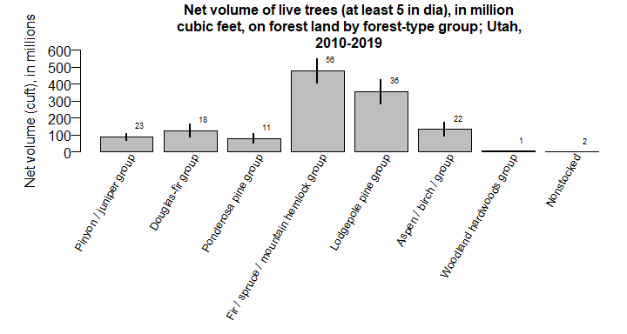 Figure 8. Total net merchantable bole volume (cubic feet) of live trees (>= 5.0 in dia) by forest type group, Fishlake, 2010-2019.

# EST8_v1 - Number of standing dead trees (>= 8.0 in dia) per acre by forest type group table.

Table 9. Number of standing dead trees (>= 8.0 in dia) per acre by forest type group, Fishlake, 2010-2019.

|  |  |  |
| --- | --- | --- |
| Forest-Type Group | Estimate | Percent Sampling Error |
| Pinyon / juniper group | 5.60 | 33 |
| Douglas-fir group | 29.23 | 22 |
| Ponderosa pine group | 0.65 | 90 |
| Fir / spruce / mountain hemlock group | 31.71 | 12 |
| Lodgepole pine group | 30.23 | 20 |
| Aspen / birch / group | 21.84 | 28 |
| Woodland hardwoods group | 12.04 | 0 |
| Nonstocked | 24.65 | 62 |

# EST8_v1 - Number of standing dead trees (>= 8.0 in dia) per acre by forest type group barplot.

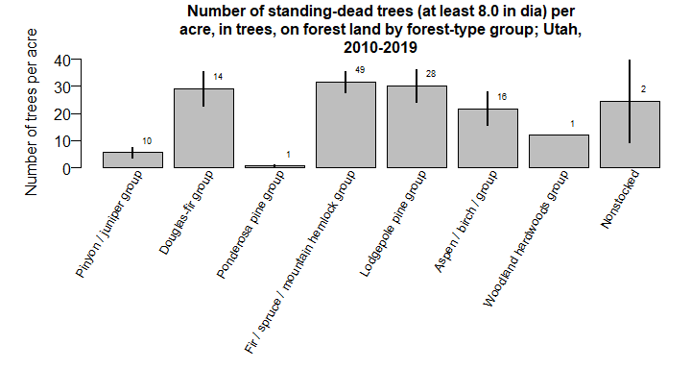 Figure 9. Number of standing dead trees (>= 8.0 in dia) per acre by forest type group, Fishlake, 2010-2019.

# EST8_v2 - Number of standing dead trees (>= 18.0 in dia) per acre by forest type group table.

Table 10. Number of standing dead trees (>= 18.0 in dia) per acre by forest type group, Fishlake, 2010-2019.

|  |  |  |
| --- | --- | --- |
| Forest-Type Group | Estimate | Percent Sampling Error |
| Pinyon / juniper group | 0.91 | 51 |
| Douglas-fir group | 4.74 | 34 |
| Ponderosa pine group | 0.00 | 0 |
| Fir / spruce / mountain hemlock group | 2.80 | 20 |
| Lodgepole pine group | 1.22 | 41 |
| Aspen / birch / group | 0.58 | 72 |
| Woodland hardwoods group | 0.00 | 0 |
| Nonstocked | 2.96 | 45 |

# EST8_v2 - Number of standing dead trees (>= 18.0 in dia) per acre by forest type group barplot.

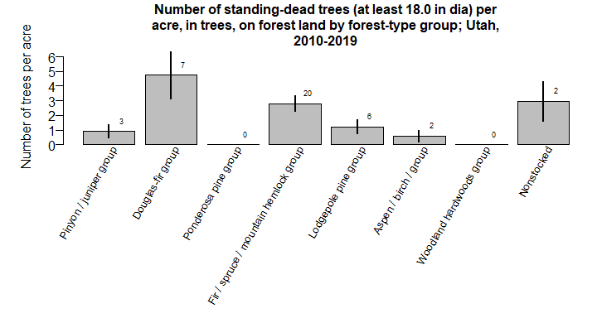 Figure 10. Number of standing dead trees (>= 18.0 in dia) per acre by forest type group, Fishlake, 2010-2019.

# EST9_v1 - Acres of forestland by stand age up to 100 years in 20 year interval classes table.

Table 11. Acres of forestland by stand age up to 100 years in 20 year interval classes, Fishlake, 2010-2019.

|  |  |  |
| --- | --- | --- |
| Stand Age Class | Estimate | Percent Sampling Error |
| 0-20 | 137,232.80 | 20 |
| 21-40 | 73,467.24 | 28 |
| 41-60 | 39,338.57 | 37 |
| 61-80 | 82,061.76 | 26 |
| 81-100 | 105,115.67 | 22 |
| 100+ | 527,073.53 | 8 |

# EST9_v1 - Acres of forestland by stand age up to 100 years in 20 year interval classes barplot.

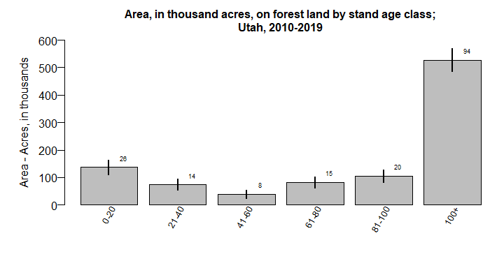 Figure 11. Acres of forestland by stand age up to 100 years in 20 year interval classes, Fishlake, 2010-2019.

# EST9_v2 - Acres of forestland by stand age up to 500 years in 20 year interval classes table.

Table 12. Acres of forestland by stand age up to 500 years in 20 year interval classes, Fishlake, 2010-2019.

|  |  |  |
| --- | --- | --- |
| Stand Age Class | Estimate | Percent Sampling Error |
| 0-20 | 137,232.80 | 20 |
| 21-40 | 73,467.24 | 28 |
| 41-60 | 39,338.57 | 37 |
| 61-80 | 82,061.76 | 26 |
| 81-100 | 105,115.67 | 22 |
| 101-120 | 130,635.24 | 20 |
| 121-140 | 93,994.33 | 24 |
| 141-160 | 79,737.74 | 27 |
| 161-180 | 35,189.28 | 39 |
| 181-200 | 42,727.99 | 36 |
| 201-220 | 58,602.24 | 31 |
| 221-240 | 28,466.60 | 45 |
| 241-260 | 24,652.04 | 49 |
| 261-280 | 16,128.42 | 59 |
| 281-300 | 10,263.54 | 73 |
| 321-340 | 6,676.11 | 95 |

# EST9_v2 - Acres of forestland by stand age up to 500 years in 20 year interval classes barplot.

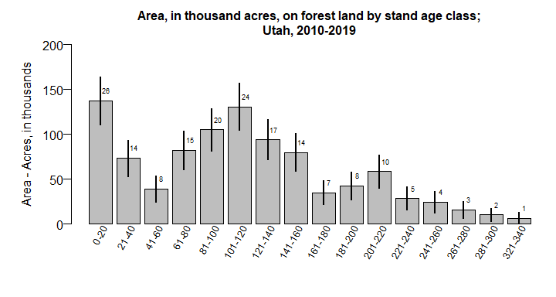 Figure 12. Acres of forestland by stand age up to 500 years in 20 year interval classes, Fishlake, 2010-2019.

# EST10 - Acres of forest by forest type group table.

Table 13. Acres of forest by forest type group, Fishlake, 2010-2019.

|  |  |  |
| --- | --- | --- |
| Forest-Type Group | Estimate | Percent Sampling Error |
| Pinyon / juniper group | 132,772.98 | 20 |
| Douglas-fir group | 99,859.21 | 23 |
| Ponderosa pine group | 61,788.85 | 30 |
| Fir / spruce / mountain hemlock group | 314,667.68 | 12 |
| Lodgepole pine group | 202,494.62 | 16 |
| Aspen / birch / group | 121,353.75 | 21 |
| Woodland hardwoods group | 5,864.88 | 103 |
| Nonstocked | 25,487.59 | 44 |

# EST10 - Acres of forest by forest type group barplot.

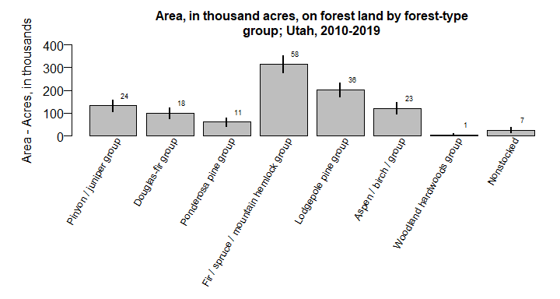 Figure 13. Acres of forest by forest type group, Fishlake, 2010-2019.

# EST11_v1 - Number of live quaking aspen stems by diameter class (0 - <1, 1 - <5, 5 - <8, 8 - <18, 18+ in dia) table.

Table 14. Number of live quaking aspen stems by diameter class (0 - <1, 1 - <5, 5 - <8, 8 - <18, 18+ in dia), Fishlake, 2010-2019.

|  |  |  |
| --- | --- | --- |
| Diameter Class (quaking aspen) | Estimate | Percent Sampling Error |
| <1 | 264,919,955 | 18 |
| 1-4.9 | 39,921,052 | 21 |
| 5-7.9 | 10,231,101 | 23 |
| 8-17.9 | 6,196,174 | 34 |

# EST11_v1 - Number of live quaking aspen stems by diameter class (0 - <1, 1 - <5, 5 - <8, 8 - <18, 18+ in dia) barplot.

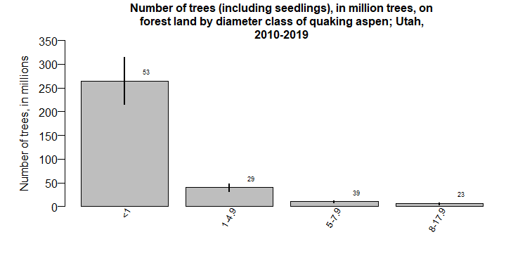 Figure 14. Number of live quaking aspen stems by diameter class (0 - <1, 1 - <5, 5 - <8, 8 - <18, 18+ in dia), Fishlake, 2010-2019.

# EST11_v2 - Number of live quaking aspen stems per acre by diameter class (0 - <1, 1 - <5, 5 - <8, 8 - <18, 18+ in dia) table.

Table 15. Number of live quaking aspen stems per acre by diameter class (0 - <1, 1 - <5, 5 - <8, 8 - <18, 18+ in dia), Fishlake, 2010-2019.

|  |  |  |
| --- | --- | --- |
| Diameter Class (quaking aspen) | Estimate | Percent Sampling Error |
| <1 | 274.73 | 18 |
| 1-4.9 | 41.40 | 21 |
| 5-7.9 | 10.61 | 23 |
| 8-17.9 | 6.43 | 34 |

# EST11_v2 - Number of live quaking aspen stems per acre by diameter class (0 - <1, 1 - <5, 5 - <8, 8 - <18, 18+ in dia) barplot.

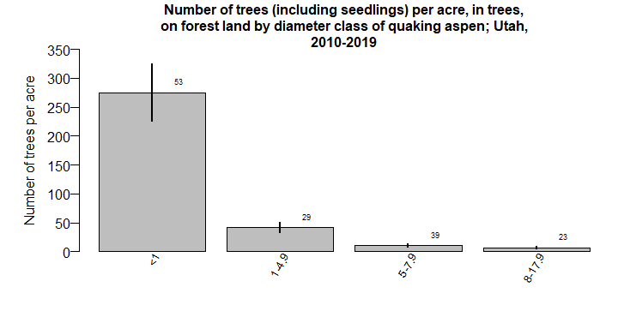 Figure 15. Number of live quaking aspen stems per acre by diameter class (0 - <1, 1 - <5, 5 - <8, 8 - <18, 18+ in dia), Fishlake, 2010-2019.

# EST12 - Basal area (square feet) per acre by forest type and stand age classes (up to 500 years in 20 year intervals) table.

Table 16. Basal area (square feet) per acre by forest type and stand age classes (up to 500 years in 20 year intervals), Fishlake, 2010-2019.

|  |  |  |  |
| --- | --- | --- | --- |
| Stand Age Class | Forest-Type Group | Estimate | Percent Sampling Error |
| 0-20 | Pinyon / juniper group | 0.00 | 0 |
| 0-20 | Douglas-fir group | 20.89 | 41 |
| 0-20 | Ponderosa pine group | 10.74 | 0 |
| 0-20 | Fir / spruce / mountain hemlock group | 32.22 | 40 |
| 0-20 | Lodgepole pine group | 39.86 | 52 |
| 0-20 | Aspen / birch / group | 24.48 | 45 |
| 0-20 | Nonstocked | 1.11 | 89 |
| 21-40 | Pinyon / juniper group | 15.22 | 0 |
| 21-40 | Fir / spruce / mountain hemlock group | 55.77 | 15 |
| 21-40 | Lodgepole pine group | 120.19 | 0 |
| 21-40 | Aspen / birch / group | 71.71 | 14 |
| 21-40 | Woodland hardwoods group | 49.71 | 0 |
| 41-60 | Pinyon / juniper group | 25.33 | 13 |
| 41-60 | Douglas-fir group | 52.88 | 0 |
| 41-60 | Ponderosa pine group | 51.72 | 0 |
| 41-60 | Fir / spruce / mountain hemlock group | 32.82 | 0 |
| 41-60 | Lodgepole pine group | 58.93 | 45 |
| 41-60 | Aspen / birch / group | 121.91 | 0 |
| 61-80 | Pinyon / juniper group | 51.06 | 32 |
| 61-80 | Douglas-fir group | 114.12 | 26 |
| 61-80 | Ponderosa pine group | 152.65 | 0 |
| 61-80 | Fir / spruce / mountain hemlock group | 64.24 | 15 |
| 61-80 | Lodgepole pine group | 127.06 | 16 |
| 61-80 | Aspen / birch / group | 69.31 | 31 |
| 81-100 | Pinyon / juniper group | 79.04 | 26 |
| 81-100 | Douglas-fir group | 58.80 | 1 |
| 81-100 | Ponderosa pine group | 95.30 | 0 |
| 81-100 | Fir / spruce / mountain hemlock group | 38.42 | 0 |
| 81-100 | Lodgepole pine group | 138.12 | 15 |
| 81-100 | Aspen / birch / group | 97.55 | 19 |
| 101-120 | Pinyon / juniper group | 49.31 | 32 |
| 101-120 | Douglas-fir group | 98.85 | 25 |
| 101-120 | Ponderosa pine group | 43.40 | 21 |
| 101-120 | Fir / spruce / mountain hemlock group | 110.47 | 26 |
| 101-120 | Lodgepole pine group | 114.78 | 14 |
| 101-120 | Aspen / birch / group | 112.08 | 27 |
| 121-140 | Pinyon / juniper group | 180.54 | 33 |
| 121-140 | Douglas-fir group | 50.32 | 0 |
| 121-140 | Ponderosa pine group | 77.11 | 15 |
| 121-140 | Fir / spruce / mountain hemlock group | 83.39 | 11 |
| 121-140 | Lodgepole pine group | 150.50 | 19 |
| 121-140 | Aspen / birch / group | 105.05 | 0 |
| 141-160 | Pinyon / juniper group | 122.61 | 18 |
| 141-160 | Douglas-fir group | 30.18 | 30 |
| 141-160 | Ponderosa pine group | 116.68 | 0 |
| 141-160 | Fir / spruce / mountain hemlock group | 93.97 | 13 |
| 161-180 | Pinyon / juniper group | 113.11 | 0 |
| 161-180 | Douglas-fir group | 116.24 | 0 |
| 161-180 | Fir / spruce / mountain hemlock group | 99.02 | 4 |
| 161-180 | Lodgepole pine group | 42.93 | 0 |
| 181-200 | Douglas-fir group | 209.19 | 0 |
| 181-200 | Ponderosa pine group | 104.26 | 0 |
| 181-200 | Fir / spruce / mountain hemlock group | 113.59 | 16 |
| 201-220 | Pinyon / juniper group | 125.39 | 19 |
| 201-220 | Fir / spruce / mountain hemlock group | 110.03 | 15 |
| 201-220 | Lodgepole pine group | 144.97 | 4 |
| 221-240 | Pinyon / juniper group | 122.82 | 0 |
| 221-240 | Fir / spruce / mountain hemlock group | 68.15 | 30 |
| 221-240 | Lodgepole pine group | 99.49 | 0 |
| 241-260 | Pinyon / juniper group | 100.43 | 0 |
| 241-260 | Fir / spruce / mountain hemlock group | 103.29 | 11 |
| 241-260 | Lodgepole pine group | 95.85 | 0 |
| 261-280 | Pinyon / juniper group | 133.49 | 0 |
| 261-280 | Fir / spruce / mountain hemlock group | 64.03 | 40 |
| 281-300 | Pinyon / juniper group | 104.89 | 0 |
| 281-300 | Douglas-fir group | 122.35 | 0 |
| 321-340 | Pinyon / juniper group | 109.17 | 0 |

# EST13 - Acres of forest by stand age class (up to 200 years in 5 year intervals) and forest type group table.

Table 17. Acres of forest by stand age class (up to 200 years in 5 year intervals) and forest type group, Fishlake, 2010-2019.

|  |  |  |  |
| --- | --- | --- | --- |
| Stand Age Class | Forest-Type Group | Estimate | Percent Sampling Error |
| 0-5 | Nonstocked | 25,487.59 | 44 |
| 6-10 | Douglas-fir group | 11,729.76 | 72 |
| 6-10 | Ponderosa pine group | 6,676.11 | 95 |
| 6-10 | Fir / spruce / mountain hemlock group | 13,195.98 | 61 |
| 6-10 | Lodgepole pine group | 11,729.76 | 72 |
| 6-10 | Aspen / birch / group | 11,074.77 | 71 |
| 11-15 | Pinyon / juniper group | 5,864.88 | 103 |
| 11-15 | Fir / spruce / mountain hemlock group | 5,864.88 | 103 |
| 11-15 | Lodgepole pine group | 4,398.66 | 103 |
| 11-15 | Aspen / birch / group | 6,676.11 | 95 |
| 16-20 | Fir / spruce / mountain hemlock group | 17,594.64 | 59 |
| 16-20 | Lodgepole pine group | 6,676.11 | 95 |
| 16-20 | Aspen / birch / group | 10,263.54 | 73 |
| 21-25 | Fir / spruce / mountain hemlock group | 13,195.98 | 65 |
| 21-25 | Aspen / birch / group | 14,007.21 | 63 |
| 26-30 | Fir / spruce / mountain hemlock group | 12,540.99 | 70 |
| 26-30 | Aspen / birch / group | 5,864.88 | 103 |
| 31-35 | Fir / spruce / mountain hemlock group | 10,263.54 | 73 |
| 31-35 | Lodgepole pine group | 5,864.88 | 103 |
| 31-35 | Woodland hardwoods group | 5,864.88 | 103 |
| 36-40 | Pinyon / juniper group | 5,864.88 | 103 |
| 41-45 | Fir / spruce / mountain hemlock group | 3,338.05 | 95 |
| 46-50 | Pinyon / juniper group | 5,864.88 | 103 |
| 51-55 | Pinyon / juniper group | 4,398.66 | 103 |
| 51-55 | Ponderosa pine group | 5,864.88 | 103 |
| 51-55 | Aspen / birch / group | 1,466.22 | 103 |
| 56-60 | Douglas-fir group | 6,676.11 | 95 |
| 56-60 | Lodgepole pine group | 11,729.76 | 72 |
| 61-65 | Fir / spruce / mountain hemlock group | 5,864.88 | 103 |
| 61-65 | Lodgepole pine group | 5,864.88 | 103 |
| 61-65 | Aspen / birch / group | 6,676.11 | 95 |
| 66-70 | Pinyon / juniper group | 9,405.74 | 70 |
| 66-70 | Douglas-fir group | 5,864.88 | 103 |
| 66-70 | Aspen / birch / group | 1,466.22 | 103 |
| 71-75 | Douglas-fir group | 5,864.88 | 103 |
| 71-75 | Lodgepole pine group | 17,594.64 | 59 |
| 71-75 | Aspen / birch / group | 5,864.88 | 103 |
| 76-80 | Douglas-fir group | 5,864.88 | 103 |
| 76-80 | Ponderosa pine group | 5,864.88 | 103 |
| 76-80 | Fir / spruce / mountain hemlock group | 5,864.88 | 103 |
| 81-85 | Ponderosa pine group | 5,864.88 | 103 |
| 81-85 | Aspen / birch / group | 8,797.32 | 76 |
| 86-90 | Douglas-fir group | 4,398.66 | 103 |
| 86-90 | Aspen / birch / group | 21,993.30 | 51 |
| 91-95 | Pinyon / juniper group | 7,533.91 | 83 |
| 91-95 | Douglas-fir group | 5,864.88 | 103 |
| 91-95 | Aspen / birch / group | 12,540.99 | 70 |
| 96-100 | Fir / spruce / mountain hemlock group | 5,864.88 | 103 |
| 96-100 | Lodgepole pine group | 32,256.84 | 42 |
| 101-105 | Pinyon / juniper group | 3,978.46 | 103 |
| 101-105 | Douglas-fir group | 5,864.88 | 103 |
| 101-105 | Ponderosa pine group | 5,864.88 | 103 |
| 101-105 | Fir / spruce / mountain hemlock group | 5,864.88 | 103 |
| 101-105 | Lodgepole pine group | 11,729.76 | 72 |
| 101-105 | Aspen / birch / group | 5,864.88 | 103 |
| 106-110 | Pinyon / juniper group | 1,669.03 | 95 |
| 106-110 | Douglas-fir group | 5,864.88 | 103 |
| 106-110 | Ponderosa pine group | 4,398.66 | 103 |
| 106-110 | Fir / spruce / mountain hemlock group | 5,864.88 | 103 |
| 106-110 | Lodgepole pine group | 6,676.11 | 95 |
| 111-115 | Pinyon / juniper group | 10,263.54 | 73 |
| 111-115 | Douglas-fir group | 6,676.11 | 95 |
| 111-115 | Fir / spruce / mountain hemlock group | 1,669.03 | 95 |
| 111-115 | Lodgepole pine group | 24,925.74 | 48 |
| 116-120 | Douglas-fir group | 5,864.88 | 103 |
| 116-120 | Ponderosa pine group | 5,864.88 | 103 |
| 116-120 | Lodgepole pine group | 5,864.88 | 103 |
| 116-120 | Aspen / birch / group | 5,864.88 | 103 |
| 121-125 | Pinyon / juniper group | 5,864.88 | 103 |
| 121-125 | Ponderosa pine group | 5,864.88 | 103 |
| 121-125 | Lodgepole pine group | 5,864.88 | 103 |
| 121-125 | Aspen / birch / group | 2,932.44 | 103 |
| 126-130 | Ponderosa pine group | 5,864.88 | 103 |
| 126-130 | Fir / spruce / mountain hemlock group | 22,804.53 | 50 |
| 126-130 | Lodgepole pine group | 11,729.76 | 72 |
| 131-135 | Pinyon / juniper group | 6,676.11 | 95 |
| 131-135 | Douglas-fir group | 4,398.66 | 103 |
| 131-135 | Fir / spruce / mountain hemlock group | 10,263.54 | 73 |
| 136-140 | Fir / spruce / mountain hemlock group | 5,864.88 | 103 |
| 136-140 | Lodgepole pine group | 5,864.88 | 103 |
| 141-145 | Pinyon / juniper group | 6,676.11 | 95 |
| 141-145 | Douglas-fir group | 5,864.88 | 103 |
| 141-145 | Fir / spruce / mountain hemlock group | 3,338.05 | 95 |
| 146-150 | Pinyon / juniper group | 6,676.11 | 95 |
| 146-150 | Fir / spruce / mountain hemlock group | 17,594.64 | 59 |
| 151-155 | Pinyon / juniper group | 5,864.88 | 103 |
| 151-155 | Douglas-fir group | 4,398.66 | 103 |
| 151-155 | Ponderosa pine group | 5,864.88 | 103 |
| 151-155 | Fir / spruce / mountain hemlock group | 17,594.64 | 59 |
| 156-160 | Fir / spruce / mountain hemlock group | 5,864.88 | 103 |
| 161-165 | Pinyon / juniper group | 5,864.88 | 103 |
| 161-165 | Fir / spruce / mountain hemlock group | 5,864.88 | 103 |
| 166-170 | Douglas-fir group | 5,864.88 | 103 |
| 171-175 | Fir / spruce / mountain hemlock group | 8,797.32 | 76 |
| 176-180 | Fir / spruce / mountain hemlock group | 4,398.66 | 103 |
| 176-180 | Lodgepole pine group | 4,398.66 | 103 |
| 181-185 | Douglas-fir group | 2,932.44 | 103 |
| 181-185 | Fir / spruce / mountain hemlock group | 11,729.76 | 72 |
| 191-195 | Fir / spruce / mountain hemlock group | 5,864.88 | 103 |
| 196-200 | Ponderosa pine group | 3,795.04 | 103 |
| 196-200 | Fir / spruce / mountain hemlock group | 18,405.87 | 58 |
| 200+ | Pinyon / juniper group | 40,306.03 | 36 |
| 200+ | Douglas-fir group | 5,864.88 | 103 |
| 200+ | Fir / spruce / mountain hemlock group | 69,293.63 | 29 |
| 200+ | Lodgepole pine group | 29,324.40 | 45 |

# EST14 - Acres of forest by disturbance table.

Table 18. Acres of forest by disturbance, Fishlake, 2010-2019.

|  |  |  |
| --- | --- | --- |
| Primary Disturbance | Estimate | Percent Sampling Error |
| No visible disturbance | 705,516.73 | 6 |
| Insect | 58,648.81 | 31 |
| Insect to trees | 105,318.47 | 22 |
| Disease | 34,534.29 | 41 |
| Disease to trees | 23,459.52 | 51 |
| Fire | 29,277.83 | 45 |
| Ground fire | 5,864.88 | 103 |
| Human-caused | 1,669.03 | 95 |

# EST14 - Acres of forest by disturbance barplot.

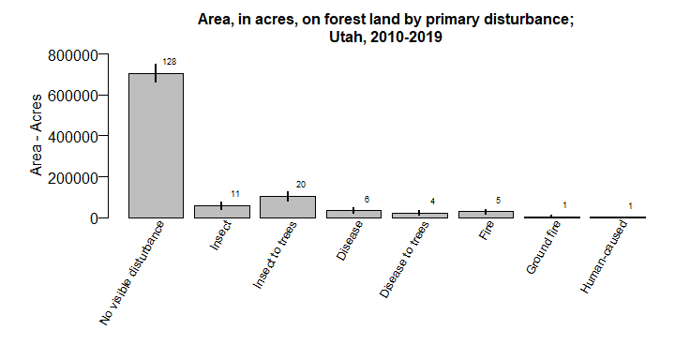 Figure 16. Acres of forest by disturbance, Fishlake, 2010-2019.

# References

Bechtold, William A.; Patterson, Paul L.; [Editors] 2005. The enhanced forest inventory and analysis program - national sampling design and estimation procedures. Gen. Tech. Rep. SRS-80. Asheville, NC: U.S. Department of Agriculture, Forest Service, Southern Research Station. 85 p.

Burrill, E.A., Wilson, A.M., Turner, J.A., Pugh, S.A., Menlove, J., Christiansen, G., Conkling, B.L., Winnie, D., 2018. Forest Inventory and Analysis Database [WWW Document]. St Paul MN US Dep. Agric. For. Serv. North. Res. Stn. URL <http://apps.fs.fed.us/fiadb-downloads/datamart.html> (accessed 3.6.21).

Frescino, Tracey S.; Patterson, Paul L.; Moisen, Gretchen G.; Freeman, Elizabeth A. 2015. FIESTA—An R estimation tool for FIA analysts. In: Stanton, Sharon M.; Christensen, Glenn A., comps. 2015. Pushing boundaries: new directions in inventory techniques and applications: Forest Inventory and Analysis (FIA) symposium 2015. 2015 December 8–10; Portland, Oregon. Gen. Tech. Rep. PNW-GTR-931. Portland, OR: U.S. Department of Agriculture, Forest Service, Pacific Northwest Research Station. p. 72.