Forest Resource Report:  
ecoM332,  
2001-2019

Rocky Mountain Research Station, Forest Inventory and Analysis | June 2021

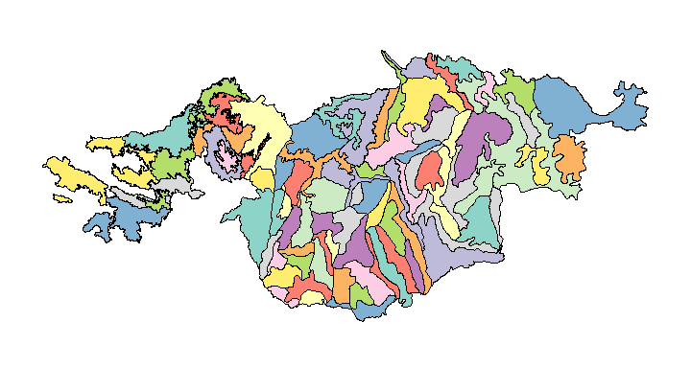 Figure 1. Small area of interest, ecoM332, 2001-2019.

# Summary

The total area of ecoM332 is 48,804,755 acres with 81 unique small areas. The area intersects 4 states (Idaho, Montana, Oregon, Washington).

Estimates are calculated using the Forest Inventory ESTimation and Analysis (FIESTA) R package (Frescino et al. 2015) and are based on small area estimators from the JoSAE package. Data for this report were extracted from the Forest Inventory and Analysis (FIA) database for years 2001-2019 (Burrill et al. 2018). All percent sampling errors are reported at 68% confidence level.

# EST1 - Area of forest land by small area domain.

Table 1. Area of forest land by small area domain, ecoM332, 2001-2019.

|  |  |  |
| --- | --- | --- |
| DOMAIN | Estimate | Percent Sampling Error |
| M332Aa | 659,093 | 0.95 |
| M332Aaa | 147,174 | 1.39 |
| M332Ab | 1,174,133 | 0.79 |
| M332Abb | 184,363 | 2.14 |
| M332Ac | 1,013,597 | 0.52 |
| M332Ad | 188,658 | 2.03 |
| M332Ae | 255,249 | 0.55 |
| M332Af | 184,831 | 1.72 |
| M332Ag | 243,212 | 1.62 |
| M332Ah | 348,870 | 0.67 |
| M332Ai | 423,161 | 1.18 |
| M332Aj | 267,555 | 2.15 |
| M332Ak | 289,473 | 0.46 |
| M332Al | 146,221 | 1.65 |
| M332All | 346,874 | 1.55 |
| M332Am | 428,443 | 1.46 |
| M332An | 267,428 | 1.95 |
| M332Ao | 601,009 | 1.25 |
| M332Ap | 198,679 | 1.50 |
| M332Aq | 158,177 | 2.89 |
| M332Ar | 129,511 | 1.67 |
| M332As | 312,603 | 1.34 |
| M332At | 376,079 | 1.90 |
| M332Au | 369,796 | 2.15 |
| M332Av | 1,076,592 | 2.36 |
| M332Aw | 182,695 | 2.34 |
| M332Ax | 189,539 | 2.29 |
| M332Ay | 401,032 | 1.59 |
| M332Az | 448,489 | 1.35 |
| M332Ba | 376,143 | 2.04 |
| M332Bb | 337,171 | 2.10 |
| M332Bc | 708,132 | 1.02 |
| M332Bd | 597,756 | 1.50 |
| M332Be | 188,713 | 2.64 |
| M332Bf | 348,309 | 1.48 |
| M332Bg | 1,187,963 | 1.11 |
| M332Bh | 391,795 | 1.29 |
| M332Bj | 299,000 | 2.51 |
| M332Bl | 340,287 | 1.22 |
| M332Bp | 322,575 | 2.30 |
| M332Db | 2,283,592 | 1.07 |
| M332Dc | 638,492 | 1.94 |
| M332De | 587,668 | 1.90 |
| M332Df | 243,122 | 0.69 |
| M332Dh | 364,753 | 1.55 |
| M332Dj | 1,354,257 | 1.16 |
| M332Dk | 2,254,664 | 2.05 |
| M332Dp | 387,750 | 2.08 |
| M332Eb | 542,124 | 2.10 |
| M332Ebb | 363,582 | 1.98 |
| M332Ee | 412,580 | 1.74 |
| M332Eee | 457,228 | 1.47 |
| M332Eg | 221,229 | 0.94 |
| M332Egg | 520,007 | 2.73 |
| M332Eh | 427,470 | 1.92 |
| M332Ehh | 343,543 | 1.62 |
| M332Ej | 1,698,935 | 2.50 |
| M332Ek | 266,105 | 1.48 |
| M332Ekk | 507,092 | 1.89 |
| M332En | 246,594 | 2.34 |
| M332Enn | 769,276 | 1.94 |
| M332Ep | 274,403 | 2.65 |
| M332Er | 1,198,280 | 1.82 |
| M332Ez | 715,087 | 2.86 |
| M332Fa | 380,629 | 2.47 |
| M332Fb | 380,064 | 1.92 |
| M332Fc | 236,496 | 2.28 |
| M332Fd | 538,498 | 2.20 |
| M332Fg | 480,120 | 1.55 |
| M332Fh | 583,763 | 1.93 |
| M332Fi | 727,169 | 1.11 |
| M332Gb | 1,561,305 | 0.70 |
| M332Gc | 1,013,452 | 1.31 |
| M332Gd | 1,477,414 | 1.78 |
| M332Ge | 578,124 | 1.20 |
| M332Gf | 638,505 | 1.59 |
| M332Gh | 1,075,853 | 0.56 |
| M332Gk | 452,917 | 3.24 |
| M332Gl | 1,304,597 | 0.79 |
| M332Gm | 222,166 | 2.57 |
| M332Gp | 699,709 | 0.54 |

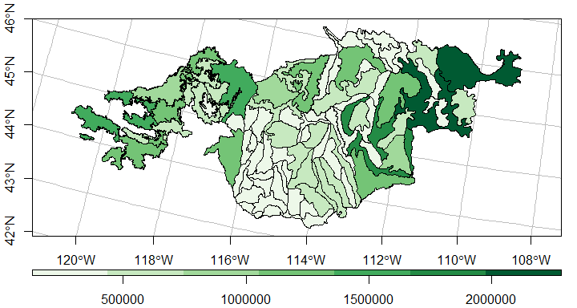 Figure 1. Area of forest land by small area domain, ecoM332, 2001-2019.

# EST2 - Net cubic-foot volume of live trees on forest land by small area domain.

Table 2. Net cubic-foot volume of live trees on forest land by small area domain, ecoM332, 2001-2019.

|  |  |  |
| --- | --- | --- |
| DOMAIN | Estimate | Percent Sampling Error |
| M332Aa | 2,448,956,793 | 6.82 |
| M332Aaa | 148,720,545 | 22.08 |
| M332Ab | 2,365,811,783 | 7.04 |
| M332Abb | 167,879,779 | 20.43 |
| M332Ac | 3,379,932,324 | 5.50 |
| M332Ad | 366,770,000 | 12.89 |
| M332Ae | 341,765,188 | 14.49 |
| M332Af | 403,743,214 | 8.48 |
| M332Ag | 591,357,711 | 10.82 |
| M332Ah | 528,283,982 | 10.03 |
| M332Ai | 538,058,792 | 13.77 |
| M332Aj | 523,059,002 | 12.02 |
| M332Ak | 487,901,767 | 13.25 |
| M332Al | 269,585,292 | 10.21 |
| M332All | 316,759,042 | 16.25 |
| M332Am | 446,504,997 | 13.04 |
| M332An | 539,338,704 | 12.14 |
| M332Ao | 1,074,013,356 | 11.07 |
| M332Ap | 223,266,263 | 20.14 |
| M332Ar | 121,157,112 | 19.70 |
| M332As | 266,821,302 | 16.51 |
| M332At | 584,643,461 | 11.32 |
| M332Au | 454,076,674 | 14.19 |
| M332Av | 2,484,819,342 | 12.37 |
| M332Aw | 310,644,899 | 16.17 |
| M332Ax | 105,686,728 | 26.61 |
| M332Ay | 599,210,841 | 12.28 |
| M332Az | 583,867,014 | 11.17 |
| M332Ba | 666,982,312 | 11.01 |
| M332Bb | 569,024,565 | 13.23 |
| M332Bc | 1,036,879,444 | 7.67 |
| M332Bd | 1,120,273,086 | 10.54 |
| M332Be | 197,825,376 | 25.85 |
| M332Bf | 419,174,733 | 11.52 |
| M332Bg | 1,731,308,852 | 6.94 |
| M332Bh | 523,661,999 | 11.40 |
| M332Bj | 319,115,911 | 17.27 |
| M332Bl | 553,141,720 | 10.58 |
| M332Bp | 293,123,902 | 12.70 |
| M332Db | 3,295,182,222 | 4.92 |
| M332Dc | 991,239,006 | 10.79 |
| M332De | 540,574,322 | 14.03 |
| M332Df | 231,151,909 | 10.61 |
| M332Dh | 500,429,098 | 10.65 |
| M332Dj | 1,550,394,149 | 6.34 |
| M332Dk | 1,436,088,504 | 15.59 |
| M332Dp | 426,973,693 | 13.43 |
| M332Eb | 641,615,373 | 13.74 |
| M332Ebb | 467,439,807 | 10.99 |
| M332Ee | 588,956,520 | 11.07 |
| M332Eee | 995,331,440 | 7.87 |
| M332Eg | 360,222,964 | 12.52 |
| M332Egg | 298,071,476 | 46.66 |
| M332Eh | 488,073,374 | 9.52 |
| M332Ehh | 741,696,615 | 9.25 |
| M332Ej | 1,672,680,983 | 17.81 |
| M332Ek | 293,940,785 | 17.06 |
| M332Ekk | 601,847,567 | 11.71 |
| M332En | 266,343,795 | 13.64 |
| M332Enn | 1,092,742,287 | 10.02 |
| M332Ep | 245,152,775 | 36.34 |
| M332Er | 1,743,785,666 | 9.96 |
| M332Ez | 428,020,089 | 53.60 |
| M332Fa | 389,540,051 | 27.07 |
| M332Fb | 521,198,166 | 13.24 |
| M332Fc | 337,162,225 | 16.80 |
| M332Fd | 550,350,283 | 17.59 |
| M332Fg | 432,876,323 | 11.29 |
| M332Fh | 672,441,666 | 18.59 |
| M332Fi | 583,174,329 | 14.32 |
| M332Gb | 3,042,870,826 | 3.50 |
| M332Gc | 1,740,196,224 | 4.38 |
| M332Gd | 2,913,396,931 | 7.38 |
| M332Ge | 1,627,692,705 | 5.13 |
| M332Gf | 1,556,220,129 | 5.70 |
| M332Gh | 1,949,974,311 | 3.15 |
| M332Gk | 529,418,224 | 31.02 |
| M332Gl | 3,270,942,557 | 3.86 |
| M332Gm | 467,494,125 | 14.47 |
| M332Gp | 1,297,882,832 | 4.40 |

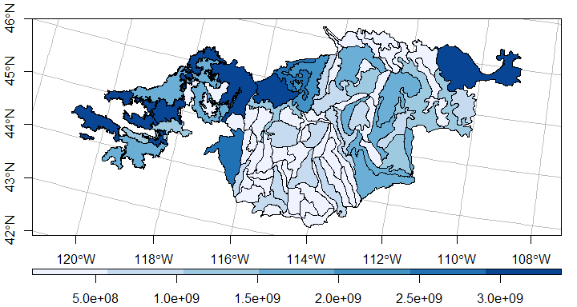 Figure 2. Net cubic-foot volume of live trees on forest land by small area domain, ecoM332, 2001-2019.

# EST3 - Square-feet basal area of live trees on forest land by small area domain.

Table 3. Square-feet basal area of live trees on forest land by small area domain, ecoM332, 2001-2019.

|  |  |  |
| --- | --- | --- |
| DOMAIN | Estimate | Percent Sampling Error |
| M332Aa | 85,174,010 | 6.15 |
| M332Aaa | 8,004,288 | 17.02 |
| M332Ab | 90,132,877 | 5.84 |
| M332Abb | 9,272,597 | 14.85 |
| M332Ac | 126,037,568 | 4.31 |
| M332Ad | 14,012,803 | 11.83 |
| M332Ae | 14,069,097 | 11.87 |
| M332Af | 15,969,799 | 6.48 |
| M332Ag | 22,430,523 | 10.17 |
| M332Ah | 21,851,082 | 9.30 |
| M332Ai | 23,396,309 | 11.33 |
| M332Aj | 20,495,408 | 10.50 |
| M332Ak | 22,491,032 | 10.00 |
| M332Al | 10,792,775 | 8.31 |
| M332All | 15,475,257 | 12.62 |
| M332Am | 20,489,415 | 10.68 |
| M332An | 21,447,894 | 10.57 |
| M332Ao | 39,414,776 | 9.50 |
| M332Ap | 9,772,503 | 16.09 |
| M332Ar | 7,083,225 | 14.35 |
| M332As | 14,125,567 | 13.19 |
| M332At | 28,964,725 | 9.46 |
| M332Au | 18,884,887 | 12.86 |
| M332Av | 98,738,864 | 11.16 |
| M332Aw | 13,883,916 | 12.85 |
| M332Ax | 5,678,101 | 19.90 |
| M332Ay | 25,889,054 | 10.71 |
| M332Az | 30,998,783 | 8.60 |
| M332Ba | 29,752,970 | 9.11 |
| M332Bb | 29,122,634 | 10.53 |
| M332Bc | 49,700,713 | 6.42 |
| M332Bd | 61,932,876 | 6.75 |
| M332Be | 13,661,147 | 15.31 |
| M332Bf | 24,360,152 | 9.02 |
| M332Bg | 91,151,166 | 5.34 |
| M332Bh | 28,146,784 | 8.97 |
| M332Bj | 21,800,522 | 13.14 |
| M332Bl | 25,980,695 | 8.56 |
| M332Bp | 18,628,595 | 9.89 |
| M332Db | 219,350,110 | 3.75 |
| M332Dc | 61,779,981 | 8.10 |
| M332De | 37,240,663 | 8.96 |
| M332Df | 18,967,836 | 8.74 |
| M332Dh | 32,213,382 | 8.03 |
| M332Dj | 106,667,036 | 4.93 |
| M332Dk | 129,340,650 | 9.08 |
| M332Dp | 27,423,123 | 9.88 |
| M332Eb | 47,761,567 | 8.70 |
| M332Ebb | 33,410,969 | 7.68 |
| M332Ee | 34,093,136 | 8.27 |
| M332Eee | 51,889,659 | 6.12 |
| M332Eg | 19,281,788 | 9.32 |
| M332Egg | 30,128,379 | 20.05 |
| M332Eh | 32,753,674 | 7.97 |
| M332Ehh | 38,309,813 | 6.96 |
| M332Ej | 121,102,008 | 11.66 |
| M332Ek | 22,822,742 | 10.91 |
| M332Ekk | 43,091,488 | 8.44 |
| M332En | 16,828,655 | 11.01 |
| M332Enn | 63,131,920 | 7.96 |
| M332Ep | 20,549,484 | 17.03 |
| M332Er | 101,378,915 | 7.42 |
| M332Ez | 35,669,610 | 26.34 |
| M332Fa | 22,479,042 | 19.27 |
| M332Fb | 27,413,286 | 10.76 |
| M332Fc | 18,320,384 | 12.30 |
| M332Fd | 35,762,485 | 11.25 |
| M332Fg | 25,513,686 | 9.47 |
| M332Fh | 41,460,388 | 12.06 |
| M332Fi | 29,003,992 | 10.55 |
| M332Gb | 135,896,216 | 2.53 |
| M332Gc | 82,157,047 | 3.37 |
| M332Gd | 116,439,564 | 5.94 |
| M332Ge | 62,483,051 | 4.05 |
| M332Gf | 59,793,230 | 4.58 |
| M332Gh | 89,457,048 | 2.43 |
| M332Gk | 29,648,213 | 21.20 |
| M332Gl | 138,395,997 | 2.79 |
| M332Gm | 19,993,819 | 11.75 |
| M332Gp | 58,307,672 | 3.50 |

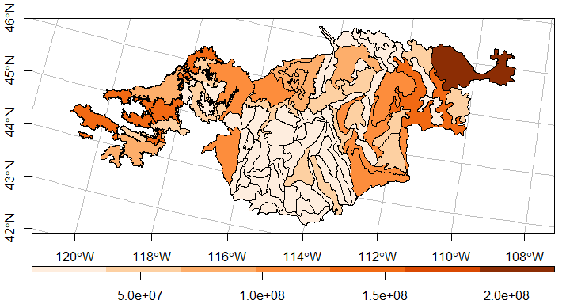 Figure 3. Square-feet basal area of live trees on forest land by small area domain, ecoM332, 2001-2019.

# References

Breidenbach, Johannes 2018. JoSAE: Unit-Level and Area-Level Small Area Estimation. R package version 0.3.0. <https://CRAN.R-project.org/package=JoSAE>.

Burrill, E.A., Wilson, A.M., Turner, J.A., Pugh, S.A., Menlove, J., Christiansen, G., Conkling, B.L., Winnie, D., 2018. Forest Inventory and Analysis Database [WWW Document]. St Paul MN US Dep. Agric. For. Serv. North. Res. Stn. URL <http://apps.fs.fed.us/fiadb-downloads/datamart.html> (accessed 3.6.21).

Frescino, Tracey S.; Patterson, Paul L.; Moisen, Gretchen G.; Toney, Chris; Freeman, Elizabeth A. 2018. FIESTA: A Forest Inventory Estimation and Analysis R Package. USDA Forest Service, Rocky Mountain Research Station, 507 25th street, Ogden, UT, USA.

Frescino, Tracey S.; Patterson, Paul L.; Moisen, Gretchen G.; Freeman, Elizabeth A. 2015. FIESTA—An R estimation tool for FIA analysts. In: Stanton, Sharon M.; Christensen, Glenn A., comps. 2015. Pushing boundaries: new directions in inventory techniques and applications: Forest Inventory and Analysis (FIA) symposium 2015. 2015 December 8–10; Portland, Oregon. Gen. Tech. Rep. PNW-GTR-931. Portland, OR: U.S. Department of Agriculture, Forest Service, Pacific Northwest Research Station. p. 72.